# Introduction

This document will be organized into sections that are defined by the requirements for a file system that presents a near-POSIX interface to the user, but whose data is stored in whatever form is most efficient for the type of data being stored. After defining the requirement the design for meeting the requirement will be explained. Finally there will be sections on configuring and administering this file system.

More and more, data dominates the computing world. There is a “sea” of data out there in many different formats that needs to be managed and used. “Mar” means “sea” in Spanish. Thus, this product is dubbed MarFS, a file system for a sea of data.

# Requirements and Design

This section defines the requirements and design elements that were crafted to meet the requirements.

## Design Overview

This design will require:

* Linux system(s) with C/C++ and FUSE support
* MPI for parallel communication in pftool (a parallel data transfer tool, see https://github.com/pftool/pftool). Thus, most any MPI library with a C interface can be used.
* Communications with the MPI library can utilize many communications methods like TCP/IP, Infiniband OFED, etc.
* If you plan to use MarFS only to combine multiple POSIX file systems into one mount point, any set of POSIX file systems can be used.
* If you plan on using multi-node parallelism for the FUSE daemon, pftool, or the batch utility programs (MarFS software), all file systems, including MarFS file systems, must be globally mounted on all nodes running MarFS software. This includes NFS and other global file systems.
* If you plan to store data on an object store, that object store needs to be accessible by all nodes running MarFS software. The MarFS metadata component must be capable of POSIX extended attributes (xattr) and must support sparse files (files that have a non-zero size but that occupy no space).

The planned MarFS implementation will use GPFS file systems as the metadata component and Scality and/or ECS ViPR object stores as the data storage component.

The interactions with the GPFS-based metadata component are via the normal POSIX interface. GPFS has some ILM (Information Lifecycle Management) capabilities for managing massive amounts of metadata that helps immensely with batch processing for management of the system.

The interactions with the Scality- and/or ECS ViPR-based data storage component are via the most efficient object protocols, such as Amazon S3 and CDMI. MarFS can put a file per object, pack many small files into one object, and spread a large file across many objects. Although the design does not call for using POSIX file systems as the data storage component, the design does not preclude it. If MarFS were configured to use a POSIX file system as the data storage component, then any such file system would work including PFSes (parallel file systems) like GPFS, Lustre, Panasas, etc., or non-PFSes, like NFSv3.

The GPFS file systems and object stores will be hidden from the users so that they cannot use them directly, but the MarFS components will know about them and how to use them efficiently.

A FUSE daemon will provide the system mount point and interactive use component of MarFS. This daemon will know that it will use the GPFS file systems for metadata operations and the specified object stores as the data storage component. The FUSE daemon enforces writing only serially from byte zero.

The parallel data movement utility, pftool, will likewise be modified to use the GPFS file systems as the metadata component and the object stores as the data storage component. pftool is a load balanced, highly parallel utility on one node or across multiple nodes. It can walk the file system tree in parallel, move data between file systems, and move small files in parallel or break-up big files to move them in parallel for any POSIX file system, including MarFS. It will be possible to write data to MarFS in parallel using pftool, or by writing one’s own parallel data movement utility using the library.

There will be some MarFS utility programs that will be run periodically to free deleted storage space and ensure that users do not exceed their assigned quotas. Other utility programs may be implemented in the future to manage other aspects of the file system that can be performed on an as-needed or periodic basis.

## Near-POSIX Interface

MarFS shall provide a near-POSIX interface.

MarFS shall provide a POSIX mount through which the user executes the supported file functionality.

MarFS is not required to allow users to update files in place for data repositories where update-in-place is not easy, like object stores.

MarFS is not required to provide an object interface to the data. This includes not being required to provide an HDFS interface.

MarFS is not required to provide file locking.

MarFS is not required to provide hard links, but shall provide symbolic links.

MarFS is not required to provide mmap and application execution, be a PFS, or a parallel archive.

### Design to Provide Near-POSIX Interface

If you are looking for a way to provide a near-POSIX file system interface over multiple POSIX file systems or over one or multiple Object Storage Systems as the data storage component, MarFS might be the answer. MarFS can use one or more POSIX file systems to hold file system metadata. The FUSE daemon provides nearly full POSIX access with a few exceptions that are specifically discussed.

Whether using interactive Linux commands in a shell or pftool, the interface to MarFS will be through a near-POSIX interface that targets what looks like a normal POSIX mount point.

pftool safely allows multiple writers to write to a single file as well as multiple readers to read a file in parallel, but it does not protect against a user using different commands/programs from updating the same file concurrently.

All programs shall work unchanged except for programs that seek around in the file and write, or append to the end of a file, or try to truncate a file in a place other than zero offset. This means that reading files will work pretty much no matter what, but writing has to be done as a complete overwrite.

MarFS could eventually provide an object interface to data, as its metadata has object information and maps POSIX files onto Objects. With respect to a HDFS interface, MarFS is POSIX and HDFS does have the ability to use POSIX files. Optimization to provide layout information to an HDFS layer is possible.

MarFS provides symbolic links through its use of GPFS as the metadata component. Hard links are not supported because the GPFS metadata component may actually be multiple name spaces and/or GPFS file systems and hard links cannot be used across name spaces and file systems.

MarFS is primarily intended as a file system for large data collections and not for application execution. That said, mmap or execution might work if it behaves relatively well. One should be able to mmap and execute off of MarFS, but mmap writing may not work if writing is not serial. MarFS is not intended to replace a PFS, as it lacks important features on purpose, although it might suffice as a PFS in some settings. Likewise, MarFS is not intended to replace deep and/or parallel archives, such as HPSS, although in some settings it might also work for this function.

## High Performance and Eventual Consistency

This requirement is related to the near-POSIX interface. Maintaining locks, collecting released space, and enforcing quotas are things that a POSIX-compliant file system does, but that affect performance. MarFS is not required to provide these POSIX file system features.

MarFS software is not required to check/lock to protect against multiple non-coordinated writers into the same file.

MarFS shall ensure that the file system’s metadata and data are consistent.

### Design to Provide High Performance and Eventual Consistency

The specified operations are not necessary to be done in real-time, as they would adversely affect MarFS performance. Utilities that can be run periodically will be provided to reclaim deleted space and ensure that users do not severely overrun their quotas for storage space and file count.

MarFS could provide file locking, but does not currently do so. Like many PFSes, MarFS will entrust the responsibility to manage access to files to the application so that parallel performance can be maintained.

In this design where MarFS uses object stores for storing data, the metadata and object store systems require some reconciliation. All metadata, except for object-specific metadata, is stored in the MarFS POSIX file systems that store the metadata. As mentioned, periodic garbage collection of freed space will be done. MarFS attempts to minimize areas where truly transactional semantics are needed, but does not make any transactional guarantees. MarFS errs on the side of making it easy to run batch inode scans or tree walks due to the parallelism in the batch utilities and ability to use many POSIX file systems and metadata servers to make for easy management of the metadata/space/etc.

## Scalable Metadata

MarFS shall provide a means to scale metadata handling as more capacity and file count is added. This scalability shall target the common use case scenario for large HPC data stores where there are many clients.

MarFS is not required to solve the scalabilty problem of very large single directories..

### Design to Provide Scalable Metadata

MarFS currently is concentrating on providing a best-in-class scalable metadata service over a best-in-class scale out object storage system. If you are looking for a way to scale metadata service, but not stripe or hash metadata, MarFS might be the answer. As mentioned, MarFS will use GPFS as the metadata component. GPFS has many features in its ILM (Information Lifecycle Management) component that allows GPFS to be used as an efficient and scalable MarFS metadata server.

Currently the MarFS design does not hash or split-up single directories to address the problem of single directories containing a large number of files. MarFS will allow multiple name spaces to be combined into one name space spread across multiple file systems by tree. It is possible for an implementation to use a metadata file system under MarFS that does hash or split-up single directories to address the scalability of directories with many files. And, future MarFS features might include hashed or split-up single directories.

The design uses scale out metadata services, via GPFS, and scale out data services, via the object stores, separately. Data and data movement can scale as N file systems or N object stores and it has features to be “friendly” to object systems by trying to form large multi-megabyte sized objects for efficient storage and tracking.

**@@@ Continue from Here @@@**

**Why MarFS**

Tools like Cleversafe, Scality, and EMC ViPR are moving towards the data lake concept where data can have multiple personalities including POSIX, Object, and HDFS. These solutions use erasure based disk systems to store the data. These tools are immature at least at this time. These tools may overtake what MarFS is suppose to provide, but for right now, MarFS allows you to use many POSIX metadata servers and one or multiple object stores to independently scale metadata and data service.

It is possible to put Object Storage Systems under scalable file systems like GPFS using a block interface over the Object Storage System, but the block write patterns of these parallel file systems are not well suited for getting the most from these Object Storage Systems. The ability to use any object storage system as a back end storage repo is also a plus for MarFS, as one could use any object store including cloud based services if you wanted to.

There doesnt appear to be other open source projects that provide the needed function exactly. Ceph provides a file system on objects but isn’t known for scaled out metadata service. GlusterFS is probably the closest thing to an alternative and indeed GlusterFS can be a global name space gluing multiple file systems together into one mount point. GlusterFS also hashes the file names across the file systems, which is something MarFS cant do at least right now. The main difference is the approach to what GlusterFS documentation refers to as unified file and object. GlusterFS has been integrated to be object storage for OpenStack Swift (for objects) and storage for OpenStack Cinder (for blocks). MarFS instead puts a POSIX interface over any Object Storage Service including OpenStack Swift. So you can see that MarFS is coming from a bit different angle for unifying file and object services.

Why not use an HSM like HPSS or DMF? These systems currently don’t utilize the enormous investments in industry on object storage. HPSS metadata performance is likely going to be 1/10th or less of a typical MarFS metadata performance. MarFS is open source and a tiny amount of coded compared to HSM’s. In fairness, MarFS is not an HSM, although batch utilities could be written easily to move data around under MarFS to various kinds of storage systems including HPSS, an HSM, LTFS, or other if someone wanted to write such code. Massive parallelism is also not typical of HSM systems like HPSS. MarFS is really designed for dozens to hundreds of metadata servers/name spaces and thousands or even tens of thousands of parallel data movement streams. HPSS is designed for about an order of magnitude less parallelism.

Why not use the General Atomics Nirvana Storage Resource Broker, IRODS, well these things are optimized for wan and hsm metadata rates. There are some capabilities for putting POSIX files over objects, but these methods are largely via NFS or other methods that try to mimic full file system semantics including update in place. These methods are not designed for massive parallelism in a single file, etc. What about other name space solutions? Well Maginatics from EMC is around but it is in its infancy and targeted at enterprise and there is an open source name space project called Camlistore but it appears to be targeted and personal storage.

Do other name space solutions exist? Bridgestore is a posix name space over objects but they put their metadata in a flat space so rename of a directory is horribly painful. Avere NFS over objects is focused at NFS so N to 1 is a non starter.

Why not use just an object system without MarFS? MarFS assumes you want a first class POSIX metadata service over your files which a typical object store avoids. MarFS is trying to be the best of both worlds allowing data scaling like an object system, metadata scaling like N POSIX name spaces, with both kinds of access to the same data, the true data lake concept.

We need an open source piece of software that enables the described function to to deploy in production and to use to set the bar high for fully integrated solutions that provide the data lake multi-personality do data on erasure disk to beat.

**Architecture**

The architecture of MarFS is split into several parts.

* the FUSE file system that provides the near full POSIX interface to MarFS
* the batch parallel listing/movement utility
* a library that both fuse and the batch utility call into for most functions
* some batch programs for scanning the metadata for updating name space info like total space used for quotas and statvfs like queries
* some batch programs for scanning metadata for space management
* the POSIX metadata file systems
* the back end storage systems which can be POSIX file systems or object systems.

In the diagram below, you can see a very rough concept of how MarFS campaign storage would fit into our Turquoise environment. You can see all the normal services on the top and the MarFS campaign storage on the bottom. The File Transfer Agents (FTAs) are where the FUSE and Batch programs run and where the POSIX metadata file systems are mounted that make up the metadata service for MarFS as well as all the other non MarFS file system mounts to NFS, GPFS Archive, Scratch, etc. The MarFS metadata storage servers (in this case running GPFS NSD) provide very fast parallel metadata file systems for MarFS. The object servers provide a scalable data repository for MarFS files.

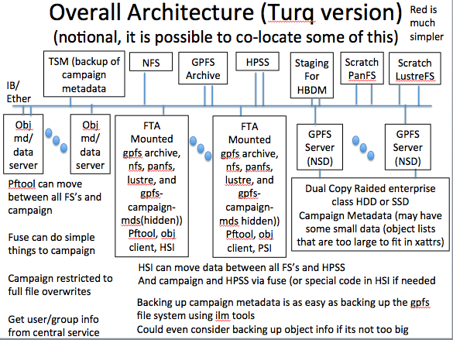

A closer look at how MarFS should be deployed is shown below. Notice separate interactive and batch FTA’s are recommended for security reasons and for performance reasons. Since the Object Security model does not match well wit the POSIX security model, it makes sense to not allow users to have access to keys needed to open/control the object stores, so those should be kept on the batch only FTA’s and provided only to the FUSE deamons on the interactive FTA’s using some secure method. The ability to control who can get access to the object servers directly without going through the FUSE daemon must be controlled. Interactive FTA’s would be used for LS, GREP, TAR, etc. These are all small/serial tools that can run by as users gaining access to files through the FUSE daemon which must run as a privileged user for a variety of reasons both management and security related.

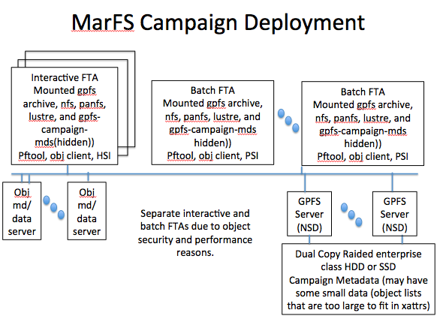

How does MarFS work?

MarFS files are created into a POSIX metadata tree (where is determined by configuration) with no special metadata. If the file is to be a normal POSIX file (determined by configuration) then the file can be written and read as normal by the FUSE and batch utilities. Depending on the path, the MarFS file metadata/data will be placed into one of many possible POSIX file systems (determined by configuration). In this way, MarFS is a global name space. Again, files are not hashed across POSIX file systems, the total MarFS namespace is decomposed into separate POSIX file systems by tree (configuration). All normal POSIX ownerships/permission/attributes like dates/sizes/etc. are obeyed. One can even add user supplied xattrs to the files.

If however, you have configured the file data to go to an external object repository (via configuration files), then only the POSIX metadata is stored in the appropriate POSIX file system name space. The difference is, the data is written to objects in the external object data repo instead of into the POSIX file. All normal attributes are kept up to date in semantically reasonable ways like permissions, dates, and even file size. The file size is updated by truncating the POSIX file to the size of the desired file even though there may be no actual bytes/space in the file itself. For this reason the POSIX file systems used for holding file metadata for files that are stored in external object repos must support sparse files. Further, some reserved POSIX xattrs are used associated with the files to point at various config and back end object repo information so that where the data is and how to access it are preserved (in those xattrs). For this reason, the POSIX file system used for metadata for files stored in external object repos must support POSIX xattrs and furthermore, some xattr names are reserved and hidden from the user.

In this design all metadata operations like reading/creating directories, managing ownership, dates, permissions, user xattrs, etc. are all just performed on the POSIX file system being used for metadata (and data for normal non external object repo files). Only operations involving space management for files on external object repos need to be handled differently from just normal POSIX. In these operations, all the POSIX permissions are adhered to and additionally Object permissions are also obeyed based on the operation. Creating, writing, and reading these files with their data in external object repos uses/updates the POSIX attrs and xattrs appropriately to manage the access needed. For special space management operations like truncate and unlink, all references to the space being freed are renamed (in case of an unlink) or copied (in the case of a truncate) to a trash directory which can be used by a batch program for space reclamation from the object server. It does require a batch program to free the objects and clean out the trash. A trash recover utility could easily be written as well if desired.

The FUSE daemons on the interactive FTA nodes allows users to run interactive file system commands but the FUSE daemon has some drawbacks. It can not pack multiple small files into one object, this must be done by a batch program after the fact if written by FUSE. The FUSE daemon enforces no update in place for all files in data repos that do not make update in place easy (like object servers). This means if you want to update a file in place you need to copy it to a full service file system, modify it and put it back. Files can be read in any order of course and all metadata operations should work (chown,chmod,mkdir,etc.) If the file is stored on an object server that does not support update in place you can only truncate to zero, meaning files have to be completely overwritten, not partially, and right now append is not supported either, but that could be added at some point.

The parallel batch listing/movement utility is a load balanced, highly parallel utility on one node or across multiple nodes. It can walk the file system tree in parallel of any POSIX file system including MarFS. It can move data between any two POSIX file systems in parallel including MarFS. It can move many small files in parallel or break up big files and move them in parallel to/from any POSIX file system including MarFS. It only runs on the batch nodes and users cant not log into the batch nodes. This is for performance isolation and for security, as access to the object repo needs to be controlled to be either in a root owned FUSE daemon or on a non interactive batch only node to protect the object server from being compromised. From an interactive FTA, commands like pcp (parallel copy) and pls (parallel ls) and pcmp (parallel compare) can be used which will run a batch job interactively. Additionally scheduling long running data management tasks through a scheduler should be made possible via normal batch scheduling mechanisms.

There also needs to be a small suite of batch programs for managing the file system. These utilities are needed for counting up space used in a namespace or part of a name space for quota enforcement. Batch utilities for space management/reclaimation/packing/repacking of small files into objects etc. also need to be provided. If GPFS is used as the POSIX metadata file systems for MarFS, the GPFS ILM features that allow for very fast inode shadow table scanning and threaded name merges etc. can be utilized to look through millions of files in minutes to perform these management tasks. These utilities need to be specified at some point and would be easy to add to over time.

In the following diagram, you can see MarFS implemented in cartoon style showing a GPFS POSIX metadata tree that has xattrs pointing at external object repos for a Uni file (one object per file) and a large Multi file (multiple objects per file). In the case of the multi-object file, the list of objects that make up the file are stored in the metadata file (which implies that the chunksize of a large file has to be larger than an objectid), and the amount of real object id data in the metadata file is stored in an xattr so you know how much data is in the metadata file and the rest is just a hole so the size of the metadata file == the size of the file logically.

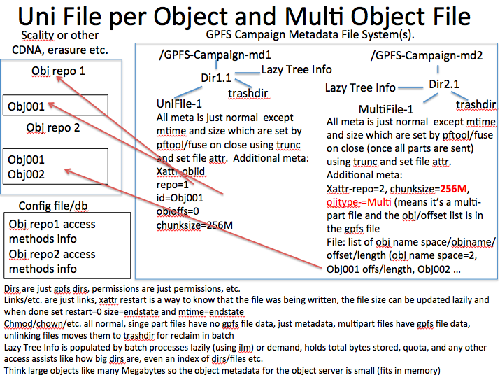

In the following diagram, you can see MarFS and a depiction of packed file which is where multiple files are packed into one object.

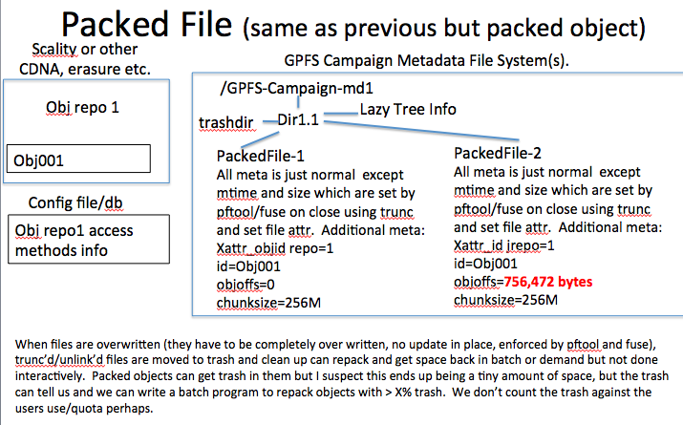

**Configuration File Information**

Much of understanding MarFS is understanding the configuration information.

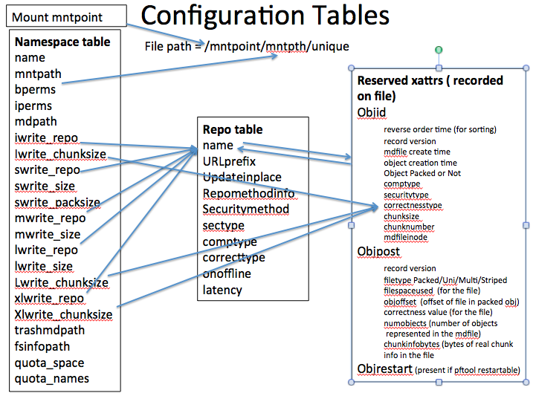

**Reserved POSIX extended attributes (xattr)**

MarFS utilizes POSIX extended attributes (xattr) to place information about the data repository/objects that hold the data for files. Files are born without extended attributes and only acquire them when the file is written. Xattrs will only exist for files in which the data exists in external data repositories. Therefore, most any POSIX file system can be used for holding metadata and data, but the requirements for storing metadata for files in which data exists in external data repositories require xattr and sparse capabilities because xattrs are used to map to the external data repo and the POSIX size field is used to store the length of the file for files where the data lives in an external repo.

Below are the reserved attributes that are used and their descriptions:

For both MAR_objid and MAR_post, the reasons this is one record with all these fields concatenated are:

* These are all variables that are short enough to concatenate into one record to form the object name to help the admin figure out things if there are issues, having this information into the name of the object will be handy.
* It makes the object name unique.
* It doesn’t add information that is too long for the name of the object (like create time path of the md file).
* It takes time to insert xattr’s, so making this be 10ish xattrs is too expensive per file create/file read

The reasons there are three XATTRS are:

* MAR_objid is the object name (or the first object name in the case of a multi object file), this info doesn’t change very often, basically only on a truncate. So it is set in stone for a file unless you throw out all the space associate with the file.
* MAR_post is information that can change from time to time on a file, like it can updated while the file is growing, etc.
* MAR_restart is just used by restart on multi-files and thus wont be present very often

MAR_objid (the name of the object for this file is named /bucketname/MAR_objid) bucketname is /namespace.repo (from the configuration file) So fully qualified object name is /namespace.repo/MAR_objid

System administrators need to set up buckets on the object server(s) for every namespace.repo combination

Concatenated fields in the MAR_objid XATTR are:

|  |  |
| --- | --- |
| Reverseorder time stamp | This is a reverse order time stamp of some kind to make sorting easy when listing objects. |
| recordvervion | Version number for this record |
| mdfilecreatetime | In the case of uni and multi files, this is the creation time from the mdfile. In the case of packed, this is the creation time of the first file being packed into the object. |
| Objcreatetime | This field is used to put current time stamp (in addition to mdfile creat time. This is used to “version” objects. For example on a truncate to zero, which would put all the objects for that file into the trash, but the names will be the same as create time and inode remain unchanged. This makes a unique name for the new objects for that file but yet they are still related by all fields except this one. |
| objtype | Packed if many files are being packed into the object or Not packed if not. |
| comptype | Compression type |
| sectype | Security type (encryption) |
| correcttype | Correctness type (crc/checksum) |
| objchnksz | Records chunk size for multi or striped file, this value is initially populated from the repo configuration table for the file based on namespace/path, chunk size is picked based on if this is interactive or batch and for batch, it is based on the size of the file being moved, (large, xlarge) derived from the configuration file. |
| objchnknumber | chunknumber this object is in the multi chunk file (this is always zero) in every case. For uni and packed there is only one object involved. For multi, the object name only changes by chunk number which is calculated based on chunksize So this is really just a placeholder value. |
| mdinode | Inode of the metadata file ( for packed it’s the first file in the object) |

MARpost (the information posted to the file after the object(s) are written)

Concatenated fields:

|  |  |
| --- | --- |
| recordversion | Version number for this record |
| objtype | Records how the file data is stored in an external object repo, there are currently 4 types:  Uni – one object stores the entire file  Multi – a file is spread across multiple objects using chunk sized objects, object id’s are recorded in the metadata file  Packed – multiple files in each object which requires using the objoffset field.  Striped – a file is striped across multiple objects using chunksize from the configuration file and round robin, object id’s are recorded in metadata file |
| spaceused | Space used in the object system for the entire file (may have to sum multiple object space used for multi) |
| objoffset | Records offset into object where file data lives, this is only used in Packed (multiple files in one object) |
| correctnessvalue | Checksum or CRC for the entire file (may have to sum multiple checksums or CRC’s for multi) |
| numobjects | For multi-object files, records the number of objects in the metadata file that contain chunk information (the rest of the file is just a hole to make the size of the metadata file == the size of the file |
| Chunkinfobytes | Number of bytes of chunk info in the file |

MAR_restart (this is an xattr that is used by the batch copy utility to put restart info in for restarting the copy of very large multi object files

Mountpoint (there is only one of these)

|  |  |
| --- | --- |
| MAR_mnttop | This is the top level directory under which all namespaces are placed. Specified as a path with slashes. |

Fuse/pftool will append MAR_mnttop on the front of all the name space segments below to construct a namespace tree

Example :

MAR_mnttop = /redsea

MAR_namespace.mntpath = /projecta

MAR_namespace.mdpath = /md/projecta

User refers to /redsea/projecta and that refers to files metadata file system/namespace in /md/projecta

MAR_namespace (there is one of these per name space you want to have appear under the mount point above

|  |  |
| --- | --- |
| name | name that refers to this namespace used in the objid that gets store as the name of the object in the object system |
| mntpath | Specifies the path for this namespace, which is appended to the MAR_mnttop (described above) (specified as a path with slashes) |
| bperms | Specifies permissions for batch programs. These permissions are above and beyond the POSIX permissions (rwx/ugo). This is because external repositories may have special permissions that don’t map exactly to POSIX permissions. The values are rmwmrdwdudtd:  rm – read metadata  wm – write metadata  rd – read data  wd – write data  ud – unlink data  td – truncate data  An example of interesting use is to allow read and write in POSIX permissions, allow metadata changes but not allow writing of data. This value is not stored with the file, it is interpreted real time, so this is a fast way to shut of write of data or metadata etc. This item can change based on allowed activity against this namespace and the data/space it represents. |
| Iperms | Specifies permissions for interactive (FUSE) programs. Same as bperms above. |
| Mdpath | Specifies the path for the POSIX file system that is to hold the metadata and potentially data for this namespace. If a file is to be written to an external repo, then only metadata is stored in this file sytem, but if data is to be stored into this file system then both data and metadata are used. Controlling whether data is written into the metadata file system is done in the repo configuration table using the repomethodinfo field so the repo you are writing to or reading from will be DIRECT (use the metadata file system) or some other external method like CDMI, S3, etc. This is specified using path notation using slashes. This can change if you have moved the metadata file system path for some reason. It might be hard to change on the fly though. |
| Iwrite_repo | Specifies what repo interactive (FUSE) applications will write new files to, points at a name in the repo table. This can be changed as it just controls where new files are written to. |
| Iwrite_chunksize | Chunksize for interactive |
| Swrite_repo | Specifies what repo batch applications will write new small files to, points at a name in the repo table. This can be changed as it just controls where new files are written to. |
| Swrite_size | Size below which is considered a small file. This can be changed as it just controls where new files are written to. |
| Swrite_packsize | Size of object to pack multiple small files into  If this value is zero then packing will not occur |
| Mwrite_repo | Specifies what repo batch applications will write new medium files to, points at a name in the repo table. This can be changed as it just controls where new files are written to. |
| Mwrite_size | Size below which is considered a medium file. This can be changed as it just controls where new files are written to. |
| Lwrite_repo | Specifies what repo batch applications will write new large files to, points at a name in the repo table. This can be changed as it just controls where new files are written to. |
| Lwrite_size | Size below which is considered a large file. This can be changed as it just controls where new files are written to. |
| Lwrite_chunksize | Chunksize for large files |
| xlwrite_repo | Specifies what repo batch applications will write new xlarge files to, points at a name in the repo table. This can be changed as it just controls where new files are written to. |
| Xlwrite_chunksize | Chunk size for xlarge files |
| trashmdpath | Specifies where in the namespace, information is stored on unlink and trunc/ftrunc operations, which could provide a trashcan function but is used by batch process for reclaiming space, repacking, reconciliation of space which is needed for external repo’s. All permanent deletion of data (both unlink and trunc) are done in batch for external repos. For “DIRECT” repos where the data is stored directly in the metadata file, unlink operations go to this path, but trunc’d space is not preserved. This is specified as a path with slashes. It is assumed that this is in the same metadata file system as the metadata file system for this name space, as rename is used for unlink operations. This value could change but much care would have to be taken because entries into this path can be occurring all the time and information about reclaimable space lives in this path. |
| fsinfopath | This is a path name specified with slashes to a file that contains the values one would get in a statfs/statvfs call like how much space is in the file system, how much space is used, etc. This file must be updated in a lazy way via periodic batch scans of inode space etc. Since the space for the files in a namespace may not be in the metadata file system associated with a name space, it is required that this info be provided in some way to be chosen by the site. It could involve walking the metadata tree or inode space and adding up spaced used or it could involve querying an external repository for space etc. This value could be change but care needs to be taken as statfs/statvfs calls will look in this file for providing information. |
| quota_space | Specifies the space quota for this name space. This value is compared to information in the fsinfopath file above about how much space has been used which is populated via lazy batch runs to determine and record space used. This can be changed at any time, but will not take effect immediately as quota’s are done in a lazy way based on batch runs to update the fsinfopath file |
| quota_name | Specifies the inode quota for this name space. This value is compared to information in the fsinfopath file above about how many inodes have been used which is populated via lazy batch runs to determine and record inodes used. This can be changed at any time, but will not take effect immediately as quota’s are done in a lazy way based on batch runs to update the fsinfopath file |

MAR_datarepo (there is one of these for every repo that is referenced in the above namespace table and for every repo that any file stored anywhere in this MarFS instance (including older files that have older repos that you no longer write to so they may no longer be referred to in the namespace table) . The only way to know if you can get rid of a data repo in this list is to ensure no references exist in both the config namespaces and in the metadata for all the name spaces. It is really recommended that you don’t delete anything, just add another row with a new repo. A repo is just a logical name that connects the data of files in any name space to a particular use of place to store the file data. It is possible for multiple repos to point at a single external object storage server with different characteristics like compress and don’t compress etc. Repo’s represents a method for talking to some back end store.

|  |  |
| --- | --- |
| name | Name for this repo, this name is used in the namespace table above in the config file and it is also used stored with the file in xattr, so this can not be changed easily. It follows the same rules as deleting a repo in this list. |
| URLprefix | This is a string associated with the repo used to access the repo  Object names will be repo URLprefex/bucket/objid  Or really URLprefex/namespace.repo/objid (which is formed and stored in the MAR_objid xattr |
| updateinplace | Updates in place for files in this repo are allowed. This lets you decide if a file is in a repo that can do update in place then the FUSE and batch programs can allow update in place. If a repo doesn’t allow this easily then you can forbid it. It is probably good practice to not allow this for all repo’s used in a namespace but you don’t have to do that. Update in place means that if you open for write, you have to overwrite the entire file from the beginning. It also means that you cannot truncate the file to any other value than zero. It also means that you cannot open with append and append to the file , (although this capability might be changed at a later date). The software can use update in place for DIRECT as the repomethodinfo (which tells the software to put the file data in the metadata file). (yes/no). This can be changed but it is not recommended. |
| repomethodinfo | Info about method for accessing the object repo, like S3 or CDMI |
| securitymethod | Specifies a method for how security works on this repo (authentication/authorization), this can change as it is not recorded anywhere other than in this file but any backend storage system must be kept in sync with this method |
| sectype | Specifies a method for encryption for data for the repo. This can NOT change as all files that have data in this repo are encrypted with this type. |
| comptype | Specifies a method for compression for data for the repo. This can NOT change as all files that have data in this repo are compressed with this type. |
| correcttype | Specifies a method for correctness for data for the repo. This can NOT change as all files that have data in this repo have this correction information calculated and stored with this type. |
| onoffline | Specifies a method for bringing online a repo if the repo is of the type that allows it to be offline. This value can change as it is dynamic. |
| latency | Specifies a time it might take to bring a repo online. This value can change as it is dynamic. |

Metadata for Multi object file:

For uni and packed files, the MAR_objid xattr holds the object id for these files.

The MAR_post xattr holds the type of file (uni, packed), space used (for the file), correctness value (for the file), and numobjects which for uni and packed files will be zero

For multi object files, the MAR_objid xattr holds the object id for these files except the chunknumber changes based on where you are at in the file.

The MAR_post xattr holds the type of file (multi), space used (for the file total), correctness value (for the file total), and numobjects which for multi files will be the number of chunks in the first part of the metadata file that contain chunk information in them and the chunkinfobytes is the number of bytes of chunk info in the metadata file. In the case of a multi file, the chunk information is stored in the metadata file, which implies that the chunksize for a multi-file must be larger than the space used, correctness info, and chunknumber fields

The format for the objid info and post info in this metadata file is just, what the chunknumber concatenated with the space used and correctness info for that chunk. These concatenated things with appropriate per chunk information are repeated for each object in the multipart object in order of offset into the file. *** These chunknumber/space used/correctness values do not have to be inserted in chunknumber order, as out of order writing is allowed, but we plan to use a fixed record size, so you can take the chunk number and with math derive the file offset for the info for that chunk. So objects can be written to, but they are not officially in the file until this information is added to the metadata file and MAR_post xattr is updated appropriately. This activity records the chunks and sizes/correctness information for each chunk into the metadata file. This information is valuable so we know when objects are ready to be associate with a multi file (for restarting etc.) but also so if you are using compression, how much compression you achieved and lets you keep checksums/crc per object, etc. It may or may not be consulted during a read operation, but it is on a write, how a new object is registered in the metadata

Object naming

The name of the object for a file is named URLprefix/bucketname/MAR_objid)

bucketname is /namespace.repo (from the configuration file) So fully qualified object name is URLprefix://namespace.repo/MAR_objid

System administrators need to set up buckets on the object server(s) for every namespace.repo combination.

URLprefix for accessing the repo is in the config file in the repo record in the URLprefix field, and how to access the repo is in repomethodinfo (cdmi, s3, etc.)

So to access the object is URLprefix://namespace.repo/MAR_objid

Object name is just what is in MAR_objid xattr has in it.

* Reverse order time stamp of some kind to make sorting of object lists easier.
* Version number
* File Create time (create time for the mdfile (for first file in object for packed))
* Object creation time (time of create for the object – this is needed because on operations like truncate or potentially on a restart, we may have objects that we need to “overwrite” the entire object. This means we could have many objects with the same name (same chunk of same file after a truncate or something), and so this makes “versions” of that object in that file.
* Packed or not
* Comptype
* Sectype (encryption)
* Correcttype (crc, checksum)
* Chunksize
* Chunknumber (for a uni file, there will be only one chunk)
* Mdfile inode

For the second and beyond objects in a multi file, just the chunknumber will be incremented.

**Security section**

All POSIX security is obeyed by MarFS and in addition special security can be added by configuration to manage what parts of the name space allow metadata and data update/read, and you can control those special permissions for interactive and batch separately

These permissions are above and beyond the POSIX permissions (rwx/ugo). This is because external repositories may have special permissions that don’t map exactly to POSIX permissions. The values are rmwmrdwd:

rm – read metadata

wm – write metadata

rd – read data

wd – write data

ud – unlink data

td – truncate data

An example of interesting use is to allow read and write in POSIX permissions, allow metadata changes but not allow writing of data. This value is not stored with the file, it is interpreted real time, so this is a fast way to shut of write of data or metadata etc. This item can change based on allowed activity against this namespace and the data/space it represents.

Object Security is provided by the following methods

1. Vault method:  stash a password or a key to open a password in a file owned by linux user stgadm and the owner of the buckets/objects are stgadm over on the object server with a password for that user
   1. Fuse runs as root or similar so it can become stgadmin, read in the secret, then it is in the fuse daemons memory.  Since it is in a different process space run by root users can’t see that info.
   2. Pftool and other batch utilities would need to either run as stgadmin/root or use setuid sticky bits to gain access to the secret to open up the object repo.  This is somewhat dangerous so the most secure thing to do would be to run batch processes on other nodes or at least different containers or something.  This might not be a hardship because running batch on interactive nodes would just make interactive users doing ls and grep mad anyway.  We would need to make all batch run remote of the users process, a bit like  google, you type something and 100 machines go off and get you an answer or do a deed and you don’t have access to the batch machines except through a controlled interface.
   3. This method is easy to implement and uses a strong security method, it allows you to change the password on object server and in the little secret files owned by stg admin whenever you feel you need to, periodically or when an admin changes.  Its just like a group of people that have the combo to a shared vault.
   4. You could have more than one password, one per repo, one per namespace, one per …  but not too many, dozens might be manageable.
2. Per object:  this is where we get Scality/ViPR/etc. to add the ability to require a secret on each object request.   We would have to stuff the secret into the POSIX metadata for each file.  This would work as well and is pretty elegant too, but it doesn’t allow you to change something simple to re-secure compromised info.
3. Combo of 1 and 2  but its unclear that this is any better than 1 by itself, it might slow down the smart hacker but not much
4. Encryption used in our case, one could sniff the wire and get the data, we could encrypt the data path with tsl or something, but that would be more than we are doing now with mass data movement.  Encryption at rest doesn’t buy you much because the data is erasured on the server and that is a per object erasure, so you would have to steal a lot of disks to make any thing out of the data.  Encryption would need to be by name space or by repo or by object.  In all cases we have to stash the encryption keys somewhere and it essentially becomes number 1 or number 2 or a combo.

Number 1 looks like its pretty elegant as you can change the secret often etc.  It requires basically no coding, just some administration for the most part.

I think we should go with number 1 but leave room in our planning for a per file password just in case we decide to go down that path.

If at some point we find a better way that doesn’t require setuid/sticky then we could make the batch processes not protected, but frankly, it seems like this is essentially the Google model and it lets us get very creative on the batch side.  You could still run pcp or pls interactively, it would just run a batch program on the batch servers and connect the console to your interactive session, just like a Google search sort of.

Protecting the trash

Unlink and truncate operations leaves pointers to files and data in the trash directory for that namespace. It is important to protect the trash directory because it will contain trash names and space from various users/groups. It does not have a directory structure so maintaining control over access has to be managed since being able to find files requires the execute permission on the directory structure above a file. Through the library that the batch utilities and FUSE daemon uses, we deny all access to the trash directory. A trash utility will be created that allows users to interrogate the trash based on file ownership/groups/POSIX permissions, which is preserved when files are moved to the trash directory and when space is moved to the trash directory when files are truncated.

**Batch utilities/backup/space management**

* Periodically using the GPFS inode scan, scanning each GPFS file system in parallel to create information needed for statvfs/statfs and quota mgmt. as well as other useful histogram info from a simple and fast inode scan, files/space in histograms, histograms on file sizes, maybe also on dates (created in the last X days) modified in the last X days, maybe type histogram multi, uni, striped, packed, normal posix file, directory, maybe combos – why do all this, well its just so cheap, you reading the data in, keeping counters and adding stuff as you go is just amazingly cheap and it helps the sysadmins. One might want to exclude trash or account for trash separately, perhaps by walking the trashdir and subtracting that space or the like.
* Periodic walking of the trash tree for space reclaim, repack, etc.
* Backing up the metadata, this can be done by just backing up the metadata file systems assuming you are not storing a lot of real data in the metadata file systems, which will be typical for us. You need to preserver all metadata attrs and xattrs and file data (which might contain object id’s) \*\***You need to ensure the backup of the file system honors space holes, so backups are not huge, the MAR_post xattr numobjects field tells you if there are chunk info in the metadata file, and chunkinfobytes tells you how much real data is in the metadata file.**
* A way to list objects used in the object repos might be nice for very infrequent reconciles
* Other utilities that use inode scanning or name merging, which can be run in parallel as each namespace can be a different gpfs metadata file system.

**Recoverability**

There are several recoverability features in MarFS.

The first being that the metadata service is broken up into multiple name spaces each of which are posix file systems. Backing up those file systems is important because that holds the metadata for the name spaces. It is possible that user data may exist in those file systems or it is also possible that user data may not exist if it is all kept in external object stores. Even if all the user data is in object stores, there still may be valid data in files in the metadata file systems, especially in the case of multi files where chunk information is stored in the metadata file representing the file, at the beginning of the file. Additionally, there is extensive use of POSIX xattr’s in MarFS and so you must back them up as well. The MAR_post xattr value numobjects will tell you if there is chunk information in the metadata file and about how much Chunkinfobytes will tell you how many bytes in the first of the metadata file hold real chunkinfo. It might make sense to backup the metadata only including xattrs in one pass. This is easy to do in something like the GPFS ILM system. Then of those files that have chunk info in the metadata file backup the first part of each of those files. Even if you lose the contents of the metadata file that contains chunk information, you still can access the data in that file/chunks, because the xattr MARobjid contains the name of the first object and the chunk size and the file size attr has the file size, so you can still know where all the object are because the only thing that changes in the object name in a objects that make up a multi file is the chunk number which can be calculated. The only think you lose if you lose the metadata file contents on a multi file is actual space taken up by the chunk, and other attributes that don’t are not absolutely necessary to read the file/chunks. Frequent backup of the metadata is wise and so keeping all user data out of the metadata file systems helps keep the cost of backing up the metadata low.

In addition to backing up the metadata, the object systems of course are erasure based so managing the non metadata storage part of the solution is important as well.

There has been an attempt in MarFS to encode as much of the metadata into the data objects as possible while not costing too much performance. This really means that because of the way objects work, at object create time, objects have fully re-creatable file information embedded in the object or its name.

Encoded in the name of the object is the xattr MARobjid

|  |
| --- |
| Reverseorder time for sorting |
| recordversion |
| Mdfilecreatetime (metadata file create time (for packed this is the first file in the object) |
| Objcreatetime (time object was created, files might have same objects but just later in time due to truncation. |
| Objtype (packed or not) |
| comptype |
| sectype |
| correcttype |
| objchnksz |
| Objchnknumber (current object chunk for multi chunk files) |
| Mdinode (inode of the metadata file at object create time) |

So it is possible to use this information to help you figure out how to piece together metadata information on the metadata file system. It is of course much harder for a packed object, as this object name just represents the first file in the packed object.

Additionally there is even more recovery information embedded in the object data itself

Fileinfo is a record that has information from mostly from stat() of the metadata file in human readable form including

Fileinfo record (remember this is recovery information captured at create time only, it is not updated upon metadata changes like chmod or chown or rename etc.)

Size of record

version of record

inode

mode

uid

gid

mtime

ctimeand

full path of the file

For objects used in uni and multi files the layout of the object is:

[ data ]

[Fileinfo record]

[ The contents of Mar_post]

[number of files (used in packed]

[ offset in this object where recovery info begins]

So normal reading of the object wont ever get to the recovery information held in the object data. The reason to put this in the data itself is the size might be large given full path is included. To recover (remember this is a create time only recover), you list objects and find the ones you are interested in (via bucket name (namespace.repo) and time stamp/etc., get the header of the object which tells you the length of the object, read the last 2 words of the object (number of files (used for packed) and location of recovery info), use the location of the recovery information to read the recovery information and then recover the metadata (create time metadata) for the file.

This does not help you with metadata only changes like chmod, rename, chown, etc. If you want to protect yourself from loss of this info, frequent backup of the metadata is the answer. Potentially one might log metadata only updates at some point but there is no plan to do that now.

For packed files, the recovery is similar. The batch utility is the only way to create a packed object, so it is possible to batch the recovery information for efficient writing at the end of the object. In this case, the packed object looks like this.

[ data file 1] . . . [data file N]

and repeating

[length of this Fileinfo+Mar_post record]

[Fileinfo record for this file]

[ Mar_post for this file ]

…

[length of this Fileinfo+Mar_post record]

[Fileinfo record for this file]

[ Mar_post for this file ]

[number of files]

[ offset in this object where recovery info begins]

So normal reading of the files in the object wont ever get to the recovery information held in the object data. The reason to put this in the data itself is the size might be large given full path is included. To recover (remember this is a create time only recover), you list objects and find the ones you are interested in (via bucket name (namespace.repo) and time stamp/etc., get the header of the object which tells you the length of the object, read the last 2 words of the object (number of files (used for packed) and location of recovery info), use the location of the recovery information to read the recovery information and then recover the metadata (create time metadata) for the file(s).

The same caveat applies to packed object recovery information, it is create time information only.

Lastly, if there is an easy way to dump a list of the objects in the buckets, the object names themselves occasionally, this would be both a good way to do reconciliation between MarFS metadata systems and object storage systems, but it also might be useful in an emergency recovery scenario of some kind.

**Futures**

* File versioning
* Indexfs as a directory xattr
* Dual copy
* Metadata update logging
* Compression (the hard part is how to read compressed files/chunks in fuse)
* Encryption (the hard part is how to read encrypted chunks in fuse)
* Offline, latency optimizations/sorting/indexing of attrs
* Maybe append or sparse support, need to consider carefully
* Other access methods than cdni/object, hpss, remote, etc.
* HDFS alternate access of same data
* Would be nice to have restart for big files but that could be deferred
* Packed file support could be later but would be nice to have sooner to make it easy on object system
* Back up of object level metadata (like list all objects in a bucket because all the metadata is in the object names ☺)
* Fancier lazy fsinfo like indexing
* User supplied xattr with search (indexing) (lazy)
* Would like to have V2 of erasure lib sooner than later, bw suffers
* Offline deep reconcile/repack – if trash is lost
* Investigate gpfs keeping track of changes for further optimizations of batch processes (only process changed parts of the tree)
* Fuse packing on write, fuse multipart write (maybe)
* May need a special way to load data from hpss to campaign that is very large, as we will need multi-part thru fuse or some other special way, in short term we could force this to go to scratch first for a while. Moving it from hpss is the hard part, once on scratch it would go fast to campaign, but need to figure a good way to do this at some point
* May want to do other optimizations to HPSS, like htar leveraging our