M11215101 謝尚恆
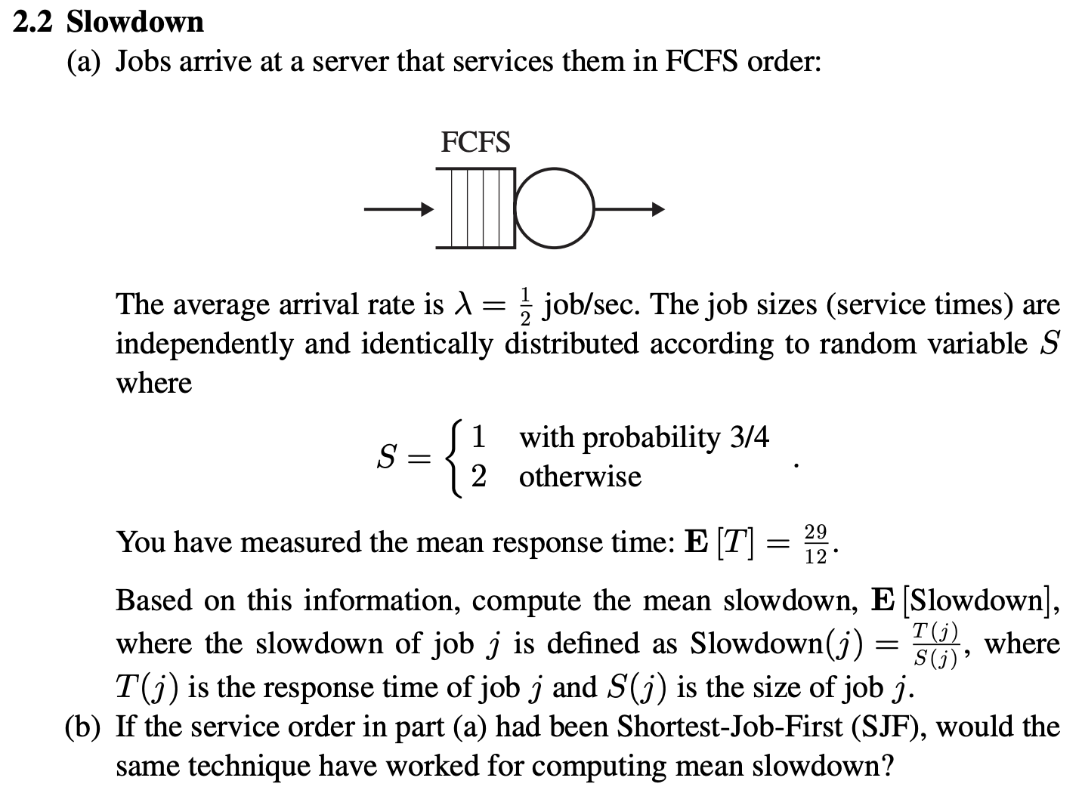
- E[S] = 1*3/4 + 2*1/4 = 5/4
E[Slowdown] = E[T] / E[S] = 29/15

- No, the same technique won’t work for SJF.
In FCFS, we can calculate the delay rate by directly relating the delay time T(j) of each task to its size S(j).
However, in the case of Shortest-Job-First (SJF), the service order changes according to the size of the tasks, and the smaller tasks are prioritized. This results in the relationship between the response time T(j) and the size S(j) of each task no longer being fixed. Therefore, it is not possible to directly apply the FCFS method to calculate the average latency.

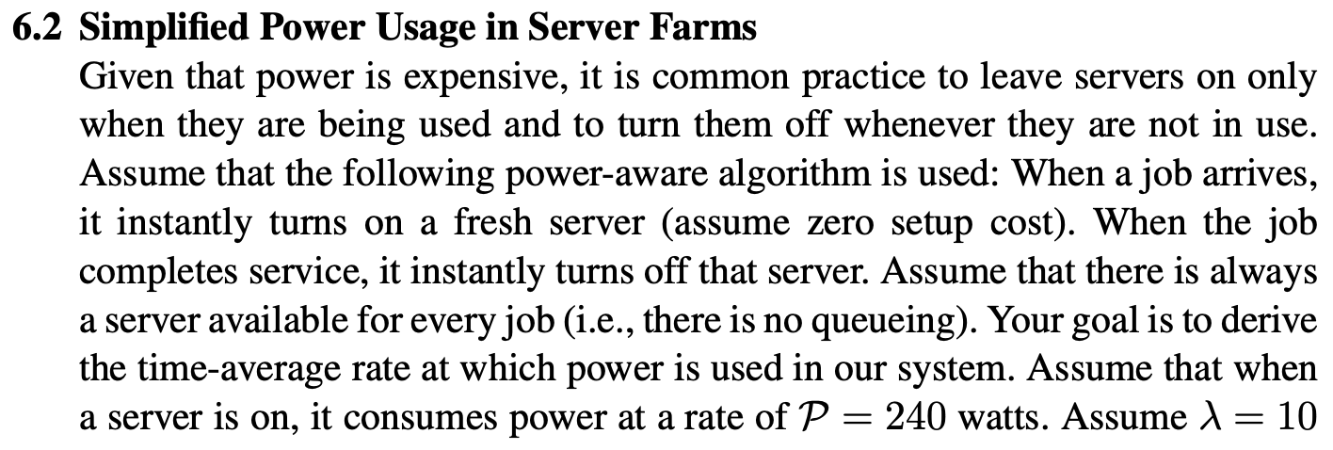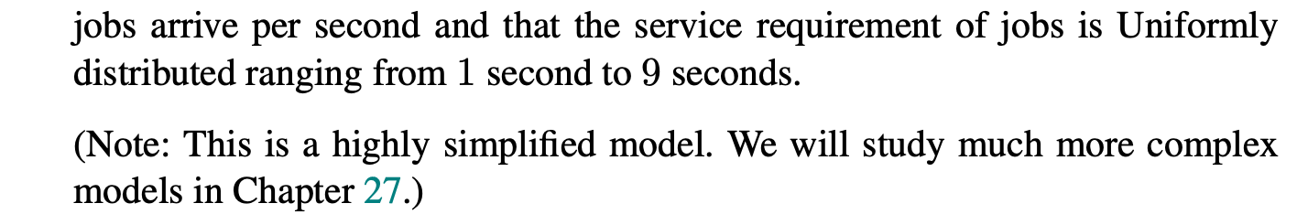
Average service requirement time = $1/9\sum_{i=1}^{10}{i}$ = 55/9 seconds
Time-average rate = 240 * 55/9 ≈ 1466.67 watts

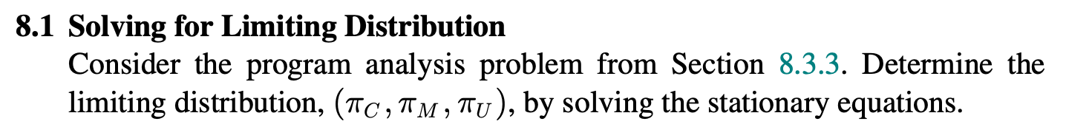
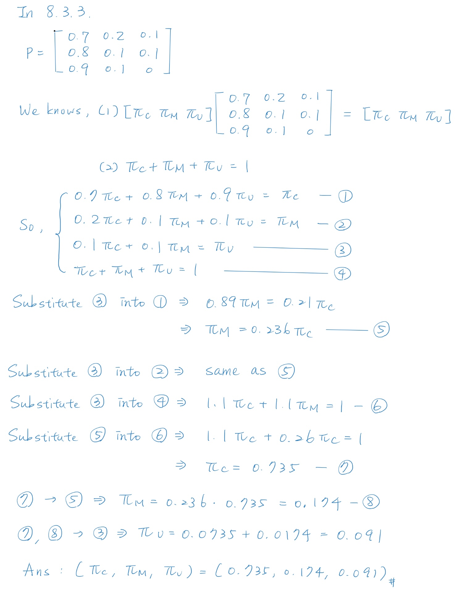
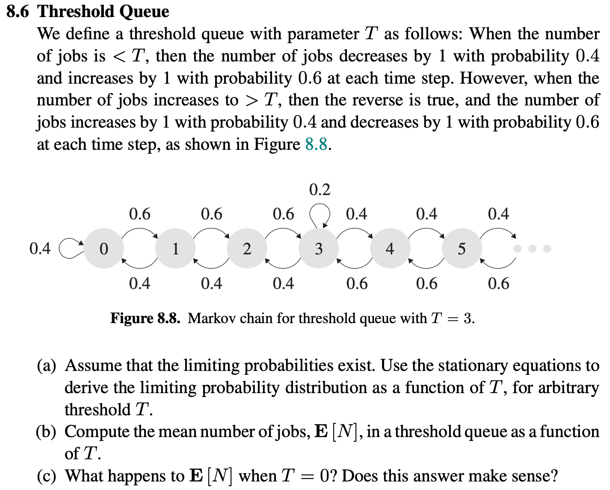
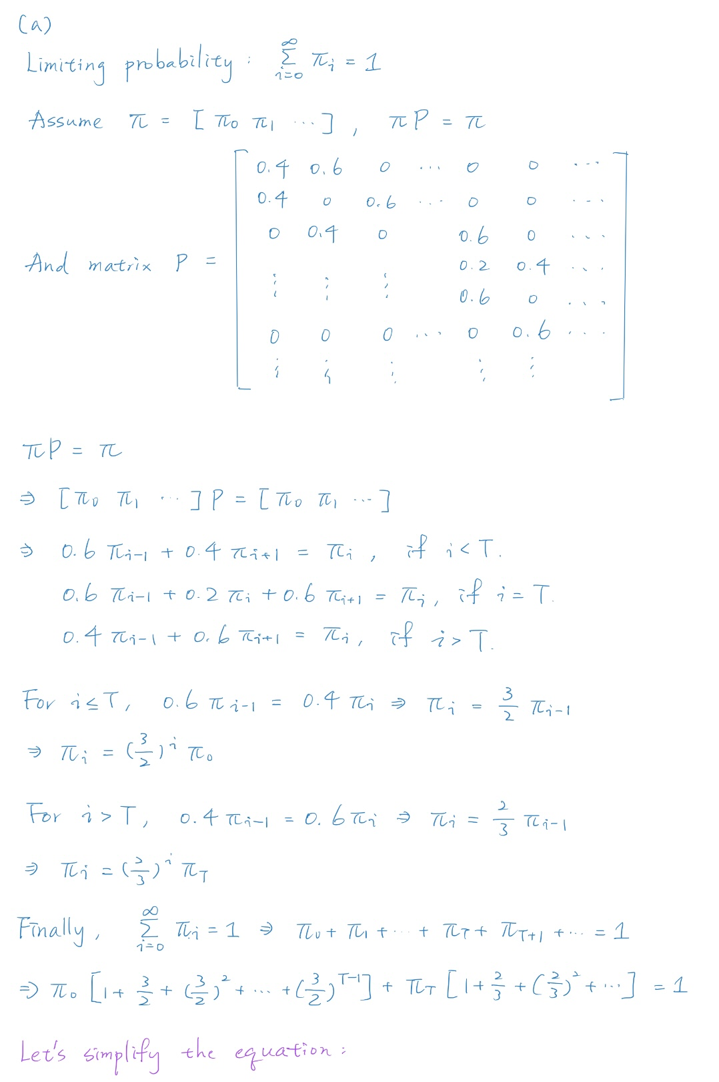
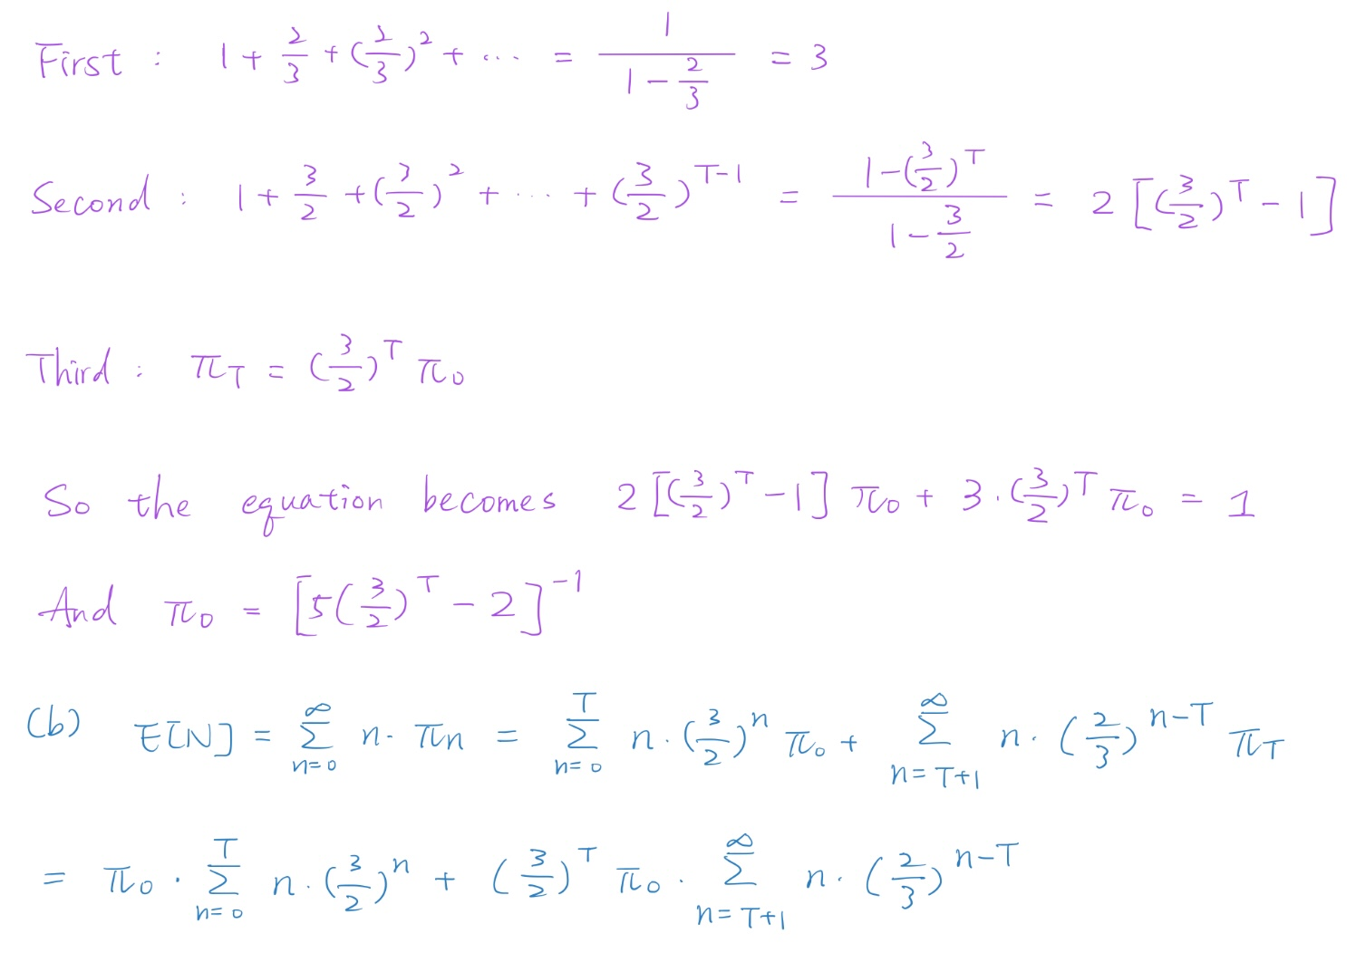
(c) When T = 0, no matter how many jobs in queue, the probability of decreases by 1 will always be 0.6, and the probability of increases by 1 will always be 0.4.
In this condition, E[N] will be small, representing that the queue will empty quickly or remain at a low number of tasks, so it is make sense.

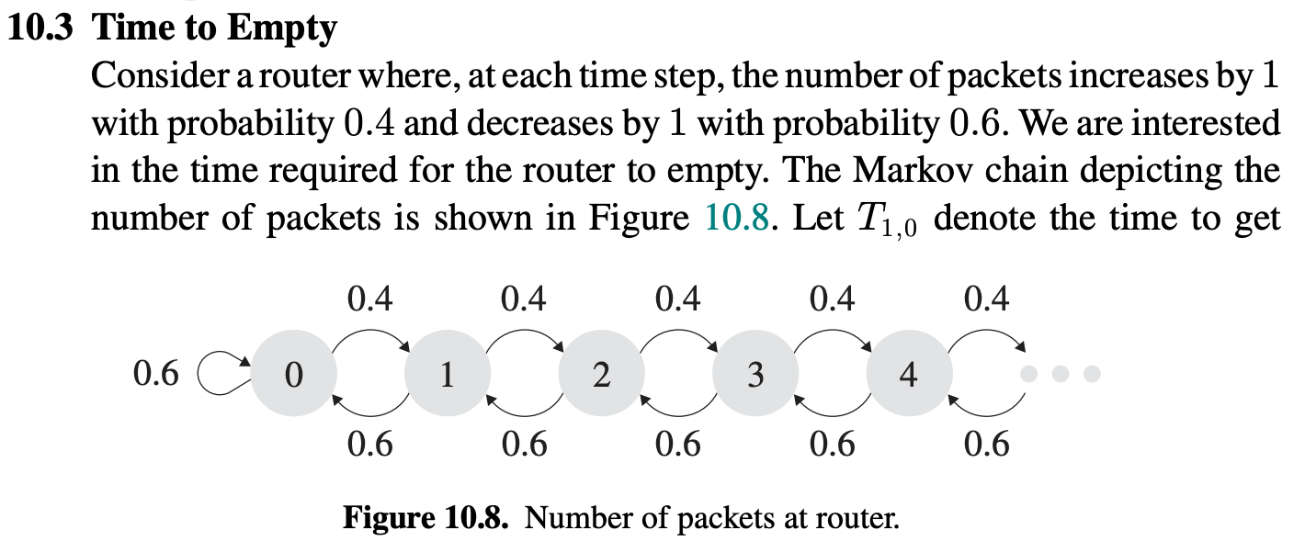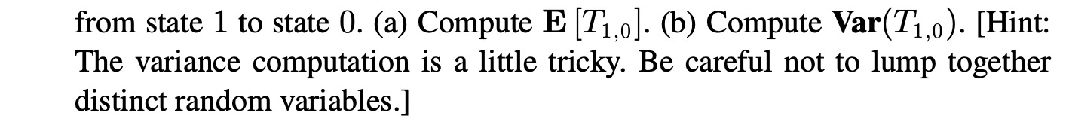
Since the number of packets decreases by 1 is with probability 0.6, we can get
$E\left[T_{1,0}\right]=\frac{1}{0.6}=5/3$.
