DATA PRIVACY AND SECURITY - CS5164701

Group 12
Members:
Name: 吳浚瑋 Student ID: M11215057
Name: 謝尚恆 Student ID: M11215101
Name: Guerin Ulysse Student ID: E11315012
Name: MENDEZ SALGADO LUIS ANDRES Student ID: D11215801

Assignment 3 – Face De-Identification & Its Attacks and Defenses

Introduction

In recent years, the increasing ubiquity of facial recognition systems in surveillance, social media, and consumer applications has raised serious concerns about personal privacy and data protection. As large volumes of facial image data are collected and shared, the risk of unauthorized identification and misuse becomes more prevalent. To address this issue, researchers and engineers have developed various face de-identification techniques—such as blurring and pixelization—to anonymize individuals in images.
However, with the rapid advancement of artificial intelligence, particularly in the field of deep learning, traditional de-identification methods are increasingly vulnerable to attack. Modern neural networks are capable of extracting subtle patterns in low-resolution or distorted images, enabling them to recover or infer identity information even after de-identification. This dynamic has led to an ongoing arms race between privacy-preserving techniques and re-identification methods.
This report focuses on implementing and evaluating a face de-identification system using simple methods such as blurring and pixelization, analyzing the effectiveness of these methods against AI-based attacks, and exploring how techniques like differential privacy can be employed to enhance protection.
Dataset Description:
https://www.kaggle.com/datasets/yveslr/open-famous-people-faces/data
For this project, we used the Open Famous People Faces dataset from Kaggle, which contains thousands of publicly available face images of well-known individuals. Each identity is stored in its own folder, and the images vary in lighting, pose, and background. This dataset is suitable for evaluating de-identification techniques, as it provides a realistic variety of face appearances while enabling identity classification for both baseline and privacy-preserving models.
At first, another dataset using 48x48 grayscale pictures was considered but only had a single photo of each person, making it less pertinent and usable.

Objective and Motivation

The primary objective of this project is to understand and critically evaluate the effectiveness of traditional face de-identification techniques in preserving privacy under adversarial conditions. Specifically, the goals are as follows:
- To implement two standard face de-identification methods: Gaussian blurring and pixelization.
- To develop and train an AI-based attack model capable of recognizing faces in both original and de-identified images, thereby simulating a real-world privacy threat.
- To measure the robustness of each de-identification method by comparing recognition accuracy before and after anonymization.
- To explore defensive techniques based on differential privacy that may mitigate the effectiveness of AI attacks.
The motivation behind this project lies in the growing demand for ethical and privacy-conscious multimedia systems. As AI becomes increasingly capable of reversing de-identification, there is an urgent need to evaluate existing methods and adopt stronger protections. Through this assignment, we aim to gain practical insights into the strengths and weaknesses of current approaches and develop a foundation for designing more secure multimedia systems.

Methodology

This project is divided into three main phases to evaluate the privacy protection of face de-identification techniques and their vulnerability to AI-based attacks. Each phase builds upon the previous one, forming a complete pipeline from anonymization to attack and defense.

De-Identification Techniques (Step 1)

We applied two widely used de-identification methods to facial images:
- Gaussian Blurring (Normal): This technique uses a Gaussian kernel to smooth the facial region, effectively reducing fine-grained identity information. Different kernel sizes were tested to analyze the trade-off between anonymization strength and visual quality.

Original | Blurred k = 15 | Blurred k = 45 | Blurred k = 99
 |  |  | 
- Gaussian Blurring (Obfuscated):

Original | Blurred k = 15 | Blurred k = 45 | Blurred k = 99
 | 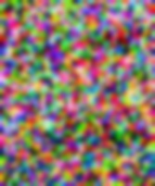 |  | 

- Pixelization (Normal): This method replaces blocks of pixels with their average color, simplifying facial details. The block size (e.g., 10×10, 20×20 pixels) determines the degree of pixilation, with larger sizes providing stronger anonymization but reducing visual utility.

Original | Pixelated b = 4 | Blurred b = 8 | Blurred b = 16
 |  | 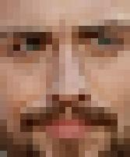 | 

- Pixelization (Obfuscated):

Original | Pixelated b = 4 | Blurred b = 8 | Blurred b = 16
 | 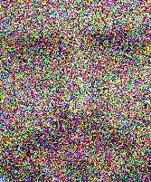 | 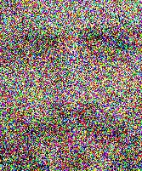 | 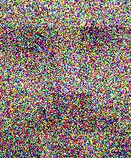

These transformations were applied to a dataset of face images using OpenCV. Each processed version (blurred and pixelated) was stored in its own directory, preserving the identity-based folder structure required for classification tasks.

AI-Based Attack Model (Step 2)

To simulate a re-identification attack, we trained a deep learning model to classify facial identities even after de-identification. The following steps were taken:
- Model Selection: We used a pre-trained ResNet18 model from the torchvision library, replacing the final fully connected layer to match the number of identities in our dataset.
- Training Procedure: The model was trained on the original (non-anonymized) dataset using cross-entropy loss and the Adam optimizer. Images were resized to 224×224 and normalized using standard torchvision.transforms. The model was trained for 15 epochs. Epoch 1 with a loss of 440.6440 and a final epoch 15 with a loss of 0.1200.
- Evaluation: After training, the model was evaluated on:
  - the original test images (to establish baseline accuracy),
  - the blurred test set, and
  - the pixelated test set.
This process reveals how well the de-identification methods resist deep learning-based re-identification. Recognition accuracy was used as the primary metric to assess vulnerability.

Differential Privacy Defense (Step 3)

To defend against the re-identification attack, we will explore techniques based on differential privacy. The aim is to either retrain the attack model with differentially private noise (e.g., using the Opacus library), or directly perturb image features in a privacy-preserving way.
Performance will be evaluated by measuring:
- Recognition accuracy under different levels of privacy (ε values),
- Utility degradation via structural similarity (SSIM) and mean squared error (MSE).
This final phase aims to assess whether privacy-preserving noise can meaningfully reduce AI attack performance while retaining image utility.

Experiment and Results

Attack Model Results (Step 2)

The model achieved 100% accuracy on the original test set, indicating perfect memorization of training identities — a result enabled by the small dataset size and extended training (15 epochs).

Dataset | Original | Blurred  k = 15 | Blurred  k = 45 | Blurred  k = 99 | Pixelated b = 4 | Pixelated b = 8 | Pixelated b = 16
Accuracy | 100 | 67.02 | 4.63 | 0.40 | 78.88 | 22.04 | 1.62

These results demonstrate the effectiveness of de-identification strategies: strong pixelation and blurring (e.g., b=16, k=99) reduced recognition accuracy to 1.62% and 0.40%, respectively, nearly matching random chance. This confirms that visual degradation techniques can effectively protect facial identity from deep learning-based re-identification attacks.

  - Differential Privacy Defense (Step 3)

Obfuscated Dataset | Original | Blurred  k = 15 | Blurred  k = 45 | Blurred  k = 99 | Pixelated b = 4 | Pixelated b = 8 | Pixelated b = 16
Accuracy  epsilon = 1.0 | 100 | 0.33 | 0.59 | 0.36 | 0.33 | 0.33 | 0.33

The table above shows how the baseline model, trained without differential privacy, performs when evaluated on obfuscated datasets created using DP-blur and DP-pixelation techniques. Despite having memorized the original training images (achieving 100% accuracy), the model's recognition accuracy drops sharply when faced with DP-obfuscated images. For example, accuracies fall to 0.33%–0.59% across all variants, which is near random guessing (∼0.387% for 258 classes). This illustrates how adding Laplace noise directly to the image (even without applying DP during training) significantly disrupts identity features. These results demonstrate that applying differential privacy at the image level is an effective standalone defense, even against strong face recognition models that have seen the original data.
Despite training models with ε = 1.0, 2.0, and 4.0, the loss remained nearly constant around 530–533 across all epochs. This indicates that differential privacy noise was dominant, severely limiting learning. Such behavior is expected under strong privacy guarantees and highlights the trade-off: as privacy increases (lower ε), model utility decreases.

Dataset | Original | Blurred  k = 15 | Blurred  k = 45 | Blurred  k = 99 | Pixelated b = 4 | Pixelated b = 8 | Pixelated b = 16
Accuracy ε = 1.0 | 0.66 % | 0.69 % | 0.66 % | 0.73 % | 0.66 % | 0.79 % | 0.86 %
Accuracy ε = 2.0 | 0.66 % | 0.69 % | 0.73 % | 0.59 % | 0.76 % | 0.69 % | 0.63 %
Accuracy ε = 4.0 | 0.30 % | 0.13 % | 0.13 % | 0.33 % | 0.23 % | 0.17 % | 0.43 %

Models trained with differential privacy showed extremely low accuracy across all test conditions, confirming the trade-off between privacy and utility. Even at the highest privacy budget (ε = 4.0), accuracy remained below 1% on all variants. This indicates that the privacy-preserving noise added during training prevented the model from learning meaningful identity representations.
Interestingly, ε = 1.0 and 2.0 achieved slightly better results than ε = 4.0, but all models effectively failed to generalize — including on the original dataset (0.66% top accuracy). This suggests that, for this dataset and training configuration, differential privacy with Opacus severely impairs recognizability, even with moderate ε values.
These results strongly support the effectiveness of DP as a defense against AI-based re-identification attacks, making it a viable tool for privacy-preserving face data publishing.

  - Utility Analysis

4.3.1 Normal Blurred and Pixelated Images Utility Analysis

To assess the visual utility of the de-identified images, we use two well-established image similarity metrics:
- Structural Similarity Index (SSIM)

SSIM measures the perceived quality of an image compared to a reference. It considers changes in luminance, contrast, and structure — making it more aligned with human visual perception than simple pixel-wise comparison.
- Range: 0 to 1
- Interpretation:
  - 1.0 → Perfect match
  - <0.5 → Severe structural degradation
- A higher SSIM means the de-identified image preserves more useful visual information.
- Mean Squared Error (MSE)
MSE calculates the average squared difference between corresponding pixels in two images. It is a low-level measure of distortion:
- Range: 0 to ∞
- Interpretation:
  - 0 → Identical images
  - Higher values → Greater pixel-wise error
- A lower MSE indicates the image is closer to the original in raw pixel terms.
These two metrics complement each other: SSIM focuses on structural fidelity (what a human might notice), while MSE gives a technical measure of noise or pixel deviation.
We computed both metrics by comparing all face images of one individual (aaron_taylor_johnson) across all anonymized variants to the original images. The results help us understand how much useful content remains after de-identification.
Image | Variant | SSIM | MSE
 | Blurred k = 15 | 0.7828 | 0.0017
 | Blurred k = 45 | 0.6330 | 0.0057
 | Blurred k = 99 | 0.5541 | 0.0118
 | Pixelated b = 4 | 0.7355 | 0.0023
 | Pixelated b = 8 | 0.5784 | 0.0057
 | Pixelated b = 16 | 0.4901 | 0.0125

Interpretation:
- Pixelated_b4 and blurred_k15 preserved the most structural similarity to the original image (SSIM > 0.73), with very low MSE.
- As the pixel size (b) or blur kernel (k) increased, both SSIM declined and MSE rose, confirming that stronger de-identification sacrifices more visual utility.
- Blurred_k99 and pixelated_b16 showed the lowest utility, indicating significant visual degradation — which supports their potential effectiveness for privacy.
These results quantitatively demonstrate the privacy-utility trade-off in face de-identification: stronger obfuscation reduces recognition risk, but also impairs image usefulness.
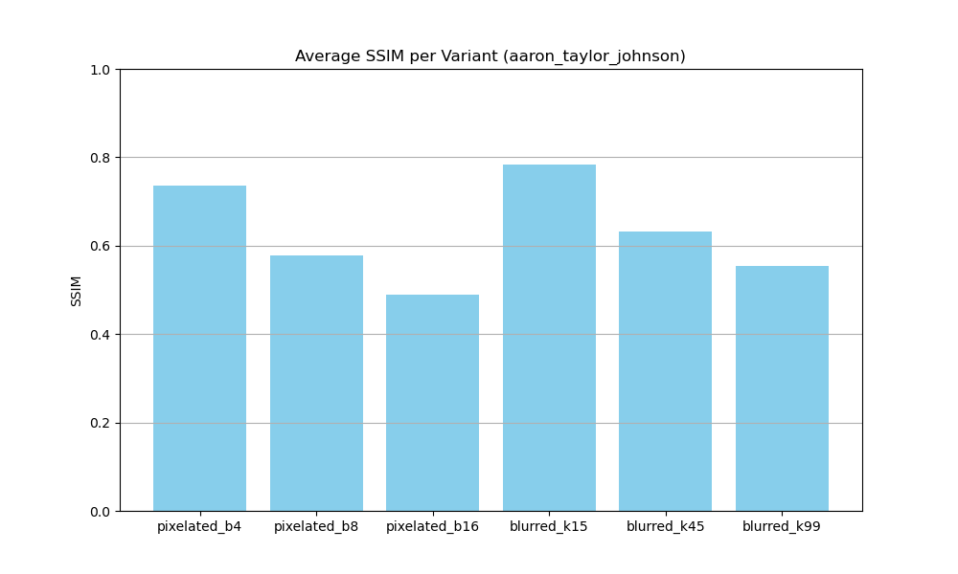

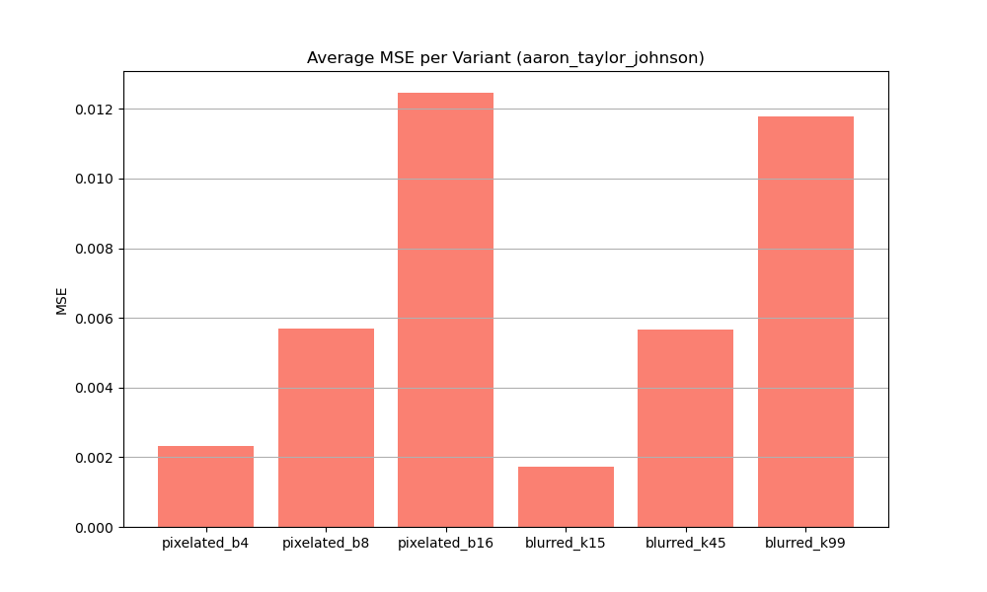

4.3.2 Obfuscated Blurred and Pixelated Images Utility Analysis

To assess the visual utility of de-identified images, we compared each variant (pixelated and blurred) against its original using two metrics: Structural Similarity Index (SSIM) and Mean Squared Error (MSE). These metrics quantify how closely the obfuscated image retains structural and pixel-level information. As expected, stronger pixelation (e.g., b=16) yielded the lowest SSIM (0.0292) and highest MSE (0.0643), indicating significant information loss. In contrast, higher blur levels (e.g., k=99) retained greater structural similarity (SSIM up to 0.5121), despite appearing visually degraded. These results highlight a key trade-off: while pixelation can offer stronger privacy, it more aggressively reduces utility, whereas blurring can better preserve general structure—potentially supporting downstream visual tasks—while still offering moderate privacy.

Image | Variant | SSIM | MSE
 | Blurred k = 15 | 0.2729 | 0.0305
 | Blurred k = 45 | 0.5009 | 0.0223
 | Blurred k = 99 | 0.5121 | 0.0231
 | Pixelated b = 4 | 0.0447 | 0.0604
 | Pixelated b = 8 | 0.0367 | 0.0620
 | Pixelated b = 16 | 0.0292 | 0.0643

To further visualize the trade-off between privacy and utility, we generated bar charts showing the average SSIM and MSE scores for each de-identified variant (Figure X). The SSIM chart clearly shows that blurring techniques, especially with larger kernels (k=45 and k=99), retain higher structural similarity to the original images (SSIM > 0.5), whereas pixelation methods result in a drastic loss of structural information (SSIM < 0.05). Conversely, the MSE chart indicates that pixelation variants introduce the highest pixel-level distortion (MSE ~0.06), while blurring causes relatively lower error (MSE ~0.02–0.03). These patterns confirm that blurring may preserve visual utility better than pixelation, especially when considering applications that rely on general structure rather than fine-grained detail.
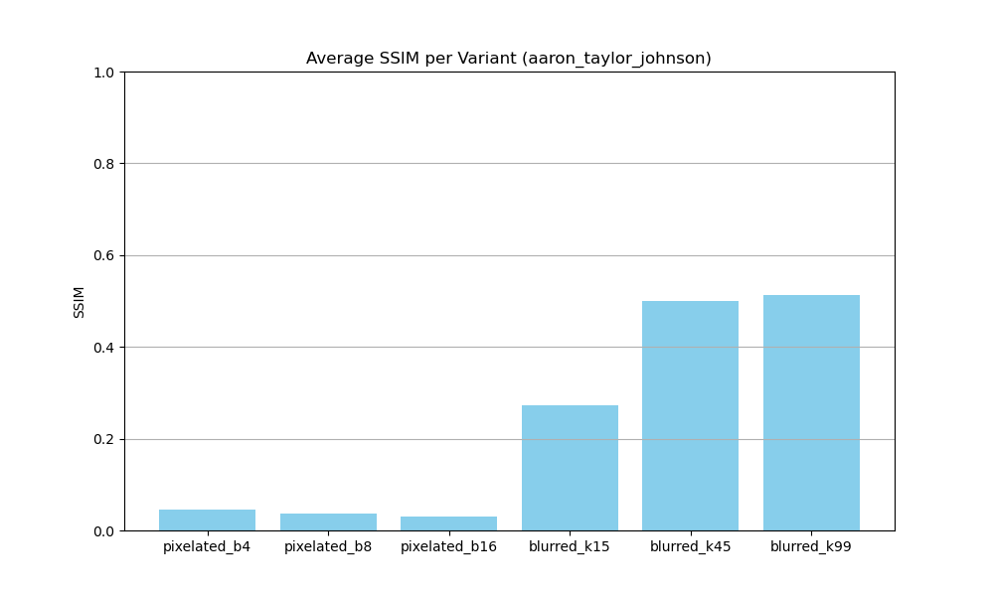
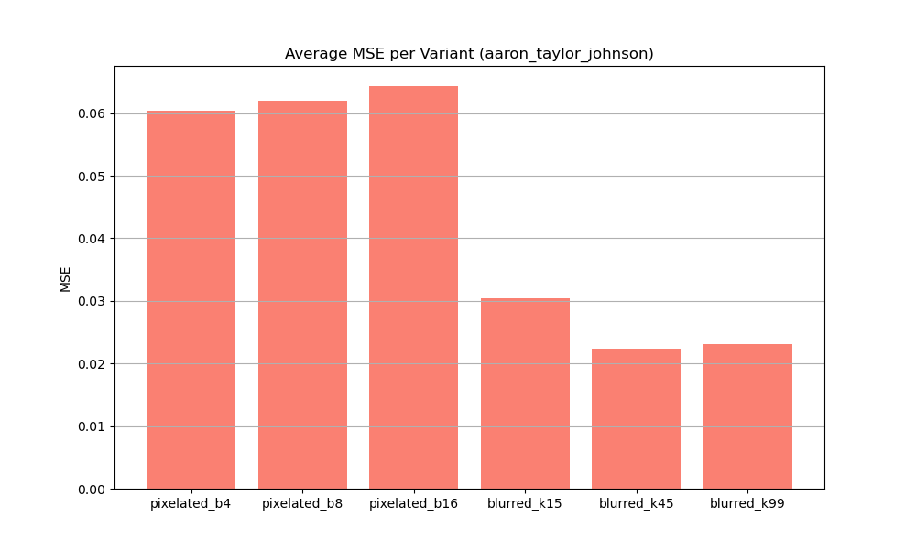

Conclusions

This project explored the effectiveness of face de-identification techniques in protecting individual identity from AI-based face recognition models. We implemented and evaluated two common anonymization approaches — pixelation and blurring — across varying intensity levels, and compared their impact on recognition accuracy using a baseline ResNet18 model. Our results demonstrated a clear trade-off: stronger de-identification (e.g., higher blur kernel or pixel block size) significantly reduced model accuracy, effectively preventing re-identification.
To further strengthen privacy, we trained separate models using differential privacy (via Opacus) with various epsilon (ε) values. While these models offered stronger formal privacy guarantees, their utility was drastically limited, achieving less than 1% accuracy even on the original dataset. This outcome highlights the challenges of training effective recognition models under strict privacy constraints.
Differential privacy ensures that models learn general patterns from data without memorizing or revealing information about any specific individual. In simple terms, it adds controlled noise during training so that even if someone analyzes or attacks the model, they cannot confidently trace a result back to any one person in the dataset. This makes it especially useful for sensitive domains like healthcare, finance, and personal data analysis — where privacy must be protected, even when data is used to train AI systems.
Finally, we assessed visual utility using SSIM and MSE metrics. While aggressive obfuscation (e.g., blurred_k99) was effective for privacy, it also led to notable structural degradation. Lighter de-identification (e.g., blurred_k15, pixelated_b4) offered a more balanced trade-off between privacy and image usability.
Overall, the findings support that visual de-identification can meaningfully reduce privacy risks, and that differential privacy further enforces strong guarantees, albeit with a cost to model performance. These insights can inform the design of privacy-aware face datasets in real-world applications.

Participation table :

Ulysse Guérin | Script writing and report
MENDEZ S. LUIS ANDRES | Scripting and report
謝尚恆 | Layout and organize the report

