DATA PRIVACY AND SECURITY - CS5164701

Group 12
Members:
Name: 吳浚瑋 Student ID: M11215057
Name: 謝尚恆 Student ID: M11215101
Name: Guérin Ulysse Student ID: E11315012
Name: MENDEZ SALGADO LUIS ANDRES Student ID: D11215801

Assignment 3 – Differentially Private Synthetic Data

Differential Private Synthetic Data

In this project, we explore the generation of differentially private synthetic data using a machine learning-based approach inspired by Team UCLANESL’s submission to the NIST Differential Privacy Synthetic Data Challenge. (https://www.nist.gov/ctl/pscr/team-uclanesl) The goal is to produce a synthetic version of the Adult Census Income dataset that preserves the statistical properties of the original data while ensuring strong privacy guarantees. This method replaces traditional privacy-preserving techniques, such as k-anonymity, with a deep learning model—specifically a Generative Adversarial Network (GAN)—in which only the Discriminator is trained under differential privacy using the Opacus library. The resulting synthetic dataset is evaluated in terms of structural similarity and utility compared to both the original and k-anonymized datasets. Through this comparison, we assess the effectiveness of differentially private synthetic data generation as a modern privacy-preserving technique for data sharing and analysis.
A Generative Adversarial Network (GAN) is a model of machine learning where the generator tries to produce “fake” data in order for the discriminator to tell if it is real or not, the two neural networks are put in competition and so are trying to “beat” each other, leading to better and better images over time, as the two networks gets increasingly good at their task.

Dataset Information:

The dataset used in this experiment is the Adult Census Income Dataset.
Source: Kaggle: https://www.kaggle.com/datasets/priyamchoksi/adult-census-income-dataset
Description:
This dataset was extracted from the 1994 Census bureau database by Ronny Kohavi and Barry Becker.
The dataset contains information of age, work-class, education, education number, marital status, occupation, relationship, race, sex, hours per week, native country and income; and income as the target variable (<50K Low-income, >50K High-income). The dataset consists of 30,163 rows and 12 original attributes.

Objective and Motivation

The primary objective of this project is to generate a synthetic version of the Adult Census Income dataset that maintains the statistical structure and utility of the original data while ensuring strong privacy protection through differential privacy. This approach is designed to provide a privacy-preserving alternative to traditional anonymization techniques, such as k-anonymity, which may be vulnerable to re-identification attacks, especially when combined with external information.
The motivation behind using differentially private synthetic data lies in its potential to enable safe data sharing and machine learning without compromising individual privacy. By applying differential privacy only to the Discriminator of a GAN, the model learns to generate realistic data samples without exposing sensitive information from the original dataset. This allows organizations to release synthetic datasets that are useful for analysis and research, while complying with privacy regulations and ethical standards. Additionally, the project serves to highlight how differential privacy can be flexibly applied at different stages of the machine learning pipeline, complementing previous work done in the midterm assignment.

K-anonymity

K-anonymity is a traditional privacy-preserving technique that aims to protect individual records in a dataset by making each record indistinguishable from at least k-1 other records based on a set of quasi-identifiers. Quasi-identifiers are attributes that, while not unique by themselves, can be combined to potentially re-identify individuals (e.g., age, gender, ZIP code).
Under k-anonymity, the dataset is modified through techniques like generalization and suppression to ensure that every combination of quasi-identifiers appears at least k times. This reduces the risk of linking an individual to a specific record. However, k-anonymity has limitations: it can still be vulnerable to linkage attacks if external information is available, and aggressive generalization can harm data utility.
In this project, the k-anonymized dataset used for comparison was generated in a previous assignment by applying Mondrian partitioning to the Adult Census Income dataset.
After implementing K-Anonymity with a k value of 5 the dataset was correctly anonymized. The following image shows an example of the original dataset:

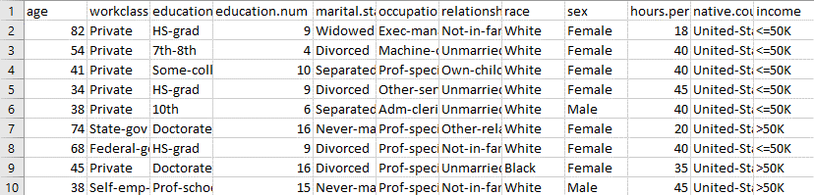
Figure 1. Original Dataset View

This is a sample of the anonymized dataset:
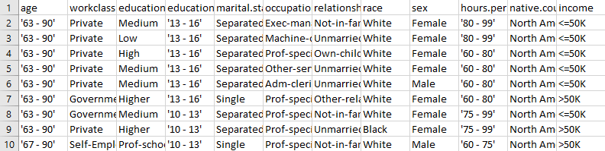
Figure 2. Anonymized Dataset Sample

As it can be seen the data is grouped in categories for non-numerical attributes and in rages for numerical attributes.

Differentially Private Synthetic Data

Differentially private synthetic data generation is a modern approach to data privacy that moves beyond modifying real records. Instead, it creates entirely new, artificial data points that preserve the statistical patterns of the original dataset without directly revealing any individual’s information.
This is achieved by training a generative model, such as a GAN, while applying differential privacy mechanisms—specifically DP-SGD—to parts of the model that interact with real data (such as the Discriminator). Differential privacy provides a mathematically rigorous guarantee: the presence or absence of any individual record has little to no impact on the model's behavior or outputs.
Compared to traditional anonymization methods like k-anonymity, differentially private synthetic data allows for much stronger privacy protection while maintaining high data utility. It is particularly well-suited for modern data sharing and machine learning applications where preserving individual confidentiality is critical.

Methodology

The project follows a machine learning-based approach inspired by Team UCLANESL’s method for differentially private synthetic data generation. A Generative Adversarial Network (GAN) architecture was implemented, consisting of a Generator and a Discriminator. The Generator is responsible for producing synthetic samples that mimic the structure of the Adult Census Income dataset, while the Discriminator distinguishes between real and synthetic samples.
To enforce differential privacy, the Opacus library was used to apply differentially private stochastic gradient descent (DP-SGD) exclusively to the Discriminator. This ensures that the Discriminator's updates are privatized by gradient clipping and noise addition, preventing the leakage of any individual real data sample during training. The Generator remains unprivatized, allowing it to learn realistic feature distributions based on feedback from the differentially private Discriminator.
Data preprocessing was performed before training: numerical features were normalized using StandardScaler, and categorical features were one-hot encoded. This transformation expanded the original 12 features into a higher-dimensional space, making the dataset suitable for GAN training. A noise vector of size 100 was used as input to the Generator, and synthetic data was generated to match the size of the original dataset (30,163 samples).
The model was trained for 100 epochs with a batch size of 64, a learning rate of 1e-4, and a noise multiplier of 1.0 for privacy. The final achieved privacy budget was ε ≈ 2.51 with a fixed δ = 1e-5, providing a strong privacy guarantee while preserving data utility. After training, synthetic data was generated, saved, and compared against the original and k-anonymized datasets for utility analysis.
In the midterm assignment, differential privacy was applied directly to the training of classification models using the Opacus library—specifically by training both a Simple Neural Network and a CNN on the MNIST dataset using DP-SGD. This protected the model's ability to generalize from private data without memorizing individual samples.
In contrast, the current project applies differential privacy at a different stage: during the training of a Generative Adversarial Network (GAN), specifically by applying DP-SGD only to the Discriminator. The Generator remains unprotected, allowing it to learn rich representations. This design enables the model to produce a fully synthetic dataset that mimics the statistical patterns of the original data while ensuring that no individual record from the training set can be reconstructed or identified.
This difference highlights two important privacy use cases: in the midterm, DP protected the model, while in this project, DP protected the data. Together, they showcase how differential privacy can be applied at multiple stages in machine learning workflows to enhance security and trustworthiness.

Experiment and Results

By implementing the Differentially Private Synthetic Data method on the Adult Census Income dataset, we successfully generated a fully synthetic dataset that captures the statistical characteristics of the original data without including any real individual records. The data was transformed into normalized numerical values through one-hot encoding and standardization, and the Generator learned to recreate realistic patterns while preserving privacy guarantees through the use of DP-SGD applied to the Discriminator.
The table below shows a sample of the synthetic dataset, where each row corresponds to a synthetic individual and each column represents a normalized or encoded feature. Although the values appear abstract, they reflect the structural relationships present in the original data, without revealing sensitive or identifiable information.
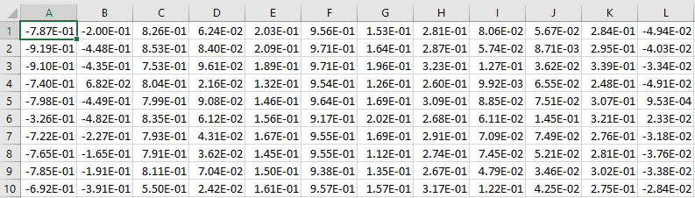
Figure 3. Sample of the synthetic dataset

6.1 Synthetic Data Privacy Budget

The GAN was trained for 100 epochs using a batch size of 64 and a noise multiplier of 1.0 for DP-SGD. This resulted in a final privacy budget of ε ≈ 2.51 with δ = 1e-5, as calculated using the Opacus PrivacyEngine. This value provides a strong privacy guarantee, ensuring that individual records from the original dataset cannot be inferred from either the model or the synthetic data it generates.
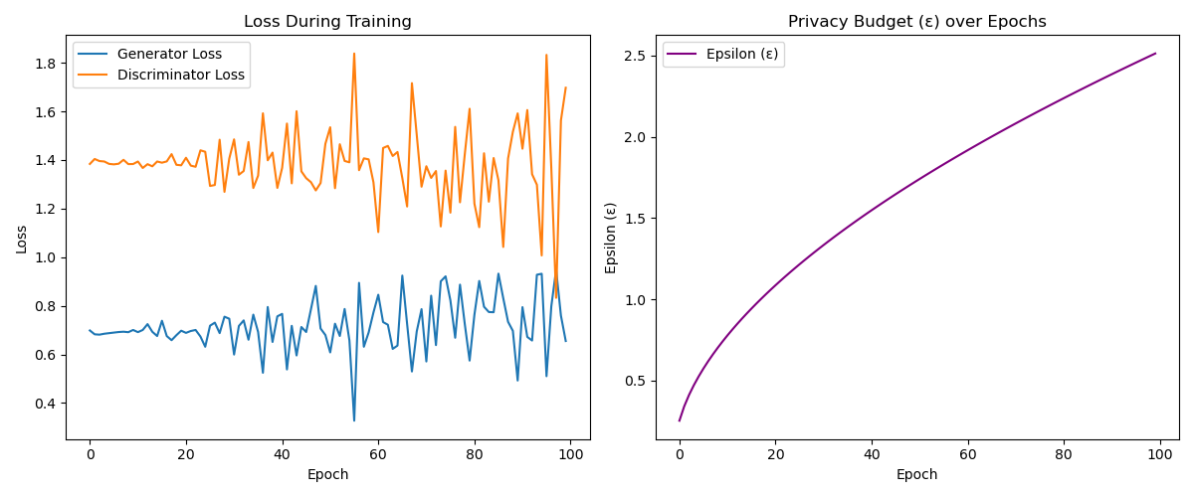
Figure 4. Training log

6.2 Utility Evaluation via SVM Classifier

To evaluate how well the anonymized and synthetic datasets preserve utility for machine learning tasks, we trained support vector machines (SVMs) on three datasets:
- The original cleaned dataset (baseline)
- The k-anonymized dataset (from k-anonymity)
- The synthetic dataset (generated in this project)
Since the synthetic dataset does not contain class labels, only the original and k-anonymized datasets were used for supervised evaluation.

Dataset | Accuracy | Precision | Recall | F1 Score | AUC
Original | 0.8289 | 0.6928 | 0.5607 | 0.6197 | 0.8639
Anonymized | 0.8462 | 0.7457 | 0.5740 | 0.6498 | 0.8833
Table 1. Performance of Supervised Evaluation

These results show that the k-anonymized dataset preserved classification performance with a slight improvement in AUC and accuracy compared to the original. This suggests that generalization introduced by k-anonymity may have reduced overfitting. The synthetic dataset was not evaluated using classification metrics due to the absence of true class labels.

6.3 Feature Distribution Comparison

To further assess the quality of the synthetic dataset, we compared the distribution of selected features across the three datasets. The age feature was chosen as a numerical attribute due to its importance in income prediction, while the workclass was analyzed as a categorical feature.
In Figure 5, we observe that the synthetic distribution of age closely follows the general shape of the original dataset, despite being normalized during training. This indicates that the Generator successfully captured the underlying pattern of this continuous variable. The anonymized version, on the other hand, introduces distortion due to generalization and frequency-based binning, resulting in a less natural-looking distribution with visible spikes.
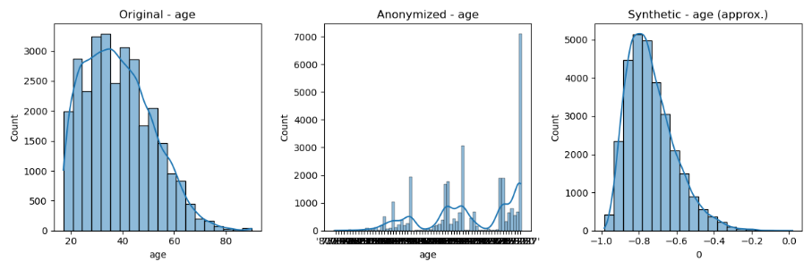
Figure 5. Comparison of the age feature across original, k-anonymized, and synthetic datasets

Figure 6 shows the original distribution of the workclass attribute, highlighting the dominance of the "Private" sector, followed by smaller segments like "Self-emp-not-inc" and "Local-gov." In Figure 7, the anonymized dataset presents a simplified version of this distribution, where fine-grained categories have been generalized into broader ones such as "Government" and "Self-Employed." This grouping is a direct result of applying k-anonymity via Mondrian partitioning, which reduces the risk of identification but also removes useful detail.
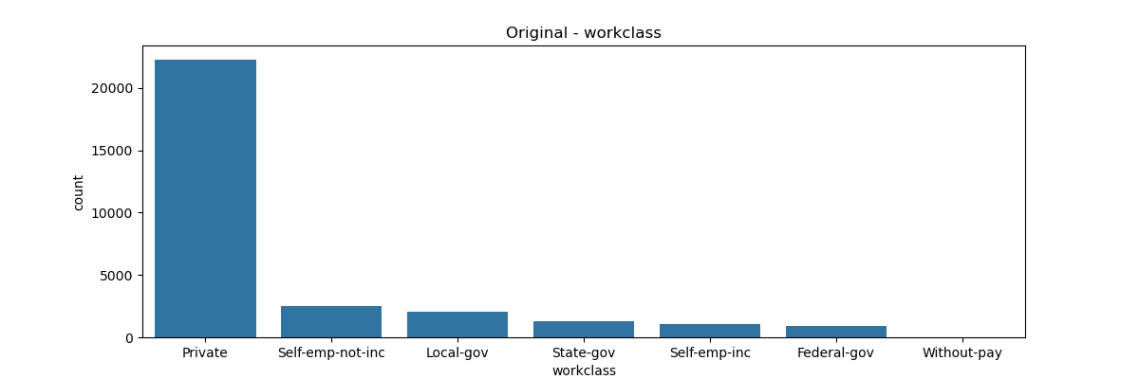
Figure 6. Original workclass distribution
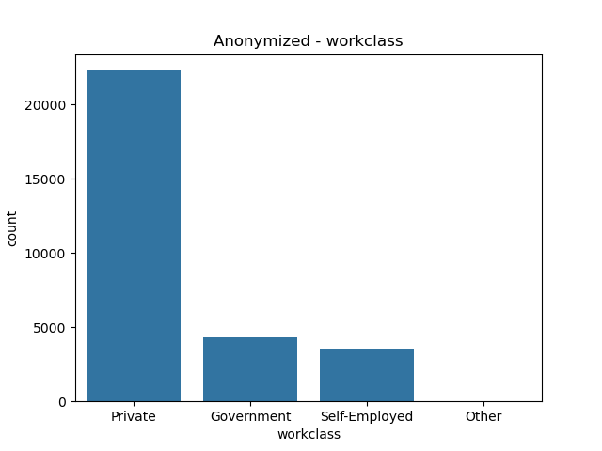
Figure 7. Anonymized workclass distribution
Due to one-hot encoding and lack of reverse mapping, the workclass distribution could not be directly visualized for the synthetic dataset. Nevertheless, the preservation of numerical feature distributions like age suggests that the synthetic dataset retains meaningful structure while offering strong privacy guarantees through differential privacy.
We also tried to apply differentially private synthetic data to the mnist dataset in order to provide a comparison with the midterm project, but the size and complexity of the dataset made it so that the code could not produce the Private dataset in an acceptable time-window, likely due to optimization problems as well as CPU-only calculations. It is still worth mentioning that a GAN model might be the best suited approach for this kind of datasets, as a correlation based approach might not make too much sense. However, given the nature of the mnist dataset, we could also argue that privacy is not really a concern, as there is not any data that could be compromising or helping to identify a person.

Conclusion

This project demonstrated the generation of differentially private synthetic data using a GAN-based architecture, following the method proposed by Team UCLANESL in the NIST Differential Privacy Synthetic Data Challenge. By training the Discriminator with DP-SGD using the Opacus library and leaving the Generator unprivatized, we were able to produce a synthetic dataset that mimics the statistical properties of the original Adult Census Income dataset while providing formal privacy guarantees. The final privacy budget achieved was ε ≈ 2.51 with δ = 1e-5, offering strong protection against individual re-identification.
Through SVM-based evaluation and feature distribution analysis, we found that the synthetic data preserved the overall structure of numerical features like age, even though categorical attributes could not be directly interpreted due to one-hot encoding. When compared to k-anonymity, which was used in a previous assignment, the synthetic data approach offers a compelling alternative that avoids overgeneralization and enables more flexible downstream applications. Additionally, this project highlighted how differential privacy can be applied at different stages of the machine learning pipeline, complementing the approach used in the midterm where DP was applied directly to model training.
Overall, differentially private synthetic data generation represents a promising direction for privacy-preserving data sharing. While it comes with challenges, particularly around interpretability and categorical reconstruction, it has the potential to provide a strong balance between utility and privacy in real-world applications. Future work could explore better categorical reconstruction methods for synthetic datasets.
We can also note that generating differentially private synthetic data is for now very costly in time and computing power, so we should pursue improvements in both quality and quantity.

MENDEZ SALGADO LUIS ANDRES | Report and python script
Guérin Ulysse | Edits and modification of report and PPT
謝尚恆 | Presentation(PPT)
吳浚瑋 | modify PPT

