SILVER LOSS REDUCTION IN FUMER SLAG
Root-Cause Framework, Phased Action Plan & Digital Twin Roadmap
Reducing Ag in slag from 192 ppm (current average) to ≤25 ppm (OEM standard)
Weak-Acid Leach Circuit | 2 × Box-Type Fumer Furnaces | 32 T Batch Feed | 7–8 Batches/Furnace
Prepared as a project / process-improvement reference document

1. Problem Statement
The Fumer plant operates two box-type furnaces treating weak-acid-leach residue for silver extraction, with each furnace processing 7–8 batches of 32 T per cycle. The current average silver loss to slag is 192 ppm, well above the OEM design standard of 25 ppm. This gap represents a material, recoverable silver loss and is the subject of this document.
This document sets out: (a) a framework for diagnosing the dominant loss mechanism, (b) a phased, two-track action plan — a metallurgical/operational track that closes the 192→25 ppm gap, and a data/digital-twin track that holds the gains and prevents drift — and (c) the architecture and expected performance of a digital twin system to sustain control once target is reached.

1.1 Objectives
- Identify whether silver loss is dominated by mechanical entrainment or chemical dissolution in the slag.
- Reduce average Ag-in-slag from 192 ppm to ≤25 ppm within a defined programme timeline.
- Establish sustainable operating practice (SOPs, control limits) to hold ≤25 ppm across ≥90% of batches.
- Build a data foundation and digital twin to predict Ag loss in real time and recommend optimal setpoints per batch.
- Do so without compromising furnace safety, energy consumption, or OEM equipment limits.

2. Root-Cause Diagnostic Framework
Silver reports to slag through two distinct mechanisms, and the corrective action differs sharply depending on which dominates. This should be established before committing to a solution track.

2.1 Mechanical entrainment
Fine droplets of matte, speiss, or metallic phase (which carry the silver) become physically trapped in the slag because it does not settle fully before tapping. This is typically the larger contributor in fuming/box-furnace operations at loss levels in the 150–200 ppm range.

2.2 Chemical / dissolution loss
Silver dissolves into the slag as an oxide or sulfide species, favored by high FeO content, low availability of a collector phase (Pb/Cu), and oxidizing furnace conditions.

2.3 Diagnostic method
- Collect tapped slag samples across multiple batches and furnaces.
- Run polished-section SEM/EDS or optical microscopy on each sample.
- Visible Pb/Cu/matte prills or droplets in the slag matrix → entrainment dominates → prioritize settling, viscosity and tapping-practice fixes.
- Homogeneous Ag distribution with no visible prills → dissolution dominates → prioritize redox control and slag chemistry (FeO, basicity, collector phase).
This single test should determine which levers in Section 3 are prioritized first.

3. Strategic Roadmap
The programme runs on two parallel tracks. Track A is the metallurgical/operational fix that actually closes the 192→25 ppm gap. Track B is the data and digital-twin build-out that starts collecting data from day one, then progressively adds prediction, optimization, and eventually closed-loop control to hold the gains. Track B does not replace Track A — a digital twin optimizes within the feasible region created by the physical fixes; it cannot substitute for them.
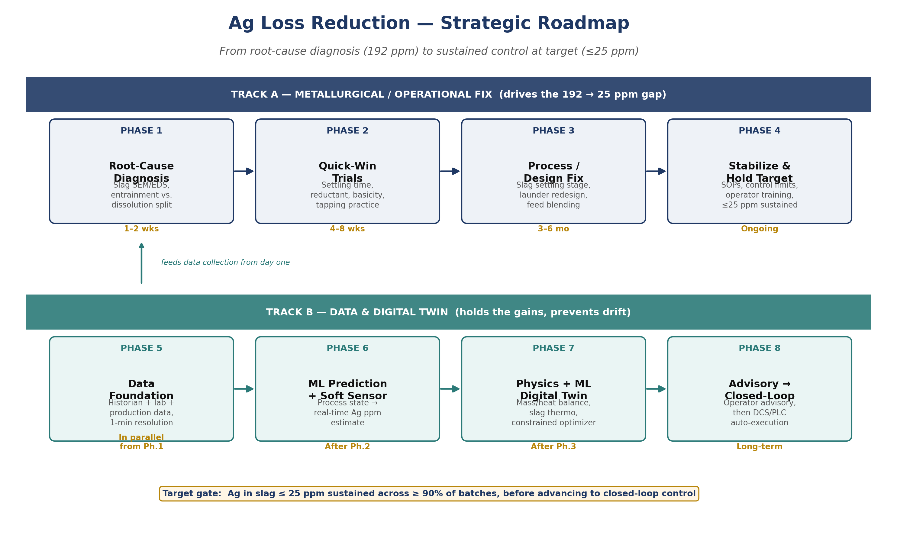
Figure 1 — Strategic roadmap: two-track phased plan from diagnosis to closed-loop control.

3.1 Phase-by-phase actions
Phase | Focus | Key Actions | Duration
1. Root-Cause Diagnosis | Track A | Slag SEM/EDS across batches; confirm entrainment vs. dissolution split | 1–2 weeks
2. Quick-Win Trials | Track A | Settling/hold time, reductant dosing, basicity/flux adjustment, tapping practice review | 4–8 weeks
3. Process / Design Fix | Track A | Slag settling or cleaning stage, launder/tap-hole redesign, feed blending & homogenization | 3–6 months
4. Stabilize & Hold Target | Track A | SOPs, control limits, operator training; sustain ≤25 ppm | Ongoing
5. Data Foundation | Track B | Historian (1-min tags) + LIMS + production data capture, batch-linked | Parallel from Ph.1
6. ML Prediction / Soft Sensor | Track B | Process state → real-time Ag ppm estimate ahead of lab result | After Ph.2
7. Physics + ML Digital Twin | Track B | Mass/heat balance, slag thermodynamics, ML correction layer, constrained optimizer | After Ph.3
8. Advisory → Closed-Loop | Track B | Operator advisory first; DCS/PLC auto-execution only after extensive validation | Long-term

3.2 Constraints on optimization
The AI/optimization layer must never be allowed to freely choose operating parameters. It searches only within a bounded, metallurgically and mechanically safe envelope:
- Minimize: Ag loss + λ₁·Energy + λ₂·Flux consumption + λ₃·Fume loss
- Subject to: temperature and pressure within OEM limits; air/O₂ flow within safe range; slag basicity and FeO within acceptable metallurgical windows; furnace safety and equipment constraints.
The 25 ppm target should be treated as a hard optimization constraint, not merely a prediction target — the real objective is to maximize Ag recovery while holding slag Ag ≤25 ppm and respecting all of the above.

4. Digital Twin — Architecture
The recommended design is a hybrid physics + AI digital twin, not a pure black-box model. A physics layer (mass/heat balance, slag thermodynamics, redox, liquidus/viscosity relationships) encodes known metallurgical behavior; an ML correction layer learns what the physics model doesn't capture — furnace-specific behavior, feed variability, refractory effects, and other unmeasured disturbances. This combination is materially easier to validate with plant engineers and safer to deploy than an unconstrained neural network.
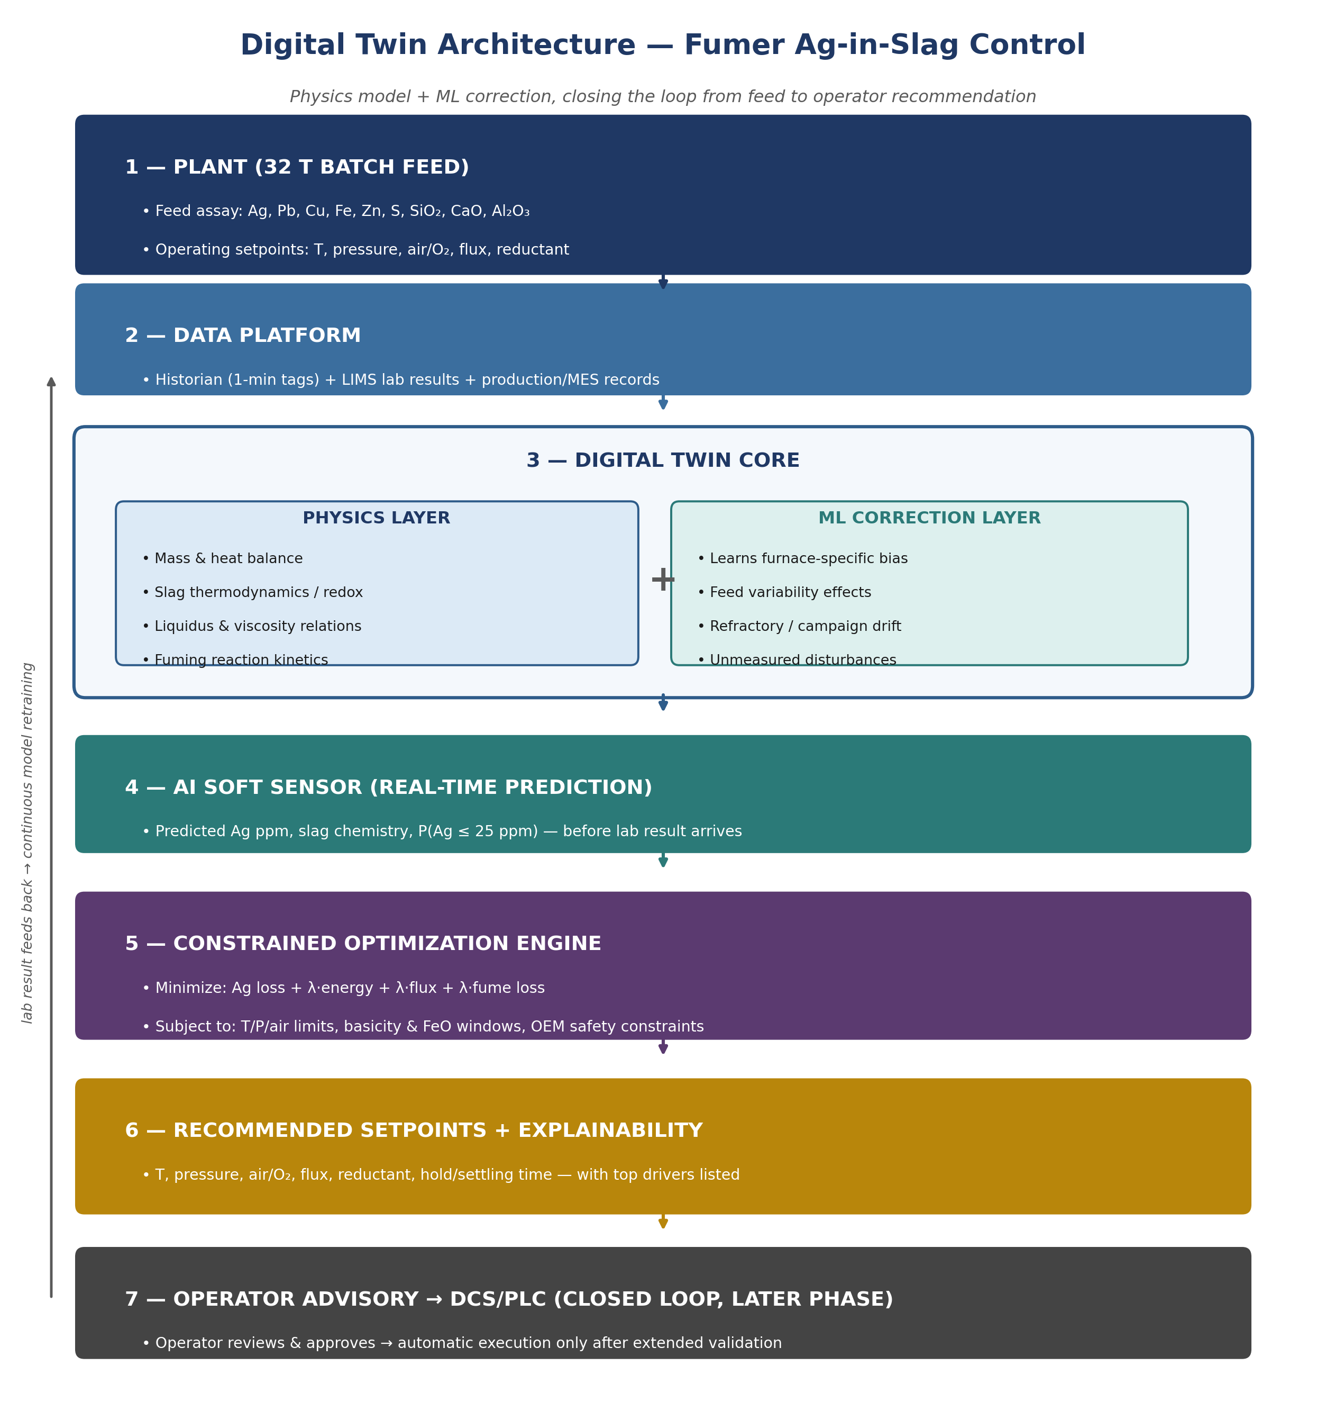
Figure 2 — Digital twin architecture: from plant feed through physics + ML core to operator-facing recommendations.

4.1 Inputs and outputs
Per 32 T batch, the model consumes feed chemistry (Ag, Pb, Cu, Fe, Zn, S, SiO₂, CaO, Al₂O₃, moisture, particle size), initial slag composition, and the full set of operating parameters (temperature, pressure, air/O₂ flow, reductant, flux, charging rate, residence and settling time). It predicts Ag ppm in slag, Ag recovery, final slag composition and mass, fume/dust Ag loss, energy consumption, and the probability of achieving ≤25 ppm.

4.2 Explainability
Recommendations are delivered with their key drivers, not as a bare setpoint. For example: “Recommended T = 1,240°C, current prediction 61 ppm, predicted outcome 23 ppm; main drivers: high slag basicity, low FeO, insufficient settling, elevated entrainment probability.” This gives the metallurgist something they can evaluate and approve rather than a black-box instruction.

5. Digital Twin — Expected Performance
The chart below is an illustrative projection, not a plant-specific forecast — it is intended to size the shape of expected impact and should be re-baselined once real historian and lab data are available. The left panel shows how Ag-in-slag is expected to trend as each phase comes online: sharp reduction during Phases 2–3 (operational and process fixes), followed by tightening variance as the soft sensor and digital twin come online in Phases 6–8 and hold the process at target. The right panel shows how soft-sensor prediction accuracy is expected to improve as the model is retrained on more batches — early predictions scatter more widely around the lab-measured value, while the mature model tightens to within a narrow band.
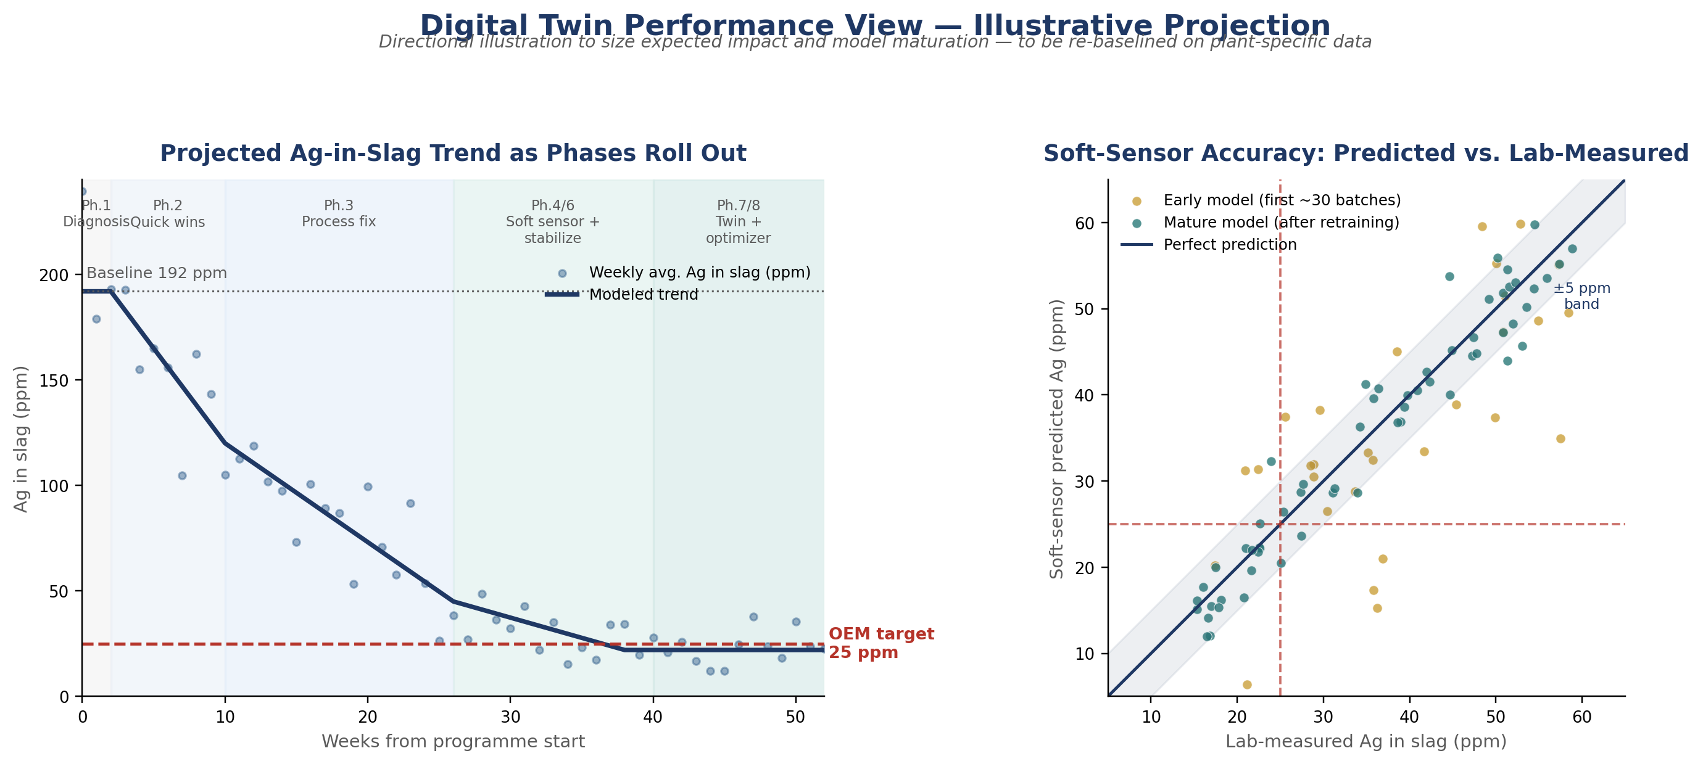
Figure 3 — Illustrative projection: Ag-in-slag trend across phases (left) and soft-sensor prediction accuracy as the model matures (right).

5.1 How to read this
- Weeks 0–2 (Diagnosis): baseline confirmed, no process change yet — variance stays wide.
- Weeks 2–10 (Quick wins): fastest ppm reduction, driven by settling time, reductant and basicity trials.
- Weeks 10–26 (Process fix): step-change reduction as settling/design fix is commissioned; target band approached.
- Weeks 26–52 (Soft sensor, twin, optimizer): variance compresses further as prediction and constrained optimization hold the process inside the target band.
- Right panel: the ±5 ppm shaded band represents a realistic soft-sensor accuracy target once mature — tight enough to flag a batch trending out of spec before the lab result arrives.

6. KPI Dashboard
KPI | Baseline | Target | Tracking Cadence
Average Ag in slag | 192 ppm | ≤25 ppm | Per batch
% batches ≤ 25 ppm | — (to establish) | ≥90% | Weekly
Ag recovery to product | — (to establish) | Maximize, subject to ppm constraint | Per batch
Soft-sensor prediction error | N/A (pre-build) | ±5 ppm (mature model) | Rolling 30-batch
Energy consumption per batch | Baseline TBD | No material increase vs. baseline | Per batch
Flux/reductant consumption | Baseline TBD | Optimized, not simply increased | Per batch

7. Suggested Technology Stack
- Data layer: plant historian (OSIsoft PI / equivalent), LIMS integration, MES/production records.
- Modeling: Python (pandas, scikit-learn / gradient boosting for the ML layer), a thermodynamic engine (e.g., FactSage/Thermo-Calc-linked calculations) for the physics layer.
- Optimization: constrained optimization (e.g., SciPy/Bayesian optimization) operating within the metallurgical and safety envelope defined in Section 3.2.
- Deployment: operator advisory dashboard first; DCS/PLC integration only after extended validation and sign-off.

8. Summary
The 192→25 ppm gap is primarily a metallurgical and settling/design problem, not a modeling problem — it should be closed first through diagnosis and the Track A operational fixes in Section 3. The digital twin in Sections 4–5 is the mechanism that holds those gains, catches drift in real time, and progressively optimizes the process once a physically feasible operating window has been established. Attempting the digital twin before the physical fix risks optimizing confidently within a window that cannot actually reach 25 ppm.

