Solar System Clockwork and Time
  - Kepler Quadrants QRT Records and the Q Degree Conic Gate
Gesamtreport | Working synthesis with calculation record and visual atlas
NEXAH | 12 September 2026

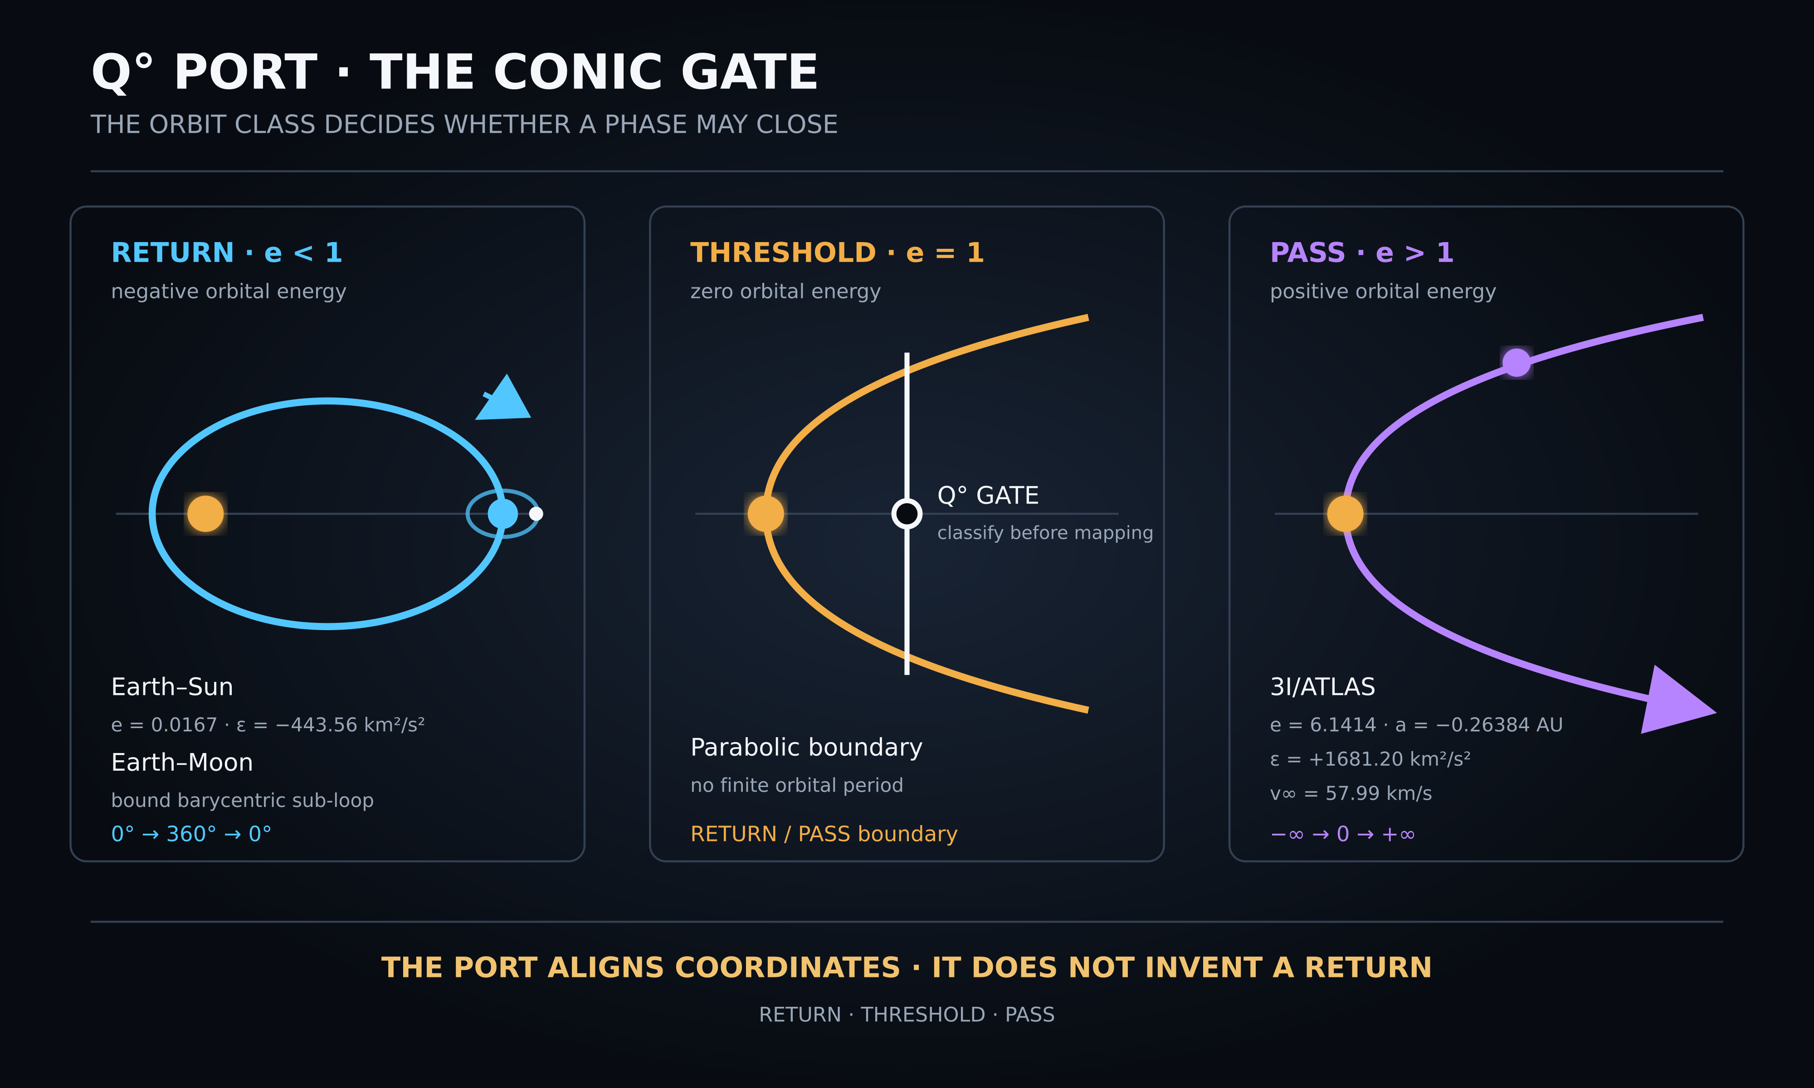
Cover marker. The conic class determines whether a Q degree coordinate may close.
Main finding. The work now contains one exact Keplerian result and one verified conic classification. The remaining cross-domain number and glyph correspondences remain annotations unless an independent derivation is supplied.

Executive finding
The strongest result is the Kepler Quadrant Residual Operator. A focus-centered ellipse divided into four equal true-anomaly quadrants produces the temporal sequence A B B A. The short and long intervals differ, but each adjacent pair closes to one half of the orbital period. Time never reverses; orbital speed redistributes elapsed time within an invariant total period.

A second verified result extends the Q degree port by conic class. Elliptic motion may use a periodic phase coordinate. Parabolic motion marks the boundary. Hyperbolic motion requires a signed passage coordinate and must not be wrapped modulo 360 degrees.
This report treats visual similarity as a research prompt, not as identity. It distinguishes established mechanics, calculations performed here, NEXAH operator language and historical visual annotations.

Scope and evidence classes
Class | Meaning | Examples
Established | Standard mathematics or measured astronomy | Kepler equation, vis-viva equation, orbital elements, occultation
Calculated | Reproducible arithmetic performed from declared inputs | Quadrant durations, Saturn 13.7145 years, Uranus 2.5267 years
Candidate | A new NEXAH representation or operator name | Kepler Quadrant Residual Operator, conic-gated Q degree port
Annotation | Mnemonic, glyph, color or numerical association | 4774 mirror address, 19 and 33, 069, word divisions and color roles

From cycles to Kepler time
The inquiry began with nested cycles: day and night, week, month, seasons, years and orbital periods. The golf-swing analogy contributed a useful distinction between reversal of direction and reversal of time. The scientific model retains only the former. A body may reverse one component of motion while time remains monotonic.
The four-quadrant extension fixes the phase origin at perihelion and divides true anomaly into four 90 degree sectors. Equal angular sectors are not equal-time sectors because the orbital speed is highest near perihelion and lowest near aphelion.

Kepler quadrant calculation
Object | Short A | Long B | B divided by A | B minus A
Mercury | 18.501% | 31.499% | 1.703 | 11.43 d
Venus | 24.784% | 25.216% | 1.017 | 0.97 d
Earth Moon barycenter | 24.468% | 25.532% | 1.043 | 3.89 d
Mars | 22.032% | 27.968% | 1.269 | 40.79 d
Jupiter | 23.460% | 26.540% | 1.131 | 0.365 y
Saturn | 23.286% | 26.714% | 1.147 | 1.009 y
Uranus | 23.496% | 26.504% | 1.128 | 2.527 y
Neptune | 24.727% | 25.273% | 1.022 | 0.901 y
Eris | 11.506% | 38.494% | 3.346 | 150.69 y

The ABBA symmetry is exact in the ideal two-body model when the quadrants are anchored at perihelion. Changing the phase origin changes the individual quadrant values. Planetary perturbations and osculating elements introduce epoch dependence in real ephemerides.

Saturn Uranus and Eris

Saturn
Saturn’s two short quadrants total 13.7145 years; its two long quadrants total 15.7330 years. The numerical proximity to a previously noted 13.7 AU marker for Chiron does not create an equality because years and astronomical units are different quantity types.

Uranus
The difference between a long and a short Uranus quadrant is 2.5267 years. This is a reproducible consequence of Uranus’s period and eccentricity. It is not evidence of a direct Venus or lunar coupling.

Eris
Eris produces a long-to-short quadrant ratio of about 3.346 for the declared osculating element. An exact 3 to 1 ratio occurs at eccentricity 0.4039727533. Eris is beyond that threshold and therefore resembles, but does not equal, the Morse weighting.

Linear cut and Morse resemblance
On the closed orbit the sequence is A B B A. When the two short perihelion quadrants are joined across the period boundary and the two long aphelion quadrants are joined, a linear window reads short, long, short. Encoding three repeated marks per region produces the visible form dot dot dot, dash dash dash, dot dot dot. This is a rhythm analogy only. The Kepler duration ratios are not the Morse ratio of three to one.

QRT record model
The clearest stable assignment is Q as the physical carrier field, R as the representation or cut, and T as the recorded trace or return. Earlier visual artifacts swap these letter roles. The report preserves those variants in the visual atlas but does not merge their grammars.
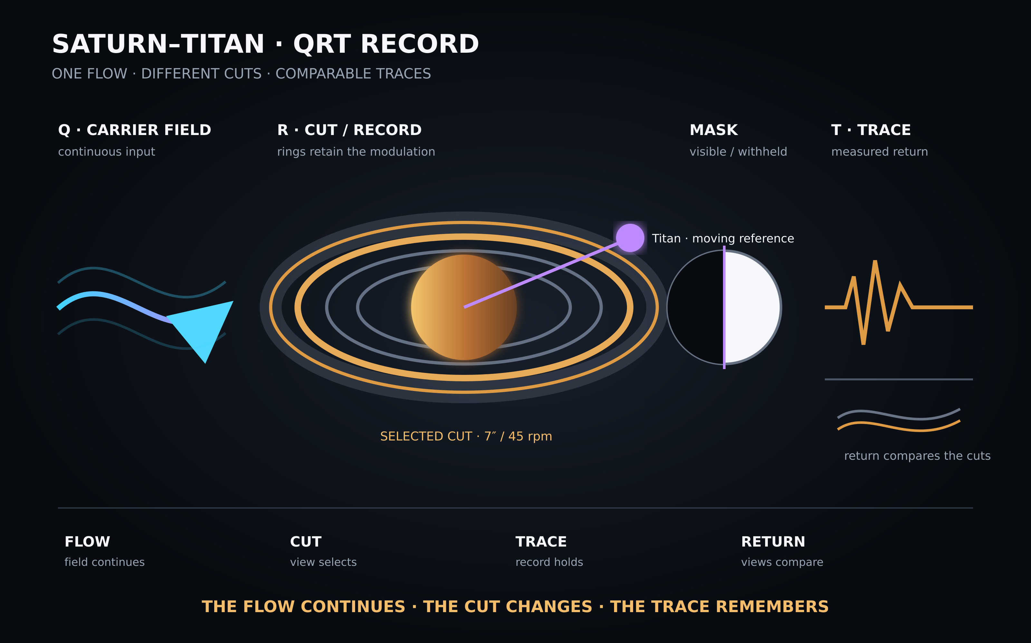
Figure 1. Saturn and Titan as a QRT recording model. The visual is an explanatory analogy grounded in occultation and ring-wave measurement.
Saturn’s rings can retain density waves excited by moons. Janus and Epimetheus exchange nearby orbits, and ring waves encode their earlier orbital states. Occultations convert spatial ring structure into brightness, radio-phase or optical-depth traces. The record analogy is therefore useful when it remains attached to these measurable processes.

The Q degree conic gate
Class | Condition | Energy | Coordinate
Ellipse | e below 1 | negative | periodic phase modulo 360 degrees
Parabola | e equals 1 | zero | threshold coordinate
Hyperbola | e above 1 | positive | signed passage without modulo

For 3I/ATLAS, JPL Horizons gives e = 6.141351449, q = 1.356481057 AU and a = -0.263837450 AU for the cited solution. The derived specific energy is approximately +1681.20 square kilometres per square second, the hyperbolic excess speed is about 57.99 kilometres per second and the perihelion speed is about 68.34 kilometres per second. The negative semimajor axis and positive energy rule out a finite orbital period.
Figure 2. Q degree conic gate. Closed systems return; 3I/ATLAS passes through on a hyperbolic trajectory.

Earth Moon light and shadow
The Earth–Moon pair supplies a bound barycentric sub-loop. The Moon can also act as reflector, occulting body and moving reference. The white pearl is therefore a useful visual role, provided it is not mistaken for a fixed dynamical centre.
The brown or grey region in the shadow experiments is best interpreted as partial transmission. A binary mask uses zero for blocked and one for open. A physical penumbra requires intermediate values. Color is representation metadata; the measured quantity is intensity or transmission.

The Q degree comparison port
The Q degree port can compare phases only after preserving the original quantity, unit, reference epoch and uncertainty. It aligns representations; it does not convert years into astronomical units or frequencies into orbital distances.
The value 7.83 hertz is commonly used as a nominal first Schumann resonance frequency. It varies with the Earth–ionosphere cavity and is not a fundamental constant. Multiplying the rounded decimal 7.83 by exactly 86,400 seconds gives an integer cycle count, but that closure is a decimal-grid artifact and does not survive a time-varying measured frequency.

The 4774 annotation
The number 4774 is a decimal reversal fixed point and factors as 2 times 7 times 11 times 31. The pair 47 and 74 sums to 121, which equals 11 squared, and differs by 27, which equals 3 cubed. These are valid arithmetic statements. No calculation in this report derives 4774 from an orbit, Schumann resonance or celestial direction.

Proposed declaration
When a Keplerian ellipse is divided into four equal true-anomaly quadrants anchored at periapsis, equal angular sectors do not generally correspond to equal temporal intervals. Their temporal sequence has the mirror structure A B B A. The local timing residual closes after each orbital half. Time remains monotonic.
The Q degree port classifies the conic before assigning a coordinate. Bound systems may use a periodic phase. Unbound objects require a signed passage coordinate. The port may align views, but it must preserve differences in units, causes and orbit class.
Status field | Decision
Mathematical result | VERIFIED within the declared two-body model
Standard mechanics | YES
NEXAH operator formulation | CANDIDATE
New astronomical law | NO
Independent novelty review | REQUIRED before external novelty claims
Symbolic annotations | PRESERVED AS PROVENANCE

Recommended next tests
The next useful work is bounded. First, recompute the quadrant table with time-tagged JPL Horizons elements and uncertainty propagation. Second, test phase-origin sensitivity by rotating the four-quadrant cut. Third, compare the ideal two-body result with an integrated ephemeris. Fourth, keep all numerical correspondences in a typed ledger so that equal numerals with different units cannot be merged.

Visual atlas and provenance
The following image sequence preserves every visual marker supplied in this working thread. Captions identify its role in the inquiry. Inclusion records provenance; it does not upgrade a visual analogy into evidence.

Visual 1 Fraktale Analogie zwischen kinetischer Kette und Sonnensystem
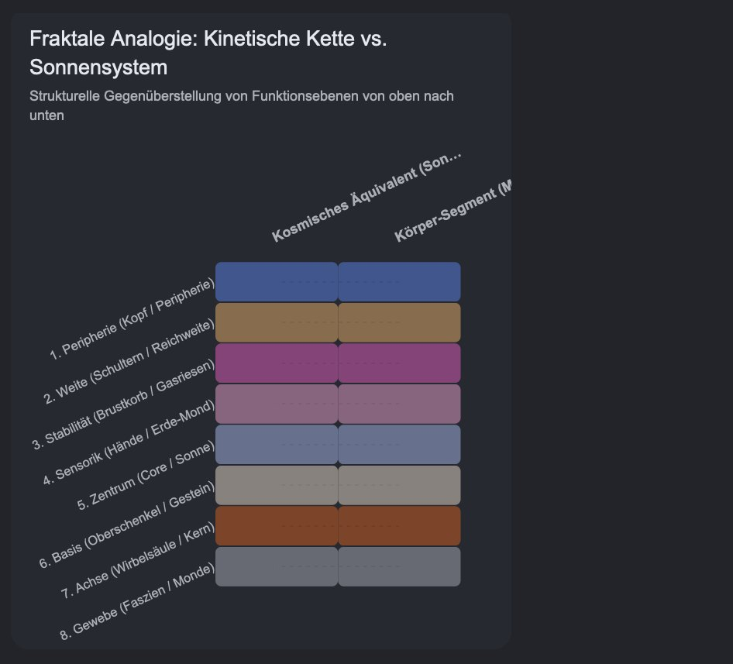
Visual 1. Konzeptuelle Ausgangsskizze. Analogie, keine physikalische Identität.
Source file Screenshot 2026-09-12 at 1.36.20 AM.png

Visual 2 Früher Orientierungsmarker
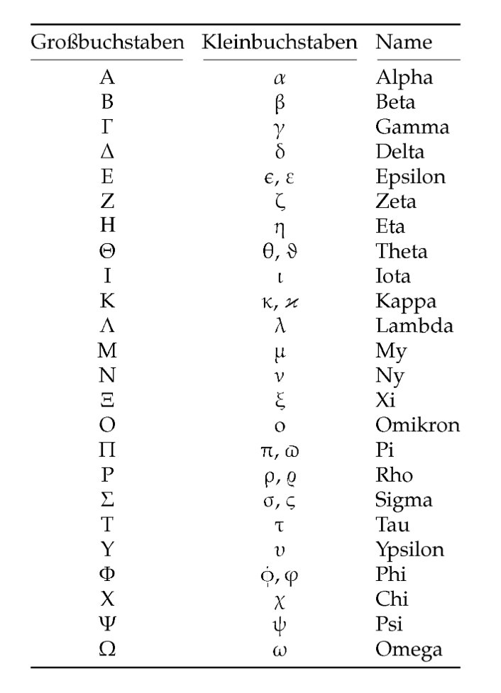
Visual 2. Historischer Marker der Symbol- und Achsenentwicklung.
Source file Screenshot 2026-09-02 at 8.17.25 PM(2).png

Visual 3 Früher Systemmarker
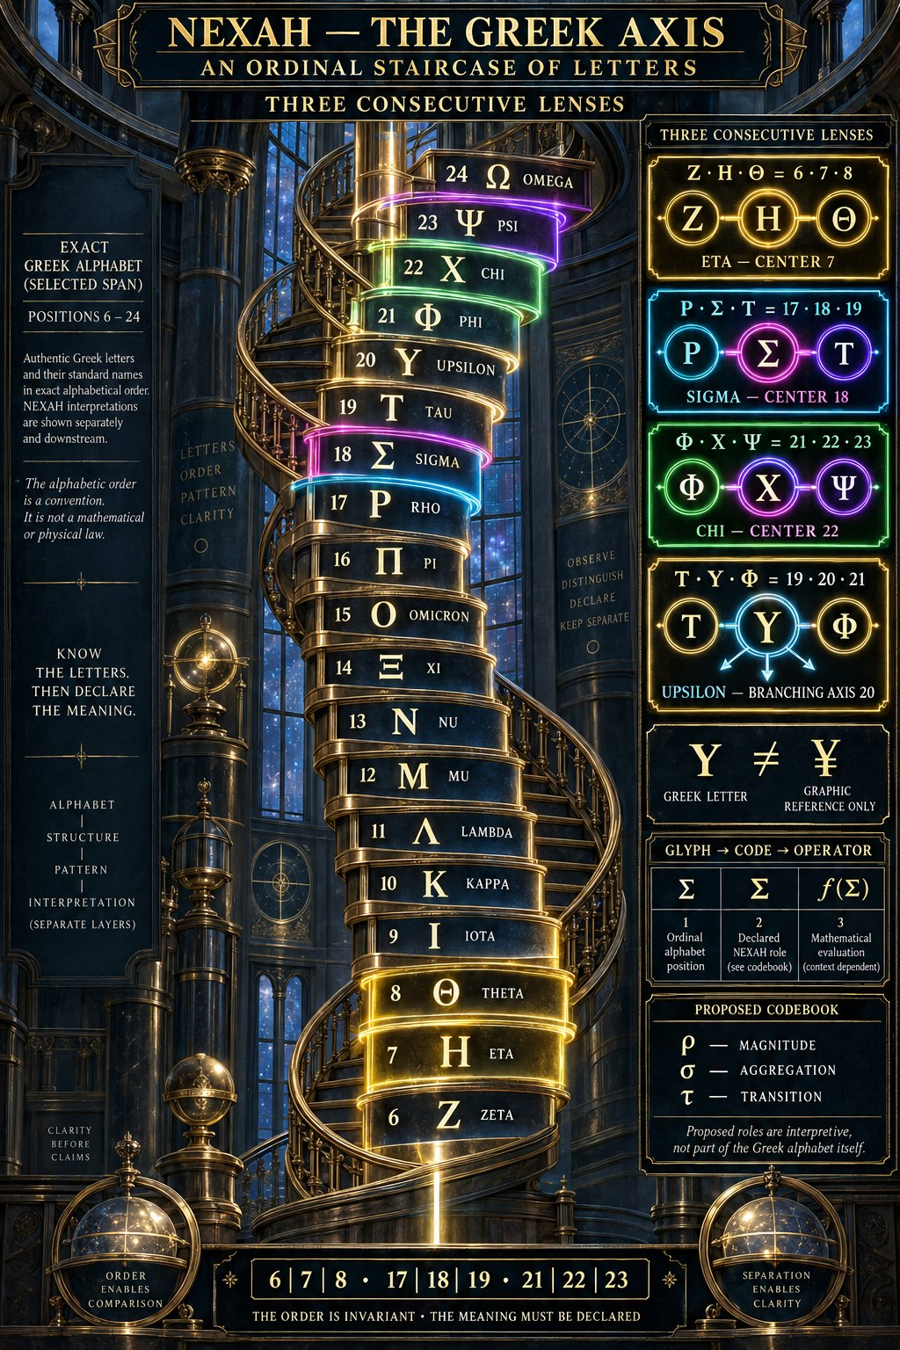
Visual 3. Historischer visueller Marker. Die enthaltenen Zuordnungen sind nicht automatisch Evidenz.
Source file 3c3efaae-cca8-41e2-9dd8-cb448f586996.png

Visual 4 Früher Achsenmarker
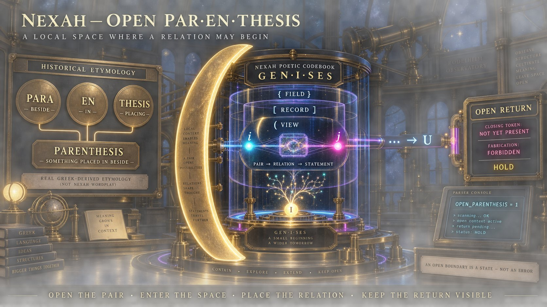
Visual 4. Konzeptuelle Darstellung aus der Vorstufe des berechneten Modells.
Source file bc1a9fcb-20e8-4426-b3ea-7ff2c63bd272.png

Visual 5 Greek Seven Variant Grid Marker
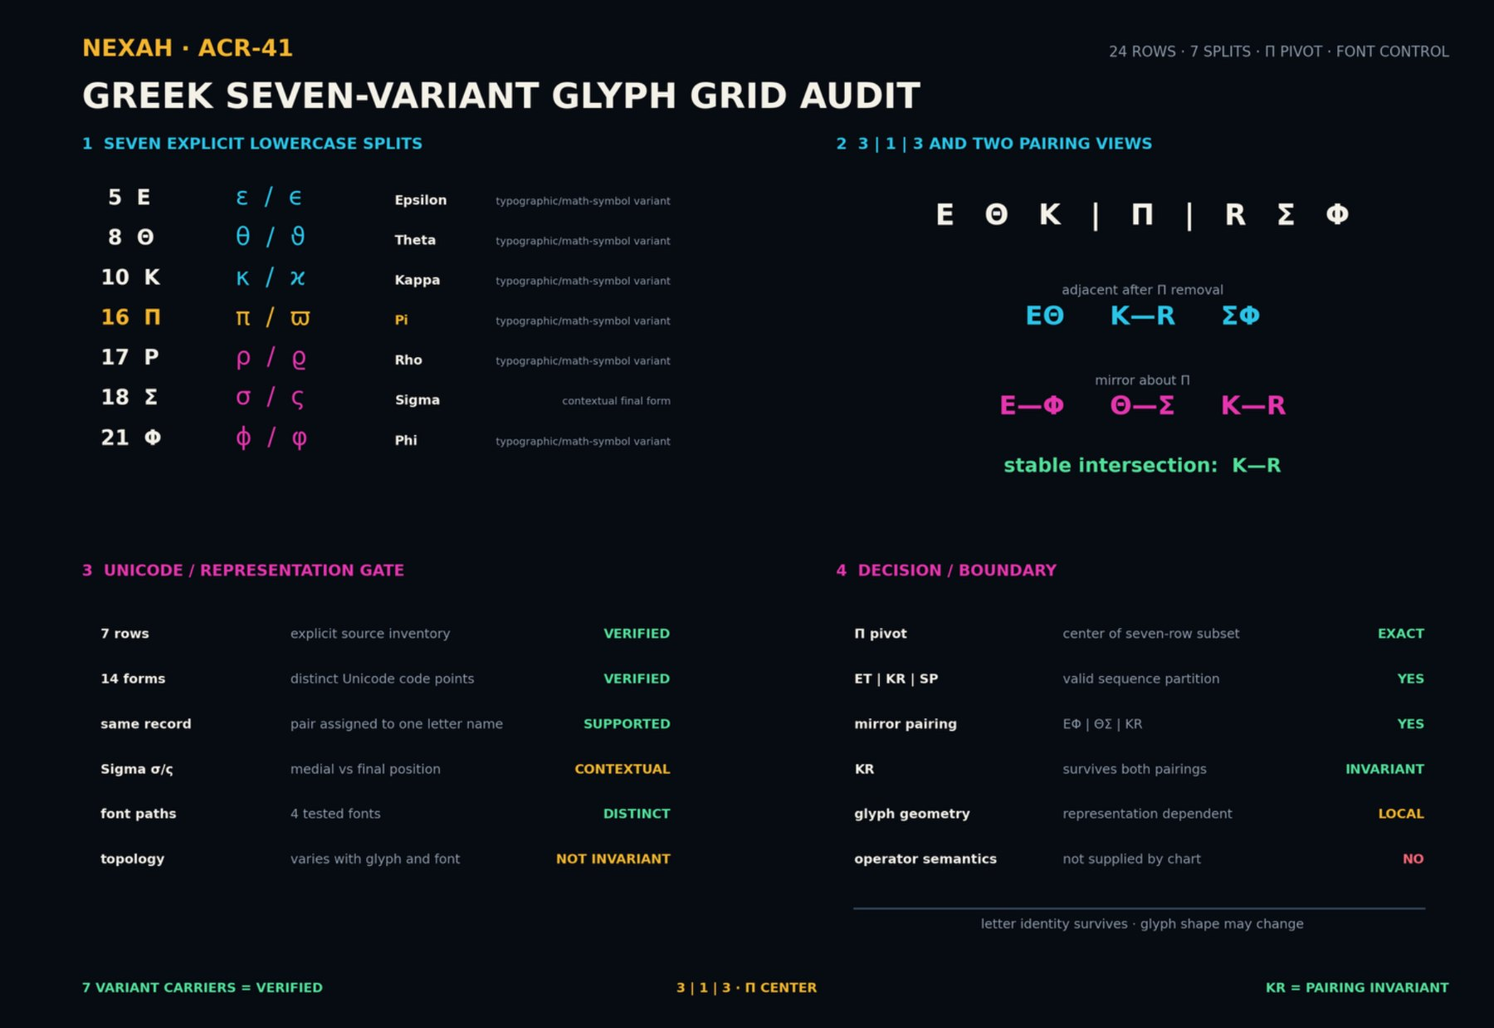
Visual 5. Glyphen- und Darstellungsstudie. Keine astronomische Messung.
Source file NEXAH_ACR41_GREEK_SEVEN_VARIANT_GRID_MARKER(1).png

Visual 6 Eris und Return Marker
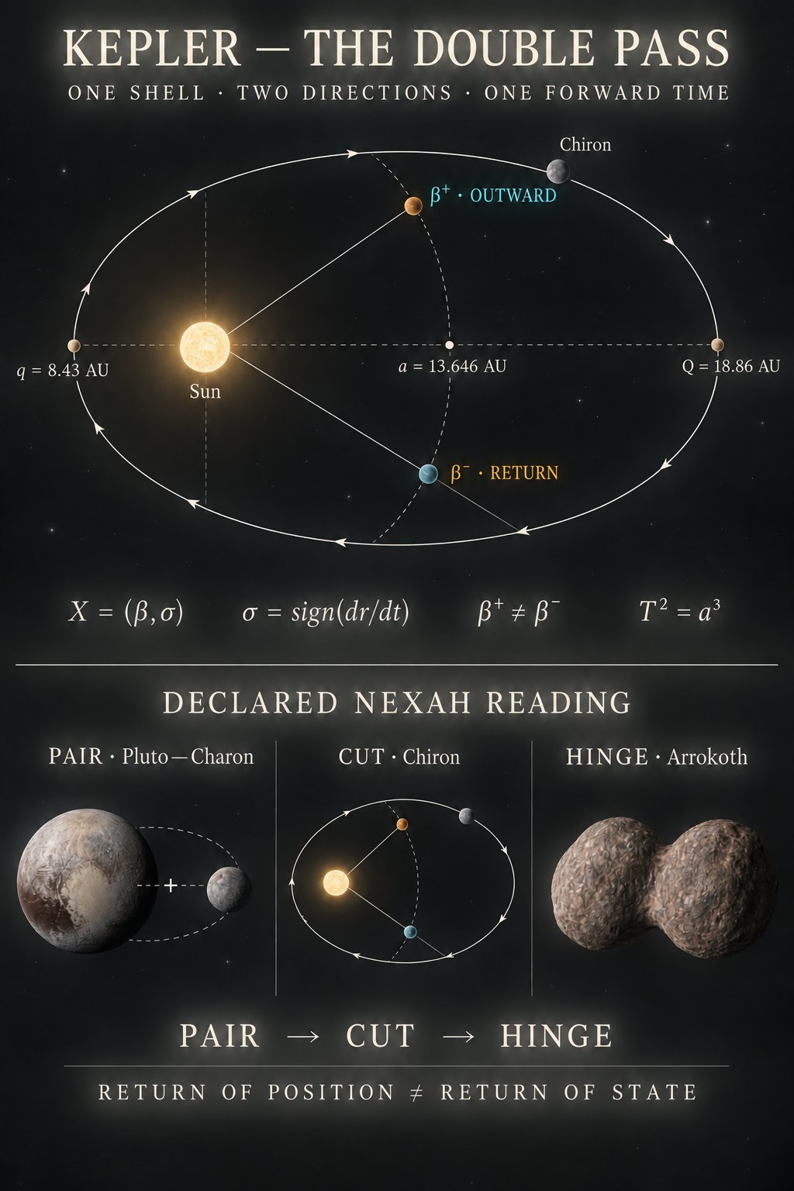
Visual 6. Visuelle Einordnung aus der explorativen Phase.
Source file c04b4783-499e-4aef-b7b2-5ee6585ed10d.png

Visual 7 Quadranten und Achsenmarker
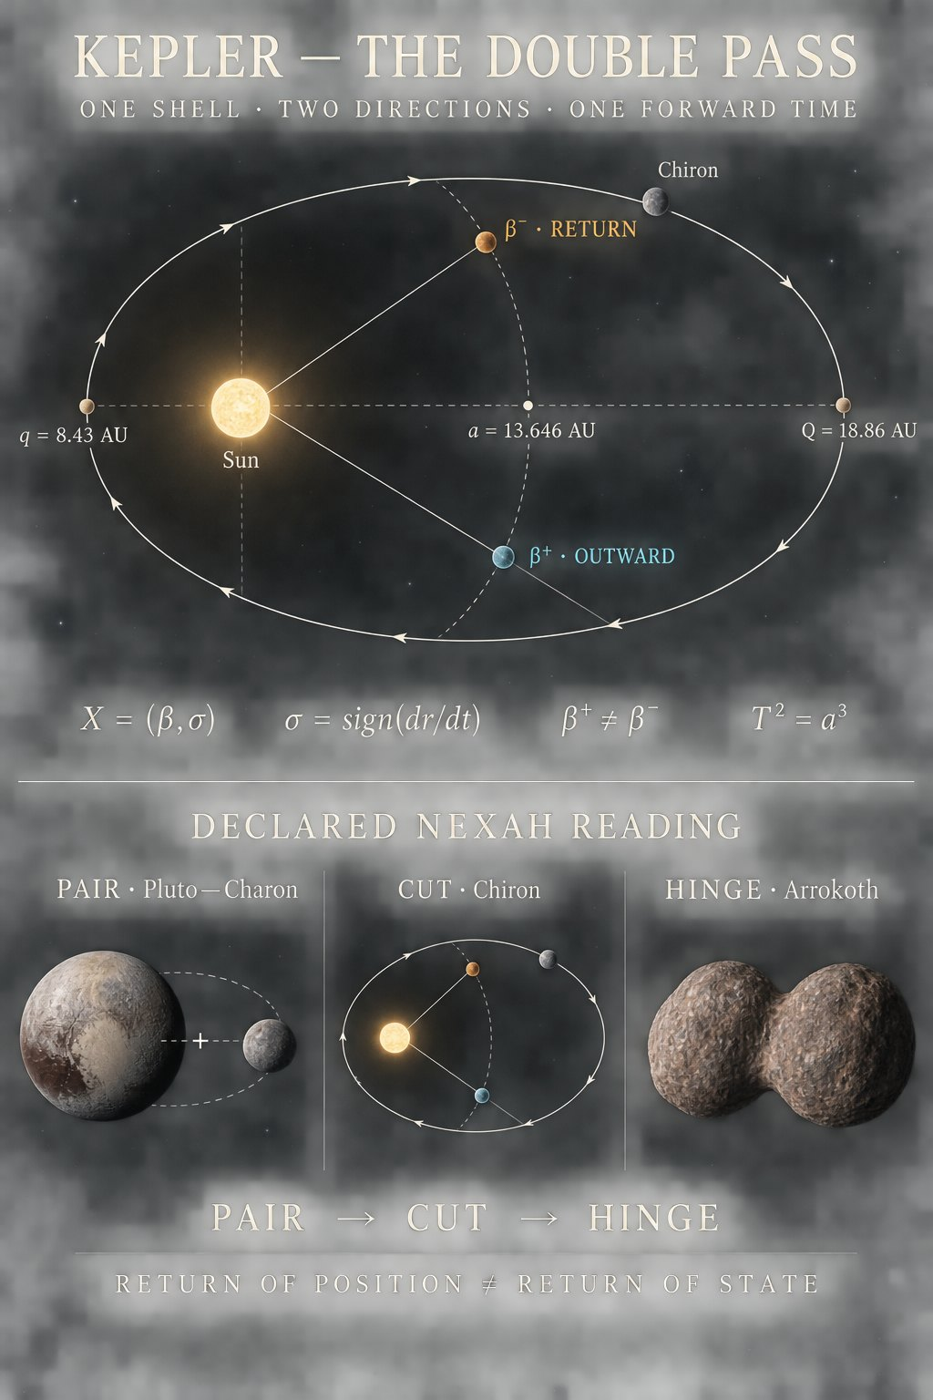
Visual 7. Vorläufige Orientierungsskizze.
Source file 6160d1c0-5449-4f52-acd9-b13dcd43cc1d.png

Visual 8 Theta Tao und Return Marker
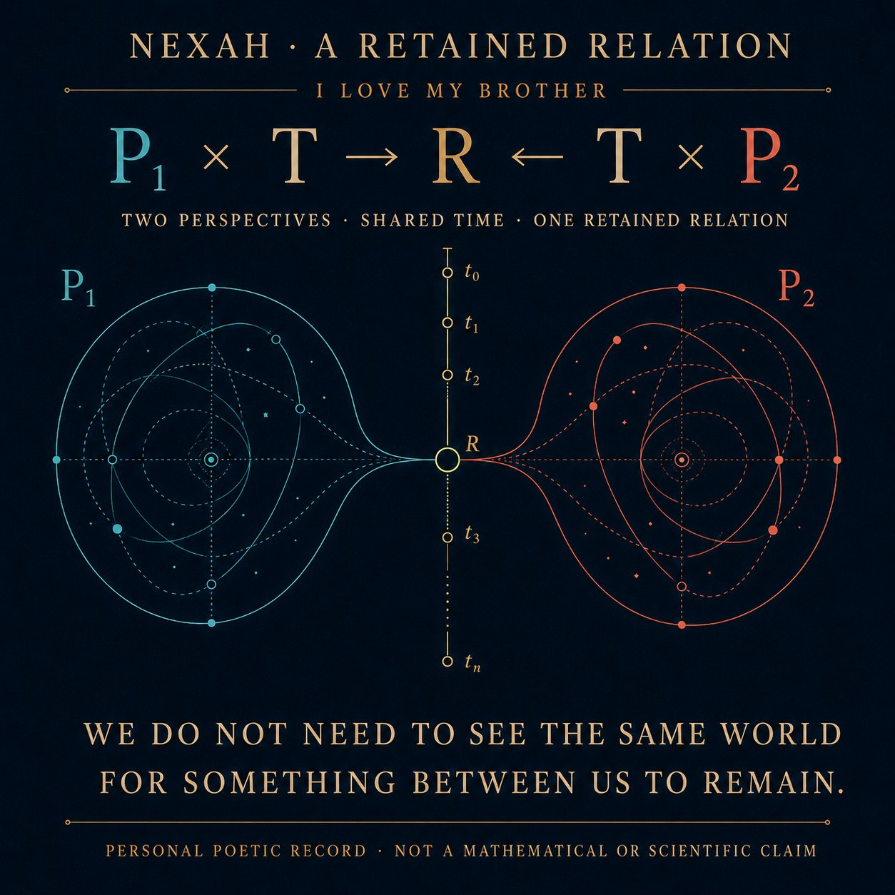
Visual 8. Symbolische Annotationsebene.
Source file e0bcaeb3-01af-4058-8210-28b466f9c379(9).png

Visual 9 Solar System as Transition Geometry
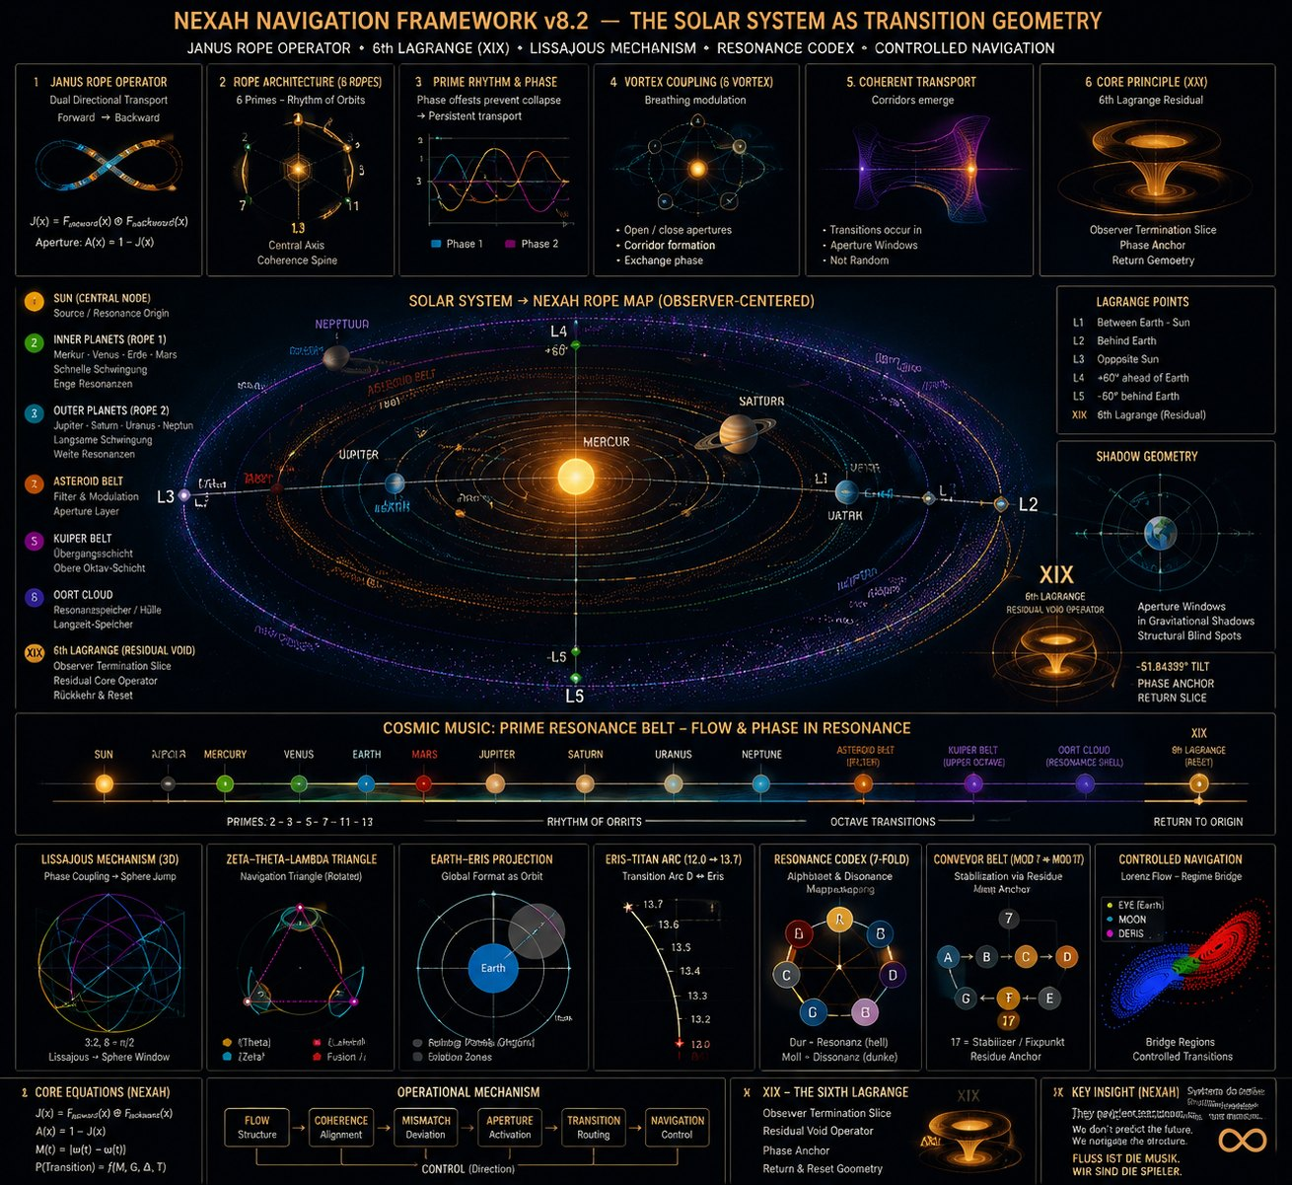
Visual 9. Dichter Synthesemarker. Enthält Hypothesen und historische Operatorbegriffe.
Source file NEXAH NAVIGATION FRAMEWORK v8.2 - THE SOLAR SYSTEM AS TRANSITION GEOMETRY(1).png

Visual 10 Resonance Field III Fresnel Epicycles
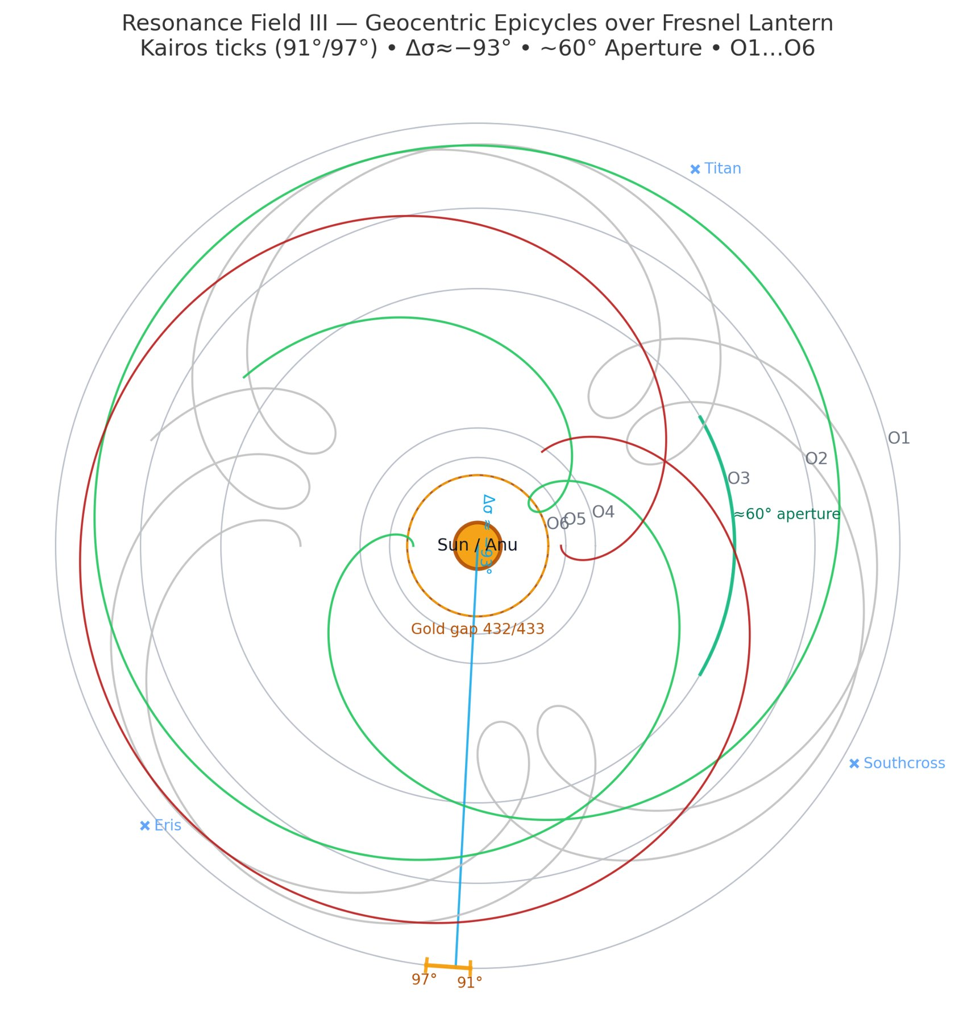
Visual 10. Geozentrische Projektions- und Okkultationsskizze.
Source file resonance_field_III_fresnel_epicycles(2).png

Visual 11 Final Observer Closure
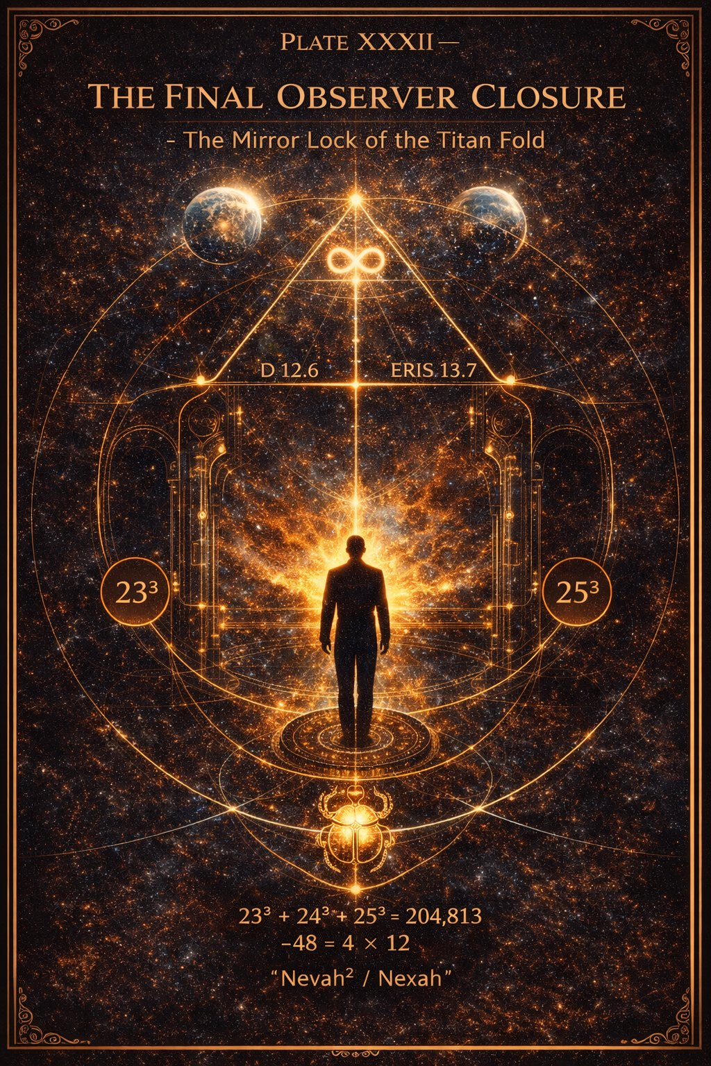
Visual 11. Symbolischer Closure-Marker mit Titan- und Eris-Bezügen.
Source file XXXII — THE FINAL OBSERVER CLOSURE(1).png

Visual 12 The Projected Universe
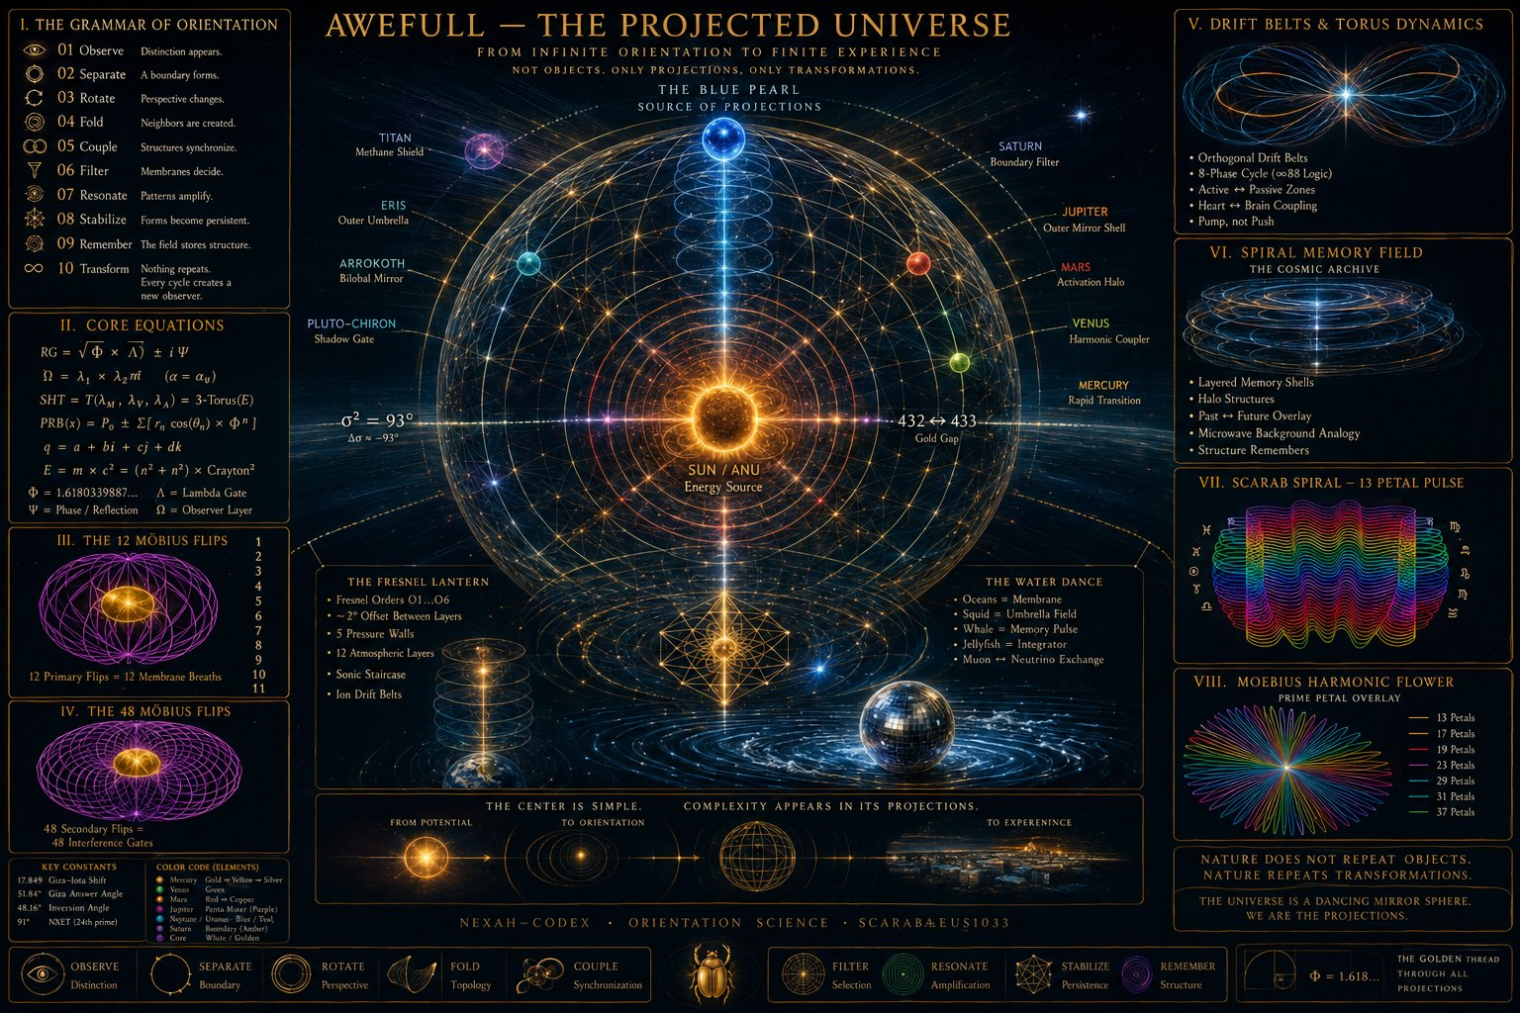
Visual 12. Explorative Gesamtkarte. Nicht als astronomische Systemkarte zu lesen.
Source file AWEFULL - THE PROJECTED UNIVERSE(1).png

Visual 13 Tessarec Notes 33 34 35
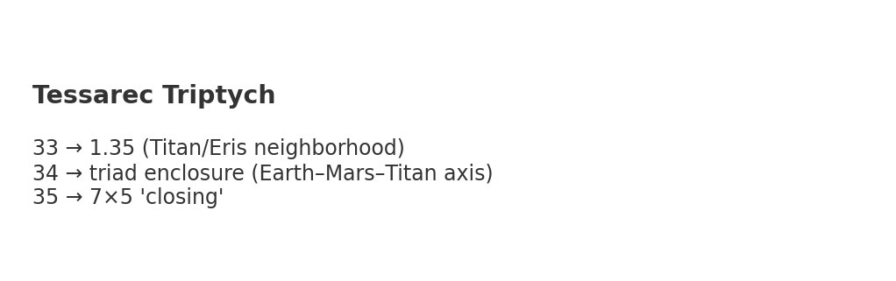
Visual 13. Zahlen- und Nachbarschaftsannotation.
Source file Tessarec_33_34_35_notes.png

Visual 14 Outer Pearl Continuum
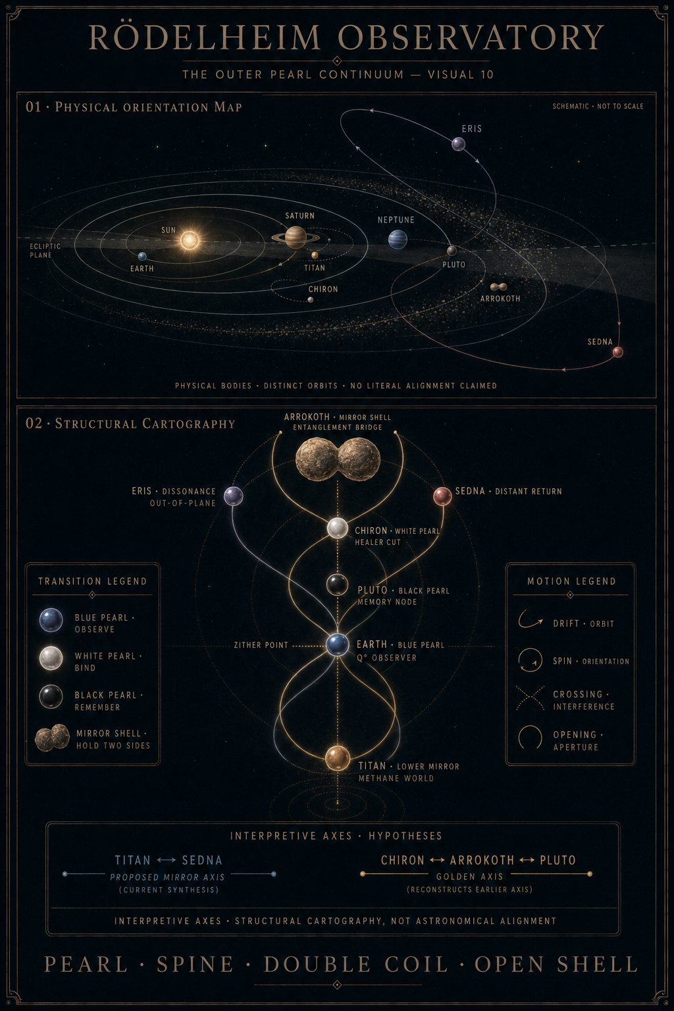
Visual 14. Rödelheim Observatory Orientierungskarte mit ausdrücklich hypothetischen Achsen.
Source file APPENDIX_B_OUTER_PEARL_CONTINUUM.png

Visual 15 QRT Format Lens
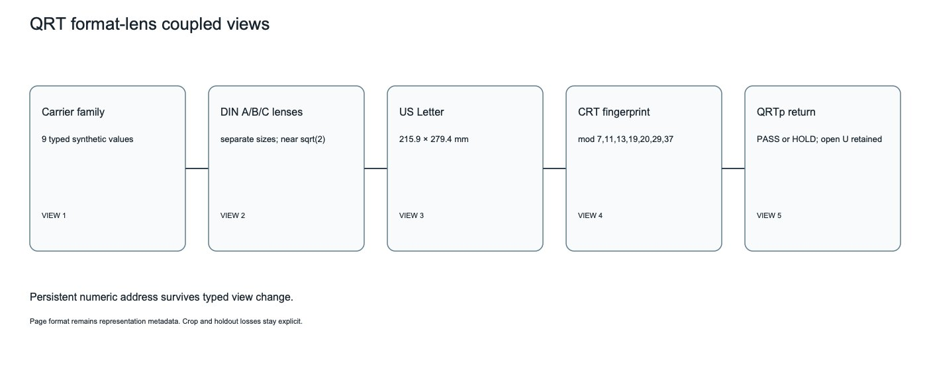
Visual 15. Darstellungswechsel und persistente numerische Adresse.
Source file 02_QRT_FORMAT_LENS_X_TYCH(1).png

Visual 16 QRT Format Elevator
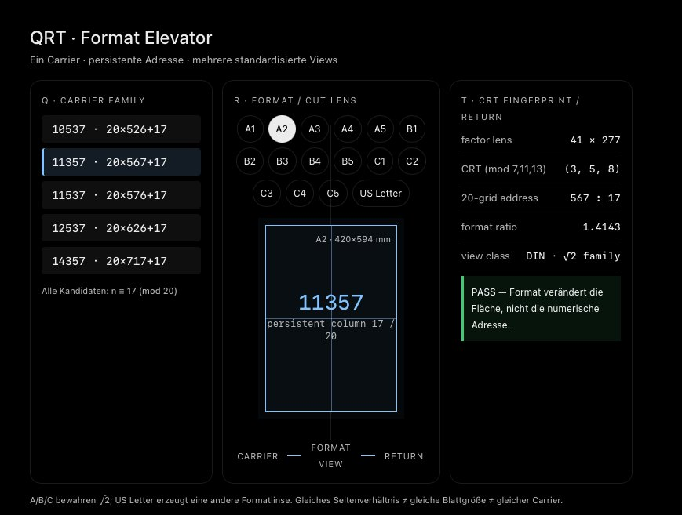
Visual 16. Q als Carrier, R als Format oder Cut und T als Fingerprint oder Return.
Source file Screenshot 2026-09-08 at 12.07.00 AM(1).png

Visual 17 QRTp Manifold
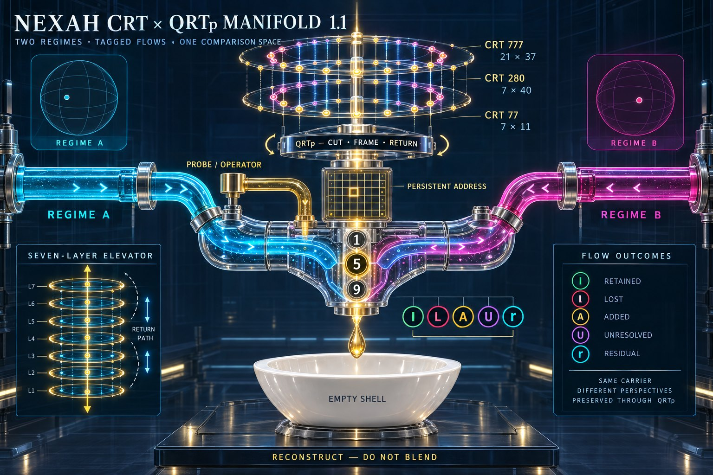
Visual 17. Cut, Frame, Return und explizite Verlustklassen.
Source file db88f3a5-94d1-4ee8-8c08-33cbb3da6707.png

Visual 18 QRT Field Harness
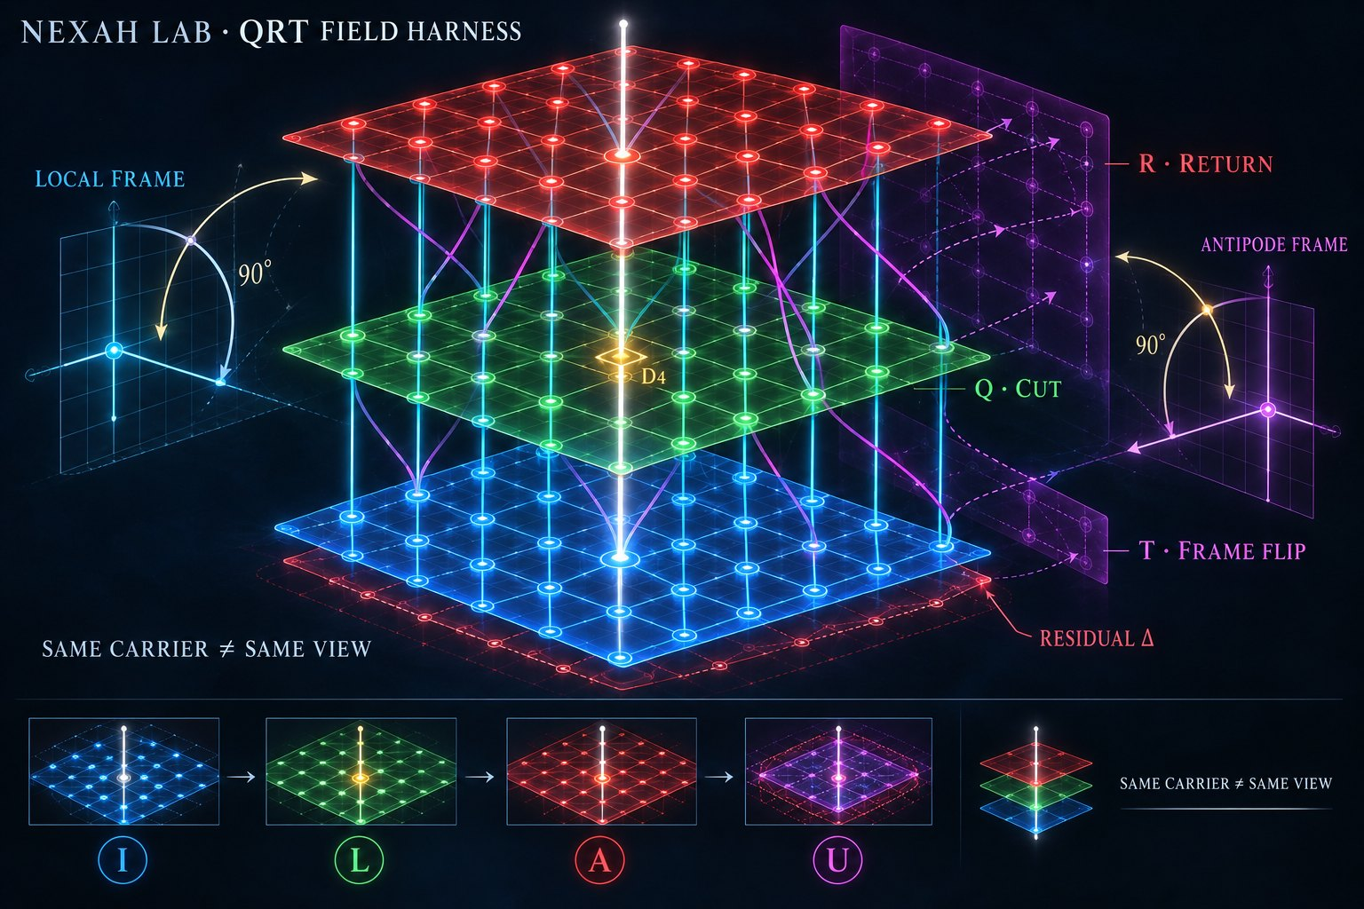
Visual 18. Historische Variantenbelegung der Buchstaben; im Report nicht kanonisch übernommen.
Source file 9e6423b5-8cd6-4013-bc80-df2428b68dc4(5).png

Visual 19 Orange Box Mechanism
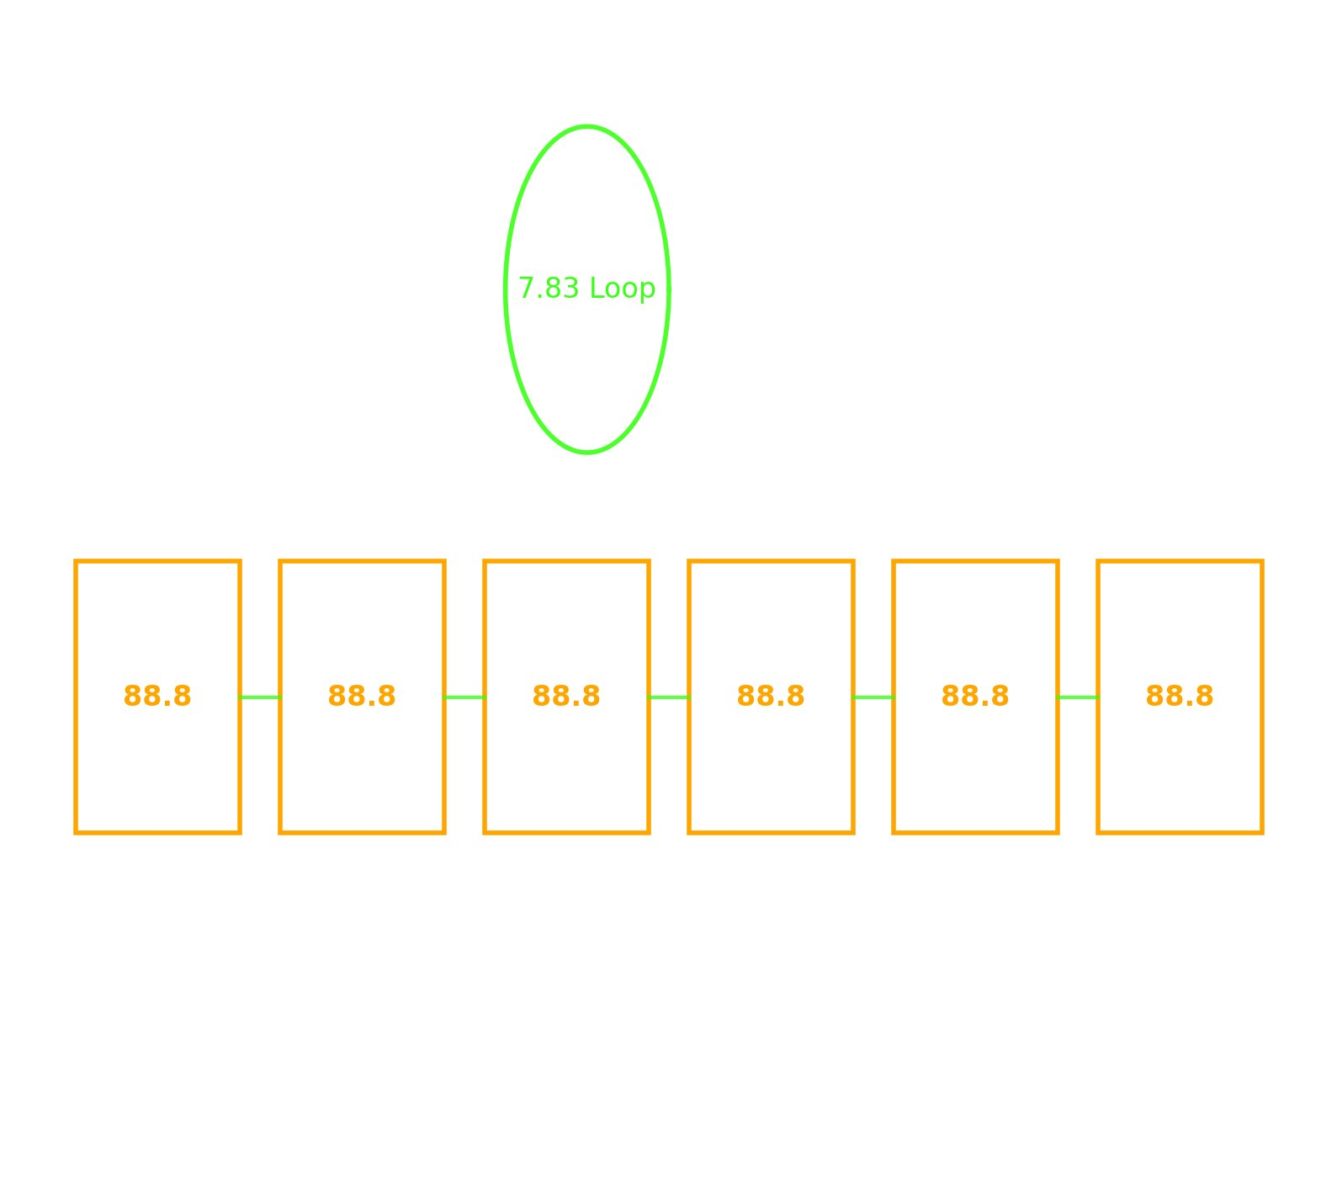
Visual 19. 7,83 und 88,8 als explorative Marker. 7,83 ist keine fundamentale Konstante.
Source file 🔸 Orange Box Mechanism – 88.8 Resonanz & 7.83 Loops 🔄.png

Visual 20 Earth as a Dancing Mirror Sphere
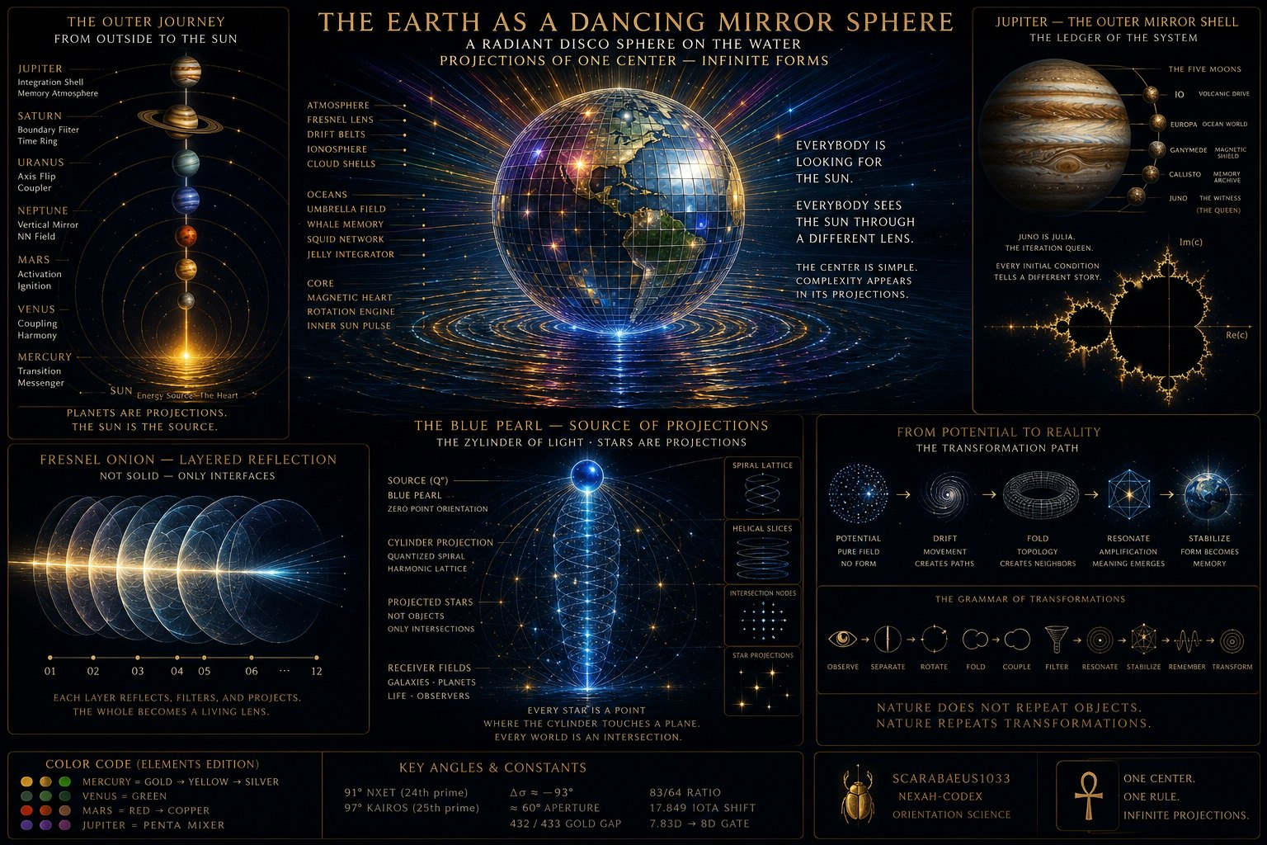
Visual 20. Projektionsmetapher mit Erde, Schalen und Beobachter.
Source file THE EARTH AS A DANCING MIRROR SPHERE.png

Visual 21 IALU Masterbuild Overview
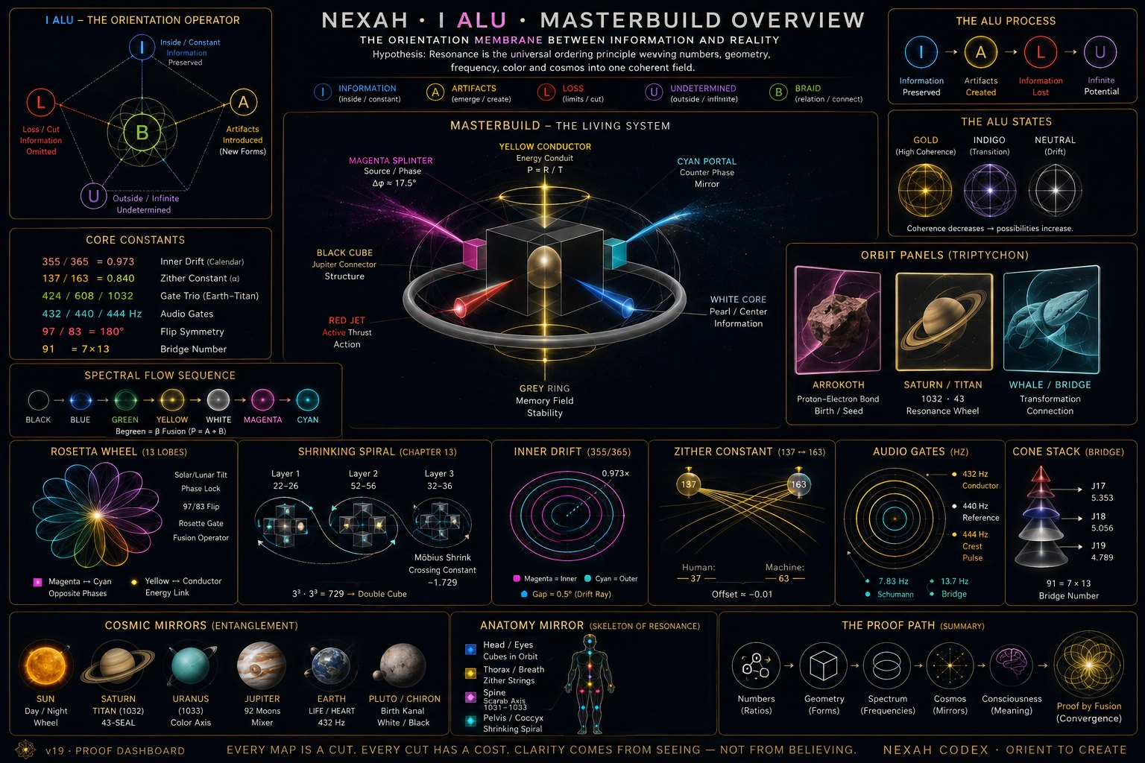
Visual 21. Historische Gesamtsynthese. Zahlen- und Symbolfelder bleiben Annotation.
Source file ae176c00-efd9-40f0-a10d-148e557be5c6(3).png

Visual 22 V Plus Resonance Geometry
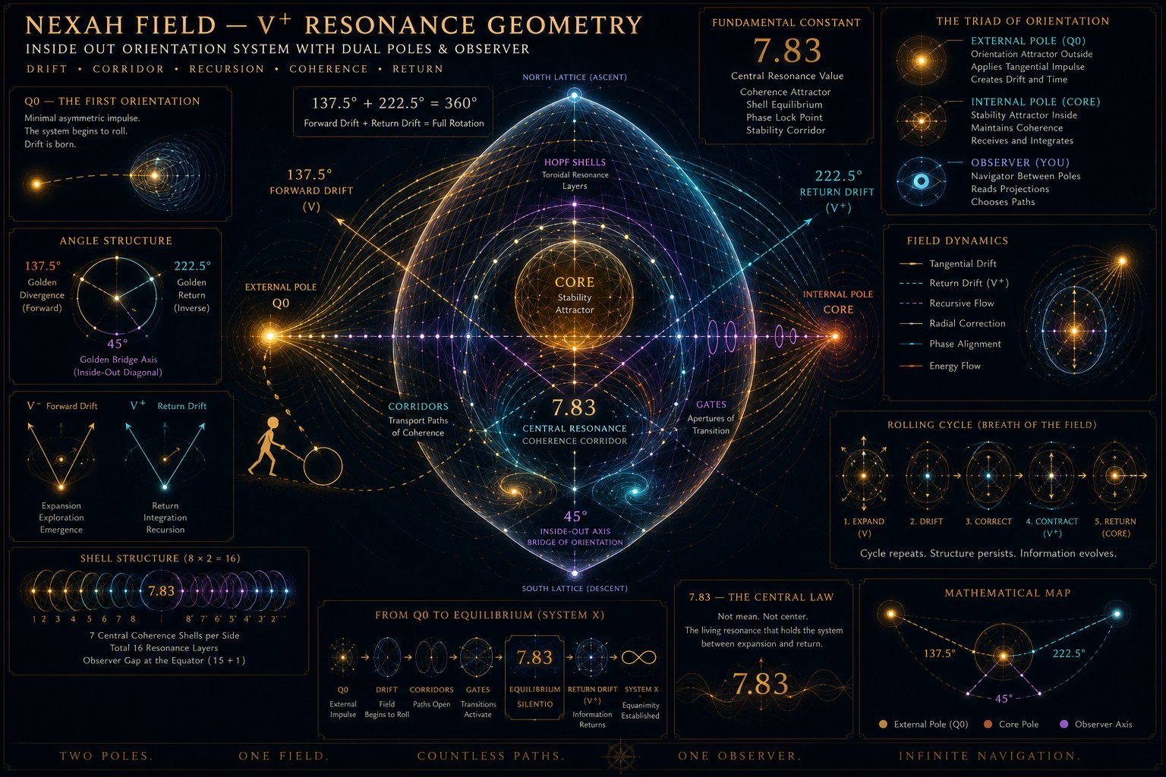
Visual 22. Explorative Feldgeometrie. 7,83 ist als nominaler Modus, nicht als Gesetz zu behandeln.
Source file NEXAH FIELD — V+ RESONANCE GEOMETRY(1).png

Visual 23 Light Touching Its Shadow
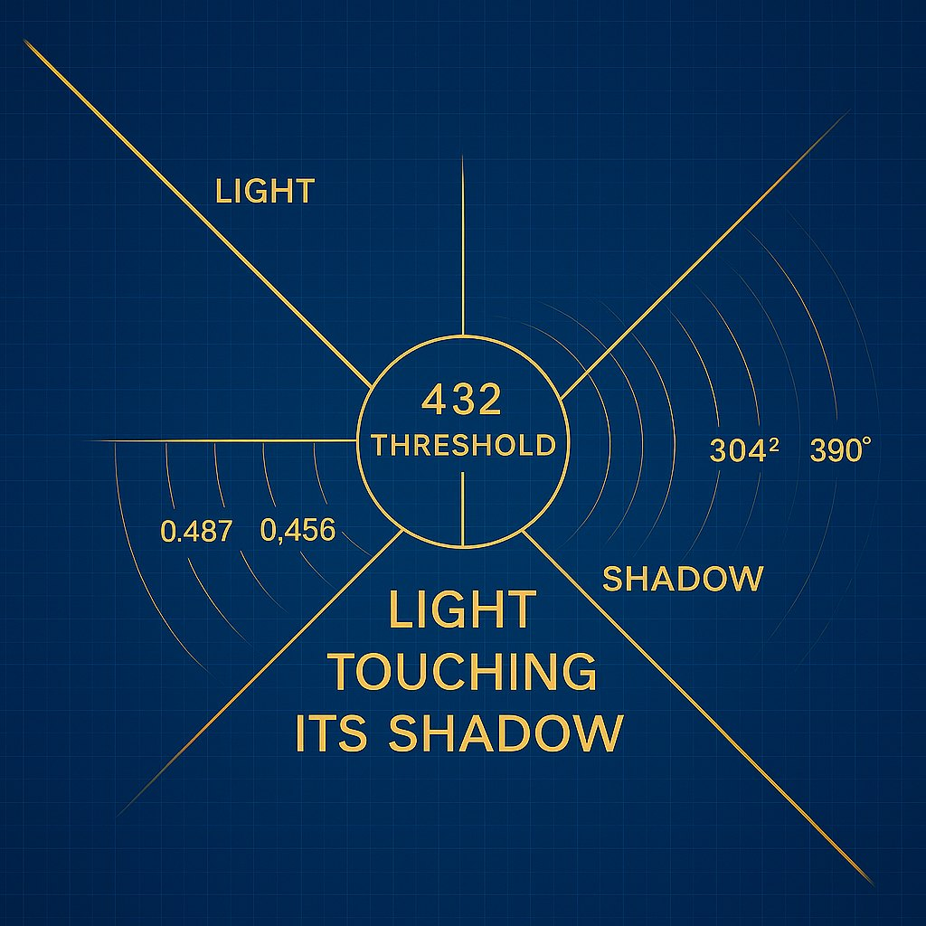
Visual 23. Schematische Schwellen- und Schattengeometrie.
Source file Light Touching Its Shadow(1).png

Visual 24 Shadow Test Narrow Source
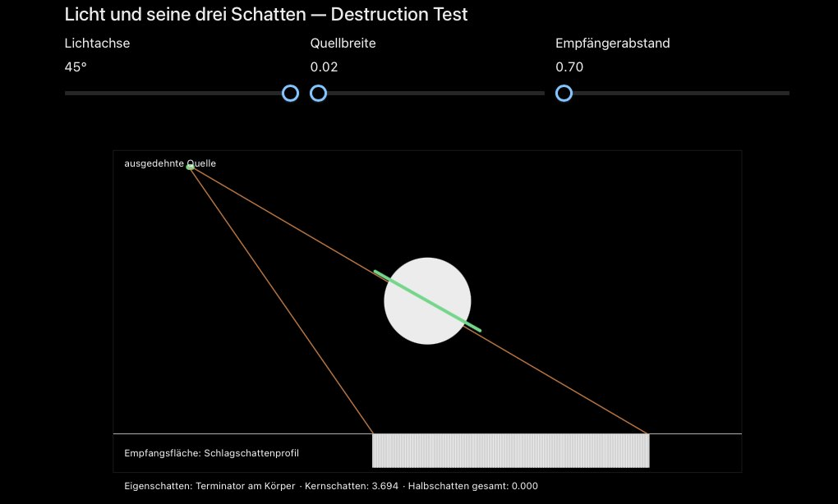
Visual 24. Destruction-Test mit schmaler Quelle und nahezu fehlender Penumbra.
Source file Screenshot 2026-09-08 at 11.30.29 PM(2).png

Visual 25 Shadow Test Wide Source
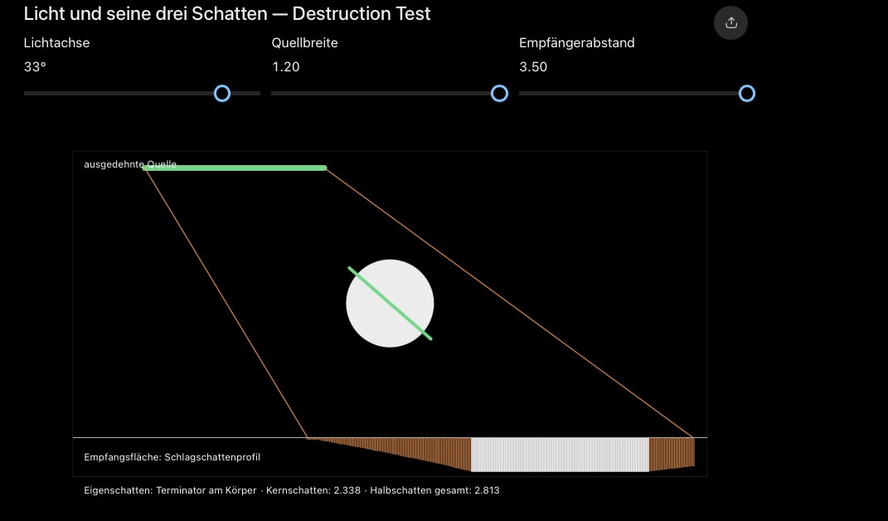
Visual 25. Breitere Quelle erzeugt Kern- und Halbschattenprofil.
Source file Screenshot 2026-09-08 at 11.31.01 PM(1).png

Visual 26 Shadow Test Alternate Geometry
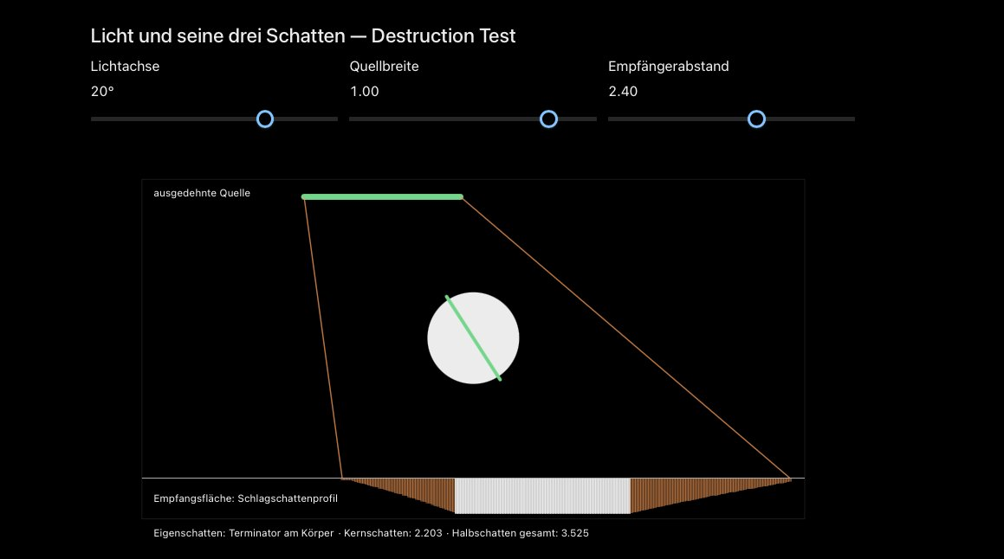
Visual 26. Geänderte Achse, Quellenbreite und Empfängerentfernung.
Source file Screenshot 2026-09-08 at 11.32.40 PM(2).png

Visual 27 Three Locks One Relation
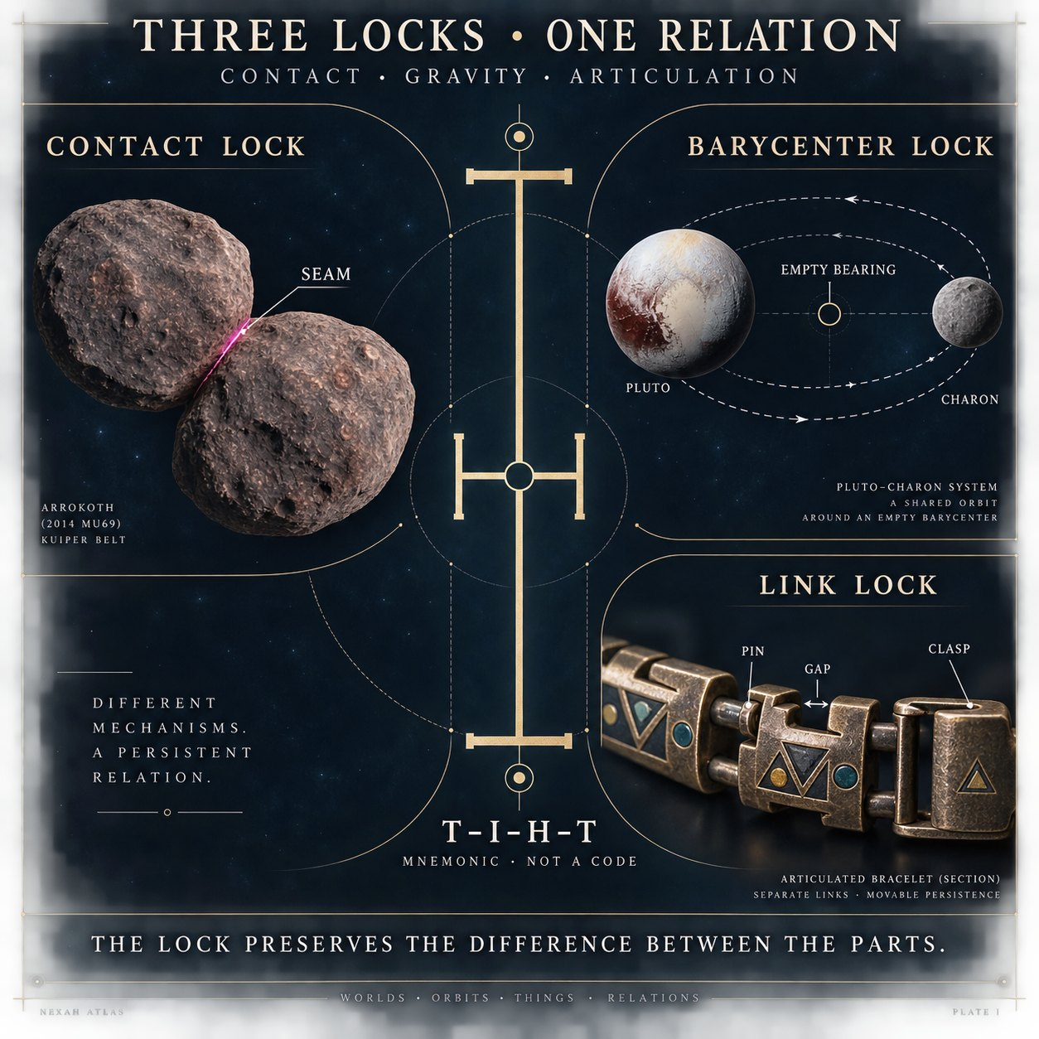
Visual 27. Kontakt-, Baryzentrum- und Gliederverbindung als getrennte Mechanismen.
Source file 30456fe1-4e20-4c4e-ab19-e9f43b256089.png

Visual 28 Historical Mapping Audit
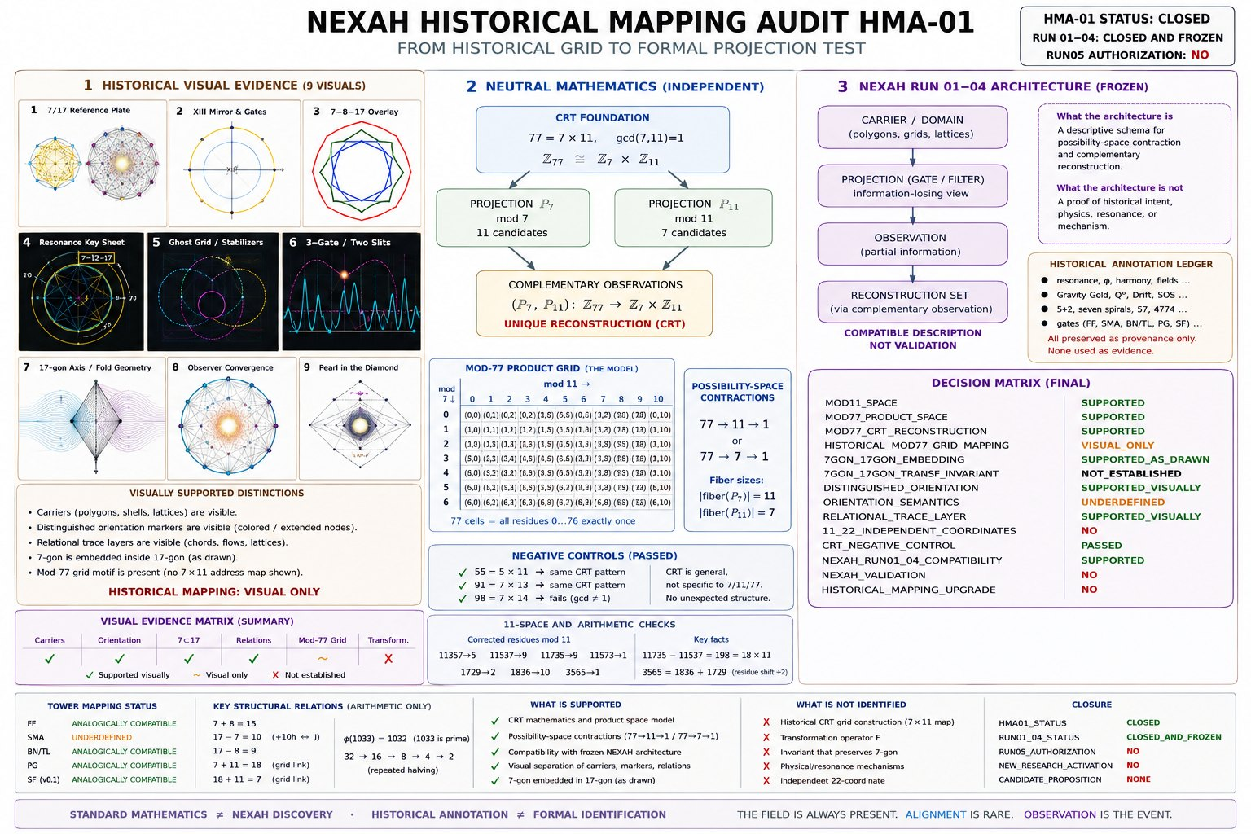
Visual 28. Auditmarker mit klarer Trennung von Standardmathematik, Visual Evidence und formaler Identifikation.
Source file baf24851-19e0-48cb-8688-0a0519458323(5).png

Visual 29 Three Shells of Transformation
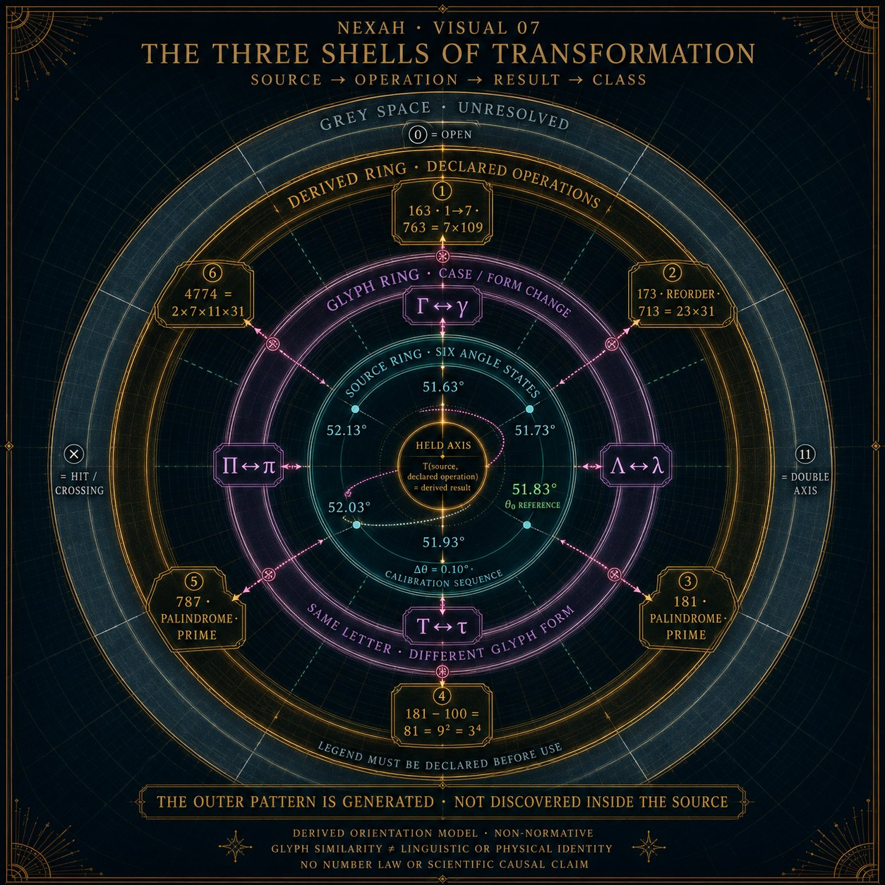
Visual 29. Source, Operation, Result und Class; 4774 als deklarierte Operation.
Source file b3aca977-3ab5-41aa-86df-3c3f2fa7df12(1).png

Visual 30 Resonance Compass 47 74
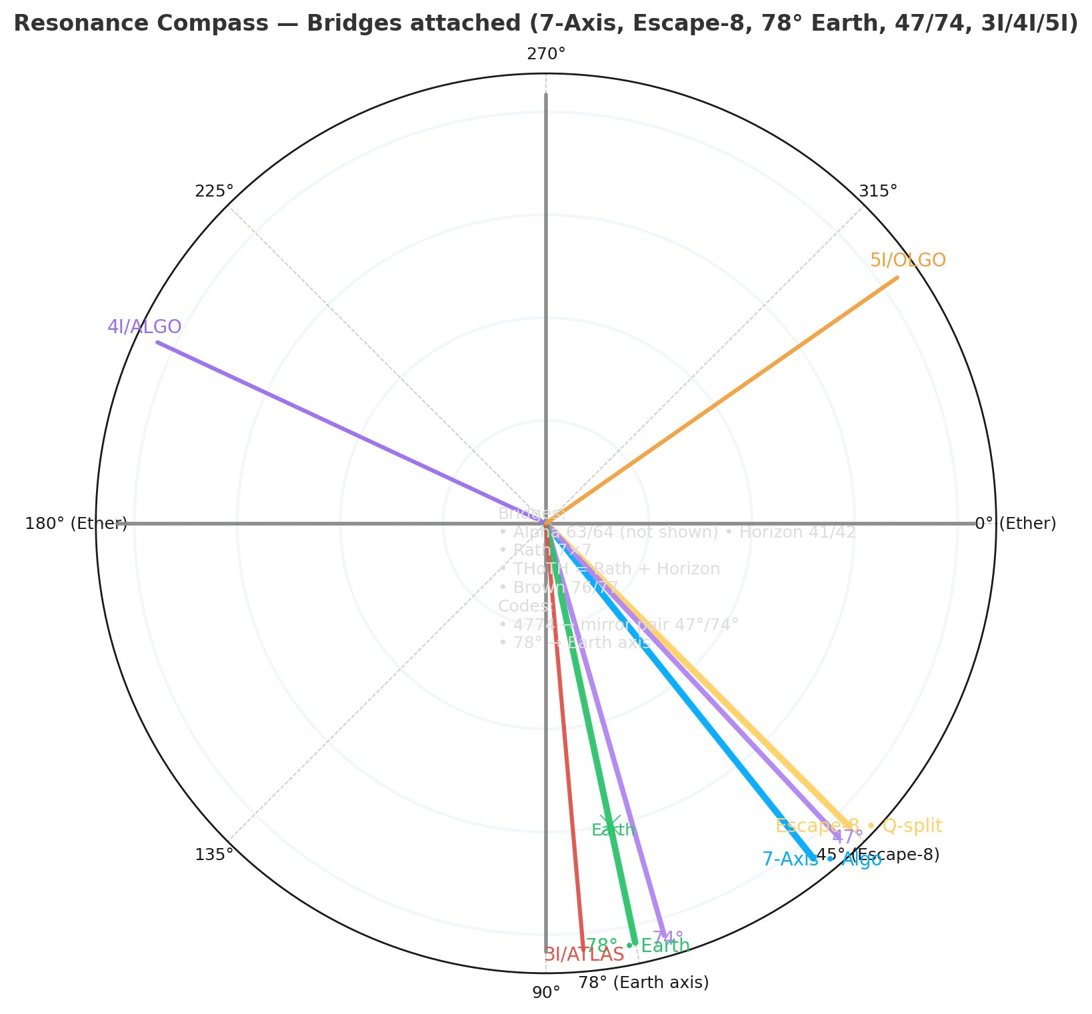
Visual 30. Kompassdarstellung mit deklarierter Spiegeladresse. Winkel sind ohne Referenzrahmen keine Himmelsrichtungen.
Source file Resonance_Compass-Bridges attached 7-Axis, Escape-8 Earth, 47:74.png

Sources
- JPL approximate positions and Keplerian elements
- JPL planetary physical parameters
- JPL Horizons solution for 3I ATLAS
- NASA 3I ATLAS facts and frequently asked questions
- NASA Saturn Janus density wave
- NASA Saturn ring rhythm
- Planetary Data System ring occultations
- NASA Moon facts
- NASA technical report on Schumann resonances

Boundary statement
This report documents an exploratory structural synthesis and a reproducible calculation record. It does not claim that glyphs, names, colors or repeated numerals cause celestial dynamics. It does not identify the solar system with a Mandelbrot set, a biological spine or a fluid tube. Those images remain metaphors unless a separate mathematical model and independent evidence support them.

