Weiwei Su
U17420699
CIS6930 Final Project

WORKFLOW

Updated 4/27/2020 10:12PM
As I might be to late to upload the result (takes time to consolidate) and give a detail analysis to it, I will be generally describe the work flow of my code first.
------------------------------------------------------------------------------------------------

The code is written in C++, the general plan is to convert all the .xlsx files into .csv file then import into the program to pre-process, calculate Spearman then the Z and P Value.
File Structure:
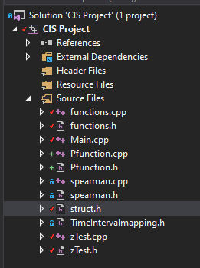
Pfunction.cpp & Pfunction.h: Store the C++ version of Pfunction, used to Calculate P Value.
zTest.cpp & zTest.h: Store the C++ version of MRR-Z Test function, used to Calculate Z Value.
Functions.cpp & functions.h: Store any other general function to process the input query from .csv file.
Spearman.cpp & spearman.h: Store the C++ version of Spearman Correlation Coefficient Formula to calculate spearman coefficient.
TimeIntervalmapping.h: I used this to store the definition of all Time window interval containers used to aid the pre-process.
Struct.h: Some custom structs is used to better help sorting the input data.

A Detail look inside Function.cpp:
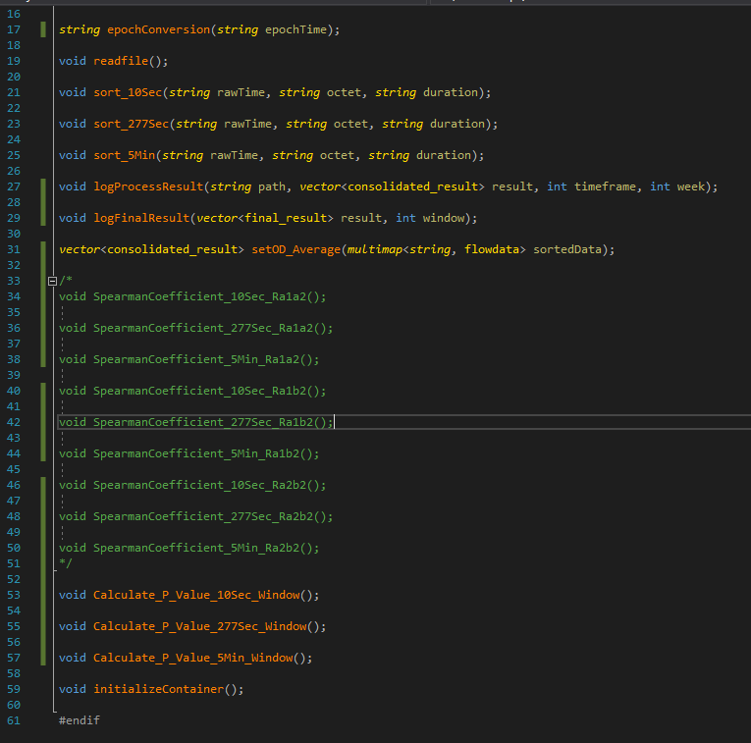
string epochConversion(string epochTime); This function is to convert Epoch time stamp into real time.

void readfile(); Main part of the program. It reads file from the folder (contains all 54 csv files user data) one by one then calling 3 sorting functions below (corresponds to 3 different time window) to sort the data. Once finished, I set to log all the sorted data into new csv for debug purpose.

void sort_10Sec(string rawTime, string octet, string duration); Sorting function for 10 Second Window

void sort_277Sec(string rawTime, string octet, string duration); Sorting function for 277 Seconds Window

void sort_5Min(string rawTime, string octet, string duration); Sorting function for 5 Minutes window

void logProcessResult(string path, vector<consolidated_result> result, int timeframe, int week); The function used to log all the sorted data (prior statistical calculation) The Logs will be stored in preprocessLog Folder. Each file represents the data of one user in Week 1 or Week 2.

void logFinalResult(vector<final_result> result, int window); The function used to log all calculated data including final value.

vector<consolidated_result> setOD_Average(multimap<string, flowdata> sortedData); The function used to calculate Octet/Duration Average for pre-processing stage.

/*
void SpearmanCoefficient_10Sec_Ra1a2();

void SpearmanCoefficient_277Sec_Ra1a2();

void SpearmanCoefficient_5Min_Ra1a2();

void SpearmanCoefficient_10Sec_Ra1b2();

void SpearmanCoefficient_277Sec_Ra1b2();

void SpearmanCoefficient_5Min_Ra1b2();

void SpearmanCoefficient_10Sec_Ra2b2();

void SpearmanCoefficient_277Sec_Ra2b2();

void SpearmanCoefficient_5Min_Ra2b2();
*/ These function I used to test Spearman Coefficient Result, not final work. But it worked flawlessly. The Logs will be stored in spearmanLog Folder. Each file represents one user compared with all other user in One certain condition. Noted the first row is user in week 1 comparing itself in week 2. First 3 Files without any user name contains R1a2a data for all user.

void Calculate_P_Value_10Sec_Window(); This is the main statistical calculation function to calculate Spearman coefficient, Z Value and P Value in one package. The function is specially for 10 Sec Window. Once finished it will log result into FinalResult Folder.

**Update 4/27/2020: As the function is finished for quite sometime, I am still battling with C++ debugging issue. It seems one of the loops is having infinite iteration despite a limiter is in place. But by looking the code as pseudocode the workflow is correct.

void Calculate_P_Value_277Sec_Window(); Same as above

void Calculate_P_Value_5Min_Window(); Same as above

void initializeContainer(); Function used for pre-process to initialize sorting container.

As for Main.cpp Driver code pretty much self explanatory:
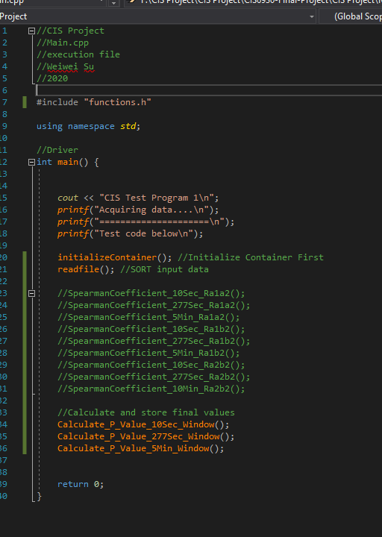
HOW TO RUN:
Run CIS Project.exe
Or
Open the project file by using Visual Studio, then run it in release mode

Note:
Run it in release mode will significantly faster as it contain so much loops and the data and it have nearly On2 of time complexity.

