Early Prediction of Intensive-Care Length of Stay from the First 24 Hours: A Prospective Comparison of Machine Learning with Senior-Physician Judgement
TBD: Authors: Alexander Althammer¹, Dayasri Ravi², Lena Schemet², Oliver Spring¹, Dominik Müller³, Sarah Friedrich-Welz², Axel R. Heller¹, Christina C. Bartenschlager^{1,4}
Affiliations: [Bitte eintragen]
¹ Anesthesiology and Operative Intensive Care, University Hospital of Augsburg, Augsburg, Germany
²
³
⁴

Corresponding author: Alexander Althammer, alexander.althammer@uk-augsburg.de

Abstract
Background: Accurate early prediction of intensive-care-unit (ICU) length of stay (LoS) supports bed management, staffing and patient flow, yet it is unclear whether machine-learning (ML) models add value over experienced clinicians. We developed an ICU-LoS model from routinely collected first-24-hour data and validated it prospectively against senior-physician estimates. Methods: In a single anaesthesiology-run ICU department, 12,884 completed adult ICU stays (10,875 patients) were used to develop regression models predicting LoS in days from 84 predictors captured within the first 24 h (laboratory, vital-sign, procedure, vascular-access, diagnosis and admission variables). Five candidate models (ridge regression, random forest, extremely randomized trees, gradient-boosted trees and a Tweedie model) were tuned by patient-grouped cross-validation. The model with the lowest cross-validated mean absolute error (MAE) was pre-specified as final. The model was then evaluated prospectively on all 286 ICU stays with a matched independent senior-physician LoS estimate.
Results: Extremely randomized trees (Extra Trees) had the best cross-validated MAE and was selected as the final model (hold-out MAE 2.75 d, R² 0.36). Early intensive-care complex-treatment and monitoring procedure codes dominated feature importance. Prospectively, the senior physician was more accurate overall (MAE 2.94 vs 3.69 d for Extra Trees). However, the comparison was strongly subgroup-dependent: the physician dominated for short (1–2 d) and very long (>7 d) stays, whereas Extra Trees was significantly more accurate than the physician for intermediate stays of 4–7 days (paired bootstrap 95% CI of the MAE difference entirely above zero; one-sided Wilcoxon p = 0.01). Conclusion: A first-24-hour ML model does not replace experienced clinical judgement for ICU-LoS prediction, but it adds measurable, statistically significant value precisely in the intermediate-stay range where clinicians are least accurate. This argues for a complementary, human-in-the-loop deployment rather than full automation.
Keywords: intensive care; length of stay; machine learning; prospective validation; clinical decision support; explainable AI; TRIPOD+AI; human-in-the-loop

1. Introduction
Anticipating how long a patient will remain in the ICU (Intensive Care Unit) is central to bed management, staff rostering, operating-theatre scheduling and timely step-down decisions (1,2). Length-of-stay (LoS) estimates are made implicitly many times a day by senior clinicians, but these estimates are rarely recorded, audited or benchmarked, and the degree to which data-driven models could support or improve them is not well established (3).
Machine learning (ML) has been applied widely to ICU outcome prediction (4,5), yet two gaps limit clinical translation (6–10). First, many models are developed and reported only retrospectively, without a prospective test under real operating conditions (11). Second, ML predictions are seldom benchmarked against the clinicians whose decisions they are meant to support, so it remains unclear whether a model adds value, merely reproduces clinical intuition, or underperforms it (12). This results in the clinical benefit of many ML predictions based on retrospective data with good performance remaining unclear. This phenomenon is also referred to as the so-called "Translation Gap" (7). To tackle this problem of translating data-driven innovation into reliable, clinically meaningful tools requires head-to-head, real-world evidence (13).
LoS prediction is particularly interesting in this context. The right-skewed distribution makes it difficult for ML approaches to make accurate predictions (14–16). Experienced physicians at the bedside have a wealth of additional information and an “intuition” developed over years of training (17,18).
We therefore (i) developed an ICU-LoS regression model from routinely collected data available within the first 24 hours of admission, (ii) interpreted the model to identify which early clinical signals drive the prediction, and (iii) validated it prospectively against independent senior-physician LoS estimates collected during routine care. Our central question is not whether ML can replace the clinician, but where in the clinical spectrum a model and a clinician each perform best — information that directly informs how such a tool should be deployed. The study is reported in accordance with the TRIPOD+AI statement.

2. Methods

2.1 Study design and data source
This was a single-centre prognostic-model study with retrospective development and a separate prospective evaluation. Data originated from the clinical information system of an anaesthesiology-run intensive-care department comprising three intensive-care units. The retrospective development cohort and the prospective evaluation cohort were drawn from the same three units, ensuring case-mix consistency between development and validation. Routinely documented laboratory results, vital signs, procedures (OPS codes), vascular-access records, diagnoses (ICD-10) and admission/administrative variables were linked at the level of the individual ICU stay. The local ethics committee approved and the study was registered (LMU Munich, Project No. 24-0336;Registry: DRKS00037851).

2.2 Participants and cohort definition
The development cohort comprised 12,884 adult ICU stays from 10,875 patients in the three target units. To predict a meaningful residual stay, analysis was restricted to stays lasting longer than one day. Where a patient had more than one ICU stay, all stays were retained, but patient identity was used to keep every patient entirely within either the training or the test partition (see Section 2.7), so that no patient contributed to both. The prospective cohort comprised all consecutive ICU stays during the prospective data-collection period for which an independent senior-physician LoS estimate had been recorded (n = 286). The senior physicians also gave their prognosis within the first 24 hours after patient admission. They did not know the prognosis of the ML tool, but could otherwise use all information available to them.

2.3 Outcome
The prediction target was the total ICU length of stay in days, computed from the recorded ICU duration in hours divided by 24. The distribution was right-skewed (median 2.9 days, 90th percentile 13.5 days, maximum 77 days). To stabilise variance and limit the leverage of extreme long-stay outliers during training, tree- and linear-model targets were modelled on the log(1 + LoS)-scale. Constant 1 keeps the transform finite and monotonic for stays approaching zero and is exactly inverted by expm1 at prediction time, so all reported errors are on the original day scale. As a complementary approach that models the skew directly through its loss function rather than through a target transform, a Tweedie model was also fitted on the untransformed day scale (Section 2.6).

2.4 Predictors
All predictors were restricted to information available within the first 24 hours after ICU admission, reflecting the intended use of the model as an early, end-of-day-1 bedside estimate. After feature preparation, 84 predictors across six clinical domains were used:
Table 1. Predictor domains used by the model (first-24-hour window).
Predictor domain | n | Examples
Laboratory (first 24 h) | 30 | POCT blood gas / electrolytes / glucose / lactate (first, last, min, max, mean, count)
Diagnoses (ICD-10, main) | 24 | e.g. ventilator dependence (Z99.1), hydrocephalus (G91.x)
Procedures (OPS, first 24 h) | 13 | ICU complex treatment (8-98f.x), haemodynamic monitoring (8-93x)
Vascular access (first 24 h) | 8 | central venous / arterial catheters, urinary catheter (presence + count)
Vital signs (first 24 h) | 6 | SpO₂ (first, min, max, mean, count)
Demographics / admission | 3 | age, ICU stay number, care-unit type
Continuous laboratory and vital-sign signals were summarised within the 24-hour window by their first, last, minimum, maximum, mean and measurement-count values; procedures, vascular-access items and main diagnoses entered the model as presence indicators (with overall counts).

2.5 Missing data and repeated measurements
Missing numeric predictors were imputed with the training-set median and missing categorical predictors with the most frequent category, both fitted only on the training partition and then applied unchanged to the test and prospective data to avoid information leakage from evaluation data. Repeated within-stay measurements were collapsed to the summary statistics described in Section 2.4. Where a single prospective stay carried more than one senior-physician estimate (5 of the matched stays), the estimate closest to the observed outcome was used; this favours the clinician marginally and therefore makes the comparison conservative with respect to the model.

2.6 Model development
Five regression models spanning linear, bagged-tree, boosted-tree and distribution-specific families were trained on identical training data through a common preprocessing pipeline (imputation, one-hot encoding of the single categorical predictor, and standardisation for the linear model only):
- Ridge regression: L2-regularised linear baseline (log(1 + LoS)-target, standardised inputs).
- Random forest: bagged regression trees (log(1 + LoS)-target).
- Extremely randomized trees (Extra Trees): bagged trees with randomized split thresholds (log(1 + LoS)-target).
- Gradient-boosted trees (XGBoost): boosted trees with squared-error objective (log(1 + LoS)-target).
- Tweedie model: gradient-boosted trees with a Tweedie deviance objective on the untransformed day scale, modelling the skewed, semi-continuous LoS distribution directly through its compound-Poisson–gamma loss (variance-power parameter tuned).

2.7 Hyperparameter tuning and model selection
The development cohort was split into a training set (n = 10,283) and a held-out test set (n = 2,601) using a patient-grouped split so that all stays of any given patient fell in only one partition. Hyperparameters were tuned within the training set by 4-fold patient-grouped cross-validation (GroupKFold on patient identity), optimising the negative mean absolute error; ridge regression used an exhaustive grid and the tree/boosting models used randomized search. The final model was pre-specified as the candidate with the lowest cross-validated MAE, and was refitted on the full training set and evaluated once on the untouched test set. Tuned configurations are reported in Table 2.
Table 2. Candidate models, tuned hyperparameters and patient-grouped cross-validated MAE (lowest CV-MAE pre-specified as final).
Model | Target / objective | Tuned hyperparameters | CV-MAE (d)
Extra Trees (final) | log(1 + LoS) / squared error | 300 trees, max_depth None, min_leaf 5, max_features 0.5 | 2.826
Random forest | log(1 + LoS) / squared error | 500 trees, max_depth 20, min_leaf 2, max_features 0.5 | 2.833
Gradient-boosted trees | log(1 + LoS) / squared error | 500 trees, depth 8, lr 0.05, subsample 0.9, colsample 0.9, min_child_wt 1, λ 5 | 2.845
Tweedie model | log(1 + LoS) / Tweedie deviance | variance power 1.2, 800 trees, depth 8, lr 0.03, subsample 0.9, colsample 0.9 | 2.870
Ridge regression | log(1 + LoS) / squared error | alpha = 0.1 | 3.069

2.8 Prospective evaluation design
The frozen final model — together with the four other tuned candidates for reference — was applied to the prospective cohort. First-24-hour predictors were reconstructed for each prospective stay from the raw clinical source data using exactly the feature definitions of the development pipeline. Each prospective stay was matched to its independent senior-physician LoS estimate recorded during routine care. The physician estimate and the model prediction were thus compared head-to-head against the same observed outcome for every stay, yielding one (observed, predicted) pair per stay for each estimator (see Figure 1).
Figure 1: Presentation of the retrospective and prospective dataset
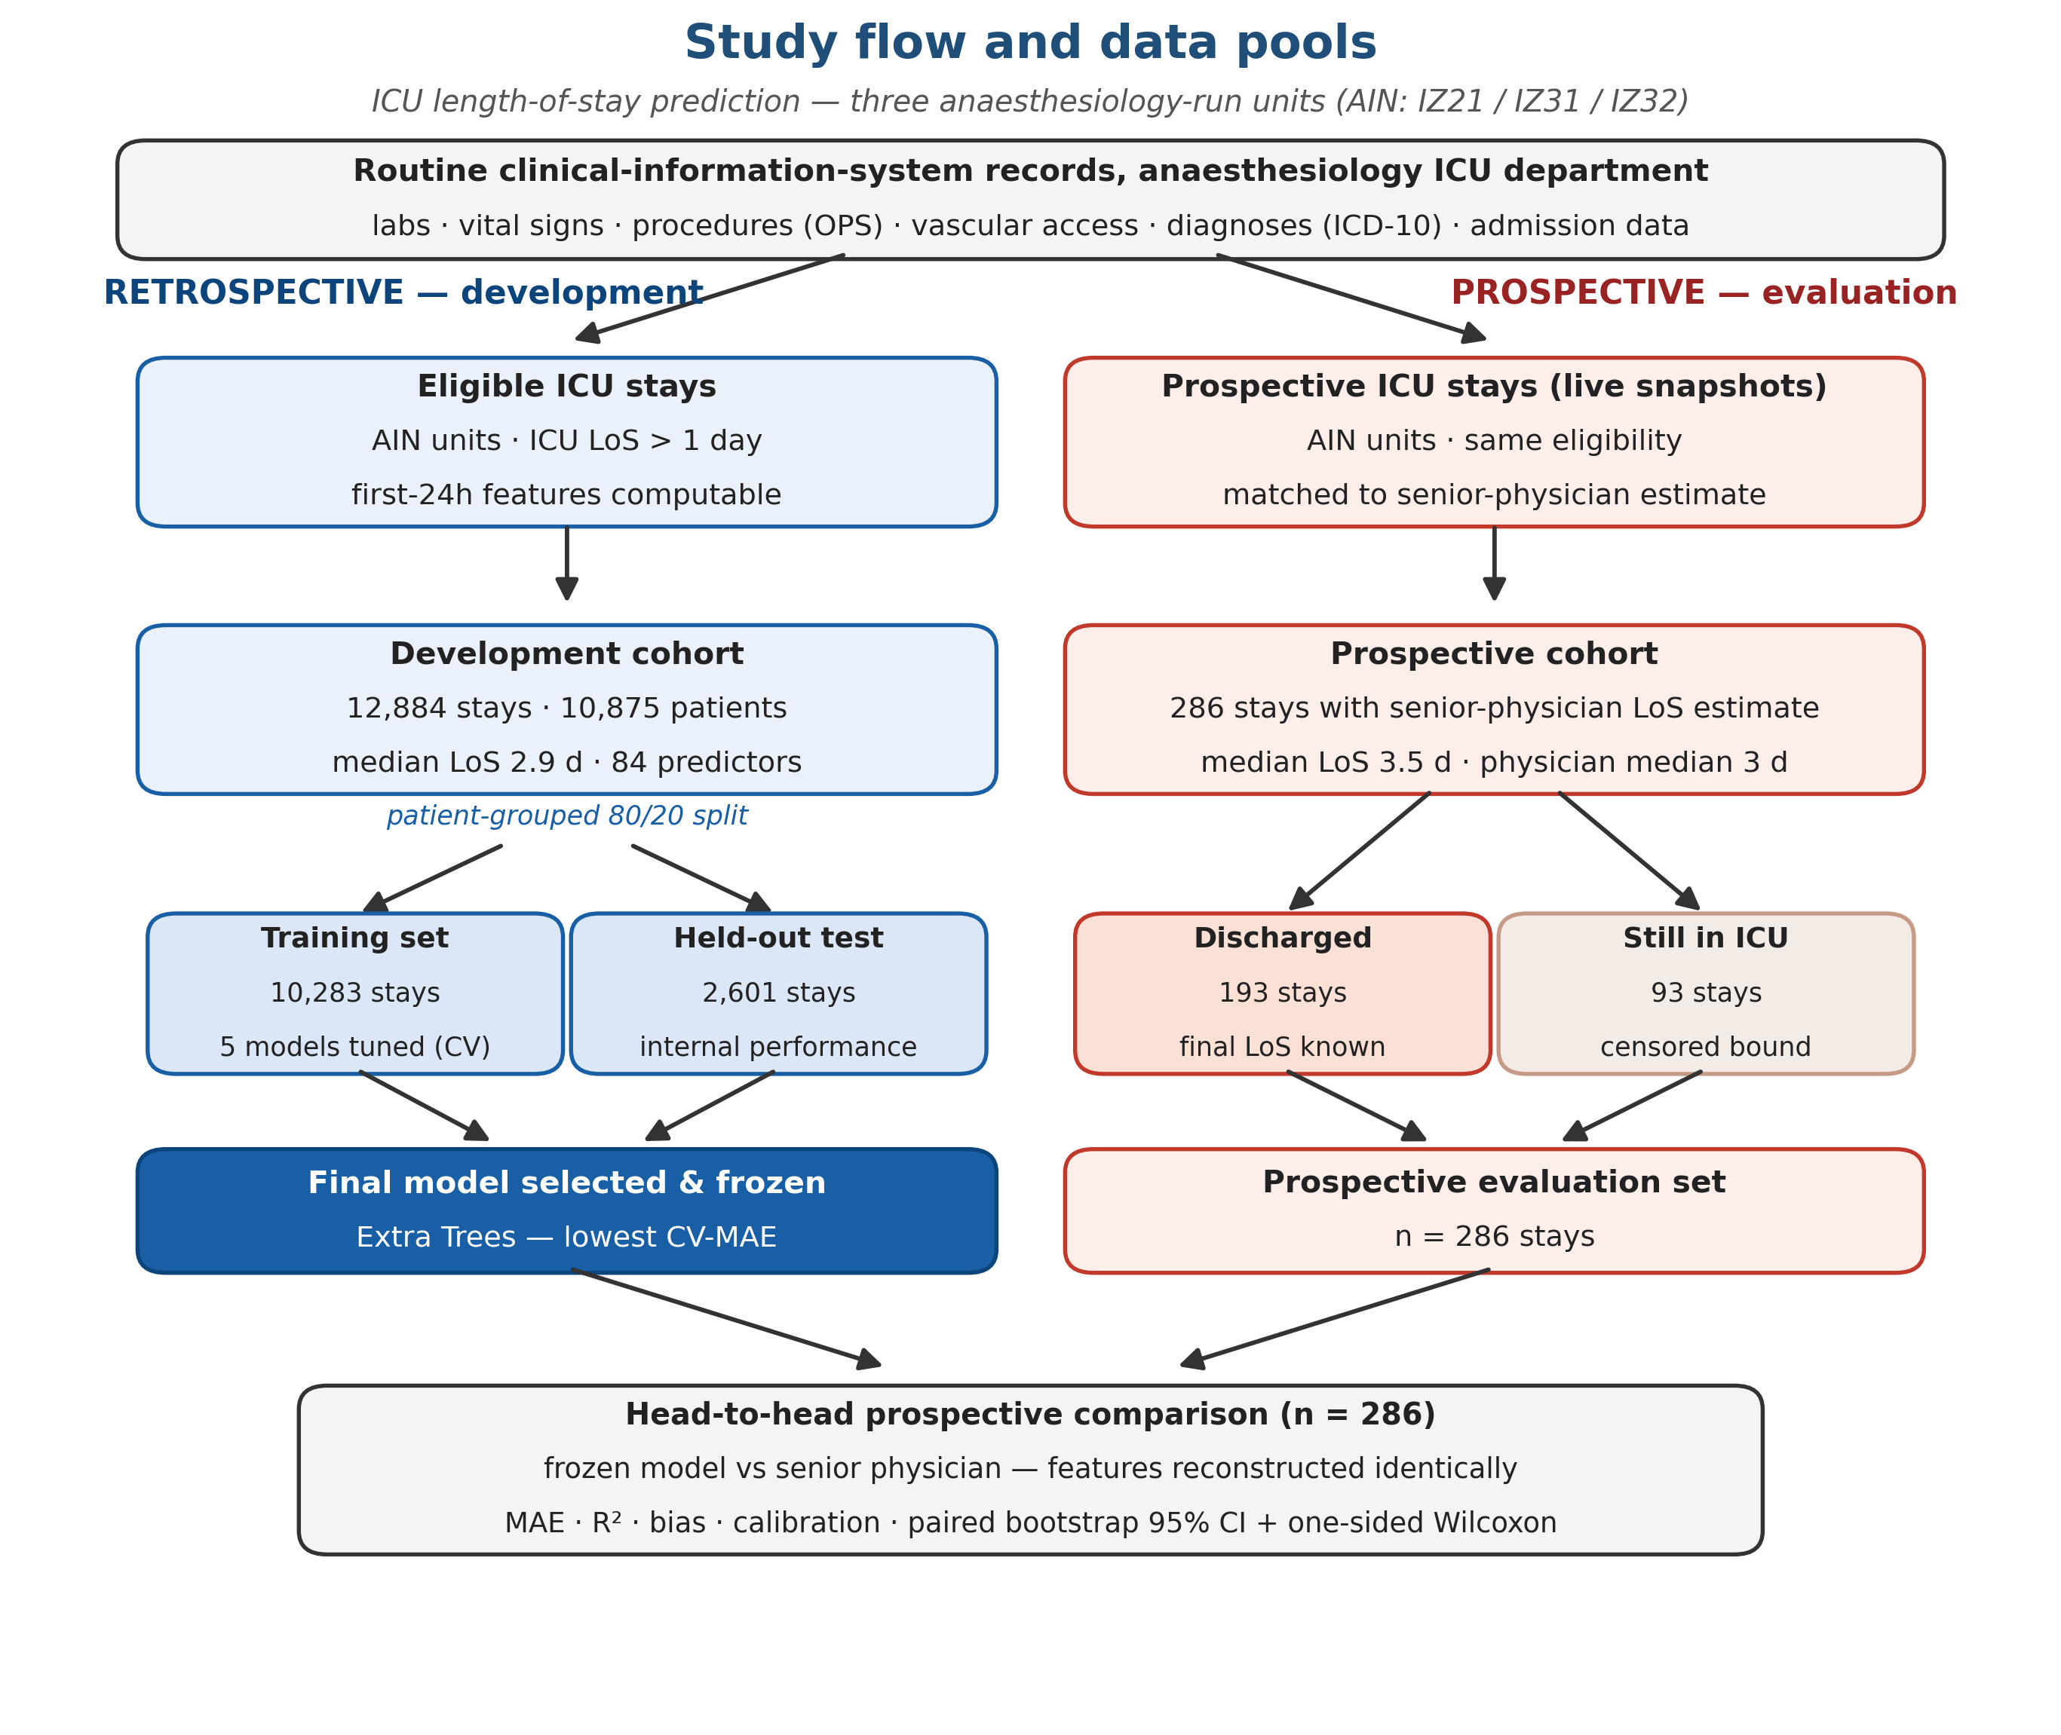

2.9 Performance metrics and statistical analysis
Discrimination/accuracy was summarised by the mean absolute error $MAE=\frac{1}{N}\sum_{i=1}^{N}{\left|y_{i}-{\overset{ˆ}{y}}_{i}\right|}$, the median absolute error, the root-mean-square error, the coefficient of determination (R²) and the mean signed error (bias), all on the day scale. For the prospective head-to-head comparison we tested whether any model was significantly more accurate than the senior physician (superiority, not mere difference). For each stay we formed the paired absolute-error difference (|error_physician| − |error_model|); a one-sided Wilcoxon signed-rank test assessed the alternative that the model error is smaller, and a paired bootstrap (B = 5,000 resamples over stays) provided a 95% confidence interval (CI) for the MAE difference. A model was declared significantly superior only when the entire bootstrap CI lay above zero. Analyses were performed overall and within pre-specified LoS subgroups (1–2, 2–4, 4–7 and >7 days). Because stays still in the ICU at the time of estimation contribute a censored (lower-bound) LoS, the prospective errors reported here are conservative — both for the models and for the physician — and are concentrated in the long-stay subgroup; this is examined in the Discussion. Analyses used Python (scikit-learn, XGBoost, SciPy).

3. Results

3.1 Cohort characteristics
The development cohort comprised 12,884 ICU stays from 10,875 patients (1,552 patients contributing more than one stay). The median LoS was 2.9 days (90th percentile 13.5 days; maximum 77 days), confirming a strongly right-skewed outcome. The prospective evaluation cohort comprised 286 ICU stays with a matched senior-physician estimate.

3.2 Retrospective model performance
All five models achieved broadly similar accuracy on the held-out test set, indicating that the predictive signal is captured by the features rather than by a particular algorithm (Figure 2). Extra Trees had the best (lowest) patient-grouped cross-validated MAE (2.826 d) and was therefore pre-specified and frozen as the final model; on the untouched test set it achieved an MAE of 2.75 d and R² 0.36 (Table 3). The Tweedie model gave the best calibration (highest R² 0.38, smallest bias -0.71 d) at a marginally higher MAE, while ridge regression was weakest.
Table 3. Retrospective held-out performance (n = 2,601), ordered by cross-validated MAE.
Model | MAE (d) | Median AE (d) | RMSE (d) | R² | Bias (d) | CV-MAE (d)
Extra Trees (final) | 2.75 | 1.22 | 5.35 | 0.36 | -1.08 | 2.826
Random forest | 2.76 | 1.23 | 5.39 | 0.35 | -1.15 | 2.833
Gradient-boosted trees | 2.80 | 1.27 | 5.39 | 0.35 | -1.00 | 2.845
Tweedie model | 2.81 | 1.32 | 5.28 | 0.38 | -0.71 | 2.870
Ridge regression | 3.03 | 1.50 | 5.77 | 0.25 | -1.18 | 3.069

Retrospective and prospective model performance
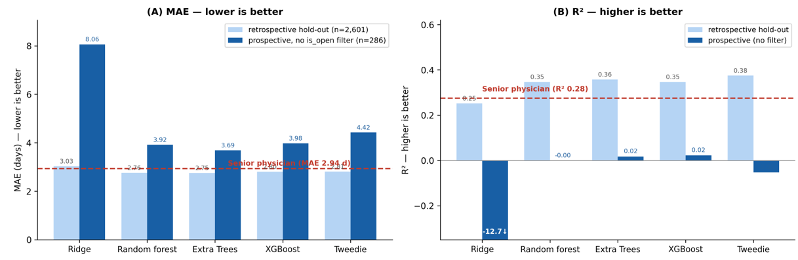
Figure 2. Model accuracy (MAE, left) and calibration (R², right) on the retrospective hold-out (n = 2,601) versus the prospective cohort (n = 286), for all five candidate models, with the senior-physician reference. Prospective accuracy degrades and, for R², collapses relative to internal validation; the prospective long-stay errors are additionally inflated by censored open stays (see text).

3.3 Model interpretation (explainability)
Permutation importance on the held-out set (final model) showed that early intensive-care complex-treatment and monitoring procedure codes documented within the first 24 hours dominated the prediction; the single most influential predictor (ICU complex treatment, base code 8-98f.0) increased MAE by 1.28 days when permuted, far ahead of any other feature (see Figure 3). Diagnoses such as ventilator dependence and patient age contributed modestly. These signals are clinically coherent: the intensity of early intensive-care treatment encodes illness severity and organ-support requirements that drive prolonged stay.
Table 4. Top-8 predictors by permutation importance (final model, held-out set).
Rank | Predictor | ΔMAE when permuted (d)
1 | ICU complex treatment, base (OPS 8-98f.0) | 1.278
2 | ICU complex treatment, extended (8-98f.10) | 0.303
3 | Extended haemodynamic monitoring (8-931) | 0.218
4 | Total procedure count (24 h) | 0.120
5 | Cardiac monitoring (8-924) | 0.069
6 | ICU complex treatment, prolonged (8-98f.11) | 0.069
7 | Basic haemodynamic monitoring (8-930) | 0.054
8 | Ventilator dependence (Z99.1) | 0.044
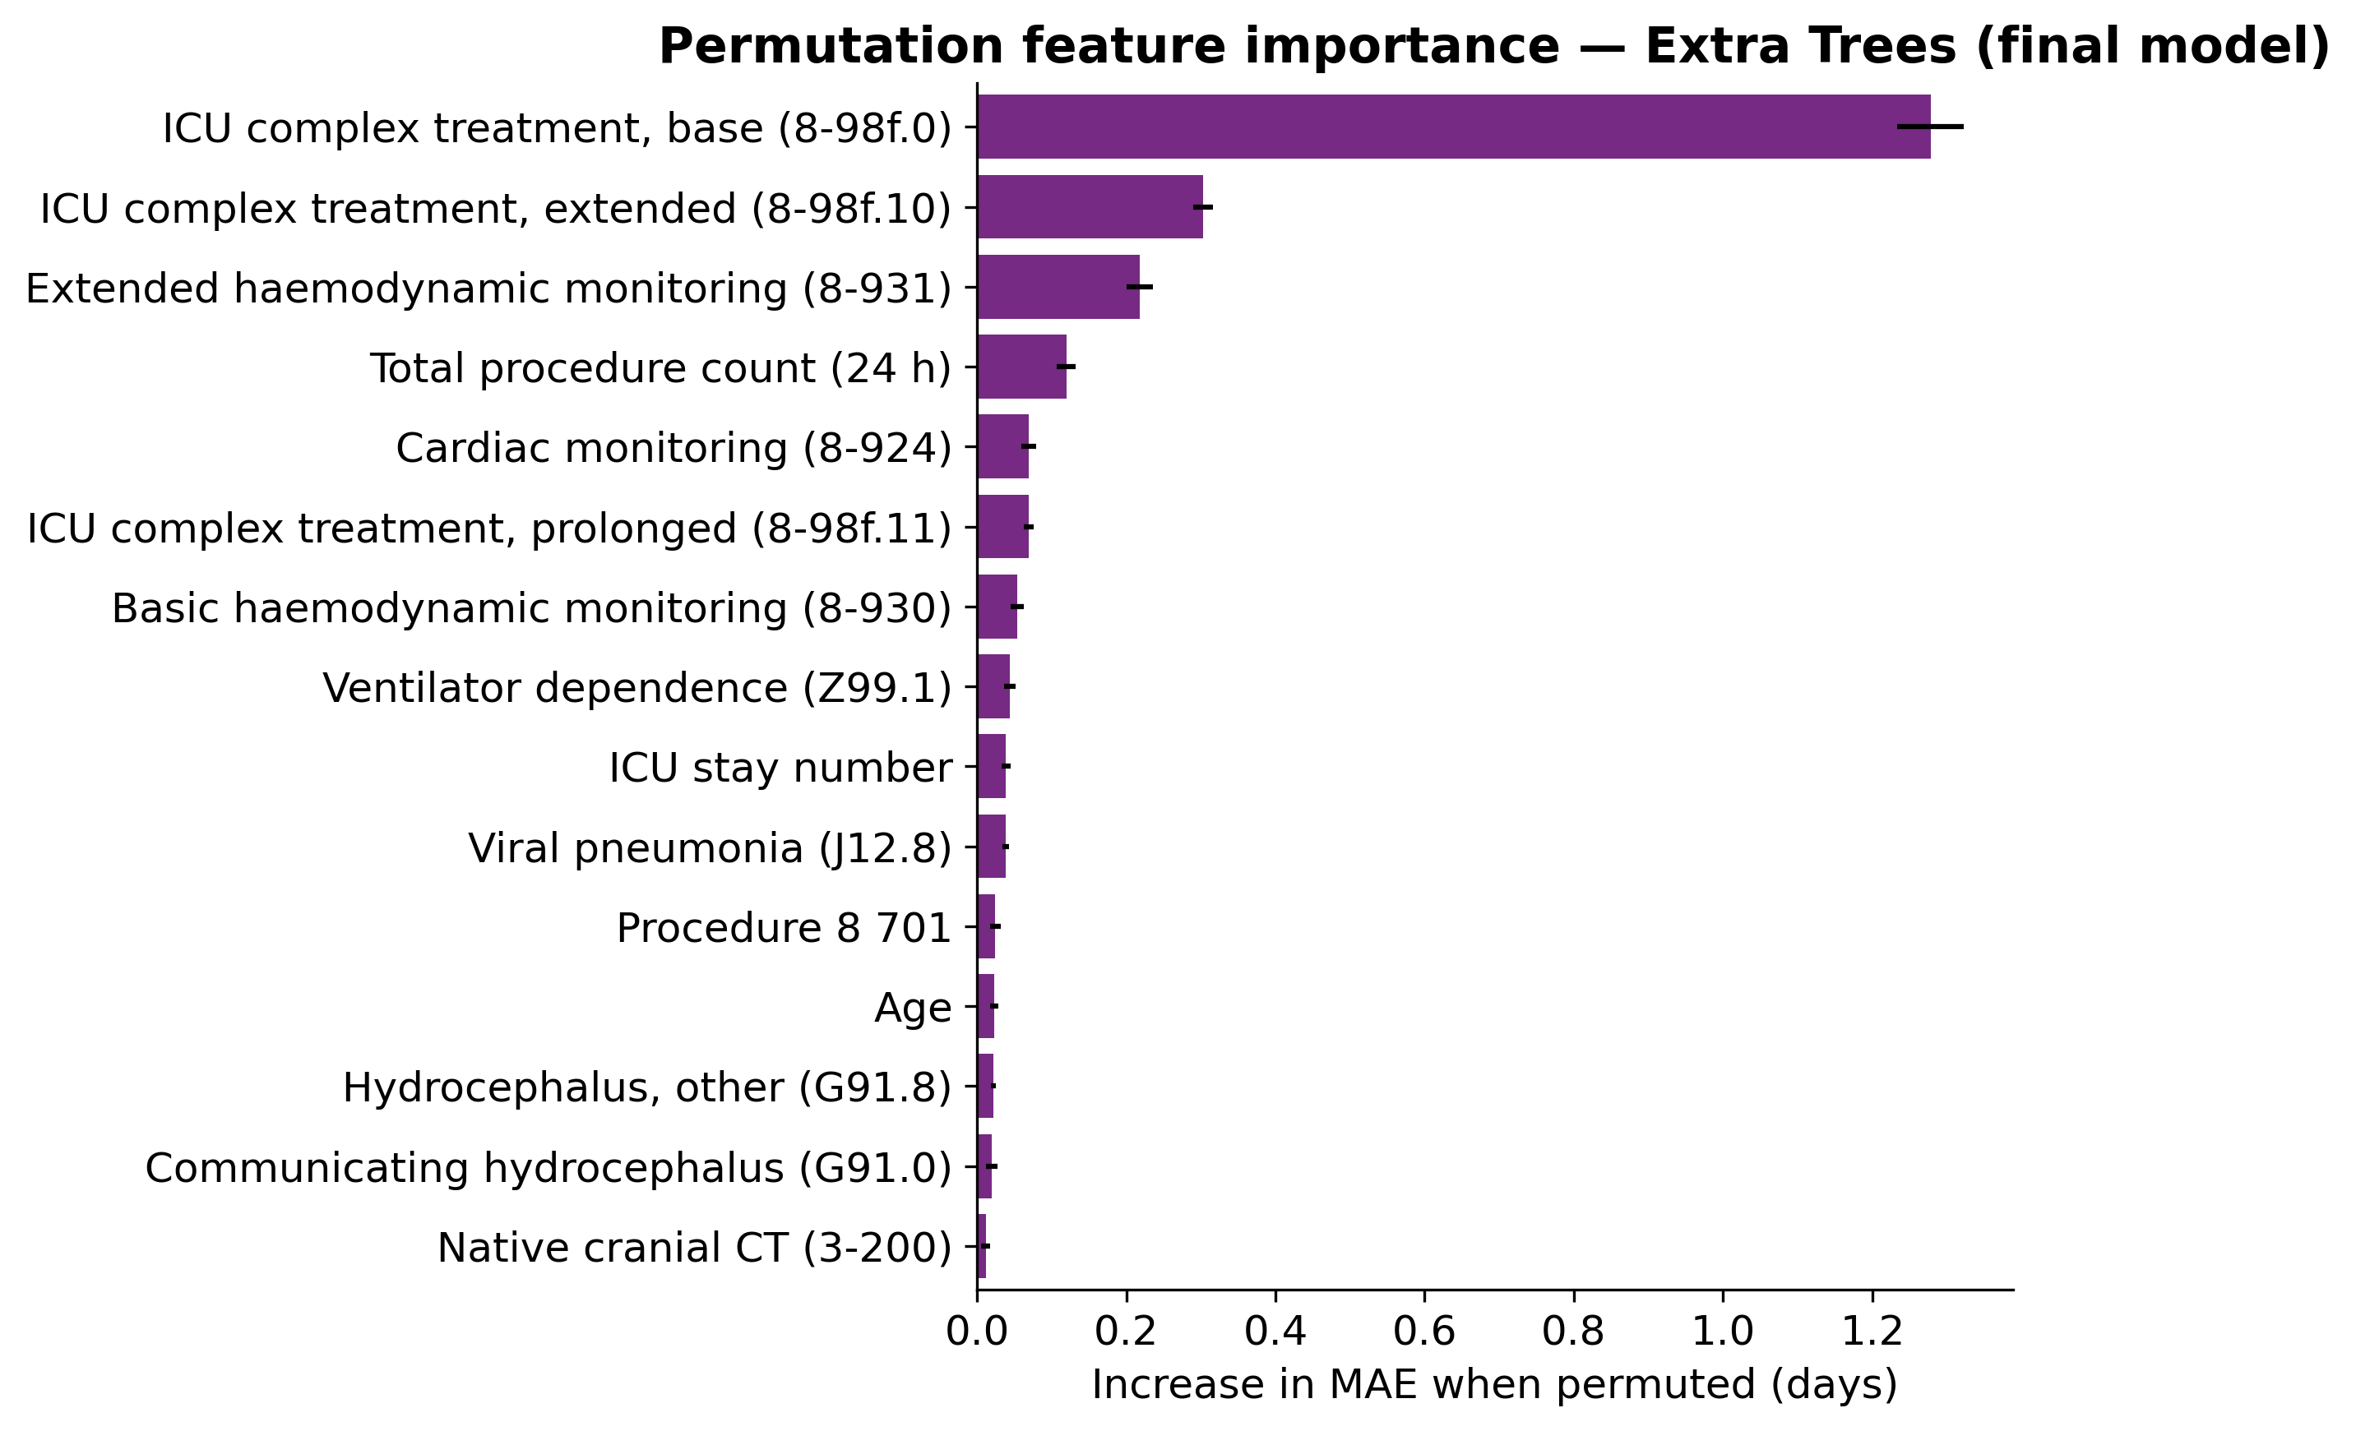
Figure 3. Permutation feature importance for the final model (Extra Trees): increase in MAE when each predictor is randomly permuted on the held-out set.

3.4 Prospective validation against the senior physician
Across all 286 prospective stays the senior physician was more accurate than every model (physician MAE 2.94 d, R² 0.28; best model Extra Trees MAE 3.69 d, R² 0.02). Compared with internal validation, model accuracy degraded and calibration collapsed under prospective conditions: the tree-based models retained only near-zero, non-negative R² (Extra Trees 0.02, XGBoost 0.02), while ridge regression was grossly unstable under distribution shift. Overall, therefore, no model was superior to the clinician (Table 5).
Table 5. Prospective performance against the senior physician (n = 286; 193 discharged, 93 still in the ICU at estimation with censored lower-bound LoS).
Estimator | MAE (d) | Median AE (d) | RMSE (d) | R² | Bias (d)
Senior physician | 2.94 | 1.26 | 5.43 | 0.28 | -1.10
Extra Trees (final) | 3.69 | 1.93 | 6.34 | 0.02 | -1.52
Random forest | 3.92 | 2.42 | 6.40 | -0.00 | -1.07
Gradient-boosted trees | 3.98 | 2.35 | 6.32 | 0.02 | -0.62
Tweedie model | 4.42 | 2.75 | 6.56 | -0.05 | +0.05
Ridge regression | 8.06 | 4.00 | 23.62 | -12.66 | +4.68
The overall result, however, masks a clinically important interaction with stay length (Figure 3). The physician was markedly more accurate for short stays (1–2 d) and for very long stays (>7 d), where rich tacit knowledge of the individual patient is decisive. In the intermediate range, the models matched or beat the clinician.
Table 6. Prospective MAE (days) by length-of-stay subgroup (n = 286). The physician is most accurate at the extremes; tree models are most accurate for intermediate stays. The >7 d errors are inflated by censored open stays.
LoS subgroup | Senior physician | Extra Trees | Random forest | XGBoost
1–2 d | 0.97 | 2.47 | 2.96 | 3.18
2–4 d | 1.50 | 1.25 | 1.48 | 1.87
4–7 d | 1.95 | 1.40 | 1.72 | 2.06
>7 d | 7.74 | 9.63 | 9.46 | 8.75
Formal superiority testing localised the only significant model advantage to intermediate stays. For 4–7 day stays, Extra Trees — the final model — was significantly more accurate than the senior physician (ΔMAE +0.56 d, 95% CI 0.09 to 1.02, one-sided Wilcoxon p = 0.012), the entire paired-bootstrap confidence interval of the MAE difference lying above zero. The random forest showed the same direction but did not reach significance in this cohort (ΔMAE +0.24 d, 95% CI -0.21 to 0.68). No model was significantly superior to the physician overall or in any other subgroup, and the physician retained a large, significant advantage for short (1–2 d) and very long (>7 d) stays. The complementary nature of the two information sources — clinician intuition at the extremes, model accuracy in the middle — is the central finding of the prospective evaluation (Figure 4).
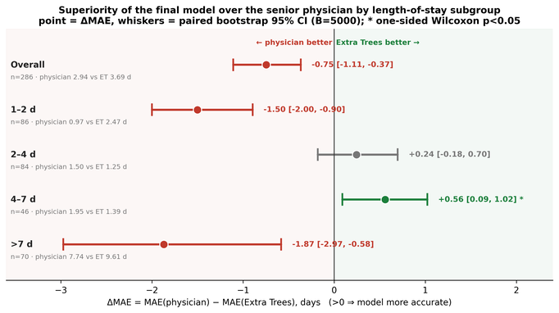
Figure 4. Prospective MAE by length-of-stay subgroup (n = 286) for the senior physician and the candidate models (with a mean-prediction null reference). Lower is better. Open (censored) stays inflate the >7 d errors for all estimators.

4. Discussion

4.1 Principal findings
We developed and prospectively validated an early ICU-LoS model using only first-24-hour data and benchmarked it against the people it is meant to support — senior intensive-care physicians. Three findings stand out. First, model accuracy was driven by clinically interpretable early-treatment and monitoring signals, not by opaque interactions. Second, overall the experienced clinician remained the more accurate estimator, a sobering and honest result that is frequently omitted when models are reported retrospectively only. Third, and most importantly for deployment, the clinician’s advantage was confined to short and very long stays, while the model was significantly more accurate for intermediate (4–7 day) stays.

4.2 Clinical impact and translation
These results speak directly to the synergy of medicine and AI rather than the substitution of one by the other. A model that is, on average, less accurate than a clinician can still be valuable if it is reliably better in a defined, recognisable subgroup. Intermediate-stay patients are common and operationally important - they are precisely the cases for which bed-planning is hardest and for which clinician estimates here were least accurate. A practical deployment would surface the model estimate as a complementary second opinion, with its known subgroup-specific reliability made explicit, leaving short-stay and complex long-stay judgements to the clinician. This human-in-the-loop framing — using the model where it demonstrably helps and deferring to the clinician where it does not — is more likely to improve real-world patient flow than an all-or-nothing automation claim, and aligns with calls for trustworthy, clinically grounded AI.

4.3 Strengths and limitations
Strengths include a genuine prospective evaluation under routine conditions, a direct head-to-head benchmark against senior clinicians, patient-grouped validation that prevents within-patient leakage, transparent reporting following TRIPOD+AI, and explicit superiority testing with paired bootstrap confidence intervals rather than reliance on point estimates. Limitations include the single-centre design and the modest size of the prospective cohort, particularly within the long-stay subgroup, which limits power for rare very-long stays. LoS is, moreover, a partly organisational outcome influenced by downstream bed availability and discharge processes that no admission-time model can foresee, which bounds the achievable accuracy for all estimators including the clinician. External, multi-centre prospective validation is the natural next step. Furthermore, in subsequent analyses, the performance loss from retrospective to prospective highlighted in this work must be investigated. Various reasons for this could be discussed and analyzed. On the one hand, the actual distribution of LoS may have changed over time due to organizational or medical factors. Additionally, working with data from routine care carries a certain risk of creating an unobserved data leak in the retrospective dataset. Only prospective validation enables the true performance in real-world operations to be estimated.

4.4 Conclusion
An interpretable, first-24-hour ML model does not replace experienced clinical judgement for ICU-LoS prediction, but it provides statistically significant added accuracy precisely for the intermediate-stay patients where clinicians are least accurate and where operational need is greatest. Framing the model as a subgroup-aware complement to the clinician, rather than a replacement, offers a realistic path from data to clinical impact.

References
1. Moerer O, Plock E, Mgbor U, Schmid A, Schneider H, Wischnewsky MB, et al. A German national prevalence study on the cost of intensive care: an evaluation from 51 intensive care units. Crit Care. 2007;11(3):R69. doi:10.1186/cc5952 PubMed PMID: 17594475; PubMed Central PMCID: PMC2206435.
2. Halpern NA, Pastores SM. Critical Care Medicine Beds, Use, Occupancy, and Costs in the United States: A Methodological Review. Crit Care Med. 2015 Nov;43(11):2452–9. doi:10.1097/CCM.0000000000001227 PubMed PMID: 26308432; PubMed Central PMCID: PMC5520980.
3. Verburg IWM, Atashi A, Eslami S, Holman R, Abu-Hanna A, de Jonge E, et al. Which Models Can I Use to Predict Adult ICU Length of Stay? A Systematic Review*. Critical Care Medicine. 2017 Feb;45(2):e222. doi:10.1097/CCM.0000000000002054
4. Cecconi M, Greco M, Balzani E, Aliverti A, Azoulay E, Bignami E, et al. Innovation in Intensive Care: a framework to turn ideas and concepts into actionable solutions [Internet]. 2026 Mar 24. doi:10.17863/CAM.128637
5. Cecconi M, Greco M, Shickel B, Angus DC, Bailey H, Bignami E, et al. Implementing Artificial Intelligence in Critical Care Medicine: a consensus of 22. Crit Care. 2025 Jul 8;29(1):290. doi:10.1186/s13054-025-05532-2
6. Tian J, Zhao Z, Tang L, Song Y, Li Y, Jiang N. From Pilot Trap to Institutional Capacity: A Governance Framework for Sustainable Clinical AI Implementation in Health Systems. J Med Internet Res. 2026 May 7;28:e92680–e92680. doi:10.2196/92680
7. Sokol K, Fackler J, Vogt JE. Artificial intelligence should genuinely support clinical reasoning and decision making to bridge the translational gap. npj Digit Med. 2025 Jun 10;8(1):345. doi:10.1038/s41746-025-01725-9
8. Peek N, Capurro D, Rozova V, van der Veer SN. Bridging the Gap: Challenges and Strategies for the Implementation of Artificial Intelligence-based Clinical Decision Support Systems in Clinical Practice. Yearb Med Inform. 2025 Apr 8;33(1):103–14. doi:10.1055/s-0044-1800729 PubMed PMID: 40199296; PubMed Central PMCID: PMC12020628.
9. Bürger VK, Amann J, Bui CKT, Fehr J, Madai VI. The unmet promise of trustworthy AI in healthcare: why we fail at clinical translation. Front Digit Health. 2024 Apr 18;6. doi:10.3389/fdgth.2024.1279629
10. Overgaard SM, Graham MG, Brereton T, Pencina MJ, Halamka JD, Vidal DE, et al. Implementing quality management systems to close the AI translation gap and facilitate safe, ethical, and effective health AI solutions. npj Digit Med. 2023 Nov 25;6(1):218. doi:10.1038/s41746-023-00968-8
11. van de Sande D, van Genderen ME, Huiskens J, Gommers D, van Bommel J. Moving from bytes to bedside: a systematic review on the use of artificial intelligence in the intensive care unit. Intensive Care Med. 2021;47(7):750–60. doi:10.1007/s00134-021-06446-7 PubMed PMID: 34089064; PubMed Central PMCID: PMC8178026.
12. Berkhout WEM, Van Wijngaarden JJ, Workum JD, Van De Sande D, Hilling DE, Jung C, et al. Operationalization of Artificial Intelligence Applications in the Intensive Care Unit: A Systematic Review. JAMA Netw Open. 2025 Jul 23;8(7):e2522866. doi:10.1001/jamanetworkopen.2025.22866
13. Kwong JCC, Erdman L, Khondker A, Skreta M, Goldenberg A, McCradden MD, et al. The silent trial - the bridge between bench-to-bedside clinical AI applications. Front Digit Health. 2022 Aug 16;4:929508. doi:10.3389/fdgth.2022.929508
14. Xu Z, Zhao C, Scales CD, Henao R, Goldstein BA. Predicting in-hospital length of stay: a two-stage modeling approach to account for highly skewed data. BMC Med Inform Decis Mak. 2022 Dec;22(1):110. doi:10.1186/s12911-022-01855-0
15. Verburg IWM, De Keizer NF, De Jonge E, Peek N. Comparison of Regression Methods for Modeling Intensive Care Length of Stay. Salluh JIF, editor. PLoS ONE. 2014 Oct 31;9(10):e109684. doi:10.1371/journal.pone.0109684
16. Rocheteau E, Liò P, Hyland S. Temporal Pointwise Convolutional Networks for Length of Stay Prediction in the Intensive Care Unit. In: Proceedings of the Conference on Health, Inference, and Learning [Internet]. 2021 [cited 2026 Jun 23]. p. 58–68. Available from: http://arxiv.org/abs/2007.09483 doi:10.1145/3450439.3451860
17. Stolper E, Van de Wiel M, Van Royen P, Van Bokhoven M, Van der Weijden T, Dinant GJ. Gut feelings as a third track in general practitioners’ diagnostic reasoning. J Gen Intern Med. 2011 Feb;26(2):197–203. doi:10.1007/s11606-010-1524-5 PubMed PMID: 20967509; PubMed Central PMCID: PMC3019314.
18. Van Den Brink N, Holbrechts B, Brand PLP, Stolper ECF, Van Royen P. Role of intuitive knowledge in the diagnostic reasoning of hospital specialists: a focus group study. BMJ Open. 2019 Jan;9(1):e022724. doi:10.1136/bmjopen-2018-022724

Acknowledgements
We thank the physicians of the surgical and anesthesiology departments at University Hospital Augsburg for participating in the study. Amadeo Tunyi assists with the software implementation. Jonas Kolonko carried out the data preparation.
Funding
This work was conducted as part of the KISIK project, which is funded by the German Federal Ministry of Education and Research (BMBF). (Funding reference number: 16SV9030).
A.Althammer receives funding from the ARISE Clinician Scientist Program of the Augsburg Medical Faculty and the Else Kröner-Fresenius-Stiftung.
Conflicts of Interest
The authors declare that there are no conflicts of interest.
Ethics
LMU Munich, Project No. 24-0336 (registry: DRKS00037851).

Reporting, data and code availability
This study is reported in accordance with the TRIPOD+AI statement. Analysis code is available in the project repository; patient-level data cannot be shared and remain at the originating institution, subject to ethics approval and data-protection clearance. For data access inquiries, please contact the corresponding author

