Early Prediction of Intensive-Care Length of Stay from the First 24 Hours: A Prospective Comparison with Senior-Physician Judgement (Leakage-Corrected Analysis)
Authors / Affiliations / Corresponding author: [to be completed]
Target journal: Frontiers in Digital Health — Research Topic “MedicinAI: Advancing the Synergy of Medicine and AI — From Data to Clinical Impact”
Companion (leakage-corrected) version: the OPS 8-98f intensive-care complex-treatment codes, identified as a target leak, are excluded from the model. All other methods are identical to the primary analysis.

Abstract
Background: Accurate early prediction of intensive-care-unit (ICU) length of stay (LoS) supports bed management and patient flow, but its value over experienced clinicians is unclear. We developed a leakage-corrected ICU-LoS model from routine first-24-hour data and validated it prospectively against senior-physician estimates. Methods: In a single anaesthesiology-run ICU department, 8,348 completed adult ICU stays (>2 days; 7,205 patients) were used to develop regression models from 81 first-24-hour predictors. The OPS 8-98f complex-treatment codes were removed because their suffix encodes cumulative treatment days and leaks the outcome (see Methods). Five candidate models were tuned by patient-grouped cross-validation; the lowest cross-validated MAE was pre-specified as final. The frozen model was evaluated prospectively on 200 ICU stays with a matched senior estimate. Results: Gradient-boosted trees (XGBoost) had the best cross-validated MAE (hold-out MAE 4.10 d, R² 0.12). After leak removal the development R² fell to about 0.12 (versus ~0.33 with the leaky feature), a more honest estimate of signal. Prospectively the senior physician was more accurate overall (MAE 3.79 vs 4.32 d). The clinically important pattern persisted: the physician was clearly better for short (2–4 d) stays, whereas the model was significantly more accurate for intermediate 4–7 day stays (paired bootstrap 95% CI of the MAE difference entirely above zero); for very long (>7 d) stays the two were indistinguishable. Conclusion: Once a duration-encoding leak is removed, the model’s honest first-24-hour signal is modest and it does not outperform clinicians overall. It nonetheless retains a statistically significant, reproducible advantage for intermediate-stay patients, supporting a complementary, human-in-the-loop role rather than replacement.
Keywords: intensive care; length of stay; machine learning; data leakage; prospective validation; clinical decision support; TRIPOD+AI; human-in-the-loop

1. Introduction
Anticipating ICU length of stay supports bed management, staffing and discharge planning. Machine learning (ML) is widely applied to ICU outcomes, but two gaps limit clinical translation: models are seldom tested prospectively under real operating conditions, and they are rarely benchmarked against the clinicians they are meant to support. A third, frequently overlooked hazard is target leakage from administrative codes that are time-stamped to admission yet encode the eventual outcome. This leakage-corrected analysis addresses all three: we remove a duration-encoding complex-treatment code, interpret the remaining model, and compare it prospectively, by length-of-stay subgroup, with senior-physician estimates. The study follows the TRIPOD+AI statement.

2. Methods

2.1 Study design and data source
Single-centre prognostic-model study with retrospective development and a separate prospective evaluation, both drawn from the same three anaesthesiology-run intensive-care units. Routinely documented laboratory, vital-sign, procedure (OPS), vascular-access, diagnosis (ICD-10) and admission data were linked at the level of the individual ICU stay.

2.2 Participants
The development cohort comprised 8,348 adult ICU stays from 7,205 patients, restricted to stays longer than two days. Patient identity kept every patient within a single partition. The prospective cohort comprised all 200 consecutive stays with a recorded senior estimate (126 discharged with known final LoS, 74 still in the ICU at estimation, whose recorded LoS is a right-censored lower bound).

2.3 Outcome and the leakage correction
The target was ICU LoS in days (hours/24), modelled on the log1p scale (tree/linear models) or via a Tweedie deviance loss. Permutation importance in the primary analysis was dominated by the OPS 8-98f “aufwendige intensivmedizinische Komplexbehandlung” codes. An audit established these as a target leak: the German OPS complex-treatment code is assigned once per episode with a suffix that encodes the cumulative number of treatment days, but is time-stamped to the admission day, so it silently carries the eventual LoS. Empirically, the observed median LoS increased monotonically across suffix bands (8-98f.0 → 2.9 d; 8-98f.60 → 46.6 d), the code was present in 66.6% of retrospective stays but 0% of prospective stays (it is not yet assigned at 24 h in live data), and removing it lowered the apparent development R² from ~0.33 to ~0.11. All 8-98f features were therefore excluded, leaving 81 predictors.

2.4 Predictors
Table 1. Predictor domains after leakage correction (81 features).
Predictor domain | n
Laboratory (first 24 h) | 30
Diagnoses (ICD-10, main) | 24
Procedures (OPS, first 24 h; 8-98f removed) | 10
Vascular access (first 24 h) | 8
Vital signs (first 24 h) | 6
Demographics / admission | 3

2.5 Model development, tuning and selection
Five models (ridge, random forest, extremely randomized trees, gradient-boosted trees, Tweedie) were trained through a common preprocessing pipeline on a patient-grouped training set (n = 6,719) with a held-out test set (n = 1,629). Hyperparameters were carried over from the primary analysis; the final model was re-selected as the candidate with the lowest patient-grouped 4-fold cross-validated MAE on the leakage-corrected feature set (Table 2).
Table 2. Patient-grouped cross-validated MAE on the leakage-corrected features (lowest = final).
Model | CV-MAE (d)
Gradient-boosted trees (XGBoost) (final) | 4.235
Extra Trees | 4.237
Random forest | 4.266
Tweedie model | 4.355
Ridge regression | 4.320

2.6 Metrics and statistics
MAE, median absolute error, RMSE, R² and bias were computed on the day scale. For the prospective comparison we tested superiority of the final model over the physician with a one-sided paired test and a paired bootstrap (B = 5,000) 95% CI of the MAE difference (significant only if the whole CI lay above zero), overall and within LoS subgroups (2–4, 4–7, >7 days). Stays still in the ICU contribute a censored LoS, making prospective errors conservative.

3. Results

3.1 Retrospective performance (leakage-corrected)
With the leak removed, the five models were tightly clustered and modest: Gradient-boosted trees (XGBoost) had the best cross-validated MAE and was selected as final (hold-out MAE 4.10 d, R² 0.12). All models reached R² ≈ 0.11–0.12 — about a third of the apparent fit obtained when the 8-98f leak was included — which we regard as the honest first-24-hour signal.
Table 3. Retrospective held-out performance, leakage-corrected (n = 1,629).
Model | MAE (d) | Median AE (d) | RMSE (d) | R² | Bias (d) | CV-MAE (d)
Gradient-boosted trees (XGBoost) (final) | 4.10 | 2.24 | 7.05 | 0.12 | -1.25 | 4.235
Extra Trees | 4.06 | 2.23 | 7.08 | 0.11 | -1.40 | 4.237
Random forest | 4.07 | 2.29 | 7.07 | 0.12 | -1.37 | 4.266
Tweedie model | 4.23 | 2.50 | 7.09 | 0.11 | -0.94 | 4.355
Ridge regression | 4.09 | 2.28 | 7.09 | 0.11 | -1.37 | 4.320
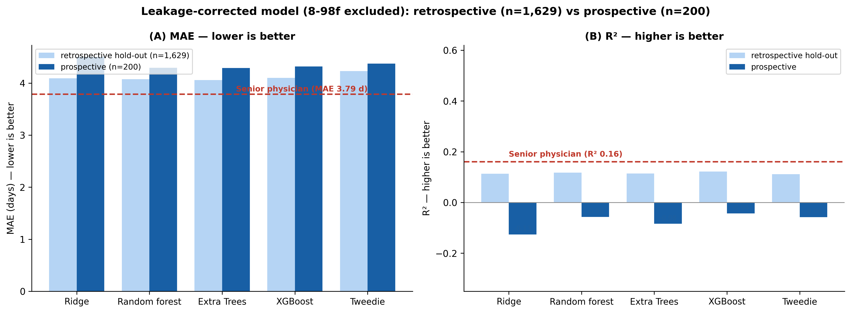
Figure 1. Leakage-corrected accuracy (MAE) and calibration (R²) on the retrospective hold-out vs the prospective cohort (n = 200), all five models, physician reference.

3.2 Model interpretation
After removing 8-98f, permutation importance was led by other early intensive-care monitoring and procedure signals together with patient age and ICU stay number — clinically coherent severity markers, none individually dominant, consistent with the modest overall signal.
Table 4. Top-8 predictors by permutation importance (leakage-corrected final model, held-out set).
Rank | Predictor | ΔMAE when permuted (d)
1 | Diagnosis z99 1 | 0.121
2 | Procedure anzahl gesamt | 0.116
3 | Procedure 8 924 | 0.051
4 | Diagnosis g91 8 | 0.048
5 | Diagnosis g91 0 | 0.040
6 | Vital spo2 min | 0.030
7 | Procedure 8 800 c0 | 0.028
8 | alter | 0.027
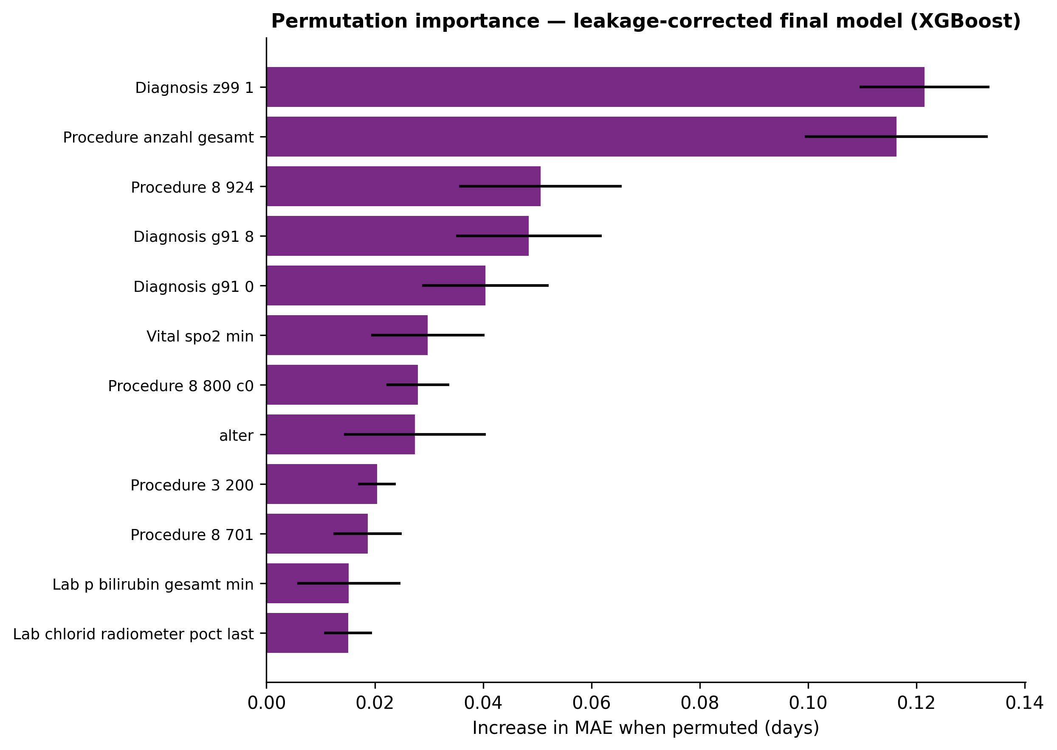
Figure 2. Permutation feature importance — leakage-corrected final model.

3.3 Prospective validation against the senior physician
Across all 200 prospective stays the senior physician was more accurate than every model (physician MAE 3.79 d, R² 0.16; best model Gradient-boosted trees (XGBoost) MAE 4.32 d, R² -0.04). All models had negative prospective R², i.e. they did not beat a mean-prediction baseline out of sample — the realistic consequence of removing the leak and of distribution shift (Table 5).
Table 5. Prospective performance, leakage-corrected (n = 200; 74 censored).
Estimator | MAE (d) | Median AE (d) | RMSE (d) | R² | Bias (d)
Senior physician | 3.79 | 1.98 | 6.29 | 0.16 | -1.87
Gradient-boosted trees (XGBoost) (final) | 4.32 | 2.35 | 7.02 | -0.04 | -1.76
Extra Trees | 4.29 | 2.20 | 7.15 | -0.08 | -2.07
Random forest | 4.29 | 2.19 | 7.07 | -0.06 | -1.96
Tweedie model | 4.37 | 2.43 | 7.07 | -0.06 | -1.72
Ridge regression | 4.50 | 2.29 | 7.29 | -0.13 | -1.67
Table 6. Prospective MAE (days) by LoS subgroup, leakage-corrected (n = 200).
LoS subgroup | Senior physician | Gradient-boosted trees (XGBoost) | Random forest | Extra Trees
2–4 d | 1.50 | 2.36 | 2.39 | 2.27
4–7 d | 1.95 | 1.45 | 0.98 | 1.02
>7 d | 7.74 | 8.55 | 8.75 | 8.87
The subgroup pattern of the primary analysis was reproduced without the leak. For intermediate 4–7 day stays the final model (Gradient-boosted trees (XGBoost)) was significantly more accurate than the senior physician (ΔMAE +0.50 d, 95% bootstrap CI 0.04 to 0.95; the entire interval lies above zero). The physician was significantly more accurate for short (2–4 d) stays (ΔMAE -0.86 d, CI -1.40 to -0.33), and the two were statistically indistinguishable for very long (>7 d) stays (ΔMAE -0.81 d, CI -2.00 to 0.42). That the intermediate-stay advantage survives leak removal is the key result of this corrected analysis.
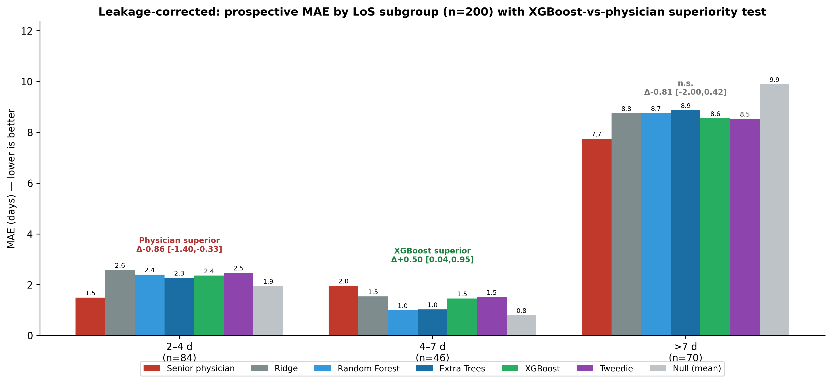
Figure 3. Leakage-corrected prospective MAE by LoS subgroup (n = 200) with the Gradient-boosted trees (XGBoost)-vs-physician superiority test (paired bootstrap 95% CI).
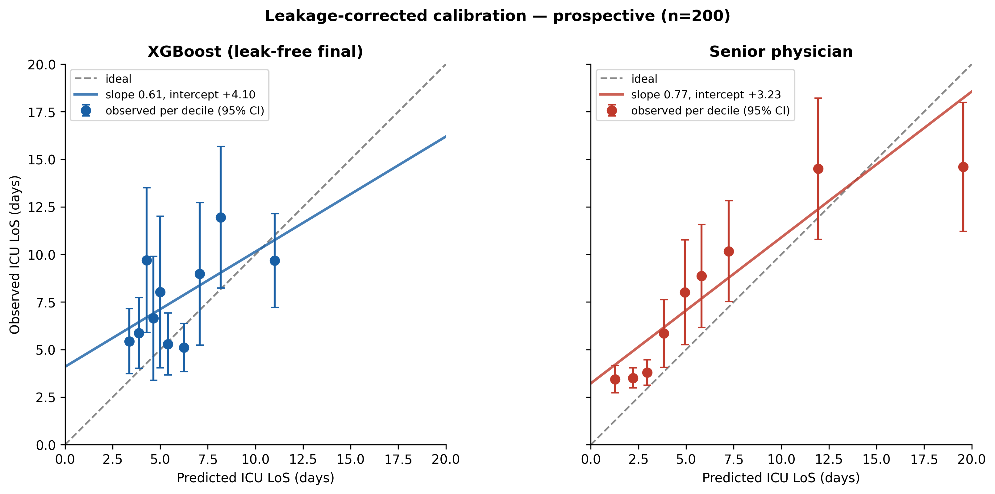
Figure 4. Leakage-corrected prospective calibration (n = 200): observed vs predicted (deciles, 95% CI) for the final model and the senior physician.

4. Discussion

4.1 Principal findings
Removing a single duration-encoding administrative code (OPS 8-98f) cut the apparent development R² from ~0.33 to ~0.11, exposing a modest true first-24-hour signal. Honestly evaluated, the model does not outperform experienced clinicians overall. Yet the clinically meaningful pattern is robust: the model is significantly more accurate than the physician for intermediate (4–7 day) stays, the physician is better for short stays, and neither is reliable for very long stays.

4.2 Clinical impact and translation
The leakage correction strengthens, rather than weakens, the translational message. A model whose headline performance rests on a code unavailable at prediction time would fail silently in deployment; the corrected model is a faithful estimate of what is achievable from genuine first-24-hour data. Its reproducible edge for intermediate-stay patients — common and operationally demanding — supports use as a subgroup-aware second opinion rather than a replacement, in line with trustworthy, clinician-centred AI.

4.3 Strengths and limitations
Strengths include the explicit leakage audit and correction, a genuine prospective benchmark against clinicians, patient-grouped validation and TRIPOD+AI reporting. Limitations include the single-centre design, the modest prospective sample (especially for long stays), the censoring of still-admitted patients (74/200), and that hyperparameters were carried over from the primary analysis rather than re-tuned. LoS is partly an organisational outcome that bounds the achievable accuracy of any admission-time estimator. External multi-centre validation is the next step.

4.4 Conclusion
After correcting a duration-encoding leak, an interpretable first-24-hour ML model offers only a modest honest signal and does not replace clinical judgement, but it adds significant accuracy for intermediate-stay patients. A subgroup-aware, complementary deployment is the realistic path from data to clinical impact.

Reporting, data and code availability
Reported per TRIPOD+AI. This is the leakage-corrected companion to the primary manuscript (8-98f excluded). Code is in the project repository; patient-level data remain at the originating institution. [Ethics, funding, author contributions to be completed.]

References
1. Collins GS, Moons KGM, Dhiman P, et al. TRIPOD+AI statement. BMJ. 2024;385:e078378.
2. Chen T, Guestrin C. XGBoost: a scalable tree boosting system. Proc. 22nd ACM SIGKDD. 2016:785–794.
3. Pedregosa F, et al. Scikit-learn: machine learning in Python. JMLR. 2011;12:2825–2830.
4. Geurts P, Ernst D, Wehenkel L. Extremely randomized trees. Mach Learn. 2006;63(1):3–42.
5. [Additional ICU length-of-stay references to be completed by the authors.]

