Early prediction of intensive-care length of stay from the first 24 hours: model development and prospective benchmarking against senior-physician judgement
Original Research prepared for the Frontiers Research Topic “MedicineAI: Advancing the Synergy of Medicine and AI — From Data to Clinical Impact.” Reported in accordance with the TRIPOD+AI statement (Collins et al., 2024). Author names, affiliations, ORCID and corresponding author to be inserted.
Author One¹, Author Two¹, Author Three², Senior Author¹*
¹ Department of Anaesthesiology and Intensive Care Medicine, [Institution], [City], [Country]
² [Second affiliation]
* Correspondence: [name, e-mail]
Abstract
Background: Accurate early prediction of intensive care unit (ICU) length of stay (LOS) could support capacity planning and patient flow. Machine-learning (ML) models for ICU LOS are rarely benchmarked prospectively against the clinicians they are intended to support, and reported accuracy is often given without any measure of uncertainty or calibration.
Methods: We conducted a single-centre study using routine data from a tertiary ICU service, restricted to the three anaesthesiology-run intensive care units (codes IZ21, IZ31, IZ32). A retrospective development cohort of 12,884 ICU stays (10,875 patients; May 2017–Jul 2024) was used to train and select a final model. Eighty-four predictors were derived from the first 24 hours after ICU admission only (the intended prediction time point). Four candidate models — ridge regression, random forest, extremely randomised trees (Extra Trees), and gradient boosting (XGBoost) — were fitted on a log1p-transformed LOS target with identical preprocessing. Hyperparameters were optimised by 4-fold patient-grouped cross-validation, and the model with the lowest cross-validated mean absolute error (MAE) was pre-specified as the final model. It was then evaluated prospectively against senior-physician estimates in 193 completed matched stays (Oct 2024–Jan 2026). Because the model and the physician assessed the same patients, the comparison used a paired, patient-level bootstrap (5,000 resamples) for 95% confidence intervals (CIs) of MAE, RMSE, bias and R², the paired difference in absolute error, and a Wilcoxon signed-rank test; calibration was assessed by calibration-in-the-large, calibration slope, observed-versus-predicted plots and LOS-group analysis.
Results: On the patient-grouped holdout (n = 2,601), the four models performed near-identically (MAE 2.75–3.03 days; R² 0.25–0.36); extra trees was selected as the final model (test MAE 2.75 days, R² 0.36). Prospectively, first-24-hour features were reconstructed from raw records (86% of the 84 features available; median per-stay completeness 77%). The senior physician outperformed the final model on MAE (2.01 [1.59, 2.49] vs 2.64 [2.22, 3.11] days) and R² (0.22 [-0.29, 0.51] vs 0.07 [-0.07, 0.15]). The paired difference in MAE was -0.63 [-1.05, -0.19] days in the physician's favour (Wilcoxon p <0.001) and remained significant when long stays were excluded (1–7 days, n = 166: -0.50 [-0.84, -0.17] days, p <0.001), so the advantage is not driven by a few extreme long-stayers. Calibration analysis showed the model compressed its predictions (calibration slope 0.86): it over-predicted very short stays (1–2 days, bias +2.5 days) and severely under-predicted long stays (> 7 days, bias −7.9 days), whereas the physician tracked both extremes more closely.
Conclusion: Under prospective, clinician-benchmarked validation with paired uncertainty quantification, a 24-hour ML model did not match senior-physician judgement for ICU LOS prediction; the physician's advantage was statistically robust and the model's predictions were poorly calibrated at both extremes of the LOS range. Direct clinician benchmarking, uncertainty quantification and calibration are essential before deployment.
Keywords: intensive care unit; length of stay; clinical prediction model; machine learning; prospective validation; calibration; bootstrap confidence intervals; TRIPOD+AI; clinical decision support
1 Introduction
Intensive care is among the most resource-intensive segments of hospital care, and ICU length of stay (LOS) is a principal driver of bed occupancy, staffing demand and cost [1]. An accurate early estimate of LOS — available at or shortly after ICU admission — could support bed management, step-down planning and communication with patients and families. Established severity scores (APACHE II, SAPS II, SOFA) were designed primarily to predict in-hospital mortality and explain only a limited portion of LOS variance [1–3].
Machine learning (ML) has been applied widely to ICU LOS prediction [4–6], frequently with encouraging reported accuracy. Yet two issues limit clinical credibility. First, models are almost invariably evaluated against historical labels rather than against the clinicians whose judgement they are meant to augment or replace, so it remains unclear whether they add value at the point of decision. Second, performance is often reported as a single point estimate (e.g. mean absolute error) without any measure of uncertainty or calibration, which is insufficient to judge clinical usefulness and reproducibility [7]. The TRIPOD+AI reporting standard therefore emphasises a clearly defined prediction time point, prospective evaluation, and explicit reporting of uncertainty and calibration [8,9].
We address these issues in a single study: (i) we restrict all predictors to the first 24 hours after admission (the intended early-prediction time point); (ii) we pre-specify a single final model through patient-grouped cross-validation; (iii) we benchmark that model prospectively and directly against documented senior-physician estimates in the same patients; and (iv) we quantify the uncertainty of that comparison with a paired, patient-level bootstrap and characterise model calibration across the LOS range. The guiding clinical question is whether a data-driven 24-hour model can match an experienced clinician at the moment of decision.
2 Materials and Methods
2.1 Study design, setting and data source
This is a single-centre prediction model development and prospective validation study using de-identified routine data from the clinical data repository (KISIK) of a tertiary care centre. ICU stay records, ICD-10 admission diagnoses, laboratory results, vital signs, OPS procedure codes and vascular-access device records were linked by a case identifier (retrospective: fallid; prospective: fallnr). The study was conducted in accordance with the Declaration of Helsinki; ethics approval and waiver of informed consent for analysis of de-identified routine data are to be inserted (see Ethics statement). Reporting follows TRIPOD+AI [9].
2.2 Cohorts: retrospective development and prospective evaluation
Two temporally non-overlapping cohorts were defined (Table 1, Table 2).
Both cohorts were restricted to the three intensive care units run by the department of anaesthesiology and intensive care medicine (care-unit codes IZ21, IZ31 and IZ32; field oebenekurz, with ward AIN). These are the closed, physician-staffed ICUs of the service; lower-acuity or intermediate-care units (e.g. code IZ01) were excluded. The retrospective development cohort covers May 2017 to July 2024 and comprises 12,884 ICU stays from 10,875 patients (11,437 hospital encounters). Inclusion criteria: (a) stay in one of the three eligible AIN intensive care units; (b) ICU LOS > 1 day (icu_duration_h / 24 > 1). Each ICU stay is one analysis unit. The data were split 80:20 by patient (GroupShuffleSplit, random seed 42) into a training set (n = 10,283) and a held-out test set (n = 2,601); no patient appears in both sets.
The prospective evaluation cohort spans October 2024 to January 2026 and was drawn from daily live-system snapshots. Two important properties distinguish it from the retrospective data: (1) The join key is fallnr rather than fallid. (2) Each snapshot contains an is_open flag: is_open = 1 means the patient is still on the ICU at snapshot time, so icu_duration_h records elapsed time only, not final LOS. To ensure that the observed LOS is the actual completed duration, only closed stays (is_open = 0) with LOS > 1 day were retained (1,462 stays in total in the three AIN units). Date formats also differ: retrospective timestamps use ISO format (YYYY-MM-DD HH:MM:SS), whereas prospective OLD-snapshot CSVs use German format (DD.MM.YYYY HH:MM:SS) and are parsed accordingly. Of the 1,462 completed prospective stays, 193 had a senior-physician LOS estimate documented during routine care and formed the matched evaluation set (all 193 fell in the three AIN units). The prospective cohort was used only for evaluation — never for model fitting or hyperparameter selection.
2.3 Outcome: ICU LOS in days
The primary outcome was ICU LOS in days. In the source data, duration is stored in hours (icu_duration_h); all modelling targets and reported metrics use icu_duration_h ÷ 24. The senior-physician estimates were recorded directly in days. This conversion is applied consistently throughout all scripts and is documented in summary.json ('units': 'icu_duration_h are HOURS; target = hours/24 = DAYS').
Because ICU LOS is strictly positive and strongly right-skewed (retrospective cohort: median 2.9 days, 90th percentile 13.51 days, maximum 76.9 days), all four models were fitted on a log1p-transformed target. log1p(x) = log(1 + x), where '1p' means 'plus one'. This transform was chosen over a plain logarithm for three reasons: (i) log1p is defined for all x ≥ 0, whereas log(0) is undefined (and LOS values at the inclusion boundary of exactly one day could produce log(1) = 0 without issue); (ii) the +1 shift avoids the singularity of log near zero; (iii) log1p compresses the long right tail, reducing the influence of extreme stays on gradient-based optimisation. All four models use an identical target-transformation wrapper (scikit-learn TransformedTargetRegressor: log1p on fitting, expm1 = exp(x)−1 on prediction). Predictions are always back-transformed with expm1 before any metric is computed, guaranteeing non-negative day-scale outputs.
2.4 Predictors and the 24-hour window
All predictors were derived strictly from the first 24 hours after ICU admission (from admission timestamp to admission + 24 h). This reflects the intended early-prediction time point: only information available to a clinician within the first day of the stay can enter any model, so the predictions are clinically realistic for early bed and step-down planning.
From 104 candidate features, 84 were available as first-24-hour variables and were retained; 20 candidates were excluded because they could not be constructed within the 24-hour window under the exact feature name. The 84 retained features span six domains (Table 3): laboratory values (30), admission diagnoses (24), procedures (13), vascular access devices (8), vital signs (6) and demographic/admission context (3).
2.5 Handling of patients with multiple stays and multiple records within the window
The analysis unit is the ICU stay, not the patient or the hospital encounter. Patients with more than one ICU stay (n = 1,552 patients; 14.3% of patients) contribute each stay as a separate prediction instance. To prevent optimistic bias from the same patient appearing in both training and evaluation, every train/test split and every cross-validation fold was grouped by patient identifier (GroupShuffleSplit and GroupKFold, respectively). This ensures that all stays from a given patient appear in either training or evaluation, never in both simultaneously.
Within the 24-hour window, most modalities contribute multiple records for a single stay (e.g. repeated laboratory measurements, several vital-sign readings, multiple procedure entries). These are aggregated as follows: for numeric variables (laboratory, vital signs), six summary statistics are computed per analyte per stay — first, last, minimum, maximum, mean and count of measurements within the 24-hour window. For binary modalities (procedure codes, access devices, admission diagnoses), a binary presence indicator (0/1) and a total count are derived. For procedures, an additional feature captures the total number of distinct procedure codes within the window. When a patient has had multiple operations or anaesthesia sessions before or during the ICU stay, all perioperative records within the window are included in the counts; timing is determined by the procedure or anaesthesia start timestamp.
2.6 Missing data and preprocessing pipeline
Missing values are expected in clinical data, particularly for analytes not routinely measured for every patient. All imputation is performed inside cross-validation — fitted on the training fold only and applied to the held-out fold — so that no information from the held-out data influences preprocessing. The preprocessing pipeline is as follows:
(1) Numeric features: median imputation (SimpleImputer, strategy='median'), using the training-fold median. For binary features derived from procedure/access/diagnosis presence, a missing value indicates the feature was not documented in the window and is treated as absent (0) rather than truly missing; these are filled with 0 before model fitting.
(2) Categorical feature (care-unit type, oebenekurz, 1 variable): most-frequent imputation followed by one-hot encoding with unknown-category handling (handle_unknown='ignore').
(3) Standardisation: applied only to ridge regression inputs (StandardScaler after imputation), because tree-based ensembles are scale-invariant and do not require standardisation.
This pipeline is implemented as a scikit-learn ColumnTransformer inside a Pipeline, all wrapped in a TransformedTargetRegressor that applies log1p before fitting and expm1 after prediction. The complete processing chain for any model is therefore: raw features → ColumnTransformer (impute, encode, [scale for Ridge]) → estimator(log1p(LOS)) → expm1(prediction) → predicted LOS in days.
For the prospective cohort, the identical feature definitions, 24-hour window and naming conventions were applied when rebuilding features from raw prospective source tables (laboratory, vital signs, procedures, access devices, diagnoses). No additional fitting was performed: the training-set imputation medians were carried over directly, exactly as they would be in a clinical deployment scenario.
2.7 Candidate models and hyperparameter optimisation
Four candidate models were evaluated throughout. All use the same preprocessing pipeline (Section 2.6) and differ only in the estimator and, for ridge, the additional standardisation step.
Ridge regression is a regularised linear model that minimises the sum of squared residuals plus a penalty on coefficient magnitude (L2 penalty = alpha). It serves as an interpretable linear baseline. Random forest [10] and extra trees [11] are bagging-based ensembles of decision trees; extra trees additionally randomises the splitting thresholds at each node, which reduces variance at the cost of some additional bias. XGBoost [12] is a gradient-boosting framework that builds an additive ensemble of trees sequentially, with each tree correcting the residuals of the previous ones.
Hyperparameters were tuned on the training set by 4-fold patient-grouped cross-validation (GroupKFold on patient identifier), optimising the negative MAE on the day scale (after expm1 back-transformation). Ridge was tuned by exhaustive grid search; the three nonlinear models by randomised search (12 candidates each, random seed 42). Search spaces: ridge alpha ∈ {0.1, 0.3, 1, 3, 10, 30, 100}. For random forest and extra trees: n_estimators ∈ {300, 500}, max_depth ∈ {None, 12, 20}, min_samples_leaf ∈ {2, 5, 10}, max_features ∈ {sqrt, 0.5}. For XGBoost: n_estimators ∈ {300, 500, 800}, max_depth ∈ {4, 6, 8}, learning_rate ∈ {0.03, 0.05, 0.1}, subsample ∈ {0.7, 0.9}, colsample_bytree ∈ {0.7, 0.9}, min_child_weight ∈ {1, 3, 5}, reg_lambda ∈ {1, 2, 5}.
2.8 Model selection: pre-specified rule
To avoid double-dipping (optimising model choice on the same data used to report test performance), the selection rule was fixed before the holdout test set was inspected: the candidate model with the lowest 4-fold patient-grouped CV-MAE on the training set is the final model. This rule selected Extra Trees (CV-MAE 2.826 days). The final model was then refitted on the full training set (n = 10,283 stays) and evaluated exactly once on the holdout test set (n = 2,601 stays) and exactly once on the prospective cohort (n = 193 stays). No further hyperparameter adjustment was made after seeing the holdout or prospective results. All four candidate models are reported consistently in Tables 4 and 5 to show the sensitivity of results to model choice.
2.9 Performance metrics: discrimination and calibration
All metrics are computed on the day scale after expm1 back-transformation, with each ICU stay contributing exactly one (observed, predicted) pair.
Discrimination — the ability to rank stays by LOS correctly — is quantified by: (i) R² = 1 − Σ(yᵢ − ŷᵢ)² / Σ(yᵢ − ȳ)², which equals 1 for perfect predictions and can be negative when a model performs worse than predicting the mean; and (ii) Spearman rank correlation ρ between observed and predicted LOS, which is robust to the non-linear scale of LOS values.
Calibration — the alignment of predicted magnitudes with observed values — is quantified by: (i) MAE = (1/N) Σᵢ₌₁ᴺ |yᵢ − ŷᵢ|, the mean absolute deviation between observed LOS yᵢ (days) and predicted LOS ŷᵢ (days) across all N stays. For example, if a model predicts 3 days for a patient who stays 5 days, the absolute error is 2 days; the MAE is the average of such errors over the entire evaluation set. (ii) Median AE = median(|yᵢ − ŷᵢ|), the 50th percentile of absolute errors, which is more robust to extreme-LOS outliers than MAE. (iii) RMSE = √[(1/N) Σ(yᵢ − ŷᵢ)²], which penalises large errors more heavily than MAE. (iv) Mean bias = (1/N) Σ(ŷᵢ − yᵢ), where a positive value indicates systematic overestimation and a negative value systematic underestimation. For Spearman ρ, the prospective predictions CSV is used directly; for retrospective ρ this cannot be computed from published summary statistics and is therefore not reported.
Uncertainty and clinician comparison (prospective cohort). Because the senior physician and the final model assessed the identical patients, 95% confidence intervals for MAE, RMSE, bias and R² were obtained by a paired, patient-level bootstrap with 5,000 resamples (percentile method; in each replicate the same resampled patients were used for every predictor). The paired difference in absolute error (physician minus model) was bootstrapped likewise, and the paired absolute errors were additionally compared with a Wilcoxon signed-rank test; both were repeated within LOS subgroups (1–7 and > 7 days) to test whether the comparison was driven by extreme long-stayers. Calibration was assessed by calibration-in-the-large (mean bias), the calibration slope (ordinary least-squares regression of observed on predicted LOS, with ideal slope 1.0 and bootstrap 95% CI), observed-versus-predicted plots with a quantile-binned calibration curve, the distribution of predictions, and performance stratified across LOS groups (1–2, 2–4, 4–7, > 7 days).
2.10 Interpretability
Predictor importance for the final model (extra trees) was assessed by permutation importance on the holdout test set (scikit-learn, 10 repeats, random seed 42). For each predictor in turn, its values in the test set are randomly permuted (destroying its relationship with LOS), the model is applied to the permuted data, and the resulting increase in MAE (in days) is recorded. A larger increase means the model relies more on that predictor. The procedure is repeated 10 times and the mean ± SD increase is reported (Table 6).
2.11 Software and reproducibility
Analyses used Python 3.12 (scikit-learn ≥ 1.4, XGBoost ≥ 2.0, DuckDB, SciPy, Pandas, NumPy, Matplotlib). A fixed random seed (42) was used for the train/test split, cross-validation sampling and model fitting. The complete pipeline and manuscript code are publicly available at https://github.com/Scarlet1991/KISIK-Dashboard.
3 Results
3.1 Cohort characteristics
Retrospective and prospective cohort characteristics are compared in Table 2. Median age was similar (retrospective 68.0 [IQR 57.0–77.0] vs prospective 68.3 [58.2–76.9] years; SMD 0.07). By design both cohorts comprise only the three AIN intensive care units (IZ21/IZ31/IZ32), so ward is constant (100% AIN) and the care-unit mix is comparable (IZ32 ≈ 50%, IZ21 ≈ 26%, IZ31 ≈ 22%). ICU LOS was marginally shorter in the prospective cohort (median 2.8 vs 2.9 days; SMD 0.21), which likely reflects the restriction to completed stays only (censored long stays are excluded). Hospital LOS was available only retrospectively. SAPS II and TISS-28 severity scores were documented for almost all retrospective stays in these units (97% each) but almost never prospectively (≤ 2%), reflecting a change in clinical scoring practice between the two periods; SOFA documentation was sparse in both (1–2%). Cross-cohort severity comparison was therefore not feasible and scores are reported descriptively only.
3.2 Model development and selection
In 4-fold patient-grouped cross-validation on the training set, the three tree ensembles were near-identical and clearly outperformed the linear baseline (Table 4): CV-MAE 2.826–2.845 days (Extra Trees, Random Forest, XGBoost) vs 3.069 days (Ridge). Extra Trees had the lowest CV-MAE (2.826 days) and was selected as the final model per the pre-specified rule. The final Extra Trees model was refitted on the full training set (n = 10,283 stays) with best hyperparameters (300 trees, max_depth None, min_samples_leaf 5, max_features 0.5).
On the held-out test set (n = 2,601 stays), all four models again performed in a narrow band: MAE 2.75–3.03 days, R² 0.25–0.36 (Table 4). Final model (Extra Trees): MAE 2.75 days, median AE 1.22 days, RMSE 5.35 days, R² 0.36, mean bias -1.08 days. The negative mean bias indicates that all four models systematically underestimate LOS, which is expected: LOS is right-skewed, long-stay patients are rare in training, and log1p compression still leaves the very long tail harder to predict. Random forest and XGBoost were statistically indistinguishable from Extra Trees on the holdout; ridge regression was consistently the weakest model.
3.3 Most important predictors
Permutation importance for the final model (Extra Trees) on the holdout test set is shown in Table 6 and Figure 2. By a large margin, the strongest single predictor was the intensive-care complex-treatment procedure code (OPS 8-98f.0, base module): permuting this feature increased MAE by 1.28 days. The next tier — the extended complex-treatment module (8-98f.10), extended haemodynamic monitoring (8-931) and the total number of procedures within 24 hours — each added 0.12–0.30 days. Cardiac monitoring (8-924), a further complex-treatment tier (8-98f.11), basic haemodynamic monitoring (8-930), ventilator dependence (ICD-10 Z99.1) and ICU stay number per patient added smaller increments; age contributed only 0.02 days. Notably, in this single-department cohort the care-unit type (which was informative in the broader multi-ward analysis) no longer ranked among the top predictors, because the three AIN units are clinically similar. In summary, procedure burden and monitoring intensity in the first 24 hours dominate LOS prediction; patient demographics and diagnoses contribute modestly.
3.4 Prospective evaluation against the senior physician (n = 193)
Prospective features were rebuilt from raw source tables (laboratory, vital signs, procedures, vascular access, diagnoses) using the identical 24-hour window, feature names and aggregation functions as in development. This yielded genuine values for 72 of the 84 predictors (86%); the remaining 12 (6 diagnoses and 6 procedure codes) did not appear in any prospective stay within the first 24 hours and were treated as absent. The median per-stay feature completeness was 77% (vs 4 features in a preliminary analysis that used the prospective parquet directly, which had near-zero 24-hour coverage).
Results are shown in Table 5 and Figure 1. The senior physician outperformed all four ML models on every summary metric. For the final model (Extra Trees): physician MAE 2.01 vs model MAE 2.64 days; R² 0.22 vs 0.07; Spearman ρ 0.68 vs 0.22. Extra Trees was the only ML model with a positive prospective R² (0.07); random forest (R² 0.00), XGBoost (R² −0.04) and especially ridge (R² −22.0) did not beat a mean predictor under the distribution shift between periods. Ridge's extreme instability (MAE 7.39 days, bias +5.80 days) confirms that a linear model extrapolates poorly here and is not recommended. Compared with the feature-impoverished preliminary analysis (where every model collapsed to R² ≈ 0), the genuine 24-hour inputs restored a modest signal for the final model.
In subgroup analyses, the physician advantage was most pronounced in short stays (1–7 days, n = 166: physician MAE 1.28 vs Extra Trees 1.78 days). For long stays (> 7 days, n = 27), all models were clearly worse than the physician (physician MAE 6.51 vs the best model, XGBoost, 7.16 days; Extra Trees 7.95 days), underscoring that the clinically important long-stay range remains the hardest for the models and the area of greatest physician advantage.
Importantly, the apparently respectable prospective MAE must be read against a null model. A trivial baseline that predicts the retrospective median LOS (2.90 days) for every patient achieved an MAE of 2.46 days prospectively — actually lower than the final model (2.64 days). The same null model on the retrospective holdout gave an MAE of 3.77 days, which the model clearly beat (2.75 days). In other words, the model added genuine skill retrospectively but none prospectively. The reason the prospective MAE does not deteriorate further is that the prospective outcome simply varies less: the completed-stay prospective cohort has a much narrower LOS distribution (SD 4.29 vs 6.76 days; 14% vs 22% of stays > 7 days; maximum 27 vs 77 days; Table 9). Because MAE scales with the spread of the outcome, the lower prospective MAE reflects an easier cohort rather than better prediction — a discrepancy that R² (which fell to 0.07) and the calibration analysis make explicit.
3.5 Uncertainty of the prospective comparison (paired bootstrap)
Because the senior physician and the final model assessed the identical 193 patients, the comparison was quantified with a paired, patient-level bootstrap (5,000 resamples; the same resampled patients were used for both predictors in each replicate). Point estimates with 95% confidence intervals (CIs) are given in Table 7.
On MAE the physician was more accurate than the final model: 2.01 [1.59, 2.49] vs 2.64 [2.22, 3.11] days. The paired difference in MAE (physician minus model) was -0.63 [-1.05, -0.19] days, and the entire 95% CI lay below zero; the Wilcoxon signed-rank test on paired absolute errors agreed (p <0.001; Figure 8). The physician also had a higher R² (0.22 [-0.29, 0.51] vs 0.07 [-0.07, 0.15]), while both methods were essentially unbiased (physician bias -0.14 [-0.66, 0.39], model -0.11 [-0.71, 0.43] days).
The advantage was not driven by a few extreme long-stayers. Restricted to stays of 1–7 days (n = 166), the physician retained a significant edge (paired ΔMAE -0.50 [-0.84, -0.17] days, Wilcoxon p <0.001). In the long-stay subgroup (> 7 days, n = 27) the point estimate still favoured the physician (-1.43 [-3.54, 1.02] days) but with a wide CI crossing zero owing to the small subgroup size, although the Wilcoxon test remained significant (p 0.006).
3.6 Calibration across the LOS range
Calibration describes how well predicted LOS magnitudes agree with observed values, independent of discrimination. We report calibration-in-the-large (mean bias), the calibration slope (least-squares regression of observed on predicted LOS; ideal = 1.0), observed-versus-predicted plots with a quantile-binned calibration curve (Figure 6), the distribution of predictions (Figure 7), and performance stratified by LOS group (Table 8).
At the cohort level both methods were well calibrated-in-the-large (mean bias near zero: model -0.11 days, physician -0.14 days). The calibration slope, however, showed that the final model compressed its predictions into a narrow range (slope 0.86 [0.30, 1.61]): predicted values clustered between roughly 3 and 6 days largely irrespective of the true LOS (Figure 7), while the physician's estimates spanned a wider range.
The LOS-group analysis (Table 8) exposed the clinical consequence: the model substantially over-predicted very short stays (1–2 days: bias +2.46 days) and severely under-predicted long stays (> 7 days: bias -7.95 days), whereas the physician tracked both extremes far more closely (1–2 days +0.58; > 7 days -3.01 days). The near-zero average bias therefore masks large, offsetting errors at the two ends of the LOS distribution — exactly the ranges most relevant to capacity planning. The retrospective holdout showed the same regression-to-the-mean pattern (mean bias -1.00 to -1.18 days across models; Figure 3), and the prospective hexbins (Figures 4–5) confirm that the physician tracks long stays better than the model.
To locate where, if anywhere, the model adds value, we compared the senior physician, the final model and the null model within bins of the actual LOS (Table 11, Figure 10). The pattern is informative. At the extremes the physician was clearly best (1–2 days: MAE 0.74 vs model 2.46; > 7 days: 6.51 vs 7.95), reflecting the model's compressed predictions. The model had a genuine advantage only in the 4–7-day band (n = 31), where it beat both the physician (MAE 1.40 vs 2.00, p 0.015) and the null model (1.40 vs 2.53, p <0.001). Across the broader 2–7-day range (n = 99), however, the model was only numerically better than the physician (MAE 1.31 vs 1.65, p 0.209) and did not beat the null model (1.16). In the 2–4-day bin a constant predictor was in fact best, because the bin sits at the constant value. (Stratifying by the true outcome favours predictors whose output concentrates in a given bin, so these within-bin comparisons should be read together with the overall calibration: the model's usefulness is confined to a narrow mid-range rather than being general.)
3.7 Temporal stability of the physician advantage
The senior-physician estimates were collected over a six-month window (July–December 2025). To verify that the physician advantage was not confined to a single period, we compared the senior physician with the final model across calendar months and quarters (Table 10, Figure 9). The physician had the lower MAE in every month and in both quarters; the advantage was statistically significant in the first quarter (2025-Q3, n = 101: ΔMAE -0.94 days, Wilcoxon p <0.001) and the second (2025-Q4, n = 92: -0.28 days, p 0.010). The gap narrowed towards the end of the window (the two methods essentially converged in November–December), but the model never outperformed the physician in any segment. The physician advantage is therefore temporally stable rather than an artefact of one period.
4 Discussion
In a large single-centre cohort we developed, pre-specified and prospectively validated an ICU LOS model from the first 24 hours. Three findings stand out.
First, the three tree-ensemble families performed indistinguishably both in cross-validation and on the holdout. The choice between random forest, extra trees and XGBoost was immaterial — a finding that simplifies model selection in practice. Ridge regression was consistently the weakest model both retrospectively and, dramatically, prospectively (R² −22.0), which can be attributed to the regression-to-the-mean property of linear models when features shift in distribution across time periods.
Second, the experienced senior physician outperformed every model prospectively, and the paired bootstrap confirmed that this advantage was statistically robust rather than a chance result: the 95% CI for the physician-minus-model MAE difference (-0.63 [-1.05, -0.19] days) excluded zero and the Wilcoxon test was highly significant (p <0.001). Crucially, the advantage was not an artefact of a few extreme long-stayers — it persisted when the analysis was restricted to 1–7-day stays (n = 166) — nor of a single time period: the physician had the lower MAE in every month and both quarters of the six-month estimate window (Section 3.7). Physicians integrate contextual knowledge — anticipated surgical trajectories, potential complications, bed-management pressures — not captured in structured 24-hour tabular data.
Third, the prospective MAE of the model must not be read at face value. A trivial null model that always predicts the retrospective median LOS achieved a lower prospective MAE (2.46 days) than the final model (2.64 days), whereas retrospectively the model clearly beat the same null (2.75 vs 3.77 days). The model thus added real skill in development but essentially none prospectively; the deceptively low prospective MAE only reflects the narrower LOS distribution of completed stays (MAE scales with outcome spread). Consistent with this, although the final model was essentially unbiased on average prospectively (-0.11 days), this single number was misleading: the calibration slope (≈ 0.86) and LOS-group analysis revealed a compressed prediction range that over-predicted very short stays (1–2 days: +2.5 days) and under-predicted long stays (> 7 days: -8.0 days). This regression towards the centre — driven by a right-skewed LOS distribution in which very long stays are underrepresented — is exactly why average bias and MAE alone are inadequate, and why uncertainty quantification and calibration reporting are essential. Post-hoc recalibration (intercept adjustment or isotonic regression) could mitigate but was not pursued here. The one bright spot was a narrow mid-range (actual LOS 4–7 days), where the model significantly outperformed both the physician and the null model (Section 3.6, Table 11); this localised skill could, in principle, be exploited for triage of intermediate stays, but it does not generalise to the short- and long-stay ranges that matter most for capacity planning.
4.1 Limitations
This is a single-centre study confined to three anaesthesiology-run ICUs; the absolute performance values and ranking of models may not generalise to other units, case mixes or information systems. The prospective comparison rested on 193 completed matched stays, and while this constitutes a genuine, undiluted prospective test with documented physician estimates, the sample is modest (only 27 stays > 7 days) and the physician's estimates may have incorporated information beyond the first 24 hours. The reconstruction of 24-hour features from raw prospective tables achieved 86% coverage; the remaining 12 features were treated as absent, which may introduce a minor conservative bias relative to a deployment where all features are fully available. The retrospective-to-prospective performance drop is consistent with distribution shift between the two periods (case mix, coding practice) but its sources were not fully characterised.
5 Conclusion
Under prospective, clinician-benchmarked validation with paired uncertainty quantification, a machine-learning model built from the first 24 hours of ICU data did not match experienced senior-physician judgement for ICU LOS prediction. The clinician advantage was statistically robust and largest for long-staying patients, who represent the greatest capacity-planning challenge, and the model's predictions were poorly calibrated at both extremes of the LOS range. Realising clinical impact will require not only stronger models but also transparent prospective validation — reported with uncertainty and calibration — against the clinicians the technology is intended to support.
Statements
Data availability statement. De-identified routine clinical data are not publicly available owing to data-protection regulations; requests may be directed to the corresponding author subject to institutional approval. The complete analysis and figure code is openly available at https://github.com/Scarlet1991/KISIK-Dashboard.
Ethics statement. The study analysed de-identified routine clinical data; the protocol and waiver of informed consent were reviewed by [ethics committee], approval number [to be inserted].
Author contributions. [To be completed.] All authors approved the final manuscript.
Funding. [To be completed; if none, state so.]
Conflict of interest. The authors declare no competing interests.
References
[1] Knaus WA, Draper EA, Wagner DP, Zimmerman JE. APACHE II: a severity of disease classification system. Crit Care Med. 1985;13(10):818–829.
[2] Le Gall JR, Lemeshow S, Saulnier F. A new Simplified Acute Physiology Score (SAPS II). JAMA. 1993;270(24):2957–2963.
[3] Vincent JL, Moreno R, Takala J, et al. The SOFA score to describe organ dysfunction/failure. Intensive Care Med. 1996;22(7):707–710.
[4] Verburg IWM, Atashi A, Eslami S, et al. Which models can I use to predict adult ICU length of stay? A systematic review. Crit Care Med. 2017;45(2):e222–e231.
[5] Johnson AEW, Pollard TJ, Shen L, et al. MIMIC-III, a freely accessible critical care database. Sci Data. 2016;3:160035.
[6] Pollard TJ, Johnson AEW, Raffa JD, et al. The eICU Collaborative Research Database. Sci Data. 2018;5:180178.
[7] Kapoor S, Narayanan A. Leakage and the reproducibility crisis in machine-learning-based science. Patterns. 2023;4(9):100804.
[8] Collins GS, Reitsma JB, Altman DG, Moons KGM. Transparent reporting of a multivariable prediction model (TRIPOD). Ann Intern Med. 2015;162(1):55–63.
[9] Collins GS, Moons KGM, Dhiman P, et al. TRIPOD+AI statement: updated guidance for reporting clinical prediction models that use regression or machine-learning methods. BMJ. 2024;385:e078378.
[10] Breiman L. Random forests. Mach Learn. 2001;45(1):5–32.
[11] Geurts P, Ernst D, Wehenkel L. Extremely randomized trees. Mach Learn. 2006;63(1):3–42.
[12] Chen T, Guestrin C. XGBoost: a scalable tree boosting system. In: Proc. 22nd ACM SIGKDD; 2016. p. 785–794.
Reference details should be verified; topic-specific references on ICU LOS prediction, calibration and distribution shift should be added before submission.

Tables
Table 1. Cohort overview and inclusion criteria.
Parameter | Retrospective (development) | Prospective (evaluation)
Data period | May 2017 – Jul 2024 | Oct 2024 – Jan 2026
Source | KISIK clinical data repository | Daily OLD live-system snapshots
Join key | fallid | fallnr (case reference differs by system)
Date format | ISO: YYYY-MM-DD HH:MM:SS | German: DD.MM.YYYY HH:MM:SS
Inclusion | AIN ICUs IZ21/IZ31/IZ32; LOS > 1 day | Same units; is_open = 0 (completed stays); LOS > 1 day
ICU stays (n) | 12,884 | 1,462 completed (193 with senior estimate)
Patients (n) | 10,875 | 1,283 (matched subset 193)
Hospital encounters (n) | 11,437 | —
Median ICU LOS (days) | 2.9 | 2.8 (matched subset)
Train / test split | 10,283 / 2,601 (patient-grouped) | Evaluation only
Role | Model development & selection | External prospective test
LOS, length of stay. Both cohorts are restricted to the three anaesthesiology-run intensive care units (IZ21/IZ31/IZ32). is_open = 0 indicates the patient had been discharged by the time of data capture, so icu_duration_h records the final ICU duration. Censored stays (is_open = 1) are excluded because their duration is still accruing. The prospective cohort was never used for model fitting or selection.
Table 2. Patient and stay characteristics: retrospective development vs. prospective cohort (completed stays, is_open = 0, LOS > 1 day).
Characteristic | Retrospective (n = 12,884) | Prospective (n = 1,462) | p-value | SMD
Age (years) | 68.0 [57.0–77.0] | 68.3 [58.2–76.9] | 0.071 | 0.065
ICU length of stay (days) | 2.9 [1.8–6.3] | 2.8 [1.7–4.8] | <0.001 | 0.208
ICU stay number | 1.0 [1.0–2.0] | 2.0 [1.0–2.0] | <0.001 | 0.118
Severity scores, first 24 h (availability %)
SAPS II | 32.0 [24.0–41.0] (97%) | n.a. (2%) |  | n.c.
TISS-28 | 10.0 [5.0–14.0] (97%) | n.a. (0%) |  | n.c.
SOFA | n.a. (1%) | n.a. (2%) |  | n.c.
Ward (overall) | n=12884 | n=1462 | 1.000
AIN | 12884 (100.0%) | 1462 (100.0%) |  | 0.0
ICU care unit (overall) | n=12884 | n=1462 | 0.046
IZ21 | 3350 (26.0%) | 391 (26.7%) |  | 0.017
IZ31 | 3115 (24.2%) | 311 (21.3%) |  | 0.069
IZ32 | 6419 (49.8%) | 760 (52.0%) |  | 0.043
Continuous variables: median [IQR], Mann-Whitney U test. Categorical variables: n (%), chi-square test. SMD = standardised mean difference (|SMD| > 0.1 indicates notable between-cohort imbalance). Hospital LOS was unavailable prospectively. Sex and BMI were not available in either dataset. Severity scores (SAPS II, TISS-28, SOFA): extracted from score records within the first 24 h; documentation rates differ markedly by period (see Section 3.1) and cross-cohort comparison is therefore not feasible (n.c. = not compared). With a large retrospective sample, small absolute differences reach statistical significance; the SMD is the more clinically meaningful measure of cohort imbalance.
Table 3. Predictor domains: 84 features, all derived from the first 24 hours after ICU admission.
Domain | Features (n) | Aggregation | Examples
Laboratory (first 24 h) | 30 | first, last, min, max, mean, count | potassium, sodium, glucose, lactate, bilirubin, creatinine, haemoglobin
Admission diagnoses (ICD-10) | 24 | binary presence (0/1) | sepsis, intracranial haemorrhage, coronary disease, ventilator dependence (Z99.1)
Procedures (OPS, first 24 h) | 13 | binary presence + total count | ICU complex treatment (8-98f.0/10/11), extended monitoring (8-931), mechanical ventilation
Vascular access (first 24 h) | 8 | binary presence + count | arterial line, central venous catheter, urinary catheter, epidural catheter
Vital signs (first 24 h) | 6 | first, last, min, max, mean, count | peripheral oxygen saturation (SpO₂)
Demographics / admission context | 3 | as recorded | age (years), ICU stay number per patient, care-unit type (oebenekurz)
Total | 84
20 of 104 candidate features were excluded because no first-24-hour version was available under the exact column name. All feature values are derived from the window [admission timestamp, admission + 24 h]. Admission diagnoses are included if documented as principal diagnosis by 24 h post-admission. Care-unit type is one-hot encoded; the remaining 85 features are numeric (binary 0/1 for presence/absence, or continuous for labs/vitals counts).
Table 4. Model development: tuned hyperparameters, 4-fold patient-grouped cross-validated MAE and hold-out test-set performance (all four candidate models; retrospective cohort, n = 2,601 test stays).
Model | Tuned hyperparameters | CV-MAE (d) | Test MAE (d) | Median AE (d) | RMSE (d) | R² | Bias (d)
Ridge (baseline) | alpha = 0.1; numeric inputs standardised (StandardScaler) | 3.069 | 3.029 | 1.500 | 5.770 | 0.252 | -1.182
Random forest | 500 trees, max_depth 20, min_samples_leaf 2, max_features 0.5 | 2.833 | 2.757 | 1.233 | 5.393 | 0.347 | -1.145
Extra Trees (final ✓) | 300 trees, max_depth None, min_samples_leaf 5, max_features 0.5 | 2.826 | 2.751 | 1.216 | 5.347 | 0.358 | -1.082
XGBoost | 500 trees, depth 8, lr 0.05, subsample 0.9, colsample 0.9, min_child_wt 1, λ 5 | 2.845 | 2.800 | 1.271 | 5.391 | 0.347 | -1.003
All models share the same preprocessing pipeline (median imputation, one-hot encoding of care-unit type) and a log1p target transformation. Ridge additionally applies StandardScaler. CV-MAE = 4-fold patient-grouped cross-validated MAE on the training set (n = 10,283); lower = better. Pre-specified selection rule: model with lowest CV-MAE → Extra Trees (CV-MAE 2.826 d). Bias = mean(predicted − observed); negative = systematic underestimation. RMSE penalises large errors more heavily than MAE.
Table 5. Prospective comparison: senior physician vs all four ML models. Completed matched stays only (is_open = 0, LOS > 1 day; n = 193; AIN units IZ21/IZ31/IZ32). First-24-hour features rebuilt from raw prospective records (86% of 84 features available).
Method | MAE (d) | Median AE (d) | RMSE (d) | R² | Bias (d) | Spearman ρ
Senior physician | 2.01 | 0.89 | 3.80 | 0.22 | -0.14 | 0.68
Extra Trees (final model) | 2.64 | 1.66 | 4.14 | 0.07 | -0.11 | 0.22
XGBoost | 3.02 | 2.11 | 4.38 | -0.04 | +0.65 | 0.16
Random forest | 2.82 | 2.01 | 4.29 | 0.00 | +0.26 | 0.18
Ridge | 7.40 | 4.24 | 20.62 | -22.05 | +5.82 | 0.06
Subgroup MAE — 1–7 days (n = 166): physician 1.28 vs Extra Trees 1.78 d; > 7 days (n = 27): physician 6.51 vs XGBoost 7.16 d (all models worse than the physician). Spearman ρ = rank correlation between observed and predicted LOS (discrimination). Bias = mean(predicted − observed); positive = overestimation. Ridge is unstable under prospective distribution shift (R² −22.0, bias +5.80 d) owing to regression-to-the-mean under covariate shift and is not recommended clinically. All four models trained on identical retrospective data (n = 10,283) with the same pipeline; only the estimator and scaling step differ (Section 2.6–2.7).
Table 6. Permutation feature importance of the final model (Extra Trees) on the retrospective holdout test set (n = 2,601; 10 repeats).
Rank | Predictor | Domain | Δ MAE when permuted (days, mean ± SD)
1 | ICU complex treatment, base module (OPS 8-98f.0) | Procedure | 1.278 ± 0.044
2 | ICU complex treatment, extended module (OPS 8-98f.10) | Procedure | 0.303 ± 0.013
3 | Extended haemodynamic monitoring (OPS 8-931) | Procedure | 0.218 ± 0.018
4 | Total procedure count, first 24 h | Procedure | 0.120 ± 0.012
5 | Cardiac monitoring / rhythm therapy (OPS 8-924) | Procedure | 0.069 ± 0.010
6 | ICU complex treatment, prolonged module (OPS 8-98f.11) | Procedure | 0.069 ± 0.007
7 | Basic haemodynamic monitoring (OPS 8-930) | Procedure | 0.054 ± 0.009
8 | Ventilator dependence (ICD-10 Z99.1) | Diagnosis | 0.044 ± 0.007
9 | ICU stay number per patient | Demographics / admission | 0.039 ± 0.006
10 | Viral pneumonia, unclassified (ICD-10 J12.8) | Diagnosis | 0.039 ± 0.004
11 | proc24_8_701 | Procedure | 0.025 ± 0.007
12 | Age (years) | Demographics / admission | 0.023 ± 0.005
Δ MAE = increase in mean absolute error (days) when the predictor's values are randomly permuted, destroying its relationship with LOS. Larger value = model more reliant on that predictor. Mean ± SD over 10 independent permutation repeats. OPS = Operationen- und Prozedurenschlüssel (German procedure classification). ICD-10 codes in parentheses.
Table 7. Prospective performance with 95% confidence intervals from a paired, patient-level bootstrap (5,000 resamples; n = 193): senior physician vs the final model (Extra Trees).
Metric | Senior physician | Extra Trees (final model)
MAE (days) | 2.01 [1.59, 2.49] | 2.64 [2.22, 3.11]
RMSE (days) | 3.80 [2.80, 4.77] | 4.14 [3.23, 5.05]
Bias (days, pred − obs) | -0.14 [-0.66, 0.39] | -0.11 [-0.71, 0.43]
R² (unitless) | 0.22 [-0.29, 0.51] | 0.07 [-0.07, 0.15]
Values are point estimate [95% CI] from a paired patient-level bootstrap (5,000 resamples; percentile method). Paired difference in MAE (physician − model): all stays -0.63 [-1.05, -0.19] days (Wilcoxon signed-rank p <0.001); restricted to 1–7-day stays (n = 166) -0.50 [-0.84, -0.17] days (p <0.001). A negative difference means the physician's absolute error was smaller; the advantage persists after excluding long stays, so it is not driven by extreme long-stayers. In each replicate the same resampled patients were used for both methods.
Table 8. Calibration of the final model (Extra Trees) vs the senior physician across LOS groups (prospective cohort, n = 193).
LOS group | n | Observed median (d) | MAE phys. (d) | Bias phys. (d) | MAE model (d) | Bias model (d)
1-2 d | 67 | 1.6 | 0.74 | +0.58 | 2.46 | +2.46
2-4 d | 68 | 2.8 | 1.48 | +0.85 | 1.28 | +0.99
4-7 d | 31 | 5.6 | 2.00 | -1.34 | 1.40 | -1.26
>7 d | 27 | 11.3 | 6.51 | -3.01 | 7.95 | -7.95
Bias = mean(predicted − observed); positive = overestimation, negative = underestimation. Calibration-in-the-large (overall mean bias): model -0.11 d, physician -0.14 d. Calibration slope (observed on predicted; ideal = 1.0): model 0.86 [0.30, 1.61], physician 0.64 [0.40, 1.02]. The model over-predicts short stays and under-predicts long stays (compressed prediction range), so its near-zero overall bias masks large offsetting errors at the extremes of the LOS range.
Table 9. Null-model baseline and ICU-LOS distribution: why the prospective MAE does not deteriorate. The null model predicts the retrospective median LOS for every patient.
Cohort | n | LOS mean / median (d) | LOS SD (d) | Stays > 7 d | Null-model MAE (d) | Final-model MAE (d)
Retrospective holdout (AIN) | 12,884 | 5.57 / 2.90 | 6.76 | 22% | 3.77 | 2.75
Prospective (n = 193) | 193 | 4.26 / 2.75 | 4.29 | 14% | 2.46 | 2.64
Null model = constant prediction of the retrospective median (2.90 days) for every patient. Retrospectively the final model beats this null model (2.75 vs 3.77 d), demonstrating genuine predictive skill; prospectively it does not (2.64 vs 2.46 d). The prospective MAE remains low only because the completed-stay cohort has a much narrower LOS distribution (lower SD, fewer long stays), and MAE scales with outcome spread; this is why R² and calibration, not MAE, reveal the loss of predictive value.
Table 10. Final model vs senior physician across calendar segments of the senior-estimate window (July–December 2025). ΔMAE = MAE(physician) − MAE(model); negative favours the physician.
Segment | n | Observed median LOS (d) | MAE physician (d) | MAE model (d) | ΔMAE (d) | Wilcoxon p
2025-07 | 32 | 2.84 | 1.94 | 3.06 | -1.13 | 0.036
2025-08 | 31 | 2.48 | 1.35 | 2.34 | -0.99 | 0.005
2025-09 | 38 | 2.70 | 1.53 | 2.28 | -0.75 | 0.007
2025-10 | 37 | 2.75 | 3.10 | 3.77 | -0.66 | 0.021
2025-11 | 27 | 2.87 | 2.36 | 2.32 | +0.04 | 0.279
2025-12 | 28 | 2.84 | 1.70 | 1.79 | -0.09 | 0.218
2025Q3 (quarter) | 101 | 2.66 | 1.60 | 2.55 | -0.94 | <0.001
2025Q4 (quarter) | 92 | 2.84 | 2.46 | 2.74 | -0.28 | 0.010
Monthly rows (n ≈ 27–38) followed by the two quarterly aggregates (bold periods). The physician had the lower MAE in every month and both quarters; the difference was significant in 2025-Q3 and 2025-Q4. Wilcoxon = signed-rank test on paired absolute errors. The two methods converged in November–December but the model never outperformed the physician in any segment (Figure 9).
Table 11. Where does the model add value? Mean absolute error by bin of the ACTUAL ICU LOS (prospective, n = 193): senior physician vs final model vs null model (constant = retrospective median, 2.9 days).
Actual-LOS bin | n | MAE physician (d) | MAE model (d) | MAE null (d) | Model − phys. (d, p) | Model − null (d, p) | Best
1-2 d | 67 | 0.74 | 2.46 | 1.33 | +1.73 (<0.001) | +1.13 (<0.001) | Physician
2-4 d | 68 | 1.48 | 1.28 | 0.54 | -0.21 (0.682) | +0.74 (<0.001) | Null
4-7 d | 31 | 2.00 | 1.40 | 2.53 | -0.60 (0.015) | -1.14 (<0.001) | Model
2-7 d (aggregate) | 99 | 1.65 | 1.31 | 1.16 | -0.33 (0.209) | +0.15 (0.389) | Null
>7 d | 27 | 6.51 | 7.95 | 10.02 | +1.43 (0.006) | -2.07 (<0.001) | Physician
Negative difference = model has the smaller error. p = Wilcoxon signed-rank test on paired absolute errors. The model has a genuine, significant advantage over both the physician and the null model only in the 4–7-day band; across the broader 2–7-day range it is not significantly better than the physician and does not beat the null. A constant predictor appears best in 2–4 days only because that bin coincides with the constant value. Caveat: stratifying by the true outcome favours predictors whose output concentrates in a given bin; these results should be read together with the overall calibration (Table 8, Figure 6).

Figures
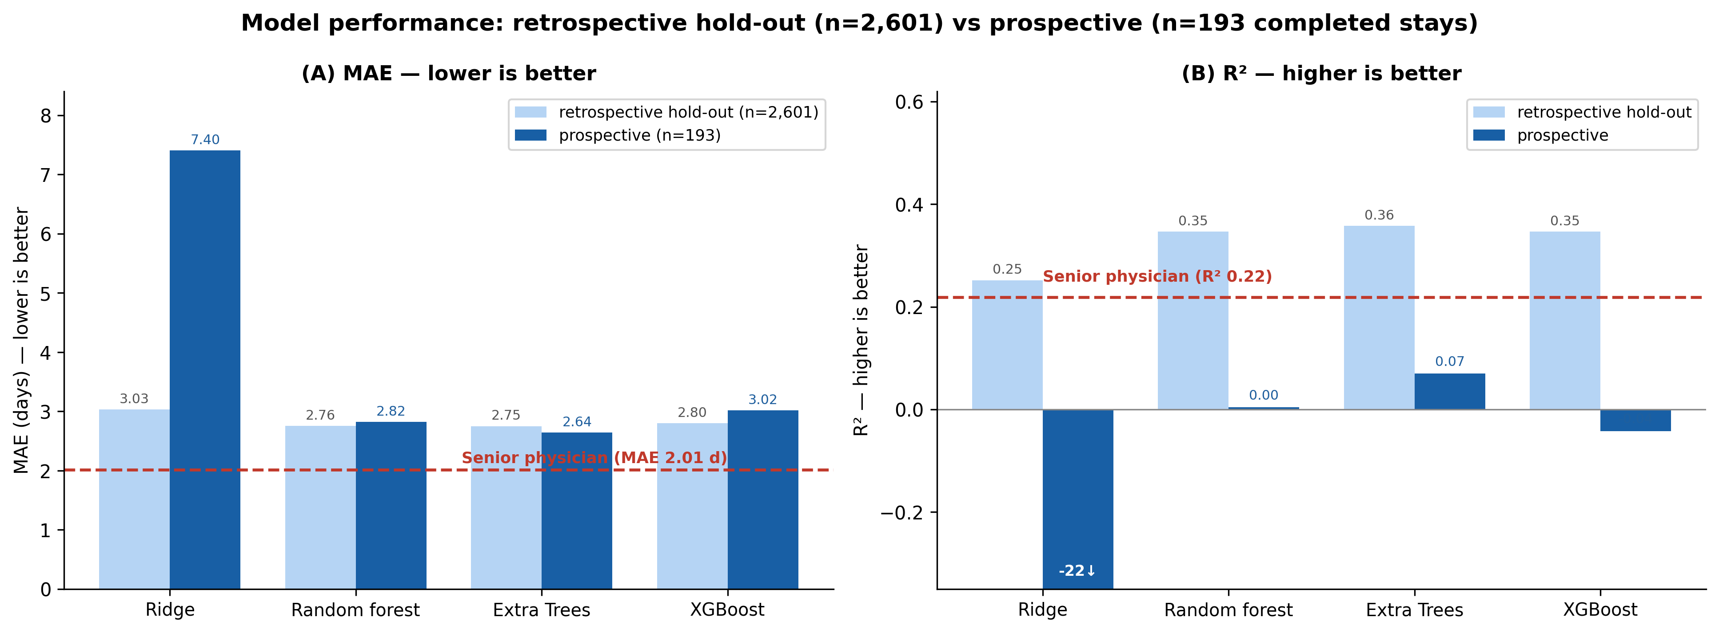
Figure 1. Model performance on the retrospective holdout test set (n = 2,601 stays) and the prospective cohort (n = 193 completed stays). (A) Mean absolute error (MAE, days; lower is better). (B) R² (higher is better; Ridge's prospective R² of −22 is off-scale and annotated ↓). Dashed red lines mark the senior physician. The two panels together show why MAE alone is misleading: for the final model (Extra Trees) the prospective MAE (2.64 d) is similar to the retrospective MAE (2.75 d), yet prospective R² collapses from 0.36 to 0.07 — the prospective case-mix has shorter stays, so absolute errors remain small while explanatory power is largely lost. The senior physician exceeds every model on prospective R². This loss is characterised further by the calibration analysis (Figures 6–8, Tables 7–8).
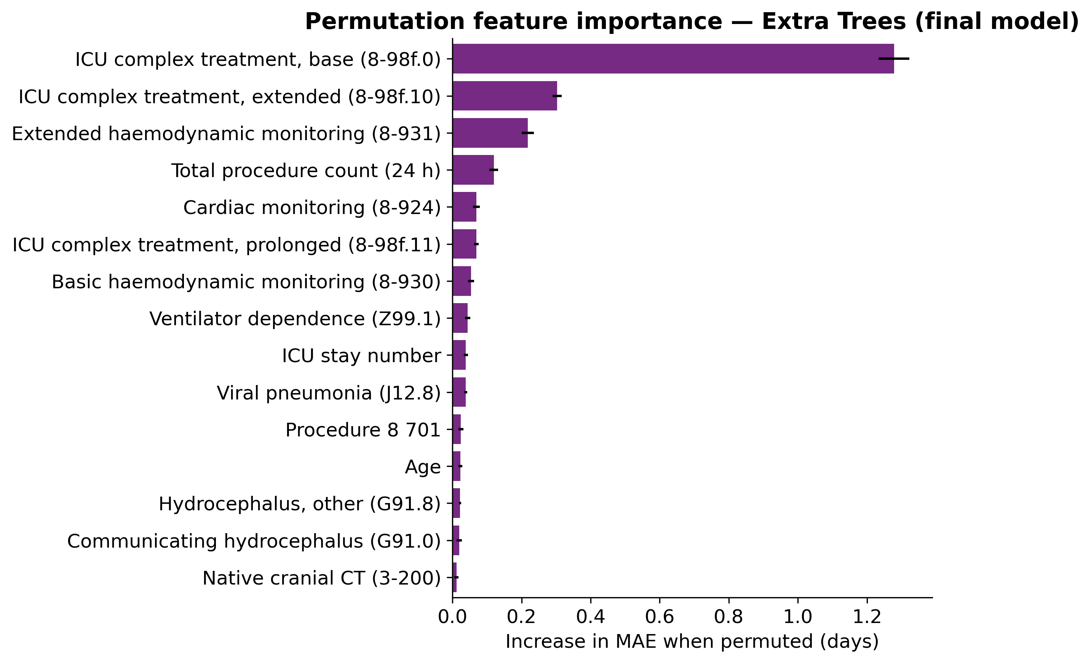
Figure 2. Permutation feature importance of the final model (Extra Trees) on the retrospective holdout test set: mean increase in MAE (days, ± SD over 10 repeats) when each predictor is independently permuted. ICU complex-treatment procedure codes dominate by a large margin. Features with Δ MAE < 0.01 d are omitted for clarity.
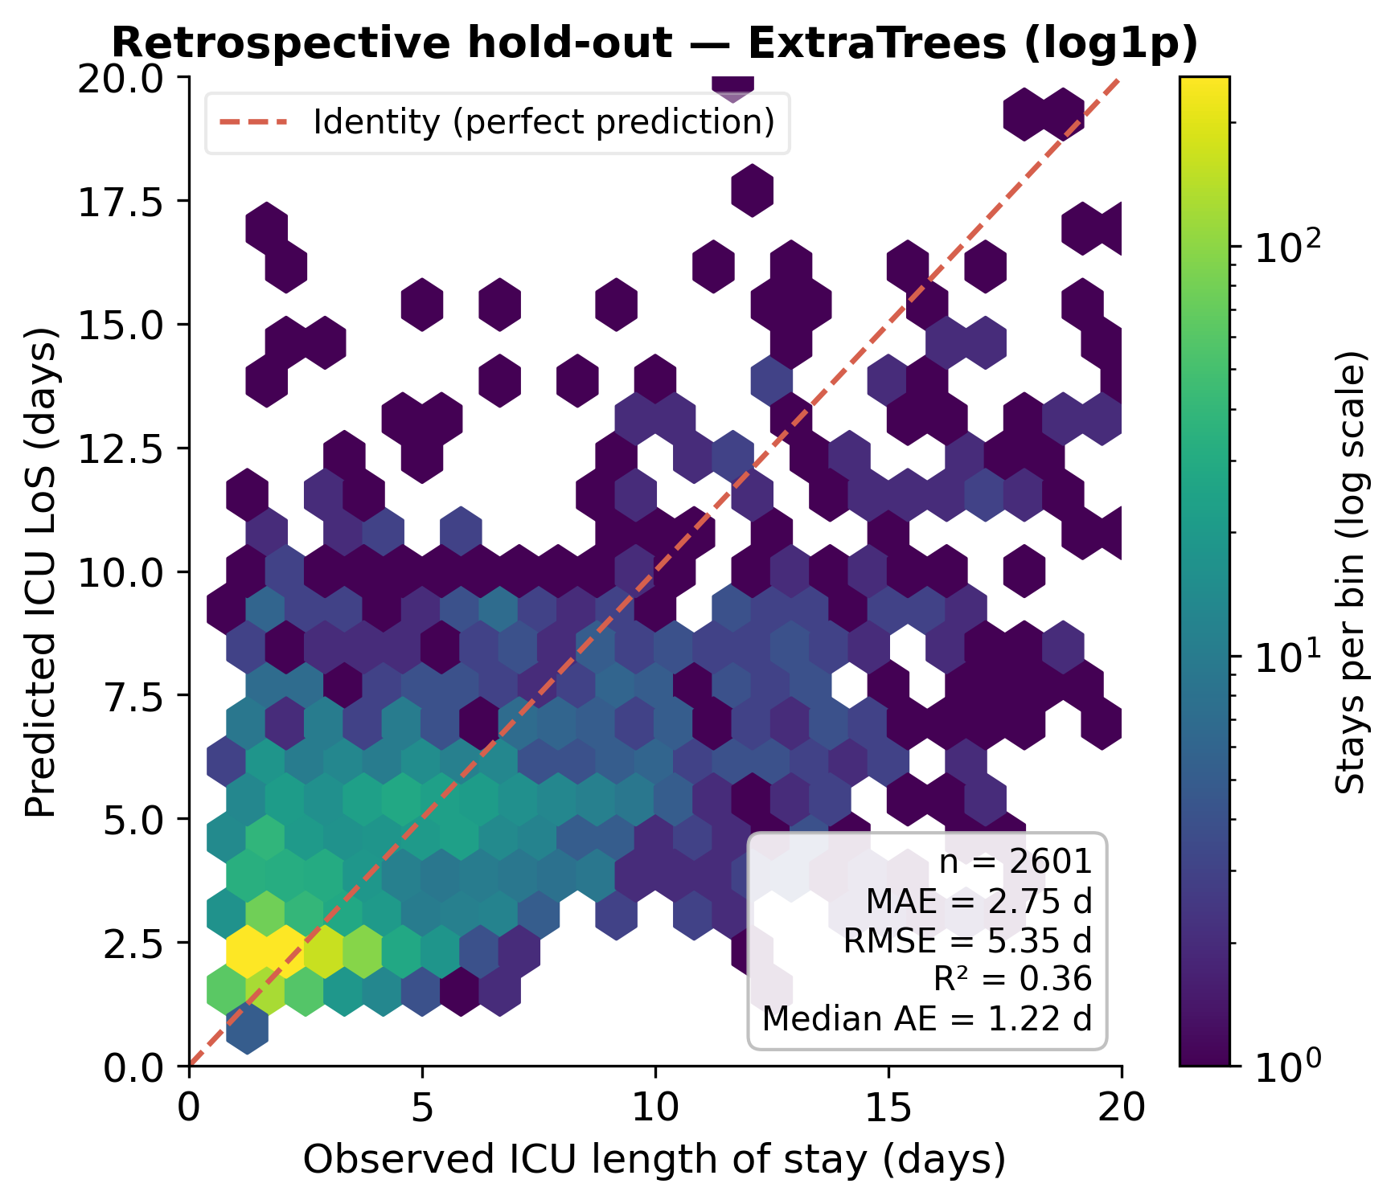
Figure 3. Retrospective holdout — observed vs predicted ICU LOS: final model (Extra Trees, n = 2,601). Axes truncated at 20 days; metrics in the inset are computed on all stays including those beyond 20 days. Colour encodes the number of stays per hexagonal bin on a log scale. The dashed red line = identity (perfect prediction). Systematic underestimation of very long stays (> ~ 7 days) is visible as the predicted values plateau while observed values continue to grow (points drift below the identity line). Discrimination: R² = 0.36. Calibration: mean bias -1.08 days (systematic underestimation).
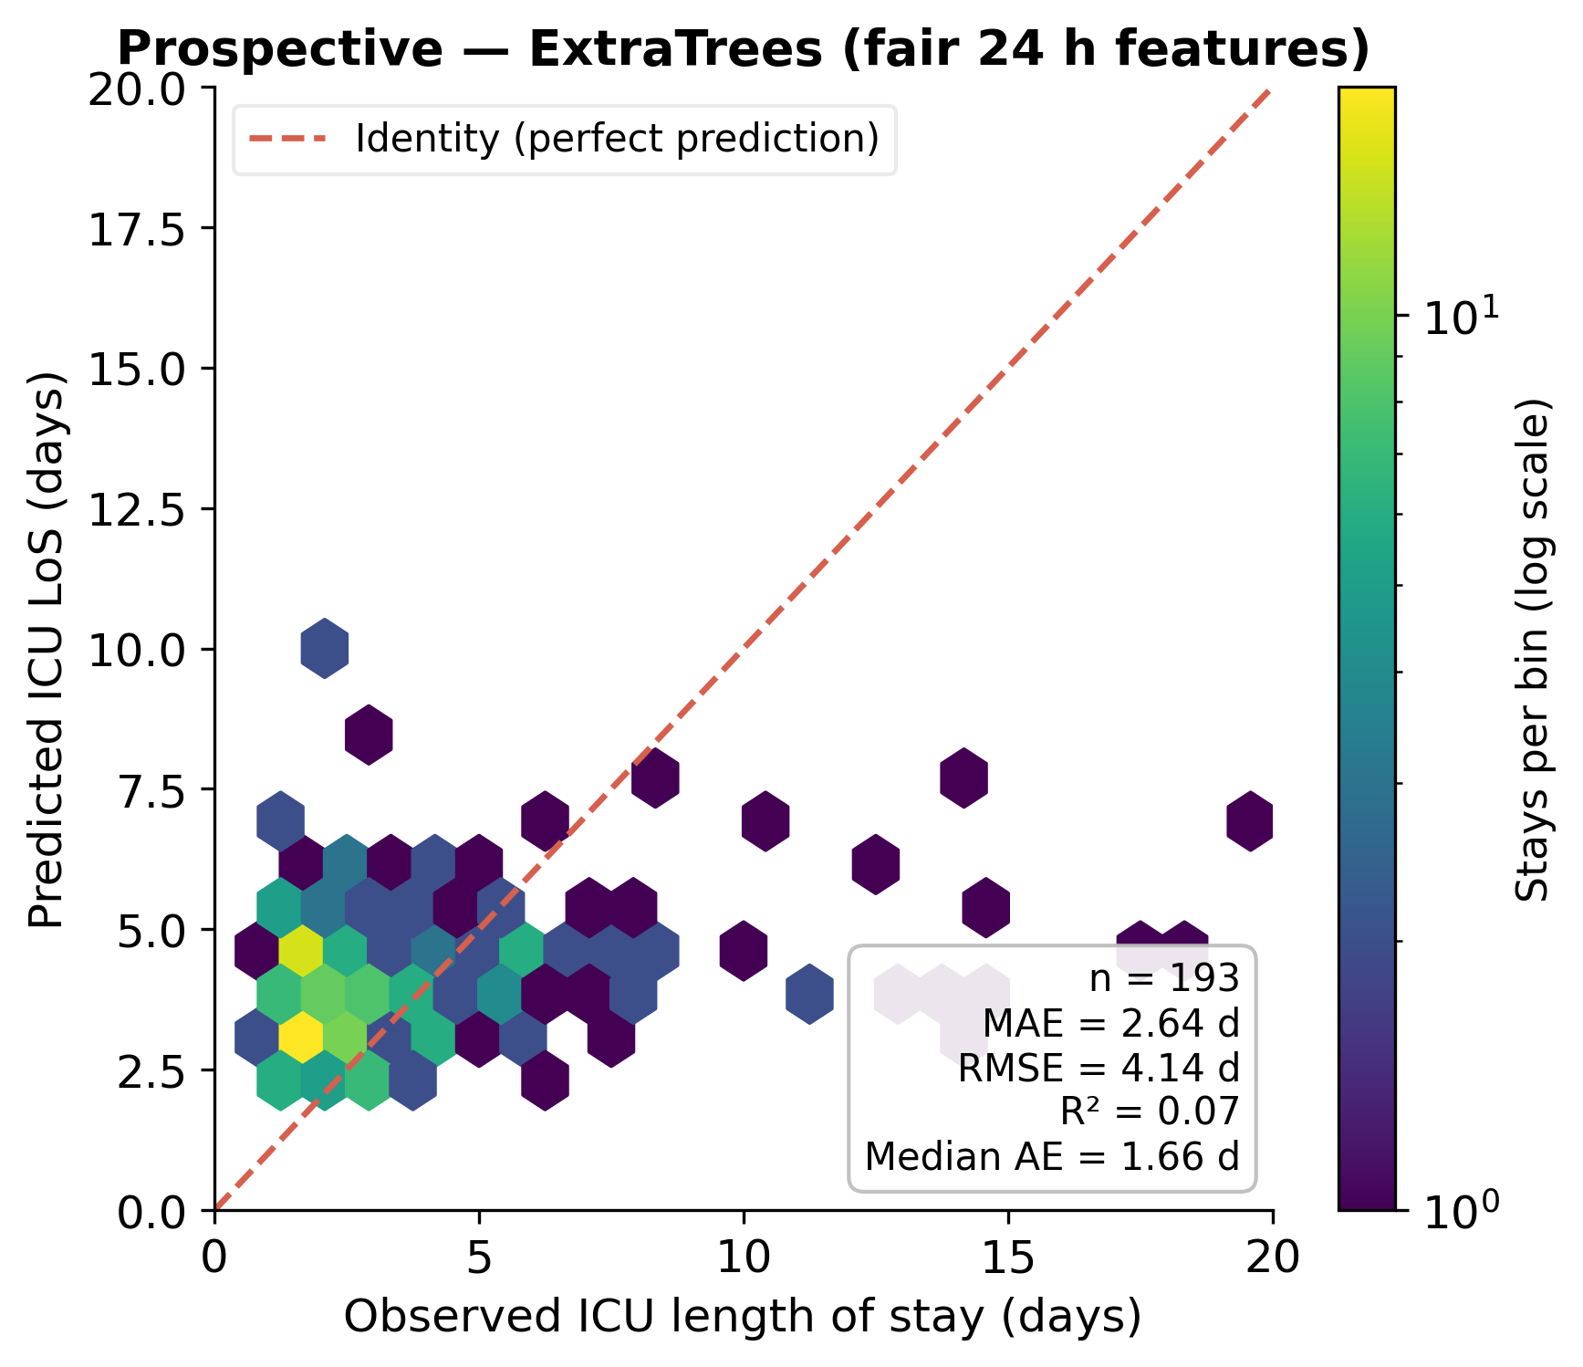
Figure 4. Prospective cohort — observed vs predicted ICU LOS: final model (Extra Trees, n = 193 completed stays). Axes truncated at 20 days; metrics computed on all stays. Features were rebuilt from raw prospective records (86% coverage). Discrimination: R² = 0.07, Spearman ρ = 0.22. Calibration: mean bias -0.11 days (nearly unbiased). The underestimation of long stays persists qualitatively, consistent with the retrospective pattern.
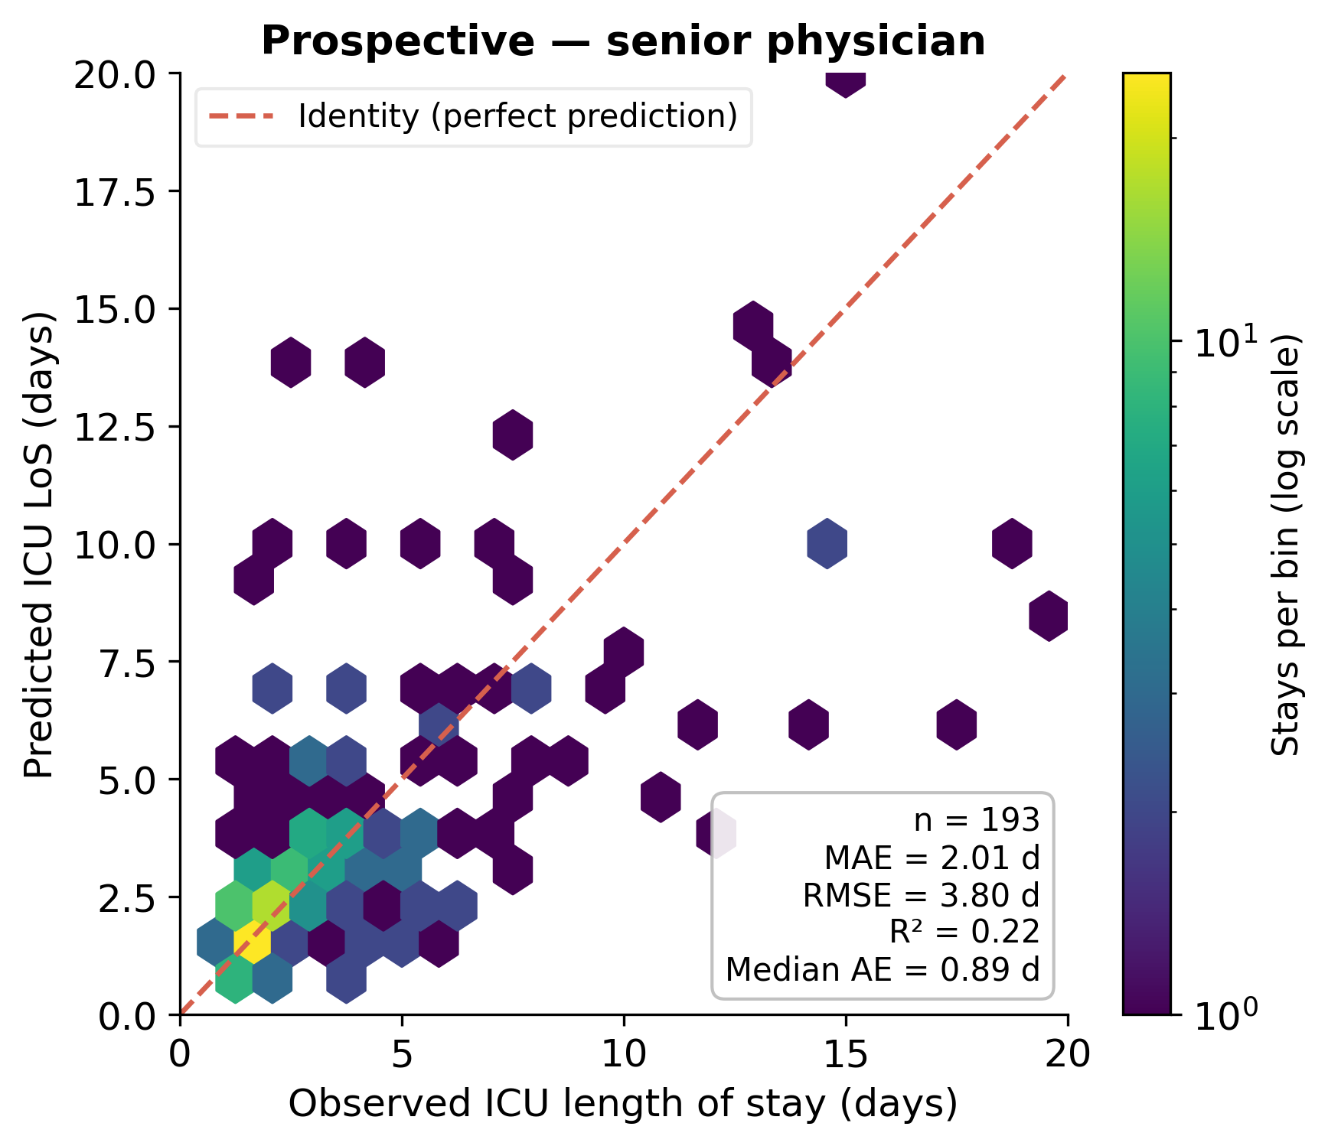
Figure 5. Prospective cohort — observed ICU LOS vs senior-physician estimate (n = 193 completed stays). Axes truncated at 20 days. Discrimination: R² = 0.22, Spearman ρ = 0.68. Calibration: mean bias -0.14 days (nearly unbiased). The physician shows better tracking of long-stay patients than any ML model (visible as tighter scatter around the identity line beyond ~ 5 days).
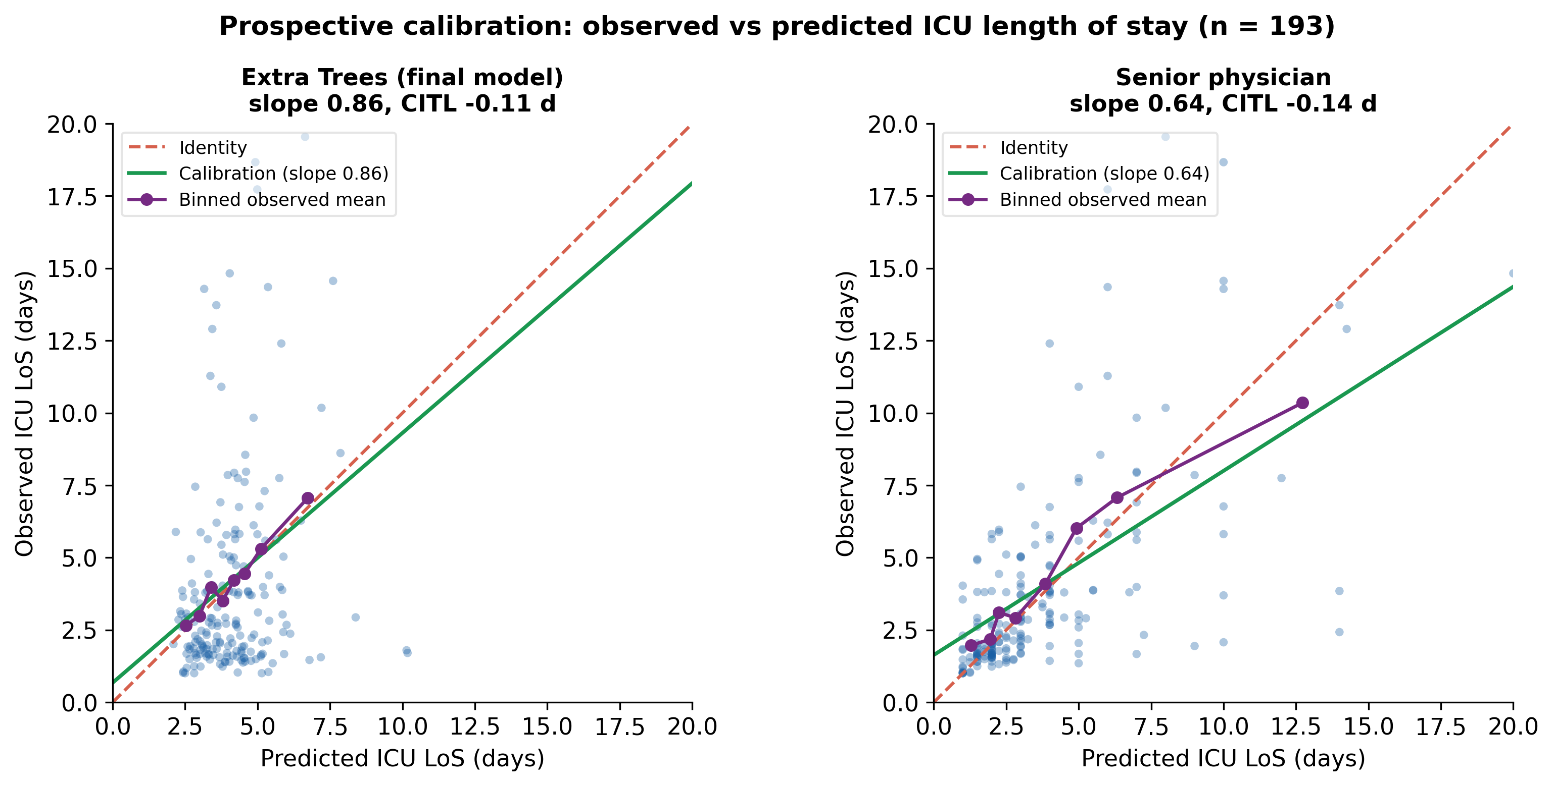
Figure 6. Prospective calibration (n = 193): observed vs predicted ICU LOS for the final model (Extra Trees, left) and the senior physician (right). Dashed red = identity (perfect calibration); green = calibration line (least-squares fit of observed on predicted); purple = quantile-binned observed means. The model's shallow, compressed prediction cloud (calibration slope 0.86) contrasts with the physician's wider spread. CITL = calibration-in-the-large (overall mean bias).
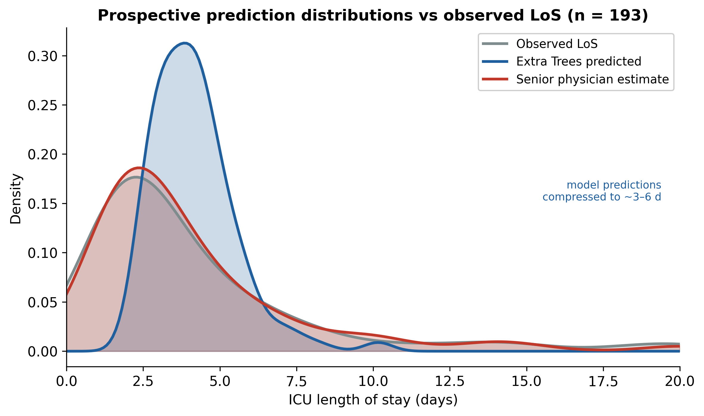
Figure 7. Distribution of predicted ICU LOS for the final model (Extra Trees) and the senior physician vs the observed LOS distribution (prospective cohort, n = 193). The model's predictions concentrate in a narrow ~ 3-6-day band, whereas observed LOS and the physician's estimates span a much wider range - the visual signature of the model's compressed prediction range (low calibration slope).
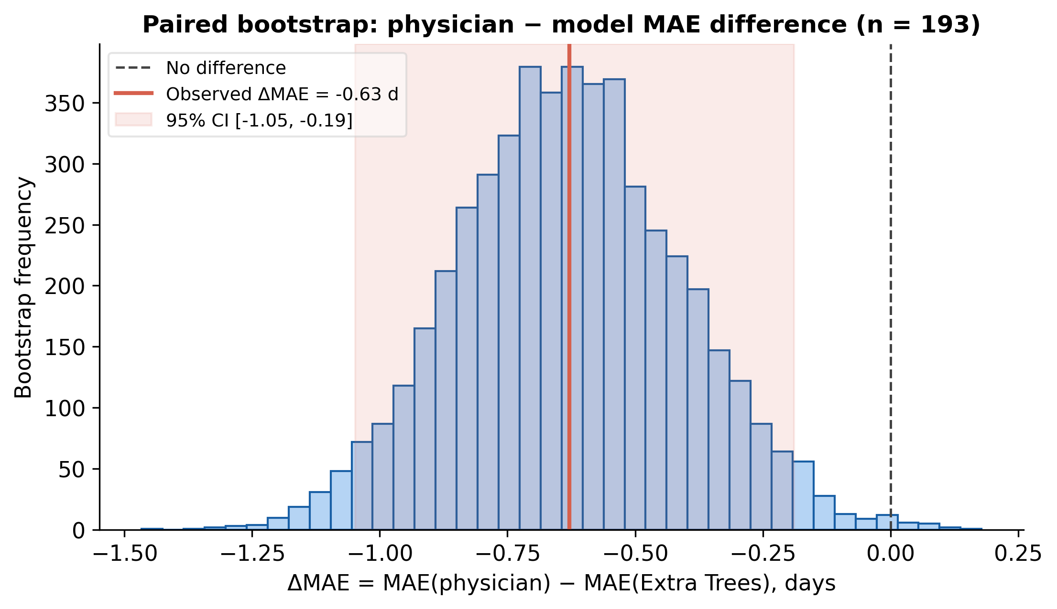
Figure 8. Paired bootstrap distribution (5,000 resamples) of the MAE difference, physician minus final model (Extra Trees), n = 193. The observed difference (-0.63 [-1.05, -0.19] days) and its entire 95% CI lie below the no-difference line (0), indicating that the physician's lower MAE is statistically robust (Wilcoxon p <0.001).
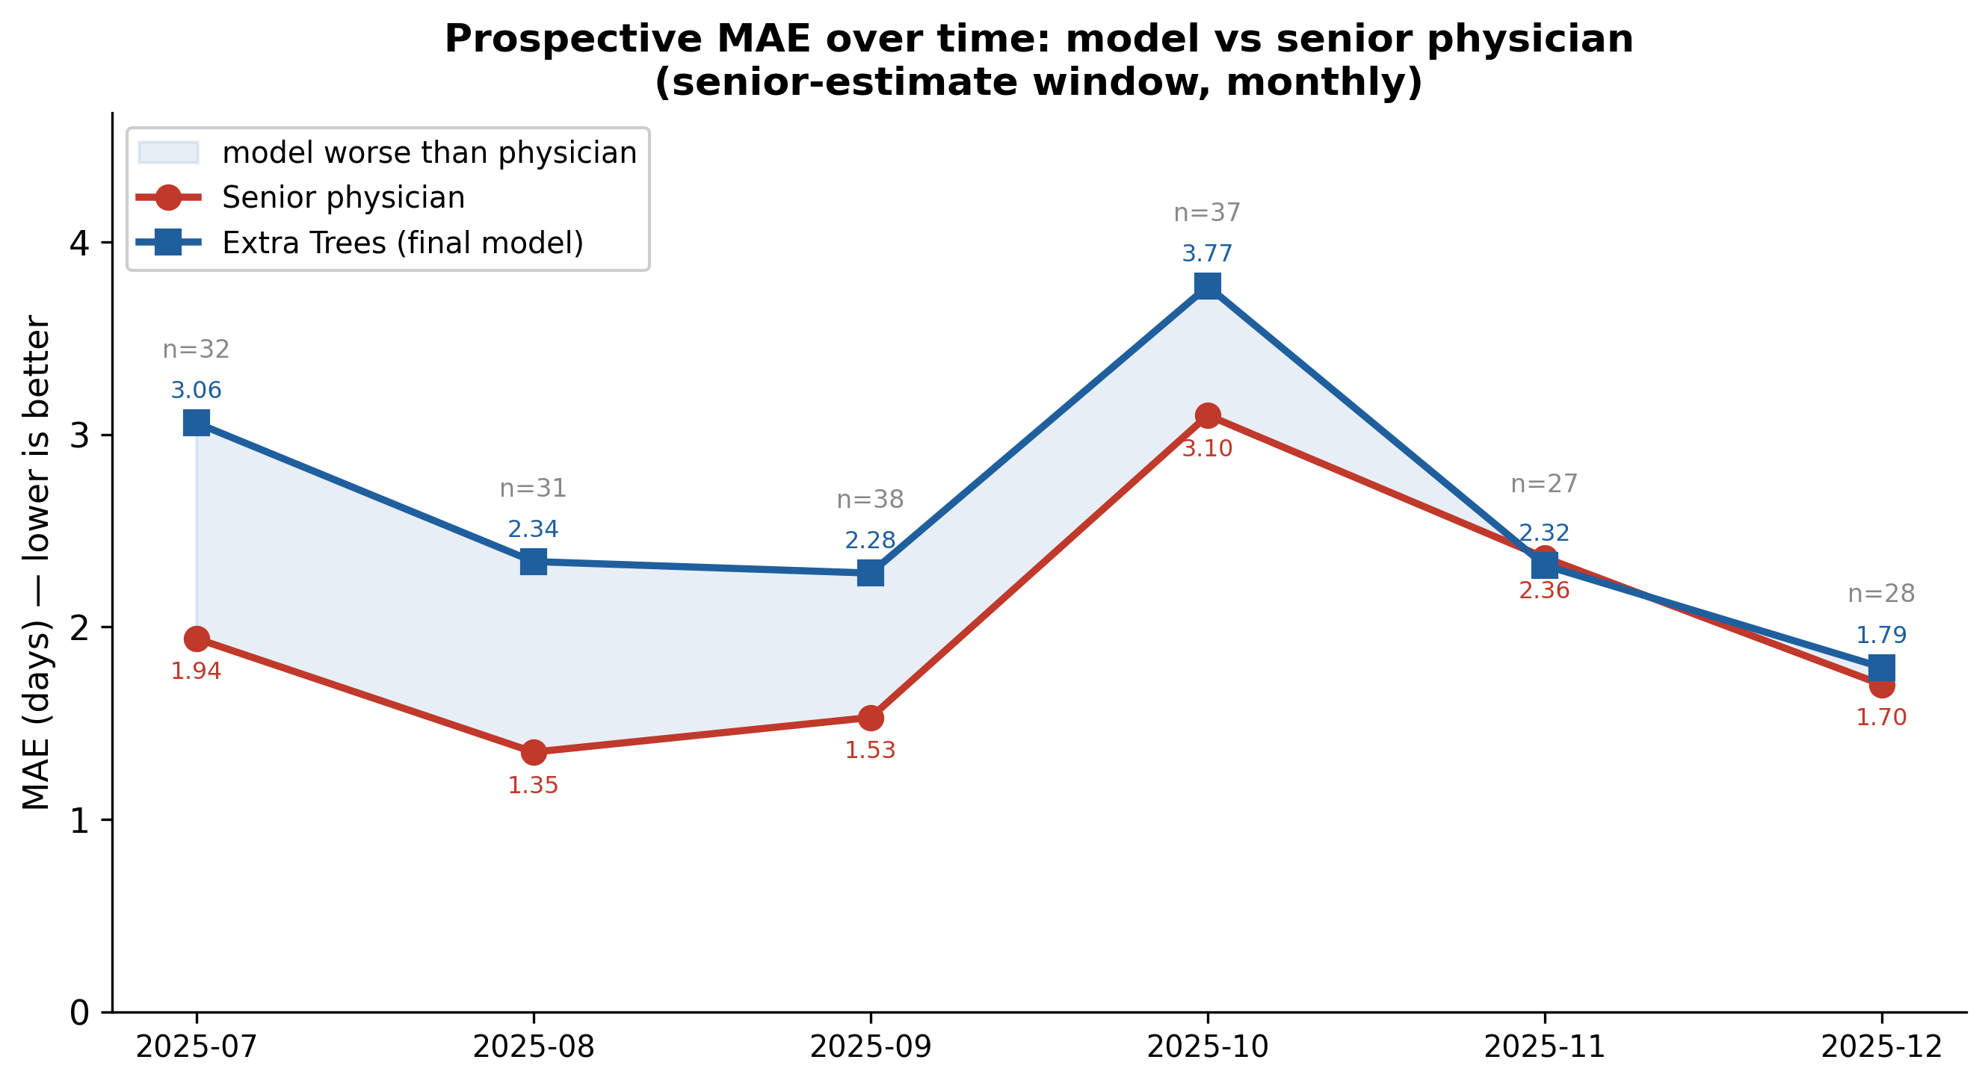
Figure 9. Prospective MAE over time: final model (Extra Trees) vs senior physician, by calendar month of the senior-estimate window (July–December 2025; n per month annotated). The physician (red) lies at or below the model (blue) in every month, confirming that the physician advantage is temporally stable rather than driven by a single period; the two converge only in November–December (Table 10).
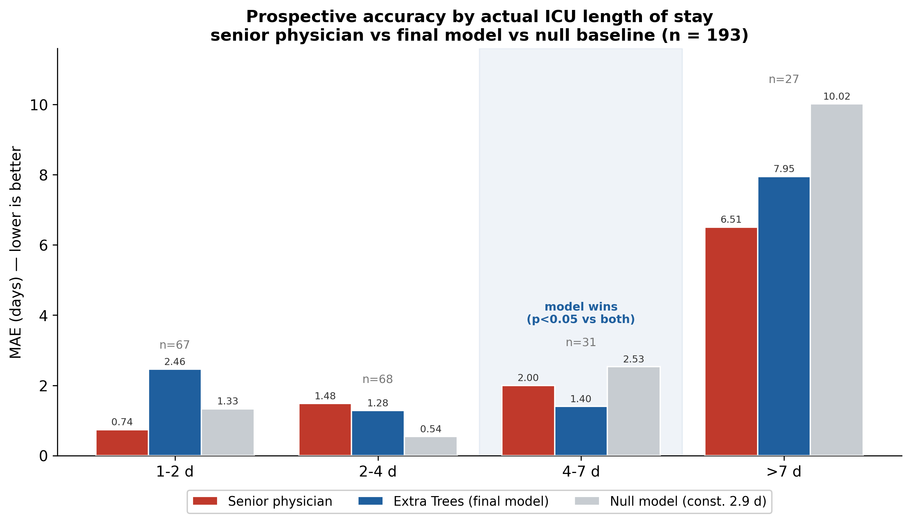
Figure 10. Prospective MAE by bin of the ACTUAL ICU LOS (n = 193): senior physician (red), final model (Extra Trees, blue) and the null model (constant 2.9 days, grey). The physician is best at the extremes (1–2 d and > 7 d). The model is lowest only in the 4–7-day band, where it significantly beats both the physician and the null model (Table 11). In 2–4 days a constant predictor is best because the bin coincides with the constant value. Stratifying by the true outcome favours predictors whose output concentrates in a bin, so this should be read alongside the overall calibration (Figure 6).

