**Energy Efficiency and Conservation Promotion Financing Project**

**Business Process Manual**

**(for IFIs)**

Version 2.1c (for UAT 1 and JICA resubmission)  
as of 28December 2017

Revision record

|  |  |  |  |
| --- | --- | --- | --- |
| Ver | Status | Date | Note |
| 1.0 | SREDA approved | 00 May 2017 | On the occasion of 1st NOC issuing |
| 2.0e | JICA commented | 30 Nov 2017 | First JICA reviewing |
| 2.1c | Drafted | 28 Dec 2017 | Incorporating JICA comments |
|  |  |  |  |
|  |  |  |  |
|  |  |  |  |
|  |  |  |  |

[1] Major revisions from Version 2.0e:

Both SREDA and IFIs Manuals:

(1) Flow chart for process No.21 “Loan Decision” amended so that disapproval will terminate the process (no returning, neither to No.14 “Name Clearance” nor No.20 “Due Diligence”).

(2) New process No.25.1 “Preparing Eligible Appliances List” added.

IFIs Manual:

(1) Process to prepare “Eligible Appliances List” newly added as process No.25.1

(2) B-type loan adjustment process simplified.

SREDA’s Manual:

(1) Temporary requirement during the pilot phase to check that Name Clearance has been conducted for all NOC requests added.

(2) Process to assess B-type loan appliances eligibility added.

(3) Term “survey” now harmonised with IFIs’ “on-site inspection”.

Annexes:

(1) Date fields added on Annex 2 form

(2) Annex 20 additionally introduced

(3) Annex 27 revised to include quantity and customer ID information

(4) Attached table on Annexes 25 and 28 revised in conformity with Annex 27

(5) Date fields added on some forms

[2] Reflection of JICA comments

c.f. Annex document.

Contents

General Provisions 0

1. Overview of EE&C Promotion Financing 0

1.1 Aim of the Facility 0

1.2 Executing Agencies 0

1.3 Fund 1

1.4 Modes of Lending 1

1.5 Subject of Loan 2

2. Basic Structure 3

2.1 Lender 3

2.2 Borrower 3

2.3Eligible Equipment (A-type loan) / Appliances (B-type loan) 3

2.4 Eligible Investment Cost 4

2.5 Timing of Loan Application and Appraisal (A-type loan) 4

2.6 Co-financing (A-type loan) 5

3. Lending Conditions 5

3.1 Applicant 5

3.2 Amount Threshold 5

3.3 Portion among the Total Eligible Amount 5

3.4 Interest Rate 5

3.5 Tenure 5

3.6 Grace Period 6

3.7 Repayment Mode 6

4. Security 6

5. Basic Principle for Business Process 6

6. Management Information System (MIS) 6

6.1 Function and Purpose of MIS 6

6.2 Information Security Features 7

7.Business Process Manuals 7

Part I A-type Loan: Formulationand Implementation 8

A-type Loan Appraisal Procedure 8

11. Preparation 14

12. Receiving Loan Applications 14

13. Preliminary Eligibility Checking 15

14. Name Clearance 16

15. Submit Request to SREDA for NOC 18

19. Forwarding NOC or Rejection Letter to Proponent 20

20. Due Diligence 21

20.1. Selecting Type of Due Diligence 21

20.2. Conducting Due Diligence 21

21. Loan Decision 23

22. Documentation for Loan 24

23. Disbursement 26

23.1. Completion of Disbursement 26

24. CheckingRepayment Status 27

24.1. Completion of Repayment 28

Part II B-type Loan: Formulation & Implementation 29

B-type Loan Formulation Implementation Procedure 29

25.Formulation of Structure 32

25.1Preparing Eligible Appliances List 32

25.2 PD Selection and Appointment 32

26.Loan Disbursementto PDs (Advance Payment Option) 33

26.1. Approving a PD for APO 33

26.2. Advance Payment Procedure 33

27. Sales Record Keeping 35

28. Loan Disbursement to PDs (Reimbursement Option) 36

29. Loan Repayment from PDs to IFIs 37

29.1. Adjustment against APO (Advance Payment Option) 37

29.2. Repayment 37

Part III Monitoring for A-type Loan 39

A-type Loan Monitoring Procedure 39

30. Managing Implementation Plan 41

31. Registration of User-ID and Password 41

32. Verification and Inspection 41

32.1. Document and Evidences on Purchasing and Installation 41

32.2. On-site Inspection 42

32.3. Requesting sub-project owners to submit required data andto cooperateforinspection 43

33. Environmental and Social Considerations 44

33.1. Environmental and Social Performance Report 44

33.2. Environmental and Social Management System (ESMS) Checklist 45

Part IV Monitoring for B-Type Loan 46

B-type Loan Monitoring Procedure 46

34. User-Registration for PDs 47

35. Inspection 47

35.1 Installation Inspection Reporting 47

35.2 Additional Information from PDs 48

Part V Reporting 50

42. Periodical Reports 50

42.1Quarterly Report (QPR) and Annual Report (AR) 50

42.2 Ongoing Sub-Projects Summary and Financial Report (Annex 367) and Statement of Expenditure 51

43. Supplemental Information 51

44. Incidental Reports 52

Notes on Editing:

Yellow marker : Reference to formats and processes

Blue marker : Reference to MIS function (tentative)

Red marker : Reference to ICT information tool external to MIS

Acronyms

|  |  |
| --- | --- |
| AR | Annual report |
| APO | Advance payment option |
| BDT | Bangladesh taka (currency) |
| BIFFL | Bangladesh Infrastructure Finance Fund Limited |
| CEO | Chief Executive Officer |
| CIB | Credit Information Bureau (of Bangladesh Bank) |
| CRG | Credit Risk Grading (of Bangladesh Bank) |
| D/D | Due diligence |
| DLD | Delay liquidated damage |
| DSRA | Debt service reserve account |
| EE&C | Energy efficiency & conservation |
| ESCO | Energy service company |
| ESMS | Environmental and Social Management System |
| FR | Functional requirement |
| ICT | Information and communication technology |
| ID | Identification |
| IDCOL | Infrastructure Development Company Limited |
| IFI | Implementing financial institution |
| ISO | International Organization for Standardization |
| JICA | Japan International Cooperation Agency |
| JPY | Japanese yen (currency) |
| L/C | Letter of credit |
| MFI | Microfinance institution |
| MIS | Management information system |
| MOF | Ministry of Finance |
| MPEMR | Ministry of Power, Energy and Mineral Resources |
| N/A | Not applicable |
| NBFI | Non-bank financial institution |
| NGO | Non-governmental organisation |
| NOC | Non-objection certificate |
| p.a. | Per annum |
| PD | Participating distributer |
| PIU | Project implementation unit |
| PLD | Performance liquidated damage |
| QPR | Quarterly progress report |
| RAID | Redundant array of independent disks |
| RO | Reimbursement option |
| ROE | Return on equity |
| SC | Steering Committee |
| SPV | Special purpose vehicle |
| SREDA | Sustainable and Renewable Energy Development Authority |
| T/A | Technical assistance |
| TAC | Technical Advisory Committee |
| VPN | Virtual private network |

# General Provisions

## 1. Overview of EE&C Promotion Financing

### 1.1 Aim of the Facility

The aim of this Energy Efficiency & Conservation (EE&C) Promotion Financing Project (the “Project”) is to encourage the penetration of EE&C equipment in Bangladesh, so as to contribute to the development of sustainable society where power demand / supply balance is well under control. It is also expected to contribute to the reduction of greenhouse effect gas emissions.

The Project is one of Sustainable and Renewable Energy Development Authority (SREDA)’s concrete measures to promote EE&C on the demand side of energy. This Project is introduced in response to Bangladesh’s Seventh Five Year Plan (December 2015). In this strategic plan, SREDA’s mandate to contribute to demand side energy management through the provision of low interest loan is clearly mentioned.

### 1.2 Executing Agencies

There are three executing agencies for the Project, which are:

(1) Sustainable and Renewable Energy Development Authority (SREDA) as the administrative authority;

(2) Infrastructure Development Company Limited (IDCOL) as an implementing financial institution (IFI), and;

(3) Bangladesh Infrastructure Finance Fund Limited (BIFFL) also as an IFI.

Japan International Cooperation Agency (JICA), who has been supporting the Government of Bangladesh from the initiation and formulation of the Project, is supporting the implementation of the Project by despatching a technical assistance (T/A) task team for the Project. The T/A task team is directly supporting the project implementation units of the three executing agencies mainly by providing technical assistance on eligibility checking, energy conservation calculation and overall interpretation of these business process manuals. JICA will also support the Project Implementation by giving concurrence on the business processes including the Eligible Technology & Equipment List(Annex 4).

### 1.3 Fund

The original fund is the concessional loan extended from the Government of Japan (represented by JICA) to the Government of Bangladesh (represented by the Finance Division, Ministry of Finance).

|  |
| --- |
| Note 1.3 (1):  JICA loan for the Project is as follows:  - Denomination: Japanese Yen (JPY)  - Amount: JPY 11.988 billion (among which JPY 9.978 billion is allocated for loan fund)  - Interest rate: 0.01%  - Tenure: 40 years  - Grace period: Initial 10 years is the grace period (only interest will be paid back).  - Loan Agreement: June 2016 |

The loan fund allocation between the IFIs will be equal, i.e. the same amount for IDCOL and BIFFL. With an aim to make use of the fund efficiently, there will be a mechanism for revision and adjustment of the fund allocation.

The Steering Committee of the Project should closely monitor the implementation progress of each IFI and if any of the IFIs is found to be slow in implementation compared to the other IFI, the Steering committee will suggest reallocating necessary amount of the remaining fund from one IFI to the other. Both IFIs would take immediate action to comply with the decisions of the Steering Committee in this regard.

Definition:

The “remaining amount” is the total available fund amount minus (i) used amount, and (ii) earmarked amount.

The “used amount” is the amount of loan allotted for sub-project loan agreement.

The “earmarked amount” is the amount of loan for sub-project applications for which NOC has been issued.

In case any of the following circumstances occurs, the fund allocation will be reviewed and adjusted:

(i) When an IFI’s allocated loan amount is almost entirely used or earmarked;

(ii) When an IFI desires to waive all or a portion of the allocated loan amount;

(iii) When a period of 2 years passes after the last allocation decision.

### 1.4 Modes of Lending

The fund is extended to the IFIs who manage and make it available for the sub-project owners in line with SREDA’s policy.

Project Executing Agency: (administrative authority)

Sustainable and Renewable Energy Development Authority (SREDA)

Other dev’t partners

JICA

Ministry of Finance (MOF)

Implementing Financial Institutions (IFIs): IDCOL / BIFFL

Participating Distributors (PDs)

Sub-project proponents (Factories, commercial facilities, etc.)

End user (Residential and small businesses)

Lending / borrowing

Payback

A-type loan

B-type loan

Participation agreement

Installment sales

EE&C appliances

Data collection and reporting

Policy and manuals

Project entrustment

On-lending Loan

Subsidiary loan

Source: JICA (2016) Preparatory Survey for Energy Efficiency and Conservation Promotion Financing Project Final Report

Figure 1 Project Structure

There are two channels for extending the EE&C promotion financing loan, which are:

(a) A-type loan: IFIs lend money directly to the companies and organisations who are introducing the EE&C equipment, and;

(b) B-type loan: There is an intermediary distribution organisation called “participating distributors (PDs)” who supply EE&C equipment (home appliances).

### 1.5 Subject of Loan

EE&C promotion financing is designed to cover three components which are:

(a) Component I : Industry / commercial sector component

(b) Component II : Building sector component

(c) Component III : Home appliances component

Loans for components I and II are extended through A-type loan channel, while loan for component III is extended through B-type loan channel.

Table 1 Three components as the subject of the Loan

|  |  |  |  |
| --- | --- | --- | --- |
| Component | User | Subject of loan | Supporting mechanism |
| (Component I) Industry / commercial sector component | Companies and other organizations | Energy efficient “listed” equipment at factory, office, commercial facility, etc. | Energy management and auditing |
| (Component II)  Building sector component | Companies and other organizations | Energy efficient “listed” equipment in buildings | Green building rating programme |
| (Component III) Home appliances component | Households and small businesses | Energy efficient “listed” home appliances | Energy efficiency labelling programme |

Source: JICA (2016) Preparatory Survey for Energy Efficiency and Conservation Promotion Financing Project Final Report

Each application for the loan will become the “sub-projects” under this EE&C Promotion Financing Project.

## 2. Basic Structure

### 2.1 Lender

Implementing financial institutions (IFI)s, which are currently the following two NBFIs:

(a) Infrastructure Development Company Limited (IDCOL)

(b) Bangladesh Infrastructure Finance Fund Limited (BIFFL)

### 2.2 Borrower

* A-type loan (for components I and II): Company or any other organisation who intends to acquire eligible EE&C equipment(= sub-project “proponent”).
* B-type loan (for component III): Participating Distributors (PDs) who sell eligible EE&C appliances.
* Note that energy service(ESCO) businesses and other services who do not acquire the EE&C equipment on their own are not eligible to this loan facility.

### 2.3Eligible Equipment (A-type loan) / Appliances (B-type loan)

* In A-type loan, eligibility should be confirmed by SREDA for each loan application (against stipulations in the Eligible Technology & Equipment List = Annex 4). The Eligible Technology & Equipment List is a predefined list of technologies and equipment as prescribed during the Project formulation.
* In B-type loan, PDs may sell the appliances that are in the “Eligible Appliances List (Annex 20): tentatively included in third part of Annex 4”. SREDA, based on advice from Technical Advisory Committee (TAC), will determine the eligibility of a given appliance.
* Eligibility criteria will be determined by the TAC prior to the launching of the Component III, and shall be approved by the Steering Committee (SC). Further specific business process for Component III shall be determined at the SC.

### 2.4 Eligible Investment Cost

Only the cost for introducing (purchasing) eligible EE&C equipment will be the subject of the loan. SREDA, when judging the eligibility of the equipment, may also include ancillary and relevant costs such as the followings as the integral subject of the loan. For components I and II:

* + Transport, assembly and installation;
  + Training and technical transfer;
  + Customs insurance and other administrative costs and commissions;
  + Auxiliary / ancillary equipment, connection and accessories,
  + Other incidental costs.

While for component III:

* + Delivery and installation.

### 2.5 Timing of Loan Application and Appraisal (A-type loan)

For A-type Loan, an IFI’s appraisal for potential sub-projects should take place prior to the actual procurement of the equipment. The letter of credit (L/C) account for purchasing the EE&C equipment may nevertheless, be opened prior to the approval of the loan.

There are exceptional cases where the Project loan may be extended for refinancing the existing loan. This will be applicable to sub-projects which are applied and authorised prior to the actual mobilisation of the Project loan.Such sub-projects should be from the pilot sub-project list which was shared and agreed by SREDA, IDCOL, BIFFL JICA and the JICA T/A task team.

|  |
| --- |
| Note 2.5:  “Pilot phase” is when sub-project formulation, appraisal and implementation are conducted prior to the full-fledged start of the Project. Ten pilot sub-projects were listed up for this purpose (6 for IDCOL and 4 for BIFFL).  The Project will start in full-fledge when the following three conditions are met:  (1) Technical Assistance Project Proposal (TAPP) is approved by the Planning Comission;  (2) IFIs have completed their consultants’ procurement, and;  (3) MIS for the Project enters into service. |

### 2.6 Co-financing (A-type loan)

The use of any other preferential financing facility (e.g. governmental, international development bank, etc.) may not hamper access to this EE&C promotion finance. The rest of the sub-project cost may be funded from any other funding source.

## 3. Lending Conditions

### 3.1 Applicant

During the pilot phase (10 pilot sub-projects are selected for priority appraisal), a proponent may submit only one application regardless of the receiving IFI.

Throughout the Project period, a proponent may submit only one application for one investment activity / site. Cross checking of the multiple application will be conducted at SREDA in parallel with the eligibility checking. IFIs are encouraged to confirm with the sub-project proponents about the existence of any other applications to the same Project loan (including application to other IFIs).

### 3.2 Amount Threshold

Maximum amount for a single sub-project is BDT 1 billion (pending, to be confirmed with the executing agencies after the completion of pilot sub-projects approvals).

Minimum amount for a single loan application is temporarily set at BDT 5 million.

### 3.3 Portion among the Total Eligible Amount

For A-type loan, the IFIs may, from time to time, restrict the loan amount to certain portion of the sub-project’s eligible cost.

### 3.4 Interest Rate

Standard (minimum) interest rate for A-type loan is 4%. For B-type loan the standard interest rate for lending from IFIs to PDs is 4%, resulting in on-lending to the EE&C appliances purchasers at the interest rate of 8%. IFIs may suggest otherwise depending on the financial appraisal result.

### 3.5 Tenure

Tenure period is set depending on the nature of the sub-projects. IFIs shall conduct financial analyses to identify an appropriate tenure period for each sub-project, to be agreed with the sub-project owner.

### 3.6 Grace Period

For components I and II, the IFIs may grant grace period for the loan, with respect to the nature of the sub-projects.

### 3.7 Repayment Mode

In principle, monthly repayment is encouraged. Quarterly payment may also be considered with respect to the nature of the sub-projects. IFIs and sub-project owners may suggest an appropriate repayment mode to be mutually agreed upon.

## 4. Security

For components I and II, IFIs, in most of the cases, ensure adequate security in the form of collateral and / or guarantee against the whole or part of the loan amount.

## 5. Basic Principle for Business Process

With the aim to promote the use of this loan facility the business process at SREDA as well as at the IFIs are kept to minimum complexity.

## 6. Management Information System (MIS)

The MIS is an ICT system accessible on public internet for by the stakeholders to the Project, who are SREDA, IFIs, PDs, sub-project owners, as well as by MPEMR, JICA, among others.

### 6.1 Function and Purpose of MIS

The Management Information System (MIS) is developed and introduced for the following purposes:

* To record and manage the progress of the Project;
* To standardise and control the business process of the Project;
* To enable the executing agencies to produce reports, and;
* To store energy usage and production related data.

The MIS, intentionally, does not offer the following functions:

* Transactions and fund transfer,
* Accounting and fund balance management,
* Credit information
* Borrowers’ identity and any other information.

### 6.2 Information Security Features

The MIS is designed to ensure security against data loss, leakage, and tampering through the following measures:

* Logging in with ID and password;
* Access through VPN;
* Data encryption, and;
* RAID data storage.

Although every possible and realistic security measures are in place, there is always a risk of information security incident. The system, however unlikely it may be, must be prepared for such incident. The MIS, for this reason, does not possess sensitive and confidential information, notably information related to creditworthiness, financial transaction and personal data.

## 7.Business Process Manuals

There are eight different manuals which stipulate the business processes in relation to this Project:

* System Specification Manual (*)
* System Administrator’s Manual (*)
* Business Process Manual for SREDA
* Business Process Manual for IFIs
* Business Process Manual (Annexes)
* Business Process Manual (Appendix: Minutes of Discussions)
* Sub-Project Owner’s Manual
* PD’s Manual

Note (*): these manuals are beingdeveloped by the system application developer

# Part I A-type Loan: Formulationand Implementation

## A-type Loan Appraisal Procedure

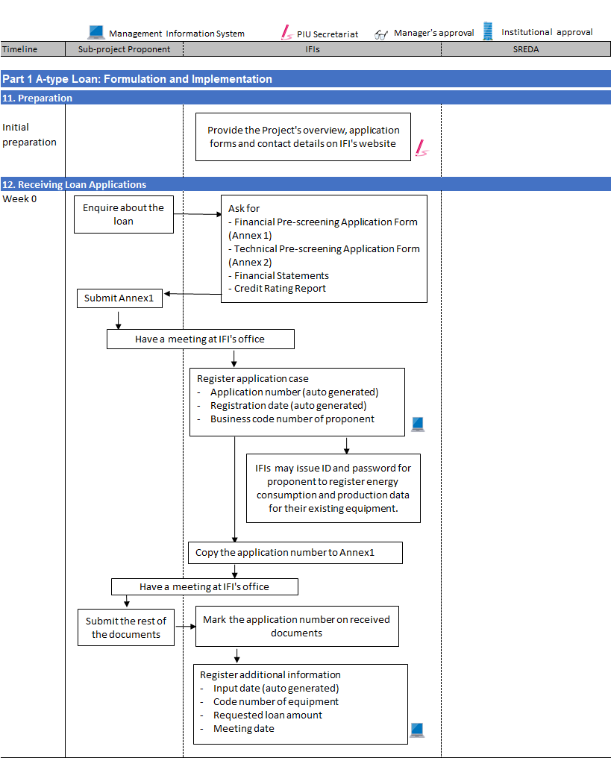

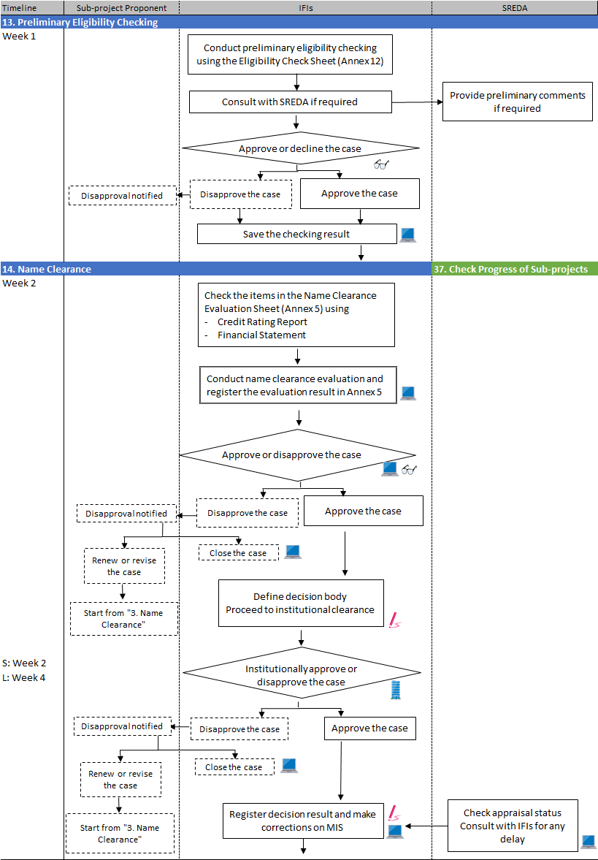

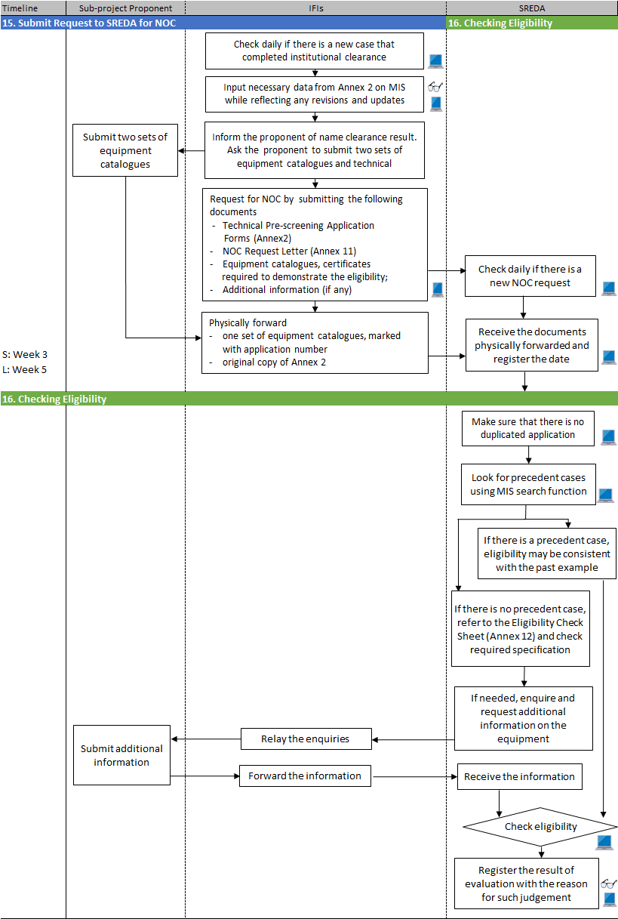

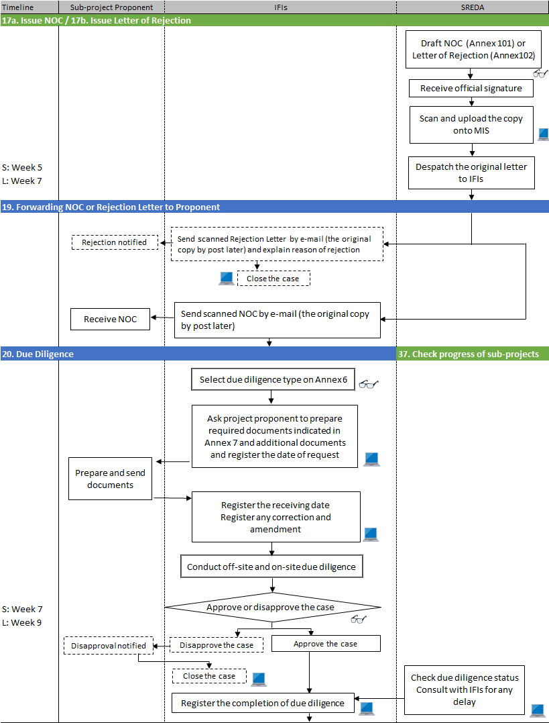

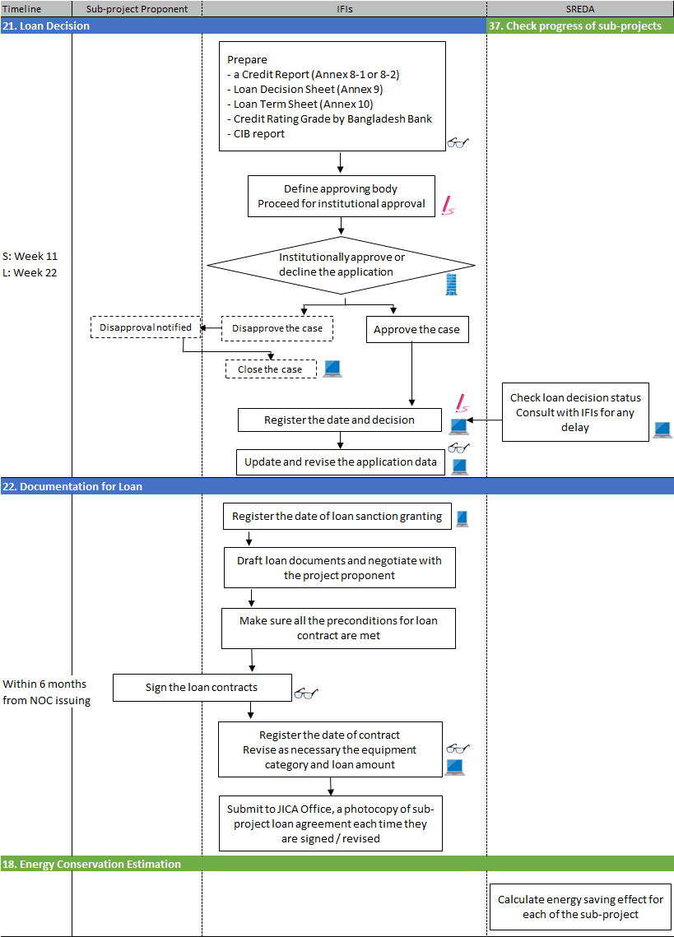

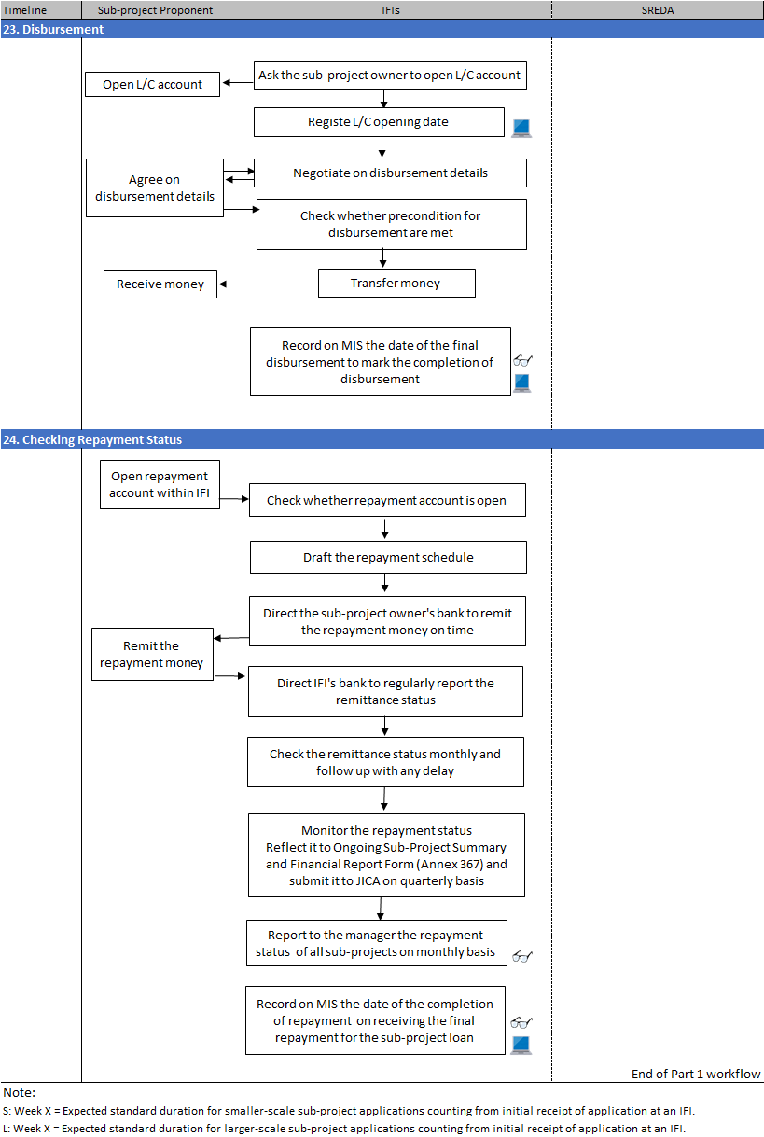

## 11. Preparation

PIU Secretariat

* Disclose overview information on Energy Efficiency and Conservation Promotion Financingloan facility together with application forms on the IFI’s website.
* Remember to clarify (i) enquiryemail address,(ii) phone number and (iii) working hours on the website for the convenience of contact from sub-project proponents (hereafter “proponents”).

## 12. Receiving Loan Applications

Officer in charge

* Respond to enquiries from the proponentson phone and / or email.
* Request the proponent to prepare the documents below:

(a) Financial Pre-screening Application Formsas in Annex 1;

(b) Technical Pre-screening Application Formsas in Annex 2  
(with catalogues, certificates and other technical information attached);

(c) Financial Statements for the last 3 years;

(d) Credit Rating Report, if available.

* Ask the proponent to send the document (a) above by email attachment asking them to actually comeoverto the IFI’s office for a meeting.
* [MIS FR-01] On receiving the document (a), register the following items based on document (a), to create a new application dataon MISfor the case:   
  - Application number (automatically assigned upon registration);  
  - Registration date (automatically registered);   
  - Proponent’s line of business as code number (line of business code number is   
  to be chosen from the list as in Annex 3.

|  |
| --- |
| Note12 (1):  The ten digitsapplication number will be automatically assigned by MIS upon new registration. The numbering rule may be a combination of category, accepted date and sequential number. It begins with “A” for application, one character representing the IFI (“D” for IDCOL and “F” for BIFFL), date in six digits (yymmdd), followed by two numerical sequential digits (example: a 12th application received by IDCOL on 25th May 2017 shall be “AD17052512”, while a third application received by BIFFL on 5th of September 2018 shall be “AF18090503”). |

* After creating the application data, copy the application number from MIS screen to document (a).
* Invite the proponent for a meeting (at IFI office)and receive documents(b), (c) and (d)as mentioned previously. The documents may be in either electronic or hard copy format.
* After receiving the documents (b) to (d) from the proponent, mark the application number on the cover of thesedocuments.
* [MIS FR-02]After the meeting and having received documents (b) to (d), add the following information items ontoMIS application data:   
  - Additional input date (automatically registered);   
  - Category of equipment as code number, to be chosen from the Eligible   
  Technology & Equipment List as in Annex 4;   
  - Requested loan amount;   
  - Meeting date.

|  |
| --- |
| Note 12 (2):  IFIs may issue ID and password for proponents whose application has been registered on MIS (optional). By doing so, the proponents can register energy consumption and production data for their existing equipment. The data will be useful for SREDA as the baseline against the new EE&C equipment.  On loan agreement conclusion (process No. 22. Documentation for Loan), the IDs that were created in this process will automatically be succeeded to sub-project owner IDs. The IFI officer in charge can skip the process to issue an ID for the sub-project owner (process No. 31. Registration of User-ID and Password). |

## 13. Preliminary Eligibility Checking

Officer in charge

* Refer to the Eligible Technology & Equipment List(Annex 4) to identify the equipment code (category).
* [MIS FR-03] Conduct preliminary eligibility checking using the Eligibility Check Sheet(Annex 12), which is identical to the eligibility criteria which SREDA will refer to. Input equipment sequence number (automatically generated), equipment code (with reference to Annex 4) (name and specification will be automatically displayed) / model, manufacturer, supplier, quantity and quoted price. By doing so, an appropriate sheet for the applicable codewill be displayed. Go through each of the checkpoints to make sure that the listed equipment, as the subject of the loan, meets the requirements. Make sure that decision making elements and evidences are recorded in the “notes” fields.
* [MIS FR-03]Save the preliminary eligibility checking result for future reference at IFI (checking result may be revised / updated later as required. There is no need for approval as this is merely a record of internal procedure). The saved sheets will later (in process No. 15) be linked to the equipment details to be registered from information on Annex 2 (2).
* Discuss with the manager as required to consider whether to proceed with the said loan application from the viewpoint of eligibility.If in doubt, consult with SREDA for their preliminary comments.
* After discussing with the manager, proceed to Name Clearance either if: (i) the eligibility of the listed equipment has been preliminary confirmed, or (ii) the proponent agrees apply for eligible equipment.

## 14. Name Clearance

Officer in charge

* Use following information to check the items in Name Clearance Evaluation Sheetin Annex 5 on MIS:  
  - Credit Rating Report, and;  
  - Financial Statement.
* In addition to the above, collect information on the proponent through communications with the other financial institutions.
* [MIS FR-04]Go through the Name Clearance Evaluation Sheet (Annex 5) to decide whether the application can be forwarded to PIU secretarial for institutional name clearance decision, or should be rejected. Registerthe evaluation result (including final decision)onto MIS when going through the sheet.
* [MIS FR-04]Submit the application case to manager for approval.

Manager

* Discuss with the officer in charge concerning his / her observation on each of the Name Clearance Evaluation Sheet submitted.
* [MIS FR-05]Approve or decline the submitted application case based on the contents of the Name Clearance Evaluation Sheetshown on MIS and discussion with the officer in charge.

Officer in charge (for declined case)

* Communicate with the proponent explaining the reason for disapproval of the case.
* [MIS FR-06]Under accord of the proponent, close the application case.

Officer in charge (for revision / renewal of application case)

* If the proponent desires, and with consent of the officer in charge, the application case may be renewed / revised to retry for name clearance. In such case, obtain any further required documents.
* [MISFR-07]Edit the MIS data to reflect the renewal / revision of the application and start again from name clearance process.

PIU Secretariat (for approved case)

* [MIS FR-08]Browse the list daily to identify applications that are cleared by the manager for institutional decision on Name Clearance.
* Name Clearance approved by manager should follow the institutional decision process based on following criteria (decisionbodywill be defined depending on the rules set by the IFI as follows):

IDCOL:

|  |  |
| --- | --- |
| Loan amount | Decisionbody |
| Up to BDT 100 million | Management(CEO) |
| In excess ofBDT 100 Million | Board of Directors |

BIFFL:

|  |  |
| --- | --- |
| Loan Amount | Decision Body |
| Up to 500 Million BDT | Executive Committee (subject to future decision on delegation of power) |
| In excess of 500 Million BDT | Board of Directors |

|  |  |  |  |  |  |  |
| --- | --- | --- | --- | --- | --- | --- |
| Note 14 (1):  Target duration from loan application to Name Clearance completion (institutional decision on approval or rejection) shall be as follows:   |  |  | | --- | --- | | Decision Body | Duration | | CEO (IDCOL)  Executive Committee (BIFFL, subject to future power delegation) | Up to 2 weeks | | Board of Directors | Up to 1 month | |

* [MIS FR-09]Register Name Clearance institutional decision result, select decision making body and decision date. In case of declination, also record the reason for declining.
* [MIS FR-NA]Make corrections as required on MIS information such as:   
  - Approved loan amount;  
  - Approved/declined date and decision making body.

Officer in charge

* Inform the proponent of the Name Clearance institutional decision result.

## 15. Submit Request to SREDA for NOC

* [MIS FR-11]Browse the list daily to identify application cases that have completed the institutional decision on Name Clearance. These application cases are ready for NOC request.
* [MIS FR-12]For cases ready for NOC approval, retrieve the information registered during the preliminary eligibility checking and register onto MIS thefollowing information on Technical Pre-screening Application Forms (Annex 2) and equipment list, which was collected from the proponent in the first meeting as document (b). Reflect any revisions and updates that took place after the preliminary eligibility checking and during the name clearance process:  
   (1) Previous record of access to the Project Fund?   
   (2) Equipment information (for all equipment):   
   model number, manufacturer, and quantity, quoted price.  
   Sub-project information on green /brown field:
* [MIS FR-12] Submit the updated application data to manager for approval.

Manager

* Discuss with the officer in charge to make sure that the Technical Pre-screening Application Forms has been recorded correctly, with any necessary revisions and updates.
* [MIS FR-13] Approve or decline the submitted application case based on the contents of Technical Pre-screening Application Formsshown on MIS.

Officer in charge

* For application cases with Technical Pre-Screening Application Forms(Annex2)information registered on MIS approved by the manager, ask the Proponent to submit two sets of equipment catalogues, technical description documents that will be required for SREDA to refer to during the eligibility checking for the equipment. Explain to the proponents that these documents will not be returned regardless of the eligibility checking result.

|  |
| --- |
| Note 15 (1):  A set of the technical documents to be submitted to SREDA will be retained at SREDA. If an IFI desires to keep the information with it, the IFI should be asking the Proponent to submit two sets of the technical documents.  Proponent’s energy audit report, sub-project feasibility study report etc. which might be found useful for SREDA to understand better the application background may also be attached to the NOC request document as references. |

* [MIS FR-14] Submit NOC request to SREDA.Request should be submitted on a format (Annex 11), with the following documents attached:   
  - Technical Pre-screening Application Forms(Annex2)  
  - Equipment list (format specified in Annex 11)   
  - Equipment catalogues,certificates required to demonstrate the eligibility;   
  - Additional information (if any)
* NOC application date will be automatically registered on MIS.

|  |
| --- |
| Note 15 (2):  Followings are some of the documentation rules for the NOC request:  i. Documents need to be indexed (with tabs), and through-numbered;  ii. All pages need to be signed by the submitting IFI;  iii. Catalogues and brochures need to be complete (not extract). Original copy (whole booklet) will be desirable.  iv. Certificates should be original, issued by the manufacturer. Photocopies may  be accepted only under a good reason for not being able to submit the original,  and only if the photocopy is duly certified by the local office or appointed agent.  v. Information on the NOC documents shall be accurate and precise. Quantity and  quoted price information on the equipment list need to be shown in breakdown  instead of “one lot”. |

* In parallel with placing NOC request for the application case, physically forward to SREDA one set of technical documents on the equipment such as catalogue(s) provided by the proponent, having marked the application number on the document(s).The original copy of Technical Pre-screening Application Forms(Annex 2) should be included in the set of technical documents. If IFI has requested the proponent to submit two sets, then the IFI may retain one set for its own reference.
* Arranging a visit to both existing and new production sites where EE&C equipment will be installed will facilitates SREDA to process the NOC request. Such visits, subject to the proponent’s approval, is encouraged.

|  |
| --- |
| Note 15 (3):  If a proponent and / or an IFI desires to withdraw a NOC request after submission, the IFI should consult with SREDA by explaining the reason for the withdrawal. After consultation, a letter of intension to withdraw the NOC request may be submitted to SREDA. The letter should fulfil the following conditions:  i. It should be signed by two parties, the proponent and the IFI. This is to indicate  that the intention is based on consent of the two parties;  ii. It should explain a rational reason for the withdrawal, and the intention should be without any reservation or condition;  iii. It should be addressed to the SREDA Member for Energy Efficiency;  iv. It should mention that the IFI agrees to have the case closed on the Project MIS  after the approval for withdrawal.  SREDA, upon approval of the withdrawal, will issue a letter (Annex 105) when returning the NOC request documents. |

* SREDA may enquire and request the IFI for additional technical information on the said equipment under eligibility checking, or the authenticity of the certificate / documents. The IFIs should relay these enquiries to the proponents so as tobe able to submit information required by SREDA. Note that any documents additionally submitted to SREDA will also be retained at SREDA, not to be returned to IFIs / proponents.
* SREDA may refuse to receive the NOC request if the document is found to be incomplete or inappropriate. SREDA may also reject the application case if revision requirements are not met even after numerous revisions by the IFIs.
* Time duration for the IFIs revision work will be counted extra to the preferred best practice time frame as stipulated in business process No. 37 Check progress of sub-projects for SREDA to conduct the eligibility checking.

|  |
| --- |
| Note 15 (4):  Process Nos 16 to 18 are explained in SREDA’s business process manual. |

## 19. Forwarding NOC or Rejection Letter to Proponent

Officer in charge

* [MISFR-22]Browse the list daily to identify the application cases that are processed by SREDA.
* [MIS FR-23]For application caseswith their eligibility status confirmed by SREDA (either NOC or rejection letter issued,scanned and registered on MIS), forward the NOC or rejection letterto the proponent by email attachment. Record the date of forwarding the NOC / rejection letter.
* In case of rejection, SREDA registryon the reason of rejection should also be explained to the proponent.
* Application cases with NOC, will proceed to process No. 20Due Diligence.
* [MIS FR-24]Rejected application cases, with the consent of the proponent, will be closed (register the closing of the application case).
* Later, having received the original copy of NOC or rejection letter from SREDA, forward them (original copy)to the proponent.

## 20. Due Diligence

### 20.1. Selecting Type of Due Diligence

Officer in charge

* There are two types of due diligence. Choose the type of due diligence among two types. The type of due diligence will be based on the following criteria:

|  |  |  |
| --- | --- | --- |
| Due diligence type | Simple | General |
| Loan Amount | Up to 100 Million BDT | In Excess of 100 Million BDT |

* The IFIs IDCOL/BIFFL management reserves the discretion to change the type of due diligence in accordance with the characteristics of the cases.
* [MIS FR-25]Check the Due Diligence Type Check Sheetin Annex 6on MIS and register the observations on the sheet. Submit the case to manager for his / her decision. Discuss on the issue with the manager as required.

Manager

* [MIS FR-26]Check the Due Diligence Type Check Sheetto approve/decline the case.

### 20.2. Conducting Due Diligence

Officer in charge

* Ask the proponent to prepare the required documents for due diligence referring to the Required Document Sheetsin Annex 7 on MIS.
* IFIs may request for additional documents when deemed required.
* [MIS FR-27]Register the date of request.
* [MIS FR-28] When obtaining additional documents for due diligence (as required), register on the remarks column of the sheet(Annex 7) together with the date received.
* [MIS FR-28] Date ofreceivingany correction, amendment, addition or replacement of the document(s)should also be registered on the sheet (Annex 7).
* Conduct off-site due diligence(at office) and on-site due diligence (at office or factory of the proponent).

|  |
| --- |
| Note 20.2 (1):  When conducting due diligence, check through the items in Credit Report Elements Sheet in Annex 8.  For security reason, the Credit Report Elements Sheet shall be kept only within the office premises and shall NOT be registered on MIS. |

|  |
| --- |
| Note 20.2 (2):  Energy conservation by improving energy efficiency is the key significance of sub-projects. In conducting due diligence, the benefit of energy saving should be considered in the financial simulation.IFIs may consult with SREDA in obtaining the theoretical energy consumption baseline data. |

Manager

* Attend on-site due diligence with the officer in charge as necessary.

Officer in charge

* [MIS FR-29] Register the date of completion of due diligence.

Manager

* [MIS FR-30] Approve the case after checking that the officer has completed all the necessary works on due diligence.

|  |
| --- |
| Note 20.2 (3):  The IFIs are requested to process the due diligence and to conclude loan agreement within 6 months from SREDA NOC issuing. Failure to do so within the period will result in the NOC validity expiration. SREDA, under rational reasoning and the IFI’s prompt procedure, may grant extension to the NOC validity period.  After consultation among three parties (IFI, proponent and SREDA),a letter may be addressed to SREDA requesting for the NOC validity extension. The letter should:  i. Be submitted well in advance before the expiration of the NOC (SREDA’sdecision  whether to grant extension can only be made prior to or on the expiration date).  ii. Be signed by two parties, i.e., both IFI and the proponent, indicating that the  extension request is based on the two parties’ consent;  iii. Indicate rational necessity for the NOC validity to be extended;  SREDA, on approval, will issue a letter notifying its consent (Annex 106). |

## 21. Loan Decision

Officer in charge

* After carrying out due diligence, prepare (as a document outside MIS) a credit report using the Credit Report Elements Sheetin Annex 8-1 or 8-2, depending on the type of due diligence.

|  |
| --- |
| Note 21 (1):  All loan approvals decisions may be made by the Board of Directors until institutional power delegation to CEO / Executive Committee is realised. |

* At the same time, prepare Loan DecisionSheet in Annex 9(as a document outside MIS) based on result in Credit Report Element Sheet.
* Obtain CRG (credit rating grade) offered by Bangladesh Bank,as an element for deciding the loan interest rate from IFI.
* Obtain CIB report from Bangladesh Bank, which is an essential source of information for conducting due diligence.
* Preparethe following documents:   
  - Credit ReportElements Sheet (Annex 8-1 or 8-2);  
  - Loan DecisionSheet (Annex 9),   
  - CRG,
* CIB report, and;
* Loan Term Sheet in Annex 10.  
  Discuss on the issues with the manager as required.
* [MIS FR-32] Report to the manager of completion of loan decision preparation.
* Notify the PIU secretariat that the case is ready for institutional loan decision, and hand over all the necessary documents to the PIU secretariat.

Manager

* [MIS FR-33]Approve or declinecase based on the documents submitted (Credit Report Elements Sheet (Annex 8-1 or 8-2), Loan Approval Sheet (Annex 9), CRG in Annex 10).

PIU Secretariat

* Having confirmed the manager’s case approval, check that the necessary documents for the case have been received. Proceed with the institutional decision making based on following criteria:

IDCOL

|  |  |
| --- | --- |
| Loan Amount | Approving Body |
| Up to 100 Million BDT | Management(CEO) (subject to delegation of power) |
| In excess of 100 Million BDT | Board of Directors |

BIFFL

|  |  |
| --- | --- |
| Loan Amount | Approving Body |
| Up to 500 Million BDT | Executive Committee (subject to delegation of power) |
| In excess of 500 Million BDT | Board of Directors |

* [MISFR-34]After the decision has been made, register on MISthe decision result, date of decision and approving body.

Officer in charge

* [MIS FR-35] Communicate with the PIU secretariat, obtain updates and revisionsto the registered application data, which were made and agreed with the proponent during the due diligence process. Reflect the updates and revisions onto MIS. Request for approval by the manager.

Manager

* [MIS FR-36] Make sure that the updates and revisions are correctly made onto the MIS, and then approve or decline.

|  |  |  |  |  |  |  |
| --- | --- | --- | --- | --- | --- | --- |
| Note 21 (2):  Target duration from start of due diligence to the loan decision shall be:   |  |  | | --- | --- | | Approving Body | Duration | | Executive Committee/CEO | Within 1 month | | Board of Directors | Within 3 month | |

## 22. Documentation for Loan

Officer in charge

* Draft loan documents based on the agreed loan terms and conditions. If internal resources are insufficient, the IFIs may seek for solicitors’ service.
* Contact with the proponent and/or the lawyer for proponent to negotiate on the content of the loan document(s).
* Make sure all the preconditions for loan contract are met.
* Concludethe loan contract and request for legal procedures for security.

|  |
| --- |
| Note 22 (1):  IFIs hold responsibility to have the sub-project owners to submit energy efficiency related data on MIS. In the loan contract to be concluded between the IFI and the sub-project owner, there needs to be clauses which stipulate:  1) Sub-project owners’ responsibility to include energy consumption and production performance tests as a condition for acceptance of the equipment (acceptance criteria should be negotiated between the equipment supplier and the buyer (=sub-project owner));  2) Sub-project owners’ responsibility to submit energy and production related data on MIS as mentioned in this business process manual, and;  3) Restrictive measures for the sub-project owners if they fail to meet the responsibilities mentioned above.  The standard format of the clause should be shared and agreed with SREDA. |

Manager

* Have loan sanction granted and the loan contract signed by institutionally approved procedure.

Officer in charge

* [MIS FR-39]Register the following dates:   
  (i) loan sanction granting  
  (ii) loan agreement signing  
  Reflect updates and revisions onto MIS data.  
  After the registration of either or both above dates (i) (ii), the application case can be transformed into a “sub-project”). Request for approval by the manager.
* In compliance with the Project Loan Agreement concluded between the GOB and JICA, submit a copy of the signed loan agreement to JICA Bangladesh Office every time the sub-project loan agreement is signed.

|  |
| --- |
| Note 22 (2):  Once an application case is registered with the loan sanction/ agreement or L/C opening dates, it will become a sub-project and will be assigned a sub-project number. The number begins with “S”followed by one character representing the IFI (“D” for IDCOL and “F” for BIFFL), and eight numerical digits identical to that of the application number (example: “AD17052512” becomes “SD17052512”, and “AF18090503” becomes “SF18090503”).  With the creation of a sub-project, the application case data will automatically be transformed into sub-project.The application case may no longer be edited. |

Manager

* Check that the application case can be transformed into a ‘sub-project’ and give approval.

## 23. Disbursement

Officer in charge

* Request the sub-project owner(formerly “proponent” to be called “sub-project owner” hereafter) to open L/C account for import payment clearing at anyscheduled bank. An IFI may designate certain bank for the purpose of offering favourable condition(s) to the sub-project owner.

|  |
| --- |
| Note 23 (1):  For those exceptional sub-project whose equipment has already been paid for, the IFI will simply confirm the sub-project owner’s bank account information (mentioning of L/C account hereafter will be read as an “account” for such sub-projects). |

* [MIS FR-NN] Register the L/C opening date.
* Negotiate with the sub-project owner on disbursement frequency and timingwith reference to the nature of the equipment.

|  |
| --- |
| Note 23 (2):  IFIs should endeavour to process due diligence, loan approval, concluding agreement and disbursement within the time frame as mentioned in process No. 37 of SREDA’s business process manual.  Disbursement of loan, in principle,should be completed by end of loan grace period. |

* Make sure all the preconditions for disbursement such as legal mortgage of in favour of IFI, first fixed charge by way of hypothecation over plant in favour of IFI are met.
* Transfer money from bank account of the IFI to L/C account of the sub-project owner.

### 23.1. Completion of Disbursement

Officer in charge

* [MIS FR-41] on the final disbursement, record on MIS the date of the final disbursement to mark the completion of disbursement from the IFI for the sub-project.

Manager

* [MIS FR-41b]check that all disbursement for the sub-project has been completed and approve the date registration.

## 24. CheckingRepayment Status

Officer in charge

* Ensure that the sub-project owner’s repayment bank account is registered with the IFI (but not on MIS).

|  |
| --- |
| Note 24 (1):  This Business Process Manual assumes that an IFI manages the disbursement and repayment through its own ICT systems such as its core banking system, and NOT on the Project MIS. |

* Draft the repayment schedule.
* Direct the sub-project owner’s banks to remit the repayment money to the IFI’s bank account within the stipulated timefor payment.
* Direct the IFI’s bank to report the remittance status every time the transfer has been made.
* Check remittance status monthly, and urge the sub-project ownerfor any delayed payment as soon as the delay has been found. Request the sub-project ownerto pay any late payment charge in accordance with the On-Lending Loan Agreement concluded with the sub-project owner.
* Register repayment transaction records.
* Monitor the repayment status through following data(to be reflected to Attachment 367 Report, which will be submitted directly to JICA on quarterly basis separately from QPR):   
  - Repayment date;   
  - Loan outstanding amount at the beginning,   
  - Repayment during month (quarter), and;   
  - Loan outstanding amount.
* Report to manager the repayment status of all sub-projects on monthly basis(in accordance with the IFI’s internal reporting procedure).
* Report to manager immediately on finding any case of late payment.

Manager

* Check the repayment status regularly. Give instruction to officer in charged for any irregularity with the repayment status including possible countermeasures.

### 24.1. Completion of Repayment

* [MIS FR-43] on receiving the final repayment for the sub-project loan, record on MIS the date of the completion of repayment (i.e. the day the final repayment was received from the sub-project owner).

Manager

* [MIS FR-43b] check that all repayment from the sub-project owner has been received and approve the date registration.

# Part II B-type Loan: Formulation & Implementation

## B-type Loan Formulation Implementation Procedure

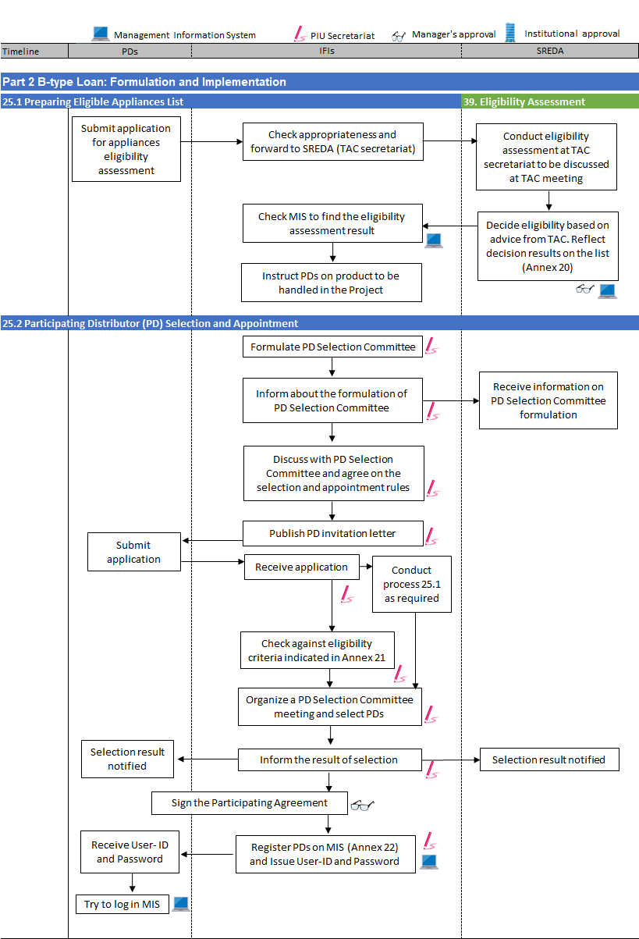

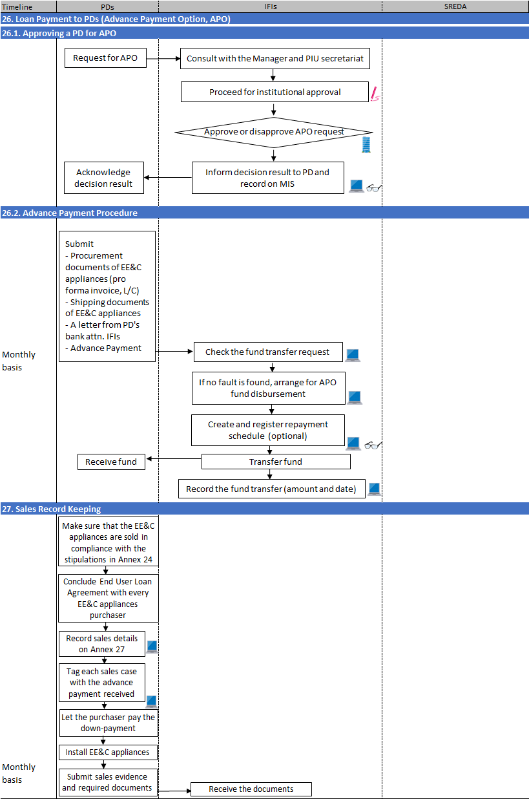

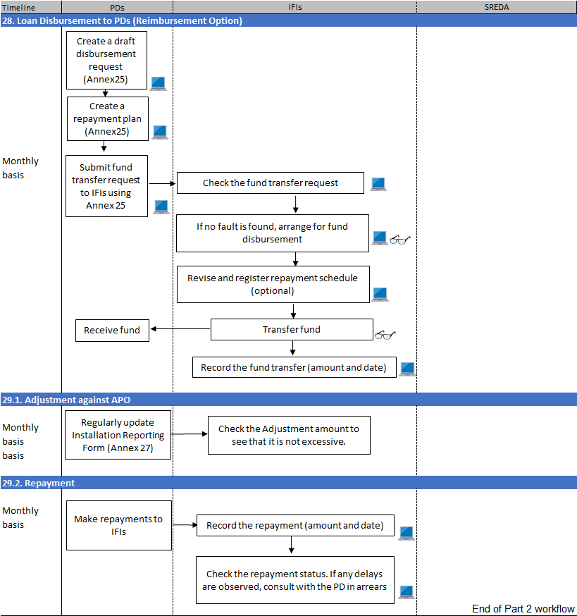

## 25.Formulation of Structure

### 25.1Preparing Eligible Appliances List

Officer in charge for Component III

* Request the PDs to follow the procedure below:
  + Submit to the IFI, an application for assessment of an appliances model that the PD desires to sell through this Project. The application should be addressed to SREDA.
* Check the appropriateness of the application for assessment of an appliances model (against the IFI’s criteria). If found appropriate, forward to SREDA PIU Secretariat for eligibility assessment.
* [MIS FR-N1c] Through communication with SREDA PIU Secretariat, and although through checking the MIS, retrieve the eligibility assessment result.

### 25.2 PD Selection and Appointment

PIU Secretariat

* Formulate Participating Distributor (PD) selection committee by nominating the committee member among the stakeholders for the IFI’s B-type loan.
* Inform the formulation of PD selection committee (including member composition) to SREDA and JICA in writing. The member list will not have to be disclosed to public.
* Discuss and agree on the PD selection an appointment rules with the PD selection committee prior to starting the selection procedure.
* Start PD selection by publishing PD invitation notice. An IFI may refer to its own agreed rules for further selection procedure. When applying for PD status, the applicant PD candidates should indicate at least one EE&C equipment from the Eligible Appliances List, that it wants to sell through this Project.
* After receiving applications, check against eligibility criteria as in Annex 21. In parallel, conduct processNo. 25.1 Preparing Eligible Appliances List
* PDs selection decision should be made by the committee.
* [MIS FR-60]Register PDs’name, type of organization, and address using a form in Annex 22 on MIS.
* Signs the participating agreement (using format in Annex 23) with selected PDs
* [MISFR-61]Issue User-ID and Password for the PDs on MIS.

|  |
| --- |
| Note 25.2 (1):  PDs will have one letter (D for IDCOL, F for BIFFL) andthree-digit number assigned when they are registered on the MIS. |

## 26.Loan Disbursementto PDs (Advance Payment Option)

### 26.1. Approving a PD for APO

Officer in charge for Component III

* When receiving a PD’s request tobe paid through advance payment option (APO), consult with the manager and PIU secretariat.

PIU Secretariat

* Proceed with the institutional decision making whether to approve / reject the PDs’ request. The judgement is up to discretion of the IFI. Appropriateness for being paid on APO should, in general, be based on past track record of the PDs.
* [MIS FR-68] Following the IFI’s internal decision to allow a PD to be paid on APO, report the case on MIS.

Manager

* [MIS FR-69] Discuss with the PIU secretariat and approve the PD’s APO status.

### 26.2. Advance Payment Procedure

Officer in charge for Component III

* Request the APO approved PD, on procuring the EE&C appliances, to follow the procedures below:
  + Submit procurement documents of EE&C appliances including pro forma invoice and L/C (at the timing of L/C opening).
  + To obtain a letter from the PD’s bank to be submitted to the IFI. Shipping documents for the EE&C appliances should also be submitted to the IFI.
  + [MIS FR-70]submit an advance payment request as in Annex 26.

|  |
| --- |
| Note 26.2 (1):  Fund transfer between IFIs and PDs are defined as follows:  “Disbursement”: Fund flow from IFIs to PDs;  “Repayment”: Fund flow from PDs to IFIs.  Fund transfer transactions will have 10 digit assigned comprising of:  one transaction type identification alphabet:  A=advance payment (for APO only);  D=disbursement under reimbursement option (for RO only),  R=repayment (for both APO and RO).  fourdigits representing the concerned PD  five digits which is a sequential number automatically assigned by the MIS (sequence is counted for transactions regardless of the transaction type, i.e. the first alphabet).  e.g. RF04700283 will represent a repayment by PD numbered F047, of which the sequential transaction is 283. |

* [MIS FR-71]Every month, a working day after the monthly fund request deadline, check the APO fund transfer requests from the APO approved PD.
* If in any doubt, conduct on-site inspection as required(c.f. Part IV for monitoring process).
* [MIS FR-71]If no fault is found with the fund transfer request, arrange for APO fund disbursement to the APO approved PD by submitting fund transfer request to the manager.

|  |
| --- |
| Note 26.2 (2):  Once fund transfer request (for advance payment option) is requested by the officer, it will appear on PD’s disbursement & repayment statement (Annex 29) under “requested” status. |

* Create repayment schedule as defined under the IFI’s own rule (out of MIS, but rather on IFI’s own payment management system).
* [MIS FR-N2]Register repayment schedule (date and amount). This process is optional and may be used as necessary by IFIs.

Manager

* [MIS FR-72/85]Browse the approval request list, go to the fund transfer request form and PD’s disbursement & repayment statement (Annex 29) to check the appropriateness for approval/rejection. Discuss with the officer in charge as necessary.

|  |
| --- |
| Note 26.2 (3):  Once fund transfer request (for advance payment option) is approved by the manager, itsstatus will change to “approved” on PD’s disbursement & repayment statement (Annex 29). |

* Give instructions to the officer to take necessary measures if any correction is deemed to be required for the fund transfer request to be approved and processed. Approve the request on MIS once the correction has been made.

Officer in charge for Component III

* [MIS FR-73]Having confirmed that the fund has actually been transferred, register that the actual fund transfer amount and execution date.

|  |
| --- |
| Note 26.2 (4):  The fund transfer transaction (for advance payment option) will change its status to “executed” on PD’s disbursement & repayment statement (Annex 29). |

## 27. Sales Record Keeping

Officer in charge for Component III

* Request the PDs to follow the procedures below.
  + Make sure that the EE&C appliances are sold in compliance with the stipulations in screening sheet in Annex 24.
  + Conclude an End User Loan Agreement with every EE&C appliances purchaser.
  + [MIS FR-74]Report on MIS, on Sales Installation and Inspection Record Form (Annex 27), each case of EE&C appliances sales(preferably on daily basis, to have sales, installation and inspection data updated by the following working day. Permissible maximum reporting interval is to be 10working days).
  + [MIS FR-74](for APO approved PDs only) Tag each sales case with the advance payment received (tagging is allowed only up to the advance payment amount).
  + Let the purchaser pay the down-payment.
  + Install the EE&C appliances.
  + [MIS FR-74]Regularly update theSales Installation and Inspection Record Form (Annex 27) on MIS
  + Submit sales evidence and required documents on monthly basis to IFI.

## 28. Loan Disbursement to PDs (Reimbursement Option)

Officer in charge for Component III

* Ask the PD to follow the procedures below.
  + [MIS FR-N3]on MIS, create a draft disbursement request. Tag sales cases to accumulate the disbursement amount to be requested (a list which comprises Attachment to Annex 25 (=Attachment List) will be generated by tagging procedure).
  + [MIS FR-63]Submit fund transfer request on monthly basis to IFI using the form in Annex 25 on MIS.
* [MIS FR-65]Every month, a working day after the monthly fund request deadline, check the fund transfer requests from the PDs.
* If in any doubt, conduct on-site inspection as required(c.f. Part IV for monitoring process).
* [MIS FR-65]If no fault is found with the fund transfer request, arrange for fund disbursement to PDs by submitting fund transfer request to the manager.

|  |
| --- |
| Note 28 (1):  Once fund transfer request (for reimbursement option) is requested by the officer, it will appear on PD’s disbursement & repayment statement (Annex 29) under “requested” status. |

* [MIS FR-N4]Communicate with the PD to mutually agree on the revised repayment schedule. Revise repayment schedule (date and amount) as necessary. Register repayment schedule (date and amount). This process is optional and may be used as necessary by IFIs.

Manager

* [MIS FR-66/85]Browse the approval request list, go to the fund transfer request form and PD’s disbursement & repayment statement (Annex 29) to check the appropriateness for approval/rejection. Discuss with the officer in charge as necessary.
* Give instructions to the officer in charge to take necessary measures if any correction is deemed to be required for the fund transfer request to be approved and processed. Approve the request on MIS once the correction has been made.

|  |
| --- |
| Note 28 (1):  Once fund transfer request (for reimbursement option) is approved by the manager, its status will change to “approved” on PD’s disbursement & repayment statement (Annex 29). |

Officer in charge for Component III

* [MIS FR-67]Having confirmed that the fund has actually been transferred, register that the actual fund transfer amount and execution date.It will be reflected on PD’s disbursement & repayment statement (Annex 29). Inform PD of money transfer (amount and date) as required.

|  |
| --- |
| Note 28 (3):  The fund transfer transaction (for reimbursement option) will change its status to “executed” on PD’s disbursement & repayment statement (Annex 29). |

## 29. Loan Repayment from PDs to IFIs

### 29.1. Adjustment against APO (Advance Payment Option)

Officer in charge for Component III

* Adjustment is calculated by subtracting tagged sales amount from the total repayment amount. The calculation is automatically conducted on MIS. Make sure that the adjustment amount is not excessive.

### 29.2. Repayment

Officer in charge for Component III

* Make sure that PDs(to both APO and RO) are conducting the following routine work:
  + Make monthly repayments to IFIs with respect to the repayment conditions / schedule as agreed with the IFI.
* [MIS FR-N5] For repayments received from the PDs, register the date and amount received. This will be reflected on PD’s disbursement & repayment statement (Annex 29) as “received” status.
* [MIS FR-N6] Check the repayment status monthly on PD’s disbursement & repayment statement (Annex 29). If any delays are observed, consult with the PD in arrears to ask for the reason as well as on the possibility of the next repayment at soonest possible timing. Report to the manager of the delay and the details of correspondence with the PD in arrears.

Manager

* For serious cases of delay reported, consider applying non-compliance clauses in the participation agreement.

Note: See Part IV for more details on B-type loan monitoring.

# Part III Monitoring for A-type Loan

## A-type Loan Monitoring Procedure

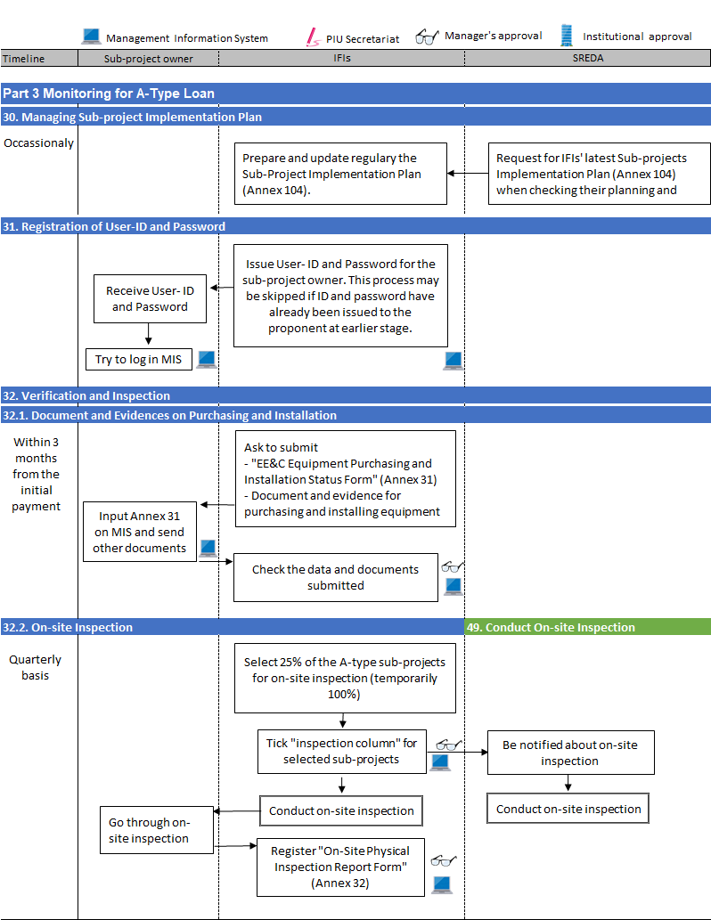

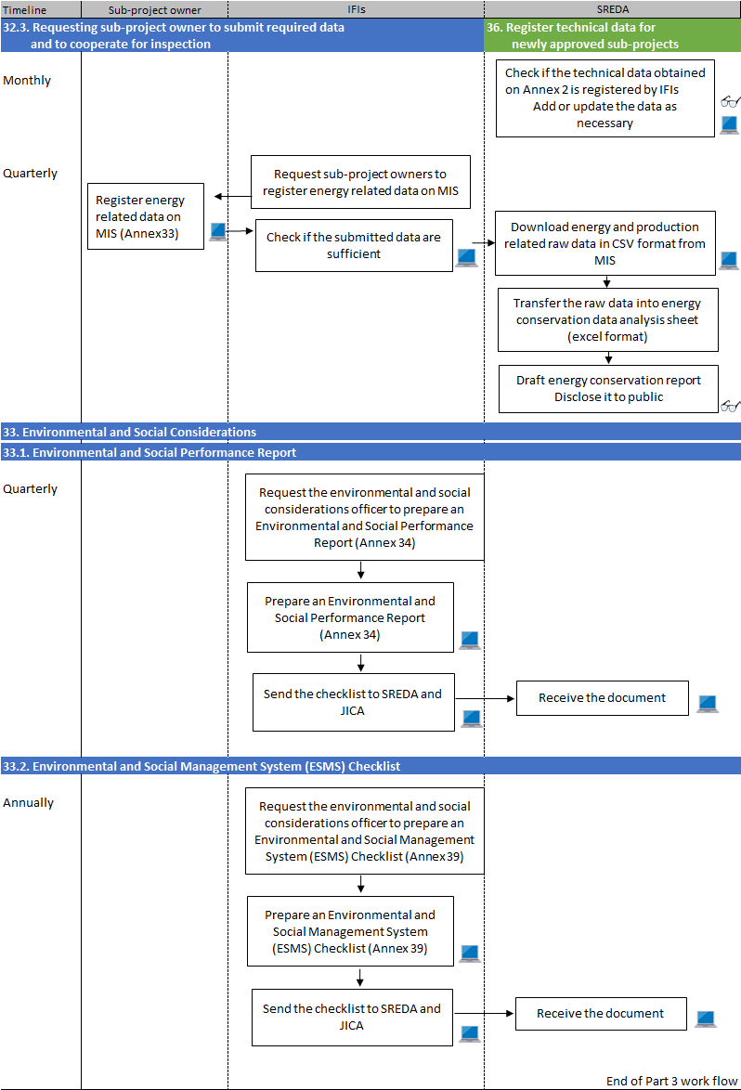

## 30. Managing Implementation Plan

Manager

* Prepare a draft of A-type loan application and sub-project implementation plan (the “Sub-Project Implementation Plan” for short) on a format given in Annex 104. Have it revised whenever there is a progress or environmental change surrounding the loan applications and sub-project (revise at least every month). Proponents / sub-project owners’ names are optional.
* Whenever requested from SREDA and JICA, share the updated version of the Sub-Project Implementation Plan. It is advisable to have it shared with SREDA at the time of NOC request submission so that the positioning of the application within the IFI’s portfolio will be visible to them.

## 31. Registration of User-ID and Password

Officer in charge

* [MIS FR-46]Issue User-ID and Password on MIS for the sub-project owner.
* Request the sub-project owners to follow the procedures below:
  + [MIS FR-47] Confirm that the sub-project owners can log into the MIS with the issued User-ID and Password.

|  |
| --- |
| Note 31 (1):  This process may be skipped if ID and password have already been issued to the proponent at earlier stage. |

## 32. Verification and Inspection

### 32.1. Document and Evidences on Purchasing and Installation

Officer in charge

* Request the sub-project owners to follow the procedures below:
  + [MIS FR-48] Submit EE&C Equipment Purchasing and Installation Status Form(Annex 31) together with document and evidences on purchasing and installingwithin3 months(to be reflected in the QPR / AR within another 3 month after submission)of the initial payment from the sub-project owner to the equipment supplierfor the purchase.
  + With respect to the stipulation in the loan agreement concluded with the IFI, conduct energy consumption and production performance test as a condition for acceptance of the equipment.
  + Submit a copy of the energy consumption and production performance test result to the IFI.

|  |
| --- |
| Note 32 (1):  Acceptance criteria for an equipment’s energy consumption and production performance will be negotiated and agreed between the supplier and the buyer (= sub-project proponent). IFI may advise the sub-project owner on the consistency of the test result with the rated (catalogue) performance. |

* [MIS FR-49]Check the data submitted. If found insufficient, request the sub-project owner to add more information on MIS or submit additional document(s).
* [MIS FR-49]For documents obtained, check tickthe “verification column” to be submit to manager for approval.

Manager

* [MIS FR-50] browse the approval request list, go to the verification subject list to check that the purchasing and installation status and approve on MIS.
* Give directionsto the officer to take necessary measures as required. Approve on MIS once the necessary measure has been conducted.

### 32.2. On-site Inspection

Officer in charge

* [MISFR-51]On quarterly basis, select 25% of the A-type sub-projects among the sub-projects with EE&C Equipment Purchasing and Installation Status Form (Annex 31) completed and has completedpurchasing and installation (IFIs may determine its proper selection methodfor checking the actual purchasing and installation status). The on-site inspection, in principle, should be conducted with the participation of SREDA officer(s).

|  |
| --- |
| Note 32.2 (1):  Temporarily, all (100%) A-type sub-projects shall be inspected. |

* Consult with SREDA on the date and participants to the on-site inspection. Make arrangement for the site visit so that SREDA official(s) can join the team.
* [MIS FR-51]Tick the “on-site inspection column” of selected sub-projects on the screen.
* [MIS FR-51]After the selection request, submit for the manager’s approval.

Manager

* [MIS FR-52] browse the approval request list, go to the inspection subject list to check that appropriate selection for on-site inspection has been made, and approve on MIS.

Officer in charge

* Conduct on-site inspection by visiting selected factories or buildings where the EE&C equipment has been installed and operating. The inspection may be conducted by inspectors whom the IFI designates.
* [MIS FR-53]After conducting on-site inspection, input data in “record of on-site inspection” column of EE&C Equipment Purchasing and Installation Status Form.

|  |
| --- |
| Note 32.2 (2):  Data on “record of on-site inspection” will automatically be reflected onto “On-site Physical Inspection Report Form(A-type) (Annex 32) on MIS: Inspection summary screen”. |

Manager

* [MIS FR-54] browse the approval request list,go to the record of on-site inspection list to check that on-site inspection has been conducted as planned, and approve the result accordingly.
* Give necessary directionand / or corrective instruction to the office in charge as necessary.

### 32.3. Requesting sub-project owners to submit required data andto cooperateforinspection

Officer in charge

* On Quarterly basis, request the sub-project owners to follow the procedures below:
  + [MIS FR-55]On quarterly basis, register on Energy Efficiency related Data Form (Annex 33) on MIS, the energy and production related data and any other required data on each event.

|  |
| --- |
| Note 32.3 (1):  IFIs hold responsibility to have the sub-project owners to submit energy efficiency related data on MIS, as well as to be able to conduct on-site inspection in conjunction with SREDA. |

|  |
| --- |
| Note 32.3 (2):  MIS will automatically send reminder to the sub-project owners’ email addresses as a measure to encourage them to submit energy and production related data. |

* [MIS FR-56]Check the submission of the data after the deadline. If any of the data is found to be missing, remind (or urge) the sub-project owner to input the data to comply with the data submission requirement.

|  |  |  |  |  |  |  |  |  |  |  |  |  |  |  |  |  |
| --- | --- | --- | --- | --- | --- | --- | --- | --- | --- | --- | --- | --- | --- | --- | --- | --- |
| Note 32.3 (3):  SREDA and JICA and other related organization shall have the right to conduct inspections based on the Loan Agreement between the two governments. IFIs are expected to cooperate with SREDA by urging the sub-project owners to submit the following required documents:   |  |  |  |  | | --- | --- | --- | --- | | No | Name of requested Documents | Format | Frequency | | 1 | Data and information required during inspection and energy audit | N/A | On Event | | 2 | EE&C equipment data | N/A | On Event | | 3 | Energy efficiency related dataon [MIS FR-55] | Annex 33 | Quarterly | |

|  |
| --- |
| Note 32.3 (4):  Energy Efficiency related data should be submitted from the sub-project owners on MIS until the sub-project owner receives a notification to terminate the data submission.  The data submission obligation, in principle, will continue until either: (i) at least 12 months after the EE&C equipment attains “stable” operation condition, or (ii) after 36 months from the start of the operation, whichever. The IFIs may consult with SREDA when making decision to let the sub-project owner terminate the data submission. |

## 33. Environmental and Social Considerations

### 33.1. Environmental and Social Performance Report

PIU secretariat

* On quarterly basis, (by end of February, May, August, and November) request the environmental and social considerations officer to prepare an Environmental and Social Performance Report (Annex 34).

Environmental and Social Considerations Officer

* [MIS FR-N7] On Quarterly basis, (by 10th of March, June, September and December) prepare an Environmental and Social Performance Report (Annex 34), save the report to be reported to SREDA and JICA.

### 33.2. Environmental and Social Management System (ESMS) Checklist

PIU secretariat

* On annual basis, (byOctober) request the environmental and social considerations officer to go through the Environmental and Social Management System (ESMS) Checklist (Annex 39).

Environmental and Social Considerations Officer

* [MIS FR-N8] On annual basis, (by 10th December), go through theEnvironmental and Social Management System (ESMS) Checklist (Annex 39), save the checklist to be reported to SREDA and JICA.

# Part IV Monitoring for B-Type Loan

## B-type Loan Monitoring Procedure

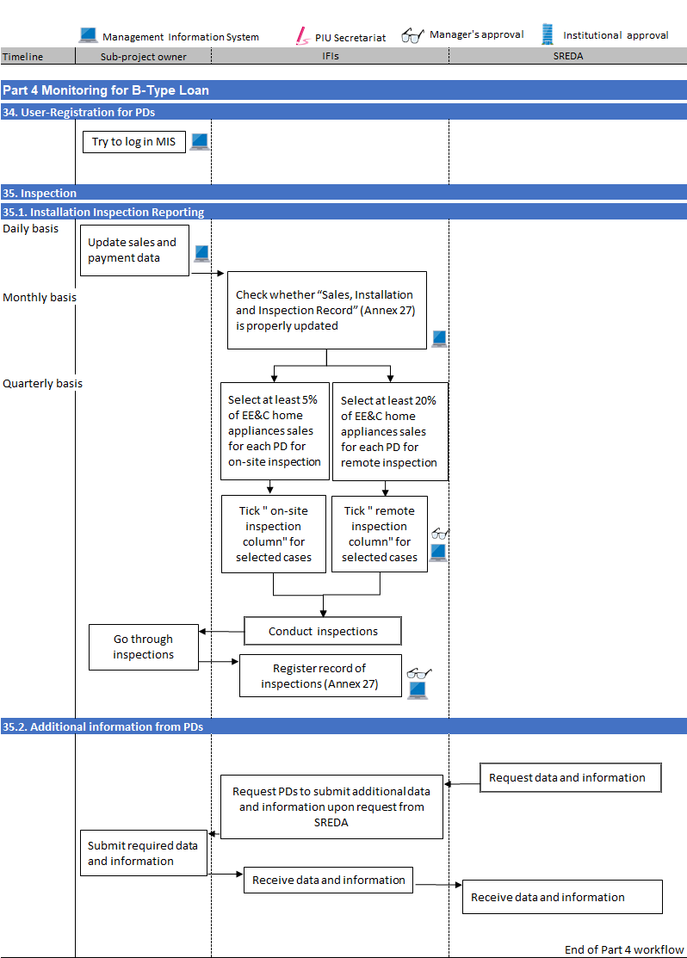

## 34. User-Registration for PDs

Officer in charge for Component III

* Make sure that the PDs are issuedwith user-ID and password to access to MIS (c.f. Part II 1.)

## 35. Inspection

### 35.1 Installation Inspection Reporting

Officer in charge for Component III

* Request the PDs to follow the procedure below:
  + To submit (update) sales and payment data preferably on daily basis (data for the day to be reflected by the end of next working day. Maximum permissible time lag is 10 working days) on [MIS FR-62/74]

|  |
| --- |
| Note 35.1 (1):  PDs may manage their customers’ repayment data on their own ICT system (IFIs may distribute to PDs their repayment data management spreadsheets. PDs are required to input repayment “status” onto MIS (not the actual repayment amount). |

* [MIS FR-79]Periodically (at least every month) observe the “Sales, Installation and Inspection Record” as in Annex 27to make sure that the PDs are updating the sales and payment data appropriately and promptly. (c.f. Part II 2. and 3.3.).
* [MIS FR-80]On quarterly basis, select at least 5% of EE&C appliances sales for each PD (IFIs may determine its proper selection method). Tick the “on-site inspection column” of EE&C appliances sales for selected case on the screen.
* [MIS FR-80]Also on quarterly basis, select at least 20% of EE&C appliances sales for each PD (IFIs may determine its proper selection method). Tick the “remote inspection column” of EE&C appliances sales for selected case on the screen.
* [MIS FR-80] After changing the selection request the manager for approval.

Manager

* [MIS FR-81] browse the approval request list, go to the Component III data table to check that on-site inspection subject has been appropriately selected, and approve reject accordingly.

Officer for B-type loan monitoring

* Conduct on-site inspection by visiting selected EE&C appliances purchasers’ premises, or by calling on the phone.

|  |
| --- |
| Note 35.1. (2):  IFIs should conduct inspection of at least 25% of the EE&C appliances purchasers. Inspection may, in principle, be visual on-site external observation, or by telephone call (5% should be on-site visual observation while remaining 20% may be inspection by telephone call). The on-site inspections must be conducted within 21 days of the fund transfer request. |

* [MIS FR-82]After conducting on-site inspection, input inspection date in inspection column of “Sales, Installation and Inspection Record Form”to be reflected in Annex 27.

Manager

* [MIS FR-83] browse the approval request list, go to the Component III data table to check that on-site inspection has been appropriately conducted, and approve reject accordingly.
* Give directions to the officer in charge when there is a necessityto take any corrective measures. Approve on MIS afterthe correction measure has been taken.

### 35.2 Additional Information from PDs

Officer in charge

* Request PDs to submit any additionally required data and information during inspection and energy audit by SREDA.
* Request PDs to cooperate with the EE&C appliances purchasers to submit data and information required during inspection and energy audit to SREDA.

|  |  |  |  |  |  |  |  |  |
| --- | --- | --- | --- | --- | --- | --- | --- | --- |
| Note 35.2 (1):  SREDA and JICA and other related organization reserve the rights to request IFIs to submit additional data based on the Loan Agreement concluded between the two governments. Hence, the IFIs may, from time to time, request PDs to cooperate with the IFIs during on-site inspections and energy auditing:   |  |  |  |  | | --- | --- | --- | --- | | No | Name of requested Documents | Format | Frequency | | 1 | Data and information required during inspection and energy audit | N/A | On Event | |

|  |
| --- |
| Note 35.2 (2):  Process Nos 36 to 40 are explained in manual for SREDA. |

# Part V Reporting

## 42. Periodical Reports

### 42.1Quarterly Report (QPR) and Annual Report (AR)

PIU Secretariat

* Draft and prepare the following report on quarterly basis. For specific reporting requirements, refer to the Minutes of Discussion concluded for the Project, between the two governments (c.f. Attachment to the Business Process Manuals).
* [MIS 3329000] Use MIS Report generation function to prepare those which can be automatically generated.

|  |  |  |  |  |
| --- | --- | --- | --- | --- |
| No | Name of Report | Quarterly | Annually | Format |
| 1 | ESMS Checklist  Automatically generated at[MIS 3329000] | - | ○ | Annex 39 |
| 2 | Environmental and Social Performance Report  Automatically generated at[MIS 3329000] | ○ | ○ | Annex 34 |
| 3 | Time-bound Action plan | ○ | ○ | N/A |
| 4 | Anticorruption Monitoring Sheet | ○ | ○ | Annex 35 |
| 5 | On-going Sub-Project Summary Report | * | * | Note*1 |
| 6 | IFI Financial Report on A-type loan user | * | * | Note*1 |
| 7 | Appraisal Process Status Report  Automatically generated at[MIS 3329000] | ○ | ○ | Annex 38 |
| 8 | On-Site Physical Inspection Report Form Automatically generated at[MIS 3329000] | ○ | ○ | Annex 32 |
| 9 | Sales, Installation and Inspection Record(includes B-type loan installation records)  Automatically generated at[MIS 3329000] |  |  | Annex 27 |
| 10 | Statement of the Designated Account, Sub Account and the Revolving Fund Account of the proceeds of the Loan | - | ○ | Annex 40 |
| 11 | Current repayment and Overdue status report | - | ○ | Annex 41 |
| 12 | Certified Audit Report on Statement of Expenditures and Audit Report | - | ○ | Annex 42 |

Note*1: These two reports as stipulated in the M/D have now been integrated into “Annex 367 Ongoing Sub-projects Summary and Financial Report”, to be submitted directly from IFIs to JICA (separately from QPR).

* [MIS: 3329200]Attach the report files and submit to manager for approval.

Manager

* [MIS 3425100] browse the approval request list,go to report submission to check that reports are prepared appropriately.
* Propose as necessary, any correction. After satisfactory corrections are made, give approval on MIS.

|  |
| --- |
| Note 42.1 (1):  Quarterly reports shall be submitted to SREDA within one month after the end of each quarter. Submission deadline therefore will be: end of April, July, October, and January. Quarterly report will become an annual report for the end of fiscal year submission. |

|  |
| --- |
| Note 42.1 (2):  Annual report will be prepared for fiscal year for the IFI. It will be submitted to SREDA within one month of the fiscal year completion. |

### 42.2 Ongoing Sub-Projects Summary and Financial Report (Annex 367) and Statement of Expenditure

Officer in charge / PIU secretariat / Manager

* Prepare an “Implementation Status Report” by using the format stipulated in Attachment 367, together with a Statement of Expenditure (Annex **). Submit to JICA Bangladesh Office after obtaining institutional approval. These reports shall be submitted directly from IFIs to JICA Bangladesh Office.

## 43. Supplemental Information

Officer in charge

* Request the A-type loan sub-project owners and the PDs to submit their annual financial statements.

## 44. Incidental Reports

PIU Secretariat / Officer in Charge

* Prepare the following report on occurrence of incidents.

|  |  |  |
| --- | --- | --- |
| No | Name of Report | Format |
| 13 | Incident report on any overdue by sub-project owners (A-type sub-project owners and B-type PDs) | N/A |

* Consult with manager for submission approval.

Manager

* Check the submitted report document.
* Propose as necessary, any correction. After satisfactory corrections are made, give approval.

|  |
| --- |
| Note 44 (1):  Process Nos 44 to 49 are explained in manual for SREDA. |

END OF DOCUMENT