**Energy Efficiency and Conservation Promotion Financing Project**

**Business Process Manual**

**(for SREDA)**

Version 2.1c (for UAT 1 and JICA resubmission)  
as of 28December 2017

Revision record

|  |  |  |  |
| --- | --- | --- | --- |
| Ver | Status | Date | Note |
| 1.0 | SREDA approved | 00 May 2017 | On the occasion of 1st NOC issuing |
| 2.0e | JICA commented | 30 Nov 2017 | First JICA reviewing |
| 2.1c | Drafted | 28 Dec 2017 | Incorporating JICA comments |
|  |  |  |  |
|  |  |  |  |
|  |  |  |  |
|  |  |  |  |

[1]Major revisions from Version 2.0e:

Both SREDA and IFIs Manuals:

(1) Flow chart for process No.21 “Loan Decision” amended so that disapproval will terminate the process (no returning, neither to No.14 “Name Clearance” nor No.20 “Due Diligence”).

(2) New process No.25.1 “Preparing Eligible Appliances List” added.

IFIs Manual:

(1) Process to prepare “Eligible Appliances List” newly added as process No.25.1

(2) B-type loan adjustment process simplified.

SREDA’s Manual:

(1) Temporary requirement during the pilot phase to check that Name Clearance has been conducted for all NOC requests added.

(2) Process to assess B-type loan appliances eligibility added.

(3) Term “survey” now harmonised with IFIs’ “on-site inspection”.

Annexes:

(1) Date fields added on Annex 2 form

(2) Annex 20 additionally introduced

(3) Annex 27 revised to include quantity and customer ID information

(4) Attached table on Annexes 25 and 28 revised in conformity with Annex 27

(5) Date fields added on some forms

[2] Reflection of JICA comments

c.f. Annex document.

Contents

Part I General Provisions 1

1. Overview of EE&C Promotion Financing 1

1.1 Aim of the Facility 1

1.2 Executing Agencies 1

1.3 Fund 1

1.4 Modes of Lending 2

1.5 Subject of Loan 3

2. Basic Structure 4

2.1 Lender 4

2.2 Borrower 4

2.3Eligible Equipment (A-type loan) / Appliances (B-type loan) 4

2.4 Eligible Investment Cost 5

2.5 Timing of Loan Application and Appraisal (A-type loan) 5

2.6 Co-financing (A-type loan) 5

3. Lending Conditions 6

3.1 Applicant 6

3.2 Amount Threshold 6

3.3 Portion among the Total Eligible Amount 6

3.4 Interest Rate 6

3.5 Tenure 6

3.6 Grace Period 6

3.7 Repayment Mode 7

4. Security 7

5. Basic Principle for Business Process 7

6. Management Information System (MIS) 7

6.1 Function and Purpose of MIS 7

6.2 Information Security Features 7

7.Business Process Manuals 8

Part II Workflow Charts 9

[Workflow]for A-type Loan Appraisal Procedure 9

[Workflow] forB-type Loan Formulation and Implementation Procedure 15

[Workflow] forMonitoring Procedure for A-type Loan 18

[Workflow] forMonitoring Procedure for B-type Loan 20

Part III Daily Operation 21

16. Checking Eligibility 21

17a. Issue NOC / 17b. Issue Letter of Rejection 23

18. Energy conservation estimation 24

Part IV Monthly Operation 24

36. Register Technical Data for Newly-approved Sub-projects 24

37. Check Progress of Sub-projects 25

Part V Quarterly Operation 27

38. Collecting data and calculatingconserved energy 27

39. B-type Loan Appliances Eligibility Assessment 28

Part VI Annual Operation 29

40. Annual implementation plan 29

41. Organize an annual reporting meeting of the Steering Committee 29

Part VII Reporting 31

45. Periodical Reports 31

Part VIII Occasional Operation 32

46. Organise a Meeting of the Technical Advisory Committee 32

47. Organise an ExtraordinaryMeeting of the Steering Committee 33

48. Revise the Eligible Technology &Equipment list 34

49. Conduct On-site Inspection 34

49.1 Targets of Inspections 34

49.2 Inspection Procedures 34

50. Operate and Maintain MIS 35

Notes on Editing:

Yellow marker : Reference to formats

Blue marker : Reference to MIS interface screen

Red marker : Reference to documents other than the business process manuals and ICT information tool external to MIS

Acronyms

|  |  |
| --- | --- |
| AR | Annual report |
| APO | Advance payment option |
| BDT | Bangladesh taka (currency) |
| BIFFL | Bangladesh Infrastructure Finance Fund Limited |
| CEO | Chief Executive Officer |
| CIB | Credit Information Bureau (of Bangladesh Bank) |
| CRG | Credit Risk Grading (of Bangladesh Bank) |
| D/D | Due diligence |
| DLD | Delay liquidated damage |
| DSRA | Debt service reserve account |
| EE&C | Energy efficiency & conservation |
| ESCO | Energy service company |
| ESMS | Environmental and Social Management System |
| FR | Functional requirement |
| ICT | Information and communication technology |
| ID | Identification |
| IDCOL | Infrastructure Development Company Limited |
| IFI | Implementing financial institution |
| ISO | International Organization for Standardization |
| JICA | Japan International Cooperation Agency |
| JPY | Japanese yen (currency) |
| L/C | Letter of credit |
| MFI | Microfinance institution |
| MIS | Management information system |
| MOF | Ministry of Finance |
| MPEMR | Ministry of Power, Energy and Mineral Resources |
| N/A | Not applicable |
| NBFI | Non-bank financial institution |
| NGO | Non-governmental organisation |
| NOC | Non-objection certificate |
| p.a. | Per annum |
| PD | Participating distributer |
| PIU | Project implementation unit |
| PLD | Performance liquidated damage |
| QPR | Quarterly progress report |
| RAID | Redundant array of independent disks |
| RO | Reimbursement option |
| ROE | Return on equity |
| SC | Steering Committee |
| SPV | Special purpose vehicle |
| SREDA | Sustainable and Renewable Energy Development Authority |
| T/A | Technical assistance |
| TAC | Technical Advisory Committee |
| VPN | Virtual private network |

# Part I General Provisions

## 1. Overview of EE&C Promotion Financing

### 1.1 Aim of the Facility

The aim of this Energy Efficiency & Conservation (EE&C) Promotion Financing Project (the “Project”) is to encourage the penetration of EE&C equipment in Bangladesh, so as to contribute to the development of sustainable society where power demand / supply balance is well under control. It is also expected to contribute to the reduction of greenhouse effect gas emissions.

The Project is one of Sustainable and Renewable Energy Development Authority (SREDA)’s concrete measures to promote EE&C on the demand side of energy. This Project is introduced in response to Bangladesh’s Seventh Five Year Plan (December 2015). In this strategic plan, SREDA’s mandate to contribute to demand side energy management through the provision of low interest loan is clearly mentioned.

### 1.2 Executing Agencies

There are three executing agencies for the Project, which are:

(1) Sustainable and Renewable Energy Development Authority (SREDA) as the administrative authority;

(2) Infrastructure Development Company Limited (IDCOL) as an implementing financial institution (IFI), and;

(3) Bangladesh Infrastructure Finance Fund Limited (BIFFL) also as an IFI.

Japan International Cooperation Agency (JICA), who has been supporting the Government of Bangladesh from the initiation and formulation of the Project, is supporting the implementation of the Project by despatching a technical assistance (T/A) task team for the Project. The T/A task team is directly supporting the project implementation units of the three executing agencies mainly by providing technical assistance on eligibility checking, energy conservation calculation and overall interpretation of these business process manuals. JICA will also support the Project Implementation by giving concurrence on the business processes including the Eligible Technology & Equipment List(Annex 4).

### 1.3 Fund

The original fund is the concessional loan extended from the Government of Japan (represented by JICA) to the Government of Bangladesh (represented by the Finance Division, Ministry of Finance).

|  |
| --- |
| Note 1.3 (1):  JICA loan for the Project is as follows:  - Denomination: Japanese Yen (JPY)  - Amount: JPY 11.988 billion (among which JPY 9.978 billion is allocated for loan fund)  - Interest rate: 0.01%  - Tenure: 40 years  - Grace period: Initial 10 years is the grace period (only interest will be paid back).  - Loan Agreement: June 2016 |

The loan fund allocation between the IFIs will be equal, i.e. the same amount for IDCOL and BIFFL. With an aim to make use of the fund efficiently, there will be a mechanism for revision and adjustment of the fund allocation.

The Steering Committee of the Project should closely monitor the implementation progress of each IFI and if any of the IFIs is found to be slow in implementation compared to the other IFI, the Steering committee will suggest reallocating necessary amount of the remaining fund from one IFI to the other. Both IFIs would take immediate action to comply with the decisions of the Steering Committee in this regard.

Definition:

The “remaining amount” is the total available fund amount minus (i) used amount, and (ii) earmarked amount.

The “used amount” is the amount of loan allotted for sub-project loan agreement.

The “earmarked amount” is the amount of loan for sub-project applications for which NOC has been issued.

In case any of the following circumstances occurs, the fund allocation will be reviewed and adjusted:

(i) When an IFI’s allocated loan amount is almost entirely used or earmarked;

(ii) When an IFI desires to waive all or a portion of the allocated loan amount;

(iii) When a period of 2 years passes after the last allocation decision.

### 1.4 Modes of Lending

The fund is extended to the IFIs who manage and make it available for the sub-project owners in line with SREDA’s policy.

Project Executing Agency: (administrative authority)

Sustainable and Renewable Energy Development Authority (SREDA)

Other dev’t partners

JICA

Ministry of Finance (MOF)

Implementing Financial Institutions (IFIs): IDCOL / BIFFL

Participating Distributors (PDs)

Sub-project proponents (Factories, commercial facilities, etc.)

End user (Residential and small businesses)

Lending / borrowing

Payback

A-type loan

B-type loan

Participation agreement

Installment sales

EE&C appliances

Data collection and reporting

Policy and manuals

Project entrustment

On-lending Loan

Subsidiary loan

Source: JICA (2016) Preparatory Survey for Energy Efficiency and Conservation Promotion Financing Project Final Report

Figure 1 Project Structure

There are two channels for extending the EE&C promotion financing loan, which are:

(a) A-type loan: IFIs lend money directly to the companies and organisations who are introducing the EE&C equipment, and;

(b) B-type loan: There is an intermediary distribution organisation called “participating distributors (PDs)” who supply EE&C equipment (home appliances).

### 1.5 Subject of Loan

EE&C promotion financing is designed to cover three components which are:

(a) Component I : Industry / commercial sector component

(b) Component II : Building sector component

(c) Component III : Home appliances component

Loans for components I and II are extended through A-type loan channel, while loan for component III is extended through B-type loan channel.

Table 1 Three components as the subject of the Loan

|  |  |  |  |
| --- | --- | --- | --- |
| Component | User | Subject of loan | Supporting mechanism |
| (Component I) Industry / commercial sector component | Companies and other organizations | Energy efficient “listed” equipment at factory, office, commercial facility, etc. | Energy management and auditing |
| (Component II)  Building sector component | Companies and other organizations | Energy efficient “listed” equipment in buildings | Green building rating programme |
| (Component III) Home appliances component | Households and small businesses | Energy efficient “listed” home appliances | Energy efficiency labelling programme |

Source: JICA (2016) Preparatory Survey for Energy Efficiency and Conservation Promotion Financing Project Final Report

Each application for the loan will become the “sub-projects” under this EE&C Promotion Financing Project.

## 2. Basic Structure

### 2.1 Lender

Implementing financial institutions (IFI)s, which are currently the following two NBFIs:

(a) Infrastructure Development Company Limited (IDCOL)

(b) Bangladesh Infrastructure Finance Fund Limited (BIFFL)

### 2.2 Borrower

* A-type loan (for components I and II): Company or any other organisation who intends to acquire eligible EE&C equipment(= sub-project “proponent”).
* B-type loan (for component III): Participating Distributors (PDs) who sell eligible EE&C appliances.
* Note that energy service(ESCO) businesses and other services who do not acquire the EE&C equipment on their own are not eligible to this loan facility.

### 2.3Eligible Equipment (A-type loan) / Appliances (B-type loan)

* In A-type loan, eligibility should be confirmed by SREDA for each loan application (against stipulations in the Eligible Technology & Equipment List = Annex 4). The Eligible Technology & Equipment List is a predefined list of technologies and equipment as prescribed during the Project formulation.
* In B-type loan, PDs may sell the appliances that are in the “Eligible Appliances List (Annex 20): tentatively included in third part of Annex 4”. SREDA, based on advice from Technical Advisory Committee (TAC), will determine the eligibility of a given appliance.
* Eligibility criteria will be determined by the TAC prior to the launching of the Component III, and shall be approved by the Steering Committee (SC). Further specific business process for Component III shall be determined at the SC.

### 2.4 Eligible Investment Cost

Only the cost for introducing (purchasing) eligible EE&C equipment will be the subject of the loan. SREDA, when judging the eligibility of the equipment, may also include ancillary and relevant costs such as the followings as the integral subject of the loan. For components I and II:

* + Transport, assembly and installation;
  + Training and technical transfer;
  + Customs insurance and other administrative costs and commissions;
  + Auxiliary / ancillary equipment, connection and accessories,
  + Other incidental costs.

While for component III:

* + Delivery and installation.

### 2.5 Timing of Loan Application and Appraisal (A-type loan)

For A-type Loan, an IFI’s appraisal for potential sub-projects should take place prior to the actual procurement of the equipment. The letter of credit (L/C) account for purchasing the EE&C equipment may nevertheless, be opened prior to the approval of the loan.

There are exceptional cases where the Project loan may be extended for refinancing the existing loan. This will be applicable to sub-projects which are applied and authorised prior to the actual mobilisation of the Project loan.Such sub-projects should be from the pilot sub-project list which was shared and agreed by SREDA, IDCOL, BIFFL JICA and the JICA T/A task team.

|  |
| --- |
| Note 2.5:  “Pilot phase” is when sub-project formulation, appraisal and implementation are conducted prior to the full-fledged start of the Project. Ten pilot sub-projects were listed up for this purpose (6 for IDCOL and 4 for BIFFL).  The Project will start in full-fledge when the following three conditions are met:  (1) Technical Assistance Project Proposal (TAPP) is approved by the Planning Comission;  (2) IFIs have completed their consultants’ procurement, and;  (3) MIS for the Project enters into service. |

### 2.6 Co-financing (A-type loan)

The use of any other preferential financing facility (e.g. governmental, international development bank, etc.) may not hamper access to this EE&C promotion finance. The rest of the sub-project cost may be funded from any other funding source.

## 3. Lending Conditions

### 3.1 Applicant

During the pilot phase (10 pilot sub-projects are selected for priority appraisal), a proponent may submit only one application regardless of the receiving IFI.

Throughout the Project period, a proponent may submit only one application for one investment activity / site. Cross checking of the multiple application will be conducted at SREDA in parallel with the eligibility checking. IFIs are encouraged to confirm with the sub-project proponents about the existence of any other applications to the same Project loan (including application to other IFIs).

### 3.2 Amount Threshold

Maximum amount for a single sub-project is BDT 1 billion (pending, to be confirmed with the executing agencies after the completion of pilot sub-projects approvals).

Minimum amount for a single loan application is temporarily set at BDT 5 million.

### 3.3 Portion among the Total Eligible Amount

For A-type loan, the IFIs may, from time to time, restrict the loan amount to certain portion of the sub-project’s eligible cost.

### 3.4 Interest Rate

Standard (minimum) interest rate for A-type loan is 4%. For B-type loan the standard interest rate for lending from IFIs to PDs is 4%, resulting in on-lending to the EE&C appliances purchasers at the interest rate of 8%. IFIs may suggest otherwise depending on the financial appraisal result.

### 3.5 Tenure

Tenure period is set depending on the nature of the sub-projects. IFIs shall conduct financial analyses to identify an appropriate tenure period for each sub-project, to be agreed with the sub-project owner.

### 3.6 Grace Period

For components I and II, the IFIs may grant grace period for the loan, with respect to the nature of the sub-projects.

### 3.7 Repayment Mode

In principle, monthly repayment is encouraged. Quarterly payment may also be considered with respect to the nature of the sub-projects. IFIs and sub-project owners may suggest an appropriate repayment mode to be mutually agreed upon.

## 4. Security

For components I and II, IFIs, in most of the cases, ensure adequate security in the form of collateral and / or guarantee against the whole or part of the loan amount.

## 5. Basic Principle for Business Process

With the aim to promote the use of this loan facility the business process at SREDA as well as at the IFIs are kept to minimum complexity.

## 6. Management Information System (MIS)

The MIS is an ICT system accessible on public internet for by the stakeholders to the Project, who are SREDA, IFIs, PDs, sub-project owners, as well as by MPEMR, JICA, among others.

### 6.1 Function and Purpose of MIS

The Management Information System (MIS) is developed and introduced for the following purposes:

* To record and manage the progress of the Project;
* To standardise and control the business process of the Project;
* To enable the executing agencies to produce reports, and;
* To store energy usage and production related data.

The MIS, intentionally, does not offer the following functions:

* Transactions and fund transfer,
* Accounting and fund balance management,
* Credit information
* Borrowers’ identity and any other information.

### 6.2 Information Security Features

The MIS is designed to ensure security against data loss, leakage, and tampering through the following measures:

* Logging in with ID and password;
* Access through VPN;
* Data encryption, and;
* RAID data storage.

Although every possible and realistic security measures are in place, there is always a risk of information security incident. The system, however unlikely it may be, must be prepared for such incident. The MIS, for this reason, does not possess sensitive and confidential information, notably information related to creditworthiness, financial transaction and personal data.

## 7.Business Process Manuals

There are eight different manuals which stipulate the business processes in relation to this Project:

* System Specification Manual (*)
* System Administrator’s Manual (*)
* Business Process Manual for SREDA
* Business Process Manual for IFIs
* Business Process Manual (Annexes)
* Business Process Manual (Appendix: Minutes of Discussions)
* Sub-Project Owner’s Manual
* PD’s Manual

Note (*): these manuals are beingdeveloped by the system application developer

# Part II Workflow Charts

## [Workflow]for A-type Loan Appraisal Procedure

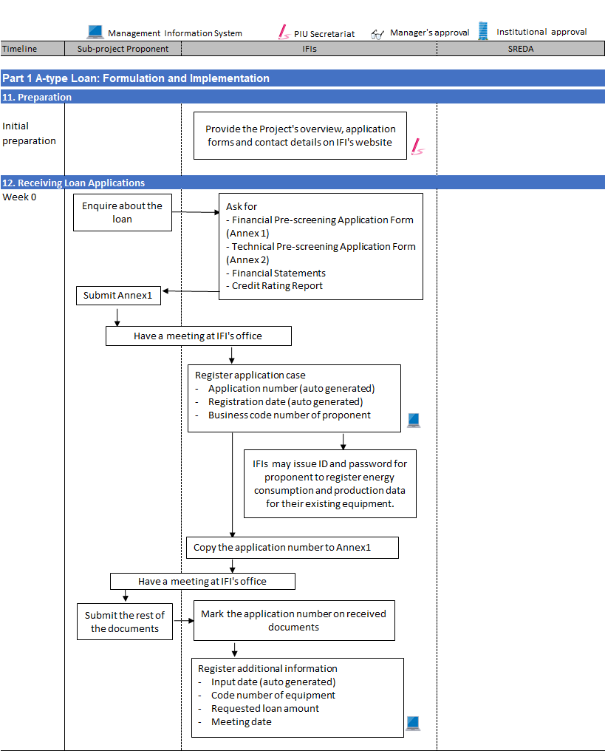

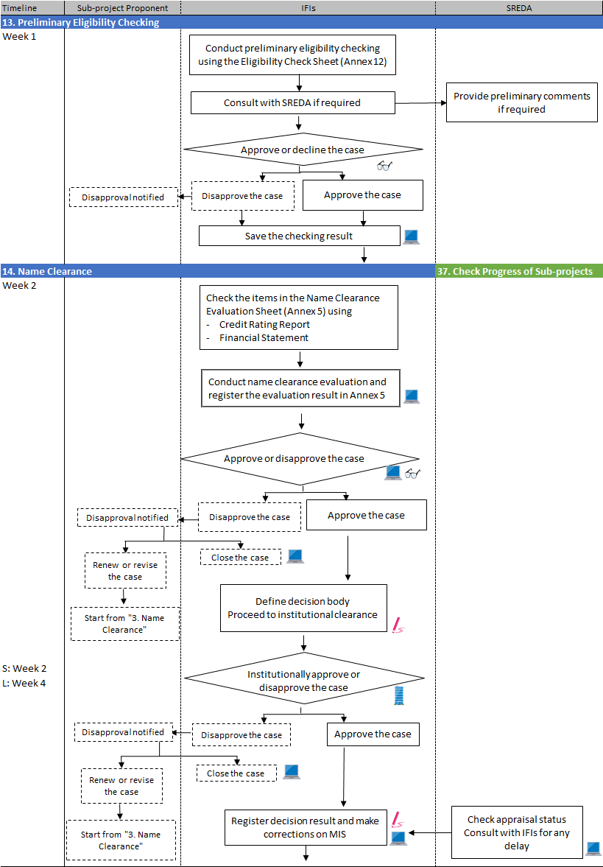

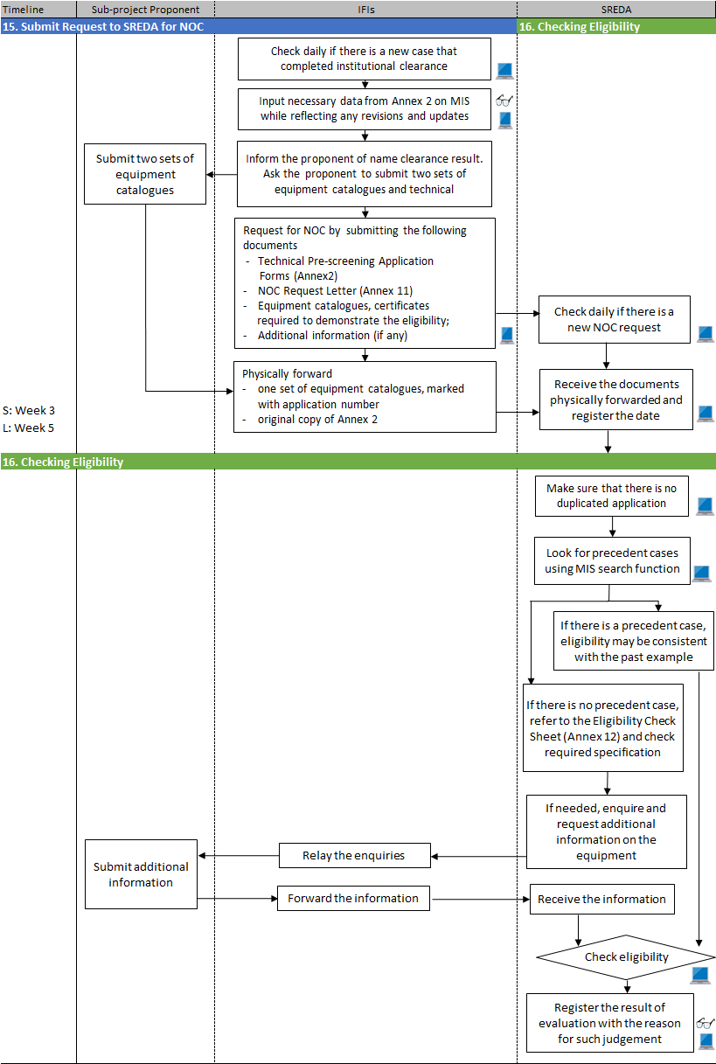

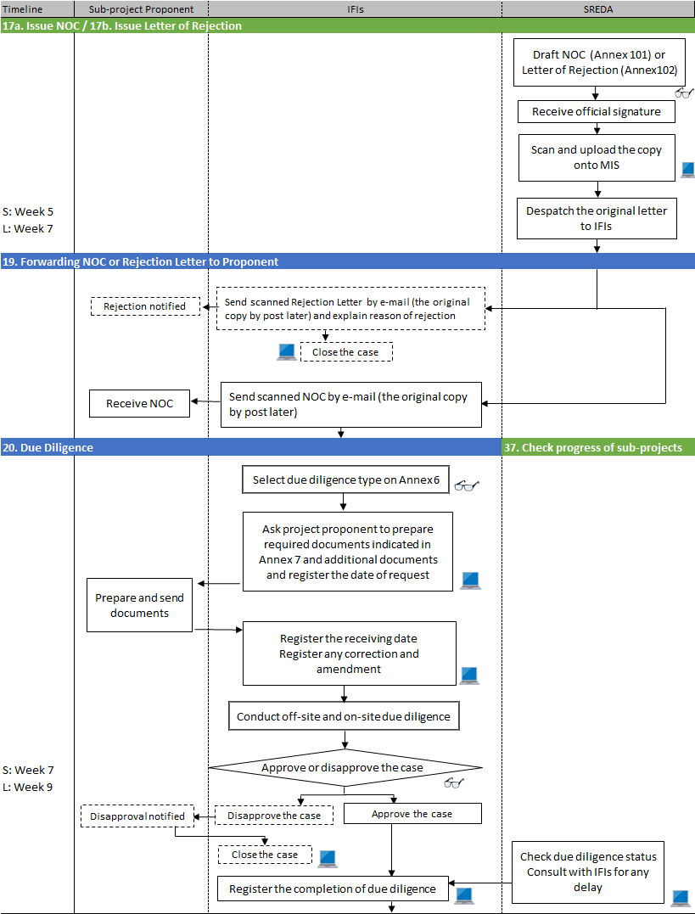

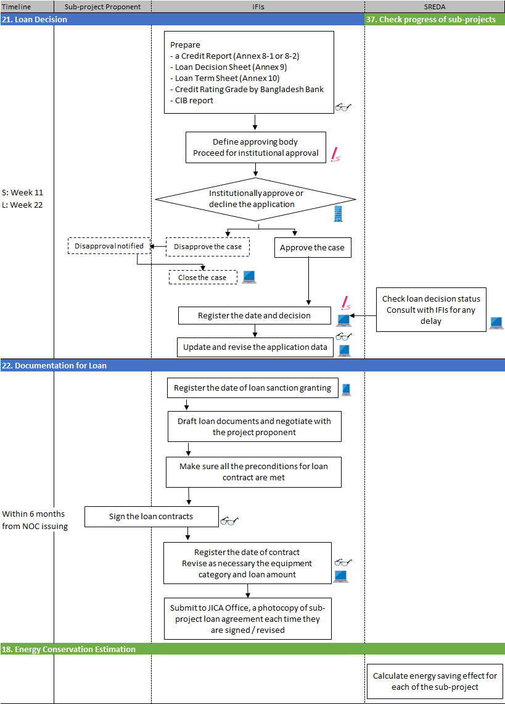

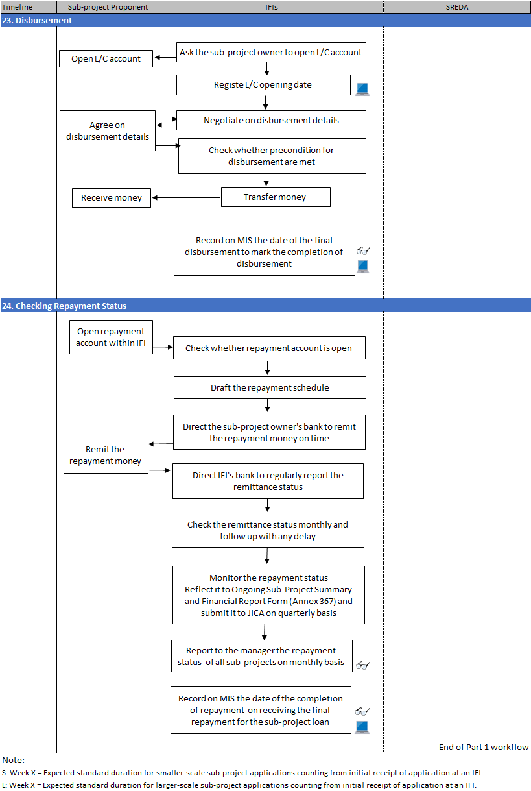

## [Workflow] forB-type Loan Formulation and Implementation Procedure

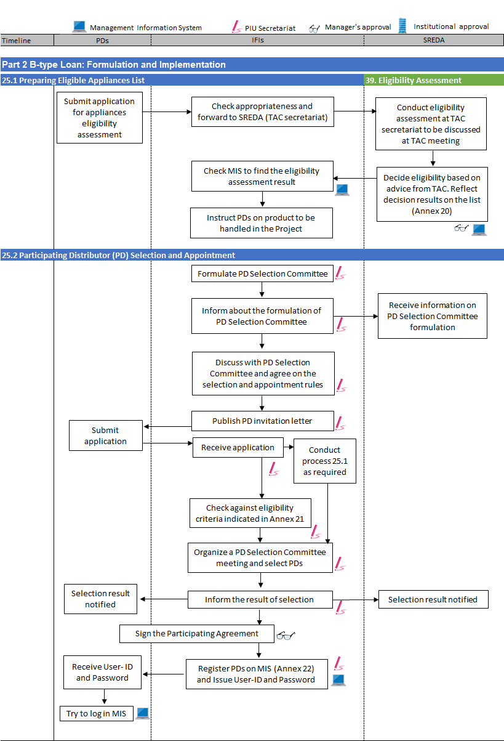

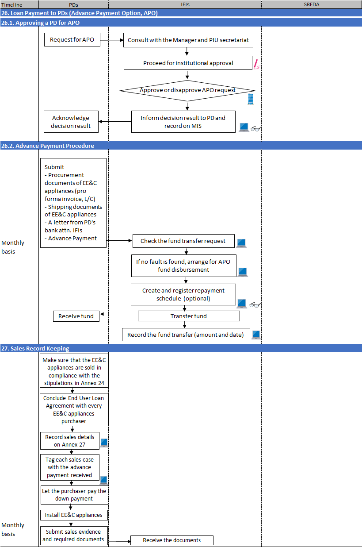

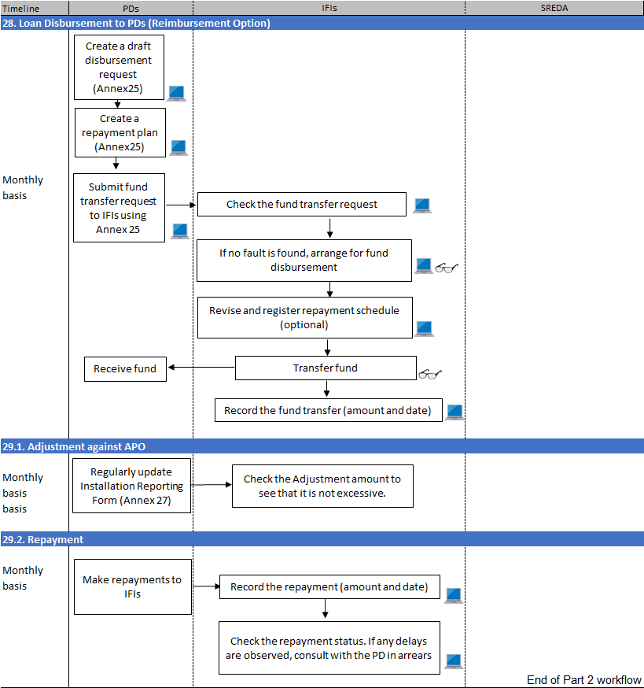

## [Workflow] forMonitoring Procedure for A-type Loan

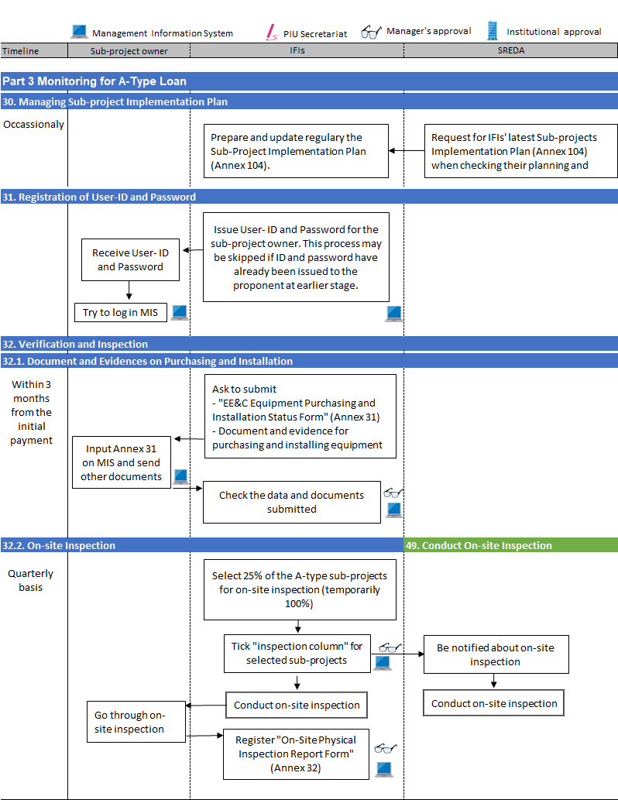

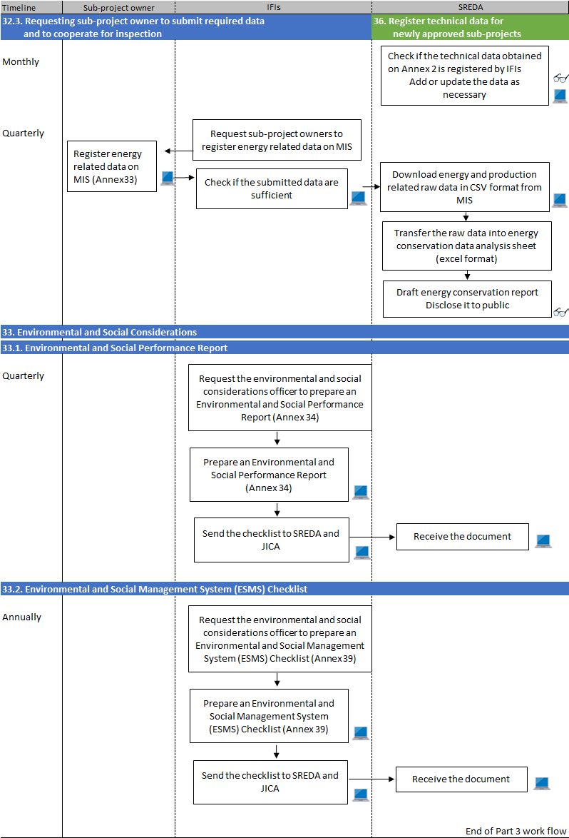

## [Workflow] forMonitoring Procedure for B-type Loan

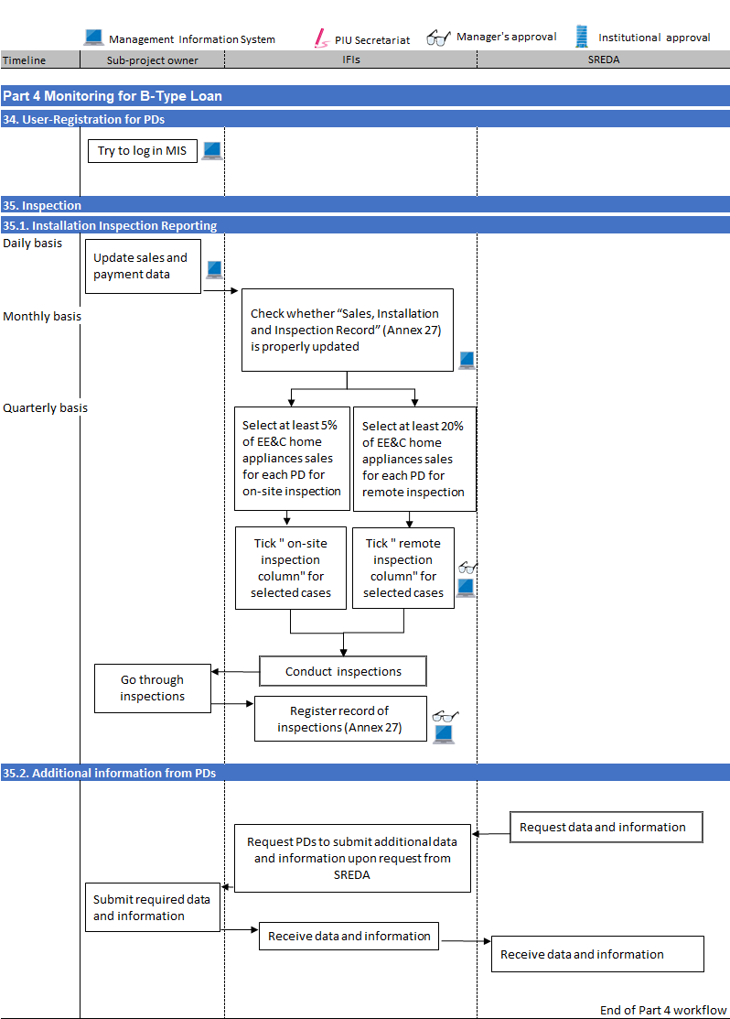

# Part III Daily Operation

## 16. Checking Eligibility

Officer in Charge

* [MIS FR-10] Browse the list daily to identify application cases for which NOC request is submitted.
* For those application cases awaiting SREDA eligibility checking, look for the accompanying documents (Annex 11 with equipment catalogues and other technical specification information, including Annex 2 formand attachments in hard copiesdespatched from the IFIs, with identical information of the equipment are already registered on MIS.
* During the pilot phase, prior to the introduction of MIS, SREDA should check that process No. 14 Name Clearance has already been conducted at the submitting IFI. If not, the application must be returned.

|  |
| --- |
| Note 16 (1):  IFIs will prepare NOC requests based on Annex 11 format, which should be accompanied by:  - Technical Pre-screening Application Form (Annex 2);  - Equipment list;  - Installation site drawings (identifying the production site and equipment  installation position);  - Equipment catalogues, certificates required to demonstrate the eligibility, and;  - Additional information, if any.  If the documents are found to be incomplete, SREDA may either (1) communicate with IFI to furnish required but missing information, or (2) call the IFI to take back the entire document to be reviewed and re-submitted. |

* [MIS FR-16] Once the documents have arrived, prior to starting the eligibility checking, register the date of receipt of these documents on MIS.
* Check recent NOC applications received by browsing the list of applications for the past 12 months. Confirm that that there is no case of duplicate applications (i.e. more than one application from a single entity’s investment activity), regardless of the receiving IFI. During the pilot phase, there should not be more than one application from any entity.
* [MIS FR-18] Use MIS search function to look for precedent cases where the same equipment was applied for.
* If there is a precedent case, eligibility shall be consistent with the past example.
* If there are no comparable cases, refer to the Eligible Technology &Equipment Listas in Annex 4to check the required specification for the equipment to be eligible.

|  |
| --- |
| Note 16 (2):  The followings checking procedure will be conducted smoothly with the presence of IFI person in charge of the request documents.SREDA officer is suggested to call the IFI person to come over for explanation and collaboration. |

* [MIS FR-19] After identifying the category of the equipment, select the relevant Eligibility Check Sheet from Annex 12. Go through the checkpoints to see whether the equipment’s specifications fully comply with the requirements as mentioned in the Eligibility Check Sheet. Mark the checking procedure on MIS and save for record. Try to include as much evidence reference information into the MIS so that the decision background can be shared with the future cases.
* Compare:  
  (a) Technical specification shown in the catalogue, brochure, other evidence documents, with;   
  (b) Technical specification required in the Eligibility Check Sheet (Annex 12).

|  |
| --- |
| Note16 (3):  The officer in charge shall communicate actively with the IFIs through meetings, emails, telephone and any other means to gather sufficient information. During the process, SREDA may request IFIs to submit further technical information if the obtained information is found to be insufficient. Keep record of the received documents on [MIS FR-16] every time new information is received.  There is a communication function in the MIS which will facilitate these communications between SREDA and the IFIs. Communications shall be conducted for each NOC application cases, and will be recorded in dialogue format. |

|  |
| --- |
| Note16 (4):  Catalogue data and specifications may not always prove to be correct. Consult with the T/A task team or Project consultants for any queries. Certificates should be obtained from internationally renowned (e.g. those in G7 countries) accreditation organisations whenever in doubt.  Energy audit reports, sub-project implementation plan (even preliminary versions) may become informative for eligibility checking and calculation of expected energy consumption. Encourage the IFIs to submit these documents or whatever that may be informative for SREDA.  The officers as well as other PIU members are encouraged to visit the actual sites (planned installation site as well as any of the existing similar production sites),by which clearer ideas on the sub-projects may be obtained. The visit may be conducted subject to the consent of the proponent. |

* [MIS FR-19]Register the result of Eligibility Check Sheetevaluation with the reason for such judgement in “evaluation reason” field, and submit it for manager’s approval.Negative information, if any, should also be recorded as the evaluation reason, as it will help the decision making for similar cases in future.

Manager

* [MIS FR-20]Approve or decline the submitted eligibility evaluation result, especially by scrutinizing the reason written in the “evaluation reason”field. Ask for explanations from the officer as required.

|  |
| --- |
| Note16 (5):  There can be cases when IFIs approach SREDA requesting for withdrawal of a submitted NOC request. In such cases, make sur that the IFIs are following the withdrawal process as stipulated in process No.15 Note 15 (3) of IFIs’ business process manual. Once the withdrawal is approved at SREDA, the original document of the NOC request should be returned, accompanied by a letter using the format in Annex 105 |

## 17a. Issue NOC / 17b. Issue Letter of Rejection

Officer in Charge

* After evaluation decision has been approved by the manager, issue either a “Objection / Non-Objection Certificate (NOC)” or a “Letter of Rejection”, using formats shown in Annex 101and 102.
* Request for manager’s approval prior to having it signed (through institutional approval procedure).
* [MIS FR-21]After having received official signature, take a scannedcopy and upload it onto MIS. Submit for manager’s approval.

Officer in Charge

* Despatch the original letter to IFIs to be forwarded to the proponents.

## 18. Energy conservation estimation

Officer in Charge

* After issuing the NOC, the office in charge will calculate energy saving effect for each of the sub-project applications. The data will be based on information from Annex 2(3) received from the IFIs. The calculation may be done on energy efficiency &conservation data analysis and reporting system jointly developed with the JICA T/A Task Team, to be integrated with the Project MIS.
* In estimating the energy conservation, baseline should, in principle, be the data before the execution of the sub-project (i.e. data on existing equipment collected on Annex 2(1-3) tables). For new installation where existing equipment data is not available, the comparison shall be made with the standard baseline data on energy conservation estimation sheet (MS Excel file), which is the data defined under joint consideration with the JICA Technical Assistance Task Team.

# Part IV Monthly Operation

## 36. Register Technical Data for Newly-approved Sub-projects

Officer in Charge

* [MIS FR-44] For newly registered sub-projects (= application cases which were approved for loans in the previous month), check against Annex 2and attachments such as the equipment list, the data already registered by IFIs. Add the following data:   
  (1-3) tables (Energy and production data for the past 12 months)  
  (3) Equipment installation including design / EPC contractor information (free format)  
  (4) brief information on energy consumption and production (free format)  
    
  Update the existing data provided by the IFIsas necessary. After registration, submit for manager’s approval.

Manager

* [MIS FR-45]Approve only after checking that the submitted data is correctly recorded from Annex 2 document. Consult with the officer as required.

|  |
| --- |
| Note36 (1):  This technical data input process may be conducted promptly any time after the emergence of a newly-approved sub-project. The officer should make sure that the data is recorded and approved no later than one month after the emergence of the newly-approved sub-project. |

## 37. Check Progress of Sub-projects

Officer in Charge

* [MIS FR-31 / 38]For application cases under appraisal, confirm on MIS that appraisalprocess duration is within the preferred best practice time frame. If a process duration is observed to be excessively beyond the best practice time frame, consult with the IFI in charge of the case to identify the cause. Encourage the IFIs,whenever possible, to catch up with the preferred process duration.

|  |  |
| --- | --- |
| Process of business operation | Preferred best practice duration |
| Name clearance at IFIs | IDCOL: Loan size =< 100 million BDT  BIFFL: Loan size =< 500 million BDT  Within2 weeks of receipt of loan application |
| IDCOL: Loan size > 100 million BDT  BIFFL: Loan size > 500 million BDT  Within1 month of receipt of loan application |
| Eligibility checking at SREDA | Within7 working days from receipt of NOC request |
| Due diligence (D/D) | Within14 working days from receipt of NOC |
| Institutional approval at IFIs | IDCOL: Loan size =< 100 million BDT  BIFFL: Loan size =< 500 million BDT  Within 1 month of D/D completion |
| IDCOL: Loan size > 100 million BDT  BIFFL: Loan size > 500 million BDT  Within3 months of D/D completion |
| Loan agreement conclusion | Within 6 months from NOC Issuing date |
| Disbursement at IFIs | Within grace period |

* [MIS 1229100] Generate Appraisal Process Status Report (Annex 38) and Appraisal and Execution Progress Report(Annex 103) on MIS at the timing of monthly internal reporting. Fill out observations.
* [MIS 1229200] Submit for manager’s approval.

Manager

* [MIS 1425100] Discuss with the officer on any issues that may have to be solved. Approve and take necessary measures. Consult with the IFIs as required.

|  |
| --- |
| Note37 (1):  SREDA should encourage prompt sub-project approval process at IFIs. Desirable time frame for the IFIs to complete the D/D process is within 14 working days. The maximum period given for D/D, loan approval and conclusion of a loan agreement is 6 months. If the loan agreement cannot be concluded within this time frame, the NOC will cease to be valid (as mentioned in the terms and conditions of the NOC).  However, the IFIs may approach SREDA requesting for extension of NOC validity. In such cases, make sure that the IFIs are following the extension request process as stipulated in process No.20 Note 20.2 (3) of IFIs’ business process manual. After consideration at SREDA, SREDA may decide to grant extension if it is deemed to be beneficial for the Project. Upon decision, SREDA should issue a letter announcing the granting of the extension using the format in Annex 106. |

Manager

* SREDA may request to the IFIs, the updated Sub-Project Implementation Plan which follows the format as stipulated in Annex 104, and should frequently be updated by the IFIs. The plan may be useful to grasp the IFI’s not only the applications, sub-projects as well as the upcoming ones.

# Part V Quarterly Operation

## 38. Collecting data and calculatingconserved energy

Officer in Charge

* In the reporting months of October, January, April and July, collect energy related data of the three preceding months from sub-project owners and calculate amount of energy saving.

|  |
| --- |
| Note38 (1):  IFIs hold responsibility to have the sub-project owners to submit energy efficiency related data on MIS, as well as to be able to conduct on-site inspection in conjunction with SREDA.  Energy Efficiency related data should be submitted from the sub-project owners on MIS until the sub-project owner receives a notification to terminate the data submission from the IFIs.  The data submission obligation, in principle, will continue until either: (i) at least 12 months after the EE&C equipment attains “stable” operation condition, or (ii) after 36 months from the start of the operation, whichever. The IFIs may consult with SREDA when making decision to let the sub-project owner terminate the data submission. |

* [MIS FR-57]Download energy and production related raw data in csv format from MIS (tentative process).
* Transfer the raw data into energy efficiency conservation data analysis and presentation system. Essential data will be:   
  - Total amount of energy saved (TOE);   
  - Amount of energy saved by energy type (kWh for electricity, m3 for gas, etc);   
  - Amount of energy saved by sector, and   
  - Amount of energy saved by equipment.
* Output from the system may be published online on SREDA website for public disclosure.
* Schedule for the reporting month is shown as below:

|  |  |
| --- | --- |
| Day of every reporting month | Action |
| 10th | * Check on MIS whether all the data are submitted by sub-project owners. * If any data is found to be insufficient, ask IFIs to follow up the sub-project owners to submit required data. |
| 15th | * Make sure that all the data are set on MIS. |
| 30th | * Complete calculation and have it approved by manager. |

Manager

* Check the submitted energy conservation report. Propose as necessary, any correction.
* After satisfactory corrections are made, give approval to have it disclosed to public.

## 39. B-type Loan Appliances Eligibility Assessment

|  |
| --- |
| Note 39:  Actual and precise procedure for B-type loan related management will be stipulated when Component III is officially launched. Procedure below is a brief and general description of B-type loan appliances eligibility assessment. |

PIU Secretariat

* Receivefrom IFIs, applications for B-type loan appliances eligibility assessment. The formats will be stipulated when Component III is officially launched.
* Forward, on quarterly basis, the accumulated applications to the Technical Advisory Committee (TAC) secretariat. Support the research works and discussions on eligibility assessment that are being conducted at the TAC secretariat.
* [MIS FR-N1a] On receipt of the TAC’s advice on the eligibility, register information on eligible appliances on Eligible Appliances List(Annex 20), and submit for manager’s approval (preferably after discussion with the manager).

Manager

* [MIS FR-N1b] Check against the advice from TAC and discussion with the PIU Secretariat. Approve after confirming appropriateness of appliances eligibility.

# Part VI Annual Operation

## 40. Annual implementation plan

PIU Secretariat

* Receivethe annual implementation plans from IFIs.
* Prepare the annual implementation plan for SREDA which should include the goals in the following scope and have it approved by the manager:
  + Organizational structure development
  + Document formats preparation
  + Capacity development
  + Number of cases to conduct eligibility check
  + Average number of days to conduct eligibility check
  + MIS maintenance

Manager

* Check the submitted report and approve it.Propose as necessary, any correction. After satisfactory corrections are made, give it an approval.

PIU Secretariat

* Upload Annual Implementation to designated folder on MIS, and notify MPEMR, IFIs, JICA and other relevant stakeholders that they are available on MIS for reference.

## 41. Organize an annual reporting meeting of the Steering Committee

|  |
| --- |
| * The Steering Committee will be formulated by Power Division, MPEMR who is the head executing ministerial body for the Project. SREDA will provide secretarial service for the Committee. * The formulation timing is on the commencement of the Project, which is within 2 months from Loan Agreement. * The Steering Committee is comprised of the following members. * Secretary, Power Division, MPEMR (Chairperson) * Chairman, SREDA * One Representative from External Relations Division, MOF as ministerial body for IDCOL(not below the rank of Joint Secretary) * One Representative from Finance Division, MOF as ministerial body for BIFFL(not below the rank of Joint Secretary) * Project Director of the PIU, SREDA (Secretary) * CEO, IDCOL * CEO, BIFFL * One Representative from JICA * Any other person who may be appropriate. |

Tasks the Steering Committee is responsible for

* Convene Project review meetings annually inviting all the stakeholders to discuss on the status of the implementation and possible improvement in the Project.
* Find out the problem and bottlenecks and recommend necessary collection in policy level such as rules and regulations, taxes, etc.
* Suggesting reallocation of necessary amount of the remaining fund from one IFI to another.

Meeting frequency and procedures

* Ordinary meetings (Annual reporting meetings) which are convened annually, within 3 months of the end of the fiscal year. The Chairperson will instruct the secretariat to arrange and call for the meetings.
* Extraordinary meetings may be arranged with short notice based on the consent of the members.

# Part VII Reporting

## 45. Periodical Reports

|  |
| --- |
| Note 45 (1):  For reporting requirements, SREDA should refer to the Minutes of Discussions signed between the two Governments (Appendix to this Business Process Manual). |

PIU Secretariat

* Collect the following reports from IFIs on quarterly an annual basis:

|  |  |  |  |  |
| --- | --- | --- | --- | --- |
| No | Name of Report | Quarterly | Annually | Format |
| 1 | ESMS Checklist  Automatically generated at[MIS 3329000] | - | ○ | Annex 39 |
| 2 | Environmental and Social Performance Report  Automatically generated at[MIS 3329000] | ○ | ○ | Annex 34 |
| 3 | Time-bound Action plan | ○ | ○ | N/A |
| 4 | Anticorruption Monitoring Sheet | ○ | ○ | Annex 35 |
| 5 | On-going Sub-Project Summary Report | * | * | Note *1 |
| 6 | IFI Financial Report on A-type loan user | * | * | Note *1 |
| 7 | Appraisal Process Status Report  Automatically generated at[MIS 3329000] | ○ | ○ | Annex 38 |
| 8 | On-Site Physical Inspection Report Form Automatically generated at[MIS 3329000] | ○ | ○ | Annex 32 |
| 9 | Sales, Installation and Inspection Record(includes B-type loan installation records)  Automatically generated at[MIS 3329000] |  |  | Annex 27 |
| 10 | Statement of the Designated Account, Sub Account and the Revolving Fund Account of the proceeds of the Loan | - | ○ | Annex 40 |
| 11 | Current repayment and Overdue status report | - | ○ | Annex 41 |
| 12 | Certified Audit Report on Statement of Expenditures and Audit Report | - | ○ | Annex 42 |

* Prepare Quarterly Progress Report (QPR) on quarterly basis except when Annual Report is due. Prepare Annual Report on annual basis. The reports will contain the following documents:

|  |  |  |  |
| --- | --- | --- | --- |
| Name of Document | Quarterly Progress Report (QPR) | Annual Report | Format |
| Main document | ○ | ○ | N/A |
| Project Status Report | ○ | ○ | JICA format |
| Time-bound Action plan | ○ | ○ | N/A |
| Documents collected from the IFIs | As above | As above |  |

Manager

* Check the prepared report and propose as necessary, any improvement. After satisfactory improvements are made, give it an approval to be shared with MPEMR, JICA and the IFIs.

PIU Secretariat

* Upload QPRsand Annual Reports in periodical report folder on MIS, and notify MPEMR, JICA, IFIs and other relevant stakeholders that they are available on MIS for reference.

|  |
| --- |
| Note45 (2):  QPRs shall be compiled by SREDA within one month after the end of each quarter. Submission deadline therefore will be: end of April, July, October, and January. Annual Reports will substitute a QPR for the end of fiscal year submission. |

|  |
| --- |
| Note45 (3):  IFIs prepare Annual Reports for their fiscal year (Jan-Dec). These will be submitted to SREDA within one month of the fiscal year completion. |

# Part VIII Occasional Operation

## 46. Organise a Meeting of the Technical Advisory Committee

|  |
| --- |
| * The Technical Advisory Committee will be formulated by SREDA upon the commencement of the Project which is within 1 month after formulation of the Steering Committee. SREDA will provide secretarial service for the Committee. * The Technical Advisory Committee is comprised of no more than 10 members. The members will be nominated from the following organizations:  1. Chairman, SREDA, will be the chairperson of the TAC. 2. One will be nominated by SREDA. 3. One will be nominated by IDCOL. 4. One will be nominated by BIFFL. 5. An expert in Component I (Industry / commercial sector). 6. An expert in Component II (Building sector). 7. An expert in Component III (Home appliances). 8. Up to two to more, nominated by the chairperson, subject to the consent of all the Executing Agencies from the followings:  * Academic experts from higher education organizations; * Expert consultants on Energy Efficiency Improvement and Conservation (EE&C) field; * Officials from the governmental organizations. |

Tasks the Technical Advisory Committee is responsible for

* To discuss the necessity of revising theEligible Technology &Equipment List(Annex 4)and submit the proposed revision SREDA.
* To advise SREDA on the preparation and revision of theEligible Technology &Equipment List.
* To give advice to the Executing Agencies, when requested, on the eligibility of the applications for sub-projects.
* To evaluate energy audit report relating to the sub-projects as needed in such cases as the regulation on energy audit is in place.
* To advise the Executing Agencies concerning any technical issues.
* To give advice to SREDA for improvement in technical aspect of the Project.

Meeting frequency and procedures

* Meetings are convened with the request of any comprising member to the Committee or the secretariat. The Chairperson will instruct the secretariat to arrange and call for the meetings.
* The secretariat will arrange and call for the meetings, at least a week in advance. Shorter notice may be accepted upon consent of the entire member.

## 47. Organise an ExtraordinaryMeeting of the Steering Committee

Tasks the Steering Committee is responsible for

* Convene Project review meetings annually inviting all the stakeholders to discuss on the status of the implementation and possible improvement in the Project.
* Find out the problem and bottlenecks and recommend necessary collection in policy level such as rules and regulations, taxes, etc.

Meeting frequency and procedures

* Extraordinary meetings may be arranged with short notice based on the consent of the members.

## 48. Revise the Eligible Technology &Equipment list

* For the first year of Project Implementation (starting from the first case of disbursement), the Eligible Technology &Equipment List(Annex 4)will remain unchanged.From the second year onwards,the Eligible Technology &Equipment Listmay be revised in response to discussions at the Technical Advisory Committee,concurrence of JICA, and with consideration for the balance of target industry sub-sectors.

## 49. Conduct On-site Inspection

### 49.1 Targets of Inspections

* For the first year of Project implementation, conduct on-site inspectionsfor all component I and II sub-projects, and around 10 cases for component III. The on-site inspections can be conducted by SREDA alone, or jointly with the IFIs.
* IFIs will select 25% of the Component I and II sub-project sites for on-site inspection, after which they will communicate with SREDA to seek for joint on-site inspection. Try to join their on-site inspections so that the sub-project owners will not be bothered from two different organisations.
* IF SREDA desires to conduct anon-site inspectionfor sub-projects other than the jointly visited ones as above, discuss with the IFI in charge of the sub-project to confirm that the IFI does not intend to conduct a joint on-site inspection. SREDA,in principle, should ask the IFIs to contact the sub-project owners to make the on-site inspection arrangement. If the IFIs are found to be insufficiently responsive, SREDA may report to IFIs that SREDA will communicate with the sub-project owners directly.

### 49.2 Inspection Procedures

* There might be a need to enter into sub-project owners’ premises in on-siteinspection (to check the report and data contents).Further in-depth on-site inspections may be conducted with reference to the Energy Audit Regulations once it has been enacted.
* Component III site (households) on-site inspections will be done only for the exterior view of the houses.
* Analyze the data obtained from the on-site inspections and report the outcomes in the Quarterly Progress Reports.

## 50. Operate and Maintain MIS

Meeting frequency and procedures

* Refer to MIS Operation and Maintenance Manual for details.

END OF DOCUMENT

Blank page

Blank page