# Originality Statement

I hereby declare that this submission is my own work and to the best of my knowledge it contains no materials previously published or written by another person, or substantial proportions of material which have been accepted for the award of any other degree or diploma at IUB or any other educational institution, except where due acknowledgement is made in the report. Any contribution made to the research by others, with whom I have worked at IUB or elsewhere, is explicitly acknowledged in the report. I also declare that the intellectual content of this report is the product of my own work, except to the extent that assistance from others in the project's design and conception or in style, presentation and linguistic expression is acknowledged.

1410458 Noushin Islam

1521947 MahaparaSayemaSiddiqua

1521439 Mahbub Rahman Akash

1522435 Arianul Islam

Acknowledgement

Acknowledge all the people who have helped to complete this task.

Dr.Mahady Hasan

Table of Contents

**Originally Statement1**

Acknowledgement 2

**1.Introduction7**

1.1 Background of the project4

1.2 Background of Organization7

**JICA** ……………………………………………………………………………………….………8

**SREDA** ………………………………………………………………………………………......9

**IDCOL**…………………………………………………………………………………….….…..10

**BIFFL**…………………………………………………………………………………………….11

1.3 Objective of the Project…………………………………………………………………………………….……....12

1.4 Scope of the Project……………………………………………………………………….13

**3. Requirement Analysis**……………………………………………………………………......12

Figure 1: Existing Business System Rich Picture (A-Type)…………… … ….…...13

Figure 2: Existing Business System Rich Picture (B-Type)………………….….....15

Table 1: Process of Existing Business system along with six elements (A-Type)……….. ...17

Table 2: Process of existing business system along with six elements (B-Type)…… ……...27

Table 3: Existing Business system problem analysis (A-Type)…………… ………………..33

Table 4: Existing Business system problem analysis (B-Type)…………………. ………….40

Figure 3: Proposed Business system Rich Picture (A-Type)………………….... …44

Figure 4: Proposed Business system Rich Picture (B-Type)……………… ……... 46

Table 5: Solution……………………………………………………………………….…….47

Table 6: Existing and Propose System Analysis……………………………………… …... 54

Business Rule…………………………………………………………………………………..87

ERD…………………………………………………………………………………………….88

Relationship…………………………………………………………………………………....89

Normalization…………………………………………………………………………….……92

Process Model………………………………………………………………………………....101

Data Dictionary………………………………………………………………………………..109

Input Forms and Output Reports……………………………………………………………...120

Abbreviation & Reference… ………………………………………………………………. 141

1. **INTRODUCTION**
   1. **Background of the Project:**

In the course CSE303 we have been instructed to construct an automated system for the Energy Efficiency & Conservation (EE&C) Promotion Financing Project .The idea of the project is to getting familiar with the information system where the knowledge of the course can be implemented to solve real world problems which is a basic requirement for this course. The project was introduced to us by our course instructor.

The purpose of the project is to save energy and natural resources as much as possible making the best use of it at the same time. Being a densely populated country Bangladesh cannot effort to waste natural resources and energy as they are limited. So making sure that this project a success is very important and to do so an automation system is needed.

The manual process of granting loans and keeping track of everything is a very long term process and costly too. In the automated system the proponent can view all the details of the process before applying for loan. The respective authorities; SREDA and IFI will have access to the documents and information given by the proponent to make the process smooth. The system will be secured with a backup of all the information so that there is no data loss. This system will also ensure the authenticity of the proponents and transparency of the loan granting process.

This automation system will make the whole process easier for both the proponent and respective authorities making it time and cost efficient while maintaining international standards.

* 1. **Background of the Organization:**

The Energy Efficiency & Conservation (EE&C) Promotion Financing Project encourages to penetrate EE&C equipment in order to contribute to the development of the sustainable society and the reduction of greenhouse effect gas emission. This project is introduced in response to Bangladesh’s Seventh Five Year Plan (December 2015). Sustainable and Renewable Energy Development Authority (SREDA) mandates to contribute to demand side energy management through the provision of low interest loan.

The Government of Japan who is represented by JICA extended the loan to the Government of Bangladesh that is represented by the Finance Division, Ministry of Finance. With JICA providing the original Funding for the loan there are three other executing agencies for the project, which are:

1. Sustainable and Renewable Energy Development Authority (SREDA) as the administrative authority
2. Infrastructure Development Company Limited (IDCOL) as an implementing financial institution (IFI)
3. Bangladesh Infrastructure Finance Fund Limited (BIFFL) also as an IFI

The loan fund will be equally allocated between the IFIs. For the sake of using the fund efficiently there will be a mechanism to revise and adjust the fund allocation and re-allocation by the Steering Committee decided through a meeting.

**JICA:**



**Mission and Vision:**

The Japan International Cooperation Agency is an agency of the government of Japan. The governmental agency assists economic and social growth in developing countries and promotes international cooperation. The mission of JICA is to work on human security and quality growth. JICA’s vision is to lead the world with trust and create opportunity for the people to explore their diverse potentials through international bonding.

**Actions:**

* JICA commits to achieve their mission and vision
* Working together with the people on field
* Thinking and acting strategically
* Making best use of resources with diverse wisdom
* Innovating impacts that are groundbreaking

**SREDA:**



Sustainable and Renewable Energy Development Authority (SREDA) implements the policies, laws and regulations relating to sustainable energy in order to respect and protect the environment. The company aims to meet its goals and objectives in an environmentally and socially responsive manner.

**Mission and Vision:**

SREDA visions to promote sustainable energy and build a nation who is energy conscious in order to ensure energy security and reduce carbon emission. By coordination and facilitating the development of renewable energy and energy efficiency SREDA missions to increase the share of renewable energy in the energy mix in order to reduce dependency on fossil fuel, to take appropriate measures for energy saving, to assess continuously for new potential sustainable energy solutions.

**Goals and Objectives:**

SREDA goals for increasing renewable energy generation and increasing the proportion or amount of energy saving. These goals are set so that they can by the year 2020 the renewable energy power generation will be 10% of the total power generation and by the year 2021 the energy saving will be 15% and 20% by 2030 of total energy consumption.

**Organogram:**

Board of Directors

Chairman (1)

Members (16)

Permanent Members (5)

Honorary Members (11)

Diagram 1: Organogram of SREDA

**IDCOL:**



Infrastructure Development Company Limited (IDCOL) plays a vital role in bridging the financing gap for developing medium to large-scale infrastructure and renewable energy projects in Bangladesh. Established on May 14, 1997 by the Government of Bangladesh and licensed by the Bangladesh Bank on January 5, 1998 as a non-bank financial institution (NBFI) the company now stands as the market leader in private sector energy and infrastructure financing in Bangladesh.

**Mission and Vision:**

The company’s mission is to create opportunity and encourage private sector to participate in promotion, development and financing of infrastructures, renewable energy and energy efficient projects in a sustainable manner through public-private-partnership initiatives. IDCOL visions to help ensuring and achieving economic development and improving the standard of living of people of the country by investing sustainable and environment-friendly projects.

IDCOL commits to deliver financial services to the clients who maintain global standards and competence. The company believes in maintaining transparency and integrity in all activities and is dedicated to perform as a developed financial institution articulating social responsibility.

**Organogram:**

Board of Directors

Executive Director and

Chief Executive Officer (1)

Chairman (1)

Directors

(6)

Diagram 2: Organogram of IDCOL

**BIFFL:**



Bangladesh Infrastructure Finance Fund Limited (BIFFL) is a Non-Banking Financial Institution that works under the Ministry of Finance, Government of the peoples, Republic of Bangladesh. BIFFL, the largest NBFI operating in the country, has an ordinance to invest in the large infrastructure project in Bangladesh. The institution invests in sustainable development projects, emphasizing on renewable energy, energy efficiency and eco-friendly project in order to develop a greener Bangladesh.

**Mission and Vision:**

BIFFL missions to perform as a professional Financial Institution by maintaining the international standards both in moral and ethical practice. The company aims to encourage Private Sector Investment in all infrastructure projects in order to promote country’s economic development. It’s another mission is to support sustainable economic growth of Bangladesh by facilitating Infrastructure development. BIFFL’s vision is to increase the economic growth by influencing the relative strengths of Public and Private Sector through financing Infrastructure Projects.

**Goals and Objectives:**

BIFFL’s major goal is to provide long-term finance to critically important infrastructure projects. The company also goals for assembling co-financing from private financial sources and to provide a unique vehicle for capital market development.

BIFFL’s objective is promoting, encouraging and financing Private Sector Investment in all infrastructure sector, extending financing facilities, attracting private investment, creating funds, sub-funds and any other appropriate kind of fund for the infrastructure projects.

The company’s one of the strategic priority is to develop, finance and monitor and implement infrastructure projects and ensure transparency, accountability and fairness in the activities done by BIFFL.

* 1. **OBJECTIVEs OF THE PROJECT:**

The main objectives of the project are:

* Promoting EE&C measures
* Facilitating installation of EE&C equipment in Bangladesh
* Recording and managing the progress of the Project in Online Automated Loan Management System (OALMS) in order to reduce paper work.
* Making the loan process more efficient by reducing the time consuming process of manual data entry and avoiding errors.
* Avoiding processing applications that are not eligible for loan
* Maintaining the standards and control the process by the authority so that the applicants are not mislead
* Maintaining security issues by not storing any sensitive and confidential information
* Avoiding the risk of data loss by storing them in OALMS with security and backup
* Extending loans at low interest and other support in order to alleviate climate change

The basic objective of the project is to develop a system with an improved data sharing and maintenance process which will also be time and cost efficient.

* 1. **SCOPE OF THE PROJECT:**

There are three components that are covered by the EE&C promotion financing project as subjects of loan. These components are chosen as a priority for low interest loan depending on their scope to utilize it effectively. The components are:

1. Component I : Industry or commercial sector component
2. Component II: Building sector component
3. Component III: Home appliances components

The scopes offered by the project are:

* The automation of the process will lead to view and submit the form online so that the applicants or the sub-project proponents and the respective authority can check the application form for necessary consultation. This will also make the process easier for the applicants as they can apply online which will save time and cost that might lead to increase the rate of interested applicants.
* The interested applicants will be able to view the list for eligible Energy Efficient Equipment list along with details and benefits before processing the application for loan
* SREDA and IFI both will track the process of primary eligibility checking and name clearance in order to ensure better evaluation and decision making. The result will be stored in the system for further consultation if necessary
* The authority related to the application process will have access to the system depending on their respective positions. So the system will have separate encrypted modules for the authorities of IFI and SREDA. IFI will evaluate, save results and notify the decision to the sub-project proponents. SREDA will keep track of the whole process by checking the progress of the applications. It will also track the progress of the projects that for which the loan has been granted
* Decisions in every step of the process will be stored in the system along with reasoning and will be notified to the sub-project proponents so that there are no misunderstandings among the authorities and applicants. It will make the whole process transparent.

**Existing Rich Picture A type**

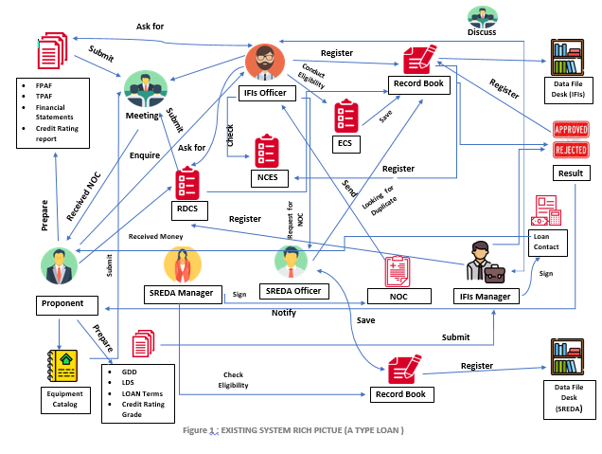

**EXISTING RICH Picture A type Description**

By observing existing system rich picture for A type loan we can see that Sub-project proponent prepare the financial pre-screen Application Form, Technical Pre-screening Form, Financial Statement, Credit Rating Report and submit these documents to IFI’s office manually by meeting by IFS’s office. IFI’s officer in charge register the application and necessary documents. IFI’s officer conduct preliminary eligibility checking using Preliminary Eligibility Check Sheet and record the information. Officer will check Name Clearance Evaluation Sheet using related documents. Going through the NCES office in charge will submit application1 case to manager for approval. If declined, the officer will communicate with the proponent explaining the reason and close the application case. Proponent can renew the application. If approved by the manager will follow the intuitional criteria. After intuitional decision the IFI’s submit NOC request to SREDA. SREDA may enquire and request the IFI for additional technical information equipment catalog. After processing the application by SREDA the IFI’s officer will record and forward the NOC or rejection letter manually. Application case with NOC will proceed to Due Diligence. IFI’s will ask the proponent to prepare the documents for due diligence and additional documents. After carrying out due diligence IFI’s officer will prepare a credit report. Manager will approve or decline case based on the documents submitted. After the decision has been made, register the decision result, date of decision and approving body. IFI’s Officer in charge will make sure all the preconditions for loan contact are met. Manager will signed the loan contact. Secretariat will register the loan contract date, loan amount, equipment code. Officer will check preconditions for disbursement of IFI are met. Transfer the money from bank account of the IFI to L/C account of the sub-project owner. IFI’s officer will draft the repayment schedule. Register the repayment transaction records.

**Existing Rich Picture B type**

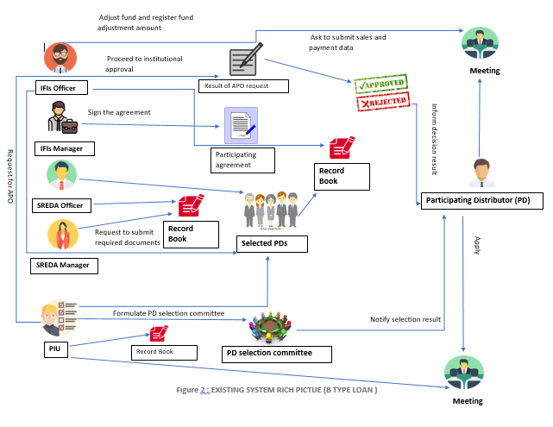

**EXISTING RICH Picture B type Description**

By observing existing system rich picture for B type loan we can see that IFI’s PIU Secretariat formulate PD selection committee and inform to SREDA and JICA in writing. Start PD selection by publishing PD invitation notice. After receiving application by meeting and check against eligibility criteria. PD selection committee select PD’s and PIU Secretariat record PD’s name, type of organization and address on record book manually. Sign the participating agreement by meeting. PD’s report sales using Sales, Installation and Inspection Record through meeting. After install EE&C home appliances submit fund transfer request to IFI’s office using request form. PIU Secretariat check transfer request. Manager approve or reject fund transfer and record fund transfer on record book. PD’s request for APO. Request proceed for intuitional approval. After intuitional approval IFI’s inform decision result and record on record book. Officer in charge will ask PD’s for submit required documents for advance payment procedure. PIU Secretariat check transfer request. Manager approve or reject fund transfer and record fund transfer on record book. PD’s will check EE&C home appliances sales status and record the sales details and install the home appliances. PD’s request for adjustment. Manager approve or reject the request and record on record book.

# **Requirement Analysis**

# **Table 01:** eXISTING Bussineess sYSTEM ALONG WITH sIX eLEMENTS (A-Type Loan)

|  |  |  |  |  |  |  |  |
| --- | --- | --- | --- | --- | --- | --- | --- |
| **Sl** | **Process Name** | **Human** | **Non-Computing Hardware** | **Computing Hardware** | **Software** | **Database** | **Communication and networking** |
| 1. | Preparation | PIU Secretariat (IFIs): Provide the project’s overview, application forms and contact details | Pen, Paper (Application form) | N/A | N/A | N/A | N/A |
| 2. | Receiving loan applications | Proponent: Submit the application form | Pen, Papers include:   * Financial statements * Credit Rating Report * Technical pre-screening form | N/A | N/A | N/A | N/A |
| Officer In Charge (IFIs) : Ask the proponent to prepare Financial Pre-screening Application Form, Technical Pre-screening Application Form, Financial Statements and Credit Rating Report and fixing a meeting date |

|  |  |  |  |  |  |  |  |
| --- | --- | --- | --- | --- | --- | --- | --- |
| **Sl** | **Process Name** | **Human** | **Non-Computing Hardware** | **Computing Hardware** | **Software** | **Database** | **Communication and networking** |
| 3. | Preliminary eligibility checking | Officer In Charge (IFIs): Conduct preliminary eligibility checking | Pen, Papers include:   * Eligibility Check Sheet * Eligibility Technology and Equipment List | N/A | N/A | N/A | N/A |
| Manager(IFIs) : Approve or Decline the checking result, consult SREDA employee and provide preliminary comments if required |
| 4. | Name Clearance | Officer In Charge (IFIs) : Check the items in the Name Clearance Evaluation Sheet, consult  With proponent for the reason of decline | Pen, Papers include:   * CIB Report * Credit Rating report * Financial Statement * Name Clearance   Evaluation Sheet | N/A | N/A | N/A | N/A |
| Conduct the Name Clearance Evaluation and register the evaluation result using Name Clearance Evaluation Sheet |
| Manager(IFIs) : Approve or Decline the case |
| PIU Secretariat(IFIs) : Define decision body and proceed to institutional clearance,  Approve or Decline the case institutionally  Register the decision result and consult IFIs for any delay |

|  |  |  |  |  |  |  |  |  |  |  |  |  |  |  |  |
| --- | --- | --- | --- | --- | --- | --- | --- | --- | --- | --- | --- | --- | --- | --- | --- |
| **Sl** | | **Process Name** | | **Human** | | **Non-Computing Hardware** | | **Computing Hardware** | | **Software** | | **Database** | | **Communication and networking** | |
| 5. | | Submit Request to SREDA for NOC | | Officer In Charge (IFIs): Check for new cases that has completed Institutional Clearance, if any change has been made update the data | | Pen, Papers include:   * Two sets of equipment catalogues * Original Copy of Technical Pre-screening Application Form * Record the decision * Draft of NOC or Rejection letter | | N/A | | N/A | | N/A | | N/A | |
| Manager (IFIs): Input necessary Information from Technical  Pre-screening Application Form, reflect revisions and updates, approve or decline Technical Pre-screening Application Form | |
| Sub-project proponent: Submit two sets of equipment catalogues | |
| SREDA: Check NOC request from IFIs, Receive documents, Physically forward and register the date | |
| SREDA: Ensure that there is no duplicate application, Check for Precedent cases, Inquire about additional information of equipment, Register the result of evaluation with reasoning, Receive official signature on NOC draft or rejection letter, Dispatch the original letter to IFIs. | |
| **Sl** | | **Process Name** | | **Human** | | **Non-Computing Hardware** | | **Computing Hardware** | | **Software** | | **Database** | | **Communication and networking** | |
| 6. | | Forwarding NOC or Rejection letter to proponent | | Officer In Charge (IFIs): Forward the NOC or rejection letter to the Sub Project Proponent,  Close the rejected case  Sub Project Proponent: Receive the NOC or rejection letter | | Pen, Papers include:   * Original copy of NOC or rejection letter | | N/A | | N/A | | N/A | | N/A | |
| Sub Project Proponent: Receive the NOC or rejection letter | |
| 7. | | Due Diligence | | Officer In Charge (IFIs): Choose the type of due diligence on Due Diligence Type check sheet, Ask Sub Project Proponent to prepare the documentsindicated in Required Document Check Sheet, Register the received date of documents,  Conduct off site and on-site due diligence, Register the completion of Due Diligence | | Pen, Papers include:   * Due Diligence Type check sheet * Required documents check sheet * Credit report elements sheet | | N/A | | N/A | | N/A | | N/A | |
| Sub Project Proponent: Prepare and send documents indicated in required document check sheet | |
| SREDA Employee: Check Due Diligence Status and consult with IFIs for any delay | |
| Manager (IFIs): Register the completion of Due diligence | |

|  |  |  |  |  |  |  |  |
| --- | --- | --- | --- | --- | --- | --- | --- |
| **Sl** | **Process Name** | **Human** | **Non-Computing Hardware** | **Computing Hardware** | **Software** | **Database** | **Communication and networking** |
| 8. | Loan Decision | Manager (IFIs) : Prepare documents (General Due Diligence, Simple Due Diligence, Loan Terms), Update and revise application data | Pen, Papers include:   * Credit report * Loan decision sheet * Loan term sheet * Credit rating rate by Bangladesh bank * Rejection/Approval Letter * Record the decision | N/A | N/A | N/A | N/A |
| Officer In Charge (IFIs): Report to the approving body of completion of loan decision,Notify rejection to Sub Project Proponent  and close the case |
| PIU Secretariat(IFIs) : Proceed to Approve or Decline the application institutionally, Register the date and decision |
| Officer In Charge (SREDA) : Check loan decision status and consult with IFIs for any delay |
| PDs: Get notified about rejection, renew or review the application starting from name clearance or due deiligence |

|  |  |  |  |  |  |  |  |
| --- | --- | --- | --- | --- | --- | --- | --- |
| **Sl** | **Process Name** | **Human** | **Non-Computing Hardware** | **Computing Hardware** | **Software** | **Database** | **Communication and networking** |
| 9. | Documentation for loan | Officer In Charge (IFIs): Draft loan documents, Negotiate with sub project proponent, sign the contract and register the date of contract, Revise the equipment category and loan amount if necessary | Pen, Papers include:   * Loan documents * Contract Paper | N/A | N/A | N/A | N/A |
| Sub Project Proponent: Sign the Contract |
| Manager (IFIs) Check the contact papers |
| 10 | Disbursement | Officer In Charge (IFIs): Ask the sub-project owner to open L/C account, Negotiate on disbursement details, Check if the pre- conditions of disbursement are fulfilled, Transfer money | Pen, Papers include:   * Documents of L/C account * Documents of negotiation | N/A | N/A | N/A | N/A |
| Sub Project Proponent: Open L/C account, Agree on disbursement details, Receive money |
| Manager (IFIs) : Get notified about the whole process |

|  |  |  |  |  |  |  |  |
| --- | --- | --- | --- | --- | --- | --- | --- |
| **Sl** | **Process Name** | **Human** | **Non-Computing Hardware** | **Computing Hardware** | **Software** | **Database** | **Communication and networking** |
| 11. | Checking Repayment Status | Sub Project Proponent: Open repayment account within IFI, Remit the repayment money | Pen, Papers include:   * Financial Report Form (Ongoing Sub-Project Summary and Financial Report Form) | N/A | N/A | N/A | N/A |
| Officer In Charge (IFIs): Check if the repayment account is open, Direct the sub-project owner’s bank and IFIs bank, Check the remittance status monthly and follow up with any delay Monitor the repayment status and submit to JICA on quarterly basis, Report to the manager about the repayment status on monthly basis |
| Manager (IFIs):Check the reports of repayment status for all sub-projects on monthly basis |
| 12. | Registration of Sub-Project proponent (approved) | Officer In Charge (IFIs):Registering the Proponent | Pen, Papers include:  Registration Record Keeping Book |  |  |  |  |
| Sub Project Proponent: Complete all the process of registration |
| Manager (IFIs) : Approve the registration |
| 13. | Verify Document and Evidences on Purchasing and Installation | Officer In Charge (IFIs) : Ask proponent to submit ‘EE&C Equipment Purchasing and Installation Status Form’ Document and evidence for purchasing and installing equipment(within three months of initial payment) | Pen, Papers include:   * EE&C equipment Purchasing and Installation Status Form   Document & evidence regarding purchase and installation of equipment |  |  |  |  |
| Sub Project Proponent:Send necessary documents |
| Manager (IFIs) : Checking data and submitted documents |
| 14. | On-site Inspection | Officer In Charge (IFIs) : Select 25% of the A-type sub-projects for on-site inspection,  Go through on-site inspection,  Registering “On site Physical Inspection Report Form”  Notify SREDA about on-site inspection | Pen, Papers include:   * On-site Physical Inspection Report Form |  |  |  |  |
| Manager(IFIs) : Check the selected sub-projects for on-site inspection and approve it |
| Officer In Charge (SREDA) : Conduct on-site inspection |
| 15 | Request sub-project Owner to submit required data and to cooperate for inspection | Officer In Charge (IFIs): Request sub-project owner to submit required energy related data | Pen, Papers include:   * Energy conservation data analysis sheet * Technical Pre-screening Application Forms * Energy Efficiency Related Data Form |  |  |  |  |
| Sub Project Proponent:Submit necessary documents |
| Manager(IFIs) : Check if the submitted data are sufficient |
| Officer In Charge (SREDA) Collect Energy and production related Raw data and transfer the raw data into energy conservation data, prepare energy conservation draft report disclose to public |

**Table 02:** eXISTING Bussineess sYSTEM ALONG WITH sIX eLEMENTS (B-Type Loan)

|  |  |  |  |  |  |  |  |
| --- | --- | --- | --- | --- | --- | --- | --- |
| **Sl** | **Process Name** | **Human** | **Non-Computing Hardware** | **Computing Hardware** | **Software** | **Database** | **Communication and networking** |
| 16. | Participating Distributor (PD)  Selection and Appointment | PIU Secretariat (IFIs):  Formulate PD selection committee and agree on the selection and appointment rules by discussing,  Send Published invitation letter to PDs and receive the application,  Check the eligibility on Eligibility Criteria for PDs and inform result to PDs and SREDA, register the PD’s on a PD List Form  PDs: Send the application to IFIs, Sign the Participating Agreement and get registered | Pen, Papers include:   * Application form * Eligibility Criteria for PDs * PDs List Form | N/A | N/A | N/A | N/A |
| Manager (IFIs): Sign the participation agreement. |
| SREDA: Get Informed and notified about the PD selection committee and selection result |
| 17. | Loan Payments to PDs (Reimbursement Option) | PDs: Agreement with EE&C of home appliance purchase who meets the required report sales, Inspect the record on monthly basis, Install of EE&C home appliances, Request for fund transfer | Pen, Record Book, Papers include:   * Sales, Installation and Inspection Record Form (Common to both APO and RO) * Request Form * Other doc?? | N/A | N/A | N/A | N/A |
| Officer in Charge (IFIs):  Periodically observer sales, installation and inspection record, Check fund transfer request and record the fund transfer |
| Manager: Approve or reject fund transfer |
|  | Loan Payments to PDs Advance Payment Option(APO) | | |  |  |  |  |
| 18. | Approving a PD for APO | PDs: Request for APO is send to IFIs,  Acknowledge decision result | Pen, Papers include:   * APO Application | N/A | N/A | N/A | N/A |
| PIU Secretariat: Proceed for institutional approval., Inform decision to PD and record |
| Officer In Charge(IFIs): Consult with manager and PIU secretariat |
| Manager: Approve or decline APO request |
| 19. | Advance Payment Procedure | PDs: Procurement document of EE&C | Pen, Papers include:   * Application Form for Advance Payment Option * Procurement document form * Invoice |  |  |  |  |
| Home appliances along with shipping documents, letter of PD’s bank attn. IFIs and advance payment of Application Form for Advance Payment Option is submitted on monthly basis. Receive approved Fund transfer |
| Officer In Charge(IFIs): Check for fund transfer request, Transfer approved fund and record amount and date, discuss with the Manager |
| Manager(IFIS): Approve or reject fund transfer request |
| 20. | Sales Record Keeping | PDs: Check EE&C home appliance sales status, Record sales details and install EE&C home appliances according to the down- payment. | * Sales, Installation and Inspection Record Form (Common to both APO and RO) |  |  |  |  |
| Officer in Charge (IFIs): check the recorded details |
| 21. | Adjustment against APO | PDs: Regular update of Installation Reporting Form on Sales, Installation and Inspection Record Form (Common to both APO and RO) and Submit adjustment request on Advance Payment Adjustment Form | Pen, Papers include:   * Sales, Installation and Inspection Record Form (Common to both APO and RO) * Advance Payment Adjustment Form |  |  |  |  |
| Officer In Charge (IFIs): Check for adjustment request, Adjust fund and record date and time |
| Manager(IFIs): Approve or decline the APO Adjustment request |
| 22. | Registration of participating distributors (approved) | PDs: Complete all the process of registration | Pen, Papers include:   * Registration Record Keeping Book |  |  |  |  |
| 23 | Installation Inspection | Manager (IFIs): Select cases and conduct on-site inspection. Record the on-site inspection | Pen, Papers include:   * Physical Inspection Report Format (B-type) |  |  |  |  |
| 24. | Additional Information from PDs | PDs: Submit required data and information | Pen and Papers(Required additional documents) |  |  |  |  |
| Officer In Charge(IFIs): Request PDs to submit additional data and information upon request from SREDA |
| Manager(SREDA): Receive required additional data |

# **Table 03**: eXISTING Bussineess sYSTEM Problem Analaysis (A-Type Loan)

|  |  |  |  |  |
| --- | --- | --- | --- | --- |
| **Sl** | **Process Name** | **Problem** | **Quantify the cost** | **Problem Analysis** |
| 1. | Preparation and receiving loan applications | i.Printing the application form | 10 tk per page 10 pages for 500 forms =500*10*10=50000 | i.Printing the form is expensive process thus we need to find mechanism to get rid of this printing process. |
| ii. Time consuming | About 50min (minimum) needs to reach Gulshan from Bashundhara Residential Area.  Cost :  Charge for meeting room: 1000tk per hour  Electricity bill per unit 8.3tk  Staff :300tk per hour work  Refreshment: 50tk per person | ii.Visiting IFI and waiting for procedure for loan is lengthy process.  It’s difficult and time consuming for the proponents to manage time for double meeting |
| iii.Problem of Transportation | Average transport cost(1person) from Bashundhara to Gulashan ,  BUS:30tk  CNG:300tk  Uber:450tk | iii.Transports are not  Available always; moreover there is traffic jam which makes it difficult for the proponent to reach destination. |
| 2. | Preliminary eligibility checking | i.Time consuming | Almost 7 days;which is 56 hours  One Employee works 8 hours per day  Payment 1000tk per day ,per hours payment 1000/8=125 tk | i.Lengthy process impacts on emergency |
| ii.Data loss | Record book 250tk | ii. Multiple papers are needed for keeping records which might get lost |
| 3. | Conducting Preliminary Eligibility Checking and Name Clearance Evaluation | i.Costly | 1 book=250tk  Per page cost 10 taka, for 250 member,  Cost will be 250*10=2500tk | i.Printing the form is expensive process thus we need to find mechanism to get rid of this printing process. |
| ii .Time consuming and hectic | It takes about 4/5 hours to go through all the papers  Per hours payment for Employee 125tk,so for 5 hours 125*5=625tk | ii .Manually conducting this step might cause the loss of data.  The workload will be time consuming and hectic too |
| 4. | Submission of request for NOC | i.Time consuming | Almost 3days  Per day payment for Employee 1000tk,so for 3 days 1000*3=3000tk | i.Lengthy process makes the whole system slow |
| ii.Loss of records | Record book 250tk  10 record books=250*10=2500tk. | ii .papers might be lost |
| 5. | Eligibility checking | i.Loss of recorded data | 1 book=250tk (for record data ) | i.Extra cost for collecting data |
| ii .Time consuming | Almost 7days  Per day payment for Employee 1000tk,so for 7days 1000*7=7000tk | ii .Lengthy process |
| iii.Check duplicate application | For duplicate application ,cost of paper becomes double | iii.Need extra paper and time |
| 6. | Forwarding NOC or Rejection Letter | i.Time consuming | Delay for 3 days  Per day payment for Employee 1000tk,so for 3 days 1000*3=3000tk | i. The forwarding process might take longer time than expected |
| ii. Document can get lost | Printing cost per page 10tk | ii. the document might get lost in the way |
| 7. | Due Diligence | i.Time consuming  and costly | 250tk=1book | i.Files saved manually can be lost and takes time to search and also costs money |
| ii .Data loss | Delay for 2 days  Per day payment for Employee 1000tk,so for 2 days 1000*2=2000tk  Printing cost per page 10tk | ii .Tracking the due diligence information and date might be hard and information might get lost |
| 8. | Institutional Clearance and documentation for loan | i.Miss out information | 3 hours delay  Per hour payment for Employee 125tk,so for 3 hours 125*3=375tk | i.By ,mistake might skip some necessary information |
| ii .Extra cost | Transport cost almost 450tk  Officer’s Salary 20000-25000 tk Per hour 25000-3000  We can save 1/3 of working hour  So we can save 6000-8000 tk  Manager’s Salary 35000-53000 tk  Per hour 4000-8000 tk  We can save 1/3 of working hour  So we can save 8000-14000 tk | ii .Cost of paper,extra charge of workers |
| 9 | Loan Decision and documentation | i.Time consuming | More than 4 days  Per day payment for Employee 1000tk,so for 5 days 1000*5=5000tk  (minimum) | i.Time consuming for revise and updating the application date |
| ii .Lose record | Record book 250tk  10 record books=250*10  =2500tk. | ii .papers might be lost |
| 10 | Registration of Sub-Project proponent (approved) | i. Time consuming | Per hour payment for an Employee is 125tk | i.Every proponents details needs to be manually saved which is tie consuming |
|  | ii.Costly | Record book 250tk  10 record books=250*10  =2500tk. | ii. Record book or files needs to be bought |
| iii.Data loss | Delay for 2 days  Per day payment for Employee 1000tk,so for 2 days 1000*2=2000tk  Printing cost per page 10tk | iii.The record book or file might get lost |
| 11. | Verification of documents and Evidences on Purchasing and Installation | i. Time Consuming | Per day payment for Employee 1000tk | i.Manual submission of form will cost time |
| ii. Expensive | Average transport cost(1person) from Bashundhara to Gulashan ,  BUS:30tk  CNG:300tk | ii. Requires transport cost to submit documents manually |
| 12 | On-site Inspection | i. Data loss | Printing cost per page 10tk | i.The inspection form might get lost |
| 13 | Request subproject Owner to submit required data and cooperate for inspection | i.Time | Per day payment for Employee 1000tk | i.the documents need to be submitted manually by going to the office and it takes more time to check data manually |
|  | ii.Costly | Average transport cost(1person) from Bashundhara to Gulashan ,  BUS:30tk  CNG:300tk | ii. Submitting documents manually will require transportation cost |

# Table 04 : eXISTING Bussineess sYSTEM Problem Analaysis (B-Type Loan)

|  |  |  |  |  |
| --- | --- | --- | --- | --- |
|  | **Process** | **Problem** | **Quantify the cost** | **Analysis** |
| 1. | Submitting application form and Checking eligibility of the applicants | i.Expensive | Average transport cost(1person) from Bashundhara to Gulashan ,  BUS:30tk  CNG:300tk  Uber:450tk  REMOVE LINE | i.Procedure of filling up manual from , which is lengthy process and costly |
|  | Per day payment for Employee 1000tk  Electricity bill per unit 8.3  Refreshment: 50tk per person | ii.Cost of transportation, electric bill charge of office room, percentage of salary of officer in charge, refreshment are also involved. |
| ii.Time Consuming | Almost 7 days  Cost of proponent per day 500tk | i.Proponents may have to go through a long process |
|  | Registration of Participating Distributor(PD) | i.Expensive | 1 Record book =250tk  10 tk per page 10 pages for 500 registration forms = 500*10*10=50000 tk | i.Printing is expensive so need to make a system where we can save the expense. |
| ii.Time consuming | Employee cost per hours 125tk | ii.Manual input is not suitable for every PD which is lengthy process |
| iii.Data Loss | Delay for 2 days  Per day payment for Employee 1000tk,so for 2 days 1000*2=2000tk  Printing cost per page 10tk | iii.The data will be stored in a file that might not have any sequence  The file or book which the proponent is registered might get lost |
| 3. | Reporting and checking sales record | i.Lack of  Communication  ii.Costly | 1 Record book =250tk  10 record books=250*10=2500tk. | i.It will be difficult to keep IFIs up to date  ii.record books are needed to record the so many data which costs money and space |
| 4. | Fund transfer request | i.Expensive | Average transport cost(1person) from Bashundhara to Gulashan  BUS:30tk  CNG:300tk  Uber:450tk | i.Printing the form costs money and also the transportation cost adds up to the expense |
| ii.Time Consuming | 2 hours delay  Per hours payment for Employee 125tk,so for 2 hours 125*2=250tk | ii.PD needs to go to IFIs office for submitting application which is time consuming .-Apart from location ,transportation matters for communication |
| 5. | Request for Advance Payment Option(APO) | i.Time Consuming  ii.Expensiveiii. safety of record book or file | 2 hours delay  Per hours payment for Employee 125tk,so for 2 hours 125*2=250tk  Average transport cost(1person) from Bashundhara to Gulashan  BUS:30tk  CNG:300tk  Uber:450tk | i.PD needs to go to IFIs office for submitting application which is time consuming and costly |
| 6. | Update Installation reporting form | i.Expensive | 1 Record book =250tk  10 record books=250*10=2500tk. | 1. The record book or forms are need to be bought |
| ii.Communication problem | Delay for 2 days  Per day payment for Employee 1000tk,so for 2 days | 1. Hard to keep track of the updates which might delay the process |
| 7. | Submit Additional Information | i. Time Consuming | Per day payment for Employee 1000tk | i.Going to the office requires time |
|  |  | ii.Costly | Average transport cost(1person) from Bashundhara to Gulashan  BUS:30tk  CNG:300tk  Uber:450tk  1 Record book =250tk  10 record books=250*10=2500tk. | ii.Manual submission reqires transportation cost and record keeping file or book |

**Proposed system Rich Picture A type**

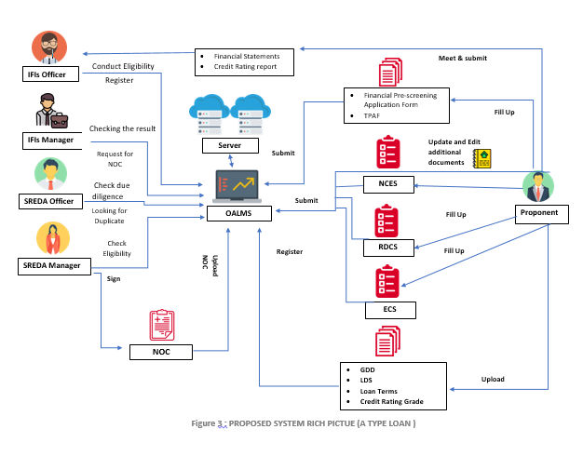

**Proposed system Rich Picture DESCRIPTION A type**

By observing the proposed system rich picture above, we can see that Proponent will sign up for application and fill up the financial pre-screening form, technical pre-screening form, financial statements, credit rating report to the IFI’s website. A registration number and proponent ID will auto generate. IFI’s Officer in charge will register application date, business code number of proponent to the IFI’s server. PD’s will submit rest of necessary documents. IFI’s officer will register additional information such as input date, code number of equipment’s, requested loan amount. Then IFI’s officer will conduct preliminary eligibility checking and register the information to the server. Proponent will fill up the name clearance evaluation sheet on the website. IFI’s officer will check the name clearance evaluation sheet using CIB report, Credit rating report, and financial statement. This information will be register to the IFI’s server. Manager will approve or reject the case. If rejected, notify the proponent through proponents ID. If approved then proceed further process and register the information to the server. IFI’s officer will submit NOC request to SREDA. SREDA will receive necessary documents through server and check there is any duplicate application. After eligibility checking the information to the server with the reason. SREDA manager will issue NOC or reject the case. If rejected, proponent will be notified. Proponent will send documents for due diligence. IFI’s officer will completion of due diligence and SREDA officer will check Due diligence. After taking loan decision by the decision body, register the decision, date and notify the proponent if rejected. SREDA check the loan decision. IFI manager Sign the loan contact with proponent and register the date of contact. Conduct disbursement, IFI transfer money to proponent. Then IFI’s officer will check repayment status and report to Manager monthly basis.

**Proposed system Rich Picture B type**

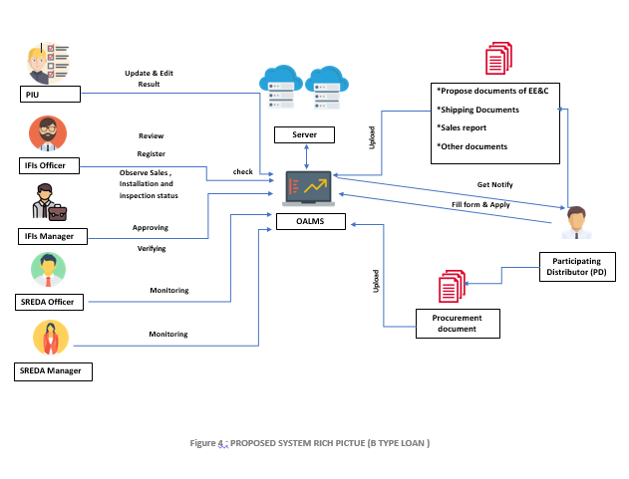

**Proposed system Rich Picture DESCRIPTION B type**

By observing the rich picture above, we can see that Participating Distributor (PD) fill up form and apply on the IFI’s website. A registration number and PD’s ID auto generate and register in server. After application received, PIU Secretariat check eligibility criteria. Selection committee select PDs. SREDA and PDs notify about selection through online. PDs upload propose documents of EE&C, shipping documents, sales report, other documents on the OALM’s server. IFI’s officer observe sales, installation and inspection record. PDs submit fund transfer request. Manager approve or reject request and record the information. PDs upload the Procurement document on the server. IFI Manager approve or reject fund transfer request and record the fund transfer amount and date. SREDA monitor the processes and server records.

# TABLE 5: SOLUTION

|  |  |  |  |  |
| --- | --- | --- | --- | --- |
| **Sl** | **Process Name** | **Problem** | **Solution** | **Quantify the saving** |
| 1. | Preparation and Receiving loan Applications | i.Printing the application form | Form will be available in the OALMS. | i.40000tk |
| Time consuming | As form will Be available in the OALMA the times it takes to visit IFIs will be saved  ADD MEETTING | About 40 minutes |
| Problem of Transportation | As form will Be available in the OALMA the cost of transportation will be saved. | Average transport cost(1person) from Bashundhara to Gulashan ,  BUS:30tk  CNG:300tk  Uber:450tk |
| 2. | Preliminary Eligibility Checking | Time consuming | The eligibility checking will be done with the OALMA which will save the time | Almost 7 days |
| Data loss | No files or papers will be needed as everything will be saved on OALMS. This will save the cost of papers and also environment | 250tk per Record book |
| 3. | Conducting Preliminary Eligibility Checking and Name Clearance Evaluation | Data loss | Everything will be saved in the system which will save the cost of printing all the documents | Saves about 2500tk |
| Time consuming and hectic | All the papers will be checked in the OALMS | Saves about 4/5 hours |
| 4. | Submission of request for NOC | Time consuming | Submit the request for NOC via OALMS | Saves almost 3days of the process |
| Loss of records | The decision will be recorded on the OALMS with backup so there is no chance of misunderstandings and lost in formation | Saves the money of the papers needed for documenting which is about 2500tk |
| 5. | Eligibility checking | Loss of recorded data | The OALMS will mark the eligibility and record everything on the system | Cost for documenting data which is about 2500tk will be saved |
| Time consuming | OALMS will take the least amount of time needed to check eligibility | Saves almost 7 days. |
| Check duplicate application | The OALMS will check for duplicate applications which will ensure that there is no mistake | The extra pare needed to documenting and the time of going through all the documents manually will be saved |
| 6. | Forwarding NOC or Rejection Letter | Time consuming  and costly | The NOC or rejection letter will be notified in OALMS | It will save time and transport cost |
|  |  | Data loss | The documents will be saved in OALMS | The documents will not get lost and becomes easy to keep track |
| 7. | Due Diligence | Time consuming  and costly | The forms will be available in OALMS | Files saved manually can be lost and takes time to search and also costs money |
| Data loss | Received documents will be saved in the system | Tracking the due diligence information and will be easy and error free |
| 8. | Institutional Clearance and documentation for loan | Loss of information | Information will be saves in OALMS with backup | The time of re-checking in case of missing information which is about 2/3 hours |
| Extra cost | Information will be saves in OALMS with backup,the Proponent will be notified by the system  As the system does most of the work ,it will need less Employee working hour | Saves transport cost which is about 450 tk.  The system will be able to save 1/3 of the working hour which will save 8000 tk to 15000tk depending on the employee |
| 9. | Loan Decision and documentation | Time consuming | Revise and update the application date and all the information in OALMS | Saves about 4 days |
| Lose record | Record the decision with backup | Cost of papers for documenting and time will be saved. 250 tk per record book. |
| 10 | Registration of Sub-Project proponent (approved) | Time consuming and costly,data loss. | Sub-Project proponents will register in OALMS | Cost of papers for documenting and time will be saved. 10 tk per page printing. |
| 11. | Verification of documents and Evidences on Purchasing and Installation | Time consuming and expensive | The documents that are received will be marked in the OALMS | Transportation cost and manually submitting time will be saved |
| 12 | Request subproject Owner to submit required data and cooperate for inspection | Time consuming and expensive | The requires data will be submitted through the OALMS | Transportation cost and manually submitting time will be saved |
| 13 | Submitting application form and Checking eligibility of the applicants | Expensive | Submit the form on OALMS | Saves the time and cost of going to the office to submit form.  Transport cost:450 tk  Time:1/2 hour; depending on the distance |
| Time Consuming | Submit the form on OALMS | The automated system speeds up the whole process and helps to avoid traffic jam. |
| 14. | Registration of Participating Distributor(PD) | Expensive | Register online via OALMS | Saves the money for printing the registration forms which is about 45000 tk |
| Time consuming | Register online via OALMS | Saves the time and cost of going to the office to submit form.  Transport cost:450 tk  Time:1/2 hour; depending on the distance |
| Data Loss | Save the required data in the system with backup | Easy to find any information and ensure everything is fine |
| 15. | Reporting and checking sales record | Lack of Communication | Report and check sales record on OALMS | IFIs will be up to date |
| Costly | Checking everything online will reduce paperwork | Saves around 2500tk per case  Which was needed for manual documentation |
| 16. | Fund transfer request | Expensive | Fill up the request form on OALMS | Saves the printing cost of the form (10 tk per form) and transport cost (450tk) too. |
| Time Consuming | PD and IFI both will be able to access the documents on OALMS | The time (1/2 hour/s) and cost (450tk) of going one from office to another. |
| 17. | Request for Advance Payment Option(APO) | Expensive | Fill up the request form on OALMS | Saves the printing cost of the form (10 tk per form) and transport cost (450tk) too |
| Safety of record book or file | Save the required data in the system with backup with security and not storing any sensitive data on OALMS | Documents will be safely recorded saving the time of redoing all the process in case of data loss |
| Time Consuming | PD and IFI both will be able to access the documents on OALMS | The time (1/2 hour/s) and cost (450tk) of going one from office to another. |
| 18 | Update Installation reporting form | Time consuming and lack of communication | The installation form will be updated in OALMS | The authority will have access to the updates so it becomes easy to keep track of records and updates |
| 19 | Submit Additional Information | Time consuming and costly | The required additional information will be submitted through OALMS | The time (1/2 hour/s) and transportation cost (450tk) of going one from office to another. |

# Table 06: Existing and proposed System Analysis

|  |  |  |  |  |  |  |  |  |  |  |  |  |  |
| --- | --- | --- | --- | --- | --- | --- | --- | --- | --- | --- | --- | --- | --- |
| **SL** | **Process** | **Existing** | | | | | | **Proposed** | | | | | |
| **Human** | **Non-Computing Hardware** | **Computing Hardware** | **Software** | **Database** | **Communication and networking** | **Human** | **Non-Computing Hardware** | **Computing Hardware** | **Software** | **Database** | **Communication and networking** |
| 1 | Preparation | PIU Secretariat (IFIs): Provide  The project’s overview, application forms and contact details | Pen, Paper | N/A | N/A | N/A | N/A | PIU (IFIs): Upload Project Overview and Contact Information | N/A | Desktop/Laptop | Browser, OALMS | Server  Mysql/ oracle | Internet |
| 2 | Receiving loan applications | * Proponent: Submit the application form * Officer In Charge (IFIs) : Ask the proponent to prepare Financial Pre-screening Application Form, Technical Pre-screening Application Form, Financial Statements and Credit Rating Report and fixing a meeting date | Pen, Papers include:   * Financial statements * Credit Rating Report | N/A | N/A | N/A | N/A | Proponent: Fill up and Submit Application form and other documents,  Register for Technology Equipment and loan amount.  Officer In Charge (IFIs): Review Application form and other documents and Notify Meeting date. | N/A | Desktop/Laptop | Browser, OALMS | Server  Mysql/ oracle | Internet |
| 3 | Preliminary eligibility checking | * Officer In Charge (IFIs) : Conduct preliminary eligibility checking * Manager(IFIs): Approve or Decline the checking result, consult SREDA employee and provide preliminary comments if required | Pen, Papers include:   * Eligibility Check Sheet | N/A | N/A | N/A | N/A | Officer In Charge(IFIs): Clarify equipment code (category) for eligibility checking  Manager (IFIs): Check and analyze result. Giving Approval for further process on OALMS. | N/A | Desktop/Laptop | Browser, OALMS | Server | Internet |
| 4 | Name Clearance | * Officer In Charge (IFIs) : Check the items in the Name Clearance Evaluation Sheet * Conduct the Name Clearance Evaluation and register the evaluation result using Name Clearance Evaluation Sheet * Manager(IFIs) : Approve or Decline the case * PIU Secretariat(IFIs) : Define decision body and proceed to institutional clearance,   Approve or Decline the case institutionally  Register the decision result and consult IFIs for any delay | Pen, Papers include:   * CIB Report * Credit Rating report * Financial Statement   Name Clearance Evaluation Sheet | N/A | N/A | N/A | N/A | Officer In Charge (IFIs): justify Name Clearance Evaluation sheet in System, Register Evaluation result and Submit it on OALMS  Manager (IFIs): Check and analyze result. Giving Approval for further process in OALMS.  PIU: Classify Application for Institutional Decision in the system | N/A | Desktop/Laptop | Browser, OALMS | Server | Internet |
| 5 | Submit Request to SREDA for NOC | * Officer In Charge (IFIs): Check for new cases that has completed Institutional Clearance * Manager (IFIs): Input necessary Information from Technical   Pre-screening Application Form, reflect revisions and updates   * Sub-project proponent: Submit two sets of equipment catalogues * SREDA: Check NOC request from IFIs, Receive documents, Physically forward and register the date   SREDA: Ensure that there is no duplicate application, Check for Precedent cases, Inquire about additional information of equipment, Register the result of evaluation with reasoning, Receive official signature on NOC draft or rejection letter, Dispatch the | Pen, Papers include:   * Two sets of equipment catalogues * Original Copy of Technical   Pre-screening Application Form   * Record the decision   Draft of NOC or Rejection letter | N/A | N/A | N/A | N/A | Officer In Charge (IFIs): Verify new cases and update Revised Information and documents on OALMS, Notify Proponent about result.  Manager (IFIs): Verify Documents and Send Request for NOC to SREDA on OALMS.  Proponent: Upload Two sets of Equipment Catalog.  SREDA: Check notification and verify documents there is no duplicate application on OALMS, check eligibility and Register Result on OALMS and Generate NOC or send rejection notification. | N/A | Desktop/Laptop | Browser, OALMS | Server | Internet |
| 6 | Forwarding NOC or Rejection letter to proponent | * Officer In Charge (IFIs): Forward the NOC or rejection letter to the Sub Project Proponent,   Close the rejected case | Pen, Papers include:  Original copy of NOC or rejection letter | N/A | N/A | N/A | N/A | Officer In Charge (IFIs): Check notification and confirmation result from SREDA on OALMS, Bypass NOC or send rejection message to proponent.  Proponent : Download NOC From OALMS | N/A | Desktop/Laptop | Browser, OALMS | Server | Internet |
| 7 | Due Diligence | * Officer In Charge (IFIs): Choose the type of due diligence on Due Diligence Type check sheet * Ask Sub Project Proponent to prepare the documentsindicated in Required Document Check Sheet,   Register the received date of documents,  Conduct off site and on-site due diligence, Register the completion of Due Diligence   * Sub Project Proponent: Prepare and send documents indicated in required document check sheet   SREDA Employee: Check Due Diligence Status and consult with IFIs for any delay | Pen, Papers include:   * Due Diligence Type check sheet   Required documents check sheet | N/A | N/A | N/A | N/A | Officer In Charge (IFIs) :  Create Due diligence Check sheet on OALMS and Give access to proponent another form to upload require documents for registration.  Proponent : Fill up the due diligence form and Submit it, Upload asking Documents on OALMS for registration  Manager : Confirm Registration for after Reviewing Documents on OALMS | N/A | Desktop/Laptop, Scanner Machine | Browser, OALMS | Server | Internet |
| 8 | Loan Decision | * Manager (IFIs) : Prepare documents (General Due Diligence, Simple Due Diligence, Loan Terms), Update and revise application data * Officer In Charge (IFIs): Report to the approving body of completion of loan decision,Notify rejection to Sub Project Proponent * PIU Secretariat(IFIs) : Proceed to Approve or Decline the application institutionally,   Register the date and decision  Officer In Charge (SREDA) : Check loan decision status and consult with IFIs for any delay | Pen, Papers include:   * Credit report * Loan decision sheet * Loan term sheet * Credit rating rate by Bangladesh bank * Rejection/Approval Letter   Record the decision | N/A | N/A | N/A | N/A | Officer In Charge(IFIs):  Generate Credit Report, Loan Decision sheet, Loan Term Sheet, Upload Credit Rating Grade By Bangladesh Bank and CIB Report  PIU secretariat : Review the necessary documents on OALMS and After approval Proceed with the institutional decision  Manager: After Reviewing Clarify all documents and Give Approval or Suspend Confirmation on OALMS. | N/A | Desktop/Laptop | Browser, OALMS | Server | Internet |
| 9 | Documentation for loan | * Officer In Charge (IFIs): Draft loan documents, Negotiate with sub project proponent, sign the contract and register the date of contract, Revise the equipment category and loan amount if necessary   Sub Project Proponent: Sign the Contract | Pen, Papers include:   * Loan documents   Contract Paper | N/A | N/A | N/A | N/A | Officer in Charger (IFI): Send Precondition terms and Condition form to Proponent for confirmation on OALMS and fix a meeting date.  Manager : Review and Sign Loan Contact and give Confirmation on OALMS  PIU Secretariat: Register and Revised necessary documents loan amount and contact date on OALMS. | N/A | Desktop/Laptop | Browser, OALMS | Server | Internet |
| 10 | Disbursement | * Officer In Charge (IFIs): Ask the sub-project owner to open L/C account,   Negotiate on disbursement details,  Check if the pre- conditions of disbursement are fulfilled,Transfer money   * Sub Project Proponent: Open L/C account, * Agree on disbursement details,   Receive money | Pen, Papers include:   * Documents of L/C account   Documents of negotiation | N/A | N/A | N/A | N/A | Officer In Charge : Send Message to Proponent to Open L/C account on OALMS, Suggest Certain Bank list, Report Proponent after Debited money on L/C Account  Proponent: Open L/C account and Update Bank Account Information on OALMS.  Manager: Review all disbursement Successfully checked and Approved date Registration. | N/A | Desktop/Laptop | Browser, OALMS | Server | Internet |
| 11 | Checking Repayment Status | * Sub Project Proponent: Open repayment account within IFI,   Remit the repayment money   * Officer In Charge (IFIs): Check if the repayment account is open,   Direct the sub-project owner’s bank and IFIs bank,  Check the remittance status monthly and follow up with any delay  Monitor the repayment status and submit to JICA on quarterly basis, Report to the manager about the repayment status on monthly basis | Pen, Papers include:  Financial Report Form (Ongoing Sub-Project Summary and Financial Report Form) | N/A | N/A | N/A | N/A | Proponent: Open Repayment Account, Update repayment account information and Upload Repayment status on OALMS  Officer In Charge: Generate Remittance Report Monthly and monitor repayment status. | N/A | Desktop/Laptop, Scanner Machine | Browser, OALMS | Server | Internet |
| 12 | Registration of Sub-Project proponent (approved) | * Officer In Charge (IFIs):Registering the Proponent * Sub Project Proponent: Complete all the process of registration * Manager (IFIs) : Approve the registration | Pen, Papers include:  Registration Record Keeping Book | N/A | N/A | N/A | N/A | Officer in charge, Proponent, Manager | N/A | Desktop/Laptop | Browser, email | Server | Internet |
| 13 | Verify Document and Evidences on Purchasing and Installation | Officer In Charge (IFIs) : Ask proponent to submit ‘EE&C Equipment Purchasing and Installation Status Form’ Document and evidence for purchasing and installing equipment(within three months of initial payment)   * Sub Project Proponent:Send necessary documents   Manager (IFIs) : Checking data and submitted documents | Pen, Papers include:   * EE&C equipment Purchasing and Installation Status Form   Document & evidence regarding purchase and installation of equipment |  |  |  |  |  |  |  |  |  |  |
| 14 | On-site Inspection | * Officer In Charge (IFIs) : Select 25% of the A-type sub-projects for on-site inspection,   Go through on-site inspection,  Registering “On site Physical Inspection Report Form”  Notify SREDA about on-site inspection   * Manager(IFIs) : Check the selected sub-projects for on-site inspection and approve it * Officer In Charge (SREDA) : Conduct on-site inspection | Pen, Papers include:  On-site Physical Inspection Report Form | N/A | N/A | N/A | N/A | * Officer In Charge (IFIs) : Select 25% of the A-type sub-projects for on-site inspection,   Go through on-site inspection,  Registering “On site Physical Inspection Report Form”  Notify SREDA about on-site inspection   * Manager(IFIs) : Check the selected sub-projects for on-site inspection and approve it   Officer In Charge (SREDA) : Conduct on-site inspection | N/A | Laptop | Browser,OALMS | Server | Internet |
| 15 | Request sub-project Owner to submit required data and to cooperate for inspection | * Officer In Charge (IFIs): Request sub-project owner to submit required energy related data * Sub Project Proponent:Submit necessary documents * Manager(IFIs) : Check if the submitted data are sufficient * Officer In Charge (SREDA) Collect Energy and production related Raw data and transfer the raw data into energy conservation data, prepare energy conservation draft report disclose to public | Pen, Papers include:  On-site Physical Inspection Report Form | N/A | N/A | N/A | Phone, letter | Officer In Charge (IFIs): Request sub-project owner to submit required energy related data through email  Sub Project Proponent:Submit necessary documents on Server  Manager(IFIs) : Check if the submitted data are sufficient  Officer In Charge (SREDA) Collect Energy and production related Raw data and transfer the raw data into energy conservation data, prepare energy conservation  draft report disclose to public | N/A | Desktop/Laptop | Browser. OALMS | Server | Internet |
| 16 | Participating Distributor (PD)  Selection and Appointment | * PIU Secretariat (IFIs):   Formulate PD selection committee and agree on the selection and appointment rules by discussing,  Send Published invitation letter to PDs and receive the application,  Check the eligibility on Eligibility Criteria for PDs and inform result to PDs and SREDA, register the PD’s on a PD List Form  PDs: Send the application to IFIs, Notified about the selection result, Sign the Participating Agreement and get registered   * Manager (IFIs): Sign the participation agreement.   SREDA: Informed and notified about the PD selection committee and selection result | Paper, Pen | N/A | N/A | N/A | N/A | *PIU Secretariat:*  -Formulate PD selection committee for B-type loan and give updates to SREDA about appointment  -Receive applications and checkfor appropriateEligibility Criteria for PDs  -Give outcomes to PDs and SREDA  Participating Distributor(PD):submit application form on online  Manager: Allow the agreement of participants | N/A | Desktop/Laptop | Browser, Email | Server | Internet |
| 17 | Loan Payments to PDs (Reimbursement Option) | * PDs: Agreement with EE&C of home appliance purchase who meets the required report sales, Inspect the record on monthly basis, Install of EE&C home appliances, Request for fund transfer * Officer in Charge (IFIs):   Periodically observer sales, installation and inspection record, Check fund transfer request and record the fund transfer  Manager: Approve or reject fund transfer |  | N/A | N/A | N/A | N/A | Officer in Charge for Component (PD): Covenant with EE&C of home appliance purchase and required report sales, installation and inspection record based on monthly basis.  Officer in Charge for Component (IFI): Overlook recent installation and inspection record.  Manager: Justify f or further fund | N/A | Desktop/Laptop | Browser, Email | Server | Internet |  | Internet | |
| 18 | Approving a PD for APO | * PDs: Request for APO is send to IFIs, * Acknowledge decision result   PIU Secretariat: Proceed for institutional approval., Inform decision to PD and record | Pen, Papers include:  Energy conservation data analysis sheet  Technical Pre-screening Application Forms  Energy Efficiency Related Data Form | N/A | N/A | N/A | N/A | Officer in Charge for Component :Appeal for APO that send to IFIs  PIU Secretariat: update decision result to PD and submit record on OALMS | N/A | Desktop/Laptop | Browser, OALMS | Server | Internet |  | | Internet | |
| 19 | Advance Payment Procedure | * PDs: Procurement document of EE&C * Home appliances along with shipping documents, letter of PD’s bank attn. IFIs and advance payment of Application Form for Advance Payment Option is submitted on monthly basis. Receive approved Fund transfer * Officer In Charge(IFIs): Check for fund transfer request, Transfer approved fund and record amount and date   Manage (IFIS): Approve or reject fund transfer request | EE&C Procurement status form  Advance payment Option form | N/A | N/A | N/A | N/A | Office in Charge for component (PD):  -Propose document of EE&C along with shipping documents, letter of PDS bank attn. IFIs and advance payment of Application Form for Advance Payment Option (based on monthly basis)  -Accept Funds by IFIs(depends on approval or rejection )  Manager: Justify f or further fund | N/A | Desktop/Laptop | Browser ,Email, OLAMS | Server | Internet |
| 20 | Sales Record Keeping | * PDs: Check EE&C home appliance sales status, Record sales details and install EE&C home appliances according to the down- payment. | EE&C home appliance status form | N/A | N/A | N/A | N/A | Officer In Charge (IFIs):  Verify EE&C home appliance sales status and fix EE&C according to down- payment. | N/A | Desktop/Laptop | Browser, OALMS | Server | Internet |
| 21 | Adjustment against APO | * PDs: Regular update of Installation Reporting Form on Sales, Installation and Inspection Record Form (Common to both APO and RO) and Submit adjustment request on Advance Payment Adjustment Form   Officer In Charge (IFI): Check for adjustment request, Adjust fund and record date and time | Sales, Installation and Inspection Record Form | N/A | N/A | N/A | N/A | Officer in Charge for Component : update current reporting form of Sales, Installation and Inspection Record Form  And verify adjustment to Advance Payment Adjustment Form | N/A | Desktop/Laptop | Browser, OALMS | Server | Internet |
| 22 | Registration of participating distributors (approved) | PDs: Complete all the process of registration | Pen, Papers include:  Registration Record Keeping Book | N/A | N/A | N/A | N/A | PDs: Complete all the process of registration on website | N/A | Desktop/Laptop | Browser, OALMS | Server | Internet |
| 23 | Installation Inspection | Manager (IFIs): Select cases and conduct on-site inspection. Record the on-site inspection  Officer In Charge(IFIs): Request PDs to submit additional data and information upon request from SREDA  Manager(SREDA): Receive required additional data | Pen, Papers include:  Physical Inspection Report Format (B-type) | N/A | N/A | N/A | N/A | Manager (IFIs): Select cases and conduct on-site inspection. Record the on-site inspection  Officer In Charge(IFIs): Request PDs to submit additional data and information upon request from SREDA  Manager(SREDA): Receive | N/A | Desktop/Laptop | Browser, OALMS | Server | Internet |
| 24 |  | PDs: Submit required data and information | Pen and Papers(Required additional | N/A | N/A | N/A | N/A | PDs: Submit required data and information online | N/A | Desktop/Laptop | Browser, OALMS | Server | Internet |

# BUSINESS RULE

# LOAN TYPE-A

Company gives loan to proponents who are eligible and fits the criteria. The company needs to keep track of the proponents and loan procedure. Proponent submits documents to the company along with loan application. Proponent has a unique id, name, office address, contact details, business related information and details of business line.

The loan application has a unique id, amount, equipment, interest rate and other necessary information. A proponent can apply for multiple loan. A loan application can have multiple equipment. The company has employees who check the eligibility of the equipment and also gives name clearance to the loan applications. The system need to keep track of the name clearance report, status, decision and the date on which the decision was made.

There is a list of equipment that are available for the loan and they have energy data and production data. Both of them are needed to be tracked. Energy data has Data no, code no, supplier, category, unit price, production, proposed energy data, actual energy data. Production data will keep track of Proponent ID, month of report, site name, site operation hours, site production volume, site electricity consumption, electricity measurement point, electricity measuring method, site gas consumption, gas measurement point, gas measuring method. All these will be received by the employees. Multiple equipment can have multiple production data. One energy data should belong to one or multiple equipment.

After the loan is granted the company need to keep track of the subprojects. The subprojects will have a unique id, name,disbursement schedule, actual disbursement, repayment schedule, actual schedule, installation plan, purchasing status, installation status. Each subproject will have a name clearance.

# ER DIAGRAM FOR A-TYPE LOAN

Has

Produces

LOAN_EQUIPMENT

**LE_Code no**

Equipment List

Model number

Quantity

Price

{Supplier}

{Manufacturer}

Manufacturer Date

Has

Has

PRODUCTION_DATA (ACTUAL)

**Production data ID**

Month of Report

{Site Name}

Site Operation Hours

Site Production Volume

{Fuel Source (Type of Fuel, Site Fuel Consumption, Fuel Measurement Point, Fuel Measuring Method)}

EQUIPMENT_ CATAGORY

**Code no**

Category Name

{Specification}

CHECK_LIST

**ID**

Code no

Check Point

Check Status

Catalogue

Equipment Status

{Documents (Financial Statements, Credit Rating Report)}

EXISTING_ENERGY_DATA

**EData no**

Code no

{Supplier}

Category

Unit price

Production

USER

**User ID**

Name

Access Type

Company

Address

Contact

SUB_PROJECT

**Subproject ID**

{Disbursement Schedule (Requested Disbursement no, Disbursement Date, Requested Amount)}

{Actual Disbursement Schedule (Disbursement no, Disbursement Date, Agreement no, Agreement Date)}

{Repayment Schedule (Total Repayment Amount, Date)}

{Actual Repayment Schedule (Amount Paid, Date)}

{Installation Plan (Eligible Equipment, Unit no, Amount, Paid Amount, Paid Date, Scheduled Date, Scheduled Amount)}

{Purchasing and Installation Status (SID, Equipment name, Specification, Model number, supplier, manufacturer, unit price, Number of Introduced, total investment amount, Quotation Attachments, Invoice Attachment, Receipt Attachment)}

{Inspection (Subproject ID, User Name, Documents Check Date, Inspection Date, Status)}

LOAN

**Loan ID**

Loan Amount

Tenure

Grace Period

Interest Rate

{Repayment terms (Repayment Amount, Date)}

Collateral

Guarantee

Company’s line of business

Sister concerns

{Due Diligence (loan amount, reason, status, approval, date)}

{Name Clearance (report name, status, decision, date)}

{NOC (loan ID, status check, decision, date)}

PROPONENT

**Proponent ID**

Company Name

Address

{Contact Details}

Year of Incorporation

Authorized Capital

Paid up Capital

Apply for

Checks

Eligible

Has

List

Checks

PROPOSED_ENERGY_DATA

**PData no**

Code no

{Supplier}

Category

Unit price

Production

Report Name

Status

Decision

Date

Contains

# RELATION SCHEMA (Loan –A type)

**PROPONENT PROPONENT _CONTACT**

**Proponent ID** Company Name Address Year of Incorruption Authorized Capital Paid up Capital

**Proponent ID**  **Contact Details**

**LOAN**

**Loan ID** Loan Amount Tenure Grace Period Interest Rate Collateral Guarantee Company’s line of business Sister concerns **Proponent ID User ID**

**LOAN REPAYMENT USER**

**User ID** Name Access Type Company Address Contact

**Loan ID Repayment Amount Date**

**LOAN_DUE DILIGEN LOAN_EQUIPMENT**

**LE Code no** Equipment List Model number Quantity Price Manufacturer **Loan ID** **Code no no**

**Loan ID** Loan amount reason status approval **date**

**EQUIPMENT_SUPPLIER EQUIPMENT_MANUFACTURE**

**LE Code no Manufacture**

**LOAN_NOC**

**Loan ID**   **status check decision date**

**LE Code no Supplier Code no ccodeCode no Code no Code no**

**LOAN_NCLEARANCE EQUIPMENT_ CATAGORY EQUIPMENT_SPECIFICATION**

**Code no** Catagory Name

**Code no** Specification

**Loan ID**  report name Status decision **datade**

|  |  |  |
| --- | --- | --- |
| **ID** | Financial Statement | Credit rating report |

**CHECK_DOCUMENT CHECK LIST**

**ID** Code no Check Point Check Status Catalogue

**SUB_PROJECT**

**SubProject ID**

**PROJECT_SCHEDULE**

**SubProject ID** Requested Disbursement no Disbursement Date Requested Amount

**PROJECT_ ACTUAL SCHEDULE**

**SubProject ID** Disbursement no Disbursement Date Agreement no Agreement Date

**PROJECT_ REPAYMENT SCHEDULE**

**SubProject ID** Total Repayment Amount Date

**PROJECT_ ACTUAL REPAYMENT**

**SubProject ID** Amount Paid Date

**PROJECT_ INSTALLATION**

**SubProject ID** Eligible Equipment Unit no Amount Paid Amount Paid Date Scheduled Date Scheduled Amount

**PROJECT INSPECTION**

**Subproject ID** SID User Name Documents Check Date Installation Inspection date

**PROJECT_ STATUS**

**PROJECT_ STATUS**

**SubProject** ID SID Equipment name Specification Model number supplier manufacturer unit price Number of Introduced total investment amount

Quotation Attachments Invoice Attachment Receipt Attachment

**SUB_PROJECT PRODUCTION DATA(ACTUAL)**

**Proponent ID** Month of Report Site Operation Hours Site Production Volume **SubProject ID**

**SubProject ID Loan for project**

**EXISTING _ENERGY_DATA NAME OF PRODUCTION**

**Proponent ID Site**  **Name**

**EData no**  Code no Category Unit price Production

**EXISTING SUPPLIER FUEL SOURCE**

**Proponent ID Type of Fuel s ite Fuel Consumption Fuel Measurement Point Fuel Measuring Method**

**EData no**  **Supplier**

**PROPOSED_ENERGY_DATA**

**EData no**  Code no Category Unit price Production

**PROPOSED_ENERGY SUPPLIER**

**PData no code Supplier**

**LOAN**

**Loan ID** Loan Amount Tenure Grace Period Interest Rate Collateral Guarantee Company’s line of business Sister concerns **PData for Loan EData for loan**

# Normalization (A-type Loan)

PROPONENT

|  |  |  |  |  |  |  |  |  |  |
| --- | --- | --- | --- | --- | --- | --- | --- | --- | --- |
| **Proponent ID** | Company Name | H# | R# | City | Area | Country | **Year of Incorporation** | Authorized Capital | Paid up Capital |

1NF:

|  |  |  |  |
| --- | --- | --- | --- |
| **Proponent ID** | **Year of Incorporation** | Authorized Capital | Paid up Capital |

2NF:

|  |  |  |  |  |  |  |
| --- | --- | --- | --- | --- | --- | --- |
| **Proponent ID** | Company Name | H# | R# | City | Area | Country |

PROPONENT_CONTACT

1NF:

|  |  |
| --- | --- |
| **Proponent ID** | **Contact details** |

No 2NF

No 3NF

LOAN

1NF:

|  |  |  |  |  |  |  |  |  |  |
| --- | --- | --- | --- | --- | --- | --- | --- | --- | --- |
| **Loan ID** | Loan amount | Company Line of Business | Sister Concerns | Grace period | Interest rate | Collateral | Guarantee | **Proponent Id** | User Id |

|  |  |  |  |
| --- | --- | --- | --- |
| **Loan ID** | Loan amount | Grace period | Interest rate |

|  |  |  |
| --- | --- | --- |
| **Proponent Id** | Company Line of Business | Sister Concerns |

2NF:

|  |  |  |  |  |
| --- | --- | --- | --- | --- |
| **Loan ID** | **Proponent Id** | User Id | Collateral | Guarantee |

No 3NF

LOAN EQUIPMENT

1NF:

|  |  |  |  |  |  |
| --- | --- | --- | --- | --- | --- |
| **LE Code NO** | Equipment List | Model No | Quantity | Price | Loan ID |

No 2NF

3NF:

|  |  |  |
| --- | --- | --- |
| **LE Code NO** | Equipment List | Loan ID |

|  |  |  |
| --- | --- | --- |
| **Model no** | **Quantity** | Price |

EQUIPMENT_SUPPLIER

1NF:

|  |  |
| --- | --- |
| **LE Code No.** | Supplier |

No 2NF

No 3NF

EQUIPMENT_MANUFACTURE

1NF:

|  |  |
| --- | --- |
| **LE Code No.** | Manufacture |

No 2NF

No 3NF

EQUIPMENT_CATAGORY

1NF:

|  |  |  |
| --- | --- | --- |
| **Code No.** | Equipment Name | LE Code No. |

No 2NF

No 3NF

EQUIPMENT_SPECIFICATION

1NF:

|  |  |
| --- | --- |
| **Code No.** | Specification |

No 2NF

No 3NF

CHECK_EQUIPMENT

1NF:

|  |  |  |  |  |  |
| --- | --- | --- | --- | --- | --- |
| **LE Code No** | **Check List ID** | Report name | Status | Decision | Date |

2NF:

|  |  |  |
| --- | --- | --- |
| **Check List ID** | Report name | Status |

|  |  |  |  |
| --- | --- | --- | --- |
| **LE Code No** | **Check List ID** | Decision | Date |

3NF:

|  |  |
| --- | --- |
| **LE Code No** | **Check List ID** |

|  |  |
| --- | --- |
| **Decision** | Date |

CHECK LIST

1NF:

|  |  |  |  |  |
| --- | --- | --- | --- | --- |
| **ID** | Code No | Check Point | Check status | Catalogue |

NO 2NF

NO 3NF

CHECK_DOCUMENT

1NF:

|  |  |  |
| --- | --- | --- |
| **ID** | **Financial statement** | **Credit rating report** |

No 2NF

No 3NF

USER

|  |  |  |  |  |  |  |  |  |  |
| --- | --- | --- | --- | --- | --- | --- | --- | --- | --- |
| **User ID** | First Name | Last name | Access Type | Company | H# | R# | City | State | Country |

1NF:

No 2NF

No 3NF

LOAN_REPAYMENT

1NF:

|  |  |  |
| --- | --- | --- |
| **Loan ID** | **Repayment amount** | **Date** |

No 2NF

No 3NF

LOAN_DUE_DILIGENCE

|  |  |  |  |  |  |
| --- | --- | --- | --- | --- | --- |
| **Loan ID** | **Loan amount** | **Report** | **Status** | **Approval** | **Date** |

1NF:

No 2NF

No 3NF

LOAN_NOC

1NF:

|  |  |  |  |  |
| --- | --- | --- | --- | --- |
| **Loan ID** | **Loan amount** | **Check Status** | **Decision** | **Date** |

No 2NF No 3NF

LOAN_CLEAEANCE

|  |  |  |  |  |
| --- | --- | --- | --- | --- |
| **Loan ID** | **Report name** | **Status** | **Decision** | **Date** |

1NF:

No 2NF

No 3NF

SUBPROJECT

1NF:

|  |
| --- |
| **Subproject ID** |

No 2NF

No 3NF

SUBPROJECT_SCHEDULE

1NF:

|  |  |  |  |
| --- | --- | --- | --- |
| **Subproject ID** | **Requested Disbursement no** | **Disbursement date** | **Requested amount** |

No 2Nf

No 3NF

SUBPROJECT_ACTUAL_SCHEDULE

1NF:

|  |  |  |  |  |
| --- | --- | --- | --- | --- |
| **Subproject ID** | **Disbursement no** | **Disbursement date** | **Agreement no** | **Agreement date** |

SUBPROJECT_REPAYMENT_SCHEDULE

1NF:

|  |  |  |
| --- | --- | --- |
| **Subproject ID** | **Repayment amount** | **Date** |

No 2NF

No 3NF

SUBPROJECT_ACTUAL_REPAYMENT

1NF

|  |  |  |
| --- | --- | --- |
| **Subproject ID** | **Amount paid** | **Date** |

No 2NF

No 3NF

SUBPROJECT_INSTALLATION

1NF:

|  |  |  |  |  |  |  |  |
| --- | --- | --- | --- | --- | --- | --- | --- |
| **Subproject ID** | **Eligible equipment** | **Unit no** | **Amount** | **Paid amount** | **Paid date** | **Schedule date** | **Schedule amount** |

No 2NF

No 3NF

SUBPROJECT_STATUS

1NF:

|  |  |  |  |  |  |  |  |  |  |  |  |
| --- | --- | --- | --- | --- | --- | --- | --- | --- | --- | --- | --- |
| **Subproject ID** | **Equipment name** | **Specification** | **Model no** | **Supplier** | **Manufacture** | **Unit price** | **Total investment amount** | **Attachment** | **Invoice attachment** | **Receipt attachment** | **Sid** |

No 2NF

No 3NF

SUBPROJECT_INSPECTION

1NF:

|  |  |  |  |  |  |
| --- | --- | --- | --- | --- | --- |
| **Subproject ID** | **SID** | **User name** | **Document check date** | **Installation check date** | **Status** |

No 2NF

No 3NF

# Process Modelling For A Type Loan:

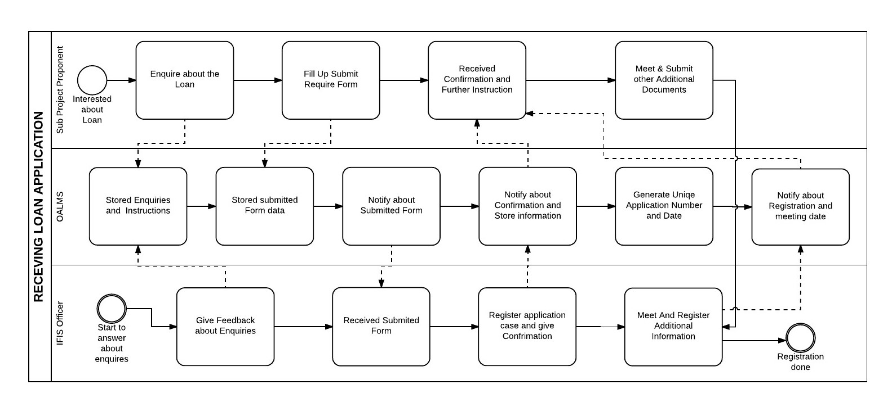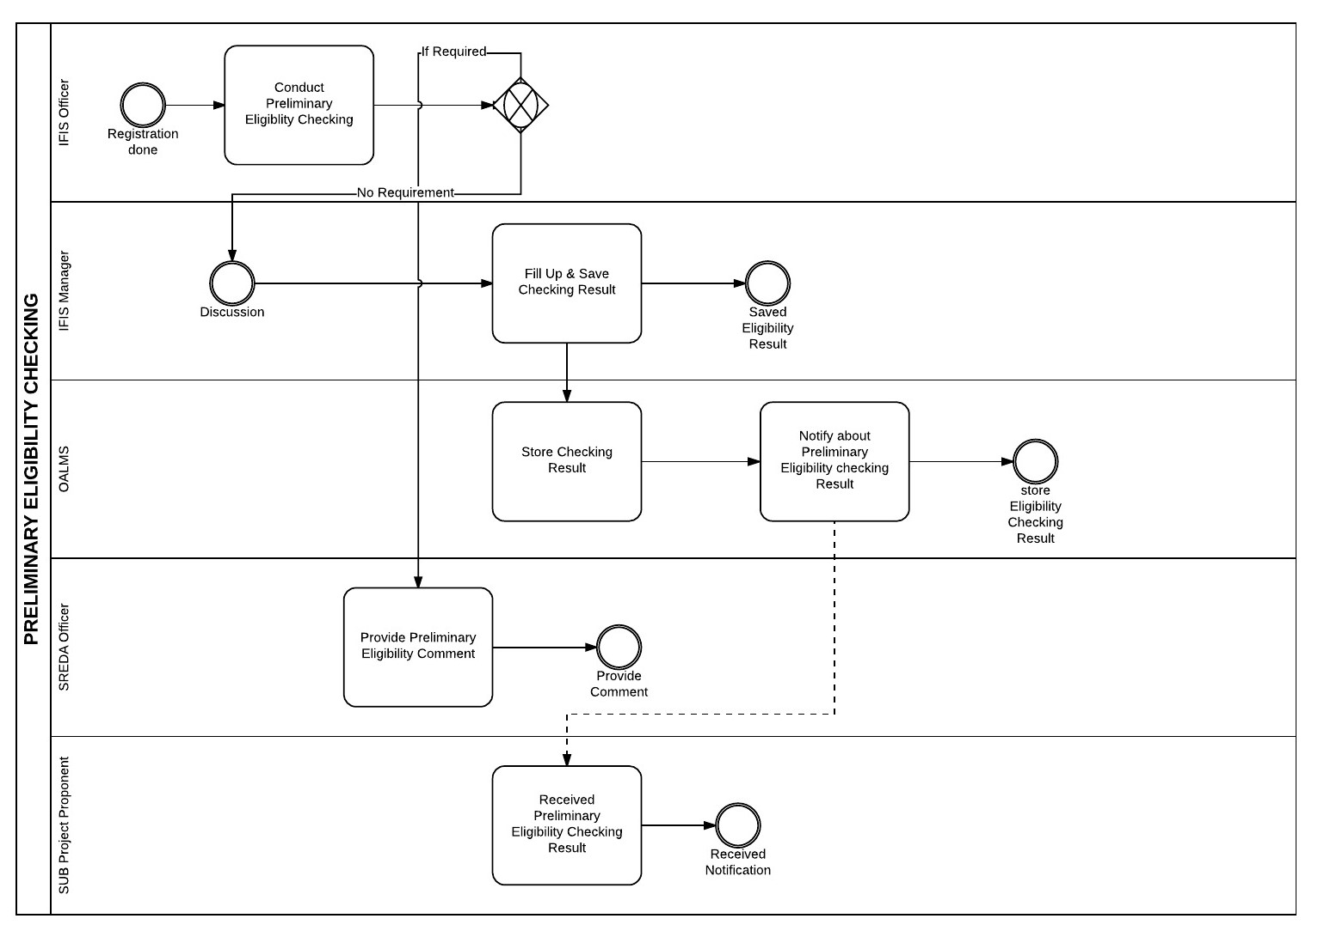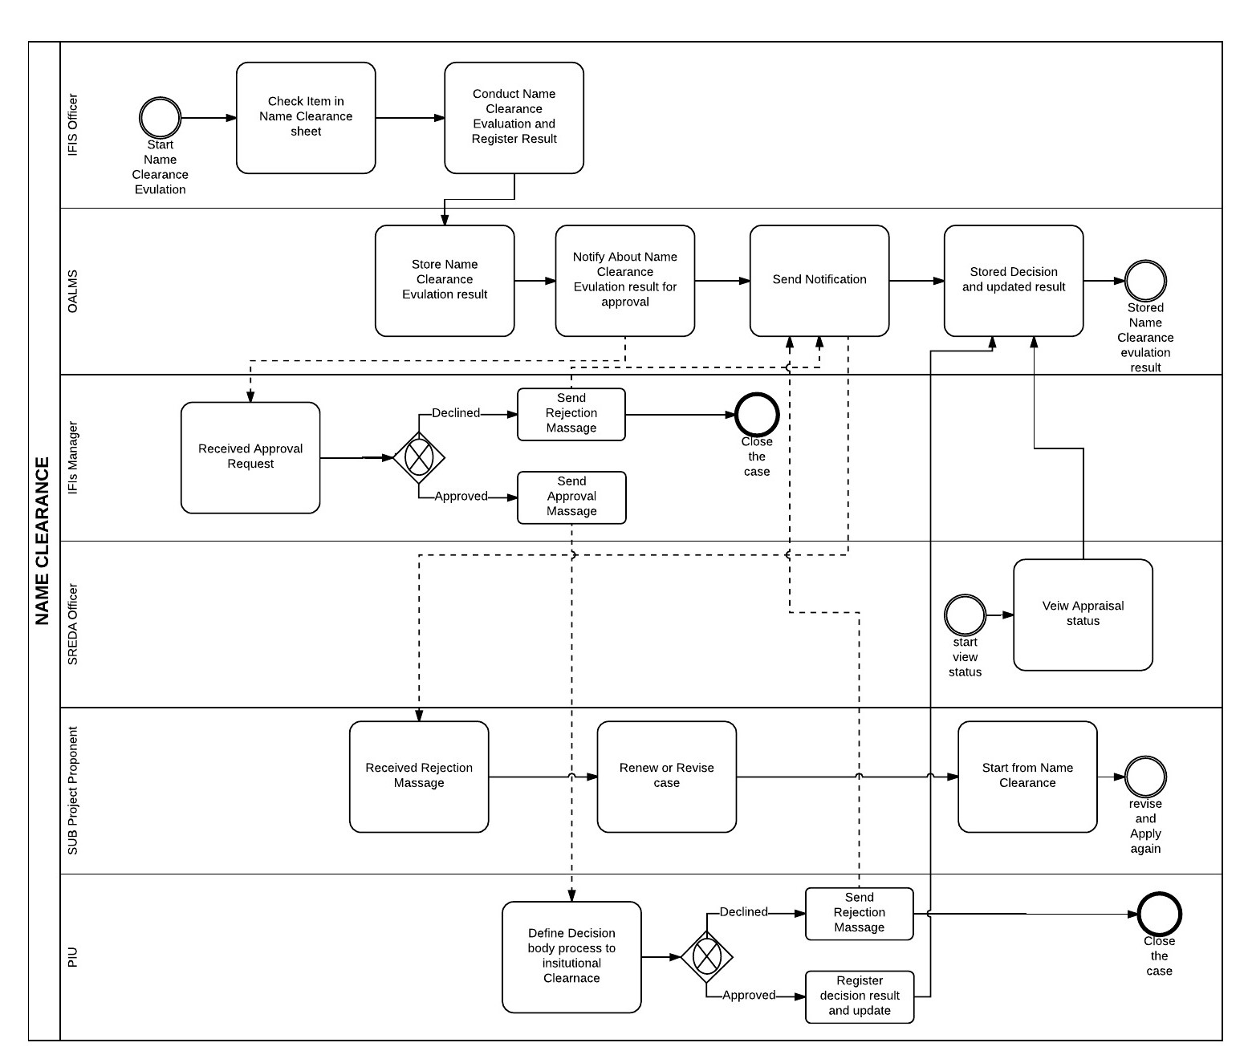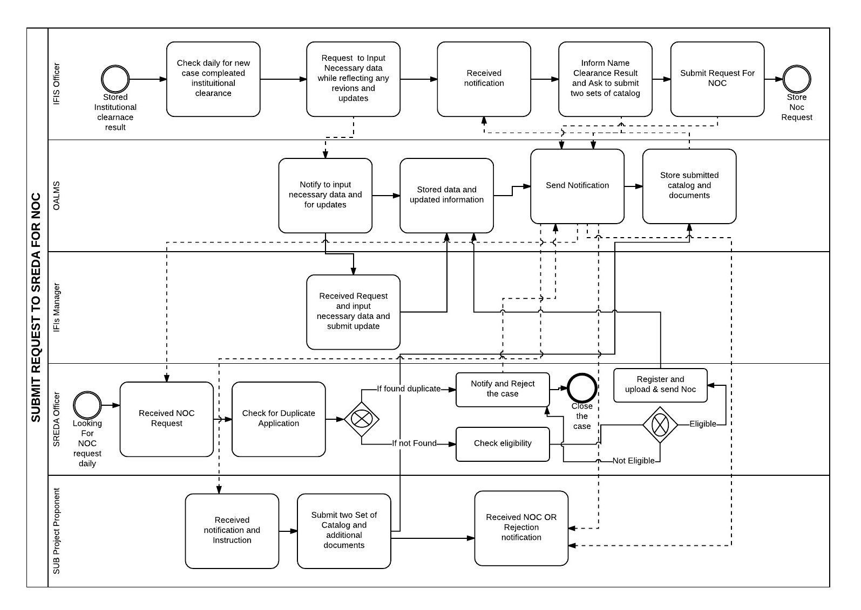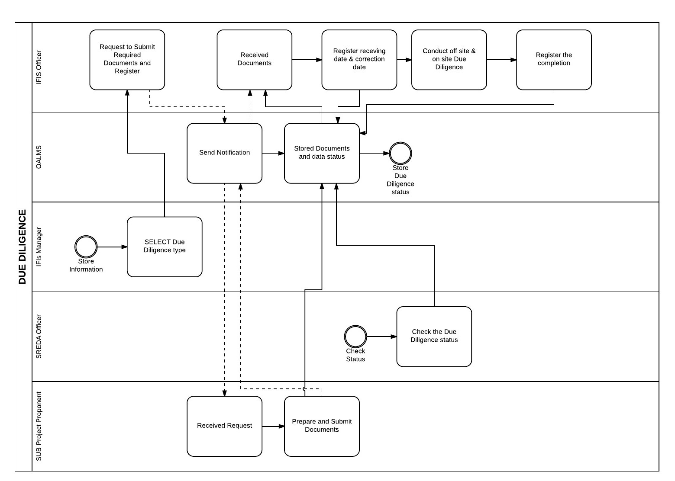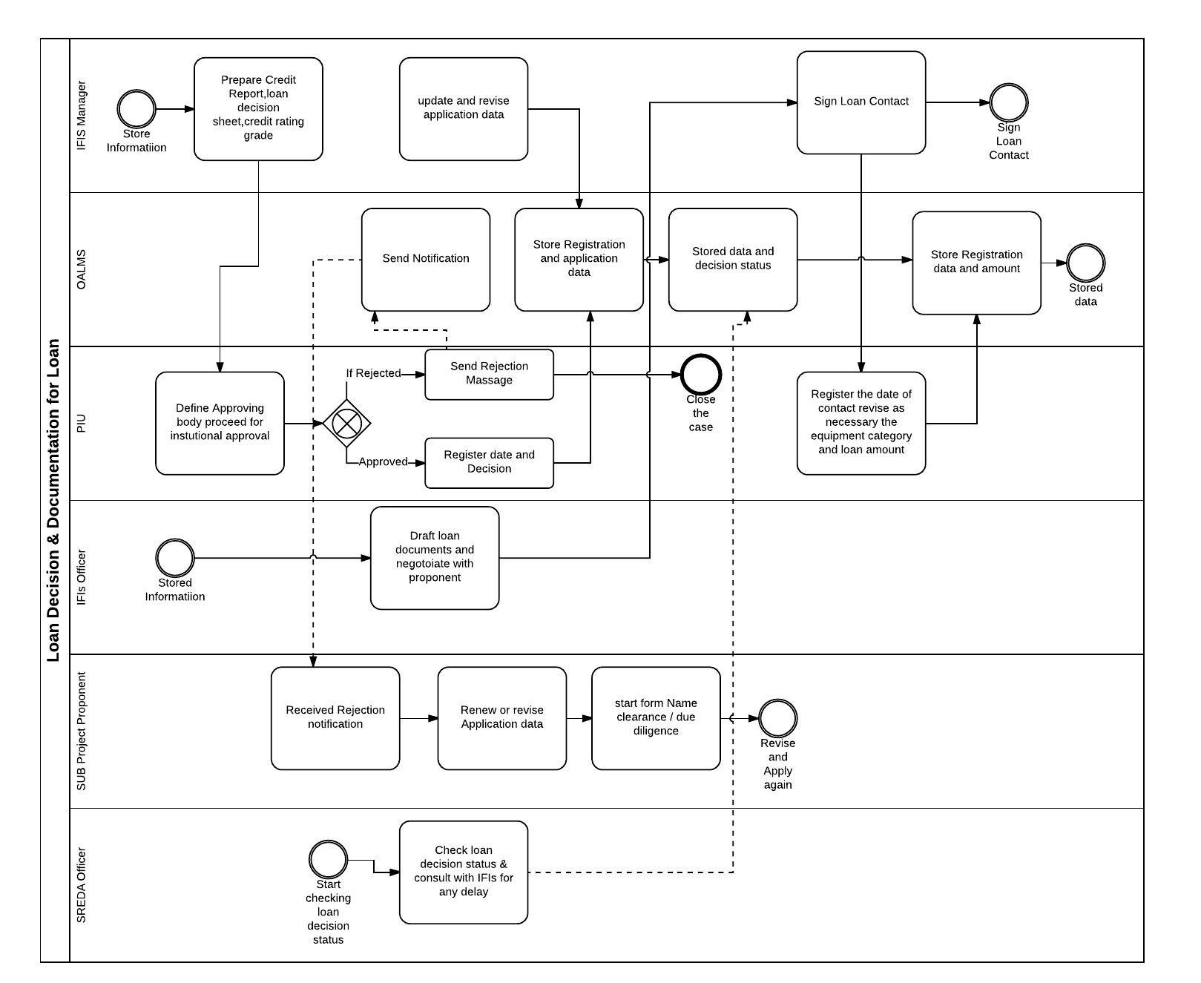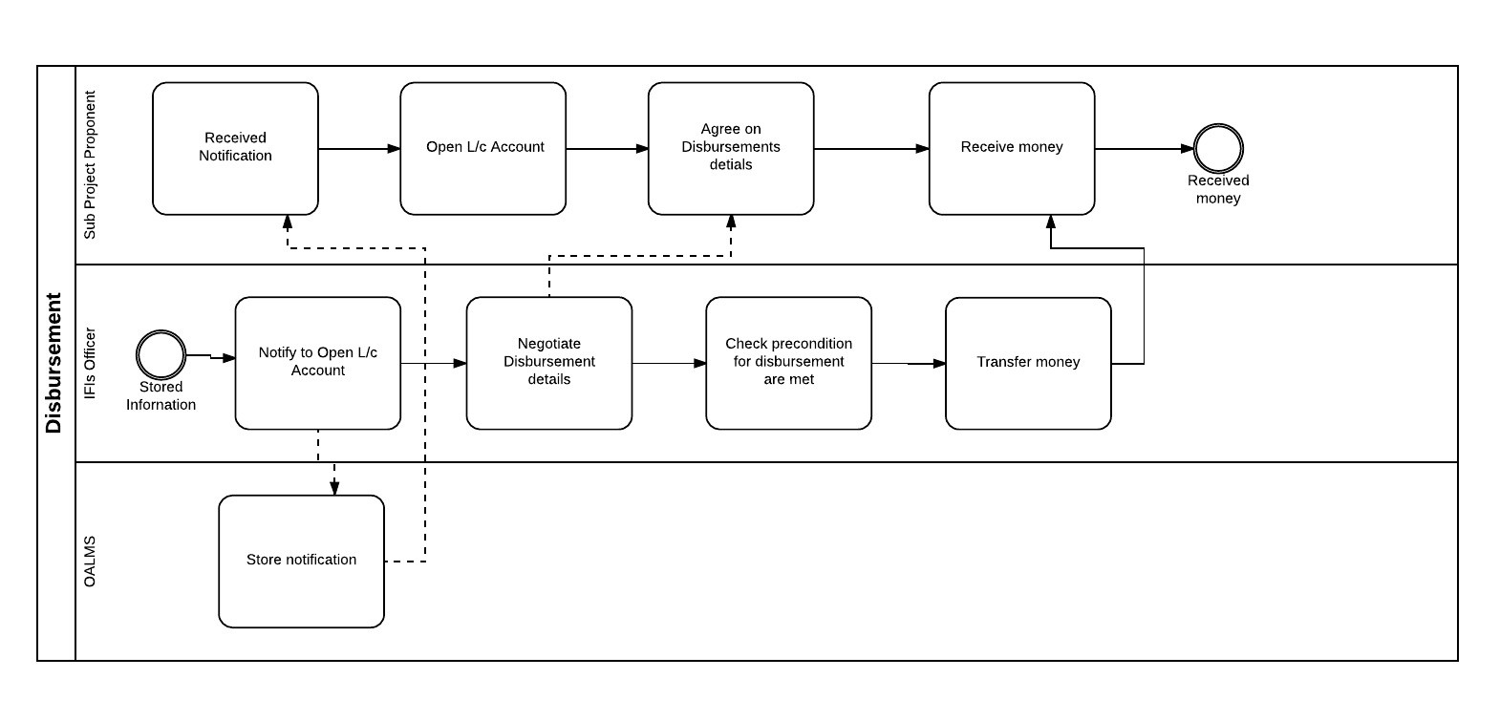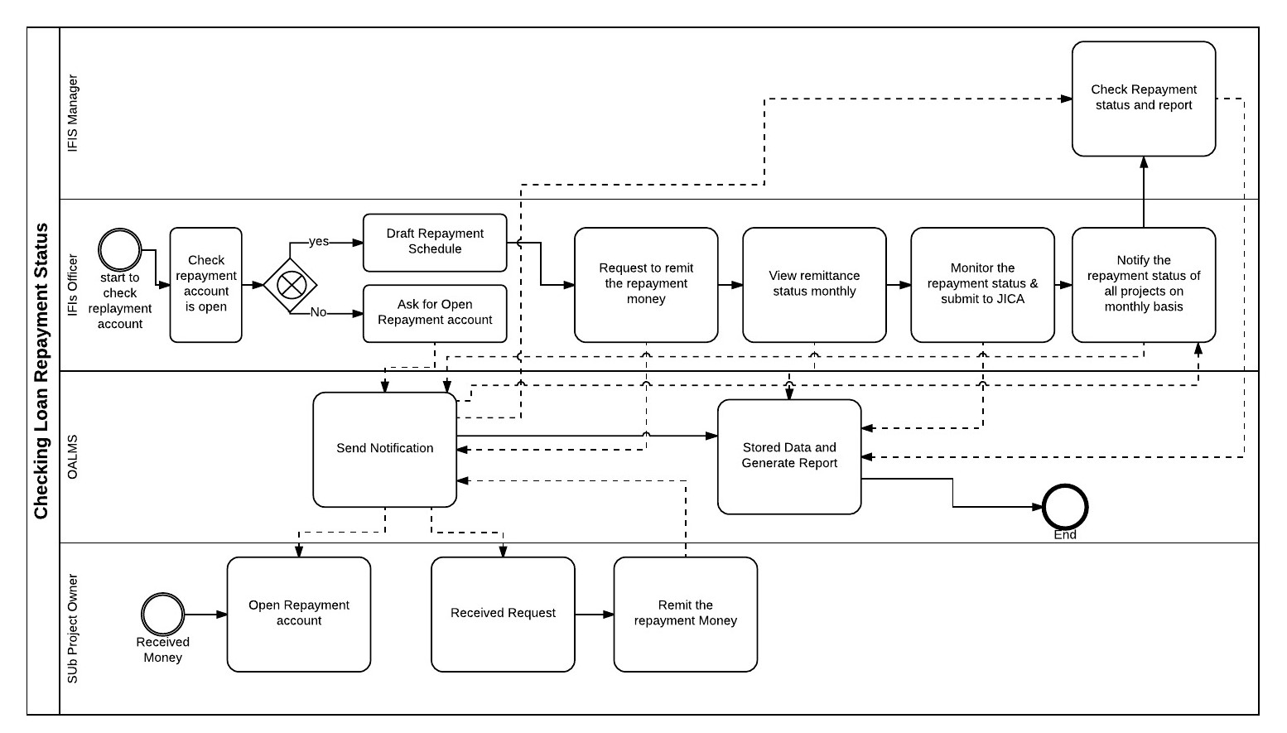

# Data Dictionary

**1.tblPROPONENT**

|  |  |  |  |
| --- | --- | --- | --- |
| Column Name | Data type | Size | Remark |
| Proponent ID | Number | 7 | Primary Key  Exmp: 1234567 |
| Company Name | Text | 20 | Company name of the proponent  Ex: Pran Int. Com. Ltd |
| House | Number | 3 | House Number of proponent  Ex: 13 |
| Road | Number | 3 | Road Number of proponent. Ex: 116 |
| City | Text | 10 | Proponent’s city  Ex: Dhaka |
| Area | Text | 10 | Proponent’s area |
| Country | Text | 10 | Proponent’s country  Ex: Bangladesh |
| Year_of_incorpo | Date | dd/mm/yy | Contains Year of incorporation  Ex: 04/06/17 |
| Aurh_cap | Number | 10 | Authorized Capital for proponent  Ex: 3500000 |
| Paid_capital | Number | 10 | Paid capital by Proponent  Ex: 3500000 |

1. **tblPROPONENT_CONTACT**

|  |  |  |  |
| --- | --- | --- | --- |
| Column Name | Data type | Size | Remark |
| Proponent_ID | Number | 7 | Primary key  Ex: 1234567 |
| Contact_details | Varchar | 11 | Primary key |

1. **tblLOAN**

|  |  |  |  |
| --- | --- | --- | --- |
| Column Name | Data type | Size | Remark |
| Loan ID | Varchar | 7 | Primary key  Ex: ab12345 |
| Loan amount | Number | 15 | Amount of the loan given to proponent |
| Company Line of Business | Text | 100 | Contains type of the company. Ex: Textile and garment |
| Sister Concern | Text | 50 | Associated companies of the proponent |
| Grace Period | Date | dd/mm/yy | Grace period of loan |
| Interest Rate | Number | 2 | It contains interest of the loan. Ex: 5 |
| Collateral | Text | 50 | It contains Collateral the loan |
| Guarantee | Text | 20 | Guarantee of the loan |

1. **tblLoan_Equipment**

|  |  |  |  |
| --- | --- | --- | --- |
| Column Name | Data type | Size | Remark |
| LE_Code_no | Number | 10 | Equipment code number |
| Equipment List | Text | 50 | Name Of the equipment. Ex: Spinning machine |
| Model no | Varchar | 10 | Equipment model number |
| Quantity | number | 3 | Quantity of equipment’s. Ex: 13 |
| Price | Number | 10 | Price of the equipment’s. Ex: 50000 |

1. **tblEQUIPMENT_SUPPLIER**

|  |  |  |  |
| --- | --- | --- | --- |
| Column Name | Data type | Size | Remark |
| LE_Code_No | Varchar | 5 | Primary  Ex: 3AZ00 |
| Supplier | Text | 15 | Supplier of the equipment |

1. **tblEQUIPMENT_MANUFACTURER**

|  |  |  |  |
| --- | --- | --- | --- |
| Column Name | Data type | Size | Remark |
| LE_Code_No | Number | 10 | Primary |
| Manufacturer | Text | 20 | Manufacturer of the equipment’s |

1. **tblEQUIPMENT_CATAGORY**

|  |  |  |  |
| --- | --- | --- | --- |
| Column Name | Data type | Size | Remark |
| Code no | Number | 7 | Primary key  Ex: 52423 |
| Equipment name | Text | 20 | Name of the Equipment |
| LE_Code_No | Number | 10 | Foreign key. Loan equipment code no |

1. **tblEQUIPMENT_SPECIFICATION**

|  |  |  |  |
| --- | --- | --- | --- |
| Column Name | Data type | Size | Remark |
| Code No | Number | 7 | Primary key. Equipment code no |
| Specification | Text | 100 | Specification of the equipment |

1. **tblCHECK_EQUIPMENT**

|  |  |  |  |
| --- | --- | --- | --- |
| Column Name | Data type | Size | Remark |
| LE_Code_No | Number | 10 | Primary key  Ex: 43524 |
| Check_List_ID | Number | 7 | Primary Key |
| Report Name | Text | 15 | Name of the report |
| Status | Text | 50 | Status of the Equipment |
| Decision | Text | 10 | Decision whether the equipment is right or not |
| Date | Date | dd/mm/yy | Date of checking  Ex: 23/07/17 |

1. **tblCHECK_LIST**

|  |  |  |  |
| --- | --- | --- | --- |
| Column Name | Data type | Size | Remark |
| ID | Number | 7 | Primary key. |
| Code_no | Number | 7 | Equipment code no |
| Check_point | Boolean |  | Contains whether Equipment is checked or not |
| Chec_sts | Text | 50 | Status of checked equipment |
| Catalogue | Text | 20 | Catalogue of the equipment |

1. **CHECK_DOCUMENT**

|  |  |  |  |
| --- | --- | --- | --- |
| Column Name | Data type | Size | Remark |
| ID | Number | 7 | Primary key |
| Check_Finan_state | Boolean |  | Checked or not |
| Check_Crd_rat_rep | Boolean |  | Checked or not |

1. **USER**

|  |  |  |  |
| --- | --- | --- | --- |
| Column Name | Data type | Size | Remark |
| User_ID | Number | 7 | Primary Key. Identity of User |
| fName | Text | 10 | First name of the user |
| lName | Text | 10 | Last name of the user |
| Access_type | Text | 7 | What type of user |
| Company | Text | 20 | Name of the company user belongs to |
| House | Number | 5 | House Number of user |
| Road | Number | 5 | Road Number of user |
| City | Text | 10 | User’s city |
| Country | Text | 10 | User’s country |

1. **LOAN_REPAYMENT**

|  |  |  |  |
| --- | --- | --- | --- |
| Column Name | Data type | Size | Remark |
| Loan_ID | Number | 7 | Primary Key |
| Repay_amnt | Number | 15 | Contains repayment amount |
| Date | Date | dd/mm/yy | Date of repayment |

1. **LOAN_DUE_DILIGENCE**

|  |  |  |  |
| --- | --- | --- | --- |
| Column Name | Data type | Size | Remark |
| Loan_ID | Number | 7 | Primary Key |
| Loan_amnt | Number | 15 | Amount of the loan |
| Report | Text | 50 | Report of due diligence |
| Status | Text | 50 | Status of due diligence |
| Approval | Boolean |  | Due diligence approved or not |
| Date | Date | dd/mm/yy | Date of approval |

1. **LOAN_NOC**

|  |  |  |  |
| --- | --- | --- | --- |
| Column Name | Data type | Size | Remark |
| Loan_ID | Varchar | 7 | Primary Key  Ex: ah6522 |
| Loan_amnt | Number | 15 | Amount of the loan  Ex: 50000 |
| Chec_sts | Text | 50 | NOC issuing status |
| Decision | Text | 10 | Decision whether the NOC is issued or not |
| Date | Date | dd/mm/yy | NOC issued Date  Ex: 12/04/16 |

1. **LOAN_CLEARENCE**

|  |  |  |  |
| --- | --- | --- | --- |
| Column Name | Data type | Size | Remark |
| Loan_ID | Varchar | 7 | Primary Key  Ex: hf4534 |
| Report_name | Text | 10 | Name of the report |
| Status | Text | 50 | Status of Name clearence |
| Decision | Text | 10 | Decision of name Clarence |
| Date | Date | dd/mm/yy | Date of decision  Ex:11/05/17 |

1. **SUB-PROJECT**

|  |  |  |  |
| --- | --- | --- | --- |
| Column Name | Data type | Size | Remark |
| Sub-project_ID | Number | 7 | Primary key. Sub-project ID |

1. **SUBPROJECT_SCHEDULE**

|  |  |  |  |
| --- | --- | --- | --- |
| Column Name | Data type | Size | Remark |
| Sub-project_ID | Number | 7 | Primary key. Sub-project ID |
| Req_disb_no | Number | 7 | Requested disbursement no |
| Date | Date | dd/mm/yy | Date of disbursement |
| req_amnt | Number | 15 | Requested Amount of disbursement |

1. **SUBPROJECT_INSTALLATION**

|  |  |  |  |
| --- | --- | --- | --- |
| Column Name | Data type | Size | Remark |
| Sub-project_ID | Number | 7 | Primary key. Sub-project ID |
| Eli_eqp | Text | 20 | Eligible equipment name |
| Unit_no | number | 2 | Quantity of equipment |
| amount | Number | 15 | Amount of installation |
| Paid_amnt | Number | 15 | Paid amount |
| Paid_date | Date | dd/mm/yy | Date of payment |
| Schedule_date | Date | dd/mm/yy | Next schedule date |
| Schedule_amnt | Number | 15 | Next schedule amount |

# Input Form and Output Report :

# Login Panel



Figure : Login Panel



Figure : Login Panel

**PURPOSE :** Every Sub-Project Owner And Employee, Authority can get access to data in the system after

input given userId and Password

**HOW THE FORM WORKS :** Individual User can Login in the system after input given userID and

Password and if you user forget userId or Password wrong userId or Password massage will appear and

user failed to login in the system.

# PRE SCREENING APPLICATION FORM :

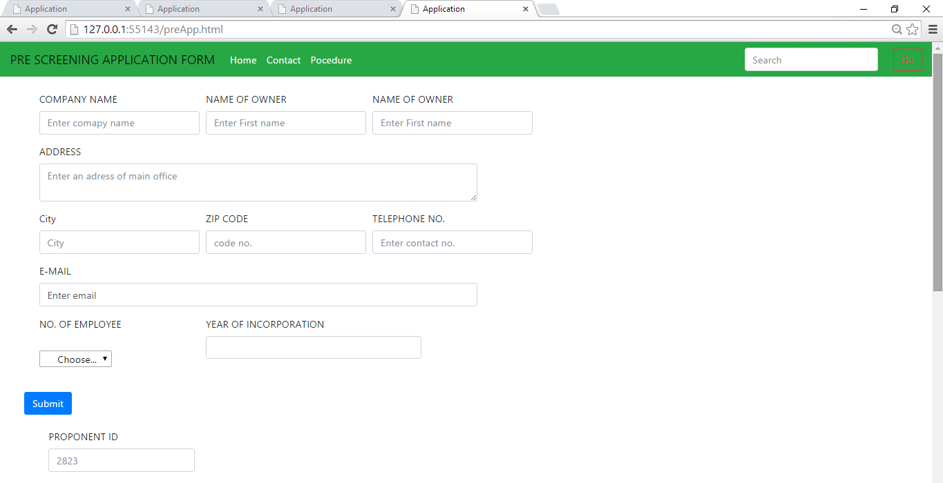

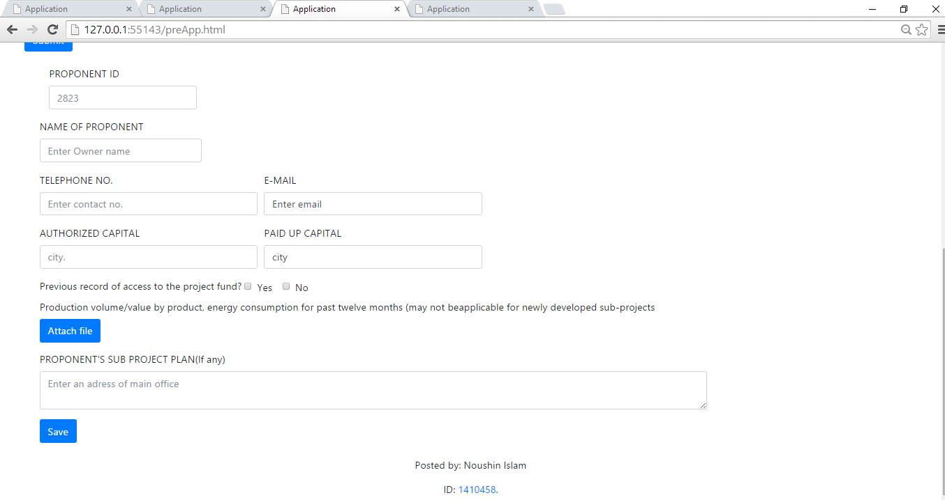

Figure : Pre screening Application form

PURPOSE:

The purpose of Pre Screening application form is to save valid information about proponent. It refers to online procedure so that proponent can submit their applications from easily.

HOW THE FORM WORKS:

Proponent fill up the form with their information and submit it,the information is stored into the database. The ID of the proponent is generated automatically. Then proponent needs to fill up their information with their sub-project overview(if any) and requirements for both technical and financial status. All information are save into OLMAS website with their ID.

**RELETED QUERY :**

INSERT INTO PRE-SCREENING APPLICATION FORM (NAME,NAME OF OWNER, NAME OF OWNER ADRESS, CITY,ZIP CODE,NUMBER OF EMPLOYEE,EMAIL,YEAR OF IN CORPURATION,AUTHORIZED CAPITAL,PAID UP CAPITAL ,PROPONENTS SUB_PROJECT PLAN

VALUES (‘P name', ‘O name’,’Islam’, ’house no. 5,sectior 13,road no.6’,Dhaka’,’1229’,’text….’);

**NAME CLEARENCE FORM:**

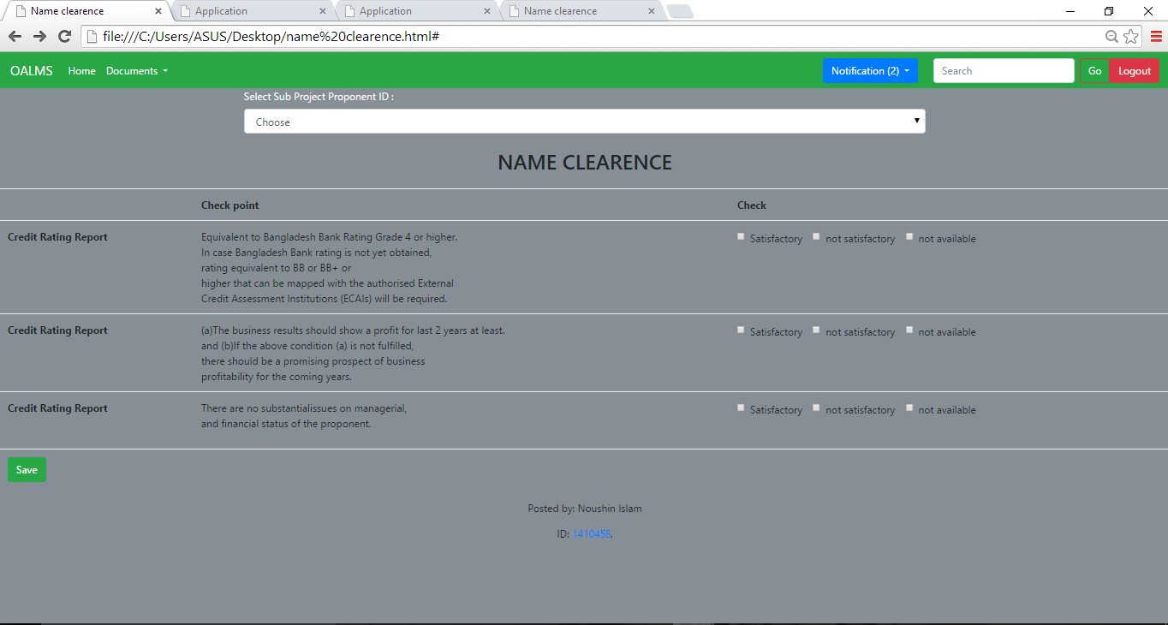

**Figure: Name clearance form**

PURPOUSE:

Purpose of name clearance is to check eligibility requirements by officers in charge(IFS) and analyze result by manager for further procedure.

HOW THE FORM WORKS:

Name clearance procedure is processed by proponent, manager and Officer In charge. The Officer In Charge (IFIs) justify Name Clearance Evaluation sheet then notify it on OALMS .

Then Manager (IFIs) Check and analyze result, giving Approval for further process in OALMS .All the record saved in OLAMS system.

**RELETED QUERY:**

INSERT INTO NAME CLEARENCE ( Sub Project Poponent ID,CHECK )  
VALUES (‘909’,’unaviliable’);

**OUTPUT FORM**

If proponent needs to verify the progress of this system ,they can see the overall view of application for load .By clicking the output button it shows the graphical view about proponents who apply for loan **.**

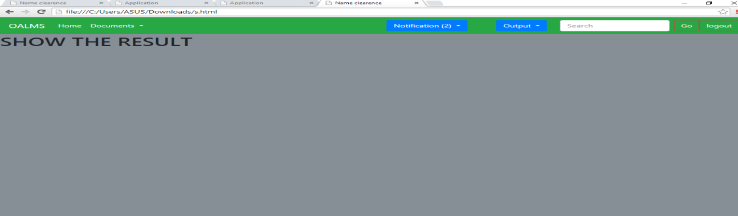

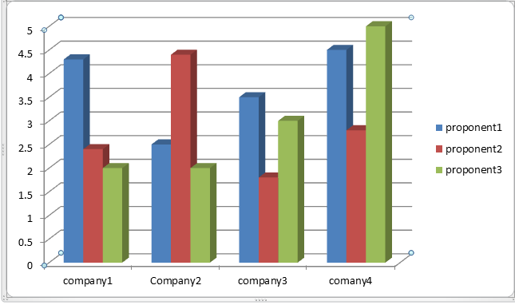

Figure :shows the request of loan application pre year

**Equipment Procurement and Installation Plan Input Form**

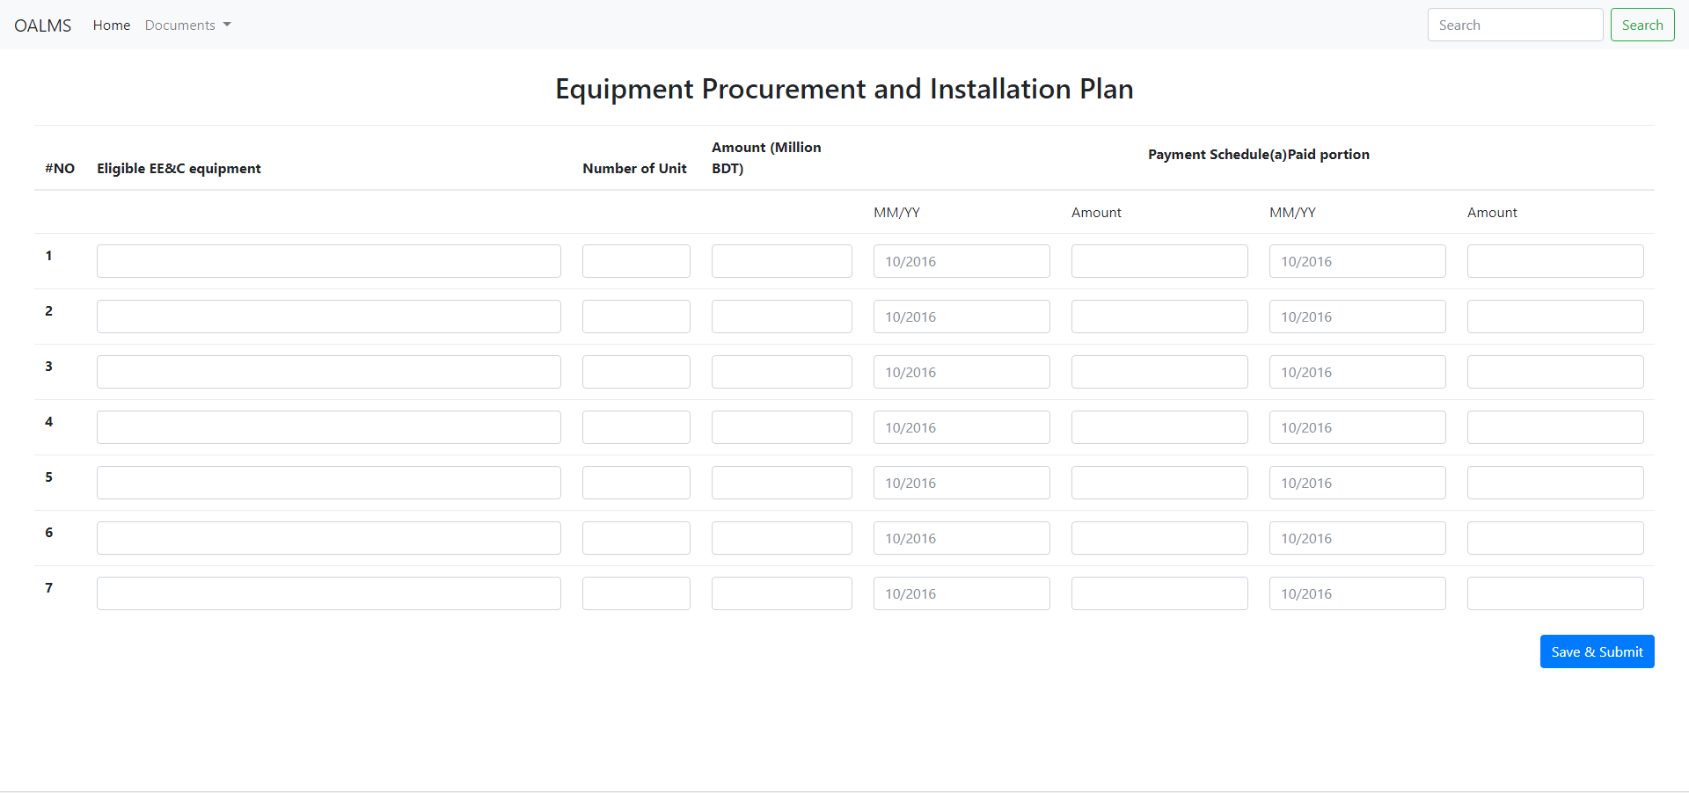

Purpose: The IFI Officer in charge will prepare this form and this information will be stored into the database through this input form. “Save & Submit” button will perform following query.

# Related Queries

INSERT INTO tblEPIP (Eligible EE&C equipment, Number of Unit, Amount (Million BDT), MM/YY1, Amount, MM/YY2,Amount)  
VALUES ('eqlb','numlb', 'amtlb', 'ddlb','amtlb2','ddlb2', 'amtlb3');

## EE&C Equipment Purchasing and Installation Status Input Form

## 

Purpose: The officer in charge will ask the sub-project owner to submit Equipment purchasing and installation information and the information will be submitted & stored through this input form. “Save & Submit” button will perform following query. ‘Choose Files’ option will allow to upload attachments.

INSERT INTO tblEPISF (Name of Equipment, Specification, Model Number, Supplier, Manufacturer, Unit price,Number of introduced, Total investment amount)  
VALUES ('nlb','slb', 'mtlb', 'splb','mulb','uplb', 'nilb', 'tilb');

# Energy Efficiency Related Data Form

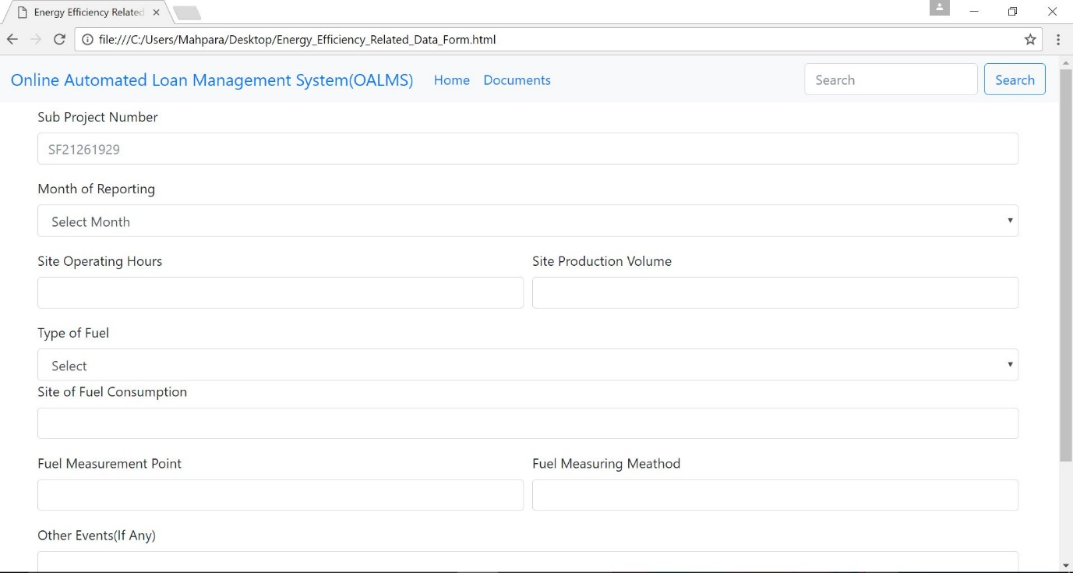

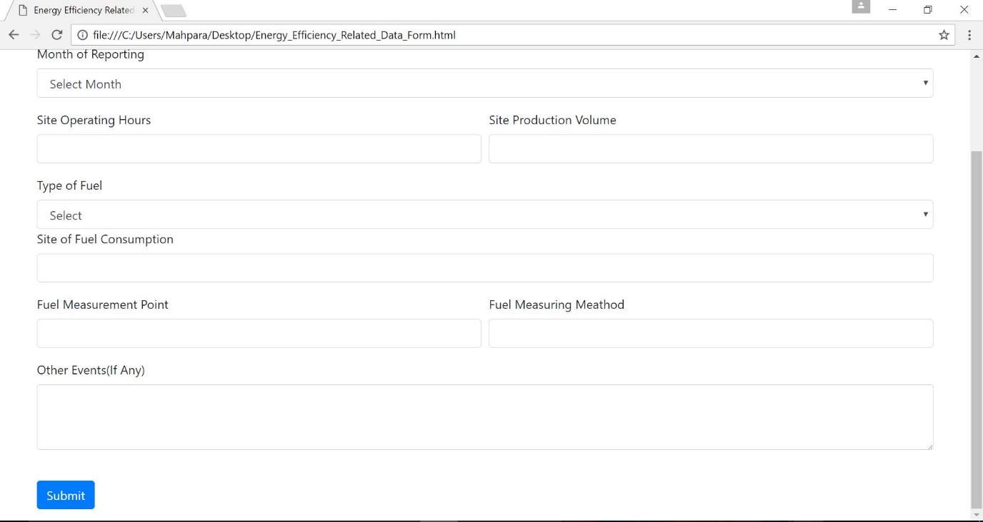

Figure: Energy Efficiency Related Data Form

# PURPOSE:

The main purpose of this form is to check the records of the energy of the installed equipment of the site. The data analysis of this form will reflect the energy efficiency of the equipment. It will also show that the goal of the project is achieved.

# HOW THE FORM WORKS:

The project is identified by the sub-project number. The name of the sub-project owner will not be stored in the system to maintain authenticity. The form will have monthly reporting so that each month the data can be stored separately and can be used further to analyze the energy usage and efficiency. The form will store data separately for different kind of sources like: electricity /gas; so that an accurate report can be generated.

# RELATED QUERIES:

INSERT INTO Energey Efficiency Related Data Form (Sub Project Number ,Month Of Reporting, Site operating hours, Site Production Volume,TypeOfFuel,SiteOfFuelConsumption,FuelMeasuringpoint,Fuel,MeasuringMethod,OtherEvents)   
VALUES (‘112',’june’‘1O’‘300ml’,’gas’,’abc’, ‘sce’,’text….’);

DUE DILIGENCE TYPE CHECK

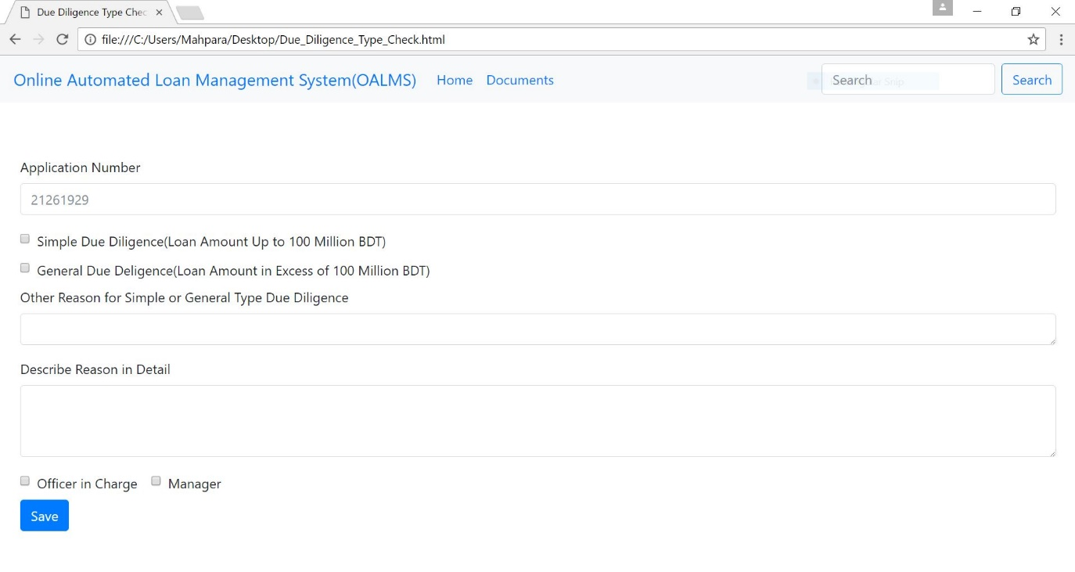

Figure: Due Diligence Type Checking Form

# PURPOSE:

The purpose of this form is to check the due diligence type. Authority checks the loan amount and decides whether the due diligence is simple or general and states the reasoning.

# HOW THE FORM WORKS:

The officer in charge and the manager both handles this form. Each of them will be able to see the other person’s decision. If the officer in charge goes through the form and makes the decision the manager will be able to see it. Both the officer in charge and the manager needs come in the same conclusion to approve this.

# RELATED QUERIES:

INSERT INTO DueDiligence (OtherReasonofsimpleor general type duediligence ,Simple Du Diliengce,GeneralDueDiligence,DescribeReasonInDetailes)   
VALUES (‘text1..’’check’’check’‘text2…’);

# EE&C Equipment Status Report

Figure: EE&C Equipment Status Report

# PURPOSE:

The purpose of this report is to see the status of the equipment. How many equipment are there and how many are being purchased and installed and then how many are in the process of being purchased and installed can be clearly seen from this report.

# HOW THE REPORT WORKS:

The authority can see this report and analyze the progress of the project. It also helps them to keep track of the equipment and their status.

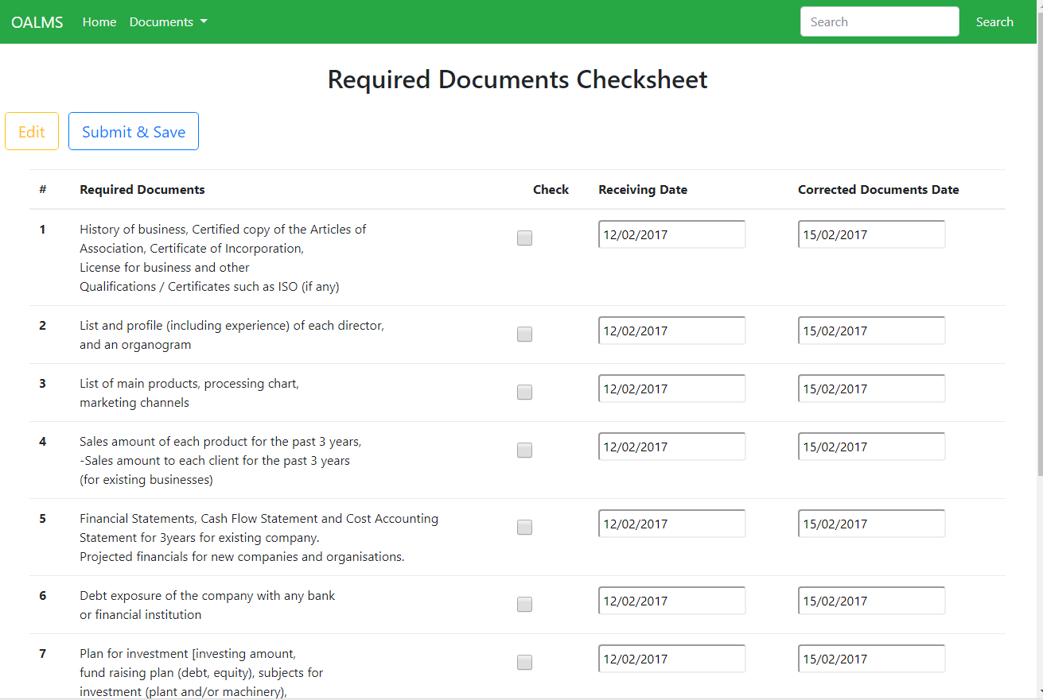

Figure : Required Documents Checking Form

Design by Ariyan

PURPOSE :The main purpose of this form is check Received Documents and Input Receiving Documents

date and Corrected documents date in the system .

HOW THE FORM WORKS :Sub-Project Owner will send Required Documents to IFIs and IFIs will Check

the received documents and register receiving and Corrected documents date in the OALMS using this

form and also can edit change data if needed.

# RELATED QUERIES :

INSERT INTO tblRequiredDocuments(RdocId , Check , RecevingDocDate, CurrectedDocDate)

VALUES (RdocId,Cresult,RDD,CDD);

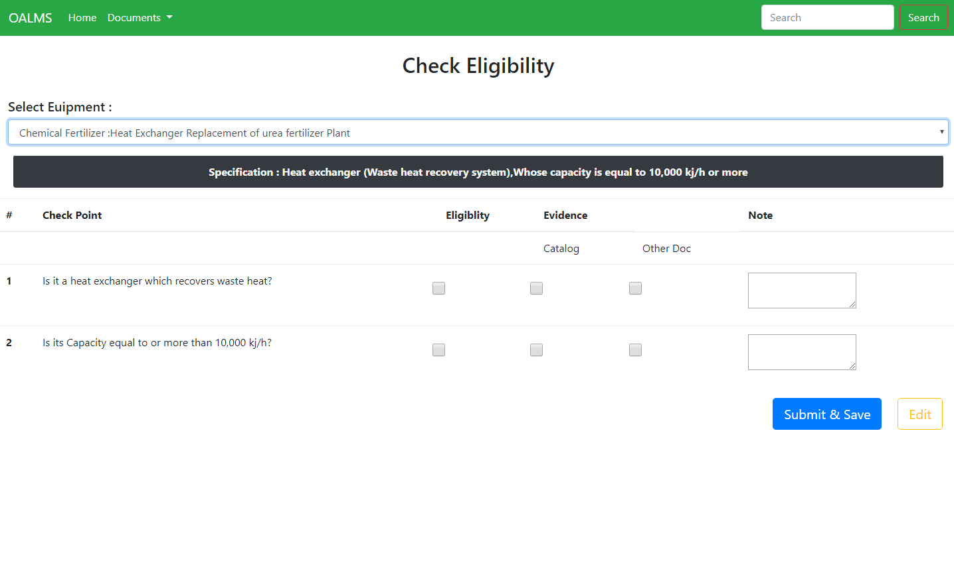

Figure : Eligibility Checking Form

Design by Ariyan

# PURPOSE:

Purpose of this form is to check eligibility and Register the result of evaluation with reason for such

judgement.

# HOW THE FORM WORKS :

Sub-Project Owner will submit Asking Equipment and Catalog and other document to IFIs. For Multiple

Equipment There will multiple Eligibility Form with Specification. IFIs Manager will check eligibility and

check submitted documents and Register the result of evaluation with reason for such judgement using

this form.

# RELATED QUERIES :

INSERT INTO tblEligibilityCheck(checkpointId,Eligibility, Catalog, OtherDoc, Note)

VALUES (icheckpointId,Eresult ,Cresult,Oresult,Note);

# Abbreviation

|  |  |
| --- | --- |
| OALMS | Online Loan management System |
| APO | Advance payment option |
| BDT | Bangladesh taka (currency) |
| BIFFL | Bangladesh Infrastructure Finance Fund Limited |
| CEO | Chief Executive Officer |
| CIB | Credit Information Bureau (of Bangladesh Bank) |
| CRG | Credit Risk Grading (of Bangladesh Bank) |
| DLD | Delay liquidated damage |
| DSRA | Debt service reserve account |
| EE&C | Energy efficiency & conservation |
| ESCO | Energy service company |
| ESMS | Environmental and Social Management System |
| FR | Functional requirement |
| ICT | Information and communication technology |
| ID | Identification |
| IDCOL | Infrastructure Development Company Limited |
| IFI | Implementing financial institution |
| ISO | International Organization for Standardization |
| JICA | Japan International Cooperation Agency |
| JPY | Japanese yen (currency) |
| L/C | Letter of credit |
| MFI | Microfinance institution |
| MIS | Management information system |
| MOF | Ministry of Finance |
| MPEMR | Ministry of Power, Energy and Mineral Resources |
| N/A | Not applicable |
| NGO | Non-governmental organisation |
| NOC | Non-objection certificate |
| p.a. | Per annum |
| PD | Participating distributer |
| PIU | Project implementation unit |
| PLD | Performance liquidated damage |
| QPR | Quarterly progress report |
| RAID | Redundant array of independent disks |
| RO | Reimbursement option |
| ROE | Return on equity |
| SC | Steering Committee |
| SPV | Special purpose vehicle |
| SREDA | Sustainable and Renewable Energy Development Authority |
| T/A | Technical assistance |
| TAC | Technical Advisory Committee |
| VPN | Virtual private network |

# Reference :

*[1] Available :* [*http://jica.go.jp/english*](http://jica.go.jp/english) *[Accessed : 6 oct - 2017]*

*[2] Available :* [*http://sreda.gov.bd*](http://sreda.gov.bd) *[Accessed : 6 oct - 2017]*

*[3] Available :* [*http://idcol.org*](http://idcol.org) *[Accessed : 6 oct - 2017]*

*[4] Available :* [*http://biffl.org*](http://biffl.org) *[Accessed : 6 oct - 2017]*

*[5] Available :* [*http://flaticon.com*](http://flaticon.com) *[Accessed : 7 oct - 2017]*