**TEAM VOID**

**Members: Juned Ahmed Chowdhury (1430211)**

**Monsura Mayeen Tasnyeem (1430045)**

**MD. T.A.M Tusar (1430163)**

**MD. Shah Ali Tarek (1430651)**

**MD. Rakib Khan (1430223)**

**University Automation System(UAS)**

**CSC- 401 Database Management**

* **Final REPORT**

**BACKGROUND OF THE PROJECT:**

The main purpose for doing this project is to learn and apply database handling with Structured query Language (SQL). Our course CSC 401: Database Management is a project based course thus this project was introduced and assigned to the whole class by our instructor, Dr. Mahady Hasan. The basic aspect of this project is to recreate the Online Registration System, Course offerings and Course allocations of an Institution in a more user-friendly way without the current occurring problems.

The world is developing at a very faster rate with technological improvements taking place everywhere. The new world is trying its best to reduce the use of manual papers, it uses computers to do different sets of work. It is seen nowadays that many Organizations are adapting these kind of technologies in order to reduce their paper works, extra labor works and keep their information safe from the outside world. Many of the upcoming educational institutes are also getting very much interested in this automated shifts.

Independent University, Bangladesh, one of the renowned university of Bangladesh, has also coped up this development and they created a web application, Integrated Register Office Automation System(IRAS), which does a variety of official works which includes course registrations, faculty evaluation, grade submission and many more. IRAS has helped the management of IUB in many different ways by eradicating a long queue at the time of registration, student can register for their desired courses with their desired timings, an online students attendance is taken by the faculty so they do not need to take any paper documents with them during the semester, faculties an also submit grades.

In contrast to all these advantages some set of users are facing problems in using IRAS. It is seen that not every task is using IRAS as there are some manual paper works involved in the system. Students are not completely satisfied during their course registration period, courses are not allocated automatically faculties are sometimes unable to take attendance and other problems are described at the problem's section.

Purpose of doing this project is to find out all the problems, analyzing them and give solutions by redeveloping the IRAS. The end users will be using a robust system with a greater UI design so that they can manage their work more accurately and precisely. There will be some Additional new features for the users such as enhanced Student Profile and Faculty Profile, which will help them in various ways. Independent University, Bangladesh, will be having a revised version of the existing system at the end of this project with a whole new level of advantages to talk about.

**BACKGROUND OF THE ORGANIZATION:**

Independent University, Bangladesh (IUB) established in 1993 is the leading private university in Bangladesh with an explicit focus on Research and Global partnerships. They are a full service, oriented university with a current enrollment of 5,500 students, 8900 Alumni and 250 faculty members (of which 25% have PhD’s mostly from North America).

The faculty members of IUB are actively engaged in research and publish regularly in peer-reviewed journals. Along with conventional classroom teaching, students are engaged in research relatively early in their studies. IUB has academic research collaborations with various universities including Harvard University, Stanford University, University of Colorado at Boulder, Brown University, McMaster University, University of Heidelberg, University of South Alabama, Southern Illinois University, University of Vermont, University of Minnesota, Aga Khan University, Institute of Psychiatry in Pakistan, Public Health Foundation of India, and Institute for Research and Development, Sri Lanka.

IUB's academic curriculum is based on a North American liberal arts model and the medium of instruction is English. Current six academic schools of IUB:

* School of Business
* School of Engineering and Computer Science
* School of Environmental Sciences and Management
* School of Liberal Arts and Social Sciences
* School of Life Sciences
* School of Public Health.

**Research Centers & Institutes**

IUB has twelve Research Centers and Institutes. These are:

* The Centre for Health Population and development (CHPD)
* International Centre for Climate Change and development (ICCAD)
* Bangla Language Institute (BLI)
* Kazi Nazrul Islam & Abbasuddin Ahmed Research and Study Centre
* Centre for Business Policy Research (CBPR)
* Centre for RMG Studies (CRMGS)
* Centre for Distance Learning (CDL)
* Green Energy Research Center
* The Centre for Social Sciences and Research (CSSR)
* Center for Cognitive Skill Enhancement
* Centre for Pedagogy (CFP)
* The International Centre for Biotechnology and Health

**RESEARCHES DONE BY CSC DEPT**

* Development of a web based application for conducting surveys using mobile phones.
* IUB community mapped for android
* Inventory management system
* Hill climb android game
* Web application for generating dynamic surveys deployable over mobile communication devices
* Cloud based e-Governance and e-Commence
* Object detection and tracking for activity classification
* Multi rotor uav
* Data mining
* Stemmer for bangla verbs
* Jhulonto Manob
* Monitoring production
* Birth record communicator
* Virtual ATM
* Bridging Digital Divide
* GPS Device for GIS systems
* Vehicle Black Box
* Possibilities are limitless

**RESEARCHES DONE BY EEE DEPT**

* Project-1: An Intelligent Fire Detection and Warning System Under Home Video Surveillance for Garments Factories in Bangladesh
* Project-2: Design and Implementation of a Novel MPPT Based Synchronous Buck Converter for Solar-Powered Fishing Trawler Installed in Chittagong Region of the Bay of Bengal
* Project-3: Design and Implementation of an Intelligent Solar Photovoltaic Energy Management System for Developing Countries
* Project-4: Non-invasive/Minimally Invasive Blood Test for Newborn/Neonate Parameters
* Project-5: Real-time Imaging/Monitoring of Vein during Blood Draw/Collection and Canula Insertion for Infants
* Project-6: Low-Cost Digitization of Saline Dropper Set
* Project-7: Automated Drone For Providing Medical Services In Bangladesh
* Project-8: Design and Implementation of Remote and Virtual Laboratory to Enhance Classroom Teaching for Undergraduate Engineering Students
* Project-9: Design and Implementation of Android App-based Wearable Real-time Body Temperature Monitoring and Alert System for Children with Risk of Febrile Convulsions
* Project-10: Optimizing the Efficiency of Solar Cells Using Patterned Nanostructures
* Project-11: New Approaches in Smart Grid and Power Failures
* Project-12: Developing a NAO Application for Robot Handwriting Using Inverse Kinematics
* Project-13: Design and Implementation of an Integrated Remote Engineering Laboratory for Undergraduate Students
* Project-14: Studies on Technical Feasibilities of Solar Powered Farm Machineries Suitable for Bangladesh
* Project-15: Studies on Economic Feasibilities of Solar Powered Cooking in the Rural Household of Bangladesh
* Project-16: Design and Construction of a Smart Electric Wheel Chair for the Mobility Impaired People

**RESEARCHES DONE BY ENV DEPT**

* Development of Eco-friendly and Cost-effective Method for the Treatment of Textile Effluent
* Development of an Eco-friendly Industrial Wastewater Treatment Process by Using Renewable Biomaterials
* Investigation of bacteriological aspects of drinking water

**RESEARCHES DONE BY LAASS DEPT**

* Social struggle of high paid professional women in Bangladesh
* Shifting Gender Roles among Wives of Migrant Workers in Traditional Societies
* Bangladeshi Women writing fiction in English
* Preservation of the Endangered Language of Bangladesh
* Expensive reading: using diaspora literature to develop learners
* Nation on air/on Screen: Bangladesh Liberation War and the Audiovisual Media
* Political Culture and Structural Instability: Problematic Governance in Bangladesh
* Mahua Shundori : Determined, Daring and Defiant
* Changes in Dhakaiya Pidgin – Status and Attitudes
* Code Switching in Children in Bangladesh and its Effects in Culture
* Preservation of Endangered Languages of Bangladesh
* Bangladesh Liberation War and the Audio visual Media (Phase 2)
* Role of Media during Shahbag Movement
* Research and Writing Project: Encyclopedia of Bangladesh Cinema
* Local Responses of Bangla Fishers to Climate Change
* Microfinance, Poverty and Human Rights: Is there any Islamic Perspective?
* Socioeconomic and Demographic Changes on Households in Bangladesh from 1997- 2014, A Village Context
* To What Extent Does the Use of Social Networking Sites Reinforce ‘Gemeinschaft’- type Community
* The Presence of Dedication in Different Literary Works of Bangla Literature
* “MohuaShundori, Determined, Daring and Defiant

**RESEARCHES DONE BY PH DEPT**

* Bangladesh Prospective Urban and Rural Epidemiological Study (PURE)
* A Cluster Randomized Control Trial: Text messaging reminders to raise care seeking among depressed women in rural Bangladesh
* ‘Scoping review of literature on suicide in South Asia’.
* Development of “HIV Web Depository” for Bangladesh ([www.hivwebportal.org](http://www.hivwebportal.org)).
* Rapid Assessment Report on Knowledge, Attitude and Behavior of at Risk Male Population in the context of Spousal Transmission of HIV /AIDS in Bangladesh, October 2009.
* Desk Review: ‘Spousal Transmission of HIV among Married Women in Bangladesh: a country assessment report, October 2008’

**RESEARCHES DONE BY PH DEPT**

* Rural/Urban Dichotomies in the Prevalence and Determinants of Asthma Incidence in Bangladesh
* Biochemical and Psychosocial Determinants of Work Stress Among RMG Workers in Gulshan: A Collaboration Between SLS/CHPD at IUB, Dhaka and Heidelberg University, Germany
* Perception of Vitamin D Nutritional Needs among Female Ready-Made Garment Workers in a Factory in Gulshan, Dhaka
* Rural/Urban Dichotomies in Lead Exposure: Prevalence, Effects, and Determinants in Bangladeshi Adults
* CWCH (Center for Woman and Child Health) Barriers to Breastfeeding Study

**OBJECTIVES OF THE PROJECT:**

The main objective of this project is to create a fully functional Integrated Registrar Office Automation System (IRAS) with some enhanced features with the help of which the management of Independent University, Bangladesh can complete their task with the help of computerized system and mostly avoid manual paper works.

* A robust system with a new and enhanced UI design
* Automated seat plan for admission examinations
* Online Course Registration, Add/Drop and course withdrawal
* Automated preregistration
* Automated Course Allocation and Offerings with timings
* Automated Registration and Installment bills
* Grade Submission
* Online Attendance
* Individual student profile
* includes basic information(Name, address, ID, CGPA etc)
* includes graphical illustration of the their individual course performance and progress(quiz results, attendance report, university progress report)
* includes course registration
* manages student bills and transcripts
* includes an announcement section for class test, deadlines of assignments and class cancellation and makeup classes.
* includes faculty evaluation during the ending of the Semester
* Individual faculty profile
* includes basic information(Name, address, ID, CGPA etc)
* online attendance of the students
* includes grades submission
* can give announcements of any exam, class cancellation or makeup classes
* can check student's performance according to their courses.
* (HEAD) Assign new courses and faculties
* Register office Staffs profile
* can add new members into the system(Students, faculties and other users)
* can be able to register for any students they want in case of problems
* can also assign any superior user such as HEAD with the permission of the Department.
* A guideline will be present along with a video tutorial for the new users of the Application
* A Notice board where all the new updates by the departments of different schools will be present and visible to the students of the desired departments

**SCOPE OF THE PROJECT:**

* A revised version of the Integrated Registrar office Automation System (IRAS)
* It will be a web application
* A proper guideline will be given to students and faculties about the new system
* Some added new features will reduce manual paper works in a better way
* A huge time will be saved with this revised system

**Existing Business System (Rich Picture):**

The existing business system has been divided into few different subsystems. Each sub system has a rich picture followed by its description. They are as follows:

* **Admission System (Rich Picture)**

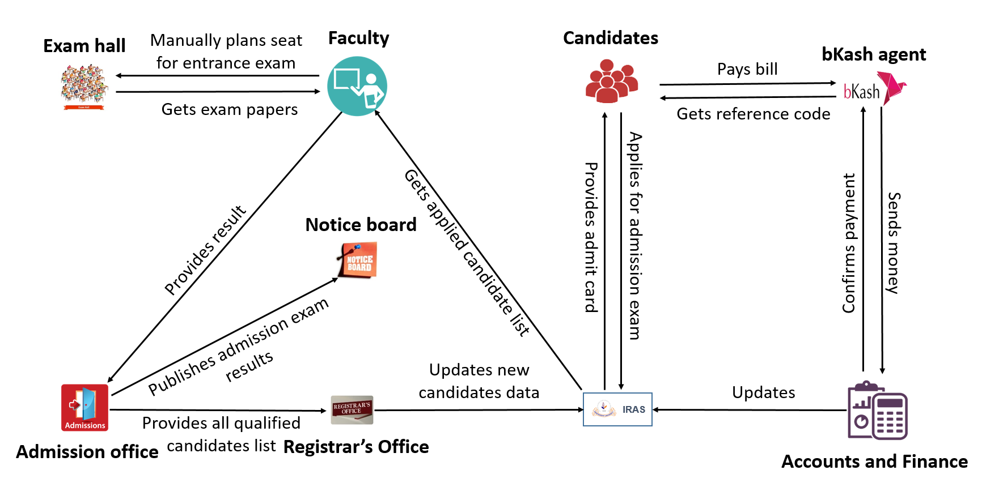

**Fig01: Admission System (Rich Picture)**

At first candidate who meets the qualification applies online for admission. Integrated Registrar Office Automation System (IRAS) guides them for the payment system. Candidates pays their bill through Bkash. Then Bkash sends the money to accounts. Accounts and finance office updates the database using IRAS. After paying the bill candidates get reference code. Using the reference code they download their admit card from IRAS. Before the day of admission exam IRAS stops the payment system and faculties get applied candidates list from IRAS. After getting all information, faculties do the seat plan manually. On the admission exam day the candidates sits for the exam. Then faculties check the exam papers and provides the result to the admission office. Admission office publishes the results and provides the qualified student list to the registrar office. Then the registrar office updates all new candidate’s data into IRAS.

**Course Allocation and course offerings**

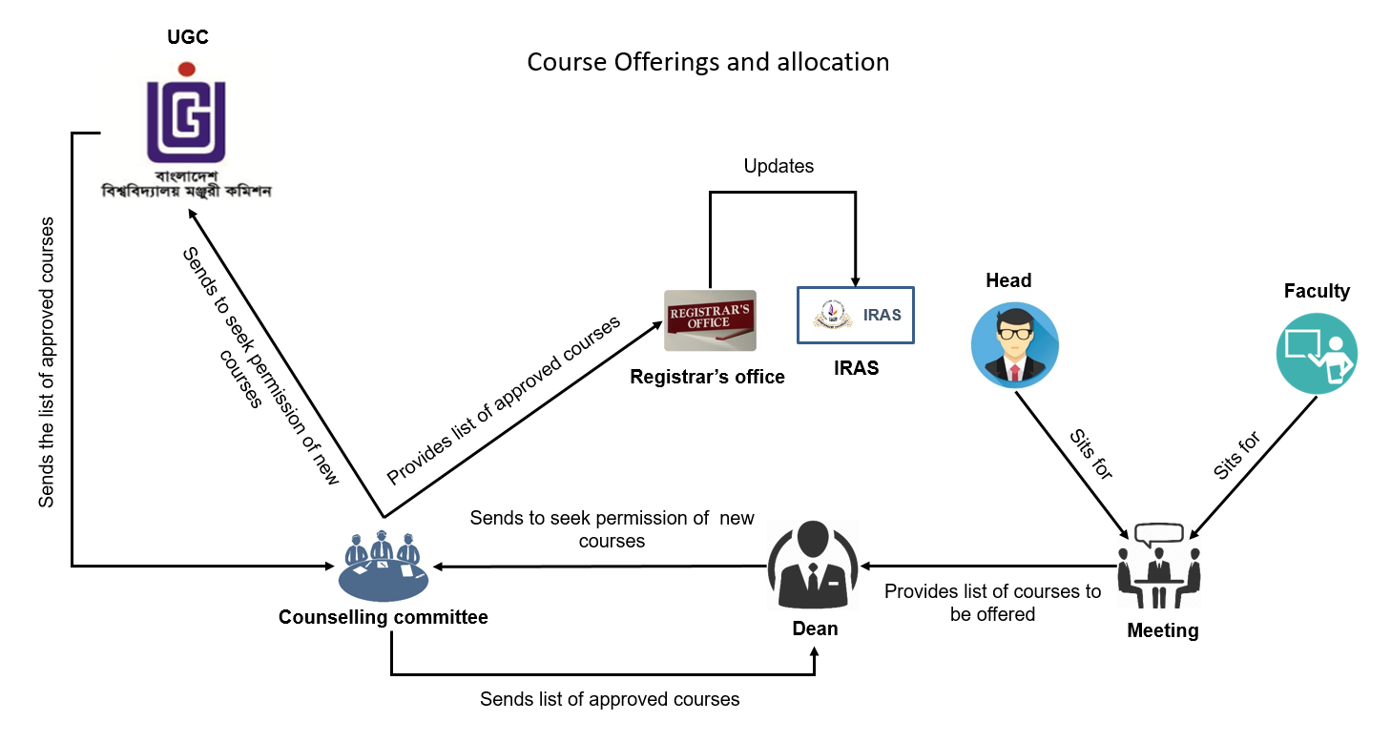

**Fig 02: Course Allocation and course offerings (Rich Picture)**

This rich picture explains the procedure of offering a new course. First department head and faculties sit for a meeting. They decide the courses they want to offer. Then they sent these course list to the dean. Dean sends this course list to the counseling committee. Counseling committee decides whether this courses should be offered or not. If they want to offer those courses then they sent these course list to University Grand Commission. If UGC approves those course only then university can offer those course. UGC provides the approved course list to the counseling committee. Then the committee send the approved student list to the registrar office and the dean. After all these processes registrar office allocates all the newly offered courses using IRAS.

* **Scholarship (Rich Picture)**

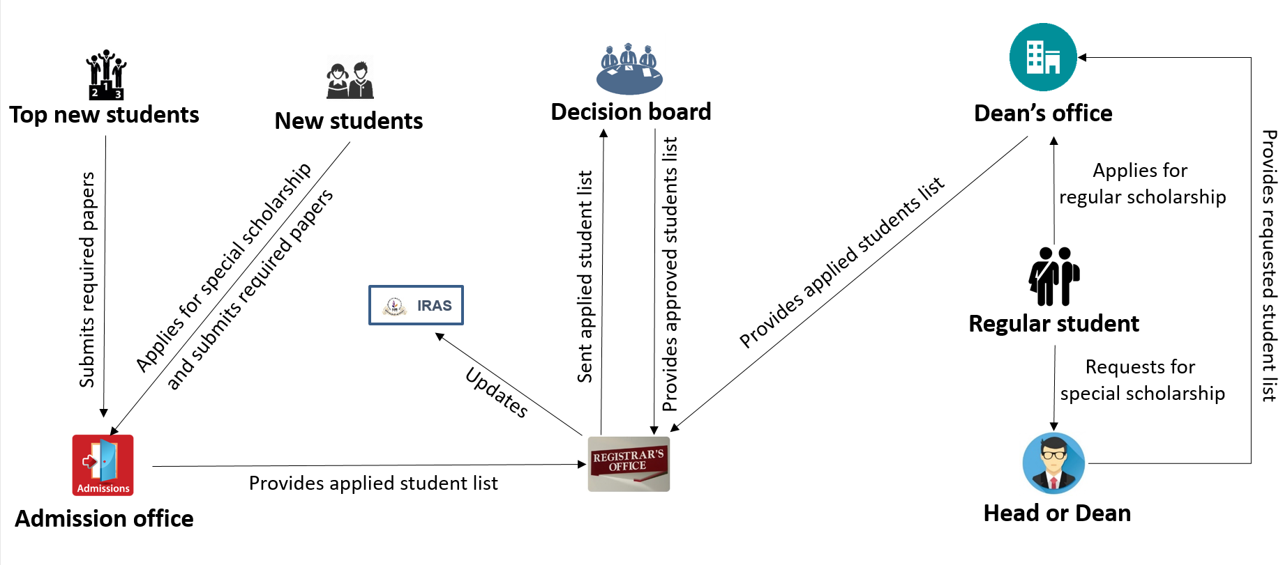

**Fig 03: Scholarship (Rich Picture)**

After admission exam the top ten student gets 100 percent scholarship. Those students submit all their required papers to the admission office. Students who are not on top may apply for special scholarship under some different quotas. The list of students who apply for scholarships has been sent to the registrar’s office by admission office staffs. Then the list with all the required papers is sent to the decision board for verification. After verification, the decision board provides the approved students list to the registrar’s office. Regular students can also apply for scholarships if they can maintain a minimum CGPA, which is required for getting scholarships. Eligible students can apply for merit-based scholarship to dean’s office and then the applied list is sent to the registrar’s office. Regular students can also request for special scholarship to the head or dean, and the requested list is also sent to the dean’s office to registrar’s office as well. All the information is then updated to IRAS.

* **Registration, payments and Attendance (Rich Picture)**

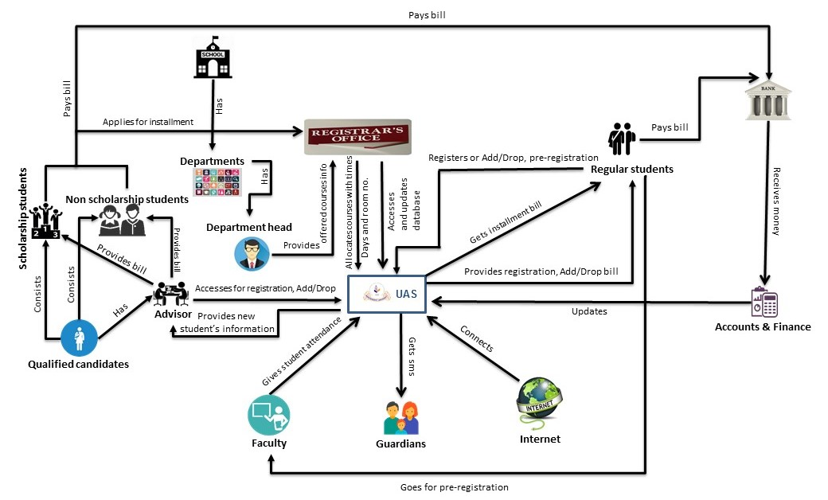

**Fig 04: Registration, payments and Attendance (Rich Picture)**

In the existing system, the candidates who wants to admit in the university applies online. Rich picture shows the procedure of payment. Then they sits in the exam hall. The qualified students list and data are provided to the admission office and the faculties in charge of admission. Top students get the scholarship. Then the admission office admits the qualified students. Their information’s and data are also provided to the registrar office.

After getting admission student’s register process starts. Newly admitted students is assigned to different advisors. Advisors fetches all student information through IRAS. Student database provides all information to IRAS. Advisors advises the students about courses. Advisors does student’s registration on registration day and allocates desired courses to them using IRAS. Courses are offered by the departments. Department heads provides all course’s information to registrar office. Course allocation is done by the Registrar office. Registrar office uses IRAS to access and update student and course database. After their registration advisor provides them the bill using IRAS. Then the student pays their bill in the bank. Bank confirms payment to university accounts and also to the students. Accounts and finance office updates their database.

Regular students uses IRAS for their registration. They got their user id and password from the registrar office. They log in to IRAS. On registration day their offered courses are shown on the registration page. They select their courses and register for that semester. IRAS also provides them the bill. They can print bill from there. If any student wants to pay bill on installment they applies for installment on the registrar office. When the procedure is done the registrar office provides them the bills. Then the students pays their bill in the bank.

In the existing system there is a procedure called Add/Drop. One day is allocated for this procedure. This is a second phase of registration. If students want to add or drop any course/courses they can do it. Regular students do this using IRAS and new students go to their advisor to add or drop.

In the existing system student can apply for scholarship manually. If they meets all requirements and conditions for the scholarship then the board selects them for scholarship and provides their information to the registrar office.

After the registration is done, the students starts their classes where faculties are involved. At the starting of the class faculties take online student attendance using IRAS. Fifteen minutes are given to the faculties to take the attendance. If any student misses eight classes then the course is automatically withdrawn. Faculties also uses IRAS for grade submission.

* **Grade submission (Rich Picture)**



**IRAS**



**Students**



**Exam hall**

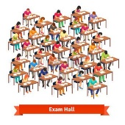

Controller of examination

**Faculty**

Sits for

Submit grades in due time

Provides answer scripts

Application / Grade submission form

Informs

Accesses IRAS and opens the grade

submission time

Collects grade changing form

**Fig 05: Grade submission (Rich Picture)**

Student sit for exams in the exam hall. Then the exam hall provides the answer script to the faculty. Grades has to be submitted to IRAS in due time by the faculties. If the faculties are unable to submit the grades in due time then they have to send an application or grade submission form to the controller of examination. The controller of examination informs the registrar’s office about the issue. Then the registrar’s office accesses IRAS and opens the grade submission time so that the faculties can submit the grades. If any student thinks that he/she was given a poor grade, which he/she was not supposed to get then they can challenge their faculty for upgrading their grade. Students can collect the form of changing grade from registrar’s office by the reference of their faculties.

**Processes along with six system elements:**

**1. Subsystem: Admission**

**Table 01: Process and comparison with six system elements:**

|  |  |  |  |  |  |  |  |
| --- | --- | --- | --- | --- | --- | --- | --- |
| **SL** | **Process**  **Name** | **Six System Elements** | | | | | |
| **Human** | **Mechanical stuff** | **Hardware** | **Software** | **Database** | **Connectivity** |
| 1 | Appling to IUB | Candidates | N/A | Computer, Mobile | IRAS | Admission Database | Internet |
| 2 | Students paying admission form price through Bkash | Candidates, bKash Agent | Money | Mobile | N/A | NA | Mobile Network |
| 3 | Candidates get admit cards for entrance exam | Candidates | Admit Card | Computer,  Mobile | Email | Server | Internet |
| 4 | Faculty collects students list from IRAS | Faculty | N/A | Computer | IRAS | Admission Database | Internet |
| 5 | seat plan for entrance exam | Faculty | Paper | N/A | N/A | N/A | N/A |
| 6 | Candidates sits in exam hall | Candidate,  Faculty | Admit Card, Photo ID,  Paper, pen | N/A | N/A | N/A | N/A |
| 7 | Exam papers are checked by using OMR | N/A | N/A | OMR | N/A | N/A | N/A |
| 8 | Admission office publishes the results on notice board | Admission  Office Stuff | Papers | N/A | N/A | N/A | N/A |
| 9 | Register office update the result to IRAS | Register  Office Stuff | N/A | Computer | IRAS,  IUB website | Admission Database | Internet |
| 10 | New students submit required papers to admission office | Student,  Admission Office stuff | Paper | N/A | N/A | N/A | N/A |
| 11 | Admission office sends data to register office | Admission Office staff,  Register Office staff | Paper | N/A | N/A | N/A | N/A |

**Table 02: Problem Analysis**

|  |  |  |  |
| --- | --- | --- | --- |
| SL | Process | Problem | Analysis |
| 1 | Admission exam seat plan | * Manual seat plan in the admission examination * Very much time consuming | * The admission process has to be stopped one day earlier for manual seat plan * Manual Seat plan can consist of wrong room numbers |
| 2 | Admission Exam results | Faculties manually provides admission results to Admission office | * Admission exam scripts are checked by faculties and the results are sent to Admission department for publishing |
| 3 | New students submit required papers to admission office | * Admission office might lose certificates. | * Official papers of Students are sometimes lost. |

**Table 03: Solution Analysis**

|  |  |  |  |
| --- | --- | --- | --- |
| SL | Problems | Solution | Constraints |
| 1 | seat plan in the admission examination | Seat plan will be done automatically done by our system. It will generate seat plan according to the number of rooms and the candidates Major. | Access to admission database, room database |
| 2 | Faculties provides admission results to Admission office | Faculty will update the Admission result through IRAS which can be readily fetched by Admission department and the Registrar's office for publishing | Access to admission database |

**2. Subsystem: Scholarship**

**Table 01: Process and comparison with six system elements:**

|  |  |  |  |  |  |  |  |
| --- | --- | --- | --- | --- | --- | --- | --- |
| **SL** | **Process**  **Name** | **Six System Elements** | | | | | |
| **Human** | **Mechanical stuff** | **Hardware** | **Software** | **Database** | **Connectivity** |
| 1 | Regular students request for special scholarship to dept. Head or Dean | Student,  Department Head,  Dean. | Paper | N/A | N/A | N/A | N/A |
| 2 | Head or Dean provides students list to register office | Dept. Head,  Dean, Register office staff | Paper | N/A | N/A | N/A | N/A |
| 3 | Regular students applies for regular scholarship and submit papers to register office | Student, Register office staff | Paper | N/A | N/A | N/A | N/A |
| 4 | Register office sends applied students list to Decision Board | Register office staff,  Decision Board members | Paper | N/A | N/A | N/A | N/A |
| 5 | Decision Board provides approved student list to register office | Register office staff,  Decision Board members | Paper | N/A | N/A | N/A | N/A |
| 6 | Register office updates scholarship student list to IRAS | Register office staff | N/A | Computer | IRAS | Student Database | Internet |

**Table 02: Problem Analysis**

|  |  |  |  |
| --- | --- | --- | --- |
| SL | Process | Problem | Analysis |
| 1 | Register office updates scholarship student list to IRAS | * Register office might make mistake while assigning scholarship | * Scholarship assigning to students are done manually by registers office Staff |

**Table 03: Solution Analysis**

|  |  |  |  |
| --- | --- | --- | --- |
| **SL** | **Problems** | **Solution** | **Constraints** |
| **1** | Scholarship can be assigned to wrong Students | This solution is applicable only on the merit based scholarship as it will be applied automatically for the students who fall in the criteria of applying for scholarship. Financial aid applications must be handled manually. | Access to student database |

**3. Subsystem: Course Offering & Allocation**

**Table 01: Process and comparison with six system elements:**

|  |  |  |  |  |  |  |  |
| --- | --- | --- | --- | --- | --- | --- | --- |
| **SL** | **Process**  **Name** | **Six System Elements** | | | | | |
| **Human** | **Mechanical stuff** | **Hardware** | **Software** | **Database** | **Connectivity** |
| 1 | Head and faculty members sit for meeting to decide the courses to be offered manually | Dept. Head, Faculty | N/A | N/A | N/A | N/A | N/A |
| 2 | Decided courses list sends to Dean manually | Dean,  faculty | Paper | N/A | N/A | N/A | N/A |
| 3 | Dean seeks permission to counseling committee for decided course manually | Dean,  counseling committee member | Paper | N/A | N/A | N/A | N/A |
| 4 | Counseling committee asks for approval to UGC manually | counseling committee member, UGC members | Paper | N/A | N/A | N/A | N/A |
| 5 | UGC sends approved and unapproved list to counseling committee manually | counseling committee member, UGC members | Paper | N/A | N/A | N/A | N/A |
| 6 | Counseling committee sends approved courses list to Register Office and Dean manually | Counseling committee member, Register office staff, Dean | Paper | N/A | N/A | N/A | N/A |
| 7 | Students meets faculty for pre-registration | Student,  faculty | Transcript  copy | N/A | N/A | N/A | N/A |
| 8 | Registers office allocates courses using IRAS electronically | Register office staff | N/A | Computer | IRAS | Student Database | Internet |

**Table 02: Problem Analysis**

|  |  |  |  |
| --- | --- | --- | --- |
| SL | Process | Problem | Analysis |
| 1 | Pre-registration | * Sometimes pre-requisite are unknown by faculty, * Some students miss the pre-registration dates. | * Faculties who are assigned for   Pre-registration of the students often stay unknown of the prerequisite courses which are to be assigned with the courses they are going to offer students to take on their next semesters. It is also seen that the prerequisites are sometimes added or lifted.   * There are many students who miss the preregistration due to some of their personal reason and face problems on the day of their registration. Sometimes desired courses are not offered to the students. |
| 2 | Registers office allocates courses using IRAS | * Input mistakes of course allocation | * Some extra courses are sometimes allocated by mistakes as it is done manually and the opposite of it also occurs. |
| 3 | Course registration | * Sometimes students can't take course in spite of completed pre-requisite. * Students enrollment information is not updated frequently. * Some unreasonable pop- up * Labs are not assigned with courses automatically * Prerequisite courses are not informed * Not robust and user friendly design | * Student's data is not always updated every semester even if they have completed the desired courses. * During the time of registration Students need   to press the LOAD COURSES button to ensure the latest  enrollment information in their desired courses' section.   * IRAS shows many pop-ups to help and show information to its user, but it is seen that the users are often disturbed with its involvement * Sometimes students of who have courses which has a LAB course assigned to it, forgets to select it while course registration. When they click the register button, a pop-up shows up and informs the students that they have missed to select a course. * Students can also select the courses whose   prerequisites are not done and then a popup shows up and says that the prerequisite of that course is not done the   * Not user friendly design * Proper guidelines are not provided in the IRAS for every semesters registration as new rules   are always sets for the students.   * Students are unable to see their Basic information such as major, minor until the day of registration. * Students cannot see their CGPA in IRAS until the day of course registration they need to download the transcript in order to see it. * Selected course are shown in a row which seems very congested students face problem * Seeing it. * Undergrad admission button appears to be a highlighted text other than being having a button look. * Search bar is also very congested |

**Table 03: Solution Analysis**

|  |  |  |  |
| --- | --- | --- | --- |
| **SL** | **Problems** | **Solution** | **Constraints** |
| 1 | Prerequisites are unknown to the faculties and the students mostly | The prerequisite for different courses will be uploaded in our system, and updated regularly if required. Thus the faculties and the students will be able to check for prerequisite courses whenever they require. | Access to course database |
| 2 | Students miss the preregistration dates | Students will be able to do their preregistration inside our system and the information will be stored in the database. | Access to student and course database |
| 3 | Mistakes in manual course allocation | New courses has to be inserted manually other than that all the course allocation will be automated according to timings and assigned  Faculty. Those courses which has lab assigned to it will be selected automatically alongside the theoretical course. In case of newly offered courses Students will be notified earlier. | Access to course database, verification of course’s identity, time clashing issues and assigning faculties |
| 4 | Sometimes students can't take course in spite of completed pre-requisite. | After the completion of a course students information will be updated automatically so that they do not face any trouble for prerequisite completion | Data manipulation of courses, access of student and course database |

**4. Subsystem: Advising & Course Registration**

**Table 01: Process and comparison with six system elements:**

|  |  |  |  |  |  |  |  |  |
| --- | --- | --- | --- | --- | --- | --- | --- | --- |
| **SL** | **Process**  **Name** | **Six System Elements** | | | | | | |
| **Human** | | **Mechanical stuff** | **Hardware** | **Software** | **Database** | **Connectivity** |
| 1 | Advisor gets all courses and student info from IRAS | Faculty | | N/A | Computer | IRAS | Student Database | Internet |
| 2 | Adviser register new students through IRAS | Faculty, Students | | Admission paper | Computer | IRAS | Student Database | Internet |
| 3 | Adviser provides bill to students | | Adviser ,Student | Paper | Computer | IRAS | Student Database | Internet |
| 4 | Regular students register through IRAS | | Student | N/A | Computer | IRAS | Student Database | Internet |
| 5 | Regular students get bills from IRAS | | Student | Paper | Computer | IRAS | Student Database | Internet |
| 6 | All students pay bill to Bank in due time | | Student,  Bank’s staff | Paper, Money | N/A | N/A | N/A | N/A |
| 7 | Students apply to Register Office for installment | | Student, Register office staff | Paper | N/A | N/A | N/A | N/A |
| 8 | Students can also register manually | | Student, Dept. Head | Paper | N/A | N/A | N/A | N/A |
| 9 | Students can also do Add/Drop courses or late registration | | Student | N/A | Computer | IRAS | Student Database | Internet |

**Table 02: Problem Analysis**

|  |  |  |  |
| --- | --- | --- | --- |
| SL | Process | Problem | Analysis |
| 1 | Students apply to Register Office for installment | Time consuming | * Students who want to pay their registration bill through installments need to visit registrar's office and they create new installment bills so that Students can pay. |
| 2 | Manual registration | long process and very much time consuming | Students collect form of manual registration form the department office and fills it up with the courses the want to register and this form needs to be signed by the HEAD of department. Then they need to submit it to the Registrar's office. The office staffs the registers on behalf of the student |

**Table 03: Solution Analysis**

|  |  |  |  |
| --- | --- | --- | --- |
| **SL** | **Problems** | **Solution** | **Constraints** |
| 1 | Students' enrollment in a course during the registration period is not updated frequently | Our System will be LIVE so students will be able to see what is actually occurring at the time of registration. They would not have to click any LOAD COURSES button to see the changes. | To make the system live and access to the course and student database |
| 2 | Manual Registration | Registration will be completely automated along with the course offerings and allocations | Access to course database |
| 3 | Students apply installments to registrar's office | Students who are willing to pay by installments will be able to apply through our system and their installment bills will be saved. | Access to student database |

**5. Subsystem: Attendance & Grading**

**Table 01: Process and comparison with six system elements:**

|  |  |  |  |  |  |  |  |  |
| --- | --- | --- | --- | --- | --- | --- | --- | --- |
| **SL** | **Process**  **Name** | **Six System Elements** | | | | | | |
| **Human** | | **Mechanical stuff** | **Hardware** | **Software** | **Database** | **Connectivity** |
| 1 | Faculty takes lectures and submit students attendance to IRAS and send email to guardian | | Faculty, Students, Guardian | N/A | Computer | IRAS, Email | Student Database | Internet |
| 2 | Students sit in exam hall | | Student, Faculty | Paper,  Pen | N/A | N/A | N/A | N/A |
| 3 | Faculty check the answer scripts | | Student, Faculty | Paper,  pen | N/A | N/A | N/A | N/A |
| 4 | Faculty submits grade using IRAS | | Faculty | N/A | Computer | IRAS | Student Database | Internet |
| 5 | Late grade Submission | | Faculty | N/A | Computer | IRAS | Student Database | Internet |
| 6 | Grade changing process | | Student, Faculty, Dept. Head | N/A | Computer | IRAS | Student Database | Internet |

**Table 02: Problem Analysis**

|  |  |  |  |
| --- | --- | --- | --- |
| SL | Process | Problem | Analysis |
| 1 | Online Attendance | * Sometimes attendance submit button disappears | * Faculties are sometimes unable to take attendance on makeup classes given by the Institution. Sometimes faculties announce their own make up classes and they are also unable to do the same there. They need to inform the registrars' office in order to take attendance. * Sometimes attendance submit button disappears due to bugs in the software. |
| 2 | Faculty submits grades using IRAS | * Faculties can submit wrong grades. * They can also miss the due date | * If a faculty submits wrong grades they need to write an application to the controller of examination so that they can Open IRAS at some tie so that they can submit again. * If a Faculty misses the assigned date of grade submission they need to write an application to the controller of examination so that they can Open IRAS at some tie so that they can submit again. |

**Table 03: Solution Analysis**

|  |  |  |  |
| --- | --- | --- | --- |
| **SL** | **Problems** | **Solution** | **Constraints** |
| 1 | No makeup class attendance | The institution will be able to declare make up class through the system, then at those times online attendance will be automatically opened. Faculties will also be able to declare make up classes through the system and the students will be notified by the system. | Access to attendance database |
| 2 | Answer scripts can be lost in some instances | In our system Students' exam marks will be uploaded by the faculties after every exam. It will be saved in the database and will be accessible from both the student and faculty profile. So the intuition will not have to pile up the answer scripts. | Access to exam, faculty and student database |

**Proposed Business System (Rich Picture)**

The proposed Business system is developed by keeping the problems of the existing system in mind New course offerings is not proposed below as it needs to pass through some major paper works. Once the new courses are inserted into the system, the system will be able to allocate them automatically for the students. The new proposed system and sub systems are described below with figures:

* **Proposed admission System ( Rich Pictures)**

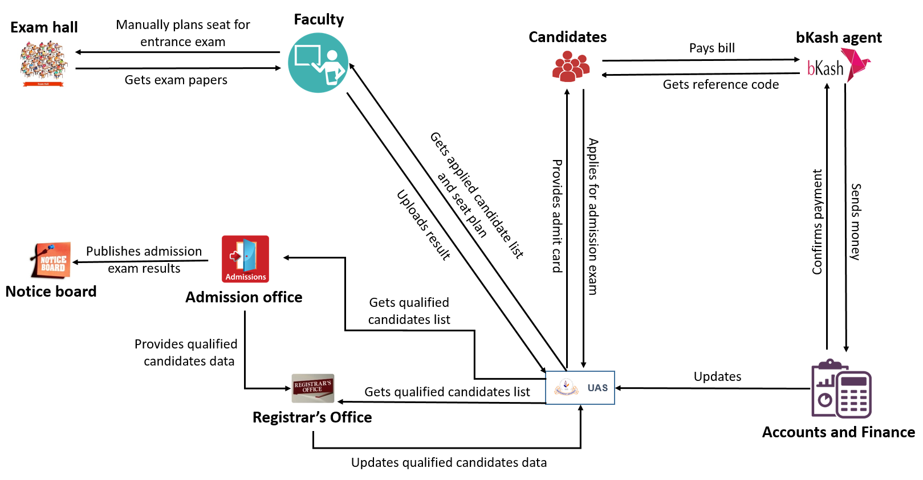

**Fig 06: Proposed admission System (Rich Pictures)**

Candidate who meets the qualification applies online for admission. UAS guides them for the payment system. Candidates pays their bill through bkash. Then bkash sends the money to accounts. Accounts and finance office updates the database using UAS. After paying the bill candidates get reference code. Using the reference code they download their admit card from UAS. Before the day of admission exam UAS stops the payment system and faculties will get applied candidates list as well as seat plan from UAS. After getting all information, Faculties will do the seat plan. On the admission exam day the candidates sits for the exam. Then OMR check the exam papers and uploads the result to the UAS automatically. Registrar’s office and Admission office will get the results from UAS. Admission office will publish the result on notice board. Then admission office will provide candidate’s data to the registrar office. Registrar office will update all new candidate’s data into UAS. In this way candidates admit them into IUB.

* **Proposed Automated Scholarships ( Rich Pictures)**

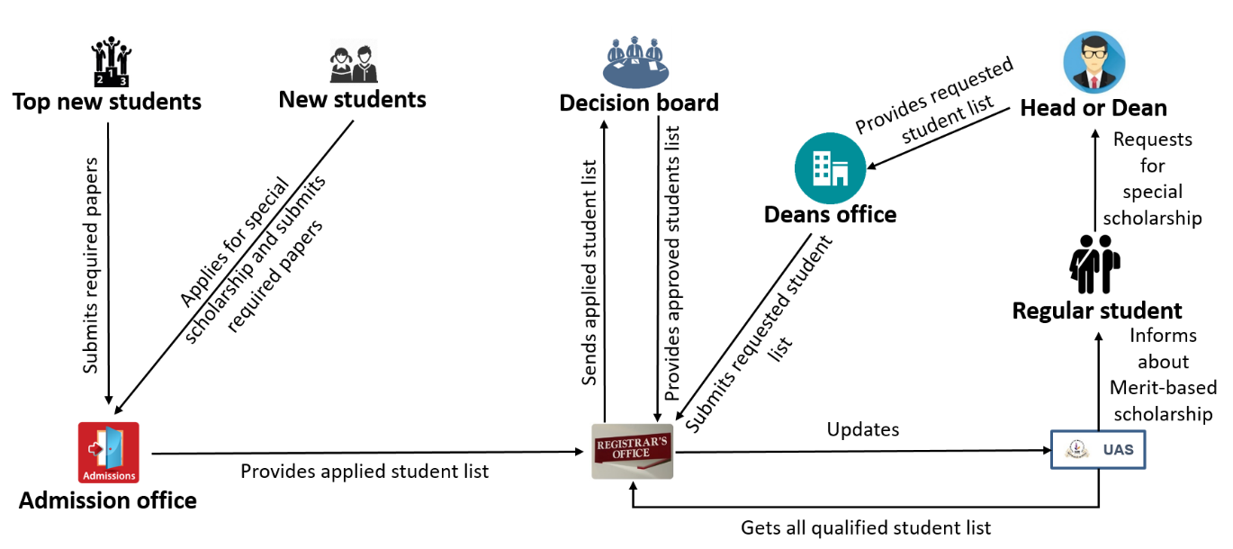

**Fig 07: Proposed Automated Scholarship (Rich Pictures)**

After admission exam the top ten student will get 100 percent scholarship. Those students will have to submit all their required papers to the admission office. Students who are not on top may apply for special scholarship under some different quotas. The list of students who apply for scholarships will be sent to the registrar’s office by admission office staffs. Then the list with all the required papers will be sent to the decision board for verification. After verification, the decision board will provide the approved students list to the registrar’s office. Regular students can also apply for scholarships if they can maintain a minimum CGPA, which is required for them to get scholarships. Eligible students will be informed about their scholarship from UAS. Then they will be able to apply for merit-based scholarship to dean’s office and then the applied list will be sent to the registrar’s office. Regular students can also request for special scholarship to the head or dean, and the requested list will also be sent to the dean’s office to registrar’s office as well. All the information’s will be updated to UAS. Registrar’s office will get the entire qualified student list from UAS.

**Course Allocation and course offerings**

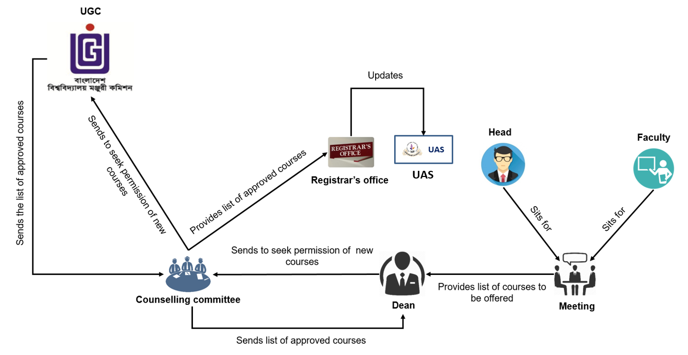

**Fig 08: Proposed Course Allocation and Course Offering (Rich Pictures)**

This rich picture explains the procedure of offering a new course. First department head and faculties sit for a meeting. They decide the courses they want to offer. Then they sent these course list to the dean. Dean sends this course list to the counseling committee. Counseling committee decides whether this courses should be offered or not. If they want to offer those courses then they sent these course list to University Grand Commission. If UGC approves those course only then university can offer those course. UGC provides the approved course list to the counseling committee. Then the committee send the approved student list to the registrar office and the dean. After all these processes registrar office allocates all the newly offered courses using IRAS.

* **Proposed Registration, Payments and Attendance ( Rich Picture)**

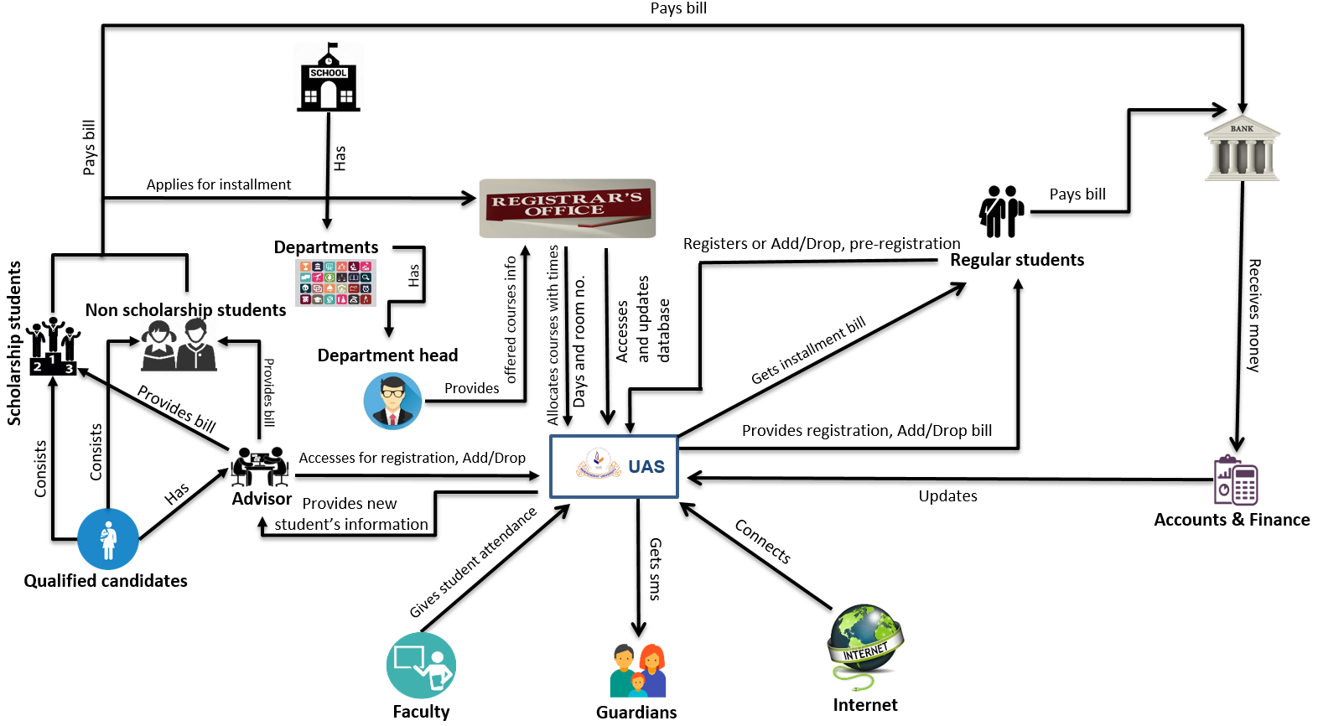

**Fig 09: Proposed Registration, Payments and Attendance (Rich Picture)**

In our proposed registration system newly admitted students will go to their assigned advisor for registration. Though our system is providing proper guideline but still it is not allowing them the online registration at the very first semester because they can still take unnecessary courses and misguide themselves. So the advisor will provide the proper guideline and do their registration. On the other hand regular students will access UAS for their registration. All the students will have to do their pre-registration on the allocated day except the fresher. UAS will automatically provide enough sections for every courses on behalf of the pre-registration. To registrar they have to go to the registrar’s office. After auto course offering and allocation students can take their desired courses online.

For the new students advisor will provide them the registration bill. On the other hand UAS will provide the registration bill to the regular students. New students will have to go to the registrar office for installment and UAS will provide installment bill to the regular students. They will pay their bill to the bank and like existing system bank will inform accounts, who will update the database.

When the class starts faculties will take online attendance using UAS like the existing system. Student have to reach the class before 15 minutes to give the online attendance. If they miss four classes UAS will automatically inform the guardians by SMS or email and after missing 8 classes they will be automatically withdrawn from the course.

* **Grade submission (Rich Picture)**

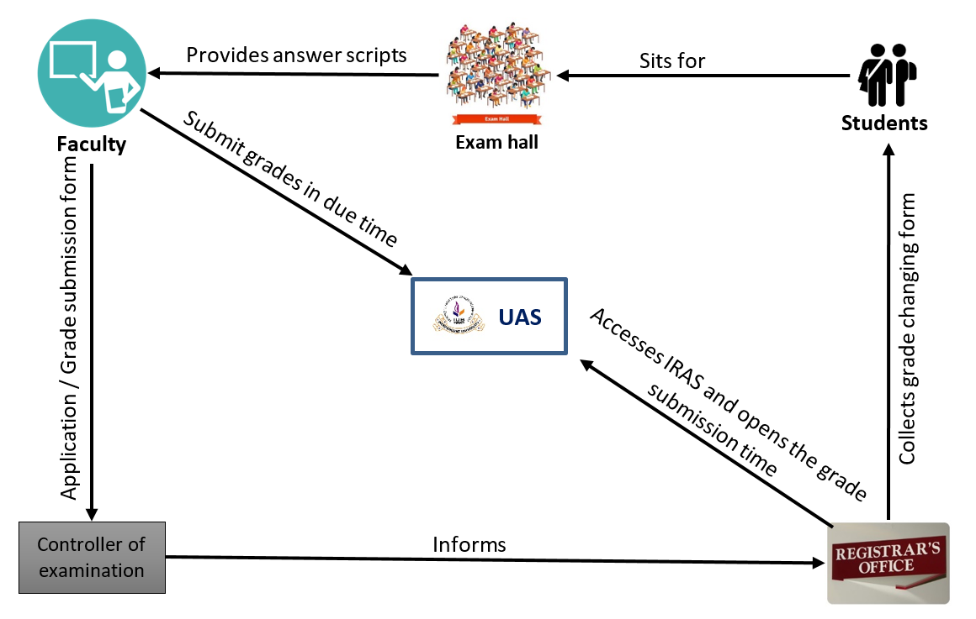

**Fig10: Grade submission (Rich Picture)**

Student sit for exams in the exam hall. Then the exam hall provides the answer script to the faculty. Grades has to be submitted to IRAS in due time by the faculties. If the faculties are unable to submit the grades in due time then they have to send an application or grade submission form to the controller of examination. The controller of examination informs the registrar’s office about the issue. Then the registrar’s office accesses IRAS and opens the grade submission time so that the faculties can submit the grades. If any student thinks that he/she was given a poor grade, which he/she was not supposed to get then they can challenge their faculty for upgrading their grade. Students can collect the form of changing grade from registrar’s office by the reference of their faculties.

**BUSINESS RULES**

* There are many schools at Independent University, Bangladesh (IUB).
* Different types of People are connected with IUB. The attributes of PERSON consists of Person ID (Identifier), Person name, Password, Father Name, Mother Name, Gender. Phone, DOB, Country, Email, Blood group, picture, address, Person Type.
* Attributes of SCHOOL are school ID, name, level. One school must have one or many department and a department must belong to a school.
* Faculties and candidate are subtype of PERSON entity.
* Attributes of FACULTY consists of faculty_ID (Identifier) and attributes of Candidates are candidate_ID and type.
* Candidate must have at least two or more academic degrees, attributes of academic degree are A_ID, Passing_year, Institution_name, Grade, Roll_no and Reg_no.
* Candidates also applies for a major, attributes of MAJOR are Major_ID and Major_name .
* MAJOR are offered by the DEPARTMENT. One DEPARTMENT offers many MAJOR and each MAJOR is offered by only one DEPARTMENT.
* Attributes of DEPARTMENT are department ID (Identifier), department name, Level. One DEPARTMENT has many faculties and faculties must belong to a DEPARTMENT.
* A Major must have MAJOR COURSEs and a course can be a MAJOR COURSE.
* A CANDIDATE can become a STUDENT after passing the ADMISSION TEST.
* Attributes of STUDENT consists of Student ID (Identifier), student, father’s name and mother’s name.
* CANDIDATE must have one financial guarantor. The attributes of FINALCIAL GUARANTOR are Fin_ID, name, relationship, occupation, phone, email, postal address. And each FINANCIAL GUARANTOR can sponsor many CANDIDATE.
* One DEPARTMENT can offer many courses and each course must belong to a DEPARTMENT.
* Attributes of COURSES are course_ID, course_name and credit. Courses has prerequisite courses. One course can have many prerequisite and there should be at least one COURSE for a PREREQUISITE course.
* One course can have many SECTION. And one section is must for one COURSE and COURSE is also must for SECTION.
* Attributes of SECTION are section_no and Course_ID. One SECTION must be taken at a particular TIMESLOT but one TIMESLOT can be for many SECTION.
* One SECTION must have many ENROLLMENT and one ENROLLMENT is must for one section.
* At least one EXAM is taken in every SECTION and each EXAM should be taken by only one SECTION.
* One ROOM must be allocated for each SECTION. And classes of many SECTIONs can be taken in one ROOM. But room must have a section and section must have a room.
* One ATTENDENCE is must for one SECTION and one SECTION is must for one ATTENDENCE.
* One course must have many QUESTIONS and one QUESTION is for one course.
* Attributes of QUESTIONS are Ques_ID, answer, option and subject.
* CANDIDATE sit for admission test in the exam hall. Attributes of ADMISSION TEST are admission_ID, semester, type and test. Admission questions are made for ADMISSION TEST
* Attributes of the ADMISSION QUESTION are Aquestion_ID, answer, option and subject.
* CANDIDATE gets many ADMISSION TEST SCORE for each ADMISSION TEST, attributes of ADMISSION TEST SCORE are mark and serial.
* STUDENT does registration. REGISTRATION has attributes Reg_ID, scholarship and percentage. One STUDENT must register only once at a time and one REGISTRATION can be done by many STUDENTs.
* REGISTRATION has scholarship.
* SCHOLARSHIP has SCHOLARSHIP ID (identifier) and sch_type. Each REGISTRATION has many SCHOLARSHIP and one student can get only one SCHOLARSHIP during one REGISTRATION.
* REGISTRATION has ENROLLMENT. ENROLLMENT has attributes Enroll_ID,grade,bill and semester.
* One student can enroll many times. And each ENROLLMENT is done by only one STUDENT.
* After enrolling for a course STUDENT must give course EXAM. Attributes of EXAM are Exm_ID,type and semester. EXAM must have one or many QUESTION and one QUESTION is must for every EXAM.
* A STUDENT must sit for one or more EXAM and one EXAM is given by only one STUDENT.
* STUDENTS have ANSWER SCRIPTs and one student must have many ANSWER SCRIPT and one ANSWER SCRIPT must be written by one STUDENT for one QUESTIONS. And one QUESTION has one ANSWER SCRIPT for one STUDENT.
* Attributes of ANSWER SCRIPT is mark.

ENTITY RELATIONSHIP DIAGRAM

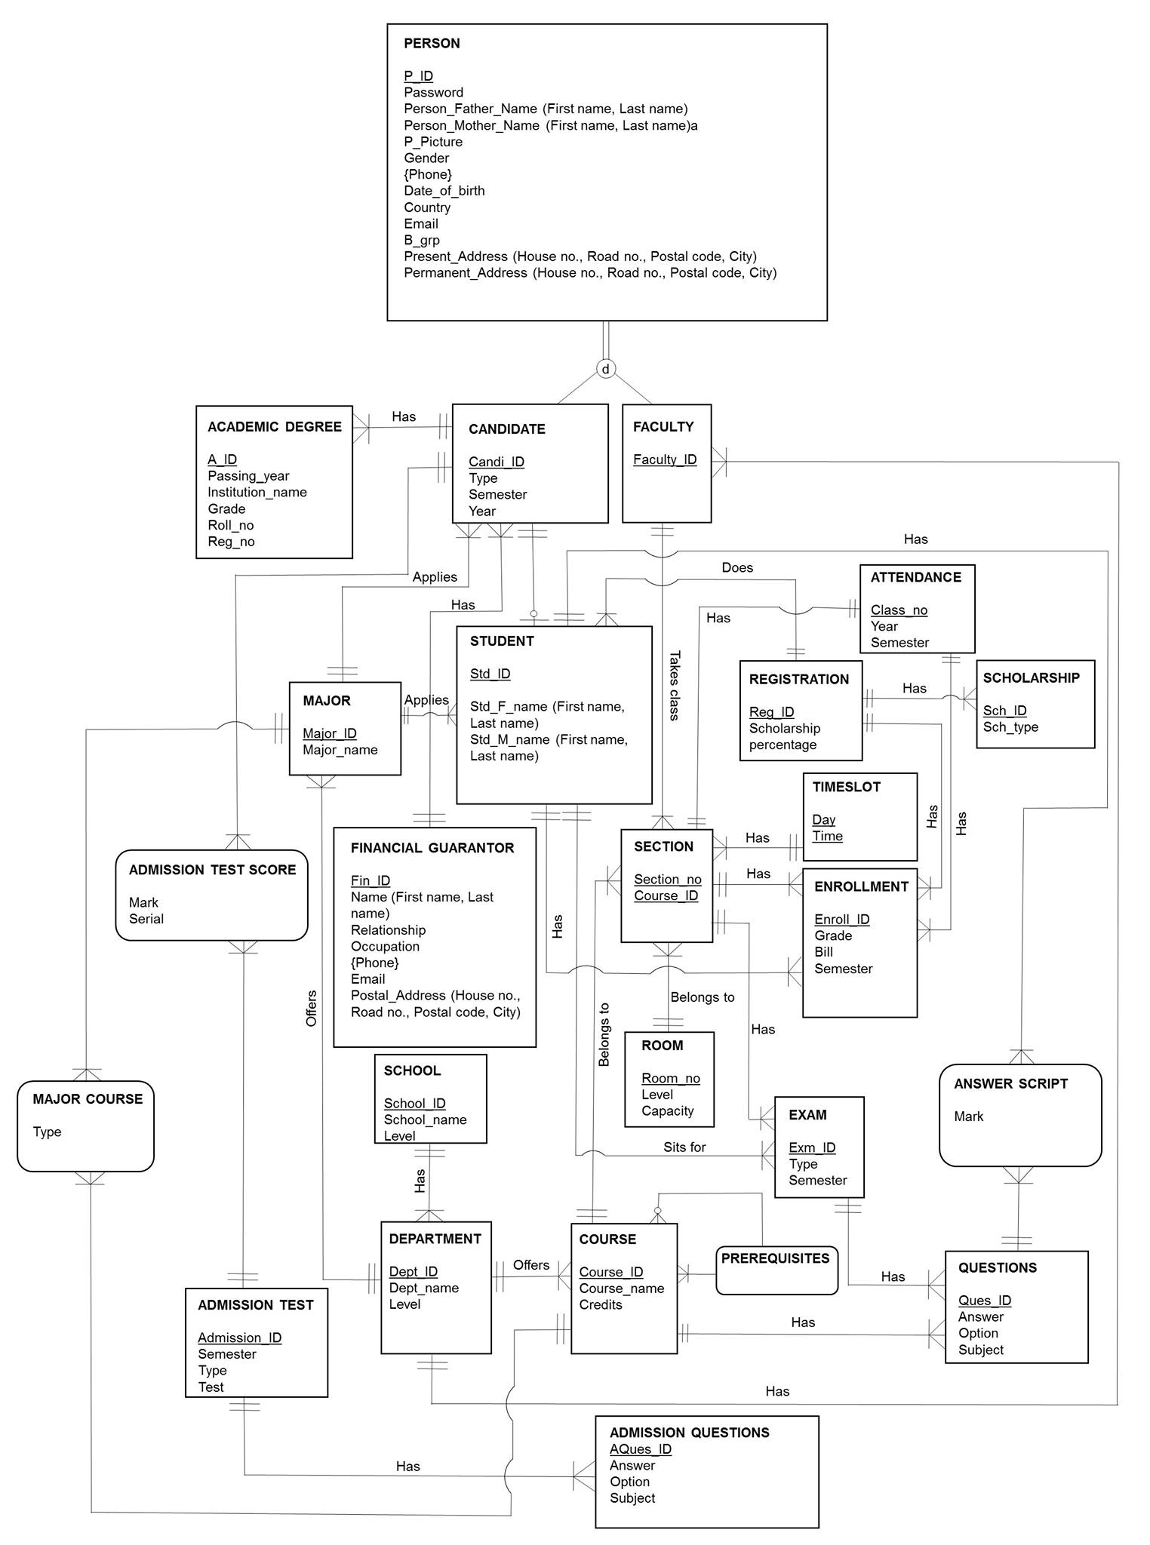

Figure 11: Entity Relationship Diagram (ERD Diagram)

**ER DIAGRAM TO RELATION**

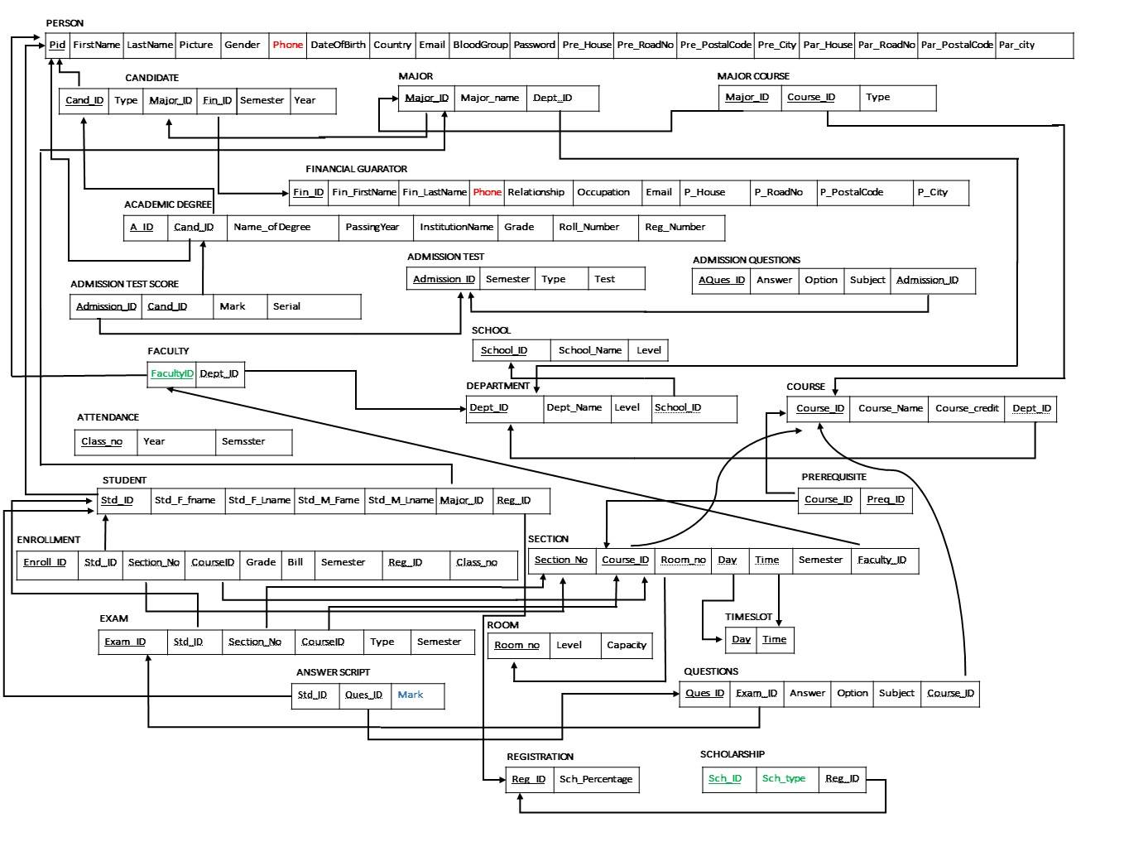

Figure 12: Entity Relationship Diagram to Relation

**NORMALIZATION**

Table Name: PERSON

1 NF: The Primary key in the table: Pid.

2NF: There is no partial key dependency so no 2NF process.

3NF: There is no transient dependencies so no 3NF process.

Table Name: CANDIDATE

1 NF: The Primary key in the table: Cand_ID.

2NF: There is no partial key dependency so no 2NF process.

3NF: There is no transient dependencies so no 3NF process.

Table Name: MAJOR

1 NF: The Primary key in the table: Major_ID.

2NF: There is no partial key dependency so no 2NF process.

3NF: There is no transient dependencies so no 3NF process.

Table Name: MAJORCOURSE

1 NF: The Primary key in the table: Major_ID,Course_ID

2NF: There is no partial key dependency so no 2NF process.

3NF: There is no transient dependencies so no 3NF process.

Table Name: FINANCIAL GURANTOR

1 NF: The Primary key in the table: Fin_ID

2NF: There is no partial key dependency so no 2NF process.

3NF: There is no transient dependencies so no 3NF process.

Table Name: ACADEMIN DEGREE

1 NF: The Primary key in the table: A_ID

2NF: There is no partial key dependency so no 2NF process.

3NF: There is no transient dependencies so no 3NF process.

Table Name: ADMISSION TEST SCORE

1 NF: The Primary key in the table: Admission_ID,Cand_ID

2NF: There is no partial key dependency so no 2NF process.

3NF: There is no transient dependencies so no 3NF process.

Table Name: ADMISSION TEST

1 NF: The Primary key in the table: Admission_ID

2NF: There is no partial key dependency so no 2NF process.

3NF: There is no transient dependencies so no 3NF process.

Table Name: ADMISSION QUESTIONS

1 NF: The Primary key in the table: AQues_ID

2NF: There is no partial key dependency so no 2NF process.

3NF: There is no transient dependencies so no 3NF process.

Table Name: FACULTY

1 NF: The Primary key in the table: FacultyID

2NF: There is no partial key dependency so no 2NF process.

3NF: There is no transient dependencies so no 3NF process.

Table Name: SCHOOL

1 NF: The Primary key in the table: School_ID

2NF: There is no partial key dependency so no 2NF process.

3NF: There is no transient dependencies so no 3NF process.

Table Name: DEPARTMENT

1 NF: The Primary key in the table: Dept_ID

2NF: There is no partial key dependency so no 2NF process.

3NF: There is no transient dependencies so no 3NF process.

Table Name: COURSE

1 NF: The Primary key in the table: Course_ID.

2NF: There is no partial key dependency so no 2NF process.

3NF: There is no transient dependencies so no 3NF process.

Table Name: ATTENDANCE

1 NF: The Primary key in the table: Class_no

2NF: There is no partial key dependency so no 2NF process.

3NF: There is no transient dependencies so no 3NF process.

Table Name: STUDENT

1 NF: The Primary key in the table: Std_ID,

2NF: There is no partial key dependency so no 2NF process.

3NF: There is no transient dependencies so no 3NF process.

Table Name: PREQUISITE

1 NF: The Primary key in the table: Course_ID,Preg_ID

2NF: There is no partial key dependency so no 2NF process.

3NF: There is no transient dependencies so no 3NF process.

Table Name: ENROLLMENT

1 NF: The Primary key in the table: Enroll_ID

2NF: There is no partial key dependency so no 2NF process.

3NF: There is no transient dependencies so no 3NF process.

Table Name: SECTION

1 NF: The Primary key in the table: Section_No,Course_ID

2NF: There is no partial key dependency so no 2NF process.

3NF: There is no transient dependencies so no 3NF process.

Table Name: EXAM

1 NF: The Primary key in the table: Exam_ID

2NF: There is no partial key dependency so no 2NF process.

3NF: There is no transient dependencies so no 3NF process.

Table Name: ROOM

1 NF: The Primary key in the table: Room_no

2NF: There is no partial key dependency so no 2NF process.

3NF: There is no transient dependencies so no 3NF process.

Table Name: TIMESLOT

1 NF: The Primary key in the table: Day,Time.

2NF: There is no partial key dependency so no 2NF process.

3NF: There is no transient dependencies so no 3NF process.

Table Name: ANSWER SCRIPT

1 NF: The Primary key in the table: Std_ID,Ques_ID

2NF: There is no partial key dependency so no 2NF process.

3NF: There is no transient dependencies so no 3NF process.

Table Name: QUESTIONS

1 NF: The Primary key in the table: Ques_ID

2NF: There is no partial key dependency so no 2NF process.

3NF: There is no transient dependencies so no 3NF process.

Table Name: REGISTRATION

1 NF: The Primary key in the table: Reg_ID

2NF: There is no partial key dependency so no 2NF process.

3NF: There is no transient dependencies so no 3NF process.

Table Name: SCHOLARSHIP

1 NF: The Primary key in the table: Sch_ID.

2NF: There is no partial key dependency so no 2NF process.

3NF: There is no transient dependencies so no 3NF process.

**DATA DICTIONARY**

tblperson

|  |  |  |  |
| --- | --- | --- | --- |
| **Attribute** | **Data Type** | **Size** | **Remark** |
| cPid | Varchar | 7 | This is the primary key of this relation. It contains the id of the person.  Example: 1430163 |
| cP_fname | varchar | 30 | It contains the first name of the person.  Example: Rakib |
| cP_Lname | Varchar | 30 | This contains the last name of the person.  Example: Khan |
| cP_pic | varchar | ----- | This contains the picture of the person. |
| cGender | Varchar | 6 | It specifies the gender of the particular person.  Example: Male/Female. |
| cPhone | Varchar | 11 | This contains the phone number of the Person.  Example: 01711-262626 |
| dDate_of_birth | Datetime | “dd-mm-yyyy” | This contains the date of birth of the person.  Example: 11-02-1996 |
| cCountry | Varchar | 20 | This contains the country name of the person.  Example: USA |
| cEmail | varchar | 45 | It contains the email of that particular person.  Example: 1430651@iub.edu.bd |
| cB_grp | varchar | 3 | It contains the blood group of the particular person.  Example: B+,AB- |
| cPassword | varchar | 40 | This contains the password of the person.  Example: cccdddeka |
| cPre_House | varchar | 10 | It contains the present house number of that particular person. |
| cPre_RoadNo | varchar | 3 | It contains the present road number of that particular person’s house. |
| cPre_PostalCode | varchar | 4 | It contains the present postal Code number of that particular person’s address. |
| cPre_City | varchar | 10 | It contains the present city’s name of that particular person |
| cPer_House | varchar | 10 | It contains the permanent house’s number of that particular person. |
| cPer_RoadNo | varchar | 3 | It contains the permanent road number of that particular person’s house. |
| cPer_PostalCode | varchar | 4 | It contains the permanent postal Code number of that particular person’s address. |
| cPer_city | varchar | 10 | It contains the permanent city’s name of that particular person |

tblcandidate

|  |  |  |  |
| --- | --- | --- | --- |
| **Attribute** | **Data Type** | **Size** | **Remark** |
| cCand_ID | varchar | 7 | This is the primary key of this relation. It contains the ID of the candidate.  Example: 1430163 |
| cType | varchar | 15 | It contains candidate’s nationality  Example: Indian |
| cMajor_ID | varchar | 3 | This is a foreign key of this relation. This contains the Major ID of the candidate.  Example: CSE |
| cFin_ID | varchar | 6 | This is the foreign key of this relation. It contains the financial guarantor’s ID of the candidate.  Example: 100009 |
| csemester | varchar | 12 | It contains the candidate’s admission semester.  Example: Summer 2014 |
| cyear | varchar | 4 | It contains the candidate’s admission year.  Example: 2014 |

tblfaculty

|  |  |  |  |
| --- | --- | --- | --- |
| **Attribute** | **Data Type** | **Size** | **Remark** |
| cFacultyID | varchar | 4 | This is the primary key of this relation. It contains the ID of the faculty.  Example: 4042 |
| cDept_ID | varchar | 3 | This is a foreign key of this relation. It contains the department name.  Example: CSE |

tblstudent

|  |  |  |  |
| --- | --- | --- | --- |
| **Attribute** | **Data Type** | **Size** | **Remark** |
| cStd_ID | varchar | 7 | This is the primary key of this relation. It contains the ID of the Student. Example: 1430163 |
| cStd_F_fname | varchar | 15 | This contains the first name of the student’s father.  Example: Rokib |
| cStd_F_Lname | varchar | 15 | This contains the last name of the student’s father.  Example: Khan |
| cStd_M_fname | varchar | 15 | This contains the first name of the student’s mother.  Example: Amena |
| cStd_M_Lname | varchar | 15 | This contains the last name of the student’s mother.  Example: Khan |
| cMajor_ID | varchar | 3 | This is a foreign key of this relation. It contains the department name.  Example: CSE |
| cReg_ID | varchar | 20 | This is a foreign key of this relation. It contains the course registration number of the student.  Example: 0022321239 |

tblregistration

|  |  |  |  |
| --- | --- | --- | --- |
| **Attribute** | **Data Type** | **Size** | **Remark** |
| cReg_ID | varchar | 20 | This is the primary key of this relation. This contains the course registration number of the student.  Example: 0022321239 |
| iSch**_**Percentage | int | 4 | It contains the scholarship percentage of the student |

tblfinancialguarantor

|  |  |  |  |
| --- | --- | --- | --- |
| **Attribute** | **Data Type** | **Size** | **Remark** |
| cFin_ID | varchar | 7 | This is the primary key of this relation. It contains the ID of the financial guarantor.  Example: 2056256 |
| cFin_FirstName | Varchar | 15 | This contains the first name of the financial guarantor.  Example: Mohib |
| cFin_LastName | Varchar | 15 | This contains the last name of the financial guarantor.  Example: Khan |
| cPhone | varchar | 11 | This contains the phone number of the Person.  Example:01711-262626 |
| cRelationship | varchar | 15 | It contains the relation between student and financial guarantor |
| cOccupation | varchar | 15 | It contains the occupation of the financial guarantor  Example: Businessman |
| cEmail | varchar | 45 | It contains the email of the financial guarantor.  Example: abc@gmail.com |
| cP_House | varchar | 10 | It contains the house number of that particular financial guarantor |
| cP_Rd_no | varchar | 3 | It contains the road number of the financial guarantor house. |
| cP_postalCode | varchar | 4 | It contains the postal Code number of that financial guarantor address.  Example:1212 |
| cCity | varchar | 10 | It contains the name of the city of that particular person  Example: Dhaka |

tblacademichistory

|  |  |  |  |
| --- | --- | --- | --- |
| **Attribute** | **Data Type** | **Size** | **Remark** |
| cA_ID | varchar | 10 | This is the primary key of this relation. It contains the academic ID of a student.  Example: 100009 |
| cCand_ID | varchar | 7 | This is a foreign key of this relation. It contains candidate’s ID.  Example: 1430651 |
| cName_of Degree | varchar | 40 | It contains the degree name.  Example:SSC/HSC/o'levels/A'levels |
| cPassing_year | varchar | 4 | It contains the passing year of that particular degree.  Example : 2013 |
| cInstitutionName | varchar | 50 | It contains the institute name of that student |
| cGrade | varchar | 2 | This contains the grade of the degree.  Example: A-/A |
| cRoll_Number | varchar | 6 | It contains the candidate’s roll number for that particular degree.  Example: 106346 |
| cReg_Number | varchar | 6 | It contains the candidate’s registration number for that particular degree.  Example: 783742 |

tblmajor

|  |  |  |  |
| --- | --- | --- | --- |
| **Attribute** | **Data Type** | **Size** | **Remark** |
| cMajor_ID | varchar | 3 | This is the composite primary key of this relation. It contains the ID of Course Major.  Example: CSC |
| Major_name | varchar | 40 | This is also composite primary key of this relation. It contains the ID of Course Major.  Example: Computer Science |
| ­­­cDept_ID | varchar | 5 | This is the foreign key of this relation. It contains the id of the department. Example: CSE |

tblmajorcourse

|  |  |  |  |
| --- | --- | --- | --- |
| **Attribute** | **Data Type** | **Size** | **Remark** |
| cMajor_ID | varchar | 7 | This is the composite primary key of this relation. It contains the ID of Course Major.  Example: CSC |
| cCourse_ID | varchar | 7 | This is also composite primary key of this relation. It contains the ID of the course.  Example: csc401L |
| Type | varchar | 10 | It contains the course type  Example: Core course |

tbladmissiontestscore

|  |  |  |  |
| --- | --- | --- | --- |
| **Attribute** | **Data Type** | **Size** | **Remark** |
| cAdmission_ID | varchar | 7 | This is the composite primary key of this relation. It contains the ID of candidate’s sdmission.  Example: 1011 |
| cCand_ID | varchar | 7 | This is also composite primary key of this relation. It contains the ID of the candidate.  Example: 1430163 |
| iMark | int | 3 | It contains the mark obtained by the candidate Example: 75/100 |
| iserial | int | 5 | It contains the candidate’s position on admission test result |

tbladmissiontest

|  |  |  |  |
| --- | --- | --- | --- |
| **Attribute** | **Data Type** | **Size** | **Remark** |
| cAdmission_ID | varchar | 7 | This is the primary key of this relation. It contains the ID of candidate’s admission.  Example: 1065780 |
| csemester | varchar | 20 | It contains the semester of admission test.  Example: Spring 2017 |

tbladmissinquestions

|  |  |  |  |
| --- | --- | --- | --- |
| **Attribute** | **Data Type** | **Size** | **Remark** |
| AQues_ID | varchar | 7 | This is the primary key of this relation. It contains the ID of question paper.  Example: 4562380 |
| cAnswer | varchar | 255 | This contains the correct answer to the questions.  Example: a/b/c/d |
| cOption | varchar | 150 | This contains the choice of the answer. |
| CSubject | varchar | 30 | This contains the subject of the question paper  . |
| cAdmission_ID | varchar | 7 | This is the foreign key of this relation. It contains the ID of candidate’s admission.  Example: 1065780 |

tblfaculty

|  |  |  |  |
| --- | --- | --- | --- |
| **Attribute** | **Data Type** | **Size** | **Remark** |
| cFacultyID | varchar | 4 | This is the primary key of this relation. It contains the ID of the faculty. Example: 4042 |
| cDept_ID | varchar | 3 | This is a foreign key of this relation. It contains the department ID  Example: CSE |

tbldepartment

|  |  |  |  |
| --- | --- | --- | --- |
| **Attribute** | **Data Type** | **Size** | **Remark** |
| cDept_ID | varchar | 3 | This is the primary key of this relation. It contains the id of the department.  Example: EEE |
| cDept_Name | varchar | 40 | It contains the department name.  Example: Computer Science and Engineering |
| nLevel | Number | 3 | It contains the level number of a department  Example: level 4 & 5 |
| cSchool_ID | varchar | 5 | This is a foreign key of this relation. It contains the ID of the school.  Example: SECS |

tblschool

|  |  |  |  |
| --- | --- | --- | --- |
| **Attribute** | **Data Type** | **Size** | **Remark** |
| cSchool_ID | varchar | 5 | This is the primary key of this relation. It contains the ID of the school. Example: SECS |
| cSchool_name | varchar | 40 | It contains the name of the school  Example: School of Engineering and Computer Science |
| iLevel | int | 5 | It contains the school level number.  Example: level 4 & 5 |

tblcourse

|  |  |  |  |
| --- | --- | --- | --- |
| **Attribute** | **Data Type** | **Size** | **Remark** |
| cCourse_ID | varchar | 7 | This is the primary key of this relation. It contains the ID of the course.  Example: csc401L |
| cCourse_Name | varchar | 40 | It contains a course name.  Example: Database Management System |
| iCourse_credit | int | 1 | This contains the number credit hour of a course.  Example: 3 credits |
| cDept_ID | varchar | 3 | This is the foreign key of this relation. It contains the department Id of the employee.  Example: CSE |

tblprerequisite

|  |  |  |  |
| --- | --- | --- | --- |
| **Attribute** | **Data Type** | **Size** | **Remark** |
| cCourse_ID | varchar | 7 | This is composite primary key  of this relation. It contains the  Id of the course.  Example: CSC401 |
| cPrerequisite_ID | varchar | 7 | This is also composite primary  key of this relation. It contains  the Id of the course that are  prerequisite for other  courses.  Example: CSC305 |

tblsection

|  |  |  |  |
| --- | --- | --- | --- |
| **Attribute** | **Data Type** | **Size** | **Remark** |
| cSection_ID | varchar | 6 | This is composite primary key  of this relation.. It contains the ID of a course.  Example: CSC203 |
| cCourse_ID | varchar | 7 | This is also a composite primary key  of this relation.. It contains the ID of a course.  Example: CSC203 |
| cFaculty_ID | varchar | 4 | It’s a foreign key from table faculty. It contains the ID of a faculty.  Example: 4042 |
| cRoom_no | varchar | 5 | It’s a foreign key from table Room. It contains the number of a room.  Example: 5003 |
| dTime | time | ‘’hh-mmconvention ’’ | It contains the starting time and end time of a section.  Example: 03:20pm-4:50pm |
| cDay | varchar | “day” | It contains the days of the section  Example: MW |
| cSemester | varchar | 20 | It contains the semester for which section are being offered.  Example: Spring 2017 |

tblenrollment

|  |  |  |  |
| --- | --- | --- | --- |
| **Attribute** | **Data Type** | **Size** | **Remark** |
| cEnroll_ID | varchar | 7 | This is the primary key of this relation. It contains the ID of the section.  Example: 1006325 |
| cStd_ID | varchar | 7 | It’s a foreign key from table Student. It contains the ID of a Student.  Example: 1430651 |
| iSection_no | int |  | It’s a foreign key from table Section. It contains the section number of a section;  Example: 11 |
| cCourse_ID | varchar | 7 | It contains the ID of the course.  Example: csc401L |
| cReg_ID | varchar | 20 | This is a foreign key of this relation. It contains the course registration number  Example: 0022321239 |
| icls_no | int | 2 | This is a foreign key of this relation. It contains the class number of the particular course.  Example: 4 |
| iBill | int | 6 | It contains the registration bill of the course  Example: 14500 |
| cSemester | varchar | 15 | It contains the semester for which courses are being offered.  Example: Spring 2017 |
| cGarde | varchar | 2 | It contains the obtained grade by students in that particular course  Example: A- |

tblattendance

|  |  |  |  |
| --- | --- | --- | --- |
| **Attribute** | **Data Type** | **Size** | **Remark** |
| icls_no | int | 2 | This is a primary key of this relation. It contains the class number of the particular course.  Example: 4 |
| csemester | varchar | 12 | This contains the semester  Example: 4 |
| Cyear | varchar | 4 | It contains year of that particular semester  . |

tblroom

|  |  |  |  |
| --- | --- | --- | --- |
| **Attribute** | **Data Type** | **Size** | **Remark** |
| iRoom_no | int | 5 | This is the primary key of this relation. It contains the number of room  Example: 10001 |
| iLevel | int | 3 | This contains the level number of the room.  Example: 4 |
| i­­capacity | int | 3 | It contains the room’s capacity |

tbltimeslot

|  |  |  |  |
| --- | --- | --- | --- |
| **Attribute** | **Data Type** | **Size** | **Remark** |
| dDay | Date | ‘’dd’’ | This is the composite primary key of this relation. This contains the day schedule of the offered courses for that semester.  Example: ST |
| Dtime | time | ‘’hh-mm-convention ’’ | This is also the composite primary key of this relation This contains the time schedule of the offered courses for that semester.  Example: 3:20-4:50 |

tblanswerscript

|  |  |  |  |
| --- | --- | --- | --- |
| **Attribute** | **Data Type** | **Size** | **Remark** |
| cStd_ID | varchar | 7 | This is the primary key of  this relation. It contains the  Id of the students.  Example: 1221123 |
| cQues_ID | varchar | 7 | It contains the question Id.  Example : 4562080 |
| iMark | int | 3 | This contains the marks obtained  by a student.  Example: 75/100 |

tblquestions

|  |  |  |  |
| --- | --- | --- | --- |
| **Attribute** | **Data Type** | **Size** | **Remark** |
| cQues_ID | varchar | 7 | This is the primary key of  this relation It contains the question Id.  Example: 4562080 |
| cExam_ID | varchar | 10 | This is a part of the composite  primary key of this relation. It contains the exam ID.  Example: Mid Term |
| cAnswer | varchar | 255 | This contains the correct answer  to the questions.  Example: a/b/c/d |
| cOption | varchar | 155 | It contains the option of the answer. |
| cSubject | varchar | 40 | This contains the subject of the question paper. |
| cCourse_ID | varchar | 7 | It contains the ID of the course.  Example: csc401L |

tblscholarship

|  |  |  |  |
| --- | --- | --- | --- |
| **Attribute** | **Data Type** | **Size** | **Remark** |
| cSch_ID | varchar | 6 | This is the primary key of this relation. It contains the scholarship ID.  Example: 300321 |
| cSch­_type | varchar | 1 | There are three types of Scholarships.  Example: Merit Based |
| cReg_ID | varchar | 20 | This contains the registration number of the student course registration.  Example: 0022321239 |

**DATAFLOW DIAGRAM**

**University Management System**

**Independent University, Bangladesh**

**Dataflow Diagram**

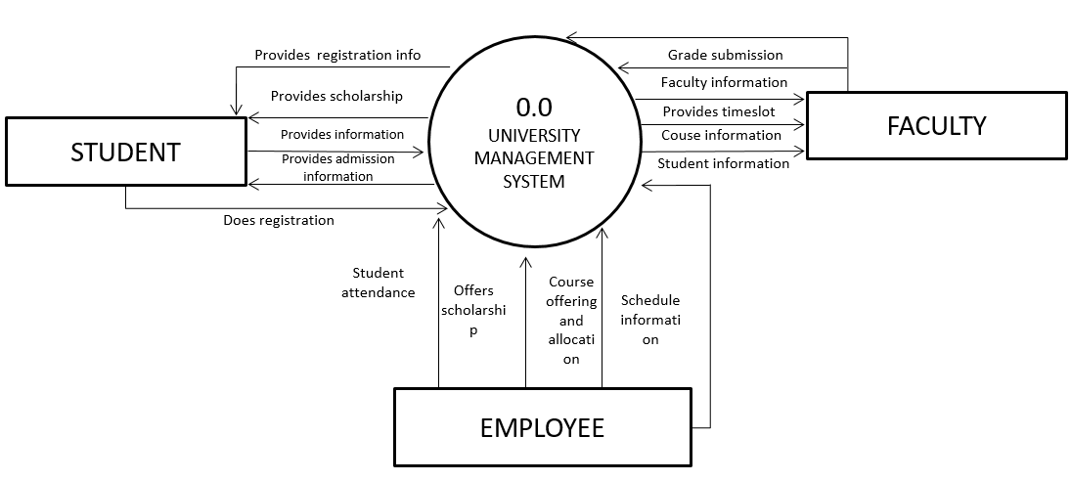 **Context Level Diagram (Logical Level View)**

Figure13: context Level Diagram

**Narration**:

From the top view of figure**,** students, faculties and employee like registrar interacts with the system. The students get their registration and payment information from the system. They do their registration process using the system. New students get admission information from the system and get admitted. Faculties get schedule information student information from the system and submit different course’s grade, faculty information into the system. They also give the online student attendance using the automated system. Registrar provides registration info, scholarship info and class schedule to the system.

**University Management System**

**Independent University, Bangladesh**

**Dataflow Diagram**

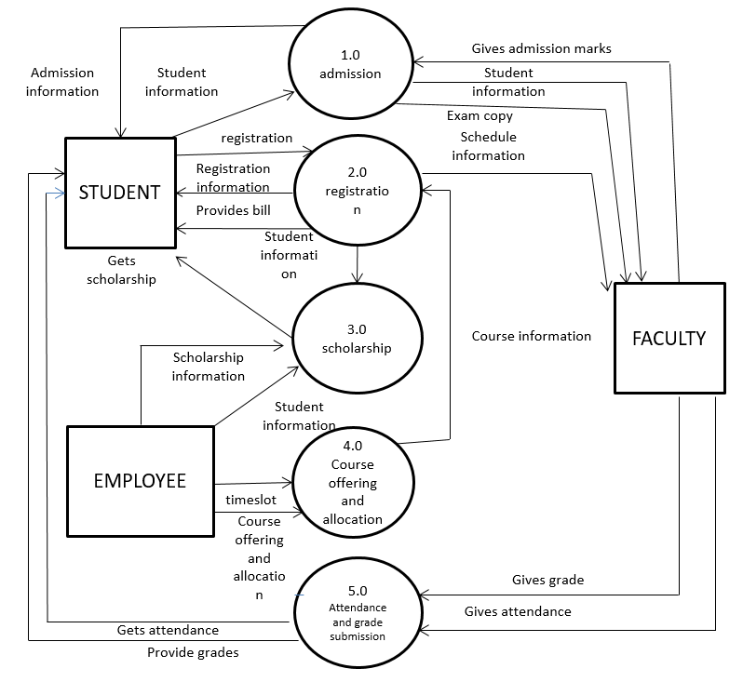 **Level 0 (System Level Diagram)**

Figure14: System Level Diagram

**Narration:**

From figure **14** students provide their information to the system and get all admission information from the system. Then the system provides student information to the faculties and the employees. Students get registration information, bills and faculty gets class schedule provided by the registration system. Registrar (employee) gives the list into the system of the scholarship students which is offered by the department. Faculties take student attendance using the system those who has registered, they offers and allocate courses to the system. Faculties submit student’s final grades into the system and students can see their grades from the system.

**Level 1.0 dfd**

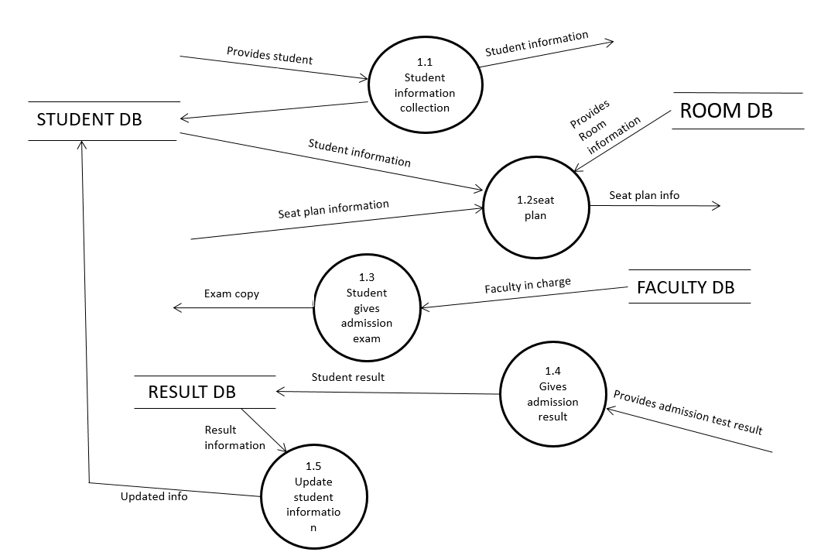

Figure15: System Level Diagram

**NARRATION:**

The actual data flow of admission process has shown in figure 15 admission system diagram. Here students provides their info to the system the info’s are used for their seat plans for exam. Room info’s are taken from the DB to plan seats according to department. Faculties are assigned as invigilator in different rooms faculty info’s are taken from the faculty db. Faculty submits the marks which is kept in the result db. Which is collected from the DB and provided to the candidate as result. The student who passed the exam their data are kept in the student database.

**Level 1.0 dfd**

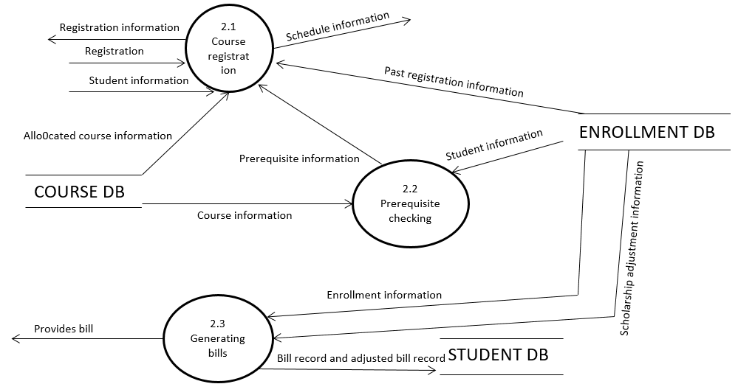

Figure16: System Level Diagram

**NARRATION:**

The actual data flow of registration process has shown in figure no 16

students registrar for different sections of course’s which has been offered and allocated by the department employees. Their enrollment information has been saved in the enrollment data table. If any course has any pre-requisite then that data will be saved in the course database. When the enrollment is done then the system will provide bill for the registration. If the student have any scholarship then the system will also adjust the bill.

**Level 1.0 dfd**

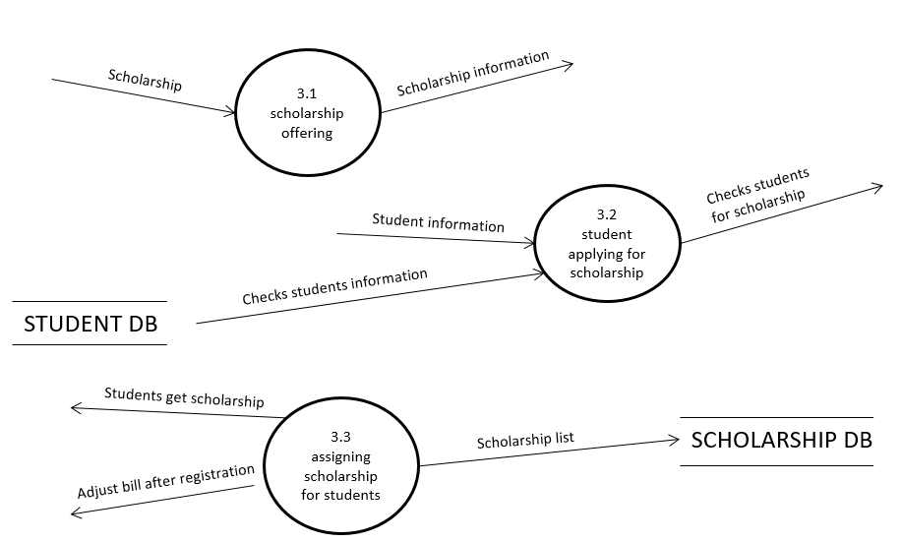

Figure17: System Level Diagram

**NARRATION:**

Figure no 17 shows the data flow of scholarship system process. Department offers different kind of scholarship to the students. Applied students information are kept in the database and hey. The employees collects the scholarship information from the database and checks them if they are qualified to get scholarship. They assign scholarship to the students. Bill adjustments are done during registration.

**Level 1.0 dfd(continued)**

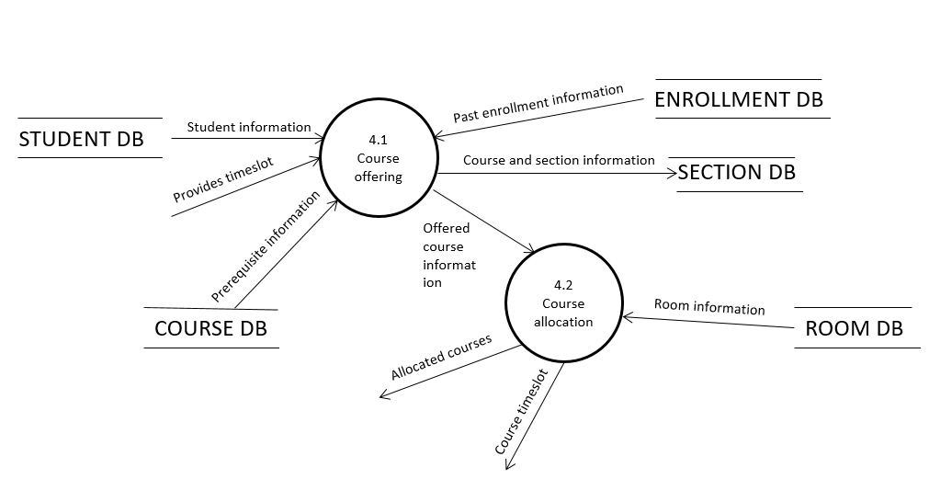

Figure18: System Level Diagram

**NARRATION:**

In Fig 08 for any courses to be offered the system needs to get the necessary information from the database. The system must get the student information, list of offered courses from the department, past enrollment information, prerequisites information, section information and schedule information from the database. The system provides the courses information for allocating courses. Faculties are involved in course allocation as they set the schedule for courses. Room information will be taken from room database.

Level 1.0 dfd(continued)

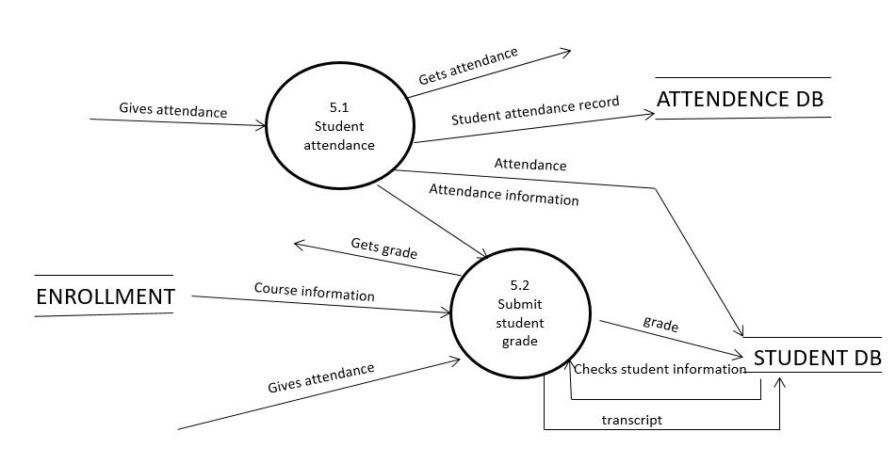

Figure19: System Level Diagram

**NARRATION:**

Figure no 19 shows the data flow of online attendance system. The students who have registered in different courses must attend class to give their attendance. Faculty will take the attendance using the system. The attendance data will be saved in the database. The students who enrolled in different courses sits in exam hall for different examination. Faculties checks their scripts and submits their grades into the system beside that student’s and course information. The attendance carries marks. So when faculties submit grades they get attendance from database. Their grades are stored in the enrollment database. Students can check their grades using the system.

**FUNCTIONAL DEPENDENCIES**

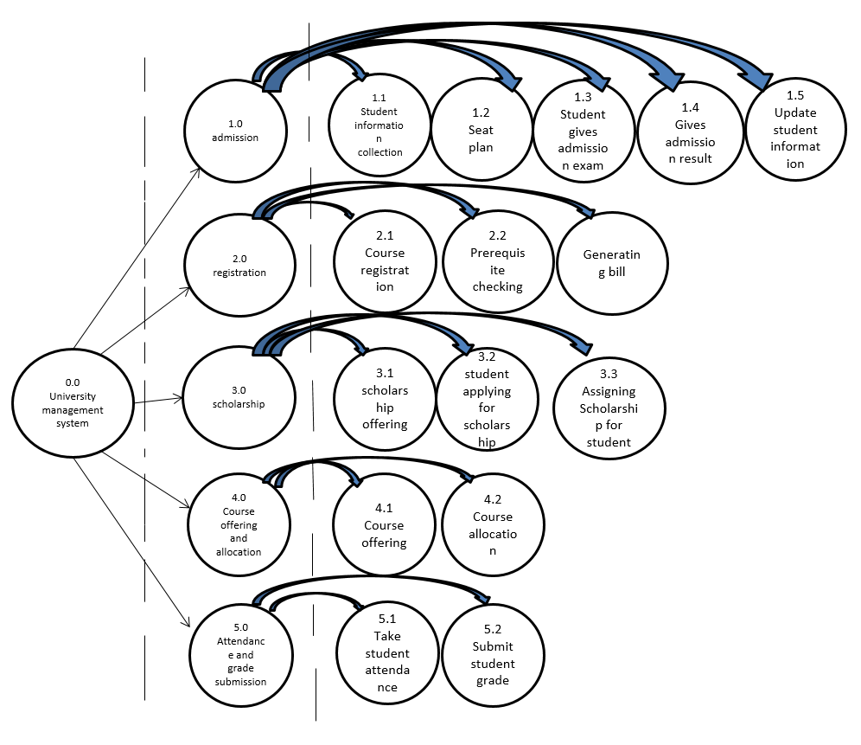

Figure20: Functional Dependencies