**ALMS**

**(Automated Loan Management System)**

**By**

**1 MMR**

1410617

saif kaisar

1530853

ajmal amir ashik

1430947

Md. Aminur rahman

1210762

noor mohammad dil



**INDEPENDENT UNIVERSITY, BANGLADESH**

**April, 2018**

**Supervisor: Radiah rose haque,faculty,cse.**

All rights reserved. This work may not be

reproduced in whole or in part, by photocopy

or other means, without the permission of the author.

© 1 MMR 2018

**Approval**

This report entitled

ALMS

by

1 MMR

has been approved by

Instructor of Database Management Course The Department of Computer Science and Engineering, Independent University, Bangladesh.

(Sign)

Instructor:Radiah rose haque, Asst. Professor, CSE

The final copy of this report has been examined by the signatory and we find that both the content and the form meet acceptable presentation standards of scholarly work in the above-mentioned discipline.



**ORIGINALITY STATEMENT**

I hereby declare that this submission is my own work and to the best of my knowledge it contains no materials previously published or written by another person, or substantial proportions of material which have been accepted for the award of any other degree or diploma at IUB or any other educational institution, except where due acknowledgement is made in the report. Any contribution made to the research by others, with whom I have worked at IUB or elsewhere, is explicitly acknowledged in the report. I also declare that the intellectual content of this report is the product of my own work, except to the extent that assistance from others in the project's design and conception or in style, presentation and linguistic expression is acknowledged.

1410617 saif kaisar

1430947 md. aminur rahman

1530853 ajmal amir ashik

1210762 noor mohammad dil



**ACKNOWLEDGEMENT**

saif kaisar

aminur rahman

ajmal amir ashik

noor mohammad dil

**Reference:**

[*www.sreda.gov.bd/*](http://www.sreda.gov.bd/)

[*www.idcol.org*](http://www.idcol.org)

*www.idcol.org*

**Appendix** (To reduce the size of the main report an extension of the report is given in this area. The main report should refer to this area. The part that is so important that you can’t exclude it from the report neither can include in the main part is normally placed in this section.)

**BACKGROUND OF THE PROJECT**

The primary aspect of this project is to construct a loan appraisal software which will allow proponents to request and getting loan from a non-bank financial institution which in this project is Infrastructure Development Company Limited (IDCOL) & Bangladesh Infrastructure Finance Fund Limited (BIFFL). Sustainable and Renewable Energy Development Authority (SREDA) is also working alongside to check the eligibility of the equipment. Using this software, a proponent can request for a loan under certain criteria from the financial institution and financial institution will check all legal details about the proponent and finally they will take decision whether to accept the loan request or reject the loan request. Financial institutions will face an enormous challenge if the procedures are done manually which prevents loans from closing on schedule. An automated system is a solution, which allows these organizations to close loans in time, keep track of projects while eliminating the monotonous stream of manual data entry which can be error prone and costly.

In the automated system, a proponent will be able to collect and enquire about the loan using a website through internet. IFIs will be able to correspond with the proponent online. Starting from submitting the required form to receiving relevant letters every step will be done using this software. After submitting the equipment, SREDA will check the eligibility of the equipment and correspond with IFIs using the software. We will create a management information system (MIS) using RDBMS (MySQL) where we can save all the data of the proponent and the results after evaluating in each step. The proponent shall also be notified about the result via e-mail notification. The advantage that we would get by using MIS is immense. We can eliminate the possibility of receiving duplicate application, easier to track down precedence cases which will be highly beneficial for the IFI. Searching submitted forms and analyzing them will become easier and employees will be able to get their work done more efficiently. Record keeping, tracking and storing reports on individual cases will become possible for IFI and SREDA.

The intention of this project is to replace conventional record framework with new mechanized framework with database which will decrease time, expenses and increment productivity and easy to understand.

**BACKGROUND OF THE ORGANIZATION**

There are basically three associations working for the project. They are:

1. Sustainable and Renewable Energy Development Authority (**SREDA**) as the administrative authority;
2. Infrastructure Development Company Limited (**IDCOL**) as an implementing financial institution (IFI), and;
3. Bangladesh Infrastructure Finance Fund Limited (**BIFFL**) also as an IFI.

**SREDA**



SREDA (Sustainable and Renewable Energy Development Authority) is the administrative authority which decrees the contribution of energy management to the demand side through the supply of loans with low interest. SREDA is now working under Power Division of the Ministry of Power, Energy and Mineral Resources of the Government of the People's Republic of Bangladesh as a coordination body for the development of the renewable energy.

**VISION**

SREDA encourages sustainable energy and helps to construct an energy efficient nation to ensure responsible energy usage and to reduce carbon footprint.

**MISSION**

Arrange and encourage the advancement of sustainable power source and vitality effectiveness-

* To build the offer of sustainable power source in the vitality blend for lessening reliance on petroleum derivative
* Take appropriate measures for energy saving
* Assess continuously for new potential sustainable energy solutions.

**GOAL**

In accordance with vision and mission, SREDA sets the accompanying goals-

* Increment Renewable Energy generation
* Decrease dependency on fossil fuels

**OBJECTIVE**

1. The renewable energy share will be increased to 10%, which will be 2000 MW by 2020 and 4000 MW by 2030
2. The energy saving will be 10% by 2020 and 15% by 2030 of total energy consumption.

**ORGANOGRAM**

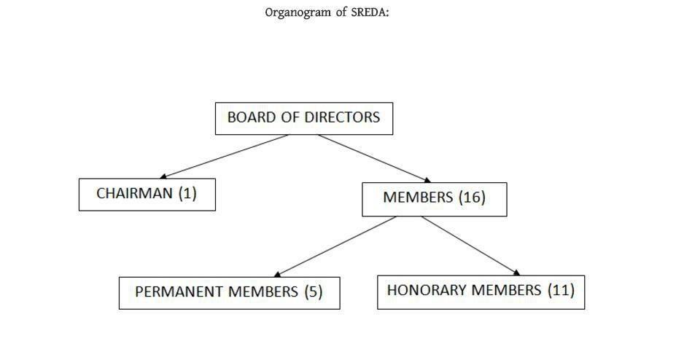

As per SREDA Act- 2012 the functions of the Authority, broadly are as follows:

* coordinate renewable energy and energy efficiency issues of the government.
* promote sustainable energy.
* standardize and labialize the products for RE and EE.
* pilot modern technologies and take initiatives for its expansion.
* create congenial environment for the investors.
* research and development on RE and EE.
* capacity development.
* create awareness for RE and EE and
* establish linkage with regional and international organizations.

The Organizational Structure of SREDA

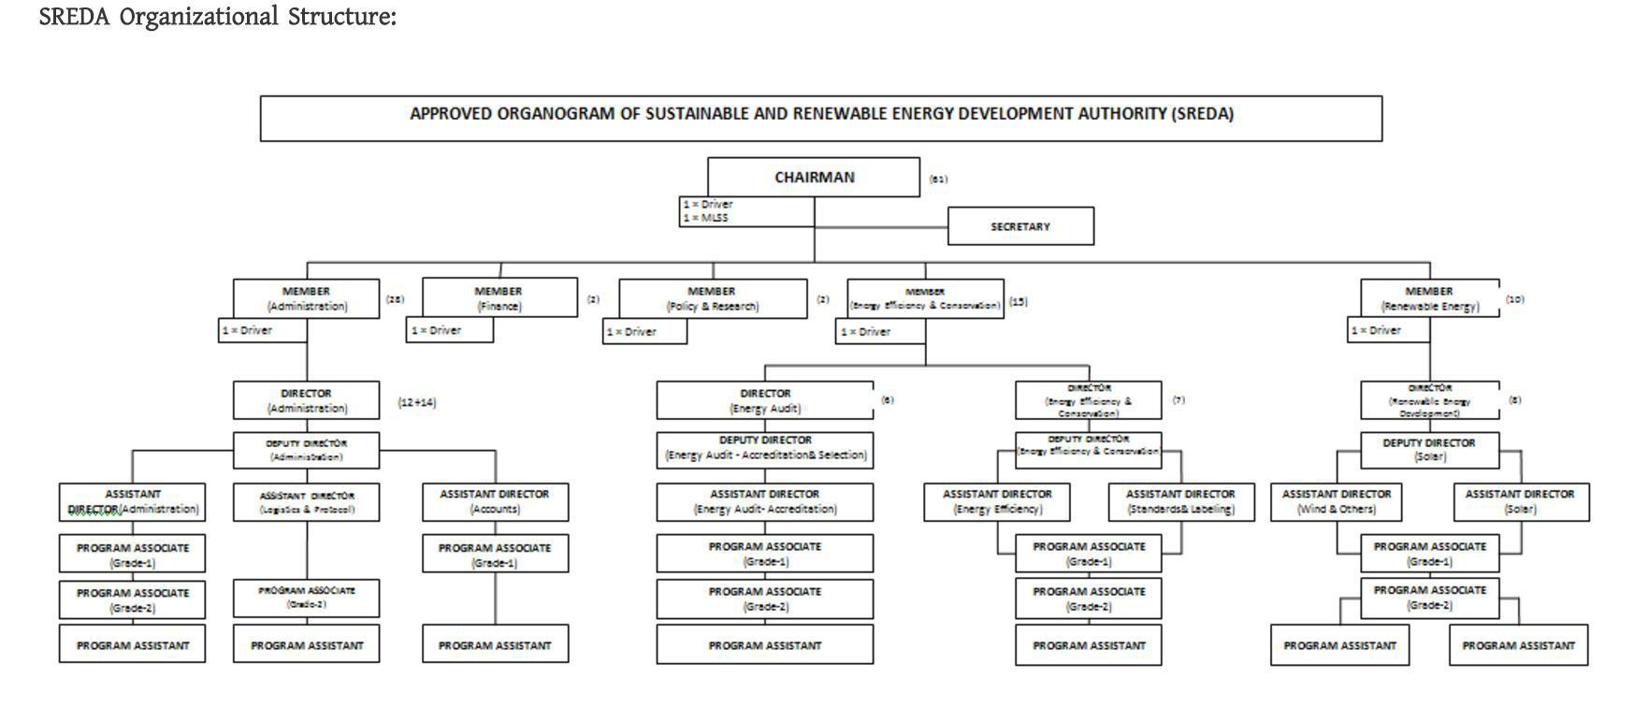

**IDCOL**



Infrastructure Development Company Limited (IDCOL) was established on 14 May 1997 by the Government of Bangladesh. The Company was licensed by the Bangladesh Bank as a non-bank financial institution (NBFI) on 5 January 1998. Since its inception, IDCOL is playing a major role in bridging the financing gap for developing medium to large-scale infrastructure and renewable energy projects in Bangladesh. The company now stands as the market leader in private sector energy and infrastructure financing in Bangladesh.

IDCOL is managed by an eight-member independent Board of Directors comprising four senior government officials, three representatives from the private sector and a full time Executive Director and Chief Executive Officer. It has a small and multi-skilled work force comprising financial and market analysts, engineers, lawyers, IT experts, accountants and environmental and social safeguard specialists. IDCOL's stakeholders include the government, private sector, NGOs, multilateral and bilateral institutions, academics and the people of Bangladesh at large.

**VISION**

To guarantee financial advancement of the nation and enhance way of life of the general population through economical and condition well-disposed speculations.

**MISSION**

The mission of IDCOL is to catalyze and optimize private sector participation in advancement, improvement, and financing of infrastructure and in addition sustainable power source and vitality effective tasks in a feasible way through open private-association activities.

**GOAL**

* Increment ideal of private segment's interest in the improvement, advancement and financial support of green infrastructure.
* Increment circulation and utilization of Energy efficient equipments and projects.

* Sort out private segment's support of joint activities made by public-private associations.
* Guaranteeing financial improvement of the nation by ntroducing sustainable & environment-friendly investments.

**OBJECTIVES**

* Catalyze and streamline private division's cooperation in the joint endeavors of public-private organizations supporting sustainable power source.
* Expanding advancement and financial development of the nation.
* IDCOL supplements the Government's goal of creating five percent of the nation's total electricity from renewable sources by 2015 and 10 percent of the total electricity from renewable energy by 2021.

**ORGANOGRAM**

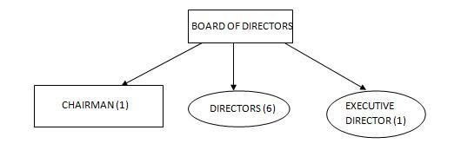

**BIFFL**



Bangladesh Infrastructure Finance Fund Limited (BIFFL) is a Government-owned Non-Banking Financial Institution, operating since 2011. It was built up to address the significance and earnestness of putting resources into the frameworks of the nation. Service of Finance is the key investor of the organization. Update of the organization permits to incorporate private accomplices later on.

BIFFL imagines drawing in private venture from nearby and outside speculators and to put resources into organizations that are actualizing foundation extends in Bangladesh. BIFFL is likewise dedicated to secure condition. Green economy and eco-accommodating measures are our chief need while considering any venture bargain.

**VISION**

Increasing speed of monetary development by utilizing relative qualities of Public and Private Sector through financing Infrastructure Projects.

**MISSION**

* To execute as an expert Financial Institution by receiving the universally acknowledged prescribed procedures and keeping up largest amount of good and moral models.
* To advance Country's financial improvement by encouraging and empowering Private Sector Investment in all framework ventures.
* To support sustainable economic growth of Bangladesh through facilitating Infrastructure Development.

**GOAL**

* Providing long-term finance to critically important infrastructure projects.
* Catalyze co-financing from private financial sources.

* Providing a unique vehicle for capital market development by exploring a number of avenues to capture domestic and foreign investment within the contexts of a robustly designed and well-governed investment vehicle.

**OBJECTIVES**

* To advance, empower and fund Private Sector Investment in all framework part.
* To broaden financing facilities for the infrastructure projects in the form of debt or equity.
* To draw in private interest in long term infrastructure projects: defeating the benefit obligation crisscross of existing bank fund.
* To create funds, sub-funds, including Islamic Funds, and any other type of Funds as deemed appropriate by the Company.

**ORGANOGRAM**

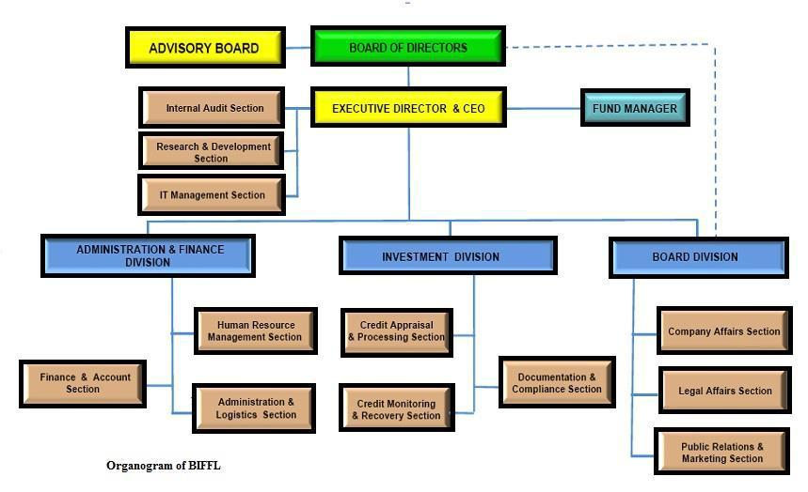

**OBJECTIVE OF THE PROJECT**

The main objectives of the project are given below:

* To record and deal with the advance of the project in MIS.
* The proposed system will also increase the efficiency of processes that financial institutions are doing while at the same time giving report shapes, asking the explanation for credit, submitting data filled structures, checking and assembling data.
* Rather than meeting face to face a few times and work physically, in the proposed system can be effectively done through composed way utilizing web as availability so versatility of working environment can be guaranteed keeping in mind the end goal to keep up productive utilization of time and vitality.
* To automate the loan to process it efficiently. Proponent can submit a loan request, get the confirmation message of loan request, interest to pay, due of payable amount through online.
* In existing system, it is conceivable to lose any records or receipt which may happen a major issue later, this issue can be tackled effortlessly through automation because in proposed automation system there will be a database for a client where his all information will be saved securely.

Overall the main objective of the project is to reduce workload, reduce time, saving money, reduce human paper work and store information about the loan projects proficiently without the danger of information misfortune and security loss.

**SCOPE OF THE PROJECT**

In this segment, we will portray the targets of the project extravagantly for better comprehension. As follows:

* Introducing an automated system which will be a web-based and desktop-based application.
* Proponent can enquire about the loan from the website and can fill up the necessary form needed to complete registration through online.
* Proponent can view the list for eligible Energy efficient equipment list for their benefit for applying for loans.
* Eligibility check list for the credits will be spared in the system for better assessment by the IFIs and SREDA.
* Approval or Rejection of Name Clearance can be done in this application. This will guarantee no loss of information, better assessment, proficient for choice improving and keeping track for the movement of the cases.
* Meeting with IFI’s will be notified by the system, furthermore if the meeting date is being canceled then notifying through the system. This system will permit the IFI and SREDA to tell the customers of their dismissal/acknowledgment of their cases(loan). What's more, if the case is rejected it will likewise tell the customer the explanation behind dismissal.
* This system will have isolate scrambled modules for managers, employees and Board of executives of IFI to assess, spare outcomes and tell the dismissal/acknowledgment of the loan cases. And, SREDA representatives, B.O.D will have the capacity to track the movement of the loan cases and track the activities for which loan has been granted.
* Scanned manual copies can be upload and all the record of the clients will be kept in the database as well. Disbursement and Repayment Status of the loan cases can be recorded and updated on monthly basis.

**EXISTING BUSINESS SYSTEM**

IFI fundamentally gives the loan and SREDA chooses if the proponent is qualified for the loan or not. The activity of SREDA is to look at the list of energy efficient equipment and to screen the task of the proponent after accepting the loan. Our activity is to computerize the framework where required and make it as productive as could be expected under the circumstances. The clients of our software are the proponents, IFI (Implementing financial institutions), SREDA (Sustainable and Renewable Energy Development Authority), PD (Participating distributor), JICA (Japan International Cooperation Agency) and also MPEMR (Ministry of Power, Energy and mineral Resources). Some portion of the existing system is pervaded with the danger of information misfortune resulting in huge economic loss for all the stakeholders participating.

**RICH PICTURE: FOR A-TYPE LOAN**

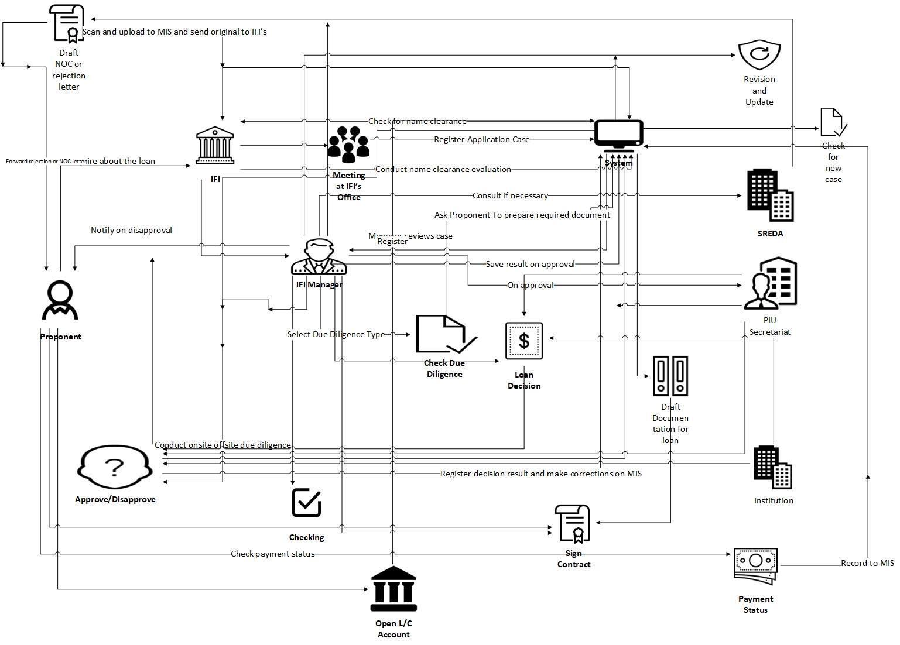

**PROCESS DIAGRAM (AS IS): FOR A-TYPE LOAN**

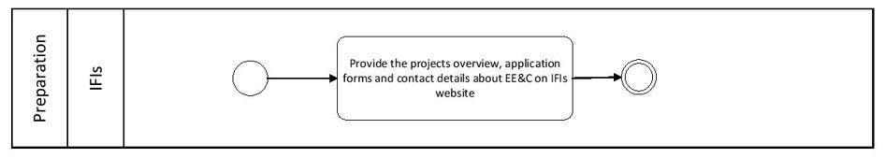

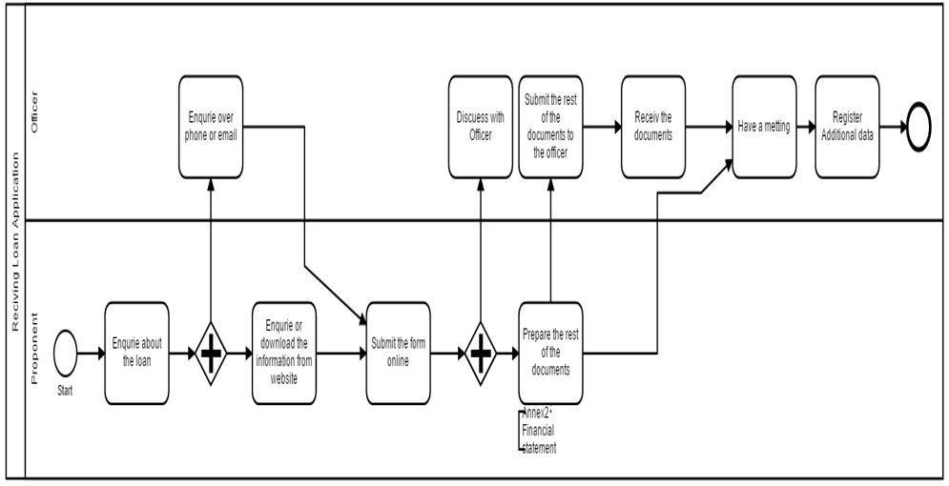

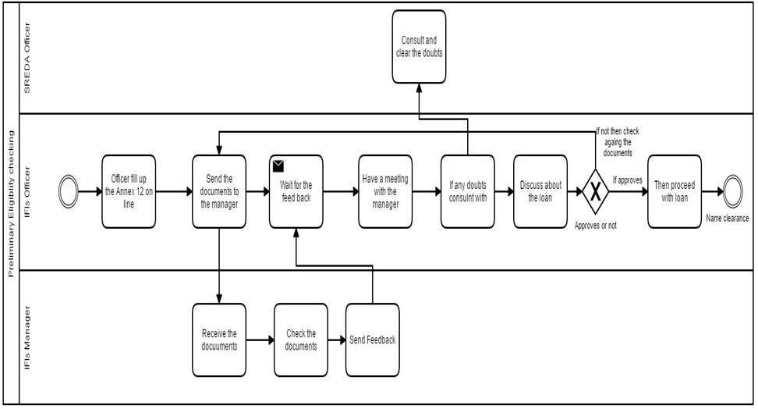

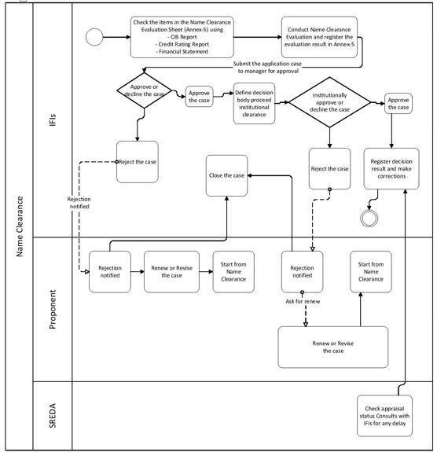

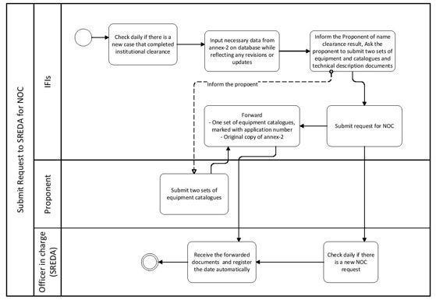

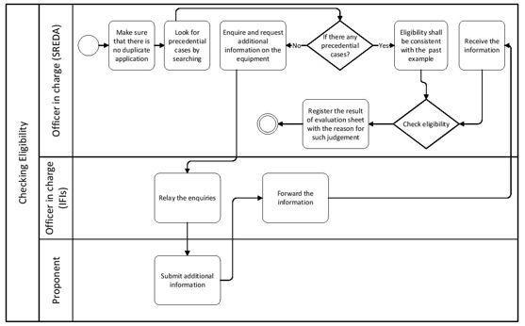

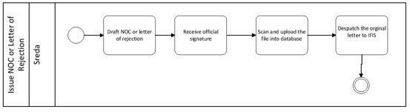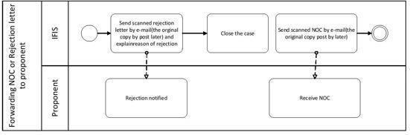

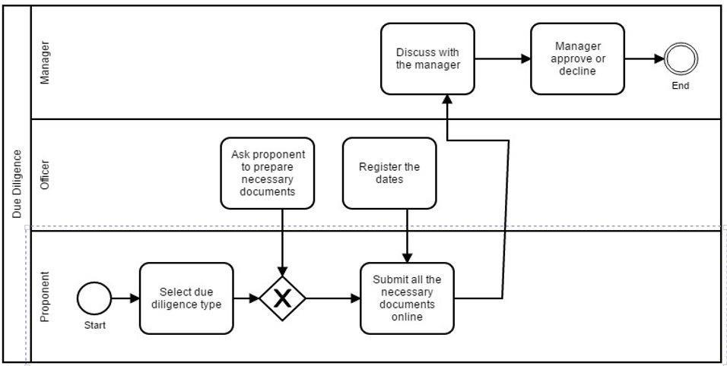

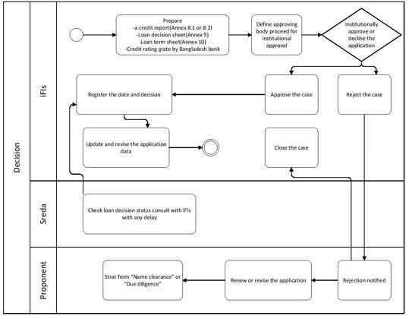

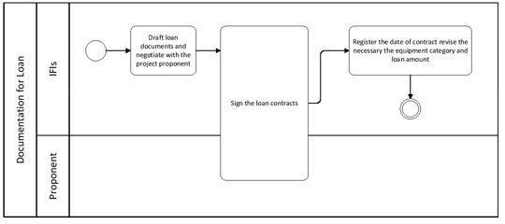

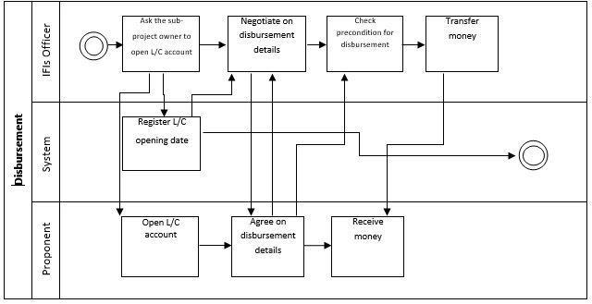

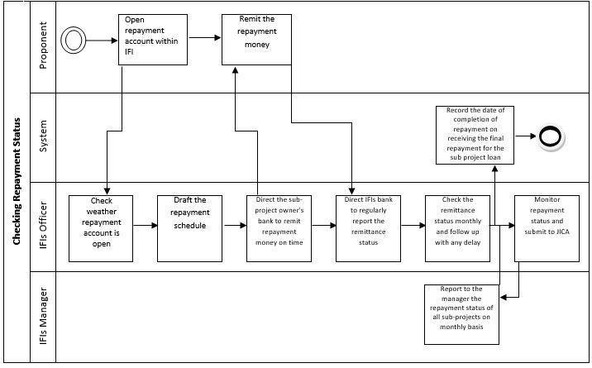

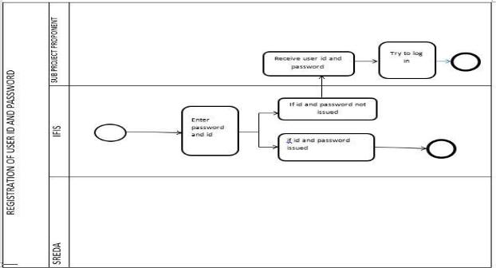

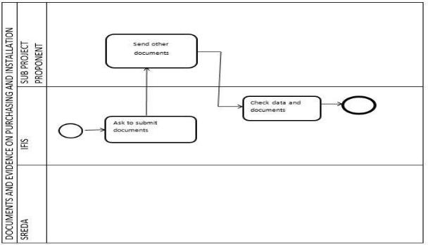

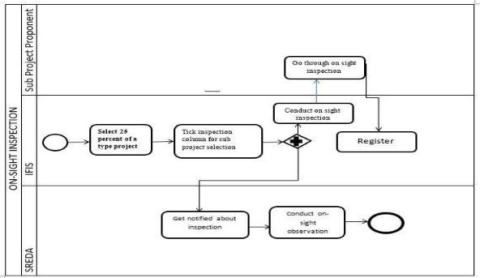

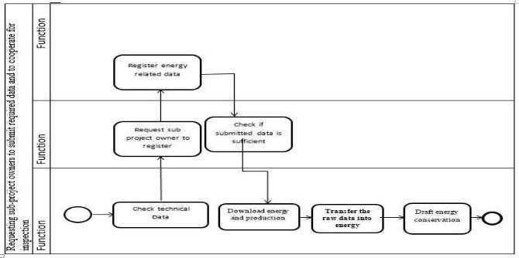

**PROCESS DIAGRAM (AS IS): FOR B-TYPE LOAN**

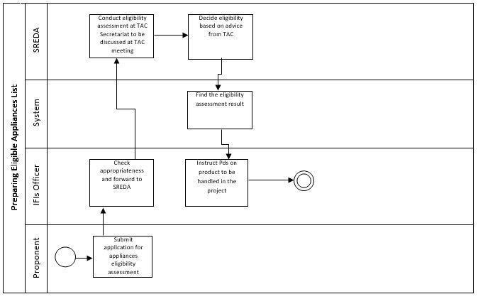

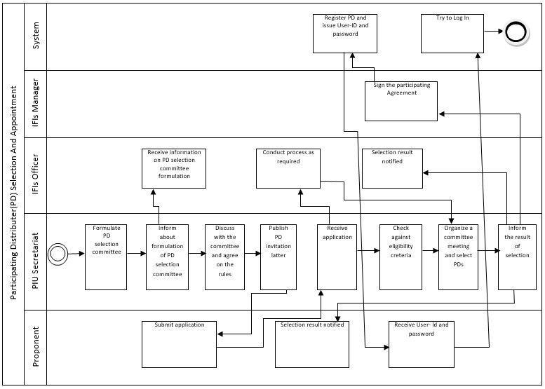

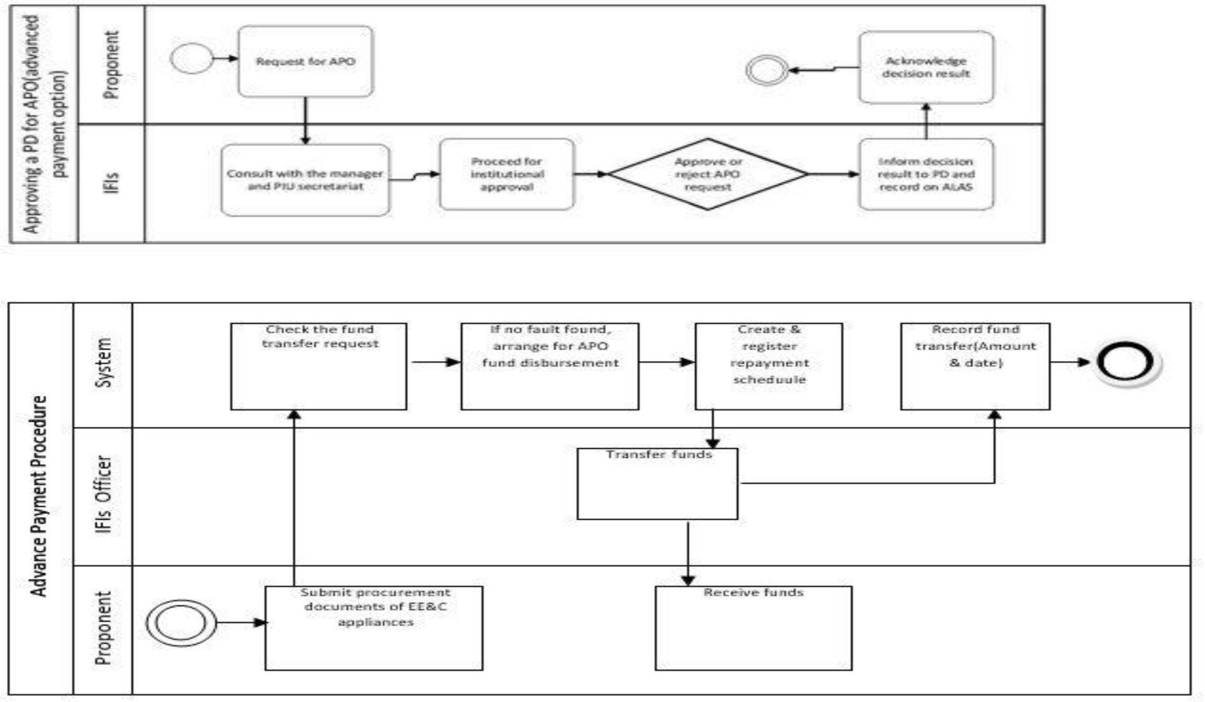

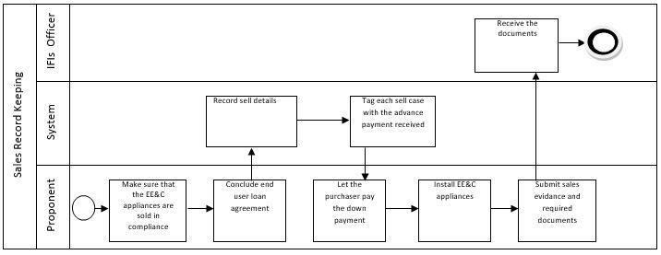

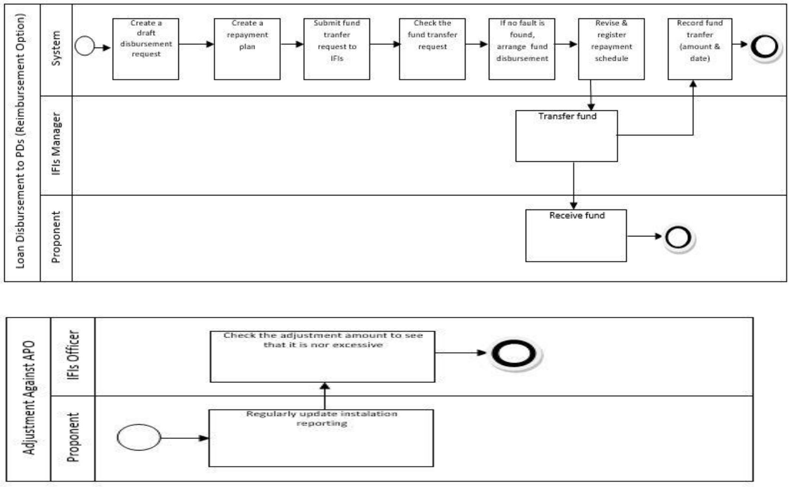

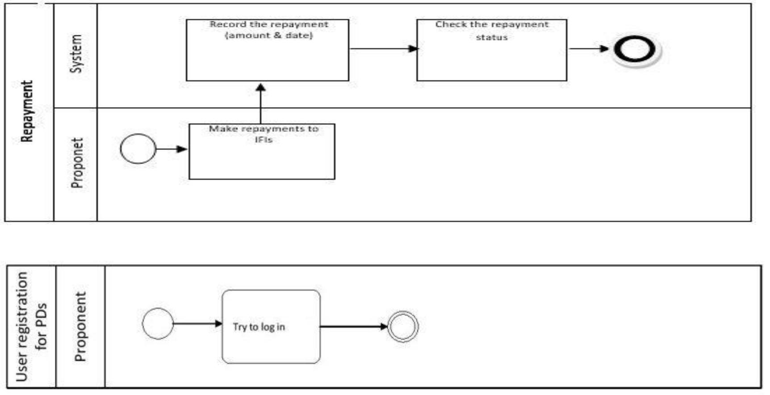

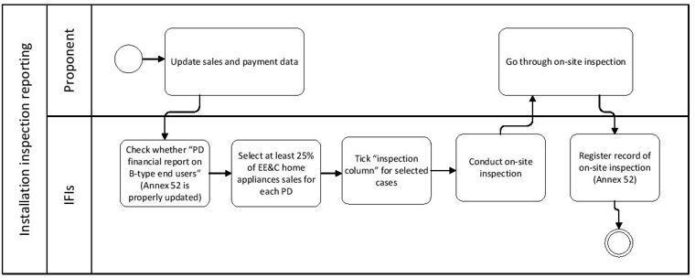

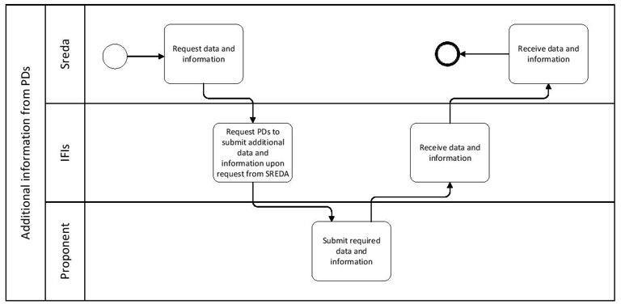

**TABLE: PROCESSES ALONG WITH EXISTING SIX ELEMENTS (A-TYPE LOAN)**

|  |  |  |  |  |  |  |
| --- | --- | --- | --- | --- | --- | --- |
| Process | Human | Non-computing hardware | Hardware | Software | Database | Connectivity |
|  |  |  |  |  |  |  |
| **Preparation** | IFI Employee (Provide application | _ | Computer | Browser | _ | Internet |
|  | forms on the IFI’s website) |  |  |  |  |  |
|  |  |  |  |  |  |  |
|  | Proponent (Submit the application | Financial Pre-screening |  |  |  |  |
|  | form) | Application (Annex 1) | Computer | MIS | _ | Internet/LAN |
| **Receiving Application** |  |  |  |  |  |  |
| **Form** | IFI Officer in Charge (Ask for the documents) | Technical Pre-screening | Scanner |  |  |  |
|  |  | Application (Annex 2) |  |  |  |  |
|  |  | Financial statements |  |  |  |  |
|  |  | Credit Rating Report |  |  |  |  |
|  | IFI Officer in Charge (Conduct the checking, |  |  |  |  |  |
|  | consult with the manager and save the | Eligible Technology & | Computer | MIS | _ | Internet/LAN |
| **Preliminary Eligibility** | checking result) | Equipment List (Annex 4) |  |  |  |  |
| **checking** |  |  | Printer |  |  |  |
|  | SREDA Officer in Charge (Provide | Eligibility Check Sheet |  |  |  |  |
|  | preliminary comments if required) | (Annex 12) | Scanner |  |  |  |
|  |  |  |  |  |  |  |



|  |  |  |  |  |  |  |
| --- | --- | --- | --- | --- | --- | --- |
|  | IFI Officer in Charge (Checks forms, |  |  |  |  |  |
|  | evaluation) | Name Clearance | Computer | MIS | _ | Internet/LAN |
| **Name Clearance** |  | Evaluation Sheet (Annex |  |  |  |  |
|  | IFI Manager (Approve/Decline the | 5) | Printer |  |  |  |
|  | case) |  |  |  |  |  |
|  |  | Credit Rating Report | Scanner |  |  |  |
|  | PIU Secretariat (Institutional Approval) |  |  |  |  |  |
|  |  | Financial Statement |  |  |  |  |
|  | Proponent (Get the result of the Name |  |  |  |  |  |
|  | Clearance Evaluation) |  |  |  |  |  |
|  | IFI Officer in Charge (Check for new |  |  |  |  |  |
|  | completed Institutional clearance, | Two set of equipment | Computer | MIS | _ | Internet |
| **Submit** | Retrieve information for NOC | catalogues (marked with |  |  |  |  |
| **request to** | submission) | application number) | Printer |  |  |  |
| **SREDA for NOC** |  |  |  |  |  |  |
|  | IFI Manager (Input necessary | Technical Pre-screening | Scanner |  |  |  |
|  | Information from Annex 2, Revisions & | Application Forms (Annex |  |  |  |  |
|  | updates) | 2) |  |  |  |  |
|  | Proponent (Submit two sets of | Equipment list (Annex 11) |  |  |  |  |
|  | equipment catalogues) |  |  |  |  |  |
|  | SREDA Officer in Charge (Checks for NOC |  |  |  |  |  |
|  | request, Receive Documents) |  |  |  |  |  |
|  |  |  |  |  |  |  |



|  |  |  |  |  |  |  |
| --- | --- | --- | --- | --- | --- | --- |
|  | SREDA Officer in Charge (Identify application | Technical Pre-screening |  |  |  |  |
|  | cases, Inquire about additional | Application Forms (Annex | Computer | MIS | _ | Internet |
| **Eligibility checking** | information of equipment, NOC letter | 2) |  |  |  |  |
|  | drafting /rejection letter) |  | Scanner |  |  |  |
|  |  | NOC request letter format |  |  |  |  |
|  | IFIs Officer in Charge (Forwarding documents) | (Annex 11) |  |  |  |  |
|  | Proponent (Provide information if | Eligible Technology & |  |  |  |  |
|  | required) | Equipment List (Annex 4) |  |  |  |  |
|  |  | Eligibility Check Sheet |  |  |  |  |
|  |  | (Annex 12) |  |  |  |  |
|  |  | Non-Objection Certificate |  |  |  |  |
|  | SREDA Officer in Charge (Evaluate decision | (Annex 101) | Computer | MIS | _ | Internet |
| **Issue NOC** | that has been approved by the Manager) |  |  |  |  |  |
|  |  | Letter of Rejection | Printer |  |  |  |
|  |  | (Annex 102) |  |  |  |  |
|  |  |  | Scanner |  |  |  |
|  |  |  |  |  |  |  |
|  | SREDA Officer in Charge (Request for |  |  |  |  |  |
|  | manager’s approval) | Scanned NOC | Computer | _ | _ | _ |
| **Issue Letter of rejection** |  |  |  |  |  |  |
|  | SREDA Officer in Charge (Dispatch the | Rejection Letter | Scanner |  |  |  |
|  | original letter to IFIs & Proponent) |  |  |  |  |  |
|  |  |  |  |  |  |  |



|  |  |  |  |  |  |  |
| --- | --- | --- | --- | --- | --- | --- |
|  | SREDA Officer in Charge (Calculating energy |  |  |  |  |  |
|  | efficiency conservation) | Application Forms (Annex | Computer | MIS | _ | Internet |
| **Energy conservation** |  | 2) |  |  |  |  |
| **estimation** |  |  | Scanner |  |  |  |
|  |  | MS Excel File |  |  |  |  |
|  |  |  |  |  |  |  |
|  | IFIs Officer in Charge (Sends scanned NOC or |  |  |  |  |  |
|  | rejection notice to Proponent) | Scanned NOC | Computer | MIS | _ | Internet |
| **Forwarding NOC/** |  |  |  |  |  |  |
| **Rejection letter to** | Proponent (Receives | Rejection NOC | Scanner |  |  |  |
| **proponent** | scanned NOC or rejection letter with | Letter |  |  |  |  |
|  | explanation) |  |  |  |  |  |
|  |  |  |  |  |  |  |
|  | IFI Officer in Charge (Conduct due diligence) | Due Diligence Type check |  |  |  |  |
|  |  | sheet (Annex 6) | Computer | MIS | _ | Internet |
| **Due diligence** | SREDA Officer in Charge (Check due |  |  |  |  |  |
|  | diligence status) | Required documents | Scanner |  |  |  |
|  |  | check sheet (Annex 7) |  |  |  |  |
|  | Proponent (Prepare required documents |  |  |  |  |  |
|  | and send documents) | Credit Report Element |  |  |  |  |
|  |  | sheet (Annex 8) |  |  |  |  |
|  |  |  |  |  |  |  |



|  |  |  |  |  |  |  |
| --- | --- | --- | --- | --- | --- | --- |
|  | IFI Officer in Charge (Create credit report, | Credit report |  |  |  |  |
|  | prepare loan decision sheet, discuss |  | Computer | MIS | _ | Internet |
| **Loan decision** | with manager, notify the PIU | Loan decision sheet |  |  |  |  |
|  | secretariat) |  | Printer |  |  |  |
|  |  | Loan term sheet |  |  |  |  |
|  | IFI Manager (Approve or Decline based |  | Scanner |  |  |  |
|  | on the documents submitted) | Credit rating rate by |  |  |  |  |
|  |  | Bangladesh bank |  |  |  |  |
|  | PIU secretariat |  |  |  |  |  |
|  | (Check all the necessary documents) | Rejection/Approval Letter |  |  |  |  |
|  |  |  |  |  |  |  |
|  | IFI Officer in Charge (Draft loan documents, |  |  |  |  |  |
|  | negotiate with the proponent and check | Loan Decision Documents | Computer | _ | _ | _ |
| **Documentation for loan** | the pre-condition) |  |  |  |  |  |
|  |  | Contract Signing | Printer |  |  |  |
|  | IFI Manager (Loan sanction granted | Documents |  |  |  |  |
|  | and signed by institutionally approved |  | Scanner |  |  |  |
|  | procedure) | Telephone |  |  |  |  |
|  |  | or Mobile |  |  |  |  |
|  | Proponent or Lawyer of Proponent (To |  |  |  |  |  |
|  | sign the contract) | Contact |  |  |  |  |
|  |  | Form |  |  |  |  |
|  | IFI Officer in Charge (Negotiate Disbursement, |  |  |  |  |  |
|  | Transfer money) | Account opening form | Computer | MIS | _ | Internet |
| **Disbursement** |  |  |  |  |  |  |
|  | Sub-project owner (open L/C account, | Documents (Negotiating | Printer |  |  |  |
|  | Negotiate Disbursement, receive | papers) |  |  |  |  |
|  | money) |  | Scanner |  |  |  |
|  |  |  |  |  |  |  |



|  |  |  |  |  |  |  |
| --- | --- | --- | --- | --- | --- | --- |
|  | IFI Officer in Charge (record the date of the |  |  |  |  |  |
|  | final disbursement) | PD’s Disbursement | _ | _ | _ | _ |
| **Completion of** |  |  |  |  |  |  |
| **Disbursement** | IFI Manager (check the disbursement |  |  |  |  |  |
|  | for the sub-project) |  |  |  |  |  |

|  |  |  |  |  |  |  |
| --- | --- | --- | --- | --- | --- | --- |
|  | IFI Officer in Charge (Monitor the repayment |  |  |  |  |  |
|  | Status, draft repayment schedule, |  | Computer | MIS | _ | Internet |
| **Checking repayment** | Submit Sub-Project Summary and | Papers of reports and |  |  |  |  |
| **status** | Financial Report Form to JICA) | repayment information | Printer |  |  |  |
|  | IFI Manager (Monitor repayment | Financial report Form | Scanner |  |  |  |
|  | status) | (Annex 367) |  |  |  |  |
|  | Sub-project owner (opens repayment |  |  |  |  |  |
|  | account with IFI, Remit the repayment |  |  |  |  |  |
|  | money) |  |  |  |  |  |
|  | IFI Manager (Prepare draft of A-type |  |  |  |  |  |
|  | loan application and sub-project | Report in form of Annex | Computer | _ | _ | _ |
| **Managing** | implementation plan, | 104 |  |  |  |  |
| **Implementation Plan** | Share sub-project implementation plan |  | Printer |  |  |  |
|  | with SREDA&JICA) |  |  |  |  |  |
|  |  |  | Scanner |  |  |  |





|  |  |  |  |  |  |
| --- | --- | --- | --- | --- | --- |
|  | IFI Officer in Charge (Registering the Proponent) |  |  |  |  |
|  |  | Computer | MIS | _ | Internet |
| **Registration of user ID** | Sub-project proponent (Acknowledge | Account opening form |  |  |  |
| **and password** | approval) |  |  |  |  |

|  |  |  |  |  |  |  |
| --- | --- | --- | --- | --- | --- | --- |
|  | Sub-project owner (Provide Documents | EE&C equipment |  |  |  |  |
|  | & evidences) | Purchasing and | Computer | MIS | _ | Internet |
| **Document & evidence** |  | Installation Status Form |  |  |  |  |
| **on purchasing and** | IFI Manager (Check & verify | (Annex 31) | Scanner |  |  |  |
| **installation** | documents) |  |  |  |  |  |
|  |  | Document & evidence |  |  |  |  |
|  |  | regarding purchase and |  |  |  |  |
|  |  | installation of equipment |  |  |  |  |
|  |  |  |  |  |  |  |
|  | IFI & SREDA Officer in Charge (Conduct |  |  |  |  |  |
|  | Onsite inspection) | EE&C Equipment | Computer | MIS | _ | Internet |
| **On-site inspection** | Sub-project owner (Cooperate with IFI, | Purchasing and |  |  |  |  |
|  | SREDA) | Installation Status Form |  |  |  |  |
|  |  | (Annex 31) |  |  |  |  |
|  | IFI Manager (Check that appropriate |  |  |  |  |  |
|  | selection is done for on-site inspection) | On-Site Physical |  |  |  |  |
|  |  | Inspection Report Form |  |  |  |  |
|  |  | (Annex 32) |  |  |  |  |





|  |  |  |  |  |  |  |
| --- | --- | --- | --- | --- | --- | --- |
| **Requesting sub project** | IFI Officer in Charge (request the sub-project |  |  |  |  |  |
| **owner to submit** | owners to register on Energy | Energy Efficiency Related | Computer | MIS | _ | Internet |
| **required data and to** | Efficiency Related Data Form) | Data Form (Annex 33) |  |  |  |  |
| **cooperate for** |  |  |  |  |  |  |
| **inspection** | Sub-project owners (Register Data) |  |  |  |  |  |
|  |  |  |  |  |  |  |
|  | PIU secretariat (Request to prepare an |  |  |  |  |  |
|  | Environmental and Social Performance | Environmental and Social | Computer | MIS | _ | Internet |
| **Environmental and** | Report) | Performance Report |  |  |  |  |
| **Social Performance** |  | (Annex 34) | Printer |  |  |  |
| **Report** | Environmental and Social |  |  |  |  |  |
|  | Considerations Officer (Prepare an |  | Scanner |  |  |  |
|  | Environmental and Social Performance |  |  |  |  |  |
|  | Report for SREDA & JICA) |  |  |  |  |  |
|  |  |  |  |  |  |  |
|  | PIU secretariat (Request Environmental |  |  |  |  |  |
|  | and Social Considerations Officer for | Environmental and Social | Computer | MIS | _ | Internet |
| **Environmental and** | an annual checking) | Management System |  |  |  |  |
| **Social Management** |  | (ESMS) Checklist (Annex | Printer |  |  |  |
| **System (ESMS)** | Environmental and Social | 39) |  |  |  |  |
| **Checklist** | Considerations Officer (Send an |  | Scanner |  |  |  |
|  | Environmental and Social Performance |  |  |  |  |  |
|  | Checklist to SREDA & JICA) |  |  |  |  |  |
|  |  |  |  |  |  |  |

**TABLE: Existing Problems & Analysis of the problem along with solution (A-TYPE LOAN)**

|  |  |  |  |  |
| --- | --- | --- | --- | --- |
| Process | Stakeholders | Problem | Analysis | Solution |
|  |  | Proponent needs to come to | No other way to get | All the necessary |
|  | Proponent | the office | information if proponent is | information can be |
| **Receiving loan** |  |  | not physically present. | filled through online. |
| **application** | IFI Officer in Charge | Manual submission |  |  |
|  |  | Chance of making mistake | No other way to submit the | Proponent don’t need |
|  |  | while filling forms | form. | to come to the office |
|  |  |  |  | for submission |
|  |  | Time consuming | IFI’s must expense a lot of |  |
|  |  |  | cost for annex sheets. | Editing is easy without |
|  |  |  |  | causing trouble. |
|  |  |  | Needs to be collected |  |
|  |  |  | manually. | Documents should be |
|  |  |  |  | available on the |
|  |  |  |  | website for download. |
|  |  |  |  |  |
|  | IFI Officer in Charge | Consulting with SREDA can | SREDA can be late due to | Check the eligibility |
| **Preliminary** |  | be time consuming | traffic or getting consultation | correctly then send it |
| **Eligibility checking** | SREDA Officer in Charge |  | date. | to the manager and |
|  |  |  |  | consult with the |
|  |  |  |  | SREDA officer over |
|  |  |  |  | the phone or through |
|  |  |  |  | email. |
| **Name clearance** | IFI Officer in Charge | Data loss | Manual Conduction of Name | Name Clearance |
|  |  |  | Clearance Evaluation might | Evaluation Sheet will |
|  | IFI Manager |  | result in loss of documents. | be an automated form |
|  |  |  |  | in our system. |
|  | PIU Secretariat |  |  |  |

|  |  |  |  |  |
| --- | --- | --- | --- | --- |
|  |  | Hectic transferring for Name | There is a lot of paper work | It is automated; |
|  |  | Clearance Evaluation Sheet | involved which will be a | therefore, paperwork is |
|  |  |  | hectic job to do. | reduced. |
|  |  | Browsing list daily is quite | Those cases that are done |  |
|  | IFI Officer in Charge | ambiguous. | with institutional decision on | Directly send the |
| **Submit request to** |  |  | name clearance are ready for | document to in charge |
| **SREDA for NOC** | IFI Manager | Wrong documents could be | NOC is difficult to identify | officer through online. |
|  |  | send for NOC. | from list daily and it might |  |
|  | Proponent |  | happen to send the wrong | Highly secure NOC |
|  |  | Duplication of | document. | uploaded in the web. |
|  | SREDA Officer in Charge | documents. |  |  |
|  |  |  | Proponent might submit the | Online verification |
|  |  |  | duplicate documents. | code for one member |
|  |  |  |  | to submitting |
|  |  |  |  | documents. |
|  |  |  |  | And duplicate cases |
|  |  |  |  | will be identified easily |
|  |  |  |  | with the NOC ID no |
|  |  |  |  | and Institution name. |
|  |  | Finding application cases is | Documents have to be | In our automation |
|  | SREDA Officer in Charge | tough and time consuming | checked one by one for NOC | system if there are any |
| **Eligibility Checking** |  |  | request which is hectic and | new application cases |
|  | IFIs Employee |  | time consuming. | arrived will be stored |
|  |  |  |  | into New NOC |
|  | Proponent |  |  | Request database. |
|  |  | Chance of not having | Annex-101 and Annex-102 | Annex-101 and |
|  | SREDA Officer in Charge | Annex-101 and Annex-102 | can be finished or formatting | Annex-102 it can be |
| **Issue NOC** |  | sheets. | again is complex for a busy | done through our |
|  |  |  | employee. | automation system |

|  |  |  |  |  |
| --- | --- | --- | --- | --- |
|  |  | Transferring troublesome for | Additional information and | Additional information |
|  | SREDA Manager | additional information and | approval decision result is | can be sent through |
| **Issue Letter of** |  | approval decision | troublesome because of | automation and |
| **rejection** |  |  | traffic. | approval decision will |
|  |  |  |  | be sent too. |
|  |  | Calculation on energy | For new installation where |  |
|  | SREDA Officer in Charge | efficiency &conservation | existing equipment data is not | Calculation can be |
| **Energy conservation** |  | data may go wrong | available, the comparison | done in our automated |
| **estimation** |  |  | shall be made with the | system and error can |
|  |  |  | standard baseline data on | be fixed without any |
|  |  |  | energy conservation | hesitation. |
|  |  |  | estimation sheet |  |
|  |  | IFIs will get original letter | SREDA will issue IFIs | IFIs should send the |
|  | IFIs Officer in Charge | from SREDA and then Scan | NOC/rejection letter through | proponent a text |
| **Forwarding NOC/** |  | it. After that they will send it | the system. IFIs will | message informing |
| **Rejection letter to** | Proponent | via email and post which | forward the letter to | about the date of |
| **proponent** |  | will take a lot of time. | proponents via email and | giving their decision. |
|  |  |  | also send a printed copy by |  |
|  |  | Make a schedule. | post. | An IFI Employee |
|  |  | Explanation for rejection. |  | should point out the |
|  |  |  |  | reason about rejecting |
|  |  |  |  | the NOC. |
|  |  |  |  |  |
| **Due diligence** | IFI Officer in Charge | Proponent need to go to the | The proponent must go to the | Proponent can fill-up |
|  |  | bank. | bank to get the necessary | the necessary form and |
|  |  |  | information about | submit it with |
|  | SREDA Officer in Charge | Must go in person for | documents. After collect, the | additional documents |
|  |  | discussion or meeting with | documents they must go to | using the system. |
|  | Proponent | the manager. | the bank again to submit the |  |
|  |  |  | documents. | The manager can |
|  |  |  |  | check the documents |

|  |  |  |  |  |
| --- | --- | --- | --- | --- |
|  |  | Preparing additional | They must discuss on this | online and approve or |
|  |  | documents can be late | issue with the manager of the | decline using the |
|  |  |  | bank. | system. |
|  |  |  | Manager must check and | Proponent will be able |
|  |  |  | select the approved | to submit them online |
|  |  |  | application. | without troubling of |
|  |  |  |  | traffic and lateness. |
|  |  |  | Proponent can be late for |  |
|  |  |  | submitting additional |  |
|  |  |  | documents with in time. |  |
|  | IFI Officer in Charge | Manually created credit | Preparing a manual credit | All the required |
| **Loan decision** |  | report and loan decision | report and loan decision sheet | documents and |
|  | IFI Manager | documents | is time consuming. | information will be |
|  |  |  |  | asked through |
|  | PIU secretariat | Must go in person for | Take manager’s schedule for | automation system |
|  |  | discussion or for meeting. | meeting which is time |  |
|  |  |  | consuming too. | Will be able to contact |
|  |  | Hand over all the necessary |  | with the manager for |
|  |  | documents to the PIU | Submitting all the necessary | meeting through |
|  |  | secretariat. | documents to the PIU | automation system. |
|  |  |  | secretariat which will take |  |
|  |  |  | time. | Will be able to contact |
|  |  |  |  | with the PIU |
|  |  |  |  | secretariat for submit |
|  |  |  |  | the documents through |
|  |  |  |  | automation system. |
| **Documentation for** |  | Contacting with wrong | Consulting with the | In proponent account, |
| **loan** | IFI Officer in Charge | proponent is a problem. | proponent or lawyer of | it will be asked to |
|  |  |  |  | contract with the |

|  |  |  |  |  |
| --- | --- | --- | --- | --- |
|  | IFI Manager | Must check all the pre- | proponent can be a wrong | proponent through the |
|  |  | condition manually. | person due to mistake. | system within less |
|  | Proponent or Lawyer of |  |  | time. |
|  | Proponent | Registering date problem | For this draft documents, |  |
|  |  |  | they must check all the | Can check |
|  |  |  | necessary precondition | precondition online |
|  |  |  | manually. | automatically within |
|  |  |  |  | less time. |
|  |  |  | Date for registering might be |  |
|  |  |  | a problem while if there a | Date will be registered |
|  |  |  | meeting with another | automatically by |
|  |  |  | proponent. | checking is there any |
|  |  |  |  | date already fixed or |
|  |  |  |  | not? |
|  |  | Lengthy process for asking | Proponent will be requested | Request can be done |
|  | IFI Officer in Charge | about L/C Account | by IFI Employee to open a | by automation system |
| **Disbursement** |  |  | L/C accounts via draft which | when previous |
|  | Sub-project owner |  | is always a lengthy process. | processed will be done |
|  |  | Lack of legal mortgage. |  | correctly consequently |
|  |  |  | Legal mortgage can be not | for opening L/C |
|  |  | Disbursement checking issue | check whether the IFI met | accounts. |
|  |  | problem | with the proponent sites. |  |
|  |  |  |  | If IFI visits the sites of |
|  |  |  | Disbursement checking have | proponent will be |
|  |  |  | completed or not is a problem | record the date and |
|  |  |  | due to not reminding the date. | some photographs. |
|  |  |  |  | Money transferring |
|  |  |  |  | date will be record by |
|  |  |  |  | automation. |

|  |  |  |  |  |
| --- | --- | --- | --- | --- |
|  |  |  |  | Disbursement checking |
|  |  |  |  | completion date will be |
|  |  |  |  | record while checked. |
| **Completion of** | IFI Officer in Charge | Record of the final | Record the date of the final | Recording can be done |
| **Disbursement** |  | disbursement can be get lost. | disbursement to mark the | through the automated |
|  | IFI Manager |  | completion of disbursement | system |
|  |  |  | from the IFI for the sub- |  |
|  |  |  | project. |  |
|  |  | Making repayment schedule is | Repayment schedule making | Account no. of bank |
|  | IFI Officer in Charge | a problem | might be wrong. IFI must | will be saved into the |
| **Checking repayment** |  | send a draft to proponent | IFI securely and |
| **status** | IFI Manager | Drafting about repayment |  | repayment schedule |
|  | schedule and remittance report | Bank have to remittance | will be created by |
|  |  | is lengthy process and quite | report about the payment | automatically |
|  |  | problematic. | status to the IFI’s on draft. | calculation. |
|  |  |  |  |
|  |  | Checking late payment and | Checking late payment and | IFI would be able to |
|  |  | calculating the charges is | send a mail or notice |
|  |  | calculating the charge can be |
|  |  | quite hard and lengthy | about the repayment |
|  |  | wrong. |
|  |  | process | schedule and Bank will |
|  |  |  |
|  |  |  |  | send the payment |
|  |  |  |  | status to IFI which will |
|  |  |  |  | auto deduct to the |
|  |  |  |  | Proponent payment |
|  |  |  |  | history. |
|  |  |  |  | If any extra charge |
|  |  |  |  | needed to calculate for |
|  |  |  |  | late payment will be |
|  |  |  |  | calculate and send to |

|  |  |  |  |  |
| --- | --- | --- | --- | --- |
|  |  |  |  | the Manager by |
|  |  |  |  | automation. |
| **Managing** |  | Preparing a draft of A-type | Preparing a draft following | Automated draft will |
| **Implementation Plan** | IFI Manager | loan application and sub- | given format in Annex 104 is | easy with up the |
|  |  | project implementation plan | quite tough. | process. |
|  |  | is lengthy. |  |  |
|  |  |  | Data might get lost | No chance of getting |
|  |  | Sharing the Sub-Project | sometimes | data loss |
|  |  | Implementation Plan with |  |  |
|  |  | SREDA & JICA might take |  |  |
|  |  | some time. |  |  |
| **Registration of user** | IFI Officer in Charge | Proponent comes to office | Proponent must come on | Complete registration |
| **ID and password** |  | physically. | registration time to submit | through online for |
|  | Sub-project proponent |  | registration form and waiting | login ID & password. |
|  |  |  | for login ID & Password. |  |
| **Document & evidence** | Sub-project owner | Carrying or sending EE&C | Submitting EE&C Equipment | EE&C Equipment |
| **on purchasing and** |  | Equipment Purchasing and | Purchasing and Installation | Purchasing and |
| **installation** | IFI Manager | Installation Status Form | Status Form (Annex 31) is | Installation Status |
|  |  | (Annex 31) is problematic. | problematic for sub-project | Form (Annex 31) can |
|  |  |  | owner while carrying. | be submit through |
|  |  |  |  | automation system. |
|  |  | For site inspection team | Team members should | Take some tests before |
|  | IFI & SREDA Officer in Charge | should be experienced | technically experience. | selecting the team |
| **On-site inspection** |  | otherwise owner will be on |  | members. |
|  | IFI Manager | problem. | Record of site-visit have to |  |
|  |  |  | save into the specific | All the records and |
|  |  | Saving the record of visit to | proponent list as photo album | videos/photos of site- |
|  |  | specific proponent is can be | or it can be done wrong for | visit can be save into |
|  |  | a problem | not selecting the original | specific proponent |
|  |  |  | proponent | database. |
|  |  |  |  |  |

|  |  |  |  |  |
| --- | --- | --- | --- | --- |
|  |  |  | Energy Efficiency Related | Energy Efficiency |
|  |  | Energy Efficiency Related | Data Form (Annex 33) filing | related Data Form |
| **Requesting sub** | IFI Officer in Charge | Data Form (Annex 33) | Submitting manually can | (Annex 33) can be |
| **project owner to** |  |  | have commonly error by | submitted through |
| **submit required data** | Sub-project owners | Submitting manually can be | human. | automation as online |
| **and to cooperate for** |  | mistake. |  | form and can be easily |
| **inspection** |  |  |  | edited. |
| **Environmental and** | PIU secretariat | Prepare an Environmental | On Quarterly basis, | An automated system |
| **Social Performance** |  | and Social Performance | Environmental and Social | can be easily send the |
| **Report** | Environmental and Social | Report (Annex 34) and | Performance Report (Annex | report to SREDA and |
|  | Considerations Officer | sending it is a lengthy | 34), need to be reported to | JICA within less time. |
|  |  | process. | SREDA and JICA. |  |





**RICH PICTURE: FOR B-TYPE LOAN**

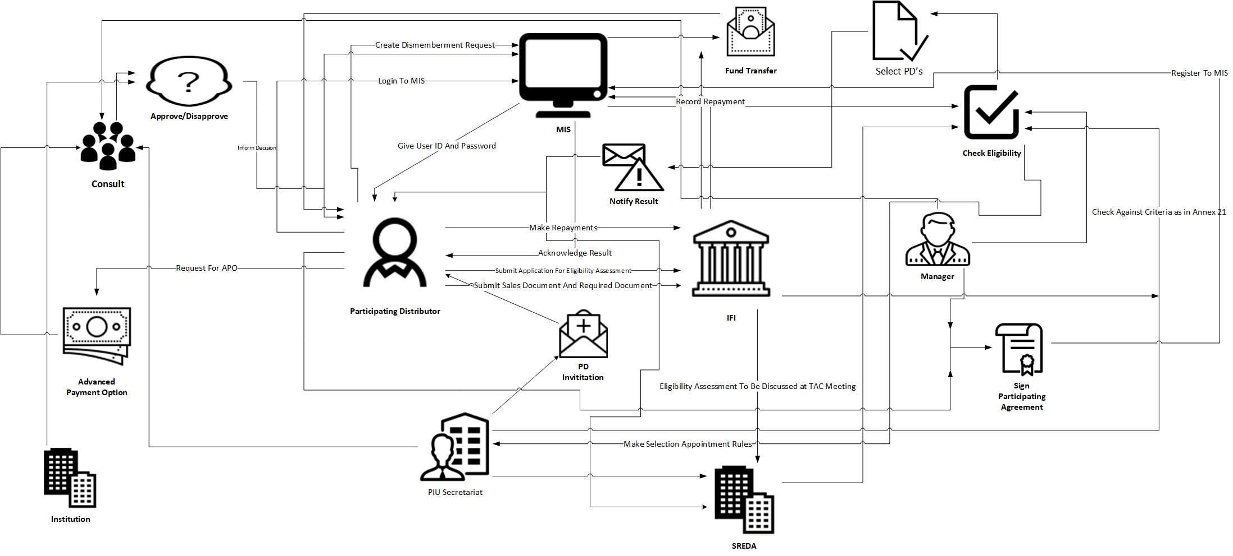



**TABLE: EXISTING PROCESSES ALONG WITH SIX SYSTEM ELEMENTS (LOAN TYPE B)**

|  |  |  |  |  |  |  |
| --- | --- | --- | --- | --- | --- | --- |
| Process | Human | Non-computing | Hardware | Software | Database | Connectivity |
|  |  | Hardware |  |  |  |  |
|  |  |  |  |  |  |  |
| **Preparing Eligible** | IFI Officer in Charge (Request PD to submit an | Application for |  |  |  |  |
| **Appliances List** | application for assessment of an appliances | assessment of an |  |  |  |  |
|  | model, Check the appropriateness of the | appliances model | Computer | MIS | _ | Internet |
|  | application for assessment of an appliances |  |  |  |  |  |
|  | model) |  |  |  |  |  |
|  | PD (Submit an application for assessment of |  |  |  |  |  |
|  | an appliances model) |  |  |  |  |  |
| **Participating Distributor** | Participant distributor (Send application, get | Eligibility Criteria for |  |  |  |  |
| **(PD) selection and** | notification, sign agreement) | PDs (Annex 21) |  |  |  |  |
| **appointment** |  |  | Computer | MIS | _ | Internet |
|  | PIU Secretariats(Check eligibility) | PDs list form (Annex |  |  |  |  |
|  |  | 22) |  |  |  |  |
|  |  | Participation |  |  |  |  |
|  |  | Agreement Template |  |  |  |  |
|  |  | (Annex 23) |  |  |  |  |
|  |  | Account opening forms |  |  |  |  |
|  |  | for PD’s |  |  |  |  |
| **Approving a PD for** | Participating Distributor (Submit | Application form |  |  |  |  |
| **APO** | application form) |  |  |  |  |
|  |  |  | Computer | MIS | _ | Internet |
|  |  | Annex 21(Check List) |  |  |  |  |
|  |  |  |  |  |  |  |

|  |  |  |  |  |  |  |
| --- | --- | --- | --- | --- | --- | --- |
|  | Officer in charge for Component III | Past track record of |  |  |  |  |
|  | (Consult with Manager and PIU Secretariat) | PD’s |  |  |  |  |
|  | PIU Secretariat (Check eligibility) |  |  |  |  |  |
|  | IFI Manager (Discuss with the PIU |  |  |  |  |  |
|  | secretariat and approve the PD’s APO |  |  |  |  |  |
|  | status) |  |  |  |  |  |
| **Advance payment** | Participant Distributor (Submits forms) | Procurement |  |  |  |  |
| **procedure** |  | documents of EE&C |  |  |  |  |
|  | Officer in charge for Component III (record | home appliances, | Computer | MIS | _ | Internet |
|  | data) | Application Form for |  |  |  |  |
|  |  | Advance Payment | EE&C |  |  |  |
|  | Manager(Checks request, Takes decision) | Option (Annex 26) | Appliances |  |  |  |
|  |  | PD’S disbursement and |  |  |  |  |
|  |  | repayment statement |  |  |  |  |
|  |  | (Annex 29) |  |  |  |  |
|  |  |  |  |  |  |  |
| **Sales record keeping** | Participating Distributor (keep all the sales | EE&C Home |  |  |  |  |
|  | information, check all sales details of | Appliances Purchasers’ |  |  |  |  |
|  | EE&C and record sales details on Annex27) | Screening Sheet | Computer | MIS | _ | Internet |
|  |  | (Annex 24), |  |  |  |  |
|  |  |  | EE&C |  |  |  |
|  |  | Stipulations in | Appliances |  |  |  |
|  |  | screening sheet |  |  |  |  |
|  |  | Sales Installation and |  |  |  |  |
|  |  | Inspection Record |  |  |  |  |
|  |  | Form (Annex 27) |  |  |  |  |

|  |  |  |  |  |  |  |
| --- | --- | --- | --- | --- | --- | --- |
| **Loan Disbursement to** | Officer in charge for Component III (keep | Annex 25 (Attachment |  |  |  |  |
| **PDs** | record of Annex 25 & 29, check the fund | List) |  |  |  |  |
|  | transfer requests from the PDs, submitting |  | Computer | MIS | _ | Internet |
|  | fund transfer request to the manager) | PD’s disbursement & |  |  |  |  |
|  |  | repayment statement |  |  |  |  |
|  | Manager (check the appropriateness for the | (Annex 29) |  |  |  |  |
|  | request form) |  |  |  |  |  |
| **Adjustment against** | Officer in charge for Component III | PD’s disbursement & |  |  |  |  |
| **APO** | (Adjustment is calculated by subtracting | repayment statement |  |  |  |  |
|  | tagged sales amount from the total | (Annex 29) | Computer | MIS | _ | Internet |
|  | repayment amount) |  |  |  |  |  |
|  |  |  |  |  |  |  |
| **Repayment** | Officer in charge for Component III (Check | PD’s disbursement & |  |  |  |  |
|  | the repayment status monthly on PD’s | repayment statement |  |  |  |  |
|  | disbursement & repayment statement | (Annex 29) | Computer | MIS | _ | Internet |
|  | (Annex 29) |  |  |  |  |  |
|  | Manager (For serious cases of delay |  |  |  |  |  |
|  | reported, consider applying non-compliance |  |  |  |  |  |
|  | clauses in the participation agreement) |  |  |  |  |  |
| **User registration for** | Officer in charge for Component III (Make | PDs list | Computer | MIS | _ | Internet |
| **PD’s** | sure that the PDs are issued with user-ID |  |  |  |  |  |
|  | and password) |  |  |  |  |  |
|  |  |  |  |  |  |  |

|  |  |  |  |  |  |  |
| --- | --- | --- | --- | --- | --- | --- |
| **Installation inspection** | Officer in charge for Component III | Annex 27 (Sales, |  |  |  |  |
| **reporting** | (request for additional docs) | Installation and |  |  |  |  |
|  |  | Inspection Record | Computer | MIS | _ | Internet |
|  | Participating Distributor(PD) | Form) |  |  |  |  |
|  | IFI Manager (for approval) |  |  |  |  |  |
|  | Officer for B-type loan monitoring (On-site |  |  |  |  |  |
|  | Inspection) |  |  |  |  |  |
| **Additional Information** | IFI Officer in Charge (request PD for additional |  |  |  |  |  |
| **from PD** | docs) | _ | _ | _ | _ | _ |
|  |  |
|  | Participating Distributor (to cooperate with |  |  |  |  |  |
|  | IFI) |  |  |  |  |  |
|  | SREDA Officer in Charge (Inspection and energy |  |  |  |  |  |
|  | audit) |  |  |  |  |  |

**TABLE: Existing Problems & Analysis of the problem along with solution (B-TYPE LOAN)**

|  |  |  |  |  |
| --- | --- | --- | --- | --- |
| Process | Stakeholders | Problem | Analysis | Solution |
|  | IFI Officer in Charge | _ | _ | _ |
| **Preparing Eligible** |  |  |  |  |
| **Appliances List** | Participating Distributor |  |  |  |
|  | SREDA PIU Secretariat |  |  |  |
| **PD Selection and** | IFI Officer in Charge | Time | PIU secretariat has to waste a | Application |
| **Appointment** |  | consuming | lot of time formulating the | distribution and |
|  | PIU Secretariat |  | PIU selection committee. | receiving them can be |
|  |  |  |  | done |
|  | IFI Manager |  |  | using the system. |
| **Approving A PD for** | IFI Officer in Charge |  |  |  |
| **APO** |  | _ | _ | _ |
|  | IFI Manager |  |  |  |
| **Advance Payment** | IFI Officer in Charge | _ | _ | _ |
| **Option(APO)** |  |  |  |  |
|  |  |  |  | Report will be saved |
|  | IFI Officer in Charge | Record keeping is lengthy | Redundant data may be | via automation, on |
| **Sales Record Keeping** |  | process. Non-efficient & | stored in MIS | Sales Installation and |
|  |  | Non-accurate. |  | Inspection Record |
|  |  |  |  | Form (Annex 27), each |
|  |  |  |  | case of EE&C home |
|  |  |  |  | appliances sales. |
|  |  |  |  | Regularly update the |
|  |  |  |  | Sales Installation and |
|  |  |  |  | Inspection Record |
|  |  |  |  | Form (Annex 27) on |
|  |  |  |  | automated software. |

|  |  |  |  |  |
| --- | --- | --- | --- | --- |
| **Loan Disbursement** | IFI Officer in Charge | PD’s need to go to the IFIs. | It is time consuming for PD’s | PD’s will find user |
| **To PD** |  | PD’s must give sales report | to go to the IFIs for user | agreement with EE&C |
|  | IFI Manager | manually. | agreement. | in this software. |
|  |  | Time consuming to track and | IFIs periodically must | All the sales record |
|  |  | observe. | observe the sales, installation | will be saved here for |
|  |  |  | and inspection record. | that IFIs can easily |
|  |  |  |  | observe sales. |
| **Adjustment Against** | IFI Officer in Charge | _ | _ | _ |
| **APO** |  |  |  |  |
| **Repayment** | IFI Officer in Charge | Time consuming. | Checking the repayment | Payment can be done online |
|  |  |  | statuses on a regular basis |  |
|  | IFI Manager |  | costs productive hours and |  |
|  |  |  | efforts |  |
| **User Registration For** | IFI Officer in Charge | _ | _ | _ |
| **PD** |  |  |  |  |
| **Installation** | IFI Officer in Charge | Time consuming | Updating data on MIS, | Report will be generated automatically |
| **Inspection Reporting** |  |  | checking all the criteria etc. |  |
|  | IFI Manager |  | takes valuable human |  |
|  |  |  | efforts and also slower when |  |
|  |  |  | done by humans |  |
| **Additional** | IFI Officer in Charge | Loss of information | There is a lot of paper work | PD can submit the form online, which saves time and paper work |
| **Information From PD** |  |  | involved which will be a |  |
|  | Participating Distributor |  | hectic job to do. |  |
|  | SREDA Officer in Charge |  |  |  |

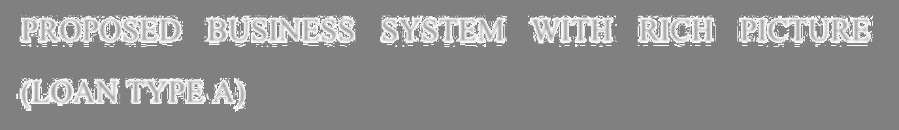

PROPOSED BUSINESS SYSTEM WITH RICH PICTURE (LOAN TYPE A)

In our proposed system, the Automated Loan Appraisal System (ALAS), we will have a database server, a web server. According to our system which will be a web based application, will be always connected to the servers. Firstly, IFIs uploads all the forms and relevant documents for proponent on the website. Proponents will download the initial forms and information from the website. After filling up the required forms, proponents will submit the form online and have a meeting with the IFIs officials using online video conferencing. Officer in charge of IFIs will register relevant data from the filled-up forms and records using the system. Then IFIs will conducts eligibility checking and records the result after providing preliminary comments to SREDA. IFIs then conducts the name clearance evaluation and records relevant data using database software. Proponents will be informed stating whether their application is approved or rejected. The results of the decision will be stored on the database using the software. IFIs officials keep checking if there is a new case that completed institutional clearance. After clearance, proponents will be informed of the result and asked to submit two sets of equipment catalogs and technical description document. After receiving the equipment catalogs IFIs will forward these equipment catalogs along with original copy of Annex 2 to SREDA. SREDA will revive the documents and record the date. SREDA then checks if there is any duplicated application. If there is a precedent case, eligibility shall be consistent with the past example. If there is no precedent case, refer to the eligible technology & equipment list. If any additional information is required, SREDA official will inform IFIs about it. Officer in charge will relay the request to the proponent. Proponent will submit additional to SREDA through IFIs. SREDA then will conduct eligibility checking and record the result. SREDA will then dispatch the original NOC/ Letter of rejection to IFIs. IFIs will forward the NOC/ Letter of rejection to the proponent by postage. Then project proponents will be asked to prepare required documents for IFIs to conduct off-site and on-site Due Diligence. Officer in charge registers records of due diligence using the software online. SREDA will check Due Diligence Status & consult with IFIs for any delay. IFIs will then prepare forms for loan decision and proceed for institutional approval. Proponents will be informed whether their application is approved or rejected. The results of the decision are stored on the database. SREDA checks loan decision status & consult with IFIs for any delay. IFIs then draft loan documents and negotiate with the project proponent. After signing the loan contracts officer in charge will register the date of contract revise equipment category & loan amount. IFIs will ask the sub proponent owner to open L/C account. After checking whether preconditions for disbursement are met, transfer money to proponent. Proponent will open repayment account within IFIs. IFIs monitors the repayment status Reflect it to Ongoing Sub-Project Summary and Financial Report Form and submit it to JICA on quarterly basis through mail. For verification & inspection proponents will be asked to submit Annex 31, Document & Evidences for purchasing & installing equipment. Officer in charge checks the data & documents submitted manually.

IFIs will conduct on-site inspection along with SREDA official present to conduct site observation. Officer in charge registers “On-site physical inspection report form”. Lastly, IFIs will request sub project owner to submit required data & to cooperate for inspection. Proponent will summit the document in hard copy to IFIs. After draft energy conservation report SREDA will then discloses it to public.



**TABLE: PROPOSED PROCESSES ALONG WITH SIX SYSTEM ELEMENTS (LOAN TYPE A)**

|  |  |  |  |  |  |  |
| --- | --- | --- | --- | --- | --- | --- |
| Process | Human | Non-computing | Hardware | Software | Database | Connectivity |
|  |  | Hardware |  |  |  |  |
|  |  |  |  |  |  |  |
| **Receiving Application** | Proponent (Submit the application form) | _ | Computer | ALMS | MySQL | Internet |
| **Form** |  |  |  |  |  |  |
|  |  |  |  | Browser |  |  |
|  |  |  |  |  |  |  |
| **Preliminary Eligibility** | IFI Officer in Charge (Conduct the checking, | Eligible Technology | Computer | ALMS | MySQL | Internet |
| **checking** | consult with the manager and save the | &Equipment List |  |  |  |  |
|  | checking result) | (Annex 4) |  |  |  |  |
|  | SREDA Officer in Charge (Provide preliminary | Eligibility Check Sheet |  |  |  |  |
|  | comments if required) | (Annex 12) |  |  |  |  |
| **Name clearance** | IFI Officer in Charge (Checks forms, evaluation) | Name Clearance | Computer | ALMS | MySQL | Internet |
|  | IFI Manager (Approve/Decline the case) | Evaluation Sheet |  | Browser |  | Email |
|  |  | (Annex 5) |  |  |  |  |
|  | PIU Secretariat (Institutional Approval) |  |  |  |  |  |
|  |  | Credit Rating Report |  |  |  |  |
|  | Proponent (Get the result of the Name |  |  |  |  |  |
|  | Clearance Evaluation) | Financial Statement |  |  |  |  |
| **Submit request to** | IFI Officer in Charge (Check for new completed | Two set of equipment | Computer | ALMS | MySQL | Internet |
| **SREDA for NOC** | Institutional clearance, | catalogues (marked |  |  |  |  |
|  |  | with application |  | Browser |  | Email |
|  | Retrieve information for NOC submission) | number) |  |  |  |  |
|  | IFI Manager (Input necessary Information | Technical Pre- |  |  |  |  |
|  | from Annex 2, Revisions & updates) | screening Application |  |  |  |  |
|  |  | Forms (Annex 2) |  |  |  |  |

|  |  |  |  |  |  |  |
| --- | --- | --- | --- | --- | --- | --- |
|  | Proponent (Submit two sets of equipment | Equipment list (Annex |  |  |  |  |
|  | catalogues) | 11) |  |  |  |  |
|  | SREDA Officer in Charge (Checks for NOC |  |  |  |  |  |
|  | request, Receive Documents) |  |  |  |  |  |
| **Eligibility checking** | SREDA Officer in Charge (Identify application | Technical Pre- | Computer | ALMS | MySQL | Internet |
|  | cases, Inquire about additional information | screening Application |  |  |  |  |
|  | of equipment, NOC letter drafting /rejection | Forms (Annex 2) | Phone | Browser |  | Email |
|  | letter) |  |  |  |  |  |
|  |  | NOC request letter |  | Skype |  |  |
|  | IFIs Officer in Charge (Forwarding documents) | format (Annex 11) |  |  |  |  |
|  | Proponent (Provide information if required) | Eligible Technology |  |  |  |  |
|  |  | &Equipment List |  |  |  |  |
|  |  | (Annex 4) |  |  |  |  |
|  |  | Eligibility Check Sheet |  |  |  |  |
|  |  | (Annex 12) |  |  |  |  |
| **Issue NOC** | SREDA Officer in Charge (Evaluate decision that | Non-Objection | Computer | ALMS | MySQL | Internet |
|  | has been approved by the Manager) | Certificate (Annex |  |  |  |  |
|  |  | 101) |  |  |  |  |
|  |  | Letter of Rejection |  |  |  |  |
|  |  | (Annex 102) |  |  |  |  |
| **Issue Letter of rejection** | SREDA Officer in Charge (Request for manager’s | Scanned NOC | Computer | ALMS | MySQL | Internet |
|  | approval) |  |  |  |  |  |
|  |  | Rejection Letter |  |  |  |  |
|  | SREDA Officer in Charge (Dispatch the original |  |  |  |  |  |
|  | letter to IFIs & Proponent) |  |  |  |  |  |

|  |  |  |  |  |  |  |
| --- | --- | --- | --- | --- | --- | --- |
| **Energy conservation** | SREDA Officer in Charge (Calculating energy | Application Forms | Computer | ALMS | MySQL | Internet |
| **estimation** | efficiency conservation) | (Annex 2) |  | Excel |  |  |
|  |  | MS Excel File |  |  |  |  |
|  |  |  |  |  |  |  |
| **Forwarding NOC/** | IFIs Officer in Charge (Sends scanned NOC or | Scanned NOC | Computer | ALMS | MySQL | Internet |
| **Rejection letter to** | rejection notice to Proponent) |  |  |  |  |  |
| **proponent** |  | Rejection NOC Letter |  |  |  | Email |
|  | Proponent (Receives scanned NOC or |  |  |  |  |  |
|  | rejection letter with explanation) |  |  |  |  |  |
| **Due diligence** | IFI Officer in Charge (Conduct due diligence) | Due Diligence Type | Computer | ALMS | MySQL | Internet |
|  |  | check sheet (Annex 6) |  |  |  |  |
|  | SREDA Officer in Charge (Check due diligence |  |  |  |  | Email |
|  | status) | Required documents |  |  |  |  |
|  |  | check sheet (Annex 7) |  |  |  |  |
|  | Proponent (Prepare required documents and |  |  |  |  |  |
|  | send documents) | Credit Report Element |  |  |  |  |
|  |  | sheet (Annex 8) |  |  |  |  |
| **Loan decision** | IFI Officer in Charge (Create credit report, prepare | Credit report | Computer | ALMS | MySQL | Internet |
|  | loan decision sheet, discuss with manager, |  |  |  |  |  |
|  | notify the PIU secretariat) | Loan decision sheet |  |  |  | Email |
|  | IFI Manager (Approve or Decline based on | Loan term sheet |  |  |  |  |
|  | the documents submitted) |  |  |  |  |  |
|  |  | Credit rating rate by |  |  |  |  |
|  | PIU secretariat (Check all the necessary |  |  |  |  |  |
|  | documents) | Bangladesh bank |  |  |  |  |
|  |  | Rejection/Approval |  |  |  |  |
|  |  | Letter |  |  |  |  |
| **Documentation for loan** | IFI Officer in Charge (Draft loan documents, | Loan Decision | Computer | ALMS | MySQL | Internet |
|  | negotiate with the proponent and check the | Documents |  |  |  |  |
|  | pre-condition) |  |  |  |  | Email |
|  |  |  |  |  |  |  |

|  |  |  |  |  |  |  |
| --- | --- | --- | --- | --- | --- | --- |
|  | IFI Manager (Loan sanction granted and | Contract Signing | Telephone |  |  |  |
|  | signed by institutionally approved | Documents | or Mobile |  |  |  |
|  | procedure) |  |  |  |  |  |
|  | Proponent or Lawyer of Proponent (To sign |  |  |  |  |  |
|  | the contract) |  |  |  |  |  |
| **Disbursement** | IFI Officer in Charge (Negotiate Disbursement, | Account opening form | Computer | ALMS | MySQL | Internet |
|  | Transfer money) |  |  |  |  |  |
|  |  | Documents |  |  |  | Email |
|  | Sub-project owner (open L/C account, | (Negotiating papers) |  |  |  |  |
|  | Negotiate Disbursement, receive money) |  |  |  |  |  |
| **Completion of** | IFI Officer in Charge (record the date of the final | PD’s Disbursement | Computer | _ | _ | Internet |
| **Disbursement** | disbursement) | List |  |  |  |  |
|  |  |  | Browser |  |  |  |
|  | IFI Manager (check the disbursement for |  |  |  |  |  |
|  | the sub-project) |  |  |  |  |  |
| **Checking repayment** | IFI Officer in Charge (Monitor the repayment | Papers of reports and | Computer | ALMS | MySQL | Internet |
| **status** | Status, draft repayment schedule, | repayment information |  |  |  |  |
|  |  |  |  | Microsoft |  | Email |
|  | Submit Sub-Project Summary and Financial | Financial report Form |  | Excel |  |  |
|  | Report Form to JICA) | (Annex 367) |  |  |  |  |
|  | IFI Manager (Monitor repayment status) |  |  |  |  |  |
|  | Sub-project owner (opens repayment |  |  |  |  |  |
|  | account with IFI, Remit the repayment |  |  |  |  |  |
|  | money) |  |  |  |  |  |
| **Managing** | IFI Manager (Prepare draft of A-type loan | Report in form of | Computer | ALMS | MySQL | Internet |
| **Implementation Plan** | application and sub-project implementation | Annex (104) |  |  |  |  |
|  | plan, Share sub-project implementation |  |  |  |  | Email |
|  | plan with SREDA&JICA) |  |  |  |  |  |

|  |  |  |  |  |  |  |
| --- | --- | --- | --- | --- | --- | --- |
| **Registration of user ID** | IFI Officer in Charge (Registering the Proponent) | Account opening form | Computer | ALMS | MySQL | Internet |
| **and password** |  |  |  |  |  |  |
|  | Sub-project proponent (Acknowledge |  | Browser |  |  |  |
|  | approval) |  |  |  |  |  |
|  |  |  |  |  |  |  |
| **Document & evidence** | Sub-project owner (Provide Documents & | EE&C equipment | Computer | ALMS | MySQL | Internet |
| **on purchasing and** | evidences) | Purchasing and |  |  |  |  |
| **installation** |  | Installation Status | Browser |  |  | Email |
|  | IFI Manager (Check & verify documents) | Form (Annex 31) |  |  |  |  |
|  |  | Document & evidence |  |  |  |  |
|  |  | regarding purchase and |  |  |  |  |
|  |  | installation of |  |  |  |  |
|  |  | equipment |  |  |  |  |
| **On-site inspection** | IFI & SREDA Officer in Charge (Conduct Onsite | EE&C Equipment | Computer | ALMS | MySQL | Internet |
|  | inspection) | Purchasing and |  |  |  |  |
|  | Sub-project owner (Cooperate with IFI, | Installation Status |  |  |  |  |
|  | SREDA) | Form (Annex 31) |  |  |  |  |
|  | IFI Manager (Check that appropriate | On-Site Physical |  |  |  |  |
|  | selection is done for on-site inspection) | Inspection Report |  |  |  |  |
|  |  | Form (Annex 32) |  |  |  |  |
| **Requesting sub project** | IFI Employee (request the sub-project | Energy Efficiency | Computer | ALMS | MySQL | Internet |
| **owner to submit** | owners to register on Energy Efficiency | Related Data Form |  |  |  |  |
| **required data and to** | Related Data Form) | (Annex 33) | Browser |  |  |  |
| **cooperate for inspection** |  |  |  |  |  |  |
|  | Sub-project owners (Register Data) |  |  |  |  |  |



|  |  |  |  |  |  |  |
| --- | --- | --- | --- | --- | --- | --- |
| **Environmental and** | PIU secretariat (Request to prepare an | Environmental and | Computer | ALMS | MySQL | Internet |
| **Social Performance** | Environmental and Social Performance | Social Performance |  |  |  |  |
| **Report** | Report) | Report (Annex 34) | Browser |  |  | Email |
|  | Environmental and Social Considerations |  |  |  |  |  |
|  | Officer (Prepare an Environmental and |  |  |  |  |  |
|  | Social Performance Report for SREDA & |  |  |  |  |  |
|  | JICA) |  |  |  |  |  |
| **Environmental and** | PIU secretariat (Request Environmental and | Environmental and | Computer | ALMS | MySQL | Internet |
| **Social Management** | Social Considerations Officer for an annual | Social Management |  |  |  |  |
| **System (ESMS)** | checking) | System (ESMS) | Browser |  |  | Email |
| **Checklist** |  | Checklist (Annex 39) |  |  |  |  |
|  | Environmental and Social Considerations |  |  |  |  |  |
|  | Officer (Send an Environmental and Social |  |  |  |  |  |
|  | Performance Checklist to SREDA & JICA) |  |  |  |  |  |



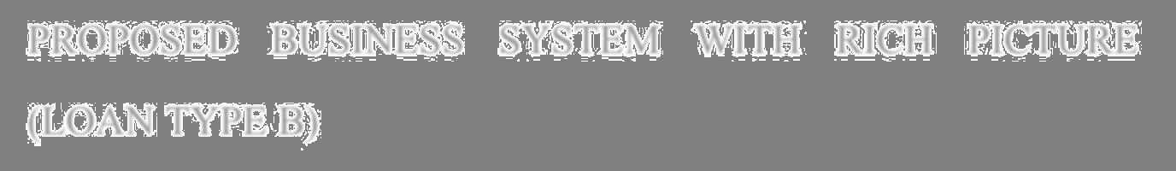

PROPOSED BUSINESS SYSTEM WITH RICH PICTURE (LOAN TYPE B)

In our proposed system, the Automated Loan Appraisal System (ALAS), we will have a database server, a web server. According to our system which will be a web based application, will be always connected to the servers. Firstly, IFIs will go through a Participating Distributor Selection Process. After eligibility checking IFIs will organize a PD Selection Committee meeting and select PDs. Participating Distributor & IFIs sign the Participating Agreement and records data on the database using the software. PD will report sales using sales installation and Inspection Record to IFIs. After installing EE&C Home appliance, PD will submit fund and transferred request to IFIs. Manager will check the eligibility and transfers the fund accordingly. Officer in charge will record the fund transfer amount and date on the database. Then PD will request for APO to IFIs. IFIs will proceed for institutional approval. After informing the result to PD, results are recorded. PD then will submit forms for advance payment procedure. If approved, IFIs will transfer the fund and record amount and date on the database for each a Participating Distributor. PD will check the home appliance sales status and record sales details. Participating Distributor regularly update installation reporting and submit Adjustment request to IFIs. IFIs will check eligibility and in approved adjusts the fund and keeps the record of amount and date.

For monitoring PD will submit sales and payment data and IFIs officials will check whether "PD financial report on B-type and users" is properly submitted. Then IFIs will conduct on-site inspection and registers records of on-site inspection on the database.

IFIs then will request PD to submit additional data and information upon request from SREDA. Lastly, PD will submit the information to IFIs and IFIs forwards the information to SREDA.





**TABLE: PROPOSED PROCESSES ALONG WITH SIX SYSTEM ELEMENTS (LOAN TYPE B)**

|  |  |  |  |  |  |  |
| --- | --- | --- | --- | --- | --- | --- |
| Process | Human | Non-computing | Hardware | Software | Database | Connectivity |
|  |  | Hardware |  |  |  |  |
|  |  |  |  |  |  |  |
| **Preparing Eligible** | IFI Officer in Charge (Request PD to submit an | Application for | Computer | ALMS | MySQL | Internet |
| **Appliances List** | application for assessment of an appliances | assessment of an |  |  |  |  |
|  | model, Check the appropriateness of the | appliances model |  | Browser |  | Email |
|  | application for assessment of an appliances |  |  |  |  |  |
|  | model) |  |  |  |  |  |
|  | PD (Submit an application for assessment |  |  |  |  |  |
|  | of an appliances model) |  |  |  |  |  |
| **Participating Distributor** | Participant distributor (Send application, | Eligibility Criteria for | Computer | ALMS | MySQL | Internet |
| **(PD) selection and** | get notification, sign agreement) | PDs (Annex 21) |  |  |  |  |
| **appointment** |  |  |  | Browser |  | Email |
|  | PIU Secretariats (Check eligibility) | PDs list form (Annex |  |  |  |  |
|  |  | 22) |  |  |  |  |
|  |  | Participation |  |  |  |  |
|  |  | Agreement Template |  |  |  |  |
|  |  | (Annex 23) |  |  |  |  |
|  |  | Account opening forms |  |  |  |  |
|  |  | for PD’s |  |  |  |  |
| **Approving a PD for APO** | Participating Distributor (Submit | Application form | Computer | ALMS | MySQL | Internet |
|  | application form) |  |  |  |  |  |
|  |  | Annex 21(Check List) |  |  |  |  |
|  |  |  |  |  |  |  |



|  |  |  |  |  |  |  |
| --- | --- | --- | --- | --- | --- | --- |
|  | Officer in charge for Component III | Past track record of |  |  |  |  |
|  | (Consult with Manager and PIU | PD’s |  |  |  |  |
|  | Secretariat) |  |  |  |  |  |
|  | PIU Secretariat (Check eligibility) |  |  |  |  |  |
|  | IFI Manager (Discuss with the PIU |  |  |  |  |  |
|  | secretariat and approve the PD’s APO |  |  |  |  |  |
|  | status) |  |  |  |  |  |
| **Advance payment** | Participant Distributor (Submits forms) | Procurement | Computer | ALMS | MySQL | Internet |
| **procedure** |  | documents of EE&C |  |  |  |  |
|  | Officer in charge for Component III | home appliances, |  |  |  |  |
|  | (record data) |  |  |  |  |  |
|  |  | Application Form for |  |  |  |  |
|  | Manager (Checks request, Takes decision) | Advance Payment |  |  |  |  |
|  |  | Option (Annex 26) |  |  |  |  |
|  |  | PD’S disbursement and |  |  |  |  |
|  |  | repayment statement |  |  |  |  |
|  |  | (Annex 29) |  |  |  |  |
| **Sales record keeping** | Participating Distributor (keep all the sales | EE&C Home | Computer | ALMS | MySQL | Internet |
|  | information, check all sales details of | Appliances Purchasers’ |  |  |  |  |
|  | EE&C and record sales details on |  | EE&C |  |  |  |
|  | Annex27) | Screening Sheet |  |  |  |  |
|  |  | (Annex 24), | Appliances |  |  |  |
|  |  | Stipulations in |  |  |  |  |
|  |  | screening sheet |  |  |  |  |
|  |  |  |  |  |  |  |

|  |  |  |  |  |  |  |
| --- | --- | --- | --- | --- | --- | --- |
|  |  | Sales Installation and |  |  |  |  |
|  |  | Inspection Record |  |  |  |  |
|  |  | Form (Annex 27) |  |  |  |  |
|  |  |  |  |  |  |  |
| **Loan Disbursement to** | Officer in charge for Component III (keep | Annex 25 (Attachment | Computer | ALMS | MySQL | Internet |
| **PDs** | record of Annex 25 & 29, check the fund | List) |  |  |  |  |
|  | transfer requests from the PDs, submitting |  |  |  |  |  |
|  | fund transfer request to the manager) | PD’s disbursement & |  |  |  |  |
|  |  | repayment statement |  |  |  |  |
|  | Manager (check the appropriateness for | (Annex 29) |  |  |  |  |
|  | the request form) |  |  |  |  |  |
| **Adjustment against APO** | Officer in charge for Component III | PD’s disbursement & | Computer | ALMS | MySQL | Internet |
|  | (Adjustment is calculated by subtracting | repayment statement |  |  |  |  |
|  | tagged sales amount from the total | (Annex 29) |  |  |  |  |
|  | repayment amount) |  |  |  |  |  |
| **Repayment** | Officer in charge for Component III | PD’s disbursement & | Computer | ALMS | MySQL | Internet |
|  | (Check the repayment status monthly on | repayment statement |  |  |  |  |
|  | PD’s disbursement & repayment statement | (Annex 29) |  |  |  |  |
|  | (Annex 29) |  |  |  |  |  |
|  | Manager (For serious cases of delay |  |  |  |  |  |
|  | reported, consider applying non- |  |  |  |  |  |
|  | compliance clauses in the participation |  |  |  |  |  |
|  | agreement) |  |  |  |  |  |
| **User registration for** | Officer in charge for Component III (Make | PDs list | Computer | ALMS | MySQL | Internet |
| **PD’s** | sure that the PDs are issued with user-ID |  |  |  |  |  |
|  | and password) |  |  |  |  |  |
|  |  |  |  |  |  |  |
| **Installation inspection** | Officer in charge for Component III | Annex 27 (Sales, | Computer | ALMS | MySQL | Internet |
| **reporting** | (request for additional docs) | Installation and |  |  |  |  |
|  |  | Inspection Record |  | Browser |  | Email |
|  |  | Form) |  |  |  |  |

|  |  |  |  |  |  |  |
| --- | --- | --- | --- | --- | --- | --- |
|  | Participating Distributor(PD) |  |  |  |  |  |
|  | IFI Manager (for approval) |  |  |  |  |  |
|  | Officer for B-type loan monitoring (On- |  |  |  |  |  |
|  | site Inspection) |  |  |  |  |  |
| **Additional Information** | IFI Officer in Charge (request PD for additional | _ | Computer | ALMS | MySQL | Internet |
| **from PD** | docs) |  |  |  |  |  |
|  | Participating Distributor (to cooperate with |  |  |  |  |  |
|  | IFI) |  |  |  |  |  |
|  | SREDA Officer in Charge (Inspection and energy |  |  |  |  |  |
|  | audit) |  |  |  |  |  |
|  |  |  |  |  |  |  |
|  |  |  |  |  |  |  |

ENTITY RELATIONSHIP DIAGRAM

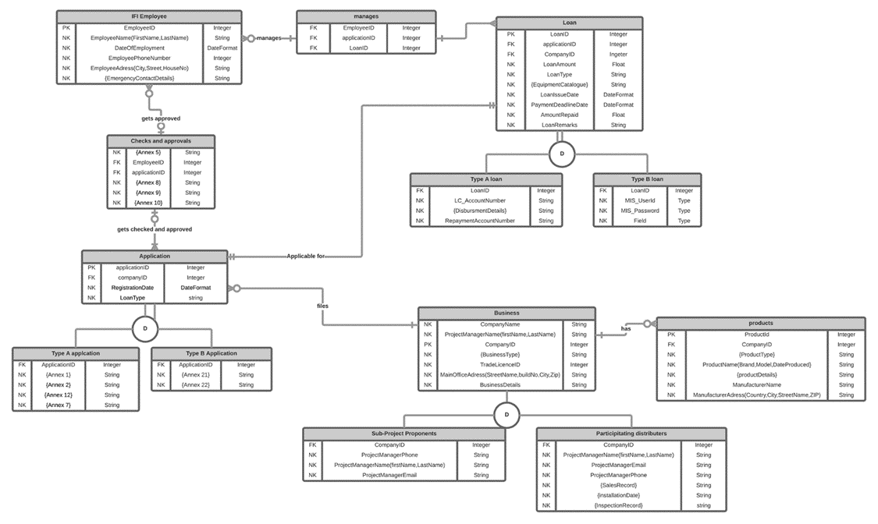

RELATIONSHIP TABLE

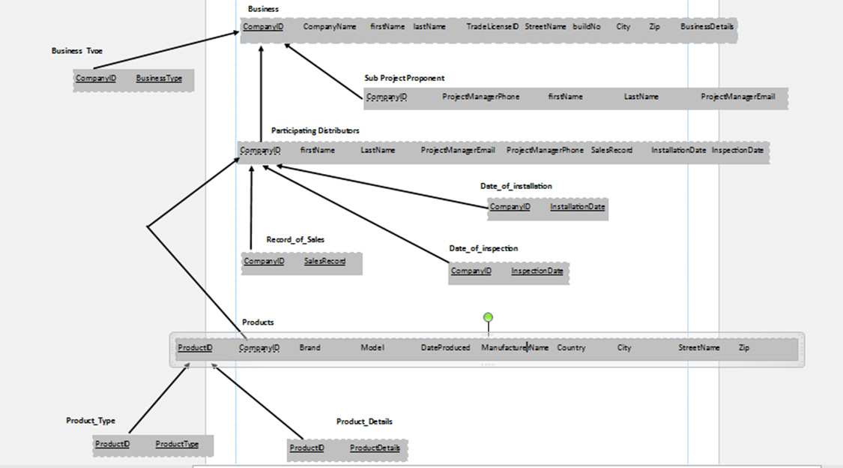

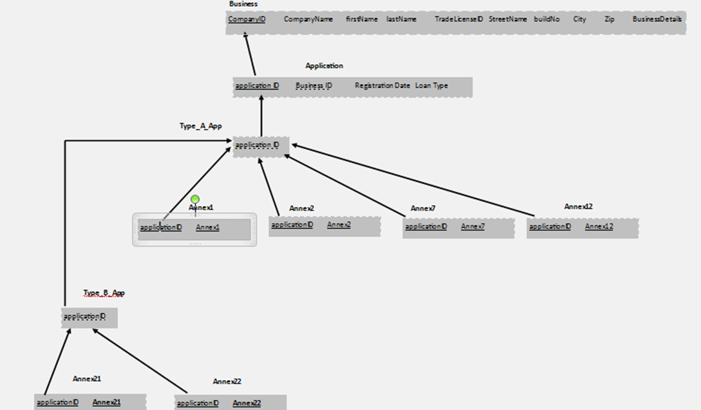

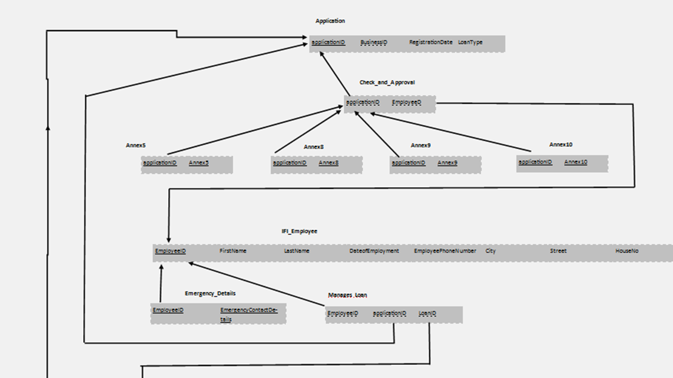

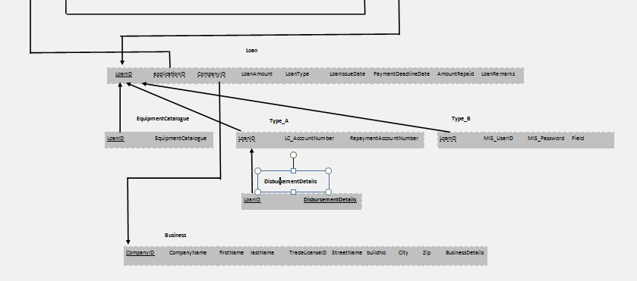

DATA DICTIONARY

1. **IFI_EMPLOYEE:**

|  |  |  |  |
| --- | --- | --- | --- |
| **Name** | **Data**  **Type** | **Size** | **Remark** |
| EmployeeID | Number | 9 | This is the primary key of this relation. This contain the ID of the IFI Employee. Example : ’128498679’. |
| EmployeeFirstName | Text | 15 | This contains the first name of Employee. Example: ‘mahady’. |
| EmployeeLastName | Text | 15 | This contains the last name of Employee. Example: ‘hasan’. |
| DateOfEmployment | Datetime | “dd/mm/yy” | This contains date of employment of the Employee. Example: 4/11/17. |
| EmployeePhoneNumber | Number | 11 | This contains the Employee phone number. Example: 01923861590. |
| EmployeeCity | Text | 15 | City of the Employee. example: “Dhaka” |
| EmployeeStreet | Text | 15 | Street name of the Employee. example: “green road”. |
| EmployeeHouseNo | Number | 10 | House number of the Employee. example: “8086”. |
| {EmergencyContactDetails} | Text | 100 | Emergency contact details of Employee. Like email, telephone number etc. it is a composite attribute of this relation. |

1. **MANAGES:**

|  |  |  |  |
| --- | --- | --- | --- |
| **Name** | **Data**  **Type** | **Size** | **Remark** |
| EmployeeID | Number | 9 | This is the primary key and the foreign key this relation. This contain the ID of the IFI Employee. Example : ’128496745’. |
| ApplicationID | Number | 9 | This is the foreign key this relation. This contain the ID of the Application. Example : ’528494556’. |
| LoanID | Number | 9 | This is the foreign key this relation. This contain the ID of the Loan. Example : ’128494653’. |

1. **LOAN:**

|  |  |  |  |
| --- | --- | --- | --- |
| **Name** | **Data**  **Type** | **Size** | **Remark** |
| LoanID | Number | 9 | This is the primary key of this relation. This contain the ID of the Loan. Example : ’128496783’. |
| applicationID | Number | 9 | ID of application. Example: ‘324523530’. |
| companyID | Number | 9 | This contains the id of company. Example: ‘345160543’. |
| LoanAmount | Number | 11 | This contains the amount of loan. Example: 10395934 tk. |
| LoanType | Boolean | 5 | Contain the type of loan. example: A-type/ B-type. |
| {EquipmentCatalogue} | Text | 15 | It contains equipment catalogue. |
| LoanIssueDate | Datetime | “dd/mm/yy” | This is the loan issue date. Example : 21/02/2014. |
| PaymentDeadlineDate | Datetime | “dd/mm/yy” | This is the deadline date of payment. Example : 21/02/2014. |
| AmountRepaid | Number | 11 | It contains the amount of repaid. Example : 1233434 tk. |
| LoanRemarks | Text | 100 | Comment about loan. |
| LC_AccountNumber | Number | 11 | It is the account number of LC. Example : “23453432404”. |
| {DisbursmentDetails} | Text | 100 | Details about disbursement. |
| RepaymentAccountNumber | Number | 11 | It contains the account number of re payment. Example : “34523222434” |
| MIS_UserId | Number | 9 | This the ID of MIS software user. Example : “234443454”. |
| MIS_Password | Text | 20 | Password of MIS users. Example : “anba2334”. |
| Field | Text | 15 | It is the type of work, which type of work will do with loan. |

1. **CHECKS_AND_APPROVALS:**

|  |  |  |  |
| --- | --- | --- | --- |
| **Name** | **Data**  **Type** | **Size** | **Remark** |
| EmployeeID | Number | 9 | This is the primary key and the foreign key this relation. This contain the ID of the IFI Employee. Example : ’128493454’. |
| applicationID | Number | 9 | This is the foreign key this relation. This contain the ID of the Application. Example : ’528494435’. |
| {Annex 5}  CreditRatingReport  FinancialStatement  InformationFinancial  OfficerInCharge  ManagerDicision | Boolean  Boolean  Boolean  Boolean  Boolean | 4  4  4  4  4 | This is rating report of credit, where check it satisfactory, not satisfactory or not available.  This shows profit for last 2 years, where check it satisfactory, not satisfactory or not available.  There are no substantial issues on managerial and financial status of the proponent. Here check it satisfactory, not satisfactory or not available.  Officer will decide is it Satisfactory / not satisfactory  Manager will take decision Approve / disapprove |
| {Annex 8}  GeneralDueDiligence  SimpleDueDiligence | Boolean  Boolean | 4  4 | This form check Credit Report Element & Result, Management Analysis, Product and Industry Analysis, Production and marketing Analysis, Profitability Analysis, Soundness and Sustainability Analysis, Repayment Capacity Analysis etc.  This part checks Credit Report Element & Result, Product and Industry Analysis, Production and marketing Analysis, Profitability Analysis, Soundness and sustainability Analysis, Repayment Capacity Analysis etc. |
| {Annex 9}  LoanDecisionSheet  Approved  Rejected | Boolean  Boolean  Boolean | 4  4  4 | In this part checks Senior executives (or owners/sponsors) and their strength and weaknesses, Main products and the industry, Production and Marketing, Compliance to statutory regulations and nature of the subject technology for introduction, Profitability, Soundness and durability,  Capability to repay, Information from CIB report etc.  Yes, if the all the requirements are full fill.  No, if something are missing or not suitable. |
| {Annex 10}  Loan amount  EligibleEquipment  Tenure  Grace period  InterestRate  Repayment terms  Guarantee | Number  Text  Varchar  Number  Number  Text  Text | 11  5  10  4  5  30  20 | The amount of the loan.  The equipment’s which is needed.  Contains tender of the loan.  The time required of grace.  The rate of interested for each loan.  The terms of repayment for every loan.  This will give guarantee of the loan. |
| EquipmentProcurement AndInstallationPlan |  |  | This form contains Eligible EE&C equipment, Number of Unit, Amount  (Million BDT), Payment Schedule  (a)Paid portion, Name of Machines, Number of Unit, Amount (Million BDT), Payment Schedule (b)Scheduled portion,  Name of Machines, Number of Unit installation Schedule. |

1. **APPLICATION:**

|  |  |  |  |
| --- | --- | --- | --- |
| **Name** | **Data**  **Type** | **Size** | **Remark** |
| applicationID | Number | 9 | This is the primary key of this relation. This contain the ID of the IFI Employee. Example : ’128494356’. |
| businessID | Number | 9 | This is the foreign key this relation. This contain the ID of the business. Example : ’5284945324’. |
| RegistrationDate | Datetime | “dd/mm/yy” | This contains the date of registration. Example : ’12/8/2014’. |
| LoanType | Boolean | 5 | The type of loan. Example: type-A/ Type-B |
| {Annex 1}  NameOfTheCompany  AddressOfMainOffice  Contact  YearOfIncorporation  AuthorizedCapitalAndPaid UpCapital  NumberOfEmployees  CompanyDescription  namesOfOwners  StockExchange  SubProjectProposal | Text  Text  Text  Number  Number  Number  Text  Number  Text | 30  50  30  4  9  6  50  4  5 | This is the company name.  The address of the main office. Where it is situated.  The contact info of the company, like email, phone, telephone etc.  It is the year of incorporation.  The capital of authorized and paid up capital.  The employee number of the company.  The disctiption of the company.  The number of owners.  About Stock exchange.  Here contain three tables which is takes Sub-Project Proposal, Project Cost, Fund Raising Plan, Debt Plan, Application Number etc. |
| {Annex 2}  ApplicationNumber  Equipment information  Code number  Name of Equipment  Specification  Model Number  Supplier  Manufacturer  quality  replacement  capacity | Number  Text  Number  Text  Text  Varchar  Text  Text  Text  Text  Text | 7  50  7  20  50  15  20  30  10  5  5 | The application number, example: 2352342.  The information of Equipment.  Code number of the Equipment.  This contains the name of the Equipment.  The details about the Equipment.  The Equipment model numbers.  Information about supplier.  Information about supplier.  Details about the quality of product.  Is the replacement available.  The capacity range. |
| {Annex 12}  Eligibility Check Sheet |  |  | This is the forms about chemical fertilizer, paper and pulp, De-inking plant, textile and garment, Loom and warier and sizer, textile and garment heat changer, combustion control of glass melting furnace, lithium ion battery, transformer for power receiving and distribution, water pump, fan and blower with inverter, air compressor, waste heat recovery System etc. everything has their own form, user should fill the forms. |
| {Annex 7}  Check  RecevingDate  RecevingDateOfCorrectDoc | Boolean  Date  Date | 4  “dd/mm/yy”  “dd/mm/yy” | This will record the checked values of the following documents.  This is the date of receiving documents.  This is the receiving date of correct documents. |
| {Annex 21}  Formulation and Implementation |  |  | This part is basically for B- type loan. Here  Data receive about Organization, Sound financial position, Financial criteria, Consistency of financial criteria,  Existence of an electrified area(s) inside the business area The organisationalready has a branch(es) inside the electrified area(s) to conduct its business operations, Adequate business plan for the EE&C loan program, Debt Service Reserve Account (DSRA) etc. |
| {Annex 22}  PDName  OrganizationalType  Remarks | Text  Text  Text | 30  20  50 | This is the name of Participating distributer.  It types of organization.  The remarks of the the pds like some comments about them. |

1. **BUSINESS:**

|  |  |  |  |
| --- | --- | --- | --- |
| **Name** | **Data**  **Type** | **Size** | **Remark** |
| CompanyName | Text | 30 | This contain the name of the company. Example : ’house building’. |
| CompanyID | Number | 9 | This is the primary key of this relation. This contain the ID of the Company. Example : ’528494594’. |
| ProjectManagerFirstName | Text | 15 | It is the first name of project manager. |
| ProjectManagerLasrName | Text | 15 | It is the last name of project manager. |
| {BusinessType} | Boolean | 5 | This contains the type of business. |
| TradeLicenceID | Number | 9 | The ID of trade licence. Example : “343523534” |
| MainOfficeStreetName | Text | 20 | The street name of main office. |
| MainOfficebuildNo | Number | 5 | It is the building number of the main office. |
| MainOfficeCity | Text | 10 | Name of the city of main office. |
| MainOfficeZip | Number | 6 | The zip code of main office. Example : “160843” |
| BusinessDetails | Text | 100 | Details about business. |
| ProjectManagerPhone | Number | 11 | This is the phone number of project manager. Example: “01539392949” |
| ProjectManagerEmail | Text | 25 | The email address of project manager. Example : [abcd@gmail.com](mailto:abcd@gmail.com). |
| {SalesRecord} | Text | 40 | This contains the record of the sale. |
| {installationDate} | Datetime | “dd/mm/yy” | The date of installation. |
| {InspectionRecord} | Text | 40 | This is the record of inspection. |

1. **PRODUCT:**

|  |  |  |  |
| --- | --- | --- | --- |
| **Name** | **Data**  **Type** | **Size** | **Remark** |
| ProductId | Number | 11 | This is the primary key of this relation. This contain the ID of the product. Example : ’34532412849’. |
| {ProductType} | Text | 25 | This contains the type of product. |
| ProductName | Text | 20 | It is the name of product. Example: “energy light”. |
| ProductBrand | Text | 15 | Brand name of product. Example: ”LG” . |
| ProductModel | Text | 6 | This contains the product model number. |
| ProductDateProduced | Datetime | “dd/mm/yy” | The date of product produced. Example: 12/12/2013. |
| {productDetails} | Text | 40 | This contains the details about products. |
| ManufacturerName | Text | 30 | It is name of manufacturer. |
| ManufacturerCountry | Text | 20 | Country name of manufacturer. Example :  “Bangladesh”. |
| ManufacturerCity | Text | 10 | The name of manufacturer city. Example : “Chittagong” . |
| ManufacturerStreetName | Text | 15 | Name of manufacturer street. Example: “elephant road”. |
| ManufacturerZIP | Number | 6 | This contains the zip code of manufacturer. Example: “106005”. |

NORMALIZATION

1NF:

|  |  |  |  |  |  |
| --- | --- | --- | --- | --- | --- |
| EmployeeID | EmployeeName | DateOfEmployment | EmployeePhoneNumber | EmployeeAdress | EmergencyContactDetails |

|  |  |  |  |  |  |  |  |  |  |  |
| --- | --- | --- | --- | --- | --- | --- | --- | --- | --- | --- |
| LoanID | Applicantion  ID | Loan  Amount | Loan  Type | Equipment  Catalogue | LoanIssueDate | Payment  DeadlineDate | Amount  Repaid | Loan  Remarks | ApplicationID | RegistrationDate |

|  |  |  |  |  |  |  |  |  |  |  |  |  |
| --- | --- | --- | --- | --- | --- | --- | --- | --- | --- | --- | --- | --- |
| Product  ID | Company  ID | Product  Type | Product  Name | Product  Details | Manufacturer  Name | Manufacturer  Address | Company  Name | Project  Manager  Name | Business  Type | Trade  Lisence  ID | Main  Office  Address | Business  Details |

2NF:

This is already in 2NF, since there are no partial dependencies.

3NF:

|  |  |  |  |  |  |
| --- | --- | --- | --- | --- | --- |
| EmployeeID | EmployeeName | DateOfEmployment | EmployeePhoneNumber | EmployeeAdress | EmergencyContactDetails |

|  |  |  |  |  |  |  |  |  |
| --- | --- | --- | --- | --- | --- | --- | --- | --- |
| LoanID | LoanAmount | LoanType | Equipment  Catalogue | LoanIssueDate | PaymentDeadlineDate | AmountRepaid | LoanRemarks | ApplicationID |



|  |  |  |
| --- | --- | --- |
| ApplicantionID | RegistrationDate | LoanType |

|  |  |  |  |  |  |  |  |
| --- | --- | --- | --- | --- | --- | --- | --- |
| ProductID | ProductType | ProductName | ProductDetails | ManufacturerName | ManufacturerAddress | CompanyName | CompanyID |



|  |  |  |  |  |  |
| --- | --- | --- | --- | --- | --- |
| CompanyID | ProjectManagerName | BusinessType | TradeLisenceID | MainOfficeAddress | BusinessDetails |

**Data definition language (DDL) Statements:**

**Creating database:**

CREATE DATABASE alm;

**Table structure for table ` products `**

CREATE TABLE `products` (

`ProductId` Integer,

`CompanyID` Integer,

`{ProductType}` VARCHAR(50),

`ProductName(Brand,Model,DateProduced}` VARCHAR(100),

`{productDetails}` VARCHAR(250),

`ManufacturerName` VARCHAR(50),

`ManufacturerAdress(Country,City,StreetName,ZIP)` VARCHAR(100),

PRIMARY KEY (`ProductId`),

KEY `FK` (`CompanyID`),

KEY `NK` (`{ProductType}`, `ProductName(Brand,Model,DateProduced}`, `{productDetails}`,

`ManufacturerName`, `ManufacturerAdress(Country,City,StreetName,ZIP)`)

);

**Table structure for table ` business `**

CREATE TABLE `business` (

`CompanyName` VARCHAR(50),

`ProjectManagerFirstName` VARCHAR(50),

`ProjectManagerLastName` VARCHAR(50),

`CompanyID` Integer,

`{BusinessType}` VARCHAR(50),

`TradeLicenceID` Integer,

`MainOfficeAdress(StreetName,buildNo,City,Zip)` TEXT,

`BusinessDetails` TEXT,

PRIMARY KEY (`CompanyID`));

**Table structure for table ` Participitatingdistributers `**

CREATE TABLE `Participitatingdistributers` (

`CompanyID` Integer NOT NULL ,

`ProjectManagerFirstName` VARCHAR(20),

`ProjectManagerLastName` VARCHAR(20),

`ProjectManagerEmail` VARCHAR(30),

`ProjectManagerPhone` int,

`{SalesRecord}` VARCHAR(50),

`{installationDate}` DATE,

`{InspectionRecord}` VARCHAR(50),

KEY `FK` (`CompanyID`),

KEY `NK` (`ProjectManagerFirstName`,

`ProjectManagerLastName`, `ProjectManagerEmail`, `ProjectManagerPhone`, `{SalesRecord}`,

`{installationDate}`, `{InspectionRecord}`)

);

**Table structure for table ` Sub_ProjectProponents `**

CREATE TABLE `Sub_ProjectProponents` (

`CompanyID` Integer,

`ProjectManagerPhone` INT,

`ProjectManagerFirstName` VARCHAR(20),

`ProjectManagerLastName` VARCHAR(20),

`ProjectManagerEmail` VARCHAR(30),

KEY `FK` (`CompanyID`)

);

**Table structure for table ` Application `**

CREATE TABLE `Application` (

`applicationID` Integer,

`companyID` Integer,

`RegistrationDate` Date,

`LoanType` VARCHAR(1),

PRIMARY KEY (`applicationID`),

KEY `FK` (`companyID`),

KEY `NK` (`RegistrationDate`, `LoanType`)

);

**Table structure for table ` TypeA_applcation `**

CREATE TABLE `TypeA_applcation` (

`ApplicationID` Integer,

`{Annex 1}` boolean,

`{Annex 2}` boolean,

`{Annex 12}` boolean,

`{Annex 7}` boolean,

KEY `FK` (`ApplicationID`),

KEY `NK` (`{Annex 1}`, `{Annex 2}`, `{Annex 12}`, `{Annex 7}`)

);

**Table structure for table ` TypeB_Application `**

CREATE TABLE `TypeB_Application` (

`ApplicationID` Integer,

`{Annex 21}` boolean,

`{Annex 22}` boolean,

KEY `FK` (`ApplicationID`),

KEY `NK` (`{Annex 21}`, `{Annex 22}`)

);

**Table structure for table ` Checks_and_approvals `**

CREATE TABLE `Checks_and_approvals` (

`{Annex 5}` boolean,

`EmployeeID` Integer,

`applicationID` Integer,

`{Annex 8}` boolean,

`{Annex 9}` boolean,

`{Annex 10}` boolean,

KEY `NK` (`{Annex 5}`, `{Annex 8}`, `{Annex 9}`, `{Annex 10}`),

KEY `FK` (`EmployeeID`, `applicationID`)

);

**Table structure for table ` IFI_Employee `**

CREATE TABLE `IFI_Employee` (

`EmployeeID` Integer,

`EmployeeFirstName` VARCHAR(20),

`EmployeeLastName` VARCHAR(20),

`DateOfEmployment` date,

`EmployeePhoneNumber` Integer,

`EmployeeAdress(City,Street,HouseNo)` TEXT,

`{EmergencyContactDetails}` TEXT,

PRIMARY KEY (`EmployeeID`)

);

**Table structure for table ` manages `**

CREATE TABLE `manages` (

`EmployeeID` Integer,

`applicationID` Integer,

`LoanID` Integer,

KEY `FK` (`EmployeeID`, `applicationID`, `LoanID`)

);

**Table structure for table ` Loan `**

CREATE TABLE `Loan` (

`LoanID` Integer,

`applicationID` Integer,

`CompanyID` Ingeter,

`LoanAmount` Float,

`LoanType` String,

`{EquipmentCatalogue}` String,

`LoanIssueDate` DateFormat,

`PaymentDeadlineDate` DateFormat,

`AmountRepaid` Float,

`LoanRemarks` String,

PRIMARY KEY (`LoanID`),

KEY `FK` (`applicationID`, `CompanyID`),

KEY `NK` (`LoanAmount`, `LoanType`, `{EquipmentCatalogue}`, `LoanIssueDate`,

`PaymentDeadlineDate`, `AmountRepaid`, `LoanRemarks`)

);

**Table structure for table ` TypeA_loan `**

CREATE TABLE `TypeA_loan` (

`LoanID` Integer,

`LC_AccountNumber` VARCHAR(15),

`{DisbursmentDetails}` VARCHAR(200),

`RepaymentAccountNumber` VARCHAR(15),

KEY `FK` (`LoanID`),

KEY `NK` (`LC_AccountNumber`, `{DisbursmentDetails}`, `RepaymentAccountNumber`)

);

**Table structure for table ` TypeB_Bloan `**

CREATE TABLE `TypeB_Bloan` (

`LoanID` Integer,

`MIS_UserId` VARCHAR(11),

`MIS_Password` VARCHAR(30),

`Field` VARCHAR(40),

KEY `FK` (`LoanID`),

KEY `NK` (`MIS_UserId`, `MIS_Password`, `Field`)

);