|  |
| --- |
| **INDEPENDENT UNIVERSITY, BANGLADESH** |
| School of [Engineering and Computer Science](http://www.secs.iub.edu.bd/)    **PROJECT: Password Based Door Lock System**  Syed Shams Elahi - 1621176    Kazi Imdadul Hoque-1522248  Instructor: Prof. Farruk Ahmed  Date: |

**Password Based Door Lock System using 8051 Micro controller**

Our Password Based Door Lock System using 8051 Micro controller is a simple project where a secure password will act as a door unlocking system.

Traditional lock systems using mechanical lock and key mechanism are being replaced by new advanced techniques of locking system. These techniques are an integration of mechanical and electronic devices and are highly intelligent. One of the prominent features of these innovative lock systems is their simplicity and high efficiency.

Such an automatic lock system consists of electronic control assembly, which controls the output load through a password. This output load can be a motor or a lamp or any other mechanical/electrical load.

Here, we developed an electronic code lock system using 8051 micro controller (a Password based Door Lock System using 8051 Micro controller), which provides control to the actuating the load. It is a simple embedded system with input from the keyboard and the output being actuated accordingly.

This system demonstrates a Password based Door Lock System using 8051 Micro controller, wherein once the correct code or password is entered, the door is opened and the concerned person is allowed access to the secured area. Again, if another person arrives, it will ask to enter the password. If the password is wrong, then door would remain closed, denying access to the person.

**Principle Behind the Circuit**

The main component in the circuit is 8051 controller. In this project, a 4×4 Matrix Keypad is used to enter the password. The password which is entered is compared with the predefined password.

If the entered password is correct, then the system opens the door by rotating door motor and displays the status of door on LCD. If the password is wrong, then the door is remains closed and displays “Incorrect Password!” on the LCD.

**Circuit Diagram of Password Based Door Lock System**

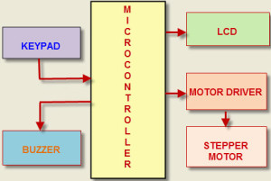

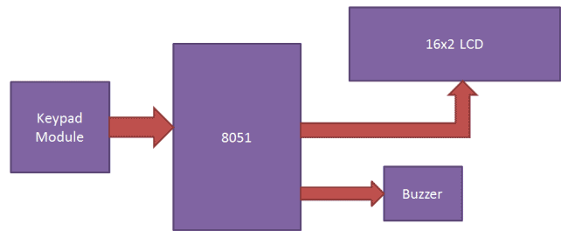

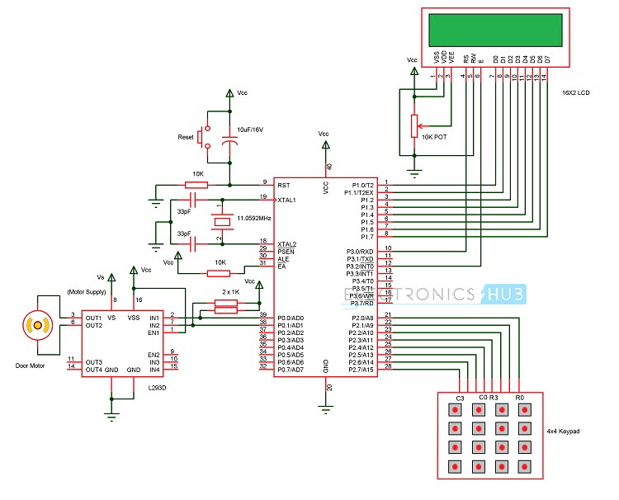

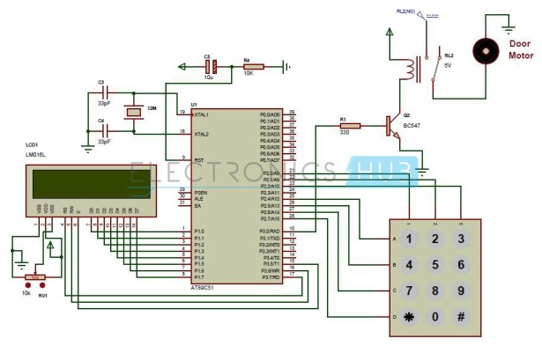

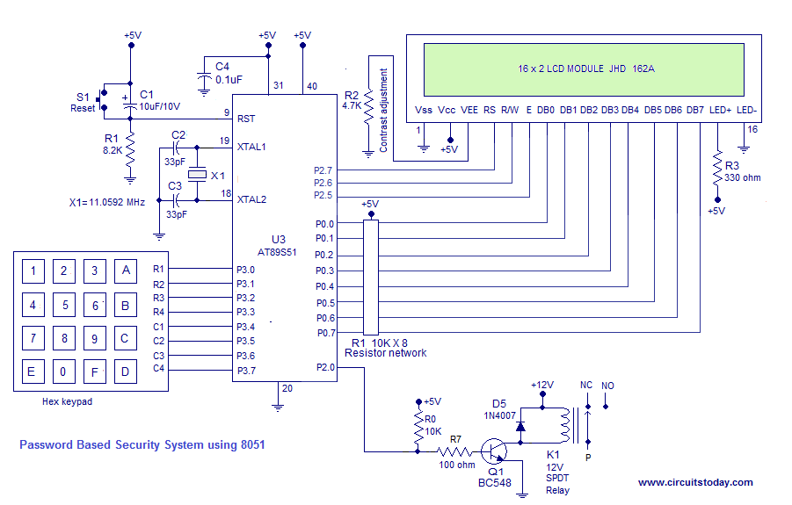

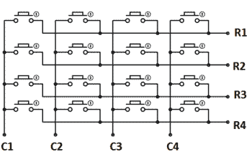

**Components Required**

**Hardware Requirements**

* 8051 Micro controller
* 8051 Development Board
* 8051 Programmer
* 4×4 Matrix Keypad
* 16×2 LCD
* L293D Motor Driver Board
* DC Motor
* 10KΩ Potentiometer
* Connecting wires
* Power Supply
* If 8051 Development Board is not used, then the following components are needed.
  + 11.0592 MHz Quartz Crystal
  + 2 x 33pF Ceramic Capacitors
  + 2 x 10 KΩ Resistor (1/4 Watt)
  + 10 µF Capacitor (Polarized)
  + Push Button
  + 2 x 1 KΩ Resistors (for pull up)

**Software Requirements**

* Keil µVision IDE
* Willar Programmer
* Proteus (for circuit diagram and simulation)

**How to Design Circuit of Password based Door Lock System?**

Password based door lock system using 8051 micro controller circuit design uses five major components – a Micro controller, an L293D Motor Driver, a DC Motor, a 4×4 Matrix Keypad and a 16×2 LCD. Here, an AT89C52 Micro controller is used and it is an 8-bit controller. This controller requires a supply voltage of +5V DC. In order to provide regulated 5V DC voltage to the controller we need to use 7805 power supply circuit. We can use 9V DC battery or 12V, 1A adaptor as a power source.

***Reset Circuit Design:***The reset pin of the micro controller is kept active till the power supply is in the specified range and a minimum oscillation level is maintained.  In other words to ensure the supply voltage does not falls below the threshold level of 1.2V and the reset pulse width is greater than 100ms (recommended for AT89C52 Micro controller),  we need to select the values of resistor and capacitor such that RC >=100ms.  Hence, we selected a 10KΩ resistor and a 10µF electrolytic capacitor.

***Oscillator Circuit Design:*** An 11.0592MHz crystal oscillator is used to provide external clock signal to the micro controller. To ensure smooth operation, we need to connect two ceramic capacitors in the range of 30pF to 40pF. This crystal oscillator is connected between pin 18 and 19 of the micro controller. Here, we used two 33pF capacitors.

***Interfacing LCD, Keypad and Motor Driver:*** First, a 10KΩ Potentiometer is connected to the LCD Display’s Contrast Adjust Pin (Pin 3). RS, RW and E of LCD are connected to P3.0, GND and P3.2 pins respectively. The eight data lines of the LCD are connected to PORT1.

The four ROW pins of the Keypad are connected to P2.0 to P2.3 and the four COLUMN pins of the Keypad are connected to P2.4 to P2.7 pins respectively. The IN1 and IN2 of (1A and 2A) of the L293D Motor Driver are connected to PORT0 pins P0.0 and P0.1. Motor is connected between OUT1 and OUT2 (1Y and 2Y) pins of L293D.

***Compilation of Micro controller Code:***Once the circuit is designed and drawn on a piece of paper, the next step is to write and compile the code. Here, we used the Keil µVision software to write the program in C language.

Prior to writing the code, general steps needs to be followed like creating a new project and selecting the target device or the required micro controller. Once the code is written, we need to save it with .c extension and then add it to the source file group under the target folder.  The code is then compiled by pressing F7 key.

Once the code is compiled, a hex file is created.  In the next step, we use Proteus software to draw the circuit. The code is dumped into the microcontroller using an external programmer and Willar Software.

**Password Based Door Locking System Circuit Operation**

Once the circuit is powered ON, micro controller sends commands to the LCD to display “enter password” on LCD.  Now we need to enter the password using the keypad. Once password is entered, it displays 5 stars (*****) on the LCD to indicate that the controller read the inputted password successfully.

Now the controller compares the entered password with predefined password. If the password is matched, then the micro controller makes P0.0 HIGH and P0.1 LOW, so the motor driver gets the input signals for forward motion of the motor.

As a result, the Door Motor rotates in forward direction to open the door. After a delay of 10 seconds, the micro controller makes P0.0 LOW and P0.1 HIGH, so the motor driver gets the input signals for reverse motion. As a result, the Door motor rotates in reverse direction to close the door.

If the password is not matched, then micro controller maintains both P0.0 and P0.1 LOW. Hence, the door motor is stationary so that door remains closed.

While giving the connections, we made sure that there is no common connection between AC and DC supplies.

**Password Based Door Lock System Algorithm**

1. Initially, declare the PORT1 to LCD data pins and control pins (RS and E) to P3.0 and P3.2. Also, declare PORT2 to keypad. Also use P0.0 and P0.1 for motor driver.
2. Then, display the message “Enter Password: ” on the LCD.
3. Now read the five digit password from the user.
4. Compare the entered password with the stored password.
5. If password is correct, then make P0.0 pin HIGH and P0.1 pin LOW to open the door. During this time, display *“Door opening!”* on LCD.
6. After some time, make P0.0 pin LOW and P0.1 pin HIGH to close the door and after this display *“Door closing!”* on LCD.
7. If the password is wrong, then display *“Incorrect Password!”* on LCD.
8. After some time delay again ask to enter password.

**Program Explanation:**

We have used a predefined password in the program, this password can be defined by the user in the code below. When user enters a password to the system, then system compares the user entered password with stored or predefined password in Code of Program. If a match occurs then LCD will show “Access Grated” and if the password doesn’t match then LCD will show “Access Denied” and buzzer will continuously beep for some time. Here we have used string.h library. By using this library we can compare or match two strings, by using “strncmp” function.

In the program, first of all we include header file and defines variable and input & output pins for keypad and LCD.

#include<reg51.h>

#include<string.h>

#define lcdport P1

sbit col1=P0^0;

sbit col2=P0^1;

sbit col3=P0^2;

sbit col4=P0^3;

sbit row1=P0^4;

sbit row2=P0^5;

sbit row3=P0^6;

sbit row4=P0^7;

sbit rs=P1^0;

sbit en=P1^2;

sbit buzzer=P2^6;

Function for creating the delay of 1 second has been created, along with some LCD functions like for LCD initialization, printing the string, for commands etc. we can easily find them in Code. Check this article for LCD interfacing with 8051 and its functions.

After this, in main program we have initialize LCD and then we read the input from Keypad using the keypad() function and stores input keys into an array and then compare it from predefined array data using strncmp.

void main()

{

buzzer=1;

lcd_init();

lcdstring("Electronic Code");

lcdcmd(0xc0);

lcdstring(" Lock System ");

delay(400);

lcdcmd(1);

lcdstring("Circuit Digest");

delay(400);

while(1)

{

i=0;

keypad();

if(strncmp(pass,"4201",4)==0)

If entered password is matched, then accept() function is called:

void accept()

{

lcdcmd(1);

lcdstring("Welcome");

lcdcmd(192);

lcdstring("Password Accept");

delay(200);

}

And if password is wrong then wrong() function is called:

void wrong()

{

buzzer=0;

lcdcmd(1);

lcdstring("Wrong Passkey");

lcdcmd(192);

lcdstring("PLZ Try Again");

delay(200);

buzzer=1;

}

**Entire Code:**

#include<reg51.h>

#include<string.h>

#define lcdport P1

sbit col1=P0^0;

sbit col2=P0^1;

sbit col3=P0^2;

sbit col4=P0^3;

sbit row1=P0^4;

sbit row2=P0^5;

sbit row3=P0^6;

sbit row4=P0^7;

sbit rs=P1^0;

sbit en=P1^2;

sbit buzzer=P2^6;

char pass[4],i=0;

void delay(int itime)

{

int i,j;

for(i=0;i<itime;i++)

for(j=0;j<1275;j++);

}

void daten()

{

rs=1;

en=1;

delay(5);

en=0;

}

void lcddata(unsigned char ch)

{

lcdport=ch & 0xf0;

daten();

lcdport=(ch<<4) & 0xf0;

daten();

}

void cmden(void)

{

rs=0;

en=1;

delay(5);

en=0;

}

void lcdcmd(unsigned char ch)

{

lcdport=ch & 0xf0;

cmden();

lcdport=(ch<<4) & 0xf0;

cmden();

}

void lcdstring(char *str)

{

while(*str)

{

lcddata(*str);

str++;

}

}

void lcd_init(void)

{

lcdcmd(0x02);

lcdcmd(0x28);

lcdcmd(0x0e);

lcdcmd(0x01);

}

void keypad()

{

int cursor=192,flag=0;

lcdcmd(1);

lcdstring("Enter Ur Passkey");

lcdcmd(0xc0);

i=0;

while(i<4)

{

flag=cursor;

col1=0;

col2=col3=col4=1;

if(!row1)

{

lcddata('1');

pass[i++]='1';

cursor++;

while(!row1);

}

else if(!row2)

{

lcddata('4');

pass[i++]='4';

cursor++;

while(!row2);

}

else if(!row3)

{

lcddata('7');

pass[i++]='7';

cursor++;

while(!row3);

}

else if(!row4)

{

lcddata('*');

pass[i++]='*';

cursor++;

while(!row4);

}

col2=0;

col1=col3=col4=1;

if(!row1)

{

lcddata('2');

pass[i++]='2';

cursor++;

while(!row1);

}

else if(!row2)

{

lcddata('5');

pass[i++]='5';

cursor++;

while(!row2);

}

else if(!row3)

{

lcddata('8');

pass[i++]='8';

cursor++;

while(!row3);

}

else if(!row4)

{

lcddata('0');

pass[i++]='0';

cursor++;

while(!row4);

}

col3=0;

col1=col2=col4=1;

if(!row1)

{

lcddata('3');

pass[i++]='3';

cursor++;

while(!row1);

}

else if(!row2)

{

lcddata('6');

pass[i++]='6';

cursor++;

while(!row2);

}

else if(!row3)

{

lcddata('9');

pass[i++]='9';

cursor++;

while(!row3);

}

else if(!row4)

{

lcddata('#');

pass[i++]='#';

cursor++;

while(!row4);

}

col4=0;

col1=col3=col2=1;

if(!row1)

{

lcddata('A');

pass[i++]='A';

cursor++;

while(!row1);

}

else if(!row2)

{

lcddata('B');

pass[i++]='B';

cursor++;

while(!row2);

}

else if(!row3)

{

lcddata('C');

pass[i++]='C';

cursor++;

while(!row3);

}

else if(!row4)

{

lcddata('D');

pass[i++]='D';

cursor++;

while(!row4);

}

if(i>0)

{

if(flag!=cursor)

delay(100);

lcdcmd(cursor-1);

lcddata('*');

}

}

}

void accept()

{

lcdcmd(1);

lcdstring("Welcome");

lcdcmd(192);

lcdstring("Password Accept");

delay(200);

}

void wrong()

{

buzzer=0;

lcdcmd(1);

lcdstring("Incorrect Password!");

lcdcmd(192);

lcdstring("Please Try Again!");

delay(200);

buzzer=1;

}

void main()

{

buzzer=1;

lcd_init();

lcdstring("Electronic Code");

lcdcmd(0xc0);

lcdstring(" Lock System ");

delay(400);

lcdcmd(1);

lcdstring("Circuit Digest");

delay(400);

while(1)

{

i=0;

keypad();

if(strncmp(pass,"4201",4)==0)

{

accept();

lcdcmd(1);

lcdstring("Access Granted ");

delay(300);

}

else

{

lcdcmd(1);

lcdstring("Access Denied");

wrong();

delay(300);

}

}

}

**Advantages of Password Based Door Lock System**

* This project provides security.
* Power consumption is less.
* Used commonly available components.
* Project is simple and easy.
* Pick-proof: Because there is no place for a key with these locks, the prevent break-ins because burglars are unable to pick or ‘bump’ the lock. Criminals methods of breaking and entering are improving and the majority of criminals can pick an ordinary key lock.
* Replacement for keys: we won’t have to carry around a large set of keys and they will be less likely to be lost or stolen. Also, if we are a landlord, we don’t have to give residents keys or replace them if they lose them.
* Control: In a company building, we can control and restrict who goes into what part of the building. Also residents and landlords of apartments and flat, can control who can enter their room with one PIN code and it reduces the risk of anything getting stolen. It is incredibly easy to change the PIN code whenever we like. The combination door locks from The Workplace Depot have over 8,000 possible code combinations with a simple code change facility.
* Aesthetically Pleasing: Door locks can come in a range of stylish colours that look smart and professional. At The Workplace Depot, we sell mechanical digital door locks in a choice of 3 colours, brass, chrome and satin chrome.
* Perfect for the elderly or disabled: The extra investment into a door lock could bring massive advantages to those who are unable to get to the door quickly and/or who struggle with keys.
* Simple to use
* Simple to deploy—since the operating system provides the user accounts and password, almost no extra configuration is needed.

**Disadvantages of Password Based Door Lock System**

**- *Have to remember the pin:***

We may be the one to forget our keys now and then, and it can be easy to forget we PIN code for the lock and when we are in a rush to get into the room or building or it is night time and dark, we don’t want to be changing the code in the middle of the night or when it’s raining!

**– *Need to keep the PIN code safe and the lock clean:***

Only tell the code to people who we trust, as we don’t want a code to wer property to be local news. When the lock has been used a few too many times, the coating may start to come away or mucky fingerprints may start to occur on the buttons. Keep the lock maintained and clean to stop unwanted people finding out the code!

**– *Power Failure:***

Some digital door locks are powered by electricity, if wer house or building has a power failure, then the door lock will not work which restricts we from entering the building. Buying a mechanical or battery powered lock will not affect we if there is a power failure.

***– Limit the PIN Code Length:***

Some digital door locks have a PIN code length up to 10 digits – this is not what we want! Digital Door Locks will be much more secure if they are only 4 digits long. Purchase a quality lock that we can change the PIN code on, don’t buy locks that are provided with a PIN code because people can find out the code.

- Security is entirely based on confidentiality and the strength of the password.

- Does not provide strong identity check (only based on password).

**Applications of Password Based Door Lock System**

* This simple circuit can be used at residential places to ensure better safety.
* It can be used at organizations to ensure authorized access to highly secured places.
* With a slight modification this Project can be used to control the switching of loads through password.

**Limitations of Password Based Door Lock System**

* It is a low range circuit, i.e. it is not possible to operate the circuit remotely.
* If we forget the password it is not possible to open the door.

**Future Development**

1. We can monitor parameters like fire, overheat

2. We can provide voice feedback system

3. We can interface GSM modem which will send sms if invalid attempt is made to open the lock

**Conclusion**

With the advent of new technology, more and more new security measures are being invented. And our personal space are always prone to invasion. Our project will serve as a way to protect our privacy and will make our belongings safe and secure. We have provided an initial prototype, and we will be putting it through several iterations to improve it. We hope it helps the user.