1. Print the confusion matrix and overall accuracy for classifiers with three features.
   1. For PCA:
      1. Code for confusion matrix:
      2. 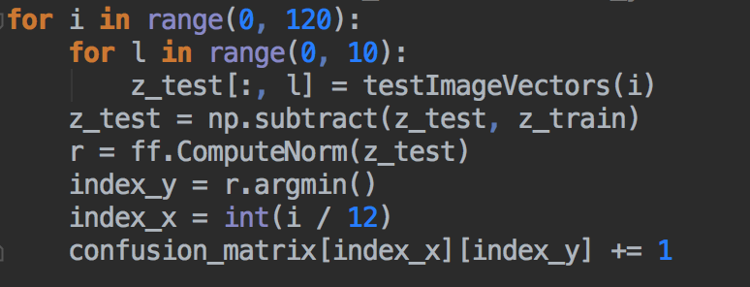
      3. Matrix:
      4. 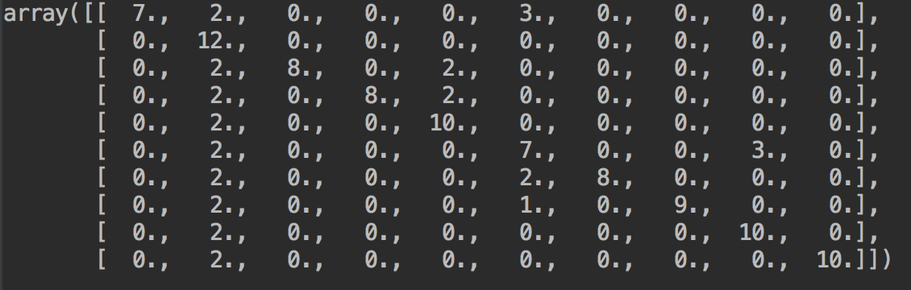
      5. Overall accuracy:
      6. 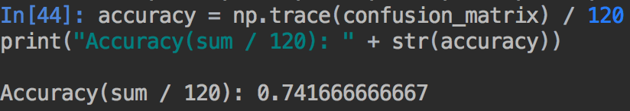
   2. For LDA:
      1. Code for confusion matrix:
      2. 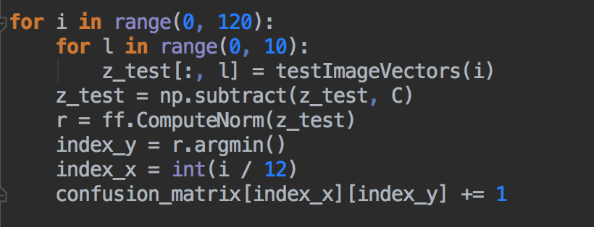

Matrix:

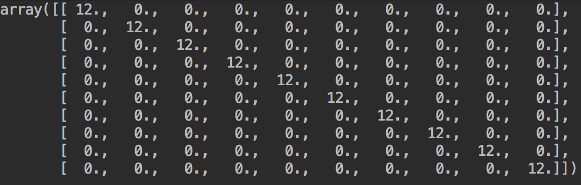

Overall accuracy:

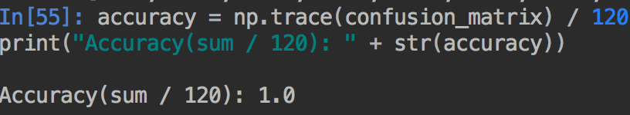

* 1. For Fusion(α = 0.5):

Code for confusion matrix:

* + - * 1. 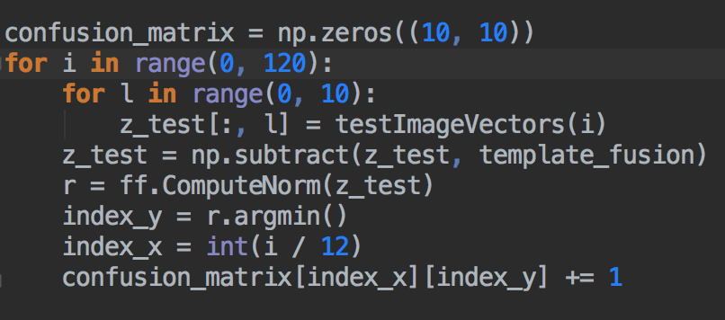
        2. Matrix:
        3. 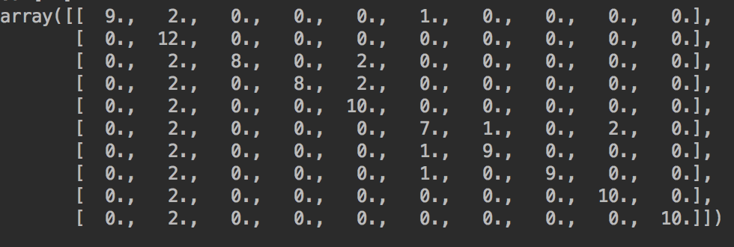
        4. Overall accuracy:
        5. 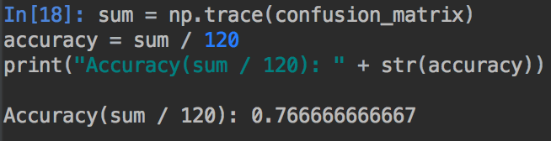

1. Compare the results for PCA feature and LDA feature, which feature is better? Why?

LDA is better.

It can be seen that the PCA dimension of the sample after the scatter plot, it's the whole sample along the X axis of the largest variance, and along the Y axis of the variance.

And for the LDA figure, X axis direction has the best area of various types of samples, followed by the Y axis.

In general, if only for classification, the effect of LDA dimension reduction is better than PCA. PCA is more suitable to explain the magnitude of the change in the sample in different directions.

1. Let α = 0.1, 0.2, . . . , 0.9. Retrain your classifier for fused feature and re-calculate its accuracy for each α. Plot accuracy versus α for different α. Submit this plot. What do you observe?
   1. α = 0.1

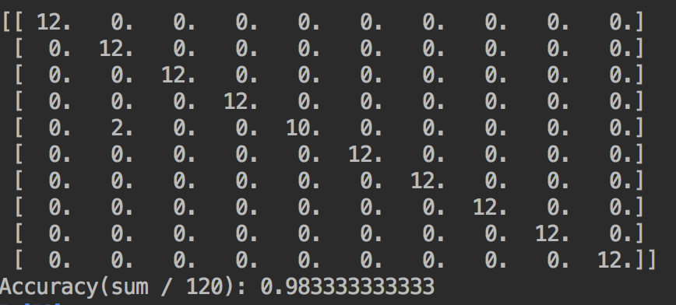

* 1. α = 0.2

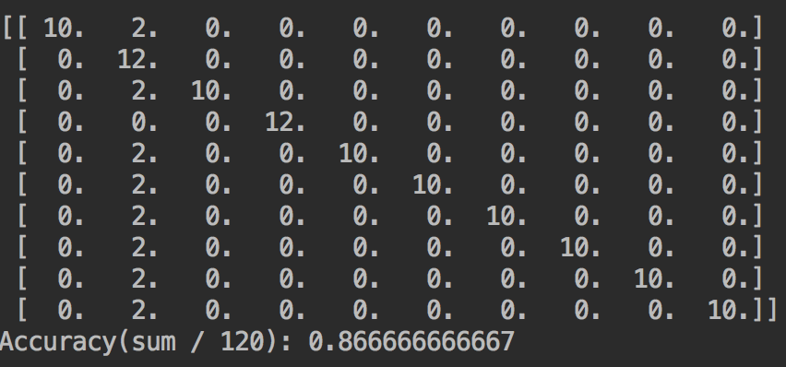

* 1. α = 0.3

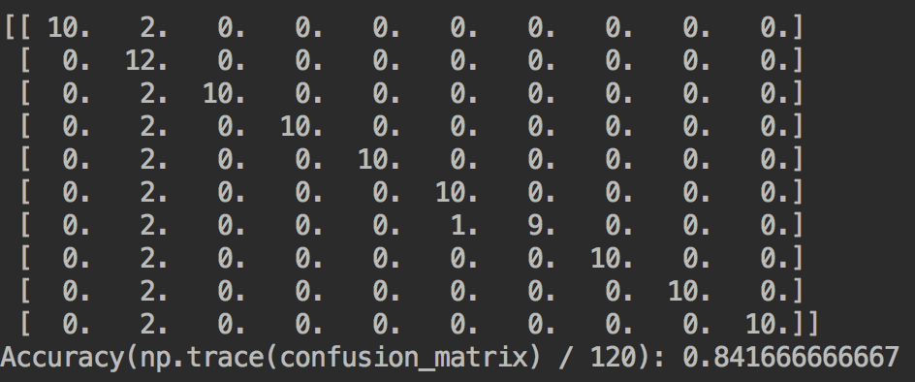

* 1. α = 0.4

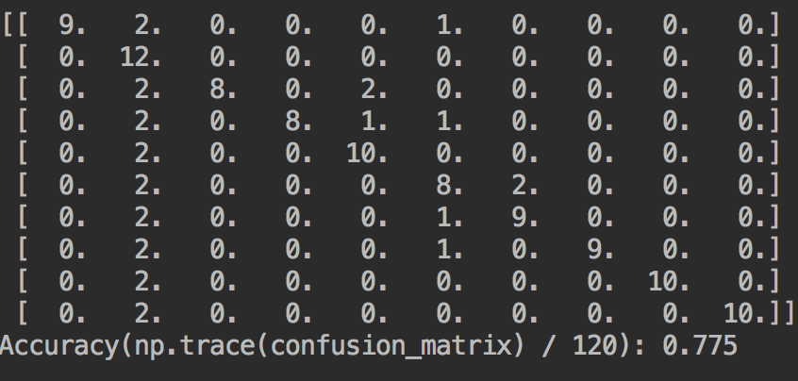

* 1. α = 0.5

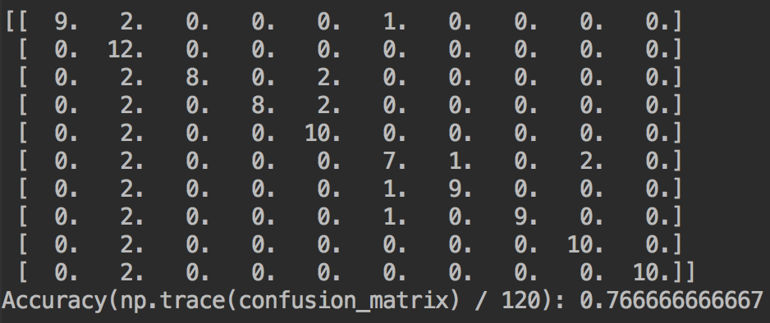

* 1. α = 0.6

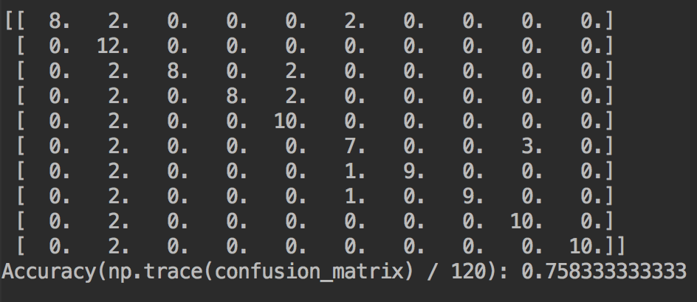

* 1. α = 0.7

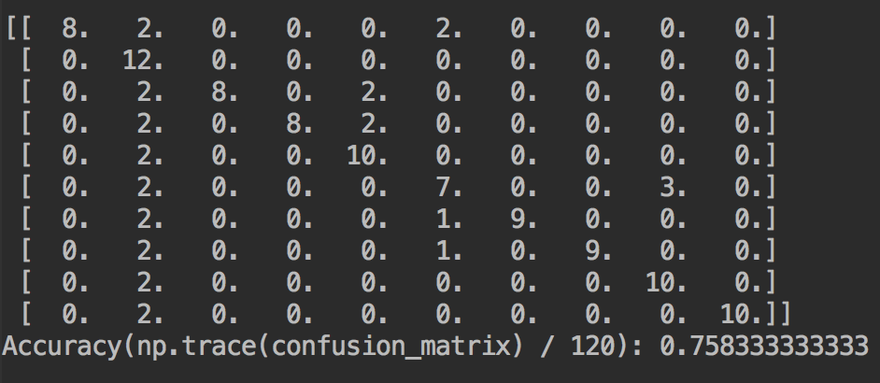

* 1. α = 0.8

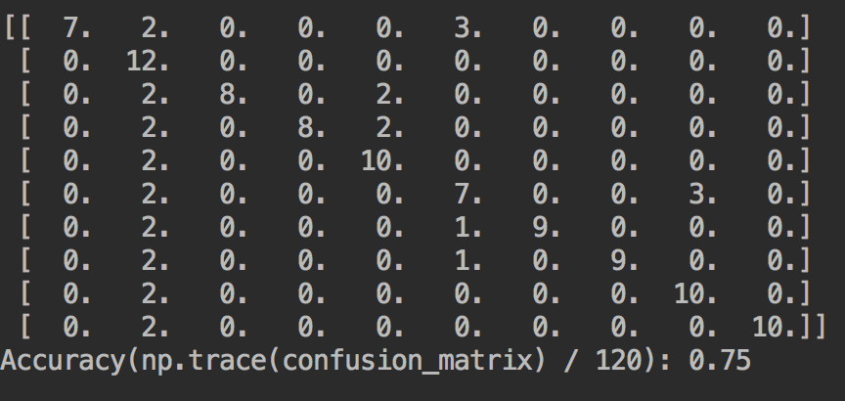

* 1. α = 0.9

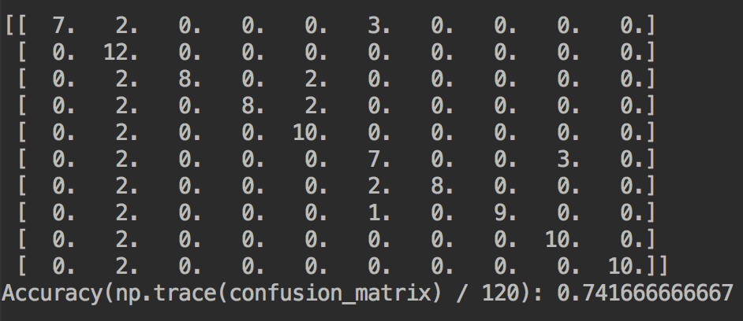

* 1. Conclusion: The overall accuracy will decrease with α increasing.

1. Does the fused feature outperform both PCA feature and LDA feature? Why?

No.

The performance of fused feature is between PCA feature and LDA. In general, LDA feature performs best, followed by fused feature and PCA feature respectively.