Neuroscience PHD Thesis

Title – How To Crush Developmental Serpent Heads, Slay Ideological Dragons, and Dine On Rampaging Demon Manifestations In Hell

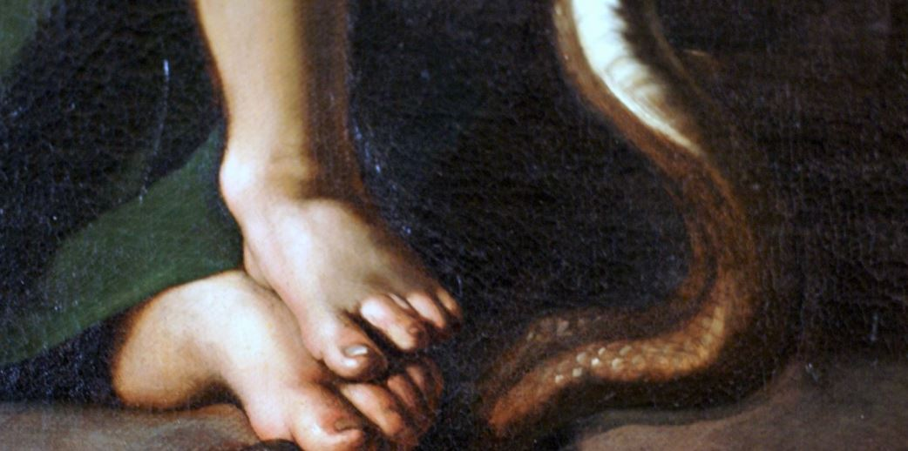

(Indeed we all have a role play)

By +Raphael+ (Michael Sinyangwe)

Submitting In the 2030s Or Beyond At Some Point… Hopefully

Spiritual Sponsor – My Grace, His Eminence Vincent Gerard Cardinal Nichols, Titular Bishop of Othona, Archbishop of Westminster, President of the Catholic Bishops' Conference of England and Wales, and ‘Joshi In To the Offing’

Financial Sponsor – William the Fourth, By the Grace Of God, Of the United Kingdom Of Great Britain and Northern Ireland, and Of His Other Realms and Territories, ‘King Out Of the Inning’, Head Of the Commonwealth, Defender Of the Faith

The Obsidian Care Lifecycle

1. **CREATION** – ‘Planning’ Psychosis Scenarios
2. **SALVATION** – ‘Modelling’ Insight Thresholds
3. **SANCTIFICATION** – ‘Informing’ Trauma Interventions
4. **PERFECTION** – ‘Optimising’ Preventative Routines
5. **RESURRECTION** – ‘Obtaining’ Miraculous Healings

Contents

Introduction 6

Other Sections 6

Conclusion 6

Appendix 7

# Introduction

The Quick Trick… Commit (Your Will As A Child), Control (Your Tongue As A Youngster), and Centre (Your Life As A Man).

# Other Sections

The Long Story Cut Short… In motion and writing as I don’t sleep.

# Conclusion

The Loud Truth… Just repeatedly shout SUDERA!

# Appendix

+Sacraments

+Sacramentals

+Relics

+Prayers

+Comfort with being in your own company

(These things will all be of great help)