PRACTICAL NO: 1
Aim: Create table sales_order (to store client's orders) and sales_order_details (used to store client's orders with details of each product ordered) Retrieve the structure of the tables. Retrieve all the attributes of all the tables.
- Connect to Oracle:
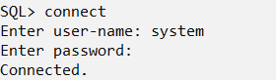
- Create user sales_user and give all permissions:
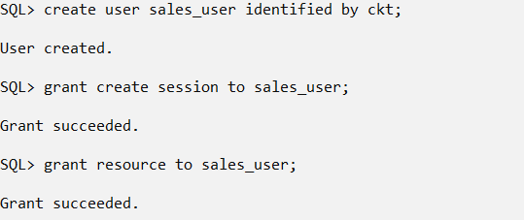
- Create user sales_dtls and give all permissions:
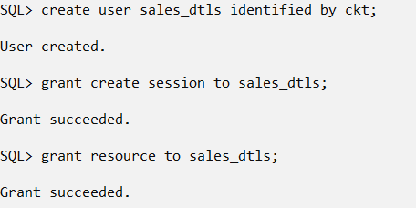

- Connect as sales_user:
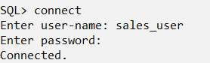
- Creating Table sales_order:
SQL> CREATE TABLE sales_order (order_id NUMBER(5), client_name VARCHAR2(30), order_date DATE);

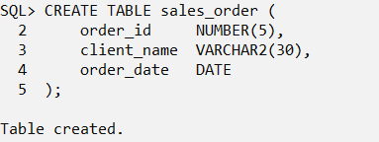
- Inserting values into the table:
INSERT INTO sales_order VALUES (101, 'Alice Smith', TO_DATE('2025-10-10', 'YYYY-MM-DD'));
INSERT INTO sales_order VALUES (102, 'Bob Johnson', TO_DATE('2025-10-11', 'YYYY-MM-DD'));
INSERT INTO sales_order VALUES (103, 'Charlie Davis', TO_DATE('2025-10-12', 'YYYY-MM-DD'));
INSERT INTO sales_order VALUES (104, 'Diana Moore', TO_DATE('2025-10-13', 'YYYY-MM-DD'));
INSERT INTO sales_order VALUES (105, 'Ethan Brown', TO_DATE('2025-10-14', 'YYYY-MM-DD'));
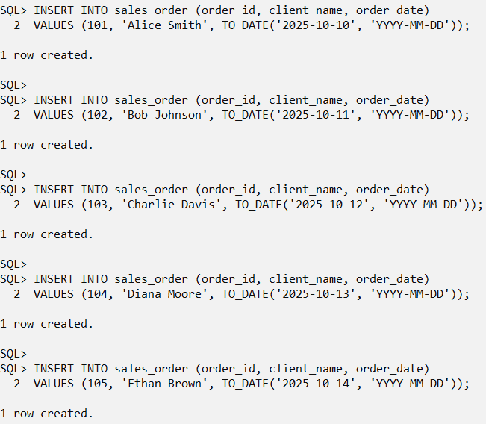
- Display Table:
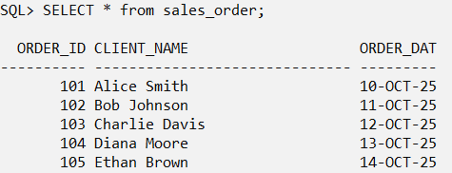

- Connect as sales_dtls user:
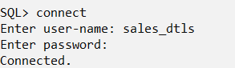
- Create Table sales_order_details:
SQL> CREATE TABLE sales_order_details (order_id NUMBER(5), product_name VARCHAR2(30), quantity NUMBER(5), price NUMBER(10, 2));

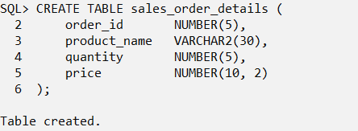
Inserting values into the Table:
SQL> INSERT INTO sales_order_details VALUES (101, 'Laptop', 1, 75000.00);
SQL> INSERT INTO sales_order_details VALUES (102, 'Smartphone', 2, 30000.00);
SQL> INSERT INTO sales_order_details VALUES (103, 'Headphones', 3, 2500.00);
SQL> INSERT INTO sales_order_details VALUES (104, 'Monitor', 1, 12000.00);
SQL> INSERT INTO sales_order_details VALUES (105, 'Keyboard', 2, 1500.00);
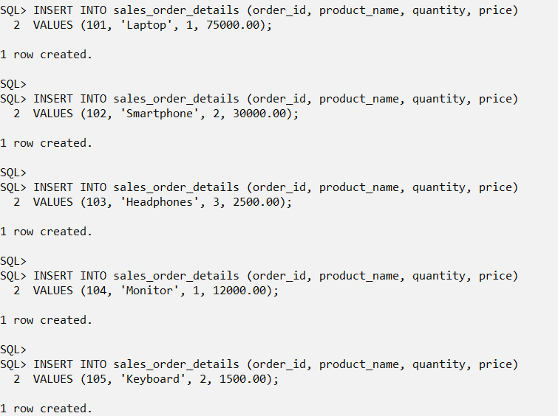
- Display Table sales_order_details:
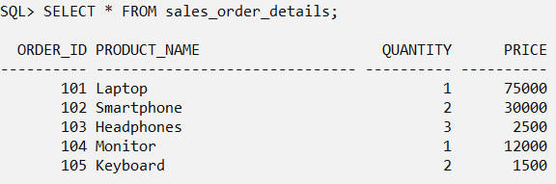

- Connect as system user:
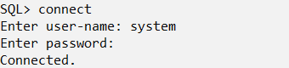

- Creating Public Database Links at the Central Machine:
CREATE PUBLIC DATABASE LINK sales_link1
CONNECT TO sales_user IDENTIFIED BY ckt
USING 'XE';
CREATE PUBLIC DATABASE LINK sales_link2
CONNECT TO sales_dtls IDENTIFIED BY ckt
USING 'XE';
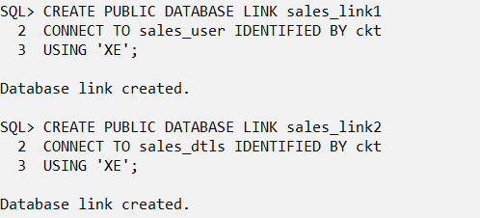

- Retrieving all the records from sales_link1 and sales_link2:
SELECT
sales_order.order_id@sales_link1,
sales_order.client_name,
sales_order.order_date,
sales_order_details.product_name,
sales_order_details.quantity,
sales_order_details.price
FROM
sales_order@sales_link1,
sales_order_details@sales_link2
WHERE
sales_order.order_id@sales_link1 = sales_order_details.order_id@sales_link2;
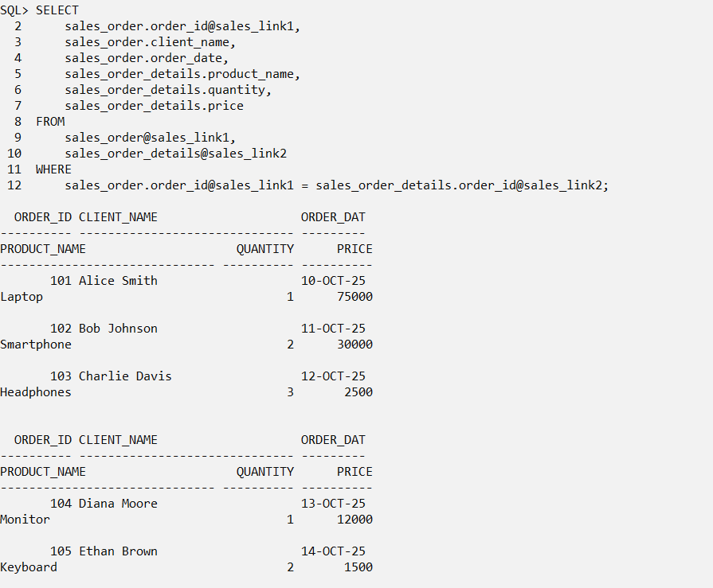

Practical No. 02
Aim : Create a global conceptual schema Emp(Eno;Ename;Address;Email;Salary)
and insert 5 records. Divide Emp into vertical fragments Emp1(Eno;Ename;Address)
and Emp2(Eno;Email;Salary) on two different nodes.
Fire the following queries:
1. Find the salary of an employee where employee number is known.
2. Find the Email where the employee name is known.
3. Find the employee name and Email where employee number is known.
4. Find the employee name whose salary is > 5000.
- Connect to the oracle
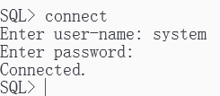
- Create user scott and give all the permission.
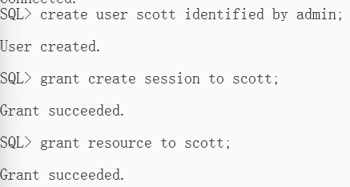
- Create user mscit and give all the permission.
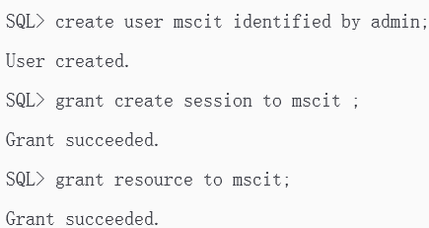
- Connecting as scott User:

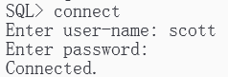

- Creating Emp1 At Node1 :
SQL> create table emp1( eno number(5), ename varchar2(20), address varchar2(30));
- Inserting values into the table:
SQL> insert into emp1 values(1,'kalyani','panvel');
SQL> insert into emp1 values(2,'shruti','parel');
SQL> insert into emp1 values(3,'sia','Santacruz');
SQL> insert into emp1 values(4,'Kritika','Vashi');
SQL> insert into emp1 values(5,'Bhavika','Kamote');
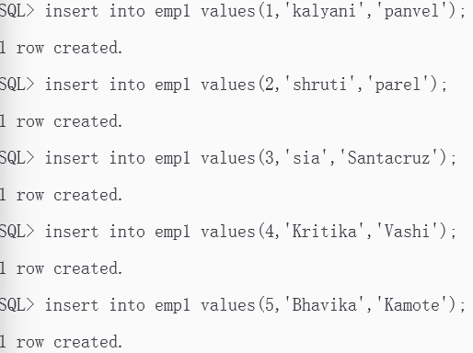
- Display table
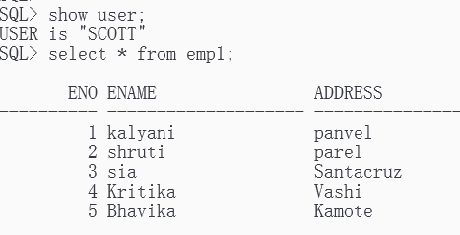
- Connecting as mscit User
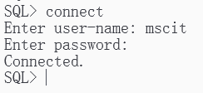
- Creating Emp1 At Node2
SQL>create table emp2( eno number(5), email varchar2(20), salary number(8));

- Inserting values into the table :
SQL>insert into emp2 values(1,'kalyani@gmail.com',11000);
SQL>insert into emp2 values(2,'shruti@yahoo.com',5500);
SQL>insert into emp2 values(3,'sia@gmail.com',5100);
SQL>insert into emp2 values(4,'Kritika@yahoo.com',4500);
SQL>insert into emp2 values(5,'Bhavika@yahoo.com',3000);
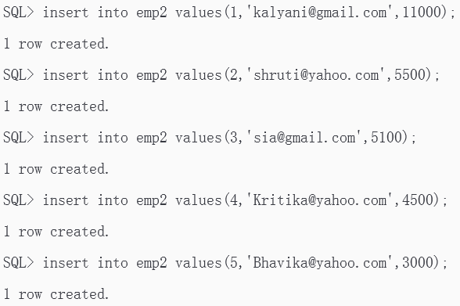
- Display table
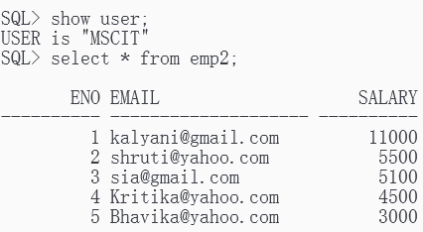
- Connecting as System User:
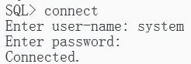
- Creating Public Database Links at the Central Machine:
create public database link emp_link1 connect to scott identified by admin using 'XE';
create public database link emp_link2 connect to mscit identified by admin using 'XE';
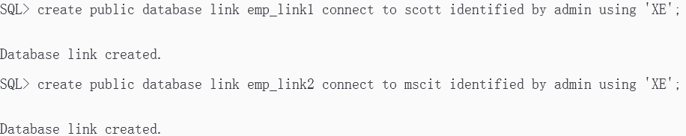

- Retrieving the records from emp_link1 and emp_link2:
select emp1.eno@emp_link1,ename,address,email,salary from emp1@emp_link1,emp2@emp_link2 where emp1.eno@emp_link1 = emp2.eno@emp_link2;
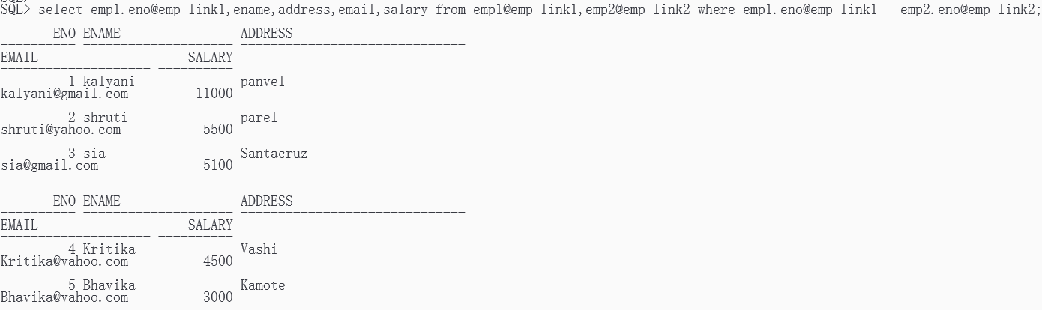

- To Find the salary of an employee where employee number is known:
select emp1.eno@emp_link1,ename,salary from
emp1@emp_link1,emp2@emp_link2 where emp1.eno@emp_link1 = emp2.eno@emp_link2 and emp2.eno@emp_link2 = 1;
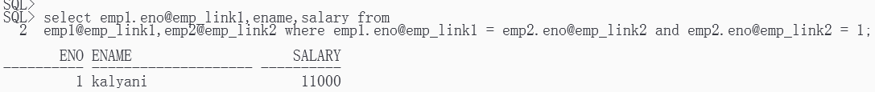
- To Find the Email where the employee name is known:
select emp1.eno@emp_link1,emp2.email@ emp_link2 from emp1@emp_link1,emp2@emp_link2 where emp1.ename@emp_link1 =
'Kritika' and emp1.eno@emp_link1 = emp2.eno@emp_link2;
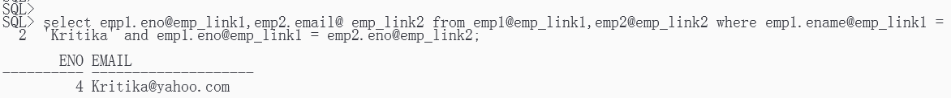
- To Find the employee name and Email where employee number is known:
select emp1.eno@emp_link1,ename,email from emp1@emp_link1,emp2@emp_link2 where emp1.eno@emp_link1 = 2 and emp1.eno@emp_link1 = emp2.eno@emp_link2;

18. To Find the employee name whose salary is > 5000.
select emp1.ename@emp_link1,emp2.salary@emp_link2 from emp1@emp_link1,emp2@emp_link2 where emp2.salary@emp_link2 > 5000 and emp1.eno@emp_link1 = emp2.eno@emp_link2;
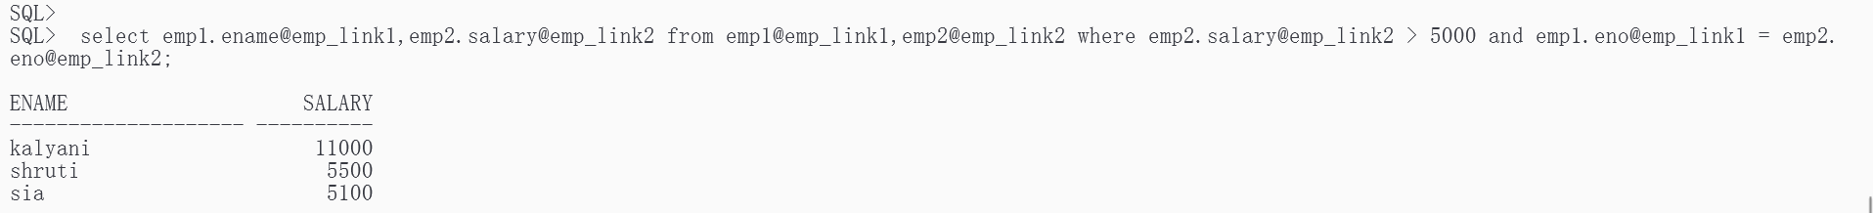

Practical No. 03
Aim : For a given global conceptual schema, divide the schema into horizontal fragments and place them on different nodes. Execute queries on these fragments that will demonstrate a distributed database environment.

- Connect to the oracle
- Create user scott and give all the permission.
- Create user mscit and give all the permission.
- Connecting as scott User:
- Creating Emp1 At Node1 :
SQL> create table emp11( eno number(6), ename varchar2(15), address varchar2(20), email varchar2(15), salary number(6));

6. Inserting values into the table:
SQL> insert into emp11 values(1001,'Suhas','Pune','suhas@gmail.com',10000);
SQL> insert into emp11 values(1002,'Rajesh','Thane','raj@gmail.com',20000);
SQL> insert into emp11 values(1004,'Mahesh','Nashik','mm@yahoo.com',3000);
SQL> insert into emp11 values(1006,’Prakash’,’Nagpur’,’pk@rediff.com’,5000);
SQL> insert into emp11 values(1008,’Rahul’,’Pune’,’rahul@dot.com’,6000);
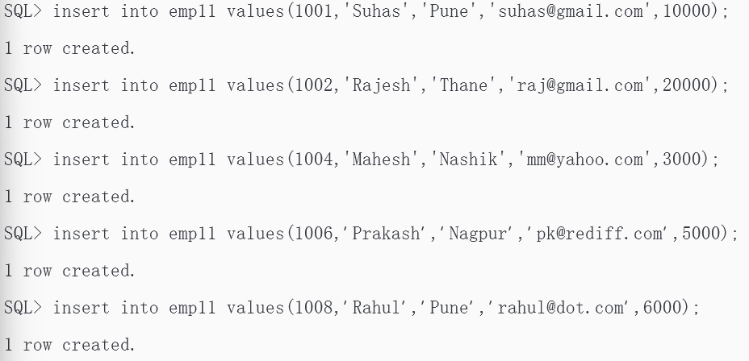
7. Display table
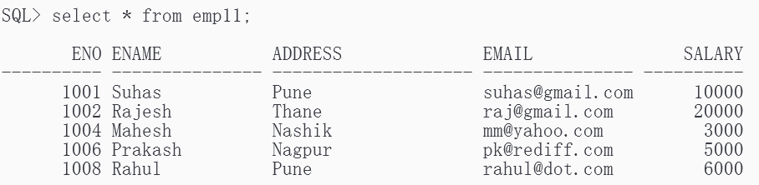
8.Connect as mscit User :
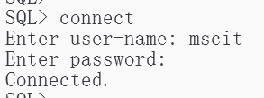
9. Creating Employee2 At Node2 :
SQL>create table employee12(eno number(6), ename varchar2(15), address
varchar2(20), email varchar2(15), salary number(6));
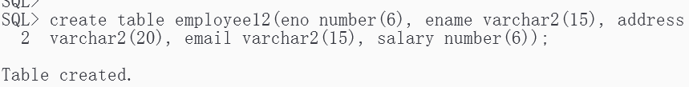

10. .Inserting values into the table :
SQL> insert into employee12 values(1003,'Shiva','Banglore','ss@hotmail.com',4000);
SQL> insert into employee12 values(1005,'Sita','Delhi','sita@yahoo.com',7000);
SQL> insert into employee12 values(1007,'Ramesh','Kerala','r_sh@yahoo.com',3000);
SQL> insert into employee12 values(1009,'Rakesh','Pune','rak@yahoo.com',2000);
SQL> insert into employee12 values(1010,'Sudha','Nashik','sudha@yahoo.com',6000);
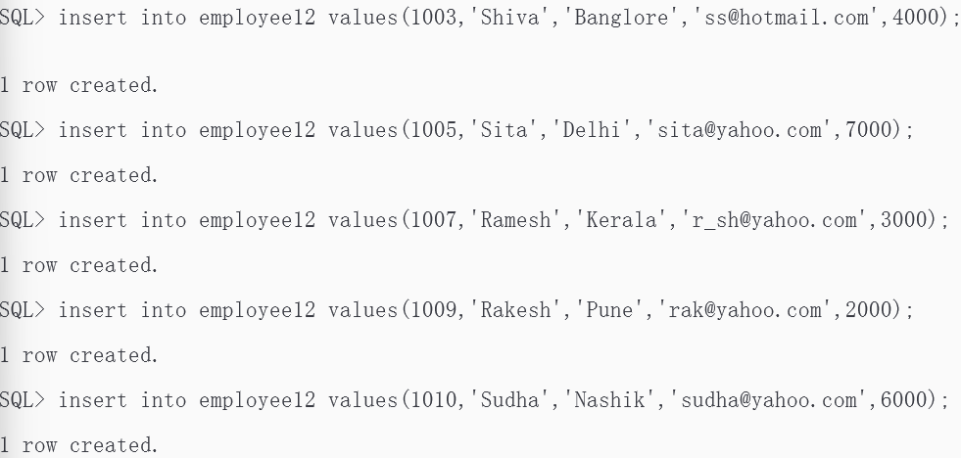

11.Show table:
select * from employee12;
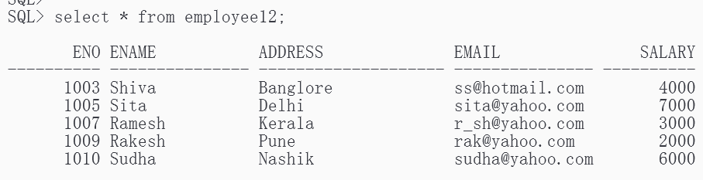
12.Connecting as System User:
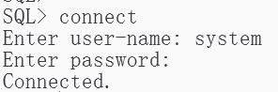
13.Creating Public Database Links at the Central Machine:
(If already exiting - drop public database link emp_link11;)
create public database link emp_link11 connect to scott identified by admin
using 'XE';
create public database link emp_link12 connect to mscit identified by admin
using 'XE';
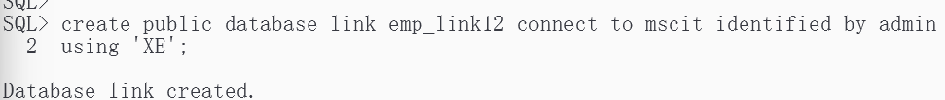

14.Retrieving the records from emp_link11:
select * from emp11@emp_link11;
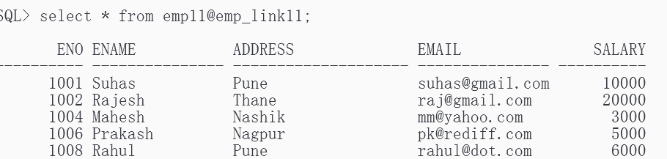
15.Retrieving the records from emp_link12:
select * from employee12@emp_link12;
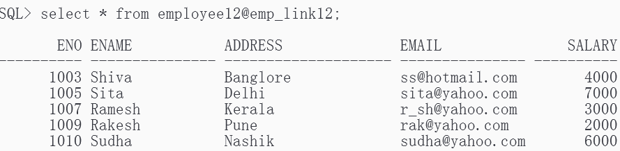
16. A)To Find the salary of all employees :
select distinct eno, Salary from emp11@emp_link11
union
select distinct eno, Salary from employee12@emp_link12 ;
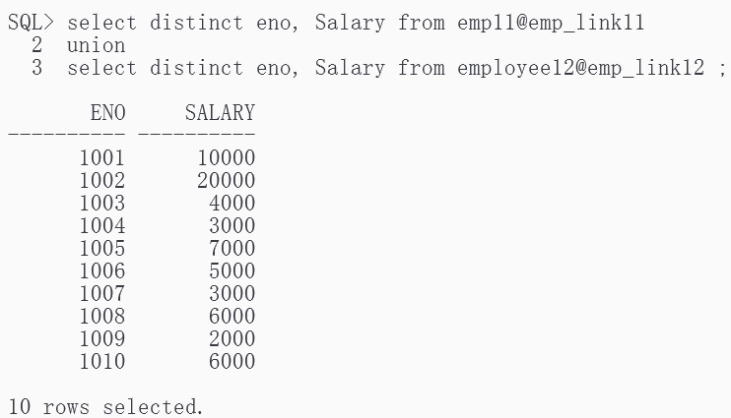

B) To Find the Email of all employees where salary > 5,000:
select distinct eno, email from emp11@emp_link11 where salary > 5000
union
select distinct eno, email from employee12@emp_link12 where salary > 5000 ;
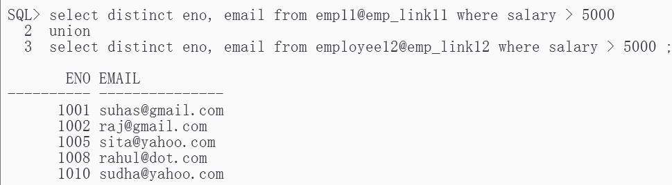
C) To Find the employee name and Email where employee number is known.
select distinct eno, email from emp11@emp_link11 where eno=1008
union
select distinct eno, email from employee12@emp_link12 where eno=1008 ;
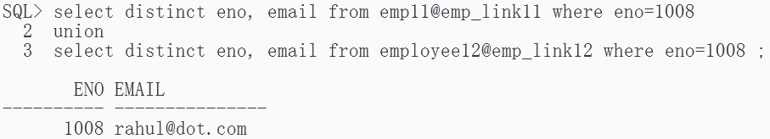
D) To Find the employee name and address where employee number is known:
select distinct ename, address from emp11@emp_link11 where eno=1010
union
select distinct ename, address from employee12@emp_link12 where eno=1010 ;
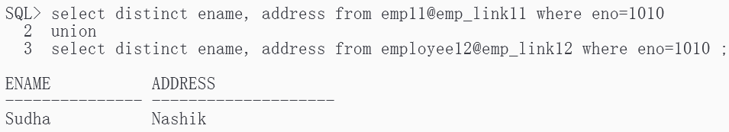

Practical No. 04
Aim : Place the replication of global conceptual schema on different nodes and execute queries that will demonstrate a distributed database environment
Create a global conceptual schema emp(eno,ename,address,email,salary)and insert 10
records. Store the replication of emp in two different nodes and fire the following
queries:
1. Find the salary of all employees.
2. Find the email of all employees where salary=15000.
3. Find the employee name and email where employee number is known.
4. Find the employee name and address where employee number is known.

1.Create table Emp
create table Employe ( Eno number(3), Ename varchar2(20), Address varchar2(30),
Email varchar(20), Salary number );
2. Create table Emp2
create table Employe2 ( Eno number(3), Ename varchar2(20), Address varchar2(30), Email varchar(20), Salary number );
3. Creating the Database Links:
CREATE DATABASE LINK "LINK1" USING 'XE';
CREATE DATABASE LINK "LINK2" USING 'XE';
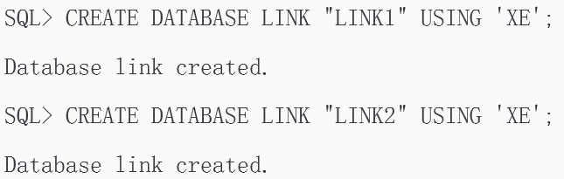
4. Creating Triggers :
1.Insert_data
create or replace Trigger insert_data
after insert on Employe
for each row
begin
insert into Employe2@LINK2
values (:new.Eno,:new.Ename,:new.Address,:new.Email,:new.Salary); end;
/
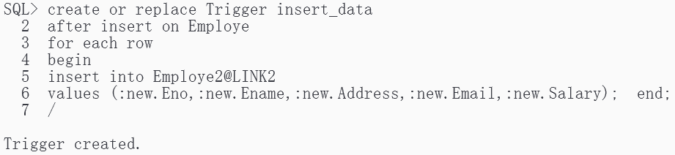
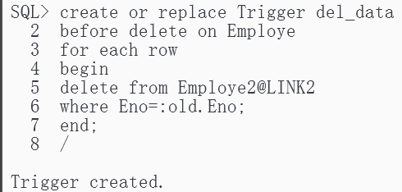
2.delete data
create or replace Trigger del_data
before delete on Employe
for each row
begin
delete from Employe2@LINK2
where Eno=:old.Eno;
end;
/
3.Update data :
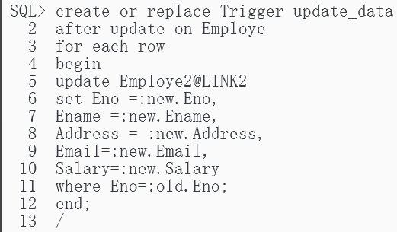
create or replace Trigger update_data
after update on Employe
for each row
begin
update Employe2@LINK2
set Eno =:new.Eno,
Ename =:new.Ename,
Address = :new.Address,
Email=:new.Email,
Salary=:new.Salary
where Eno=:old.Eno;
end;
/
5. Inserting Data into EMP table:
SQL > insert into Employe values(111,'Shweta','Goregaon','shweta@yahoo.com',100000);
SQL > insert into Employe values(112,'Sweha','Goregaon','sweha@yahoo.com',10400);
SQL > insert into Employe values(113,'Lata','Virar',’lata@yahoo.com',100000);
SQL > insert into Employe values(114,'Sheejal','Goregaon','sheejal@yahoo.com',15000);
SQL > insert into Employevalues(115,'Shalmali','Jogeshwari','shalmali@yahoo.com',5000); SQL > insert into Employe values(116,'Meghna','Borivali','meghna@yahoo.com',100000);
SQL > insert into Employe values(117,'Swati','Andheri','swati@yahoo.com',15000);
SQL > insert into Employe values(118,'Reena','Kandivali','reena@yahoo.com',300000);
SQL > insert into Employe values(119,'Niyati','Malad','niyati@yahoo.com',15000);
SQL > insert into Employe values(120,'Ekta','Kandivali','ekta@yahoo.com',20000);

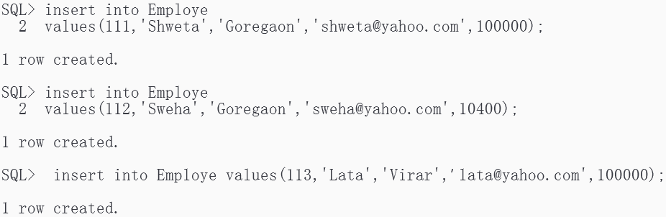
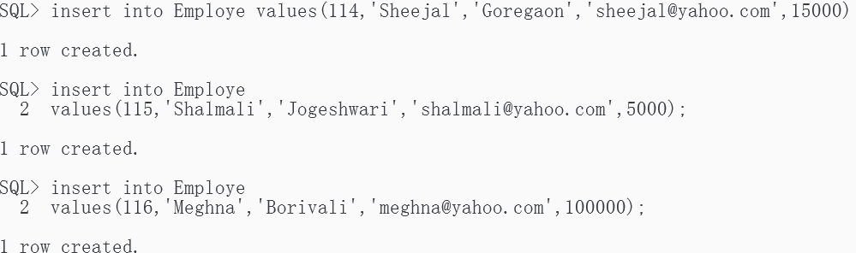
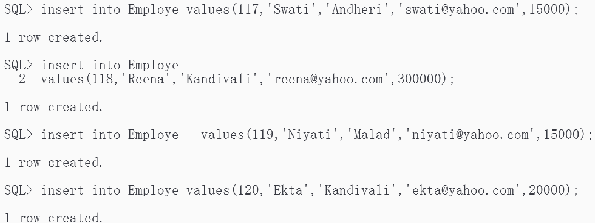
- ) Select statement from the Master and the Replicated table:
select * from Emplye@LINK1;
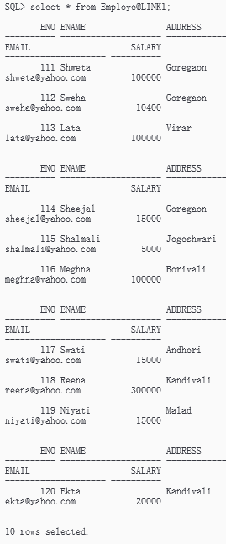

select * from Employe2@LINK2;
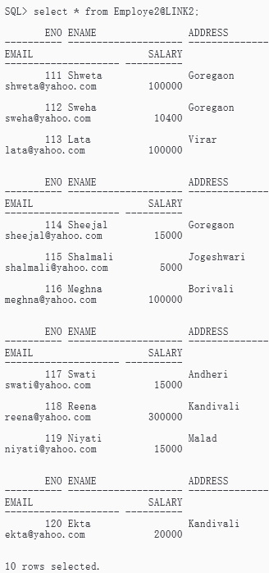

7. ) Query to find the Salary of all Employees from the Master and Replicated Table:
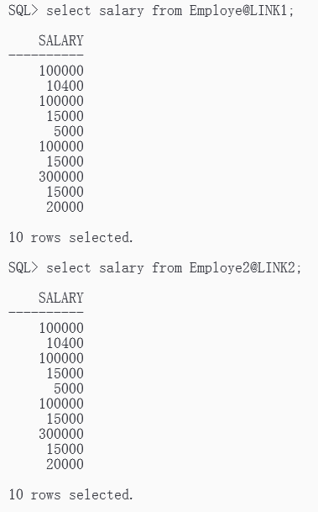
select salary from Employe@LINK1;
select salary from Employe2@LINK2;

8. ) Select Statement to display the email of employees with salary 15000, on the master and the replicated table:
select email from Employe@LINK1 where salary = 15000;
select email from Employe2@LINK2 where salary = 15000;
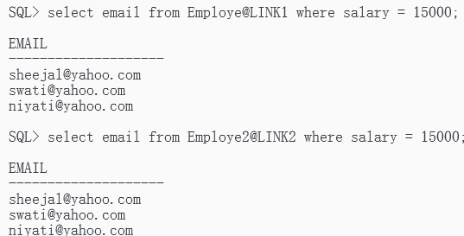
9. ) Select statement to list the employee name and Email where employee number is known from the replicated and master table:
select ename, email from Employe@LINK1 where eno = 120 and ename = 'Ekta'; select ename, email from Employe2@LINK2 where eno = 120 and ename = 'Ekta';
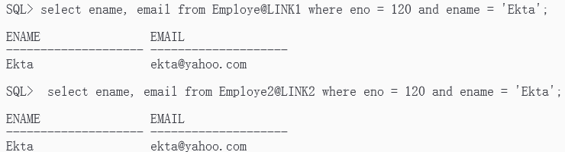
10.) Select statement to list the employee name and address where employee number is known from the replicated and master table:
select ename, address from Employe@LINK1 where eno = 111;
select ename, address from Employe2@LINK2 where eno = 111;
select ename, email from Employe2@LINK2 where eno = 111;
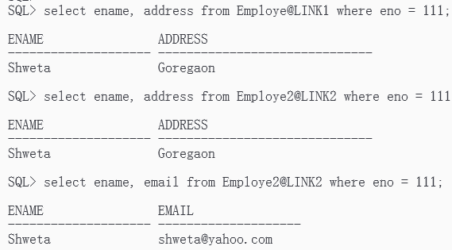
Practical No. 05
Aim : Create different types that include attributes and methods. Define tables for these types by adding a sufficient number of tuples. Demonstrate insert, update and delete operations on these tables. Execute queries on them
1. Create different Types and Tables
SQL> Create or replace type AddrType1 as object(
Pincode number(5),
Street char(20),
City varchar2(50),
state varchar2(40),
no number(4) )
/
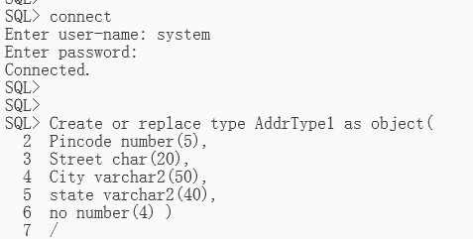
SQL> create or replace type BranchType as object(
address AddrType1,
phone1 integer,
phone2 integer )
/
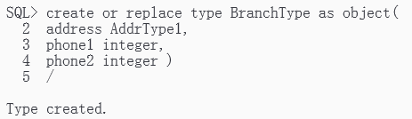
SQL> create or replace type BranchTableType as table of BranchType; /
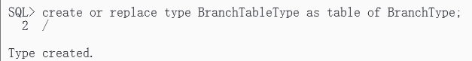
SQL> create or replace type AuthorType as object(
name varchar2(50),
addr AddrType1 )
/
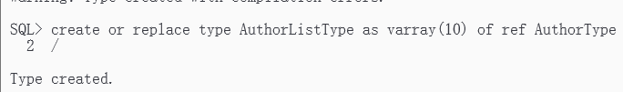

SQL> create table authors of AuthorType;
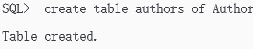
SQL> create or replace type AuthorListType as varray(10) of ref AuthorType /
SQL> create or replace type PublisherType as object(
name varchar2(50),
addr AddrType1, branches BranchTableType)
/
SQL> create table Publishers of PublisherType NESTED TABLE branches STORE as branchtable;
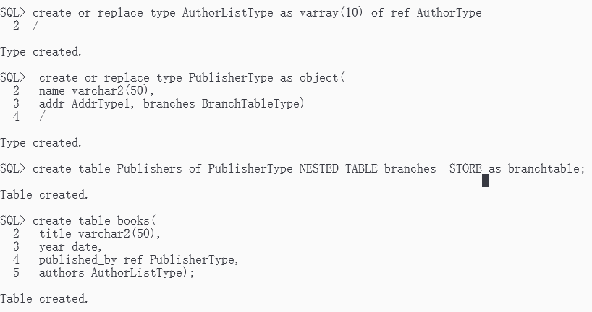
SQL> create table books(
title varchar2(50),
year date,
published_by ref PublisherType,
authors AuthorListType);
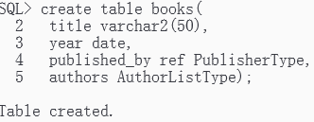
2. Insertion of different values in the tables
Table Name1: Authors
Format: Authors(name, addr:<pincode,street,city,state,no>)
/*Here addr is the name of an object-valued attribute, which has 5 components.*/
SQL> insert into Authors values('Rabiner', AddrType1(5002,'sstreet','pune','mha',04));
SQL> insert into Authors values('Rabiner', AddrType1(7007,'sstreet','mumbai','mha',1007));
SQL> insert into Authors values('Schiller', AddrType1(7008,'nstreet','nasik','mha',08));
SQL> insert into Authors values('Jerry', AddrType1(7003,'dstreet','mumbai','mha',1003));
SQL> insert into Authors values('Paulraj', AddrType1(7008,'sstreet','mumbai','mha',1007));
SQL> insert into Authors values('Elmasri', AddrType1(7006,'nstreet','mumbai','mha',1006));
SQL> insert into Authors values('Ramakrishnan', AddrType1(8002,'dstreet','pune','mha',1003));
SQL> insert into Authors values('Jerry', AddrType1(8003,'dstreet','pune','mha',1003));

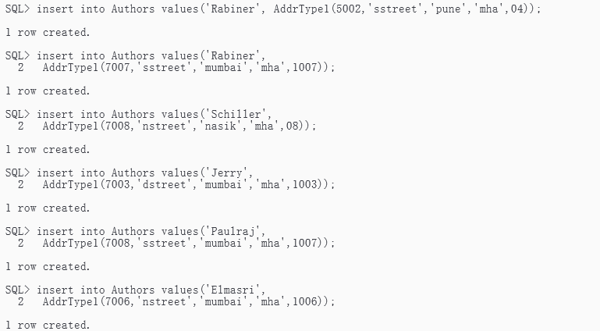
Table name2: Publishers
Format: Publishers(name,addr:<pincode,street,city,state,no>, branches:setof<address:<pincode,street,city,state,no>,phone1,phone2>)
/*where addr is an object-valued attribute. Branches is a complex-valued attribute, in this case a nested table where each element in the table has 3 parts: an address and two phones*/
SQL> insert into Publishers values('Pearson', AddrType1(4002,'rstreet','mumbai','mha',03),
BranchTableType(BranchType( AddrType1(5002,'fstreet','mumbai','mha',03),23406,69896)));
SQL> insert into Publishers values('ekta', AddrType1(7007,'sstreet','mumbai','mha',1007),
BranchTableType(BranchType( AddrType1(7007,'sstreet','mumbai','mha',1007),4543545,8676775)));
SQL> insert into Publishers values('joshi', AddrType1(7008,'sstreet','mumbai','mha',1007),
BranchTableType(BranchType( AddrType1(1002,'sstreet','nasik','mha',1007),456767,7675757))); SQL> insert into Publishers values('ekta', AddrType1(7002,'sstreet','pune','mha',1007),
BranchTableType(BranchType( AddrType1(1002,'sstreet','pune','mha',1007),4543545,8676775))); SQL> insert into Publishers values('wiley', AddrType1(6002,'sstreet','nasik','mha',1007),
BranchTableType(BranchType(
AddrType1(6002,'sstreet','nasik','mha',1007),4543545,8676775)));
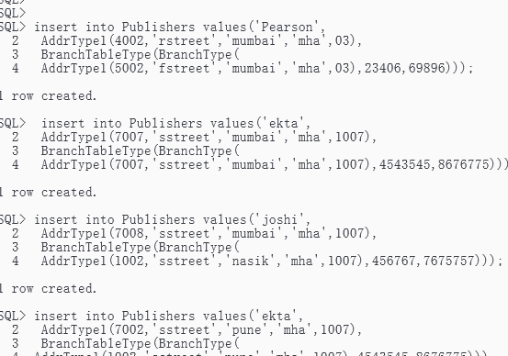
Table Name3: books
Format: Books(title,year,published_by: ref<Publishers>, authors:list of refAuthor)
/*Where published_by is a reference to elements of the table Publishers; authors is a complex-valued attribute, in this case a list of references to objects of the type author(managed by table ‘Author’.*/
SQL> insert into books select 'DSP','28-may-1983',ref(pub),AuthorListType(ref(aut)) from Publishers pub,Authors aut where pub.name='joshi' and aut.name='Elmasri';
SQL>insert into books select 'compiler','09-jan-1890',ref(pub),AuthorListType(ref(aut)) from Publishers pub,Authors aut where pub.name='wiley' and aut.name='Jerry';
SQL> insert into books select 'c','25-may-1983',ref(pub),AuthorListType(ref(aut)) from Publishers pub,Authors aut where pub.name='Pearson' and aut.name='Rabiner';
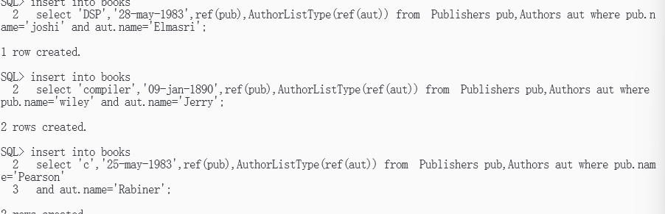
3. Firing queries on the created tables.
a) List all of the authors that have the same pin code as their publisher:
SQL> select a.name from authors a, publishers p where a.addr.pincode = p.addr.pincode;
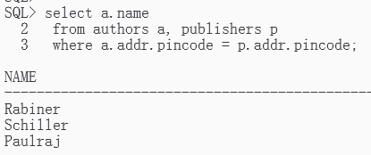
b) List all books that have 2 or more authors:
SQL> select * from books b where 1 < ( select count(*) from table(b.authors));
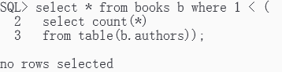
c) List the name of the publisher that has the most branches:
SQL> select p.name from publishers p, table(p.branches) group by p.name having count(*)> = all (select count(*) from publishers p, table(p.branches) group by name);
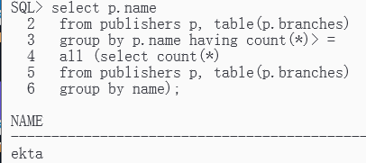
d) Name of authors who have not published a book: SQL> select a.name
from authors a where not exists( select b.title from books b, table(select authors from books b1
where b.title = b1.title) a2 where a.name = name);
OR
SQL> select a.name from authors a where not exists( select b.title from books b, table(b.authors)
where a.name = name);
/*Here all the branches belonging to 'ekta' is moved(copied) to wiley's branch i.e wiley will have its own branch with 3 more branches of ekta that ekta has*/
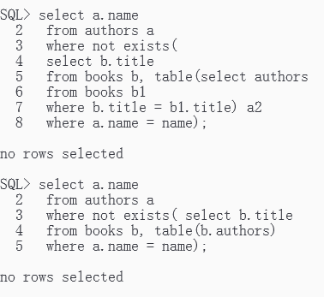
e) List all authors who have published more than one book:
SQL> select a.name from authors a, books b, table(b.authors) v where v.column_value = ref(a)
group by a.name having count(*) > 1;
/*This query will give the names of those authors who have published a book*/
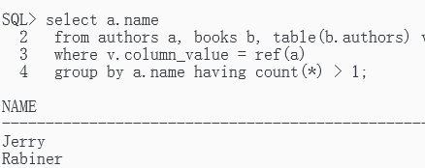
f) List all books (title) where the same author appears more than once on the list of authors (assuming that an integrity constraint requiring that the name of an author is unique in a list of authors has not been specified).
SQL> select title from authors a, books b, table(b.authors) v where v.column_value = ref(a) group by title having count(*) > 1;
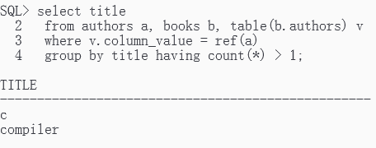

Practical No. 06
Aim : Create a temporal database and issue queries on it.
A) Create a table EMP_ANT, which stores the account number, name, and
valid time say, recruitment data retirement date. Insert records and fire the
following queries .
a) Find all the employees who join the company on 2/3/2001
b) Find all the employees who will retired on 2/3/2001

1. Table Definition:
SQL> CREATE TABLE EMP_ANT
(
ACC_NO NUMBER(10),
ANAME VARCHAR2(20),
JOIN_DATE DATE,
RETIRE_DATE DATE
);
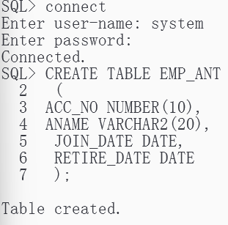
2. Insertion of different values in the tables.
Table Name: EMP_ANT
Format: EMP_ANT(ACC_NO, ANAME, JOIN_DATE ,RETIRE_DATE)
SQL> INSERT INTO EMP_ANT VALUES(1, 'AJITI', '02-MAR-2001', '21-MAR 2004');
SQL> INSERT INTO EMP_ANT VALUES(2,'MUKESH', '04-APR-1999', '10- MAY-05');
SQL> INSERT INTO EMP_ANT VALUES(3, 'SANJAY', '01-DEC-1998', '10- JUNE-2002');
SQL> INSERT INTO EMP_ANT VALUES(4, 'PARAG', '15-MAY-2000', '02-MAR 2001');
SQL> INSERT INTO EMP_ANT VALUES(5, 'SIDDHESH', '10-AUG-1995', '9- AUG-2005');
SQL> INSERT INTO EMP_ANT VALUES(6, 'YATIN', '02-MAR-2001', '20-MAR 2005');
SQL> INSERT INTO EMP_ANT VALUES(7, 'KAVITA', '12-SEP-2000', '02-MAR 2001');

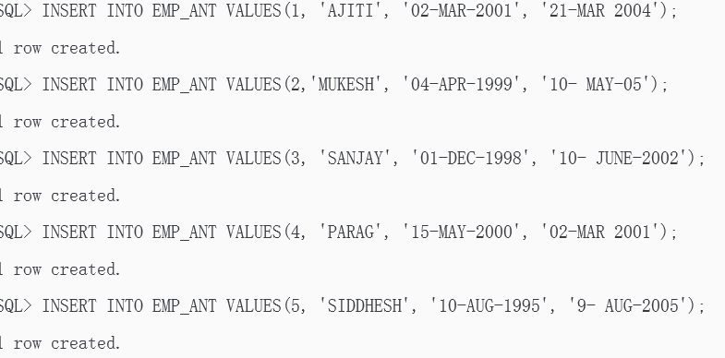
3. Display Table
SQL> SELECT * FROM EMP_ANT;
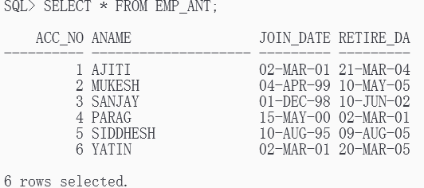
4. Firing queries on the created tables
1) Find the employees who have joining date 02-MAR-2001
SQL> SELECT * FROM EMP_ANT WHERE JOIN_DATE = '02-MAR-2001' ; 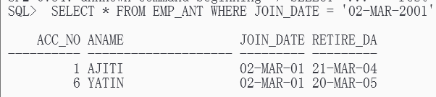
2) Find the employees who have retirement date 02-MAR-2001
SQL> SELECT *FROM EMP_ANT WHERE RETIRE_DATE = '02-MAR-2001'; 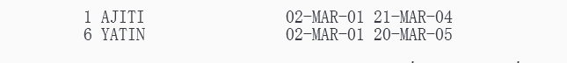
Question: Create a table tbl_shares, which stores the, name of company, number of shares, and price per share at transaction time. Insert records and fire the following queries.
a) Find all the names of a company whose share price is more than Rs.100 at 11:45 A.M.
b) Find the name of company which has highest shares price at 5.00 P.M.
b)
1. Table definition :
SQL> CREATE TABLE TEL_SHARES
( CNAME VARCHAR2(20), NOFSHARES NUMBER(5), PRICEPSHARE NUMBER(5),
TRANSTIME TIMESTAMP(6) );
2. Insertion of different values in the tables
Table Name: TBL_SHARES
Format: TBL_SHARES(CNAME, NOOFSHARES, PRICEPSHARE , TRANSTIME)
SQL> INSERT INTO TEL_SHARES VALUES('SAIL',250,25,SYSTIMESTAMP);
SQL> INSERT INTO TEL_SHARES VALUES('TATATELE',205,20,'05-JUN-04 11.45.00.000000 AM');
SQL> INSERT INTO TEL_SHARES VALUES('WIPRO',250,25,'10-MAR-03 06.15.00.000000 PM');
SQL> INSERT INTO TEL_SHARES VALUES('INFOSYS',115,15,'08-MAY-01 07.25.00.000000 AM');
SQL> INSERT INTO TEL_SHARES VALUES('BHARTI',140,12,'14-APR-05 05.30.00.000000 PM');
SQL> INSERT INTO TEL_SHARES VALUES('TAJHOTEL',310,30,'12-SEP-03 10.30.00.000000 AM');
SQL> INSERT INTO TEL_SHARES VALUES('MARUTI',100,250,'21-AUG-04 05.30.00.000000 PM');
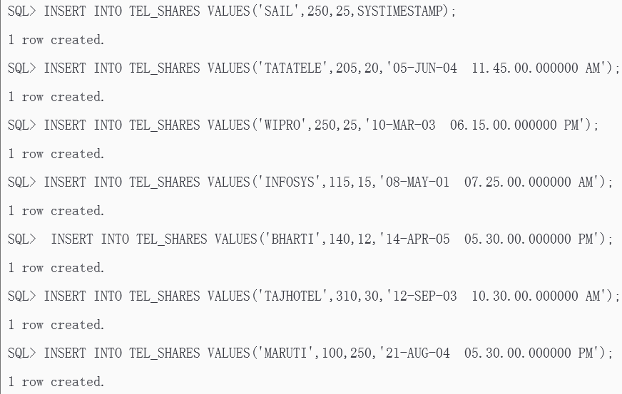
3. Display Table
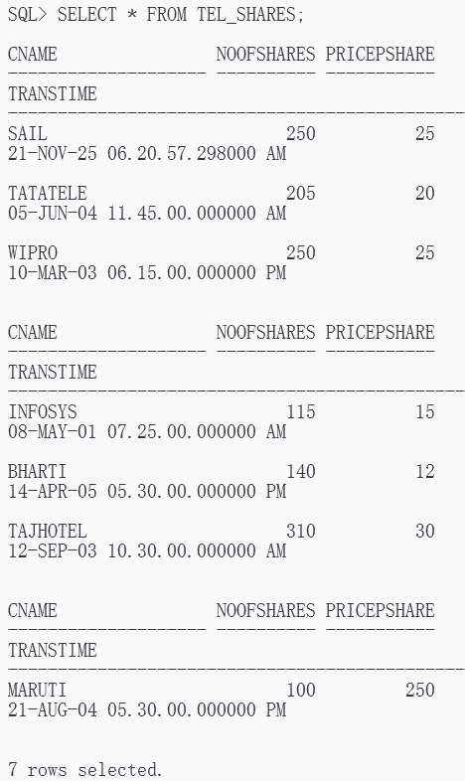
SQL> SELECT * FROM TEL_SHARES;
;

4. Queries:
a) Find all the names of a company whose share price is more than Rs.100 at 11:45 A.M.
SQL> SELECT CNAME FROM TEL_SHARES
WHERE PRICEPSHARE > 15
AND TO_CHAR(TRANSTIME,'HH12:MI:AM')='11:45:AM';
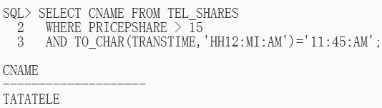
2) Find the name of company which has highest shares price at 5.30 P.M.
SQL> SELECT CNAME FROM TBL_SHARES WHERE PRICEPSHARE IN ( SELECT MAX(PRICEPSHARE) FROM TBL_SHARES
WHERE TO_CHAR(TRANSTIME,'HH12:MI:AM')='05:30:PM');
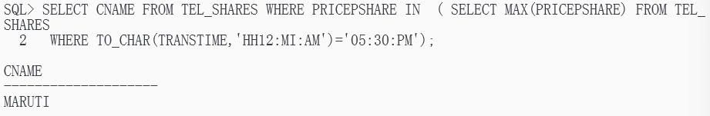

Practical No. 07
Aim : Create a table that stores spatial data and issue queries on it.

1. Creating Table:
SQL>create table university_15 ( mkt_id number primary key, name varchar2(32), shape mdsys.sdo_geometry);
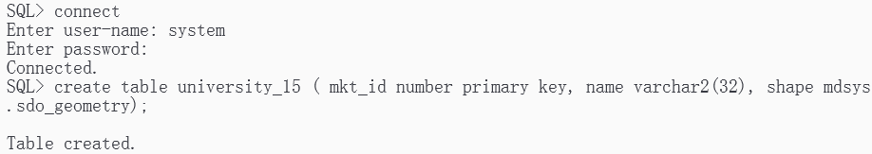
2. Inserting values in the tables:
Table Name1: university_15
Format: university_15(mkt_id, name, shape)
SQL> insert into university_15 values(
1,
'abc',
mdsys.sdo_geometry(
2003, -- 2-dimensional polygon
null,
null,
mdsys.sdo_elem_info_array(1,1003,3), -- one rectangle (1003 = exterior)
mdsys.sdo_ordinate_array(1,1, 5,7) -- only 2 points needed to define rectangle
)
);
SQL> INSERT INTO university_15 VALUES(
2,
'pqr',
mdsys.sdo_geometry(
2003, -- 2-dimensional polygon
NULL,
NULL,
mdsys.sdo_elem_info_array(1,1003,1), -- one polygon (exterior ring)
mdsys.sdo_ordinate_array(5,1, 8,1, 8,6, 5,7, 5,1)
)
);
SQL> INSERT INTO university_15 VALUES(
3,
'mno',
mdsys.sdo_geometry(
2003, -- 2-dimensional polygon
NULL,
NULL,
mdsys.sdo_elem_info_array(1,1003,1), -- one polygon (exterior ring)
mdsys.sdo_ordinate_array(3,3, 6,3, 6,5, 4,5, 3,3)
)
);
SQL> INSERT INTO university_15 VALUES(
4,
'xyz',
mdsys.sdo_geometry(
2003, -- 2-dimensional polygon
NULL,
NULL,
mdsys.sdo_elem_info_array(1,1003,4), -- one circle
mdsys.sdo_ordinate_array(8,7, 10,9, 8,11)
)
);
SQL> INSERT INTO user_sdo_geom_metadata
VALUES (
'university_15',
'shape',
mdsys.sdo_dim_array(
mdsys.sdo_dim_element('x', 0, 20, 0.005),
mdsys.sdo_dim_element('y', 0, 20, 0.005)
),
NULL -- SRID
);
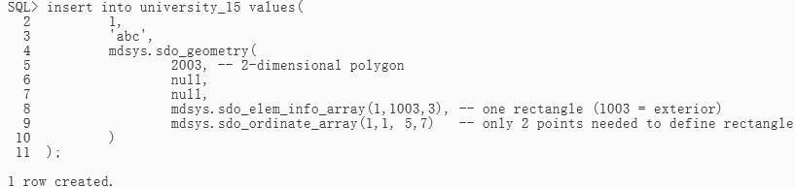
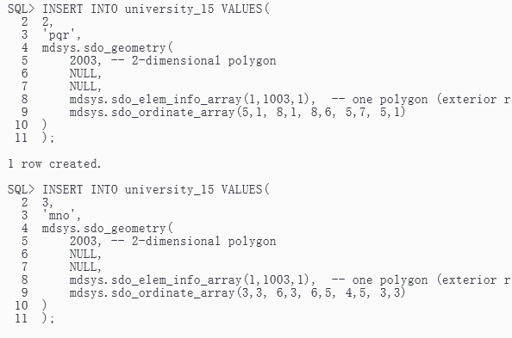
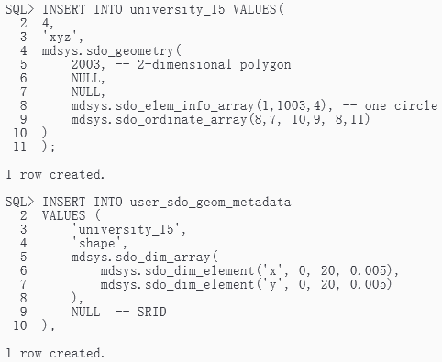
3. Creating index:
create index university_spatial_idx on university_15(shape) indextype is mdsys.spatial_index;
4. Firing queries on the created tables:
1) Find the topological intersection of two geometries.
SQL> select sdo_geom.sdo_intersection(c_a.shape, c_c.shape, 0.005)
from university_15 c_a, university_15 c_c
where c_a.name = 'abc' and c_c.name = 'mno';
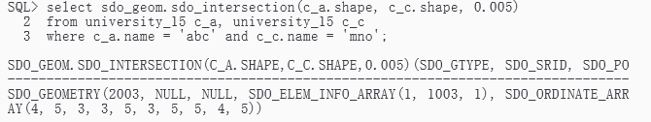
2) Find whether two geometric figures are equivalent to each other.
SQL>select sdo_geom.relate(c_b.shape, 'anyinteract', c_d.shape, 0.005) from university_15 c_b, university_15 c_d
where c_b.name = 'pqr' and c_d.name = 'xyz';
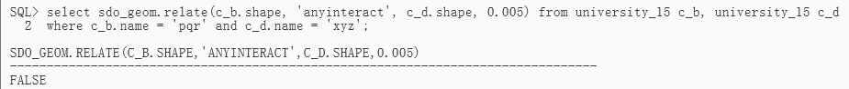
SQL>select sdo_geom.relate(c_b.shape, 'anyinteract', c_a.shape, 0.005) from university_15 c_b, university_15 c_a
where c_b.name = 'pqr' and c_a.name = 'abc';
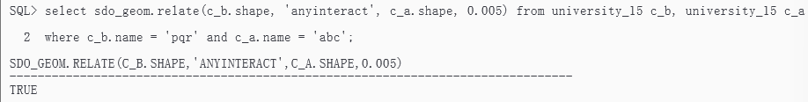
3) Find the areas of all direction locations.
SQL>select name, sdo_geom.sdo_area(shape, 0.005) from university_15;
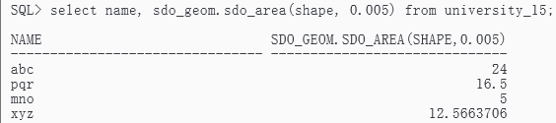
4) Find the area of only one location abc.
SQL>select c.name, sdo_geom.sdo_area(c.shape, 0.005) from university_15 c where c.name = 'abc';
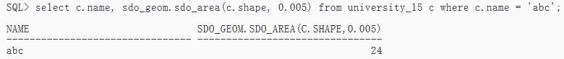
5) Find the distance between two geometries.
SQL>select sdo_geom.sdo_distance(c_b.shape, c_d.shape, 0.005) from university_15 c_b, university_15 c_d
where c_b.name = 'pqr' and c_d.name = 'xyz';
