**Setup Development Environment (Windows)**

## **Download Apache Tomcat: (Tomcat provides a "pure Java" HTTP web server environment in which Java code can run)**

<https://mirrors.estointernet.in/apache/tomcat/tomcat-9/v9.0.39/bin/apache-tomcat-9.0.39.exe>

Run the exe file

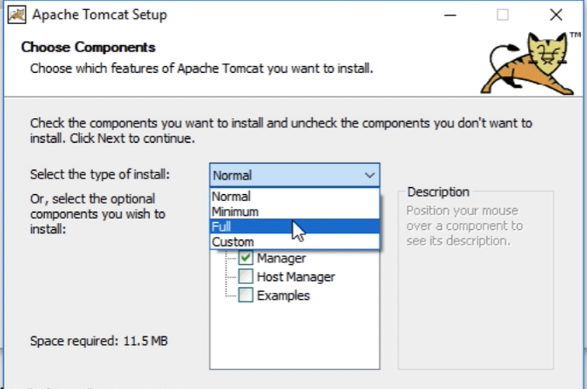

Choose Full

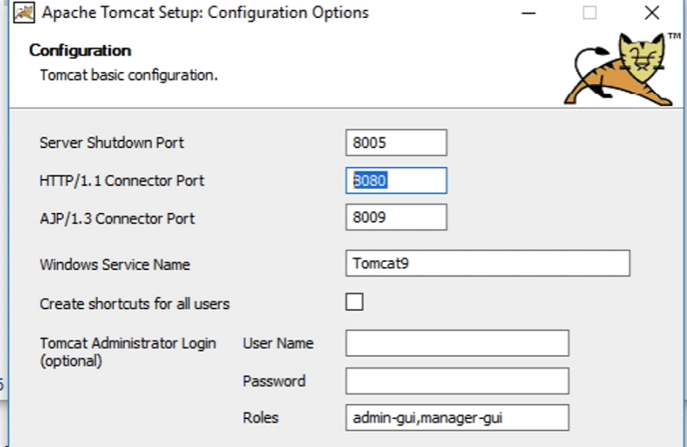

Default port for tomcat is 8080 so don’t change it

You can give your own username and password

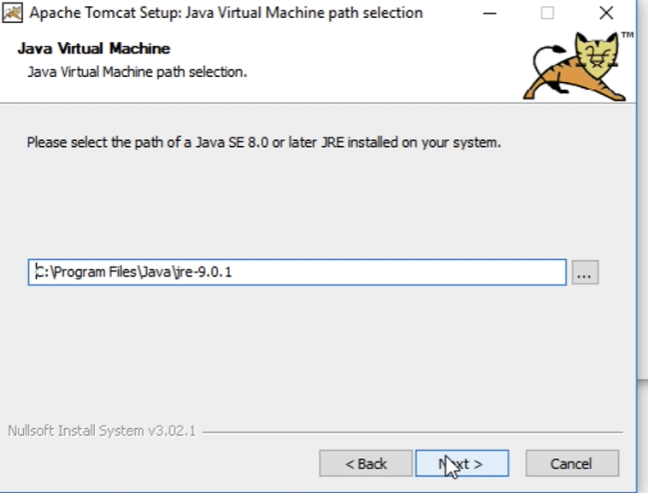

For the rest of the installation process give the path required/leave it to defaults.

**Verify the installation at:**

<http://localhost:8080/>

The page should appear like this:

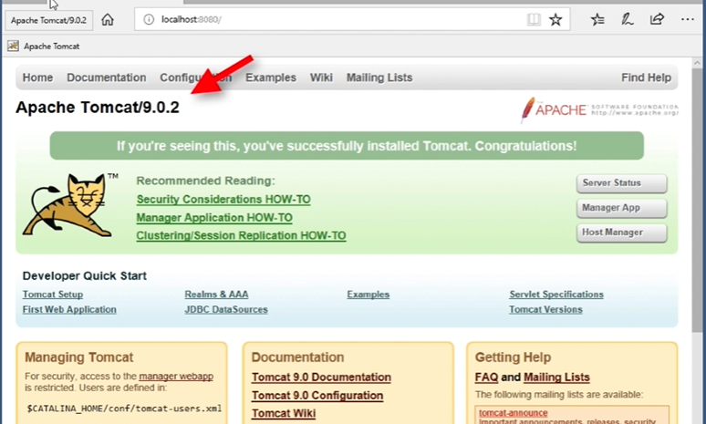

## **Stop the Tomcat service:**

Now go to settings on your machine -> Services

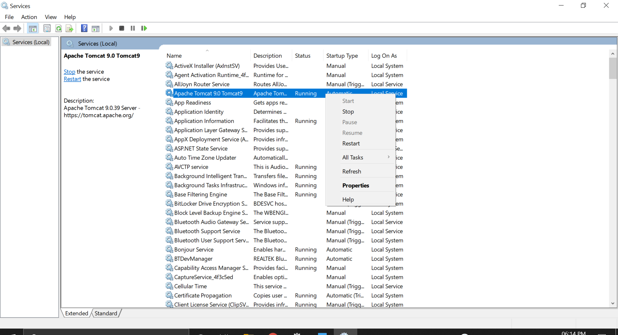

Stop the Apache Tomcat 9.0 by right clicking on it and pressing STOP

We will run the server via eclipse later

## **Download Eclipse from:**

<https://www.eclipse.org/downloads/packages/>

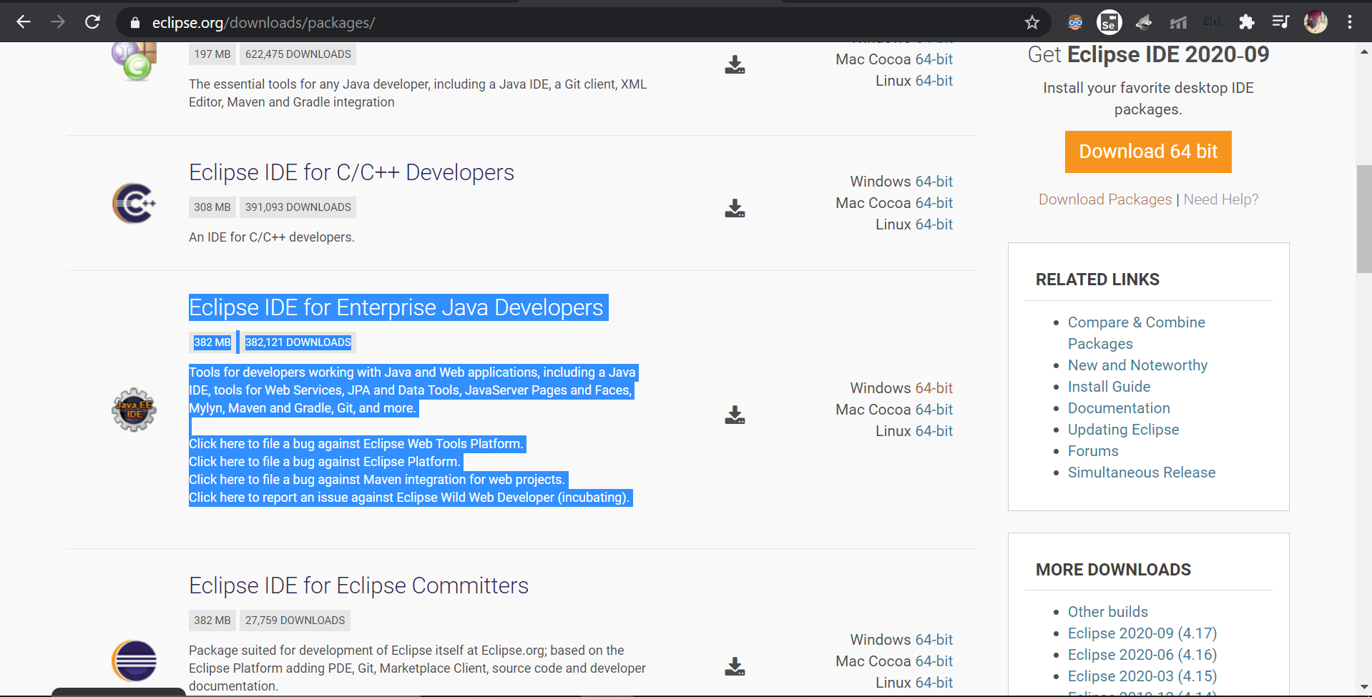

You need to download the Eclipse IDE for Enterprise Java Developers to be able to create dynamic web projects.

## **Connecting Eclipse to Tomcat:**

Open Eclipse and click on the Server tab in the bottom

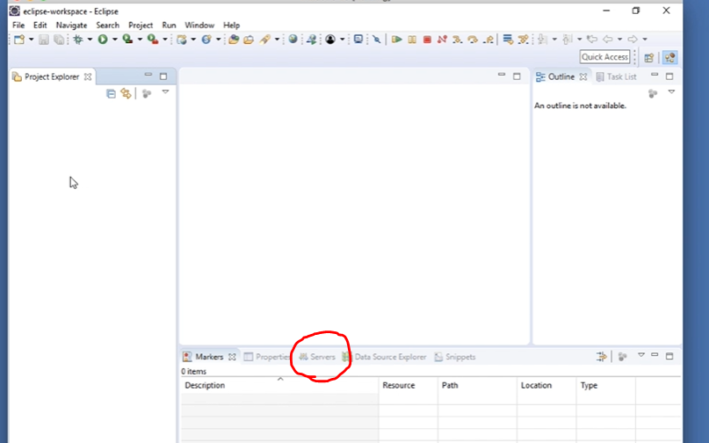

Which will look like this

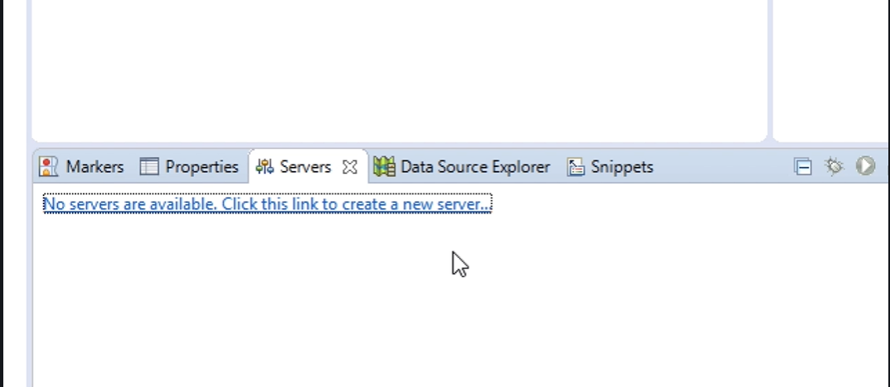

Click on the ‘No servers are available….’ Link

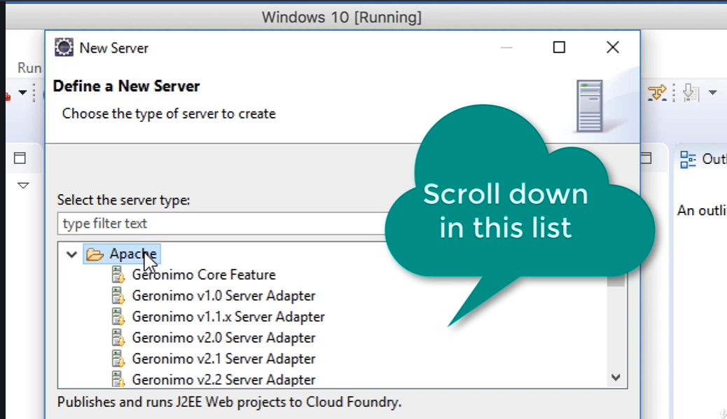

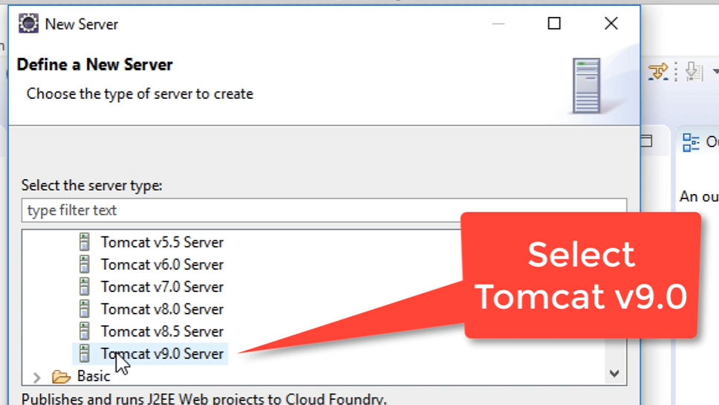

Then click on the Next button

The below window will appear

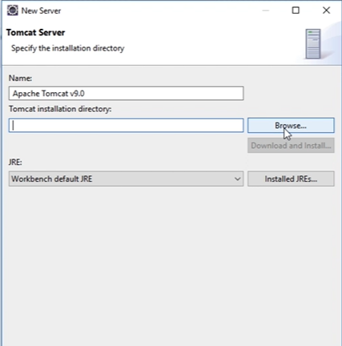

Browse for the Tomcat installation directory (wherever you installed tomcat)

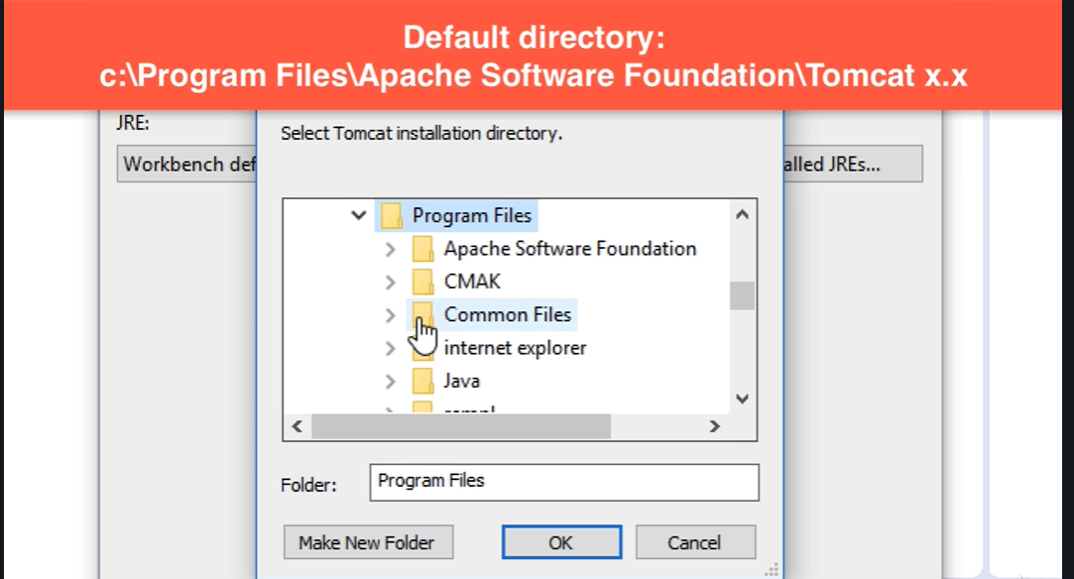

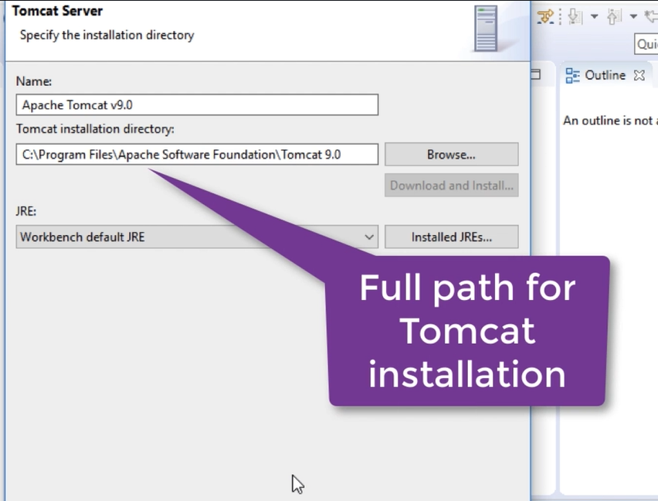

After giving the right path, click on the Finish button.

Now the Servers tab should look like this.

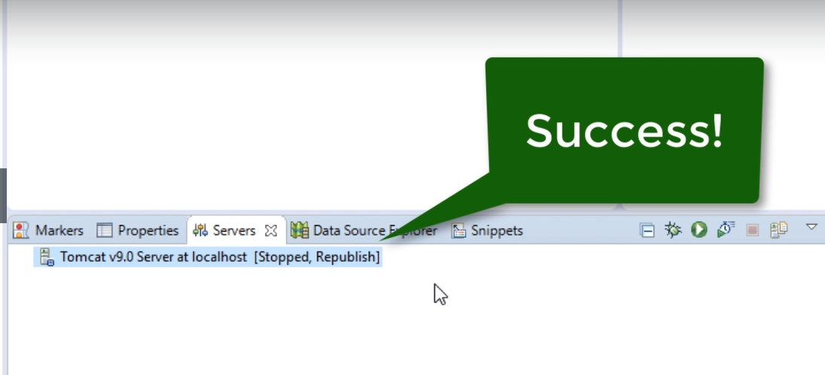

Double click on the above – “Tomcat v9.0 Server at localhost [Stopped, Republish]

The below window appears

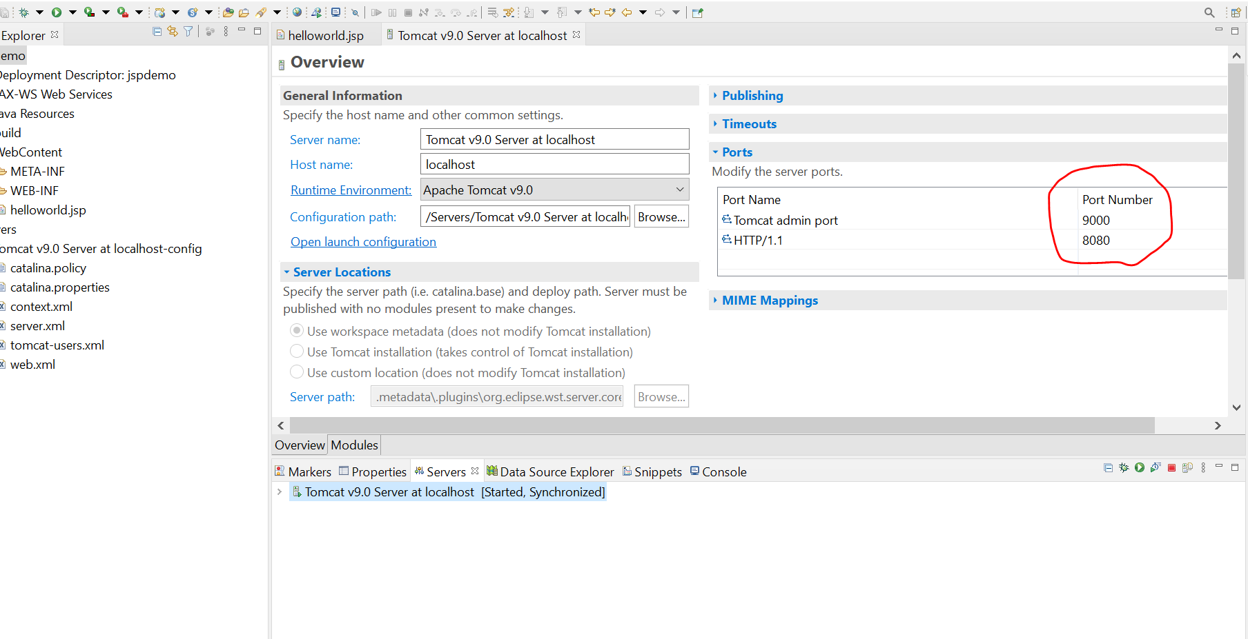

If the PORT NUMBER of **Tomcat admin port** is not 9000, change it to 9000

## **Clone the Repository and open the Project “CWBackend” from the Eclipse window**

## **Install MySQL Workbench too!!**

## **Run the Dynamic web project**

CWBackend -> WebContent -> Right click on index.html -> Run As -> Run on Server

Now you are good to go!