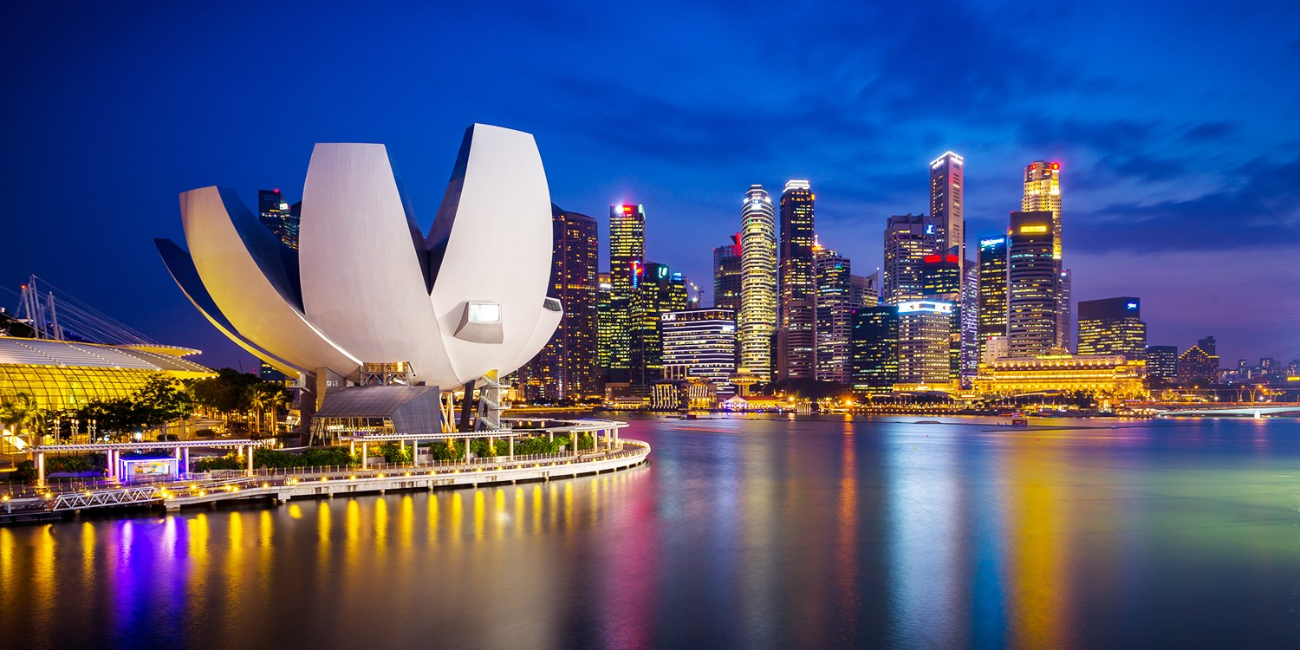

|  |
| --- |
| Coursea Capstone  2021 |
|  |
| Singapore: a global city of opportunity  Authored by: Scarlett GENDREY |

# Introduction

**Background:** Singapore is located off the southern edge of the Malay Peninsula, between Malaysia and Indonesia and has the 2nd highest population density in the world [1]. It has a **population of 5.7 million** with a **population density of 7,894/km2** [2].

**Problem:** The business problem of this project is to analyze and provide insights into discovering ideal locations for people who are migrating such as housing prices and schools. Offering them a look at which neighborhood might be the best fit for easy access to cafes, supermarkets, grocery shops, malls, theaters, etc. It will help people make smart and efficient decisions about which area and neighborhood to choose before moving to a new city, state, country.

**Target audience:** The target audiences are foreigners who intend to move to Singapore or Singaporeans who simply want to know better their neighborhood.

# Data description

The different data gathered for this project are

* The postal districts, sectors and general location of Singapore’s neighborhoods. Singapore’s postal codes are in 6 digits format and the first 2 digits represent the postal sector [3].
* Private Property Transaction Data API (Feb 2019 to Feb-2021) by postal district [4].
* Private education institution by region [5].
* FourSquare API to get the venues by district [6].

# Methodology

# Data modeling

# Results

# Discussion and recommendations

# Conclusions

# References

1. <https://en.wikipedia.org/wiki/List_of_countries_and_dependencies_by_population_density>
2. <https://www.singstat.gov.sg/modules/infographics/population>
3. <https://en.wikipedia.org/wiki/Postal_codes_in_Singapore>
4. <https://www.ura.gov.sg/realEstateIIWeb/transaction/search.action>
5. <https://data.gov.sg/dataset/private-education-institutions>
6. <https://developer.foursquare.com>