Refresh:

In chain of responsibility, sender sends a request to a chain of objects. The request can be handled by any object in the chain.

A Chain of Responsibility Pattern says that just "avoid coupling the sender of a request to its receiver by giving multiple objects a chance to handle the request". For example, an ATM uses the Chain of Responsibility design pattern in money giving process.

In other words, we can say that normally each receiver contains reference of another receiver. If one object cannot handle the request then it passes the same to the next receiver and so on.

It used when:

* When more than one object can handle a request and the handler is unknown.
* When the group of objects that can handle the request must be specified in dynamic way.

Exercise:

Based on the diagram below, try to apply the Chain-of-responsibility pattern to get the code of this repository complete.

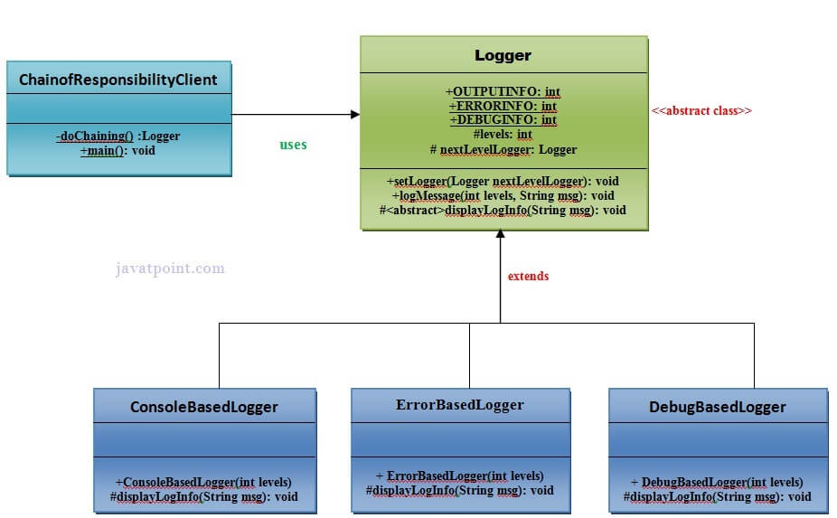

And get the next output:

Check the complete solution at:

[Chain of Responsibility Pattern - Javatpoint](https://www.javatpoint.com/chain-of-responsibility-pattern)