Exercise:

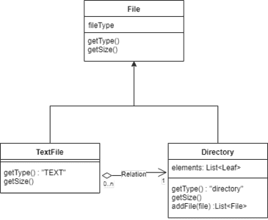

As shown in the image we will create interface for "File". Then we will have two different classes. One for Directory type and second for other than directory like .txt, .doc, etc.

The Directory class is composite class that can contain other files or directories.

Implement the code for this diagram to implement composite pattern.

To get the solution in detail, visit:

[Composite design pattern in java with real life example and code (stacktraceguru.com)](https://stacktraceguru.com/composite-design-pattern/)