Exercise:

Decorator design pattern in Java shows you how to add new functionality to an existing object without altering its structure. This pattern is used when you want to add functionality to a class without modifying that class.

Look at the following UML diagram representing the Decorator design pattern (for my example):

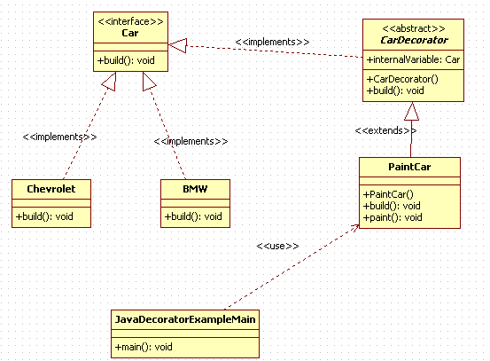

Implement the proper code for the above diagram

Hint:

In Decorator Design Pattern, the main idea is to wrap a class and to add functionality to that class.

Check the complete solution at:

[Decorator (Java Design Pattern) - explanation and example (learn-it-with-examples.com)](https://learn-it-with-examples.com/development/java/java-design-patterns/java-decorator.html)