Consider we want to implement a notification service through email, SMS, and push notification. Let’s try to implement this with the help of factory method design pattern.

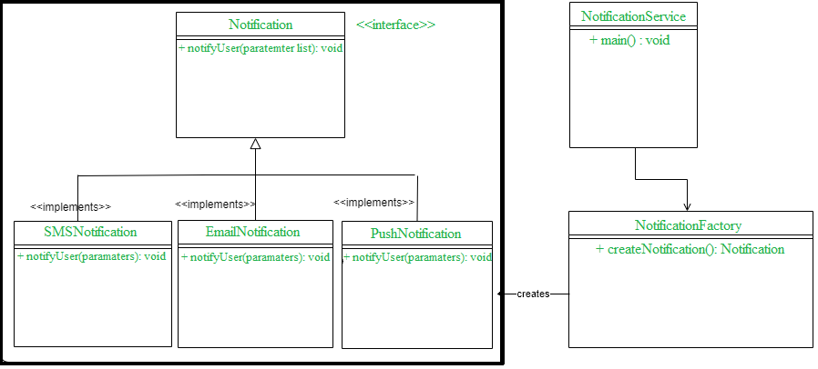

$$Fig. 1 UML Diagram$$

In the above class diagram we have an interface called **Notification**, and three concrete classes are implementing Notification interface. With the help of this diagram add the properly code to each one of the classes to get the notification of SMS on the output or another service from the interfaces we’ve shown in here using the pattern.