Refresh:

A Memento Pattern says that "to restore the state of an object to its previous state". But it must do this without violating Encapsulation. Such case is useful in case of error or failure.

The Memento pattern is also known as Token.

Undo or backspace or ctrl+z is one of the most used operation in an editor. Memento design pattern is used to implement the undo operation. This is done by saving the current state of the object as it changes state.

* It is used in Undo and Redo operations in most software.
* It is also used in database transactions.

Exercise:

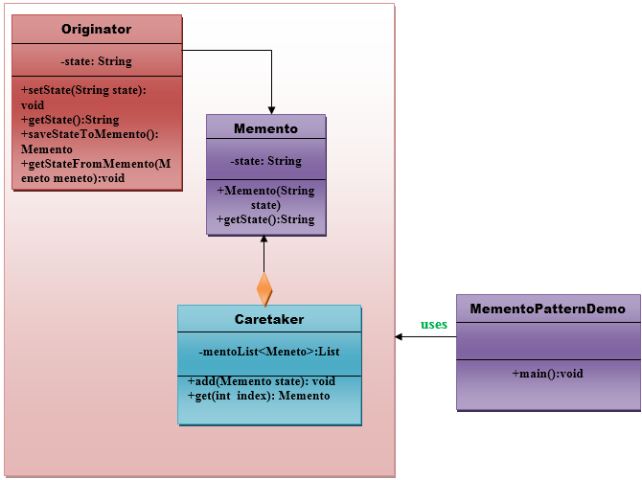

Memento:

* Stores internal state of the originator object. The state can include any number of state variables.
* The Memento must have two interfaces, an interface to the caretaker. This interface must not allow any operations or any access to internal state stored by the memento and thus maintains the encapsulation. The other interface is Originator and it allows the Originator to access any state variables necessary to the originator to restore the previous state.

Originator:

* Creates a memento object that will capture the internal state of Originator.
* Use the memento object to restore its previous state.

Caretaker:

* Responsible for keeping the memento.
* The memento is transparent to the caretaker, and the caretaker must not operate on it.

With the information of above implement this pattern by completing the missing classes at MementoExercise.zip exercise to solve it and run it.

Check the complete solution at:

[Memento Pattern - Javatpoint](https://www.javatpoint.com/memento-pattern)