Exercise:

Based on the diagram below and steps, try to apply the Proxy pattern to get the code of this repository complete.

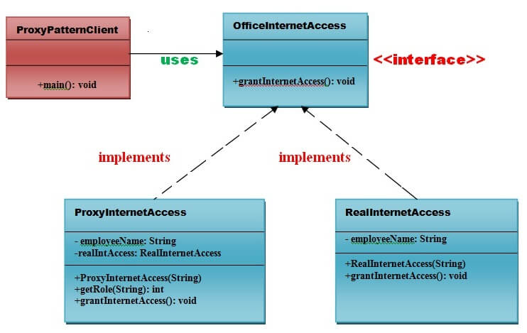

Steps:

1. Create an OfficeInternetAccess interface
2. Create a RealInternetAccess class that will implement OfficeInternetAccess interface for granting the permission to the specific employee.

Check the complete solution at:

[Proxy Pattern - Javatpoint](https://www.javatpoint.com/proxy-pattern)