Exercise:

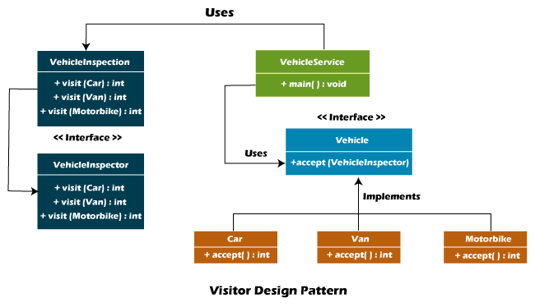

Based on the diagram of above and the VisitorExercise.zip complete the code to get the next output:

One of the classes that is missing has these attributes:

Private int storageCapacity

Private int numberOfDoors

Check the complete solution at:   
  
[Visitor Design Pattern Java - Javatpoint](https://www.javatpoint.com/visitor-design-pattern-java)