Code Plagiarism Checker - System Design Report
Group 8, SDN260S Software Design II, CPUT · Nov 1, 2026 · Dembe Kwinda

1. Problem definition
Students can copy a Java assignment and rename the variables, which defeats a plain text comparison. Our tool compares every pair of submitted .java files on their code structure instead of their wording, ranks the pairs by similarity, and flags pairs at or above 70% for a person to review.
The main users are lecturers and markers who must check a folder of submissions quickly and fairly. A flag only marks a pair for human review; it is not a finding of plagiarism. The group approved the similarity method and the 70% threshold on 1 Nov 2026.
The tool runs offline, reads only the files it is given, and offers three interfaces: a console menu (--cli), a Swing GUI (--gui) and a one-shot run (Main <path>).

2. System design
The system is 18 classes in one package, plagiarismchecker. The pipeline below is the core; CodeFile, SimilarityResult and Pair carry data between stages, and ResultsTableModel feeds the GUI table.
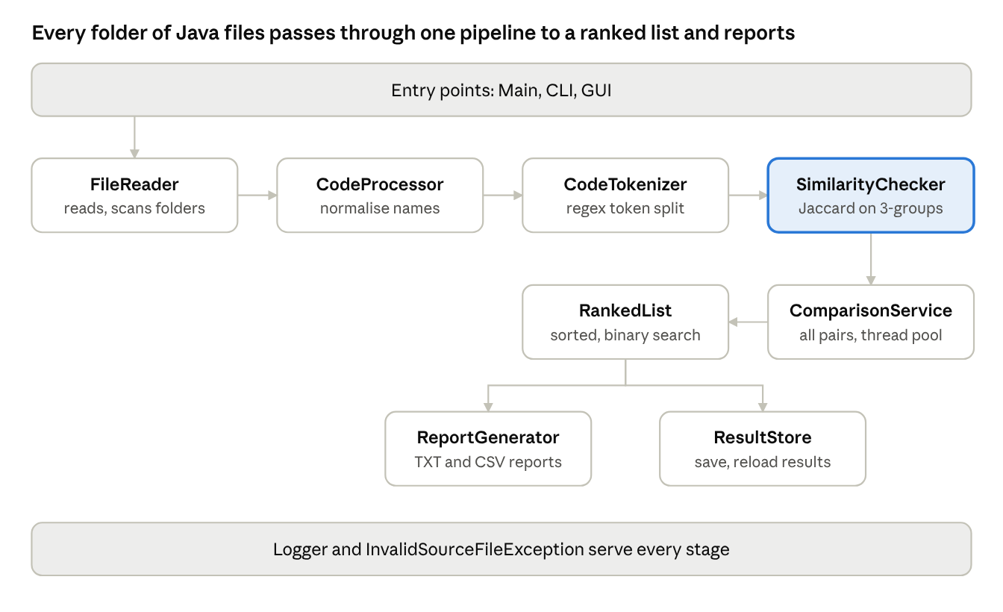
system pipeline · 8 classes, 1 parallel step
Read left to right: a file is read, normalised, tokenised and scored; ComparisonService repeats that for every pair in parallel, RankedList sorts the scores, and the results go to a report or the store. The UML class diagram is in docs/uml_class_diagram.png.

3. Design decisions
The Check-In 1 design held up; five changes were made while building. Each class has one job, so a change to one stage (for example the tokenizer) does not touch the others.
Check-In 1 design | What the code does now | Why
CodeProcessor.tokenise() | Moved to a new CodeTokenizer class | Cleaning text and splitting tokens are separate jobs
Comparison inside the checker | New ComparisonService | One place to run all pairs, in parallel
Plain lists of results | New Pair<A,B> and RankedList<T> | Reusable generic types; sorted insert and binary search
Results lost on exit | New ResultStore (serialization) | Reload earlier runs; uses an allow-list input filter
Print statements | New Logger and InvalidSourceFileException | Proper logging and clear errors for bad files
Two choices are worth defending in the demo. Renamed variables are mapped to a single ID token, so renaming does not hide a copy. The report always says "flagged for review" because a similarity score cannot prove intent.

4. Data structures and algorithms
Similarity is computed in four steps, and the whole run is O(n²) in the number of files.
- Normalise (CodeProcessor): strip comments and package/import lines; strings become STR, numbers NUM, other names ID; keywords are kept.
- Tokenise (CodeTokenizer): split with regular expressions into a token list.
- Group: overlapping 3-token groups form a set per file.
- Score (SimilarityChecker): Jaccard similarity, the size of the intersection of two sets divided by the size of their union. A pair at or above 70% is flagged.
J(A,B) = |A ∩ B| / |A ∪ B|
FileReader.scanRecursively walks folders by recursion. RankedList<T> keeps results sorted on insert and uses binary search, so a lookup costs O(log n). Comparing n files means n(n-1)/2 pairs: 14 sample files give 91 pairs and 160 files give 12,720. Doubling the files roughly quadruples the time, which matches the benchmark (about 4× per doubling). The full analysis is in docs/BIG_O.md.

5. Advanced features
Four advanced topics from the course are used in the working code, not just described.
Topic | Where | What it does
Generics | Pair<A,B>, RankedList<T> | Type-safe pair and sorted list reused across the program
Serialization | ResultStore | Saves and reloads results; an ObjectInputFilter allow-list rejects unexpected classes
Multithreading | ComparisonService (ExecutorService), GUI (SwingWorker) | Compares pairs in parallel; the GUI stays responsive while it runs
Streams | Light use in sorting and filtering results | Short, readable result handling
On our 2-core test machine, 160 files (12,720 pairs) took 5,518 ms on one thread and 3,109 ms on two, a speed-up of about 1.77×. These timings come from a test machine with few processor cores, so the speed-up on a laptop with more cores will differ.

6. Testing strategy and evidence
All 87 automated tests pass (18 test classes, mvn test: 0 failures), run on two team members' machines; Bandile Qwane's run on 1 Nov 2026 finished with 87 run, 0 failures, 0 errors, 0 skipped, BUILD SUCCESS in 40.3 s. The tests cover each class on its own, plus an end-to-end run over the sample folder.
ID | Case | Type | Input | Result
N1 | Exact copy | Normal | Alice and Bob | 100%, flagged
N2 | Renamed variables | Normal | Gina and Hank | 100%, flagged
N3 | Partly changed copy | Normal | Dan and Eve | 80.4%, flagged
N4 | Similar, below threshold | Normal | StudentC and Frank | 66.7%, not flagged
N5 | Partial copy (two methods) in a different program | Normal | Gina and Kim | 61.0%, not flagged (borderline, worth a look)
N6 | Whole sample set | Normal | 14 files | 91 pairs, 4 flagged
E1 | Empty file | Edge | One empty .java file | Warning "File is empty", nothing loaded, exit code 1
E2 | One file only | Edge | One valid file | "Add at least two files to compare them"
E3 | Identical files | Edge | A.java and B.java, same code | 100.0%, flagged
E4 | Wrong path | Error | /no/such/folder | "File does not exist", exit code 1, no crash
E5 | Not a Java file | Error | A .txt file | "Only .java files can be checked", exit code 1
E6 | No arguments | Error | None | Usage message, exit code 2
The full run of the demo folder is reproduced by Main <path>; the TXT and CSV reports are the sample outputs. Cases E1 to E6 were run on the integrated project on 1 Nov 2026. Murunwa Khorommbi also confirmed a clean build, the Maven tests, the CLI, sample comparisons, a wrong path and a one-file input on her computer; her screenshots are in her Check.docx. Kagiso Lengolo's separate edge-case harness (8 of 8 passed, including the 69.9%, 70.0% and 80.0% threshold cases) tests his own prototype, which uses a different method (longest common subsequence), so it is not counted as evidence for this project. The largest tests were a pair of 1,300-line files and a generated 160-file folder.

7. GA2 reflection: application of scientific and engineering knowledge
We applied set theory and algorithm analysis to a practical problem. Jaccard similarity on 3-token groups turns "do these two programs look alike" into a number between 0 and 100%, and normalising names to ID removes the easiest way to disguise a copy.
We used Big O to predict cost before measuring it: n files mean n(n-1)/2 comparisons, so time grows with the square of the folder size. Our benchmark confirmed this, and we added threads to use the work that can run in parallel.
What we learned: a design that looked complete at Check-In 1 still needed five changes once we tested it. Measuring and testing, not assuming, decided each one.

8. GA7 reflection: sustainability and impact of engineering activity
A wrong flag can harm a student, so the tool reports "flagged for review", never "plagiarised". The 70% threshold was approved by the group on 1 Nov 2026, and a person makes the final decision.
The tool runs offline on the user's own machine, so student code is not uploaded to any service. Saved results are loaded through an allow-list filter so a tampered file cannot run unexpected code. It needs no special hardware, and its O(n²) cost is documented so users know that very large folders take longer.
Limits we accept: similar code can be honest (short exercises, shared templates), so scores are a starting point for a conversation, not evidence on their own.

9. Team collaboration and process
Group 8 has six members: Dembe Kwinda, Murunwa Grace Khorommbi, Kagiso Lengolo, Liphelo Tayo, Ndugiselo Masase and Bandile Qwane. Roles are those on the group hub; the last column is what each person does for Check-In 3 (due 1 Nov 2026, 23:59). Task status is tracked on the group hub.
Member | Role | Check-In 3 task (31 Oct)
Dembe Kwinda | Project coordination and system design | Integrate, final demo run, design report, submit
Murunwa Grace Khorommbi | Java implementation and core classes | Run the project clean from the zip; fix any core-class bug found
Kagiso Lengolo | Similarity algorithm and data structures | Write the edge-case tests (empty file, single file, identical files); check the 70% threshold on the sample set
Liphelo Tayo | GUI and CLI development | Screenshot GUI results and CLI menu; check error messages on a bad path
Ndugiselo Masase | Testing and documentation | README and user guide; collect test evidence and sample outputs
Bandile Qwane | Code development and testing | Run mvn test and report the result; test the project on a second computer
Version control evidence (GitHub commit history and a coordination log from the group hub) is to be attached.

10. Limitations and next steps
The tool compares structure, so it can miss copies that reorder statements heavily and can flag honest code that follows a shared template. Cost grows with the square of the folder size.
- ☐ Group approves the similarity method and the 70% threshold
- ☐ Add empty-file, single-file and large-folder test cases
- ☐ Record benchmark timings from a team member's own machine in docs/BIG_O.md
- ☐ Fill in roles and contributions; attach GitHub history
- ☐ Final submission on 8 Nov 2026: zipped source, ReadMe, this report, reflection, demo

