MANUAL
{{VERSION}}
VOID MERCHANTS IS A SPACE INVADERS-INSPIRED ROGUELIKE ACTION GAME BUILT IN PICO-8.

BLAST ENEMIES, COLLECT RESOURCES, AND TRADE YOUR WAY TO UPGRADES AS YOU PROGRESS THROUGH INCREASINGLY DIFFICULT SPACE BATTLES!

THIS IS THE GAME MANUAL. IT INTENTIONALLY DOESN’T REVEAL EVERY LITTLE DETAIL.

BUT IT SHOULD STILL AID YOU WELL IN YOUR ADVENTURE.

THANK YOU FOR PLAYING!

CONTROLS

↑ ↓ ← → MOVE YOUR SHIP AND CURSOR WHILE TRADING

X OR V SHOOT—CAN BE HELD DOWN

Y/Z OR C INTERACT—TALK TO CHARACTERS OR PERFORM TRADES

CONTROLLERS ARE ALSO SUPPORTED!

THE BUTTONS SHOWN IN THE GAME ARE FOR THE PLAYSTATION CONTROLLER BUTTON LAYOUT.

SAVE & LOAD

YOU CAN CREATE A SAVE FOR YOUR CURRENT GAME AT EACH VISIT TO THE TRADER BY HITTING THE SHOOT BUTTON.

YOU CAN LOAD THEM AGAIN AT THE TITLE SCREEN BY HITTING THE INTERACT BUTTON.

Abbreviations

HP SHIP HEALTH POINTS

SH SHIP SHIELD POINTS

DR DRONE HEALTH POINTS + SHIELD

STG COMBINED FREE SHIP & DRONE STORAGE

DMG COMBINED SHIP & DRONE DAMAGE

WPS COMBINED EQUIPPED WEAPONS

SP YOUR SPEED AS DECIMAL

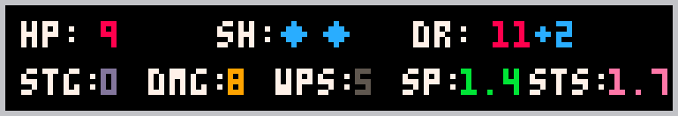
STS YOUR SHOT SPEED AS DECIMAL

Trading

NAVIGATE WITH ↑ AND ↓.
SELL OR BUY WITH THE INTERACT BUTTON.

SAVE WITH THE SHOOT BUTTON.

THE FOLLOWING OPTIONS ARE AVAILABLE AT THE TRADER:

- SELL GOODS – SELL ALL GOODS YOU’VE PICKED UP
- SELL UPGRADES – SELL ALL YOUR STORED UPGRADES
- REPAIR SHIP HULL – FULLY RESTORE YOUR SHIP’S LIFE
- UPGRADE SHIP – UPGRADE YOUR SHIP TIER. THIS IS ONLY AVAILABLE WHEN YOUR SHIP IS AT FULL LIFE
- REPAIR DRONES – FULLY RESTORE YOUR DRONES’ LIFE
- RESTORE SHIP SHIELD – RESTORE ONE POINT OF YOUR SHIP’S SHIELD
- RESTORE DRONE SHIELD – RESTORE ONE POINT OF YOUR DRONES’ SHIELD
- INSTALL STORED UPGRADES – INSTALL STORED UPGRADES THAT COULD NOT BE EQUIPPED DURING THE BATTLE
- INSTALL STRONGER WEAPONS – APPLIES ONLY TO SHIP WEAPONS
- INSTALL NEW WEAPON – POSSIBLE NUMBER OF WEAPONS INCREASES WITH UPGRADED SHIP AND MORE DRONES
- BUY ATTACK / CARGO DRONE – GET AN ADDITIONAL DRONE
- REBUILD DRONES TO ATTACK / CARGO – CHANGES THE DRONE TYPE. BEWARE! CAN COME WITH CAVEATS!
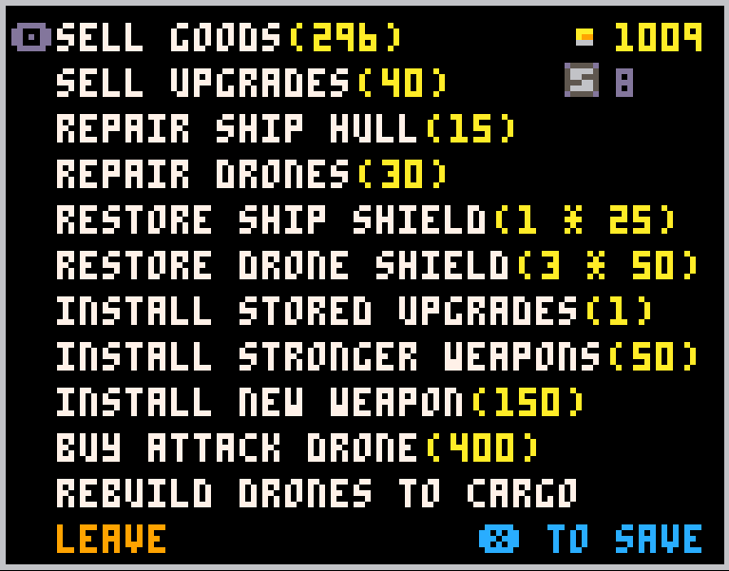
YOUR CREDIT BALANCE
STORED ITEMS

LEAVE THE TRADER

ITEMS

THESE ARE ALL ITEMS THAT CAN BE
DROPPED BY ENEMIES, LISTED IN THEIR ORDER OF RARITY AND VALUE.

BUFFS & RESTORATION
 | SPEED BUFF
 | SHOT SPEED BUFF
 | LIFE RESTORE
 | SHIELD RESTORE

CREDITS
 | CREDIT
 | SUPER CREDIT

UPGRADES
 | DAMAGE UPGRADE
 | EXTRA WEAPON UPGRADE
 | EXTRA DRONE UPGRADE

TRADING GOODS
 | SCRAP
 | COPPER
 | GOLD
 | PARTS CRATE
 | COBALT
 | PLATINUM
 | VOID FRAGMENT
 | VOID CRYSTAL

