VDFEditor

for Graupner HoTT Radios

# Description

The VDFEditor is a program that can edit voice announcements for the Graupner HoTT radios. The program is more advanced and is easier to use than what is available in the Firmware Upgrade Studio.

Announcements are stored in so called VDF files (Voice Data File). Inside the VDF, the announcements are compressed to account for the available memory resources of the radio.

## Supported radios and versions

**Variants**

* **System VDFs** – These files contain the announcements that are used internally be the radio for pre-defined events. The count and order of announcements is fixed.
* **User VDFs** – These files contain user-defined announcements that can be freely assigned to various events.

**Versions**

* **Voice 2** (v2.0) – These files are used by radios with older software. Only system VDFs are supported.
* **Voice 3** (v2.5) – These files are used by radios with newer software. The internal version number of these files is 2.5.
* **Voice 3** (v3.0) – These files are used exclusively by the mc-26 and mc-28 radios and provide more announcements than the other Voice 3 files.

**Country Code**

* **Global** – This code is used for most VDF files.
* **USA** – Distance and speed announcements use the imperial dimensions (feet, miles).
* **China, Korea, Japan** – Specific versions for Asian countries.

The following table lists all supported radios and versions:

|  |  |  |  |
| --- | --- | --- | --- |
| VDF Version | Number of System Announcements | Number of User Announcements | Radio and Software Version |
| Voice 2 (v2.0) | 253 | - | mx-12, mx-16, mx-20 with v1.xxx  mc-16, mc-20, mc-32 with v1.xxx  mz-12, mz-18, mz-24 with v1.xxx |
| Voice 3 (v2.5) | 284 | up to 10 | mx-12, mx-16, mx-20 with v2.xxx  mc-16, mc-20, mc-32 with v2.xxx  mz-12PRO, mz-24PRO with v2.xxx |
| Voice 3 (v3.0) | 432 | up to 40 | mc-26, mc-28 with v1.xxx |

# Installation

The VDFEditor requires a Java 8 runtime environment. Java can be downloaded free of charge from the following location:

<http://www.oracle.com/technetwork/java/javase/downloads/index.html>

No installation is required for the VDFEditor. The program can be stored in any folder on your computer. On the Windows operating system, you can start the VDFEditor simply by double-clicking it. On MacOS and Linux, the program file should be renamed from VDFEditor-x.x.x.x.exe to VDFEditor-x.x.x.x.jar to allow the operation system to automatically start the Java runtime environment.

# User Interface

The user interface shows a list of announcements. Each row contains a running number, a playback button and the name of the announcement.

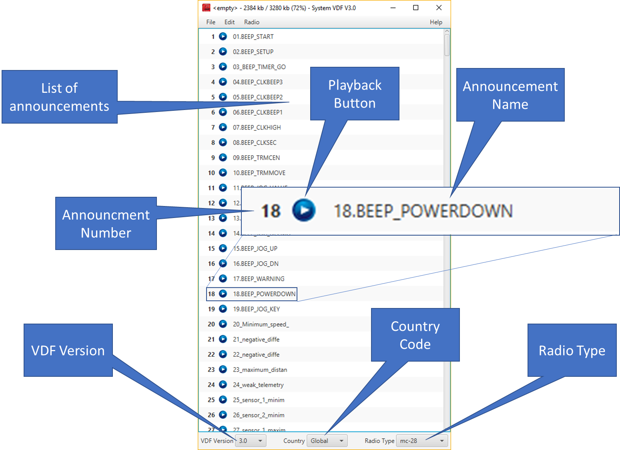

On the bottom of the window, there are combo boxes to select the VDF version, the country code and the radio model.

The title bar contains information about the file name, the memory usage and the VDF variant.

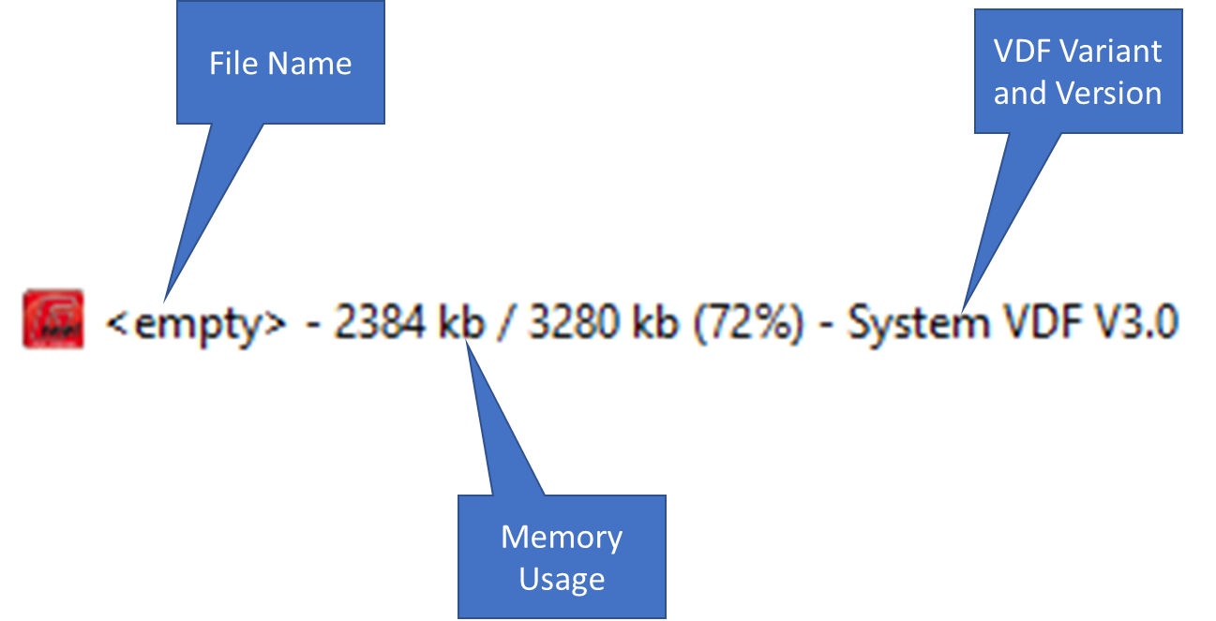

# Functions

All functions can be reached via menu items and the three combo boxes at the bottom of the window. In addition, most functions also provide keyboard shortcuts. The most comfortable way however, is the use of Drag & Drop. This way, you simply drag files and drop them into the window of the VDFEditor or rearrange announcements inside the list. The following sections describe each function in detail and highlight the use of Drag & Drop where applicable.

## File Menu

The file menu allows to work on whole VDF files.

### New VDF (Ctrl + N)

This will create a new empty user VDF. This menu item is always available. If the current VDF was modified, the program will ask if you would like to save the changes first.

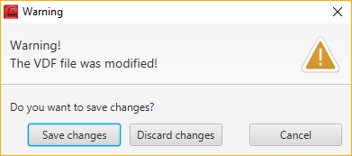

### Open VDF (Ctrl + O)

This will open the file select dialog to choose an existing VDF for editing. Alternatively, the VDF file can be dragged and dropped into the Window of the VDFEditor. The folder that was used to open the VDF will be memorized and used later on.

### Restore System VDF

This menu provides all current official system VDF files in all supported languages. Use these files in case you want to factory-reset the system announcements of your radio.

### Save VDF (Ctrl + S)

This will save all changes into the previously opened VDF file. The function will only be available if a VDF was opened from a file.

### Save VDF as (Ctrl + Shift + S)

Opens the file select dialog to choose a new name for the VDF and save it under the new name.

### Close (Alt + F4)

Closes the VDFEditor.

## Edit Menu

The edit menu provides functions to work on individual announcements.

### Undo (Ctrl + Z)

Rolls back the last change on the VDF.

### Redo (Ctrl + Y)

Restores a previously rolled back change.

### Move Up (Ctrl + U)

Moves the selected announcement up by one position. This function is only available for user VDFs. The count and order of system announcements is fixed.

### Move Down (Ctrl + D)

Moves the selected announcement down by one position. This function is only available for user VDFs. The count and order of system announcements is fixed.

### Rename (Ctrl + R)

Opens a text field to enter a new name for the announcement. Alternatively, you can double-click the name to open the text field. The new name will be saved when you hit the enter key.

### Play (Ctrl + P)

Starts playback of the selected announcement on the computer. Alternatively, you can click the playback button to the left of the name of the announcement.

### Add Announcement (Insert)

Opens the file select dialog to open an audio file for a new announcement. The VDFEditor supports WAV, MP3 and OGG encoded audio files. Alternatively, one or more supported audio files can be dragged and dropped on the announcement list. The new announcements will be inserted at the selected location.

All audio files will be converted into 16-bit PCM, mono with a sample rate of 11kHz. Therefore, audio files with a higher quality do not provide any advantage.

This function is not available for system VDFs. The count and order of system announcements is fixed.

### Replace Announcement (Shift + Inset)

Opens the file select dialog to open an audio file for a new announcement. The new announcement will replace the selected announcement.

For system VDFs, one or more audio files can be dragged and dropped on the announcement list. The new announcements will replace existing announcements from the selected announcement downwards.

### Delete Announcement (Delete)

Deletes the selected announcement. For system VDFs, an empty placeholder will be used to keep the count and order of system announcements constant.

### Export

The export of announcements can be performed via Drag & Drop only. After selecting one or more announcements from the list, drag and drop them on the desktop or the file manager. All announcements will be converted to WAV format for export.

You can also start the VDFEditor twice and copy announcements between these two instances using Drag & Drop.

## Radio Menu

The radio menu allows to connect to a radio that was attached via USB or Bluetooth.

### Load user announcement from radio

The current user announcements from the radio will be loaded into the VDFEditor.

Before the transmission starts, the serial port needs to be selected.

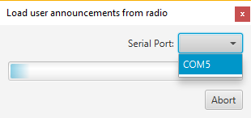

After selecting the serial port, the program will show a warning message that the RF output on the radio will be turned off.

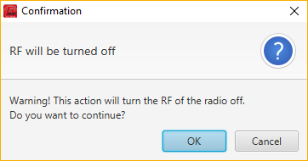

### Load system announcements from radio

The current system announcements from the radio will be loaded into the VDFEditor.

### Play on radio (Ctrl + Shift + P)

The currently selected announcement will be played over the radio speaker or head phone jack.

Note, that the radio will playback the announcement at the selected location, which may or may not match the announcement in the VDFEditor at this location.

### Send announcements to radio

All announcements in the VDFEditor will be send to the radio. The program will check if the type of radio and VDF version of the radio match the current VDF. You may need to set the correct radio model and VDF version using the combo boxes at the bottom of the window.

## Help Menu

### About

Shows a short description of the VDFEditor.

### User Manual

Shows this user manual.

## Combo boxes at the bottom of the window

### VDF Version

For radio models mc-16, mc-20, mc-32, mx-12, mx-16 and mx-20, you can select between VDF version 2.0 with 253 system announcements and 2.5 with 284 system announcements. Each version requires a corresponding software version on the radio. User announcements are only supported on VDF versions 2.5 or higher.

For radio models mz-12, mz-18 and mz-24, only VDF version 2.0 can be selected. User announcements are not supported on those radios.

For radio models mz-12PRO and mz-24Pro, only VDF version 2.5 can be selected.

For radio models mc-26 and mc-28, only VDF version 3.0 can be selected.

### Country

This selects the country code for the VDF. The country code is independent from the language of the announcements. The country code controls special behavior of the radio (e.g. speed as miles per hour instead of kilometer per hour).

### Radio Type

This selects the type of radio. It may also change the VDF version in case the radio does not support the current VDF version. If the new VDF version results in fewer announcements, a warning message will be displayed and additional announcements will be deleted. If the new VDF version allows more announcements, empty placeholders will be inserted for system VDFs.

# Notes on changing system announcements

Correct system announcements are essential for the reliable operation of the radio. The radio expects certain announcements at pre-defined positions in the announcements list. Exercise extreme care when changing system announcements. Otherwise, incorrect system announcements could result in wrong announcements for telemetry and system messages. Always use user announcements when possible.

To reduce the probability of incorrect system announcements, some functionality is restricted on system VDFs:

* Depending on the VDF version and radio type, the count and order of announcements is fixed and cannot be changed.
* Although the order of system announcements is fixed, they may still be replaced with other announcements.
* The names of system announcements will always start with a number corresponding to the position in the list.
* You cannot convert system announcements into user announcements and vice versa.
* A warning message is displayed when saving system VDFs.

# Notes on using Drag & Drop

A major improvement of the VDFEditor compared to the Firmware Upgrade Studio is the option to use Drag & Drop to import, export and organize announcements. This makes most tasks much easier.

## Rearrange announcements

For user announcements, you can rearrange announcements using the mouse. Simply click an announcement with the left mouse key and while holding the mouse key drag it to the new position. When releasing the mouse button, the announcement will be inserted at that location.

This also works for more than one announcement by selecting more announcements before starting the drag operation.

## Opening VDF files

You can simply drag a VDF file and drop it into the window of the VDFEditor. This will replace the current list of announcements with those from the VDF file. This corresponds to the menu item “Open VDF” from the file menu.

## Importing audio files

You can drag one or more supported audio files and drop them on the list of announcements in the VDFEditor. This will insert the audio files for user VDFs or replace existing announcements for system VDFs.

Audio files are converted into the internal format of the radio during import using a lossy compression algorithm. Therefore, multiple compressions lead to a loss of audio quality. Keep the original audio files available for later re-use.

To import multiple audio files at the same time, simply select all files before dragging them into the VDFEditor. The order of the import relies on the order of the audio files on the clipboard. Therefore, make sure that you drag the topmost audio file after selecting them. This will ensure that the order in the VDFEditor is the same as in the file manager.

## Exporting audio files

Announcements can be exported using Drag & Drop. You can select one or more announcements in the VDFEditor and drag them to the desktop or the file manager. The announcements will be converted into the WAV audio format. Due to the lossy compression algorithm, the exported WAV has a lower audio quality than the original that was previously imported.

## Copying announcements between VDF files

To copy announcements between two VDF files, you can start the VDFEditor twice and load each VDF in a separate instance. Announcements can now be copied directly between the two VDFEditor instances without storing them temporarily on the desktop or file manager. Because there is no decompression / compression involved, no loss of audio quality will occur.