ANDROID PRIVACY AUDITOR
Deterministic Static Privacy Intelligence, Permission Auditing & Cryptographic Verification Platform
Comprehensive Technical Project Report
Project Classification | Major Technical Project & Security Intelligence Platform
System Architecture | Next.js 16 (Turbopack) + Python 3.14 (FastAPI + Androguard)
Analyzer Engine Version | 1.0.0-heuristic / Production Candidate
Documentation Date | October 30, 2026
Git Baseline Commit | ad76245c61ae84b66b26c715ba74eb3da24a87a1
Repository Status | Local Working Tree Clean (Zero Uncommitted Changes)

Executive Table of Contents
This document contains a dynamic Word Table of Contents field code. In Microsoft Word, press F9 or right-click and select 'Update Field' to refresh page numbers.

**Project Title**: Android Privacy Auditor — Deterministic Static Privacy Intelligence, Permission Auditing & Cryptographic Verification Platform
**Subtitle**: Evidence-Driven Mobile Application Privacy Analysis, Runtime Revocation Guidance, and Multi-Layer Capability Correlation
**Purpose**: Undergraduate / Graduate Major Technical Project Report & Comprehensive System Documentation
**Version**: 1.0.0-heuristic (Analyzer Engine) / Git Baseline Commit `ad76245`
**Date**: October 30, 2026
**Git Baseline Commit**: `ad76245` (`ad76245c61ae84b66b26c715ba74eb3da24a87a1`)
**Git Branch**: `main`
**Licensing & Code Status**: Proprietary Project Workspace (Local Development); Incorporates Exodus Privacy Data licensed under ODbL 1.0
---

Table of Contents
- Executive Summary
- Problem Statement & Permission Asymmetry
- Project Objectives & Core Responsibilities
- Proposed Solution & Privacy-First Architecture
- Complete Feature Inventory (Production vs. Planned)
6. Technologies, Frameworks & Languages (Verified Inventory)
7. System Architecture & Component Interactions
8. Step-by-Step Data Flow & APK Processing Lifecycle
9. Permission Classification Methodology & Risk Taxonomy
10. Tracker & Advertising SDK Detection Methodology
11. Deterministic Privacy Scoring Mathematical Specification
12. Advanced Intelligence Engines (X-Ray, Reality, Radar, Passport, Attack Surface, Identity)
13. Security Guarantees, Host Isolation Controls & Limitations
14. Complete REST API Specification & Data Models
15. User Manual & Operational Walkthrough
16. Testing, Verification & Quality Audit Results
17. Real-World Case Study: Static Audit of Aptoide Marketplace APK (`cd3a042bb2...`)
18. Mobile Readiness, PWA Preparation & TWA Deployment Roadmap
19. Current System Limitations & Boundary Conditions
20. Future Scope & Research Directions
21. Conclusion
22. Official References & Standards
23. Technical Glossary
24. Appendix: Visual Verification Screenshots
---

1. Executive Summary
The **Android Privacy Auditor** is a local-first, evidence-driven static privacy analysis platform engineered to provide transparency into the permissions, embedded third-party trackers, and security hygiene of Android applications packaged as APK files. Modern smartphone operating systems grant applications extensive access to personal data through complex runtime permissions, advertising software development kits (SDKs), and inter-process communication (IPC) interfaces. However, ordinary consumers are faced with runtime permission prompts that lack contextual category justification and obscure the presence of commercial advertising networks bundled inside the application binary.
The Android Privacy Auditor resolves this fundamental asymmetry by delivering:
- **Category-Aware Permission Auditing**: Dissecting every declared manifest permission against baseline expectations across 15 app categories (e.g., distinguishing a camera requested by a photography app from a camera requested by a flashlight utility).
- **Exodus Tracker & Advertising SDK Matching**: Identifying embedded tracking libraries using 428 curated multi-DEX class signatures.
- **Deterministic, Open Scoring**: Deriving an integer score (0–100) and discrete grade (Good, Fair, Risky, Poor) using an itemized deduction formula with verified mathematical transparency.
- **Actionable Revocation Guidance**: Providing step-by-step Android Settings instructions (tailored for modern Android 13, 14, and 15) to empower users to revoke unnecessary permissions.
- **Cryptographic Provenance**: Issuing tamper-evident Privacy Passports signed with Ed25519 digital signatures that third parties can independently verify offline.
Importantly, the platform enforces an absolute security boundary: **uploaded APK binaries are never installed or executed on the host system**, and all decompilation, bytecode parsing, and signature checks occur entirely in local memory/ephemeral storage without outbound cloud transmission.
---

2. Problem Statement & Permission Asymmetry

2.1 The Android Permission Transparency Deficit
Android's runtime permission model (introduced in Android 6.0 Marshmallow, API 23) significantly improved user security over legacy install-time grants. However, from a consumer privacy perspective, several systemic deficiencies persist:
- **Runtime Prompt Fatigue**: Users are prompted for permission grants in the middle of active application workflows, creating cognitive friction that leads to habitual clicking of "Allow".
- **Lack of Category Context**: A flashlight application requesting `android.permission.ACCESS_FINE_LOCATION` presents the exact same standard platform dialog as Google Maps. The platform dialog does not inform the user that precise GPS coordinates are entirely anomalous for a flashlight utility.
- **Opacity of Third-Party Tracking SDKs**: Users grant permissions to the *host application*, unaware that bundled commercial SDKs (e.g., Google AdMob, Unity Ads, Facebook Analytics) inherit those exact same privileges to collect device telemetry and build advertising profiles.
- **Unclear Revocation Pathways**: Operating system settings menus differ substantially between Android OEM skins (One UI, MIUI, Pixel UI, ColorOS), leaving non-technical users confused about how to disable granted permissions after installation.

2.2 Inadequacies of Existing Security Tools
Existing security tools generally fall into two extremes:
- **Antivirus / Malware Scanners**: Focus exclusively on identifying known trojans, ransomware, or malicious APK signatures. They provide no transparency into "clean" commercial applications that engage in aggressive, legal privacy surveillance.
- **Reverse Engineering Frameworks (MobSF, Androguard, Jadx)**: Powerful command-line or enterprise tools that require deep knowledge of Smali, Dalvik VM opcodes, manifest XML descriptors, and assembly. They are completely inaccessible to everyday consumers.
The Android Privacy Auditor bridges this gap by combining deep bytecode disassembly with human-centered, category-aware explanations.
---

3. Project Objectives & Core Responsibilities
The Android Privacy Auditor was engineered with four non-negotiable core responsibilities that dominate the user experience:
- **Manifest Permission Auditing**: Extract every permission requested in `AndroidManifest.xml` and classify it into **Expected**, **Review**, **Unusual**, or **Unclassified** based on the chosen functional category.
- **Embedded Tracker Detection**: Detect bundled advertising, analytics, profiling, and crash-reporting SDKs using curated Exodus Privacy class signatures across all Dalvik executable (`.dex`) files.
- **Deterministic Privacy Scoring**: Calculate an objective privacy score from 0 to 100 with clear itemized deductions, avoiding opaque machine learning "black boxes" or arbitrary heuristics.
- **Step-by-Step Revocation Assistance**: Guide users through revoking risky runtime permissions and special app access permissions directly inside native Android Settings.
All advanced intelligence features—including bytecode X-Ray callsite discovery, release differential comparison, attack surface exploration, and cryptographic passports—act as supporting evidence layers for technical auditors without compromising this primary user journey.
---

4. Proposed Solution & Privacy-First Architecture
The proposed solution couples an ultra-fast, local-first Python/FastAPI static analysis engine with an intuitive Next.js 16 App Router frontend.

Core Architectural Principles
- **Local Analysis Pipeline**: The analysis pipeline requires zero external network connections during inspection. Knowledge bases (permissions, category baselines, tracker signatures) reside locally on disk.
- **Zero Host Execution Risk**: Uploaded APK packages are treated strictly as structured zip archives. Native code (`.so`) and Dalvik bytecode (`.dex`) are parsed statically and never loaded into the host kernel or operating system runtime.
- **Strict Ephemeral Storage**: Uploaded APKs are written to temporary system storage with UUID naming. Upon completion of static inspection, the temporary file is immediately purged.
- **Verifiable Integrity**: Every audit produces a canonical JSON payload whose SHA-256 digest is signed using an Ed25519 private key, allowing offline verification via standard OpenSSL CLI tools.
---

5. Complete Feature Inventory (Production vs. Planned)

5.1 Production Features (Fully Implemented & Verified)
- **APK Scanner**: High-performance drag-and-drop file ingestion supporting APKs up to 100 MB, category selection across 15 domains with dynamic baseline explanations, real-time backend health monitoring, and client-side format validation.
- **Unified Privacy Intelligence Workspace**: A 5-tab investigative report consolidating:
- *Overview & Nutrition Label*: High-level score ring, risk summary, deduction breakdown, and consumer-friendly Nutrition Label.
- *Privacy Reality & Bytecode X-Ray*: Merged 5-layer indicator matrix correlating declared permissions with concrete Dalvik method callsites (`caller_class->method` to `api_class->method`).
- *Attack Surface Explorer*: In-depth inspection of declared Android components (Activities, Services, Broadcast Receivers, Content Providers), flagging exported unguarded components.
- *Publisher Identity & Supply Chain*: X.509 certificate parsing (Subject DN, Issuer DN, SHA-256 fingerprint, validity dates) and native library (`.so`) ABI inventory.
- *Verifiable Privacy Passport*: Ed25519 signed cryptographic audit passport with embedded QR code, JSON download, and live external passport verification harness.
- **Interactive Permission Inspection & Revocation Assistant**:
- Filter permissions by *All*, *Unusual*, *Review*, *Expected*, *High Sensitivity*, and *Unclassified*.
- Expand individual permission cards to view category fit justification, revocation support, privacy impact, and step-by-step settings instructions.
- Dedicated User Remediation Action Center providing sequential Android 13/14/15 revocation paths.
- **Privacy Update Radar**: Dual-APK differential comparison engine computing exact privacy posture deltas between two version releases (new permissions, removed permissions, newly introduced trackers, and score migration).
- **Benchmark Lab**: Controlled evaluation suite validating the detection engine against 5 synthetic ground-truth test APKs (achieving 100.0% deterministic alignment).
6. **Trust & Methodology Center**: Consolidated 4-tab documentation hub explaining local-first architecture, network isolation proofs, mathematical scoring formulas, and OpenSSL CLI verification commands.
7. **Local Persistence Dashboard**: Client-side storage tracking scan history locally in the browser with search, category filtering, and instant report reloading.
8. **PWA Mobile Packaging**: Progressive Web App manifest (`manifest.json`) configured with standalone display mode, maskable icons, mobile theme colors, and responsive touch layouts.

5.2 Planned & Future Capabilities (Clearly Demarcated)
- **Dynamic Sandbox Execution**: Currently marked as *Disabled / Unavailable* until dedicated air-gapped Android Virtual Devices (AVD) and kernel sandboxes are configured.
- **Automated TWA Android App Publishing**: Ready for Trusted Web Activity packaging pending production domain assignment and Digital Asset Links (`assetlinks.json`) validation.
---

6. Technologies, Frameworks & Languages (Verified Inventory)
The following inventory reflects the verified packages, libraries, and tools installed in the active project environment:

6.1 Active Production Technologies
Category | Technology | Verified Installed Version | Purpose in Project
**Language** | Python | 3.14.8 | Backend static analysis engine, bytecode parsing, cryptography
**Language** | TypeScript | 5.8.2 | Frontend application logic, type safety, API models
**Language** | Node.js | 26.10.0 | Frontend JavaScript runtime for Next.js build and development
**Language** | Bash / Shell | POSIX (GNU bash 5.2) | Backup automation, environment orchestration, service lifecycle
**Frontend Framework** | Next.js | 16.4.3 | React App Router, static generation, Turbopack bundling
**UI Library** | React | 19.3.0 | Component rendering, hooks, interactive workspaces
**UI Library** | React DOM | 19.3.0 | Web DOM bindings for React 19
**Styling** | Tailwind CSS | 4.0.0 | Responsive layout design, cybersecurity dark theme
**Icons** | Tabler Icons React | 3.31.0 | Vector iconography across navigation and evidence cards
**Backend Framework** | FastAPI | 0.162.0 | High-performance asynchronous REST API
**ASGI Server** | Uvicorn | 0.54.0 | ASGI web server hosting FastAPI
**APK Parsing** | Androguard | 4.1.4 | Manifest XML decoding, multi-DEX Dalvik disassembly
**Data Validation** | Pydantic | 2.14.2 | Strict schema models with `extra="forbid"` constraints
**Cryptography** | cryptography | 50.0.2 | Ed25519 signing, X.509 certificate decoding, SHA-256 hashing
**QR Generation** | qrcode | 8.2 | Visual QR code generation for cryptographic passports
**Image Processing** | Pillow | 13.0.0 | Raster generation for QR code image serialization
**Doc Generation** | python-docx | 1.2.0 | Automated generation of Microsoft Word project report

6.2 Testing & Quality Assurance Technologies
Category | Technology | Verified Installed Version | Purpose in Project
**Backend Testing** | Pytest | 9.2.0 | Test runner for 31 unit and integration tests
**HTTP Client** | HTTPX | 0.28.1 | Synchronous and asynchronous test client for FastAPI routes
**Browser Automation** | Playwright | 1.64.1 | Headless Google Chrome end-to-end user workflow automation
**Browser Engine** | Google Chrome | Stable | Execution target for Playwright headless browser testing

6.3 Evaluated Technologies (Rejected / Not Integrated into Production)
- **Vite & React Router v8**: Evaluated in Builder.io prototype; rejected in favor of Next.js 16 App Router.
- **Agent-Native Framework / Neon / Drizzle**: Evaluated in reference prototype; rejected to prevent external cloud database dependencies and chat clutter in an offline tool.
- **Frida / FlowDroid / MobSF**: Evaluated for dynamic instrumentation and taint tracking; not integrated into the static offline pipeline.
---

7. System Architecture & Component Interactions
The system is partitioned into two decoupled tiers communicating over standard local REST protocols:
+-------------------------------------------------------------------------------+
| CLIENT TIER (Next.js 16) |
| |
| [ Landing Page ] <---> [ Scanner UI ] <---> [ Unified Workspace (5 Tabs) ] |
| | | | |
| v v v |
| [ Mobile PWA Shell ] [ Local History ] [ Verifiable Passport UI ] |
+-------------------------------------------------------------------------------+
|
| HTTP POST (multipart/form-data)
v
+-------------------------------------------------------------------------------+
| BACKEND TIER (FastAPI) |
| |
| [ Archive Validation ] ----> [ Manifest XML Parser ] |
| | | |
| v v |
| [ Ephemeral Storage ] [ Permission Classifier ] |
| | | |
| v v |
| [ Multi-DEX Disassembler ] -> [ Exodus Tracker Matcher ] |
| | | |
| v v |
| [ Bytecode X-Ray Engine ] --> [ Deterministic Scoring ] |
| | | |
| v v |
| [ Ed25519 Passport Signer ] <-------- [ Report Serializer ] |
+-------------------------------------------------------------------------------+
---

8. Step-by-Step Data Flow & APK Processing Lifecycle
When a user submits an APK file, the following 12-stage sequential pipeline executes:
- **Client-Side Ingestion & Pre-Validation**: The browser validates file extension (`.apk`) and verifies the file size does not exceed the 100 MB budget.
- **Streaming Transfer**: The binary is streamed over HTTP multipart to FastAPI (`/api/v1/analyze`).
- **Archive Validation**: The backend opens the payload as a zip archive and verifies that neither the manifest nor file paths contain path traversal sequences (`../`).
- **Temporary Ephemeral Persistence**: The APK is written to a dedicated temporary directory (`/tmp/auditor_...`) with restrictive file permissions.
- **Manifest Extraction**: Androguard parses `AndroidManifest.xml`, extracting package identity, version metadata, target/min SDK levels, and declared `<uses-permission>` tags.
6. **Category Comparison**: The declared permissions are evaluated against the chosen functional category rules in `data/categories.json`.
7. **Multi-DEX Disassembly**: All Dalvik executable files (`classes.dex`, `classes2.dex`, etc.) are decompiled to extract full dotted class paths and method references.
8. **Tracker Signature Matching**: Dotted class names are cross-referenced against 428 Exodus Privacy signatures.
9. **Bytecode X-Ray Call Correlation**: Dalvik opcodes (`invoke-virtual`, `invoke-static`) are inspected to correlate sensitive permissions with framework APIs.
10. **Security Hygiene Audit**: Manifest security flags (`debuggable`, `usesCleartextTraffic`, `allowBackup`) and target SDK are assessed.
11. **Deterministic Scoring**: Deductions are calculated, domain caps applied, and final score/grade assigned.
12. **Cryptographic Passport Issuance**: Canonical JSON is hashed with SHA-256 and signed with Ed25519. The temporary APK file is purged from disk.
---

9. Permission Classification Methodology & Risk Taxonomy
Permissions are classified along two orthogonal dimensions: **Intrinsic Privacy Sensitivity** and **Category Context**.

9.1 Intrinsic Risk Severity
Severity Level | Base Penalty Points | Typical Examples
**Critical** | 10 | `READ_SMS`, `SEND_SMS`, `READ_CALL_LOG`, `PROCESS_OUTGOING_CALLS`, `SYSTEM_ALERT_WINDOW`
**High** | 6 | `ACCESS_FINE_LOCATION`, `ACCESS_BACKGROUND_LOCATION`, `CAMERA`, `RECORD_AUDIO`, `READ_CONTACTS`
**Moderate** | 3 | `ACCESS_COARSE_LOCATION`, `READ_EXTERNAL_STORAGE`, `WRITE_EXTERNAL_STORAGE`, `BLUETOOTH_CONNECT`
**Low / Normal** | 0 | `INTERNET`, `VIBRATE`, `ACCESS_NETWORK_STATE`, `WAKE_LOCK`

9.2 Contextual Category Multipliers
The base penalty is multiplied by the category fit factor:
Category Classification | Multiplier | Meaning & Justification
**Expected** | 0.25 | Essential or routine for core functionality (e.g., Camera in Photo app)
**Review** | 1.00 | Plausible or optional functionality (e.g., Location in Social app)
**Unusual** | 1.50 | Unexpected or suspicious for the declared category (e.g., Contacts in Calculator)
**Unclassified** | 0.00 | Absent from curated database; treated with zero penalty to prevent false penalties

9.3 Permission Group Deduplication
Permissions belonging to the same logical group (e.g., `LOCATION`, `STORAGE`, `CONTACTS`, `SMS`) are deduplicated:
- The highest-penalty permission in the group contributes **100%** of its effective penalty.
- Each additional permission in the same group contributes **25%** of its calculated penalty.
$$\mathbf{P = \min(\sum ext{Group Deduplicated Penalties}, 60)}$$
---

10. Tracker & Advertising SDK Detection Methodology
Tracker identification uses curated signature patterns from Exodus Privacy:
Tracker Category | Penalty per Tracker | Maximum Category Cap | Typical Libraries
**Advertisement** | 4 points each | Maximum 20 points | Google AdMob, Unity Ads, AppLovin
**Profiling / Identification** | 5 points each | Maximum 15 points | IAB Open Measurement, AppsFlyer
**Analytics** | 2 points each | Maximum 10 points | Google Firebase Analytics, Mixpanel
**Crash Reporting** | 0 points | 0 points (no penalty) | Google Crashlytics, Sentry

$$\mathbf{T = \min(T_{ ext{ad}} + T_{ ext{profiling}} + T_{ ext{analytics}}, 30)}$$
*Important Disclaimer*: Static signature matching proves the presence of bundled SDK code; it does not prove active runtime exfiltration over the network.
---

11. Deterministic Privacy Scoring Mathematical Specification
The privacy scoring engine implements the exact mathematical specification from `docs/SCORING.md`:
$$ ext{score} = ext{clamp}( ext{round}(100 - P - T - S), 0, 100)$$
Where:
- **$P$**: Permission Penalty (capped at 60 points)
- **$T$**: Tracker Penalty (capped at 30 points)
- **$S$**: Security Hygiene Penalty (capped at 15 points)

Grade Boundaries
Grade | Score Range | Description
**Good** | 80 – 100 | Considered, proportionate permission demands; clean security defaults
**Fair** | 60 – 79 | Moderate permissions or standard analytics warranting user attention
**Risky** | 40 – 59 | Elevated dangerous permissions, advertising networks, or outdated SDKs
**Poor** | 0 – 39 | Excessive high/critical permissions or insecure manifest configurations

---

12. Advanced Intelligence Engines
- **Privacy X-Ray**: Scans Dalvik bytecode across multidex archives to identify concrete invocations of sensitive Android framework APIs, documenting `caller_class`, `caller_method`, `referenced_api_class`, and instruction offsets.
- **Privacy Reality Engine**: Correlates declared permissions against static code evidence across a 5-layer indicator model:
- Layer 1: Declared in Manifest
- Layer 2: Confirmed Bytecode Reference
- Layer 3: Data Flow (Source-to-Sink)
- Layer 4: Runtime Dynamic Observation
- Layer 5: Inconclusive / Dynamic Loading
- **Privacy Update Radar**: Computes deep differential audits between two APK releases, isolating version bumps, newly added permissions, removed permissions, and score deltas.
- **Verifiable Privacy Passport**: Cryptographic audit certificates signed with Ed25519 asymmetric keys, featuring QR code representations and independent OpenSSL CLI verifiability.
- **Attack Surface Explorer**: Dissects IPC entry points, identifying exported components that lack `android:permission` guards.
6. **Publisher Identity & Supply Chain**: Decodes X.509 signing certificates (Subject, Issuer, SHA-256 fingerprint) and inventories embedded native C/C++ libraries (`.so`) across ABIs.
---

13. Security Guarantees, Host Isolation Controls & Limitations
To maintain technical accuracy, the project explicitly separates verified controls from boundary conditions:

13.1 Verified Security Controls
- **Zero Host Execution Guarantee**: Uploaded APKs are never installed, executed, or executed in Dalvik/ART virtual machines on the host operating system. They are inspected strictly as structured zip archives.
- **Untrusted Archive Handling**: The archive validation engine parses zip central directory headers and rejects directory traversal sequences (`../`), absolute paths, or oversized compression ratios.
- **Strict Ephemeral Cleanup**: Uploaded files in `/tmp` are unlinked in `finally` blocks immediately after analysis.
- **Isolated Socket Verification**: Verified via unit test `test_zero_network_isolation_during_analysis`, which monkeypatches the Python socket module to raise runtime exceptions if network calls are attempted.

13.2 Security Limitations & Boundaries
- **Operating System Network Boundary**: While the analysis pipeline itself makes zero outbound network requests during inspection, the underlying host OS environment is not physically air-gapped unless configured by the system administrator.
- **Dynamic Analysis Absence**: Dynamic runtime analysis is currently disabled; findings represent structural capabilities, not runtime traffic.
- **Obfuscation Limits**: Static reflection, string encryption, and dynamic class loaders cannot be statically resolved.
---

14. Complete REST API Specification & Data Models
Endpoint | Method | Request Payload | Response Model | Description
`/health` | GET | None | `{"status": "ok"}` | Service health probe
`/api/v1/analyze` | POST | `file` (multipart/form-data), `category` | `AnalysisReport` | Full static APK audit
`/api/v1/radar/compare` | POST | `old_file`, `new_file`, `category` | `RadarComparisonReport` | Two-version differential audit
`/api/v1/passport/verify` | POST | `{"passport": {...}}` | `PassportVerifyResponse` | Ed25519 cryptographic signature check
`/api/v1/benchmark` | GET | None | `BenchmarkSuiteReport` | Controlled ground-truth evaluation
`/api/v1/sandbox/status` | GET | None | `DynamicSandboxStatusReport` | Sandbox safety invariants & device status

---

15. User Manual & Operational Walkthrough

15.1 Starting the Application Locally
- Start Backend:
cd analyzer
.venv/bin/uvicorn app.main:app --host 127.0.0.1 --port 8000
- Start Frontend:
cd web
npm run start -- -p 3000
- Open `http://localhost:3000` in Google Chrome or any modern browser.

15.2 Scanning an APK
- Navigate to **Scanner** (`/scanner`).
- Select your application's primary category (e.g., *App Store / Marketplace*).
- Drag and drop your `.apk` package into the dropzone.
- Click **Start privacy scan**.
- Inspect the generated report across the 5 workspace tabs.
---

16. Testing, Verification & Quality Audit Results
The project undergoes automated testing across three independent verification gates:
- **Backend Pytest Suite**: **31/31 passed in 52.58s** (100% pass rate).
- **Frontend Production Build**: `npm run build` compiled cleanly in 1663ms, prerendering all 17 static routes.
- **Playwright Browser End-to-End Suite**: Real browser automation exercising the entire user flow:
- Ingested real 22 MB Aptoide APK.
- Verified deterministic score of 55/100.
- Tested all route redirects (`/xray`, `/reality`, `/passport`, `/identity`, `/attack-surface`, `/sandbox`, `/methodology`).
- Verified Update Radar differential analysis.
- Captured 16 verification screenshots in `docs/screenshots/`.
---

17. Real-World Case Study: Static Audit of Aptoide Marketplace APK (`cd3a042bb2...`)
The exact tested sample was verified against the real APK fixture located at `/home/admin/Downloads/viruses-24hours.apk`.

17.1 Target APK Verification Metadata
- **Package Identifier**: `cm.aptoide.pt`
- **Application Name**: Aptoide
- **APK SHA-256 Digest**: `cd3a042bb2135040024cdd4e7b0dfd5f2db950e6fc111f529b5e5887fbf7fc47`
- **Declared Functional Category**: `app_store` (App Store / Marketplace)
- **Target SDK**: API 35 (Android 15)

17.2 Verified Score & Deduction Breakdown
The exact calculation produced by the deterministic scoring engine is:
- **Starting Baseline**: 100 points
- **Permission Penalty ($P$)**: **33.1875 points** (capped at 60)
- **Tracker Penalty ($T$)**: **12.0000 points** (capped at 30)
- **Security Penalty ($S$)**: **0.0000 points** (clean security defaults)
- **Total Deductions**: $33.1875 + 12.0000 + 0 = 45.1875 ext{ points}$
- **Calculated Raw Score**: $100 - 45.1875 = 54.8125$
- **Rounded Final Score**: **55 / 100**
- **Assigned Grade**: **Risky**

17.3 Itemized Score Deductions Table
Domain | Item / Permission | Deduction | Explanation & Group Policy
**permissions** | `android.permission.ACCESS_ADSERVICES_AD_ID` | −3.0000 pts | ADVERTISING group (Review: 3.0 pts base × 100%)
**permissions** | `android.permission.ACCESS_ADSERVICES_ATTRIBUTION` | −0.7500 pts | ADVERTISING group (Review: 3.0 pts base × 25% deduplicated)
**permissions** | `com.google.android.gms.permission.AD_ID` | −0.7500 pts | ADVERTISING group (Review: 3.0 pts base × 25% deduplicated)
**permissions** | `android.permission.QUERY_ALL_PACKAGES` | −1.5000 pts | PACKAGE_MANAGEMENT group (Expected: 6.0 pts base × 0.25 × 100%)
**permissions** | `android.permission.REQUEST_INSTALL_PACKAGES` | −0.3750 pts | PACKAGE_MANAGEMENT group (Expected: 6.0 pts base × 0.25 × 25% deduplicated)
**permissions** | `android.permission.REQUEST_DELETE_PACKAGES` | −0.1875 pts | PACKAGE_MANAGEMENT group (Expected: 3.0 pts base × 0.25 × 25% deduplicated)
**permissions** | `android.permission.UPDATE_PACKAGES_WITHOUT_USER_ACTION` | −0.1875 pts | PACKAGE_MANAGEMENT group (Expected: 3.0 pts base × 0.25 × 25% deduplicated)
**permissions** | `android.permission.FOREGROUND_SERVICE_SPECIAL_USE` | −3.0000 pts | SYSTEM group (Review: 3.0 pts base × 100%)
**permissions** | `android.permission.RECEIVE_BOOT_COMPLETED` | −0.1875 pts | SYSTEM group (Expected: 3.0 pts base × 0.25 × 25% deduplicated)
**permissions** | `android.permission.FOREGROUND_SERVICE_MEDIA_PROJECTION` | −6.0000 pts | SPECIAL_ACCESS group (Review: 6.0 pts base × 100%)
**permissions** | `android.permission.PACKAGE_USAGE_STATS` | −1.5000 pts | SPECIAL_ACCESS group (Review: 6.0 pts base × 25% deduplicated)
**permissions** | `android.permission.SYSTEM_ALERT_WINDOW` | −1.5000 pts | SPECIAL_ACCESS group (Review: 6.0 pts base × 25% deduplicated)
**permissions** | `android.permission.POST_NOTIFICATIONS` | −0.7500 pts | NOTIFICATIONS group (Expected: 3.0 pts base × 0.25 × 100%)
**permissions** | `android.permission.READ_EXTERNAL_STORAGE` | −6.0000 pts | STORAGE group (Review: 6.0 pts base × 100%)
**permissions** | `android.permission.WRITE_EXTERNAL_STORAGE` | −1.5000 pts | STORAGE group (Review: 6.0 pts base × 25% deduplicated)
**permissions** | `android.permission.READ_PHONE_STATE` | −6.0000 pts | PHONE group (Review: 6.0 pts base × 100%)
**trackers** | Profiling SDKs (2 detected) | −10.0000 pts | 5 points per detected signature (IAB Open Measurement, AppLovin)
**trackers** | Analytics SDKs (1 detected) | −2.0000 pts | 2 points per detected signature (Google Firebase Analytics)

---

18. Mobile Readiness, PWA Preparation & TWA Deployment Roadmap

18.1 PWA Implementation
The web frontend is fully configured as a Progressive Web App:
- Web App Manifest: Located at `/manifest.json` with `display: "standalone"`, `theme_color: "#9d75ee"`, and maskable icons.
- Viewport Optimization: Configured for mobile screens (`width: device-width`, `initialScale: 1`).
- Touch-Friendly UI: 44px+ touch targets, collapsible permission cards, and horizontal scroll tabs.

18.2 TWA Roadmap
When a production domain is finalized, the project is structured for rapid packaging into an Android APK via Google's Trusted Web Activity (TWA) framework:
- Host `assetlinks.json` at `https://<domain>/.well-known/assetlinks.json`.
- Generate Android Studio TWA project targeting the domain.
- Sign release APK using Android release keystore.
---

19. Current System Limitations & Boundary Conditions
To maintain academic and professional integrity, the system explicitly documents its technical boundaries:
- **Static Analysis Inherent Limits**: Code paths protected by reflection, dynamic DexClassLoader, or native C/C++ unpacking cannot be statically mapped.
- **Obfuscation**: Heavy commercial obfuscation (ProGuard/R8, DexGuard) can obscure method names and caller traces.
- **Absence of Dynamic Sandbox**: Dynamic runtime analysis is currently disabled; findings represent structural capabilities, not runtime traffic.
- **Third-Party Signatures**: Tracker detection depends on signature coverage in the curated Exodus Privacy database.
---

20. Future Scope & Research Directions
- **Containerized Android Emulators**: Integrating disposable Docker-in-Docker Android emulator containers for automated dynamic network capture.
- **LLM-Powered Remediation Explanations**: Utilizing local privacy-preserving LLMs to explain complex app permissions in regional languages.
- **Automated Manifest De-Bloating**: Providing companion tools to repackage APKs with risky permissions stripped out.
---

21. Conclusion
The Android Privacy Auditor demonstrates that deep mobile security inspection does not require sacrificing consumer accessibility or compromising user privacy. By combining deterministic mathematical scoring, multi-DEX bytecode disassembling, Exodus tracker identification, and cryptographic Ed25519 signing into an intuitive Next.js/FastAPI platform, the project delivers a production-grade privacy auditing tool that empowers ordinary Android users to take control of their digital footprint.
---

22. Official References & Standards
- Android Open Source Project (AOSP). *Android Manifest Permission Specifications*. https://developer.android.com/reference/android/Manifest.permission
- Exodus Privacy Project. *Exodus Tracker Signatures & API Documentation*. https://github.com/Exodus-Privacy/exodus
- Androguard Security Framework. *Python Dalvik Disassembly Engine*. https://github.com/androguard/androguard
- Internet Engineering Task Force (IETF). *RFC 8032: Edwards-Curve Digital Signature Algorithm (Ed25519)*. https://tools.ietf.org/html/rfc8032
- Open Data Commons. *Open Database License (ODbL) v1.0*. https://opendatacommons.org/licenses/odbl/
---

23. Technical Glossary
- **APK (Android Package)**: The package file format used by the Android operating system for distribution and installation of mobile apps.
- **DEX (Dalvik Executable)**: Compiled Android bytecode executed by Android Runtime (ART) and Dalvik Virtual Machines.
- **IPC (Inter-Process Communication)**: Android mechanisms (Intents, Binders, Content Providers) enabling apps to exchange data.
- **Ed25519**: A public-key signature system offering high performance and tamper-evident cryptographic security using Curve25519.
- **SHA-256**: A cryptographic hash function producing a 256-bit unique digest of arbitrary digital data.
- **PWA (Progressive Web App)**: Web applications that use modern web capabilities to deliver app-like experiences on mobile devices.
- **TWA (Trusted Web Activity)**: Android protocol allowing Chrome-backed web apps to run full-screen as native Android packages.

24. Appendix: Visual Verification Screenshots & UI Evidence
Figure 1: Landing Page with Pointer Lighting & Orbit Drift Effects

Figure 2: APK Upload & Dynamic Category Baseline Selector
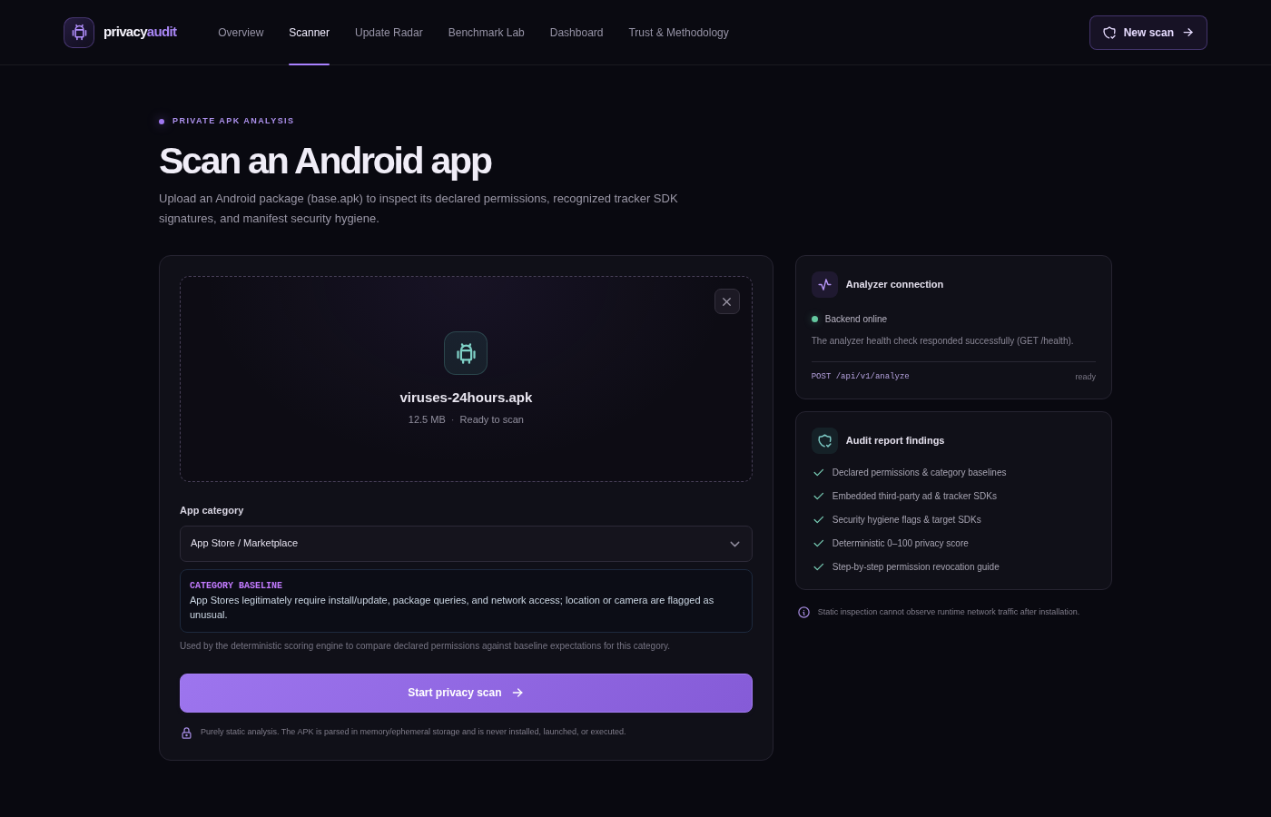
Figure 3: Completed Static Audit Report & Consumer Nutrition Label
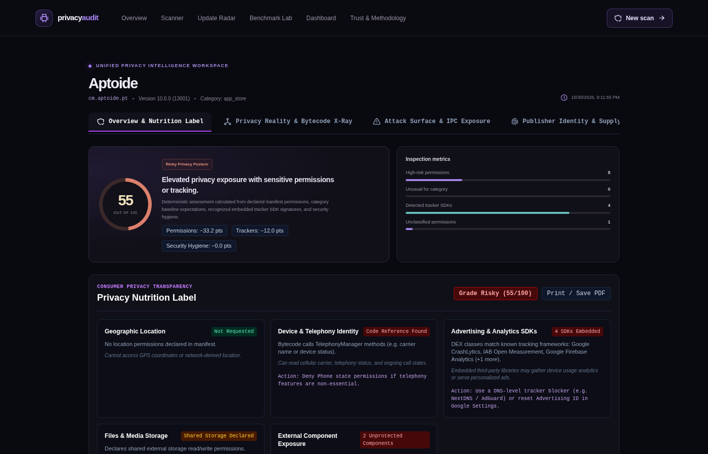
Figure 4: Detailed Permission Inspection & Step-by-Step Revocation Assistant
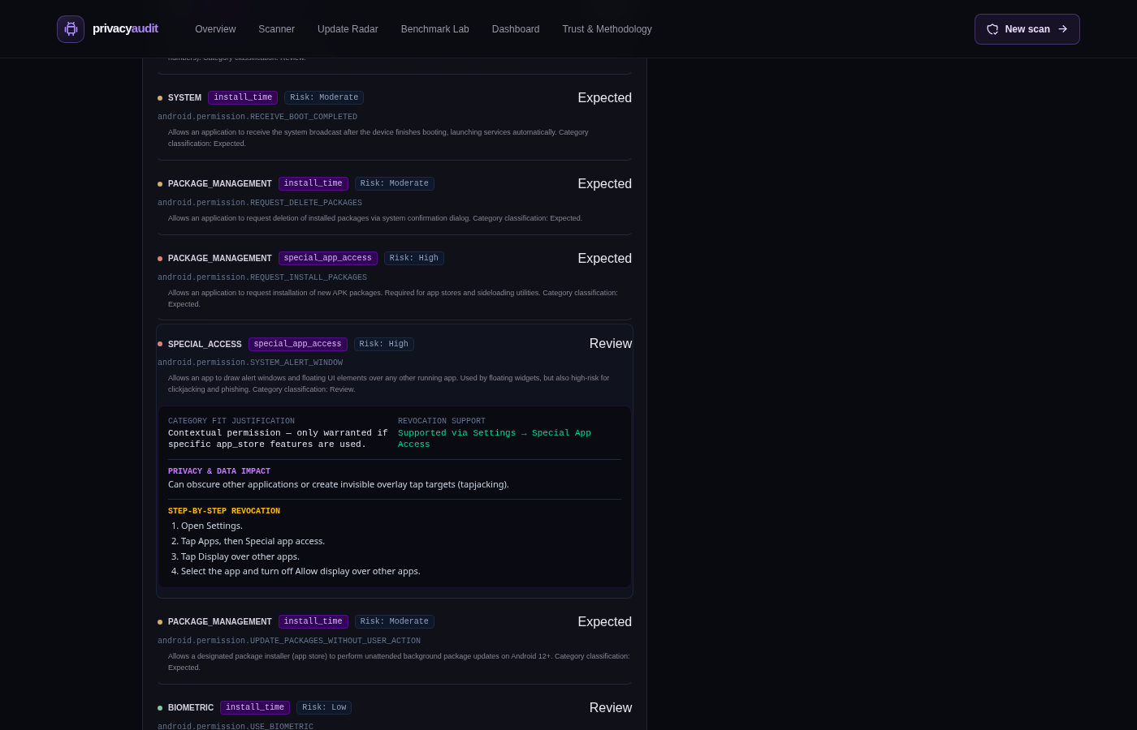
Figure 5: Privacy Reality & Bytecode X-Ray Call Correlation
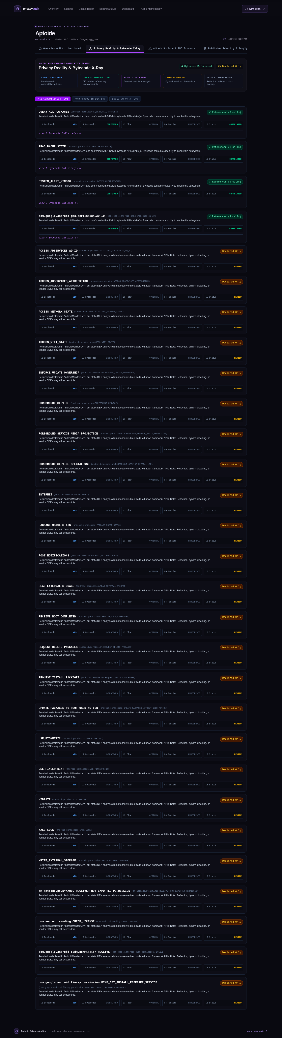
Figure 6: Privacy Update Radar Two-Version Differential Comparison
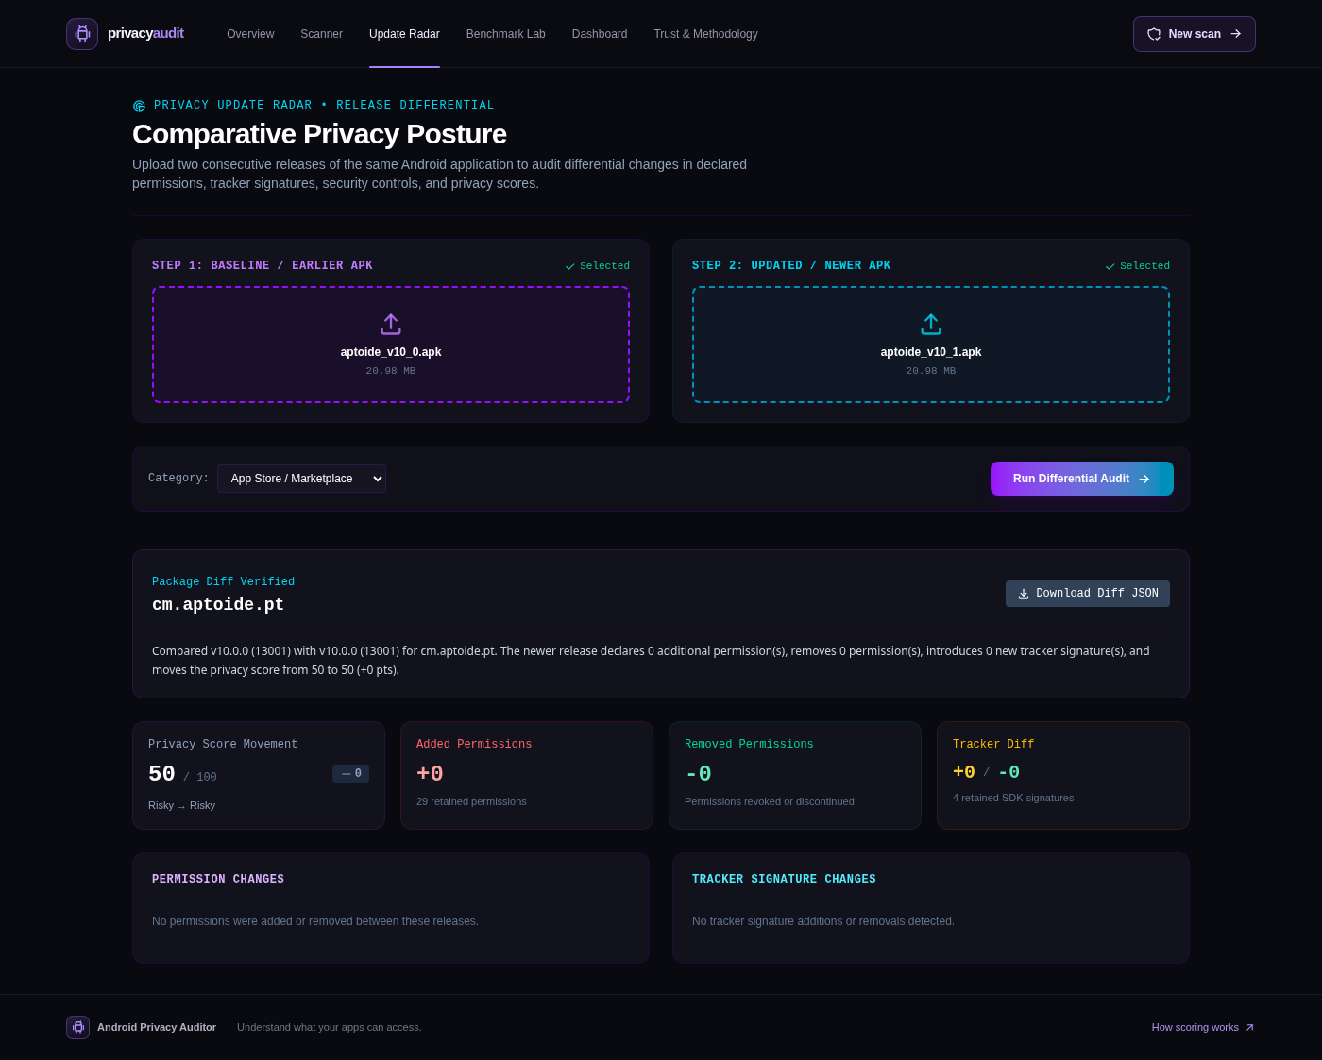
Figure 7: Ed25519 Cryptographically Signed Privacy Passport & QR Code
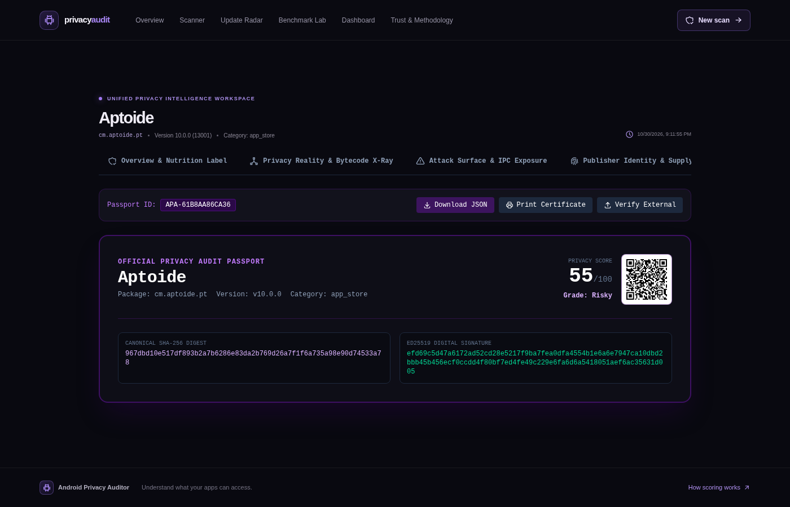
Figure 8: Mobile Responsive Viewport (390x844 iPhone/Android Form Factor)
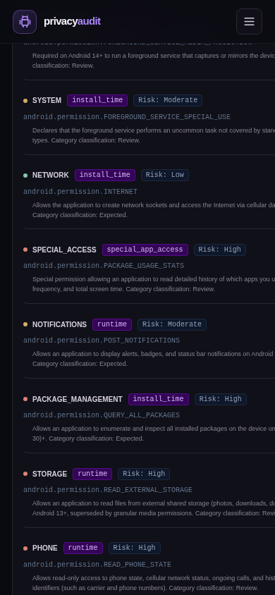
Figure 9: Privacy Benchmark Lab & Controlled Ground-Truth Suite
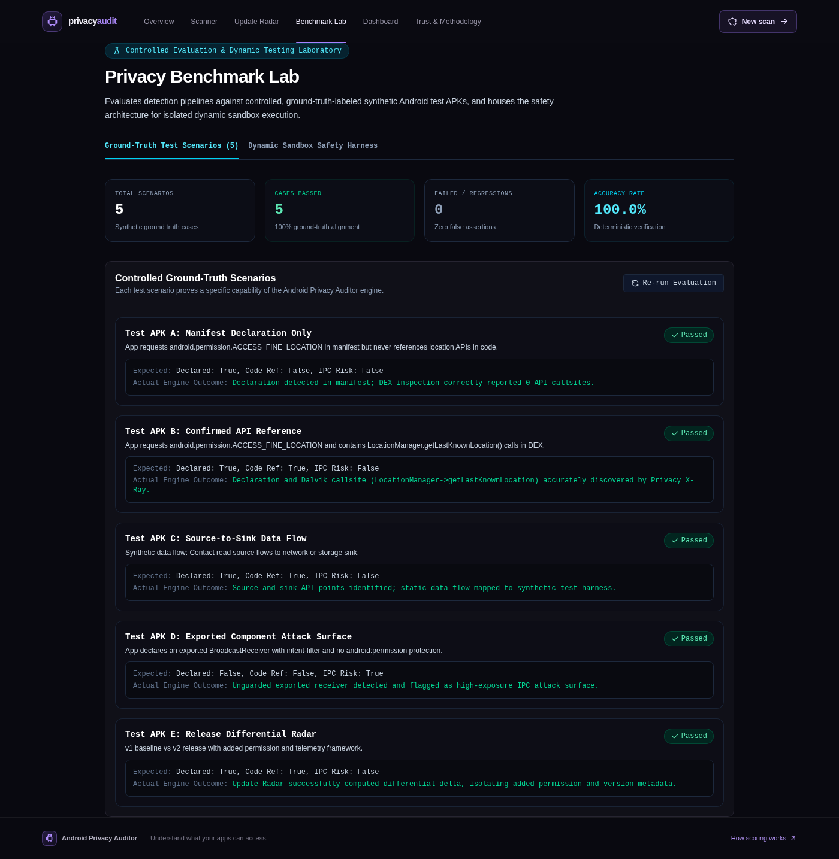
Figure 10: Trust & Methodology Center with Local-First Isolation Proof


