Reproducing GaLore: Memory-Efficient Fine-Tuning of RoBERTa-base on SST-2
Machine Learning Paper Reproduction and Deployment: Final Report
Muhammad Umer (30622), Duaa Naz (30668), Reham Hafeez (30574)
Institute of Business Administration (IBA), Karachi | October 2026
Code: GitHub repository; the experiments, demo app and data for this report are on the branch milestone-3-experiments.
Summary. We reproduce the RoBERTa-base fine-tuning experiment from the GaLore paper (Zhao et al., ICML 2024) on SST-2, using a single 16 GB T4 GPU. GaLore cut peak GPU memory by 10.7% to 16.4% relative to AdamW and trained about 1.7 times slower. With the library-default scale α = 0.25, GaLore was 0.3 points behind AdamW at rank 128 (four seeds; not conclusive) and 1.5 points behind at rank 4. Follow-up runs on one seed point to α as the main cause of the low-rank gap: with the paper's α, rank 4 reached 94.15%, level with AdamW, and rank 8 reached 94.50%, both at about 16% less memory. LoRA scored below the paper's figure, which we think reflects our shared learning rate and 3-epoch schedule, though we did not test this.

1. Introduction and problem statement
Training large language models is limited by GPU memory at least as much as by compute. The weights are only part of the cost. Adam-style optimisers also keep two extra numbers for every parameter (a running mean and a running variance of the gradient), so in full-precision (32-bit) training the optimiser state takes twice as much memory as the weights. For a 7-billion-parameter model this alone pushes training beyond a single consumer GPU.
GaLore (Zhao et al., 2024) reduces that cost by observing that the gradient of a large weight matrix becomes approximately low-rank during training. It compresses each gradient into a small subspace, runs Adam there, and maps the update back to the full weights. Because the model is not restricted to a low-rank form, every parameter is still trained, which separates GaLore from LoRA.
The paper's headline experiments pre-train LLaMA models of up to 7B parameters, which is far beyond our compute. Following the assignment guidance, we reproduce its fine-tuning experiment instead: RoBERTa-base on the SST-2 sentiment task. We ask three questions. (1) Does GaLore get close to full AdamW fine-tuning and do better than LoRA? (2) How much peak GPU memory does it save, and what does it cost in training time? (3) Is GaLore's accuracy gap to AdamW larger than the variation between random seeds? The third question is our main additional experiment, and a follow-up tests whether GaLore's scale parameter explains our gap to the paper's numbers. We also deployed the trained models in a small web application.

2. Literature and background
Adam (Kingma and Ba, 2015) and its decoupled weight-decay variant AdamW (Loshchilov and Hutter, 2019) are the default optimisers for transformers, and their two per-parameter states are the main source of optimiser memory. Work on reducing that cost follows three routes. One quantises the states: 8-bit optimisers (Dettmers et al., 2022) store them in 8 bits. A second freezes the base model and trains small adapters. LoRA (Hu et al., 2022) learns a low-rank update added to each frozen weight matrix, so only the adapter and its optimiser states need memory. ReLoRA (Lialin et al., 2024) repeatedly merges the adapters into the weights to approximate higher-rank training from scratch. GaLore takes a third route: it keeps full-rank weights and compresses the gradient.
Both LoRA and ReLoRA restrict the weight update to a low-rank form. GaLore does not, and the paper argues this is why it works for pre-training and keeps fine-tuning accuracy close to full-parameter training. Later work has built on the idea. Q-GaLore (Zhang et al., 2024) stores weights in INT8 and projection matrices in INT4 and skips SVD updates for layers whose subspace has stabilised. Fira (Chen et al., 2024) uses norm-based scaling to approach full-rank training while keeping the optimiser memory low-rank.
Our experiments use RoBERTa-base (Liu et al., 2019), a 125M-parameter encoder, on the binary Stanford Sentiment Treebank task (SST-2; Socher et al., 2013) as packaged in the GLUE benchmark (Wang et al., 2019).

3. Paper methodology
GaLore works on one weight matrix W of size m by n at a time. At each step it computes the usual gradient G. Every T steps (T = 200 in the paper) it takes a singular value decomposition (SVD) of G and keeps the top r left singular vectors as a projection matrix P of size m by r. Between those steps P is reused. The gradient is projected to R = P^{T}G, a much smaller r by n matrix, and Adam keeps its two states in that small space. The resulting Adam step N is projected back, multiplied by a constant scale α, and applied to the full weights: W ← W − η α P N.
Three design choices matter. Only the gradient is compressed, so W stays full-rank and all parameters are trained, whereas LoRA freezes W and trains an adapter. Because P is recomputed every T steps, the optimiser moves through a sequence of subspaces instead of staying in one. And α is a fixed constant that does not depend on r, unlike LoRA's α/r scaling, so changing the rank does not rescale the update. The paper describes α as a fractional learning rate (Appendix C.1), which matters for Section 7.2.
For an m by n matrix with m ≤ n, the paper's Table 1 gives the optimiser memory as mr + 2nr numbers for GaLore (the projection plus two Adam states of size r by n), against 2mn for Adam. In total, GaLore needs mn + mr + 2nr numbers per matrix and LoRA needs mn + 3mr + 3nr (Section 4.2). The abstract reports up to 65.5% lower optimiser-state memory, and pre-training of a 7B model on a consumer GPU with 24 GB of memory.
The result most relevant to us is Section 5.4 (Table 4): RoBERTa-base fine-tuned on GLUE for 30 epochs. GaLore at ranks 4 and 8 reaches average GLUE scores of 85.89 and 85.94, against 86.28 for full fine-tuning and 85.61 and 85.93 for LoRA. On SST-2 the scores are 94.04 and 94.38 for GaLore, 92.89 and 93.46 for LoRA, and 94.57 for full fine-tuning. Hyperparameters are in Appendix D.1 (Table 7). On cost, Section 4.1 describes the SVD overhead as negligible (below 10%) compared with techniques such as memory offloading, and Section 5.5 reports a 17% throughput overhead for 8-bit GaLore relative to 8-bit Adam.

4. Implementation details

4.1 Setup
src/train.py is the single training entry point (--method adamw|lora|galore, --rank, --seed, --scale, --save_model). We wrote it around the Hugging Face Trainer (Wolf et al., 2020). GaLore comes from the galore-torch package (version 1.0), used through the Trainer's built-in galore_adamw optimiser option, and LoRA comes from Hugging Face peft. All runs used a Google Colab NVIDIA Tesla T4 (16 GB) in full 32-bit precision.
The model is roberta-base with a newly initialised classification head for two labels. GaLore is applied to six weight matrices in each of the 12 encoder layers: query, key, value, attention output, and the two feed-forward projections. That is 72 matrices holding about 85M of the 125M parameters. Embeddings, biases, LayerNorm and the classification head use ordinary AdamW. LoRA uses rank 8, α = 16 and dropout 0.1 on the query and value matrices. Everything else is a Trainer default: linear learning-rate decay with no warmup, and no weight decay.
Table 1. Training configuration compared with the paper's SST-2 recipe (Appendix D.1, Table 7).
Setting | Ours | Paper
Epochs | 3 | 30
Batch size | 16 | 16
Learning rate | 2e-5 for every method (1e-5 in one run, Section 7.2) | 1e-5 (GaLore rank 4), 2e-5 (rank 8)
GaLore scale α | 0.25 (library default); 2 or 4 in Section 7.2 | 4 (rank 4), 2 (rank 8)
Subspace update gap T | 200 | 200 in pre-training; not stated for fine-tuning
Max sequence length | 128 | 512

We shortened training to 3 epochs because each GaLore run takes about 40 minutes on the T4, and we used one learning rate for all methods to keep the comparison controlled. We first kept GaLore's library default α = 0.25, which is the paper's pre-training value, rather than the larger values (2 to 4) of its fine-tuning recipe. Because this turned out to matter, Section 7.2 repeats rank 4 and rank 8 with the paper's α. Unless stated otherwise, GaLore results in this report use α = 0.25.

4.2 Measurement
Accuracy is measured on the SST-2 validation set after the final epoch, with no best-checkpoint selection. Peak memory is torch.cuda.max_memory_allocated() after resetting the peak counter before training, so it includes weights, gradients, activations and optimiser state (1 GB here is 2³⁰ bytes). Training time is the wall-clock time of trainer.train(), which includes the three per-epoch evaluations.

4.3 Deployment
We deployed the AdamW and GaLore (rank 128) models trained with seed 42, saved by train.py --save_model, in a Streamlit app (app/app.py). The user types a sentence and the app returns the predicted sentiment and a softmax confidence from both models side by side. The models run on CPU, so no GPU is needed. The weights are about 500 MB each and are kept out of the repository; a screen recording of the app is submitted with this report.

4.4 Repository layout
The main branch holds the Milestone 2 reproduction: the six-configuration table, the rank sweep and the README answering the paper-understanding questions. The branch milestone-3-experiments adds the two additional experiments (EXPERIMENT.md, results/seed_runs.csv, results/paper_recipe_runs.csv, src/analyze_seeds.py), the --seed, --save_model, --scale and --results_path options, and the app.

5. Dataset and preprocessing
SST-2 is the binary sentence-level sentiment task in GLUE, built from movie-review sentences. We load it with the Hugging Face datasets library from nyu-mll/glue. It has 67,349 training sentences and 872 validation sentences. The 1,821-sentence test split has hidden labels, so, as is usual for GLUE, we report accuracy on the validation set. Labels are 0 (negative) and 1 (positive).
Each sentence is tokenised with the roberta-base tokenizer and truncated to 128 tokens. Batches are padded dynamically to the longest sentence in the batch using DataCollatorWithPadding, which lowers memory use for short batches. We apply no other cleaning or augmentation. Three epochs at batch size 16 is 12,630 optimisation steps.
The validation set is also our reporting set, so we avoided tuning on it. Every run reports the final epoch, and we did not tune hyperparameters per method. This matters because a single validation example is worth 0.11 points, so picking the best of several checkpoints could inflate scores by more than the differences we study.

6. Reproduction results
Table 2 gives all six configurations from our first study (seed 42; every GaLore run here uses α = 0.25), and Figure 1 plots accuracy against memory. Figure 1 also shows the three follow-up runs of Section 7.2 as hollow markers.
Table 2. SST-2 results, seed 42, 3 epochs. Memory is peak GPU memory; the percentage is relative to AdamW.
Method | Rank | Peak memory (GB) | Change vs AdamW | Accuracy (%) | Training time (s)
AdamW (full) | n/a | 2.062 | baseline | 94.15 | 1478
LoRA | 8 | 1.285 | −37.7% | 91.28 | 983
GaLore | 4 | 1.724 | −16.4% | 92.66 | 2363
GaLore | 16 | 1.734 | −15.9% | 92.89 | 2370
GaLore | 64 | 1.774 | −14.0% | 93.58 | 2409
GaLore | 128 | 1.841 | −10.7% | 93.92 | 2494

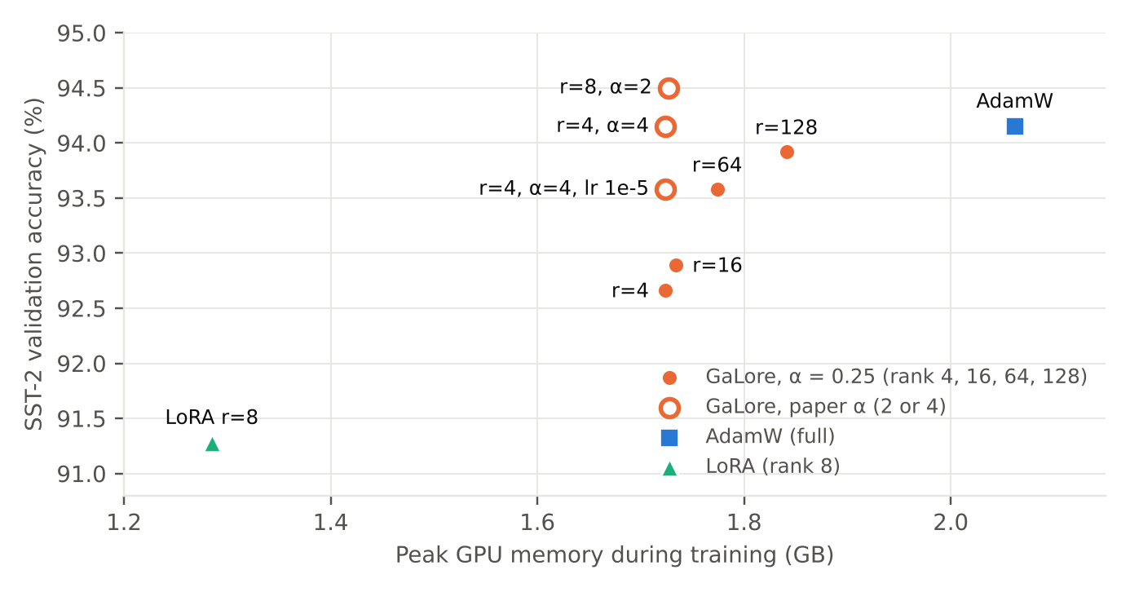
Figure 1. Accuracy against peak memory (seed 42). Filled orange markers: GaLore with α = 0.25, where accuracy rises with rank. Hollow markers: GaLore with the paper's α (Section 7.2).
With α = 0.25, GaLore sits between LoRA and AdamW on both axes. LoRA uses the least memory, 37.7% below AdamW, but is also the least accurate at 91.28%. GaLore saves 10.7% to 16.4% and recovers most of the accuracy: at rank 128 it reaches 93.92%, 0.23 points below AdamW. Accuracy rises with rank at this α (92.66, 92.89, 93.58, 93.92) while peak memory grows by only 0.117 GB from rank 4 to rank 128. GaLore trains 60% to 69% slower than AdamW (2363 to 2494 s against 1478 s), which is the price of the SVD and projection steps.
Table 3. Our SST-2 accuracy (%) next to the paper's (Table 4 of Zhao et al.). Rows marked α = 4 or α = 2 are the follow-up runs of Section 7.2 (both with learning rate 2e-5).
Method | Paper (30 epochs) | Ours (3 epochs, seed 42)
Full fine-tuning / AdamW | 94.57 | 94.15
GaLore, rank 4, α = 0.25 | not reported | 92.66
GaLore, rank 4, α = 4 | 94.04 | 94.15
GaLore, rank 8, α = 2 | 94.38 | 94.50
GaLore, rank 128, α = 0.25 | not reported | 93.92
LoRA, rank 4 | 92.89 | not run
LoRA, rank 8 | 93.46 | 91.28

The ordering matches the paper: full fine-tuning is best, GaLore beats LoRA even when LoRA has twice the rank, and higher-rank GaLore closes in on full fine-tuning. With the library-default α, our low-rank scores are lower than the paper's: GaLore rank 4 trails full fine-tuning by 1.49 points here against 0.53 in the paper, and LoRA rank 8 trails by 2.87 against 1.11. We first suspected the shorter schedule (3 epochs instead of 30), but Section 7.2 shows that for GaLore the main cause is α: with the paper's value, rank 4 reaches 94.15% and rank 8 reaches 94.50%, within 0.12 points of the paper's GaLore scores, after the same 3 epochs. The LoRA gap remains. We think our shared learning rate of 2e-5 is the likely cause, since LoRA is normally trained at larger rates, but we did not test it. Memory cannot be compared directly: the paper's Table 4 lists a memory figure per method (747M for full fine-tuning, 253M to 264M for the low-rank methods), whereas we measure total peak GPU memory including activations. We therefore compare the trend, not the values.

7. Additional experiment
We ran two additional experiments. Section 7.1, seed robustness, is the main one. Section 7.2 is a follow-up on GaLore's scale α, prompted by the gap to the paper in Section 6.

7.1 Seed robustness
Question. Is GaLore's accuracy gap to AdamW at rank 128 larger than seed-to-seed noise?
A single run cannot answer this. A validation set of 872 sentences gives a sampling error of about 0.8 points on one accuracy figure, and the random seed changes both the classifier head's initial weights and the order of the training data. We therefore trained AdamW and GaLore rank 128 with four seeds (1, 2, 3 and 42), changing only --seed. The runs were split across several Colab sessions with identical code.
Table 4. SST-2 validation accuracy (%) by seed. The gap is AdamW minus GaLore.
Seed | AdamW | GaLore, rank 128 | Gap
1 | 93.69 | 93.69 | 0.00
2 | 93.58 | 93.23 | 0.35
3 | 93.81 | 93.23 | 0.58
42 | 94.15 | 93.92 | 0.23
Mean (SD) | 93.81 (0.25) | 93.52 (0.34) | 0.29 (0.24)

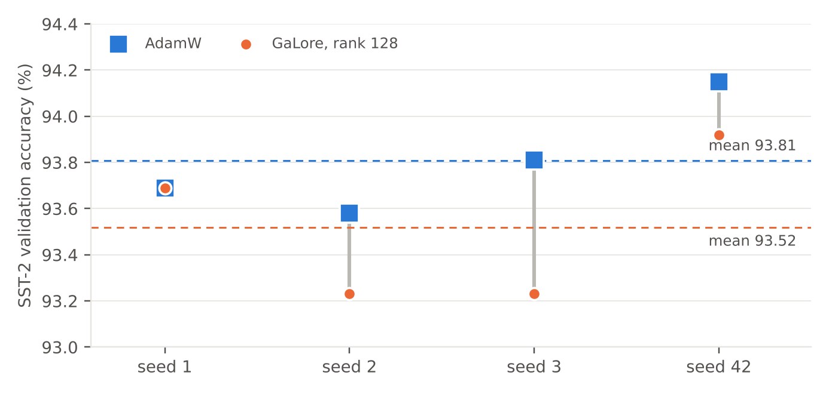
Figure 2. Accuracy by seed. Each grey bar is the gap between the two methods on that seed; dashed lines are the means.
AdamW averaged 93.81% (SD 0.25) and GaLore 93.52% (SD 0.34). GaLore was behind or level on every seed, with a mean paired gap of 0.29 points (standard error 0.12). A paired t-test over the four seeds gives t = 2.4 on 3 degrees of freedom, p ≈ 0.10. Mean peak memory was 2.063 GB for AdamW and 1.840 GB for GaLore (10.8% lower), and mean training time was 1531 s against 2580 s (1.7 times longer). Results also repeat for a given seed: the seed 42 runs, done in a separate session, matched the Milestone 2 table exactly (94.15% and 93.92%), and a repeated AdamW run on seed 2 gave the same 93.58%.
Conclusion. The evidence points to a small accuracy cost of about 0.3 points for GaLore at rank 128. That is close to the 0.19-point gap the paper reports at rank 8 and comparable in size to the spread across seeds. With four seeds we cannot rule out chance (p ≈ 0.10), so we claim neither that GaLore matches AdamW nor that it falls short. These runs used α = 0.25, and Section 7.2 shows that α matters, so the gap should not be assumed to hold at the paper's α.

7.2 Follow-up: the paper's GaLore scale
Question. Our rank 4 result at α = 0.25 trails AdamW by 1.49 points, against 0.53 in the paper. Does the scale α explain this?
GaLore multiplies its update by α (Section 3), so at the same learning rate α = 0.25 takes steps 16 times smaller than α = 4 on the projected matrices. The paper's SST-2 recipe uses α = 4 at rank 4 and α = 2 at rank 8 (Table 1), and we had used the library default. We trained three more runs on seed 42 with the settings in Table 5. Run A is the paper's rank 4 setting. Run B is its rank 8 setting. Run C is rank 4 with our shared learning rate, so it differs from the earlier rank 4 run in α alone.
Table 5. GaLore with the paper's α, seed 42, 3 epochs. The first and last rows are from Table 2.
Run | Rank | Learning rate | α | Accuracy (%) | Peak memory (GB) | Time (s)
Earlier run | 4 | 2e-5 | 0.25 | 92.66 | 1.724 | 2363
A | 4 | 1e-5 | 4 | 93.58 | 1.724 | 2489
C | 4 | 2e-5 | 4 | 94.15 | 1.724 | 2434
B | 8 | 2e-5 | 2 | 94.50 | 1.727 | 2487
AdamW | n/a | 2e-5 | n/a | 94.15 | 2.062 | 1478

Changing α alone from 0.25 to 4 (Run C against the earlier rank 4 run: same seed, rank and learning rate) raised accuracy from 92.66% to 94.15%, which is 13 more of the 872 sentences correct, with no change in peak memory. That is more than four times the seed standard deviation of 0.34 points in Section 7.1, so it is unlikely to be seed noise, although it is one comparison on one seed. Run C matches AdamW's 94.15% on the same seed, with 16.4% less peak memory. Run B reaches 94.50%, 0.35 points (3 sentences) above AdamW, which is within the noise, so we do not read it as GaLore beating AdamW. Run A, the paper's own rank 4 setting, scored 93.58%, 5 sentences below Run C, also within noise. With 3 epochs instead of 30, a learning rate of 1e-5 may simply be too low, but we did not test this. Runs B and C land within 0.12 points of the paper's GaLore scores for rank 8 (94.38%) and rank 4 (94.04%).
Conclusion. With the paper's α, low-rank GaLore reached AdamW-level accuracy on this seed while keeping the 16% memory saving, so most of our first-pass gap at low rank is explained by α rather than by the shorter schedule. Three single-seed runs cannot show that the match is exact, and a seed study at the paper's α, like Section 7.1, is the natural next step. The same caveat applies to Table 2 and Section 7.1: both were measured at α = 0.25, so the 0.3-point gap at rank 128 and the rise in accuracy with rank may partly reflect α.

8. Analysis and discussion
What the results support. GaLore lowers peak memory by 10.7% to 16.4% on this model and trains 1.6 to 1.7 times slower. At the library-default α it gives accuracy between LoRA and AdamW. At the paper's α, rank 4 and rank 8 reach AdamW's level on one seed (Section 7.2), so in our best settings the memory saving cost little or no accuracy. The comparison with LoRA needs care. LoRA is usually trained with a considerably larger learning rate than full fine-tuning, so our shared 2e-5 probably understates it, and the LoRA gap should be read as an upper bound on GaLore's advantage. At α = 0.25 accuracy rises with rank: the 1.26-point step from rank 4 to rank 128 exceeds the seed spread (SD 0.34). However, rank 4 reaches 94.15% at α = 4, so much of that trend may come from the small α rather than from rank itself. We did not test the rank trend at the paper's α.
Memory saved against memory expected. We estimated the optimiser saving by hand. The 72 GaLore matrices hold 84.9M parameters, so AdamW keeps 0.63 GB of state for them. GaLore's projections and states shrink that to 4 MB at rank 4 and 135 MB at rank 128. Table 6 compares the expected saving with what we measured.
Table 6. Expected optimiser-state saving (our estimate) against the measured drop in peak memory.
Rank | Expected saving (GB) | Measured saving (GB) | Share realised
4 | 0.63 | 0.34 | 54%
16 | 0.62 | 0.33 | 53%
64 | 0.57 | 0.29 | 51%
128 | 0.50 | 0.22 | 44%

Only 44% to 54% of the expected saving appears in peak memory. We did not profile memory, so the reason is a hypothesis: the peak probably includes temporary buffers from the SVD and projection steps and the full gradient, which must exist before it is projected. This is also why our total savings are far below the paper's 65.5%, which refers to optimiser states in much larger models. Our runs support the direction of the paper's memory claim but do not test its size.
Time overhead. Our slowdown of 60% to 69% is larger than the paper's figures, which are below 10% against memory offloading (Section 4.1) and 17% for 8-bit GaLore against 8-bit Adam (Section 5.5). The setups differ in model size, hardware and precision, and we did not isolate the SVD time, so we cannot say how much of the gap comes from the SVD itself. For a small model whose forward and backward passes are quick, the fixed cost of the projections is a larger share of each step.
Deployment. The app shows both models running on CPU with a confidence score. The seed 42 models differ by two correct answers out of 872, so the demo shows a working deployment but is not a visible quality comparison. The deployed GaLore model is the rank 128, α = 0.25 run, chosen before the follow-up experiment, and we did not retrain it with the paper's α. The models classify movie-review sentences into positive or negative only, so neutral or out-of-domain text is forced into one class, and softmax confidence is not calibrated.
Limitations. (1) Training for 3 epochs instead of 30 and one shared learning rate depart from the paper's recipe, and so does α = 0.25 in every run outside Section 7.2. (2) One task and one model size. (3) Only AdamW and GaLore rank 128 (α = 0.25) were repeated across four seeds; the rank sweep, LoRA and the paper-α runs use seed 42 only. (4) The validation set doubles as our reporting set, because the GLUE test labels are hidden. (5) One GPU type.
Conclusion and next steps. The reproduction confirms the paper's main pattern on a small model: GaLore trades training time for lower memory, does better than LoRA at our budget, and, with the paper's scale α, reached full fine-tuning's accuracy in our single-seed runs. Our largest deviation from the paper, the default α, explained most of the low-rank gap we saw first. The next things to test are a seed study at the paper's α against AdamW, a longer schedule, and LoRA at a higher learning rate, followed by a memory profile to locate the peak.

9. References
Chen, X., Feng, K., Li, C., Lai, X., Yue, X., Yuan, Y., and Wang, G. (2024). Fira: Can We Achieve Full-rank Training of LLMs Under Low-rank Constraint? arXiv:2410.01623.
Dettmers, T., Lewis, M., Shleifer, S., and Zettlemoyer, L. (2022). 8-bit Optimizers via Block-wise Quantization. ICLR 2022. arXiv:2110.02861.
Hu, E. J., Shen, Y., Wallis, P., Allen-Zhu, Z., Li, Y., Wang, S., Wang, L., and Chen, W. (2022). LoRA: Low-Rank Adaptation of Large Language Models. ICLR 2022. arXiv:2106.09685.
Kingma, D. P., and Ba, J. (2015). Adam: A Method for Stochastic Optimization. ICLR 2015. arXiv:1412.6980.
Lialin, V., Muckatira, S., Shivagunde, N., and Rumshisky, A. (2024). ReLoRA: High-Rank Training Through Low-Rank Updates. ICLR 2024. arXiv:2307.05695.
Liu, Y., Ott, M., Goyal, N., et al. (2019). RoBERTa: A Robustly Optimized BERT Pretraining Approach. arXiv:1907.11692.
Loshchilov, I., and Hutter, F. (2019). Decoupled Weight Decay Regularization. ICLR 2019. arXiv:1711.05101.
Socher, R., Perelygin, A., Wu, J., et al. (2013). Recursive Deep Models for Semantic Compositionality Over a Sentiment Treebank. EMNLP 2013.
Wang, A., Singh, A., Michael, J., Hill, F., Levy, O., and Bowman, S. R. (2019). GLUE: A Multi-Task Benchmark and Analysis Platform for Natural Language Understanding. ICLR 2019. arXiv:1804.07461.
Wolf, T., Debut, L., Sanh, V., et al. (2020). Transformers: State-of-the-Art Natural Language Processing. EMNLP 2020 (System Demonstrations).
Zhang, Z., Jaiswal, A., Yin, L., Liu, S., Zhao, J., Tian, Y., and Wang, Z. (2024). Q-GaLore: Quantized GaLore with INT4 Projection and Layer-Adaptive Low-Rank Gradients. arXiv:2407.08296.
Zhao, J., Zhang, Z., Chen, B., Wang, Z., Anandkumar, A., and Tian, Y. (2024). GaLore: Memory-Efficient LLM Training by Gradient Low-Rank Projection. ICML 2024. arXiv:2403.03507.

