STUDY OF THE LIFE SATISFACTION INDEX IN WOMEN

To raise awareness on the problem of gender inequality

Michalina Bienkiewicz

Anna Dabrowska

Elena Garcia Gomez

Milena Haładaj

Paulina Nanikowska

Jasmine Ross

Ana Tavares da Silva

# 

# 

# 

# 

# 

# 

# 

# 

# 

# Table of Contents

### Introduction 1

### Background 1

### Steps Specifications 1

### Implementation and Execution 2

### Result Reporting 2

### Conclusion 6

### Annex 8

# 

# INTRODUCTION

Our project aims to increase awareness of gender inequalities by examining the Life Satisfaction Index of women using the Better Life Index dataset.

Having the opportunity to test ourselves and focus the discussion around women's needs, we aim to find initial relations and insights that could motivate further analysis from us or other interested parties and maybe go as far as to influence gender policies with the analysis results.

With this report, we present a comprehensive summary of our ideas, organisation, methods, data sources and most importantly, the results and conclusions obtained from our analysis.

# BACKGROUND

The analysis is divided into three key sections. Firstly, we compare trends in the overall dataset with women-only data from the Better Life Index to underscore the importance of analyzing gender-specific information in addressing gender inequities effectively. Secondly, we identify factors within the Better Life Index that demonstrate a strong correlation with women's Life Satisfaction ratings, enabling policymakers to prioritize areas for targeted interventions and promote gender equality. Lastly, we explore the relationship between a country's GDP and women's Life Satisfaction Index to investigate whether higher GDP is associated with greater happiness among women. These findings could serve as motivation for governments to invest in gender-focused policies.

Our analysis is relevant to a diverse audience, including political parties, feminist groups, statistical institutions, state development entities, activists, and individuals considering migration. The outcomes of our analysis will inform policy decisions, empower advocacy efforts for gender equality, and provide valuable insights to individuals making informed choices regarding migration.

Leveraging tools such as Jupyter, pandas, data cleaning, visualization, and data analysis, our presentation approach strikes a balance by providing clear and accessible explanations for non-technical audience members while presenting detailed insights and technical information for professionals. Visually appealing visuals and illustrations complement the presentation, enhancing overall understanding.

# STEPS SPECIFICATIONS

In our first step we combined framing questions and data gathering. Every member of the group proposed topics with datasets, and since most suggestions referred to the Hapinness Index we decided to follow the lead. Due to the fact that our course is dedicated to women and to limit the extent of our analysis we decided to focus on women's life satisfaction. Then we started to search for datasets about life satisfaction that provided gender division and that’s how we found the Better Life Index. We used 2 datasets to answer our project questions. Both are from the Organisation for Economic Co-operation and Development, <https://stats.oecd.org/>

* In Social Protection and Well-being themes we chose Better Life Index:<https://stats.oecd.org/index.aspx?lang=en>. There are many factors which can correlate with Life satisfaction index divided into groups: : Housing, Income, Jobs, Community, Education, Environment, Civic engagement, Health, Life-satisfaction, Safety, Work-Life Balance.
* In the National Accounts theme we chose Gross domestic product (GDP):<https://stats.oecd.org/Index.aspx?DatasetCode=SNA_TABLE1> . There are information about GDP in different years and countries.

Afterwards, in the process of brainstorming we created project's final questions. In the preprocessing step our content leader signalised what steps need to be done, we divided them among volunteers and we set up the deadline for this initial sprint. We took up this iterative approach also for the in-depth analysis, and worked in the system of sprints till the end of the project, which is described in the next point.

# IMPLEMENTATION AND EXECUTION

This project was a big challenge for us since each member of our group is at the beginning of their data analysis path, moreover in short time, without predefined roles, we needed to find agreement in the field new for everybody, both regarding content and organisation of the workflow.

Defining the topic and the scope of our project turned out to be problematic. We also faced difficulties in work division between the group members. We overcame the content difficulties with the help and advice of our group supervisor, Sayo, and decided to reduce the amount of data resources used in the project. We also needed to adjust the subject of our analysis to the available datasets and time limitations. We overcame the organisational difficulties by setting the project timeline and the work schedule. We also took care of clear communication within the group and encouraged the members to voice their needs.   
  
Two leaders emerged in the group, a content and an organisational one. They took the initiative in these two domains within the first few days of the project and after about 10 days the group was asked if anybody felt not ok with the situation. Since nobody signalled objections, we worked according to this system till the end of the project. Our development approach was agile and iterative. We worked according to the project timeline, in 5-7-day-long sprints. At the beginning of the project Elena, the content leader, created the technical basis for the work and signalised what steps should be performed next. Each member of the group volunteered to undertake a specific task, and we set a fixed deadline for it. At the end of the interval, we had time to familiarise ourselves with the created code, comment, and ask questions. That was our first sprint and we worked in this way for the whole project. Everybody worked in the shared files, we used Google Colab for the project work and Google Docs for the work schedule, project notebook, homework 2, etc. In order to avoid overwriting the project document, we tried our code in project copies, and the final version of the code was pasted into the main project file. The same principle applied to refactoring, e.g. working to adjust the visualisation so that the names of countries don’t overlap. At times two codes performing the same task were visible in the main file one below another so that everybody could see the difference and comment on is. Some members of the group worked individually, some preferred to work in pairs during several sprints. There were no delays in our work. We used the following libraries: pandas, pandassdmx, requests, numpy, sci-kit-learn, matplotlib, and seaborn.

# RESULT REPORTING

We could not respond to our global question by just analysing general data instead of specific data about women, but we have found several interesting insights.

**Regarding the *Life Satisfaction* scores (1 to 10), all countries approve from the women's perspective**, although bottom-ranking countries fail to pass when looking at the data from the men's perspective, which lowers the mean of the total population values.

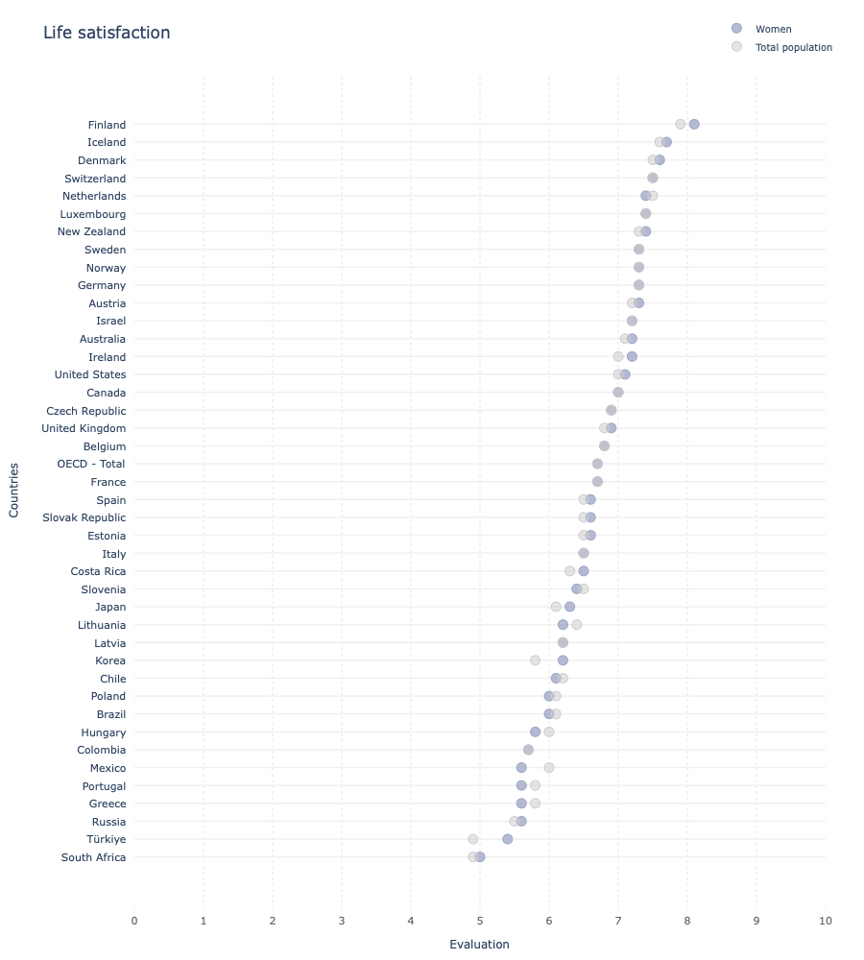Life satisfaction visualisation comparing women’s data to total population’s data[1]

There is a tendency throughout the analysis where the countries with worse data show a slight change in the trend or worsen the results for women even more than for the general population, e.g. as observed on the *Employment rate* graph. **Where conditions are worse, those conditions affect women in a magnified way**, and therefore our initial hypothesis seems to make sense, even for selected cases only.

**From the fourteen features that we have analysed from the Better Life Index dataset**, we found a mix of objective (gathered from institutions) and subjective (surveyed directly from the population) features. For some of them, **women's data show noticeable differences from the general population**:

* **Higher values**, like **'long-term unemployment rates' (-)[2]** (although the difference is only visible in the higher ranking countries), **'student skills' (+) and 'life expectancy' (+)**. In these cases, the pattern differences are more irregular than when we look at the lower values. In 'Life satisfaction' (+), 'quality of support network' (+) and 'educational attainment' (+) , women also show higher values but with a minimum difference to the total population.
* **Lower values**, like ***'feeling safe walking alone at night' (-), 'homicide rate due to assault' (+), 'employment rate' (-), 'employees working very long hours' (+)*** and most cases in **'self-reported health' (-)**. There is one more feature where the women's values are lower than the general population but with a small difference, 'time devoted to leisure' (-). Here, we could also analyse a reduced number of countries due to the available data, and therefore can not be considered relevant to the global results.

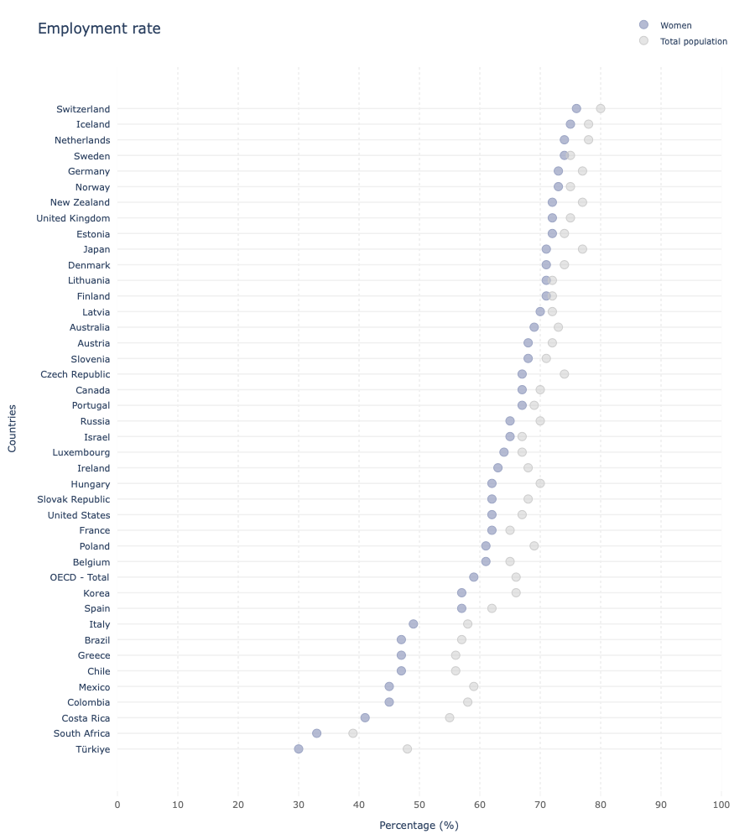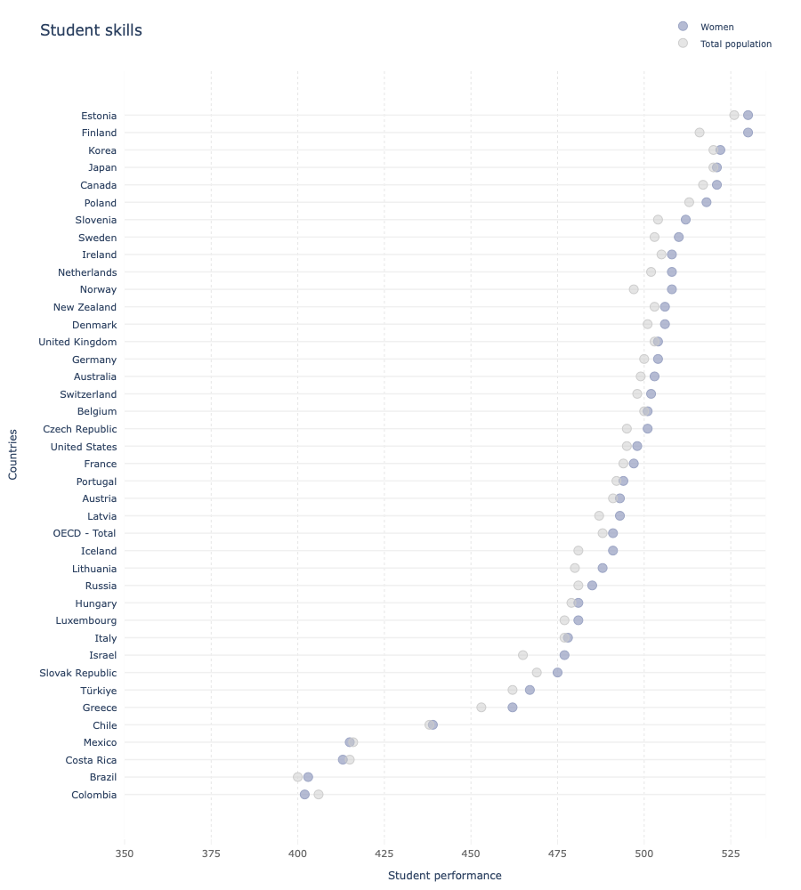

Employment rate and Student skills visualisations comparing women’s data to total population’s data[3]

**The results reveal insights about the existence and causes of gender inequality**, e.g. while women excel with their *student skills*, this does not translate into the job market due to the higher *unemployment rates*. Another interesting fact within this data is that women are objectively meant to live longer, i.e. their health must be better, but their *health self-perception* is lower than that of men.

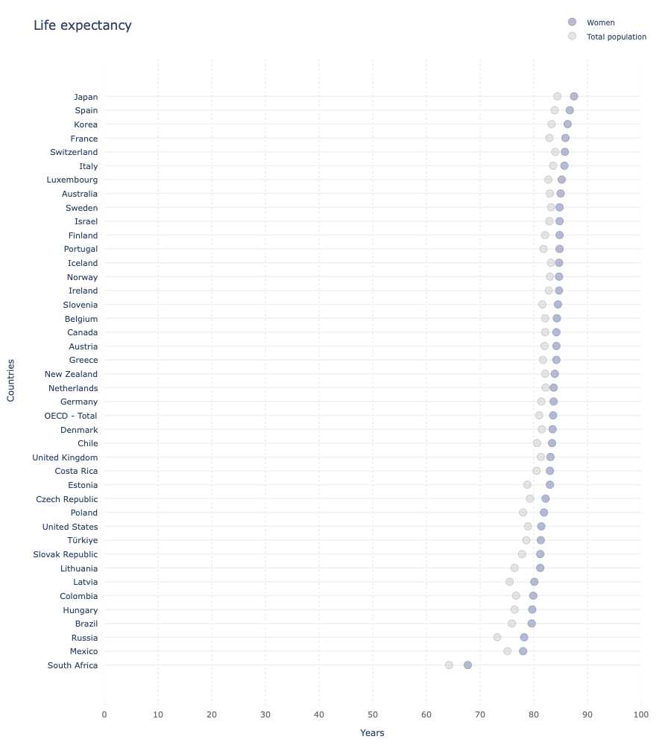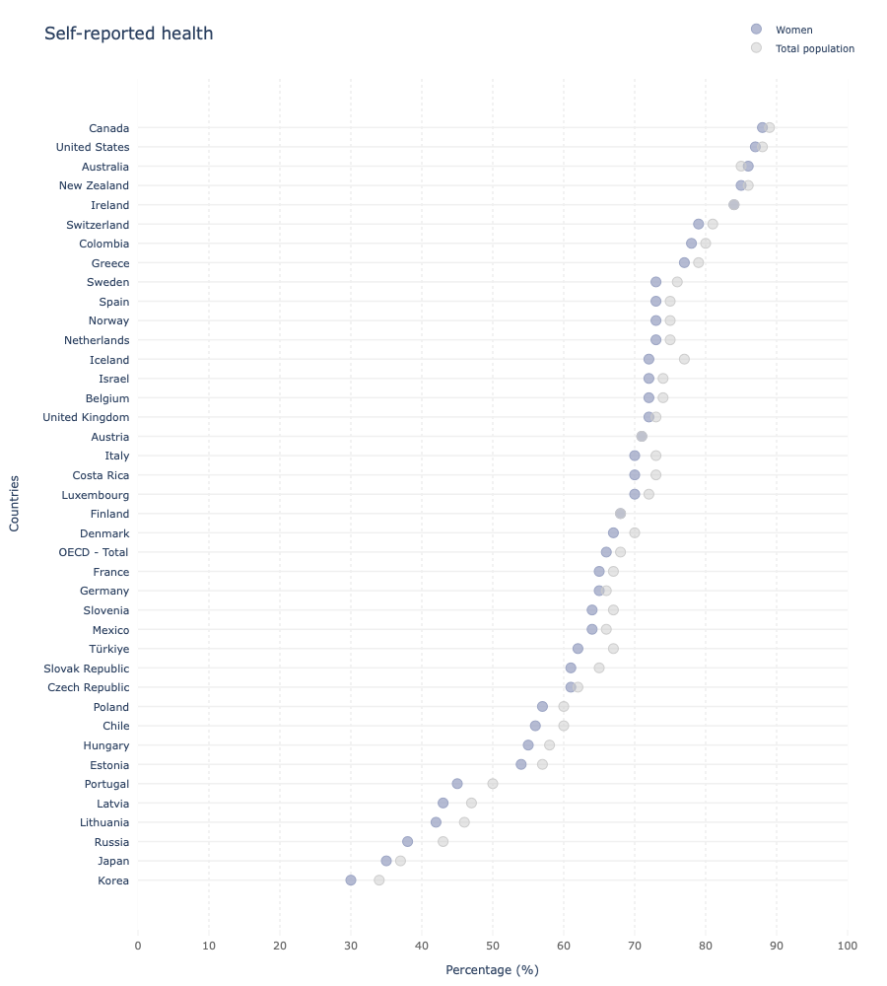

Life expectancy and Self-reported health visualisations comparing women’s data to total population’s data[4]

* 'How does this fact correlate to the life satisfaction score?'
* 'What factors affect this negative perception?'
* 'Could this be a key factor to work on, to improve how satisfied women are with their lives?'

These are interesting questions derived from this first part of the analysis, that although does not provide a complete answer, opens the way to further analysis.

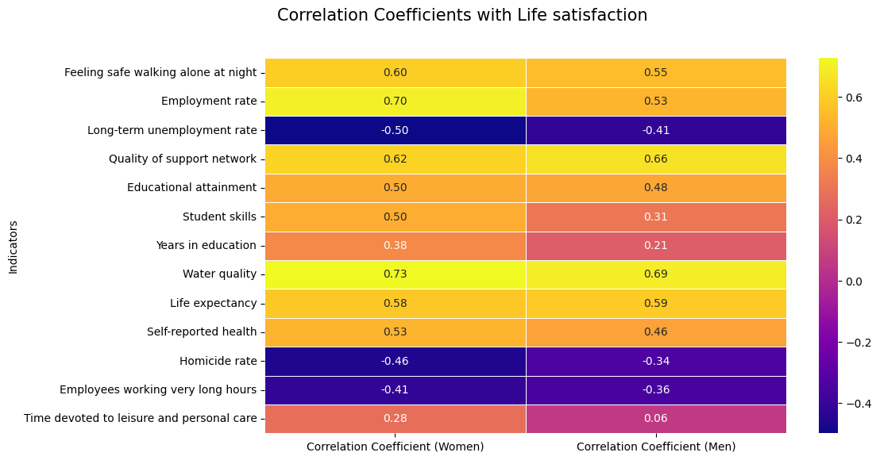

Visualisation showing the correlation of factors to the Life satisfaction score for women and men

By analysing scatter plots and heatmaps, we gained insights into the indicators that exhibit stronger significance in relation to women's well-being.The analysis revealed that the following indicators in the 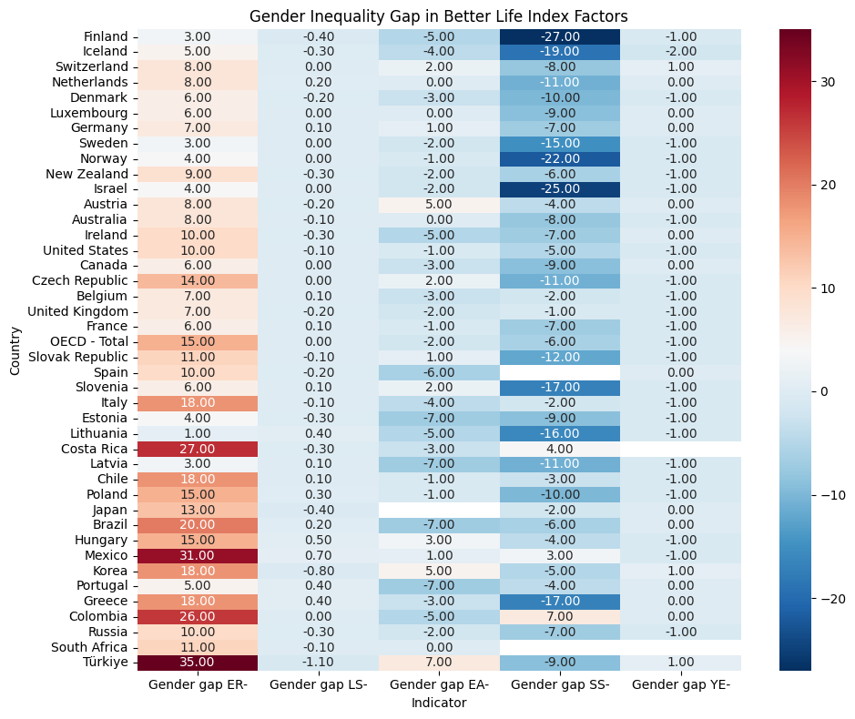

Visualisation showing the *Gender gap* calculations

Better Life Index exhibit stronger correlations with women's life satisfaction: Water Quality, Employment Rate, Feeling safe walking alone at night, Quality of support network, and Life Expectancy. Improving these areas can have a positive impact on women's well-being and life satisfaction. It should be noted that correlation is not causation and that even though correlations have been drawn from the data it is not enough to state for fact that women’s life satisfaction would be improved if the given indicators were improved.

Gender Differences: Employment Rate had a higher correlation with women's life satisfaction compared to men's. Other indicators, such as Time devoted to leisure and personal care, Student Skills, and Years in education, also displayed significant differences between genders.

Gender Gaps: Biases towards women were observed in 19 out of 42 countries, while Educational Attainment favoured women in 27 countries. These gaps indicate areas where efforts should be focused to address inequalities and promote gender equality.

Policy Interventions: Suggestions for reducing gender gaps and improving women’s life satisfaction include promoting women's workforce participation, providing financial aid for education, creating safe spaces and support networks, and addressing gender-based violence and discrimination.

In addition, we wanted to see if there is a relationship between the GDP per head and women's life satisfaction. Through our regression analysis, we calculated a correlation of 0.74, which means there is a positive correlation. When the GDP per head increases, women tend to have higher life satisfaction. Furthermore, we determined that 49% of the variation in life satisfaction can be explained by the variation in GDP per head. It is important to note that economic prosperity alone does not guarantee women’s happiness and satisfaction. Other social-cultural and individual factors play a role.

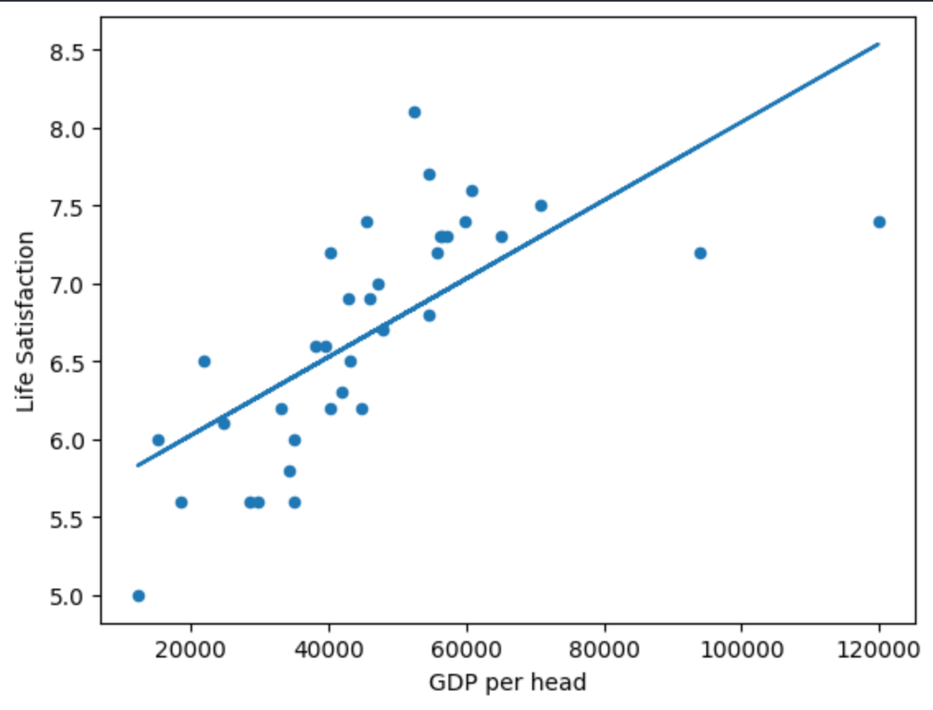

Visualisation of the linear regression model vs the actual data

# CONCLUSION

In conclusion, our analysis of specific data about women has shed light on the existence of gender inequalities and their implications for women's well-being and life satisfaction. We have uncovered valuable insights into the factors that affect women's lives and have identified areas where targeted interventions can make a difference.

The data has revealed that women's perspectives on life satisfaction differ from men's, particularly in lower-ranking countries. This highlights the need to consider gender-specific viewpoints when assessing overall population values. Moreover, we have observed a concerning trend where adverse conditions disproportionately affect women, exacerbating gender disparities in various aspects of life.

Within the Better Life Index dataset, we have found distinct differences between women's data and the general population. While women tend to excel in educational attainment, life satisfaction, and quality of support network, they face challenges in areas such as feeling safe, employment, and self-reported health. These findings underscore the need for targeted efforts to address gender gaps and promote gender equality.

We have also identified indicators with stronger correlations to women's life satisfaction, including water quality, employment rate, safety, support networks, and life expectancy. Focusing on improving these areas can positively impact women's well-being. However, it is important to note that correlation does not imply causation, and further research is required to establish definitive causal relationships.

Furthermore, our examination of the relationship between GDP (per head) and women's life satisfaction revealed a positive correlation, suggesting the potential influence of economic factors. However, it is important to note that economic prosperity alone does not guarantee women's happiness, and other socio-cultural and individual factors play a significant role.

Our analysis has prompted thought-provoking questions about women's health self-perception and its impact on life satisfaction. Exploring these questions further could uncover key factors influencing women's satisfaction with their lives and guide efforts to improve their well-being.

With the application of multiple linear regression and the predictive model we have created the interactive possibility for each female recipient of our project to predict one's satisfaction level based on the given independent variables.

In conclusion, our findings emphasise the need for targeted policy interventions to address gender inequalities, promote women's empowerment, and enhance their life satisfaction. By understanding the nuances of gender-specific data and addressing the identified disparities, we can strive towards a more inclusive and equitable society.

Further steps that could be taken:

* Examine additional factors and their relationships: The investigation concentrated on parameters with high correlation rates. To gain a deeper understanding of the correlations between these factors and women's life happiness.
* Analyse information from other regions: The analysis was limited to OECD countries. Data from other countries may be useful for gathering a broader perspective on gender inequality and life happiness.
* Analyse the effects of gender policies: more research might examine the influence of particular gender policies or interventions on women's life satisfaction. This could offer proof to back up the argument that investing in gender policies is a good reason for nations to do so.

# Annex

Visualisations









1. Refer to page 8 for full size visualisations on *Life satisfaction*
2. Marking '+' or '-' whether the difference affects positively or negatively to women
3. Refer to pages 9 and 10 for full size visualisations on *Employment rate* and *Student skills*
4. Refer to pages 11 and 12 for full size visualisations on *Life expectancy* and *Self-reported health* 