Photoshop Assignment Minor – Creature Photograph

Due Date: Oct 18, 2018 Midnight Course Weight 10%

Using the techniques that we have covered in class, you are to create a color composite image from numerous source photographs creating a mythical, crossbred, or unusual creature. A past theme has been mammals producing the following:

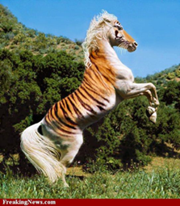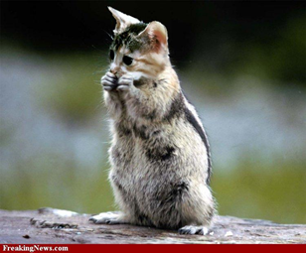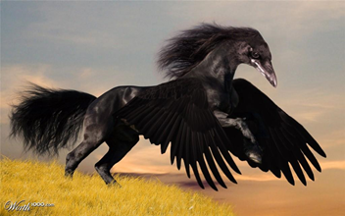

Requirements

Your instructor will provide additional details regarding the theme of this assignment, submissions that do not meet the specifications are incomplete and will be graded appropriately. You must create new original work for this assignment. Work from previous semesters, yours or someone else, will not be acceptable and will receive a mark of zero.

Theme: Insect

- Your final document must be a minimum size of 1024px by 768px
- You must use a minimum of 3 separate insect photographs.
- You must sign your name on the final image using a brush on a separate layer.
- Your instructor may request a copy of all original images.

Save the file as “PhotoShop_Assignment_Minor.psd ”. Submit your work in Moodle. Your instructor may also ask you to submit your work into your course drop box. The finished PSD file must be submitted by end of day on End of Day (midnight) Oct 18, 2018.

Assignment Key and Rubik: Name:

Item | Max Score | Mark Earned
Files set up to supplied specs | 1
Layers have been suitably named | 1
Minimum 3 separate animal images have been used | 1
Final image is a believable mythical, crossbred, or unusual creature | 3
Masks are used on layers to isolate display images | 3
Image edges are appropriately adjusted for image integration | 2
Image perspective has been applied appropriately to individual photo items | 3
Adjustment layers have been appropriately applied | 2
Attention to photo quality details | 3
Signature exists | 1
Total | 20

Comments:

Assignment Rubik Value breakdowns
1 1 = Proficient (requirement is done)
0 = Incomplete ( requirement not done)
2 2 = Proficient (requirement is well done overall)
1 = Limited ( requirement is not done well, limited attention to detail )
0 = Incomplete ( requirement poorly done, missing large portions)
3 3 = Proficient (requirement is well done overall)
2 = Capable (requirement has minor errors)
1 = Limited ( requirement is not done well, limited attention to detail )
0 = Incomplete ( requirement poorly done, missing large portions)

Project Rubik Value breakdowns
1 1 = Proficient (requirement is done)
0 = Incomplete ( requirement not done)
2 2 = Proficient (requirement is well done overall)
1 = Limited ( requirement is not done well, limited attention to detail )
0 = Incomplete ( requirement poorly done, missing large portions)
3 3 = Proficient (requirement is well done overall)
2 = Capable (requirement has minor errors)
1 = Limited ( requirement is not done well, limited attention to detail )
0 = Incomplete ( requirement poorly done, missing large portions)

TIP: To submit your original images and final image in a single file, copy your original images into your .psd file. This should place them on their own layers. You can then use a mask on these layers. To see the original image, Shift + click on your mask icon, it will turn off the mask. Shift + click on the mask icon again, and the mask will be in effect.

Save the file as “PhotoShopAssignmentMinor.psd ”. Submit your work in Moodle. Your instructor may also ask you to submit your work into your course drop box. The finished PSD file must be submitted by end of day on End of Day (midnight) Feb 12, 2015.

