Masking Bucket

To be completed in class.

You may use your class notes or Photoshop help files to assist you. You must complete the assignment without assistance from your classmates or the instructor. You may ask your instructor for assistance if the software is behaving abnormally to correct the problem.

Using the masking tools covered in class and the supplied images create a composite image that matches the final image.

Each layer will need a mask applied to it to create the final image (except the background). At times, you may need only a small section of the original image. You may use the Marquee tool to reduce the amount of selection from the original image. You must select sufficient area from the original image as to apply a mask on the final image. DO NOT select only the required image from the original image, this is a masking assessment.

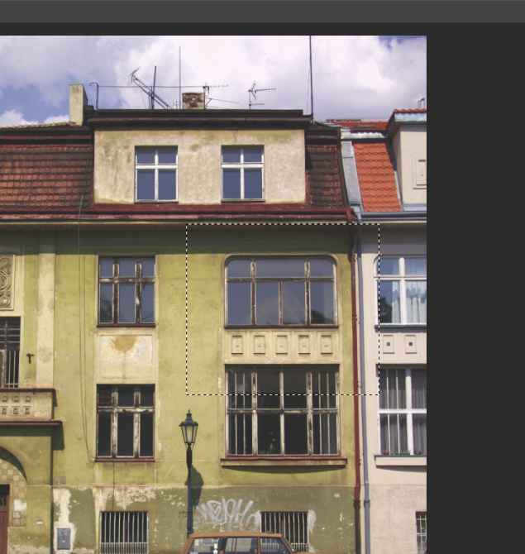
This is an example of a partial selection from original image. Sufficient area has been selected to transfer to your work so a mask can still be applied.

Save the file as “Assignment06.psd ”. Submit your work in Moodle. Your instructor may also ask you to submit your work into your course drop box. If you have not completed the task, at least submit what you have completed for partial marks.

