Sean Blanton

Introduction to Java

Project 01

Aug 19 2015

**Programming Guidelines Followed (20pts)**

-Required comments present in class comment block

-Indentations consistent

-Block bracing consistent

**Java “public class” is created (20pts)**

-project01BlantonMain is a public class

**Java “main” method is created (20pts)**

-main() method as member of project01BlantonMain class

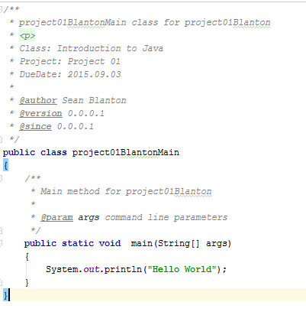

**Program displays a “Hello World” message to command line (20pts)**

-Results of jar execution

**Program files are placed in an *executable* JAR file (20pts)**

-Execution of jar file

-Manifest file

-**javac 1.8.0_51**

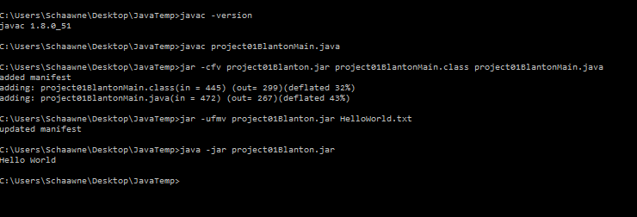

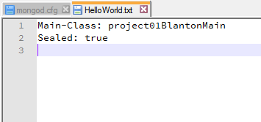

# Summary

Created a standard HelloWorld project for java. Used intelliJ IDEA community IDE. Originally made class a part of com.IntroJava2015 package and executable jar file/manifest by intelliJ executed but refactored to follow provided directions more closely. Elected not to in-line comment println call because naming seemed self explanatory “print line to system out”.