Sean Blanton

Introduction to Java

Project 02

Sep 2 2015

**Jar file is executable and Programming Guidelines are followed (25pts)**

-Required comments present in class comment block

-Indentations consistent

-Block bracing consistent

**Program reads input from the args array (25pts)**

-AverageMain.java main() method

-Reads String array args and stores

**Program calculates and displays the average of the given input (25pts)**

-AverageMain.java main() method displays calculated average to 3 decimals

-AverageMain.java calcAverage() method calculates average over List of Integers

**Program displays a welcome message when launched and ​*gracefully* ​handles the case of no arguments (25pts)**

-AverageMain.java main() method displays a welcome message before processing args

-AverageMain.java main() method detects empty input list and notifies user.

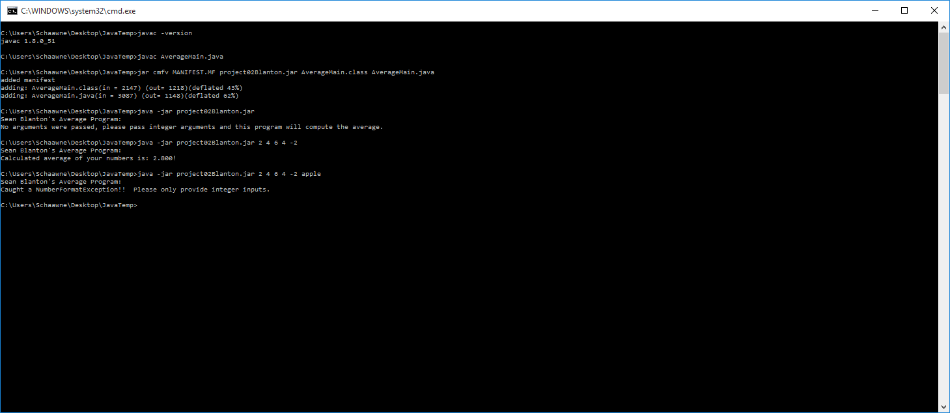

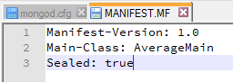

# Summary

Created a simple average calculator project for java. Used intelliJ IDEA community IDE. Manually compiled and packed source for release to provide concise screenshots of functionality. Chose to use Exception Handling to deal with non-integer inputs. Also added generic exception catch which should not be hit. Used a separate static method for calculating the average but elected to mark it private but still static. Discovered a truncation problem when the sum variable in calcAverage() was an int instead of double, truncated decimal results to integer sope, resolved before submission. Attempting to use javadoc comments as practice but no requirement to submit generated documentation.