Sean Blanton

Introduction to Java

Project 05

Oct 14 2015

**Programming Guidelines are followed and jar file is executable (10pts)**

-Required comments present in class comment block

-Indentations consistent

-Block bracing consistent

-jar compilation and execution in screenshot

**Documentation report is created with screenshots (10pts)**

-This document

**JFrame with Title is created (10pts)**

*//Call the JFrame constructor and set the window title*

**super**(**"Hello World Frame"**);

-Screenshots below

**JLabel is created and displays a changing value (10pts)**

**m_displayText = STR_DEFAULTLABEL;**

**m_textLabel = new JLabel(m_displayText, JLabel.*CENTER*);**

-Screenshots below

**JPanel is created to manage the display of buttons (15pts)**

m_buttonPanel = **new** JPanel();

Screenshots below

**Uppercase JButton converts display to uppercase (15pts)**

**case STR_TOUPPERCASE:**

**m_displayText = m_displayText.toUpperCase();**

**break;**

**m_textLabel.setText(m_displayText);**

Screenshots below

**Lowercase JButton converts display to lowercase (15pts)**

**case STR_TOLOWERCASE:**

**m_displayText = m_displayText.toLowerCase();**

**break;**

**m_textLabel.setText(m_displayText);**

Screenshots below

**Reset JButton restores program to original state (15pts)**

**case STR_RESETLABEL**:

**m_displayText** = **STR_DEFAULTLABEL**;

**break**;

m_textLabel.setText(**m_displayText**);

Screenshots below

**New JButton gets a new String value from the user via a dialog box (15pts)**

**case STR_NEWLABEL:**

**m_displayText = JOptionPane.*showInputDialog*("What text would you like to see?", m_displayText);**

**break;**

**m_textLabel.setText(m_displayText);**

Screenshots below

# 

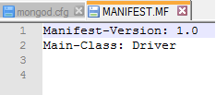

# 

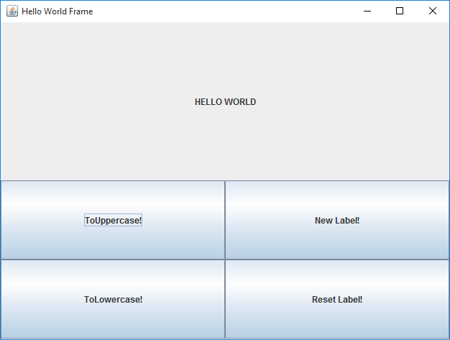

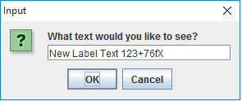

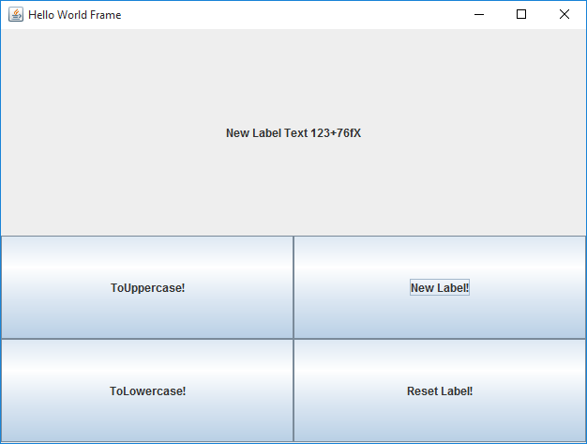

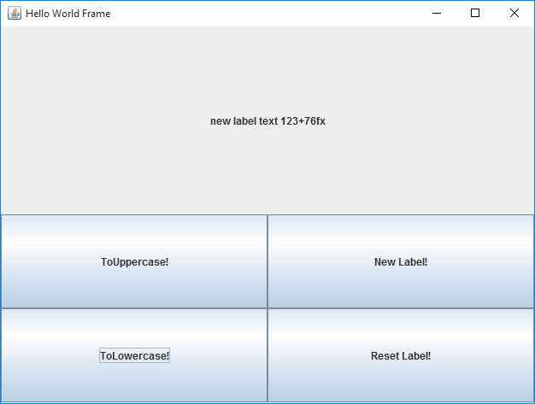

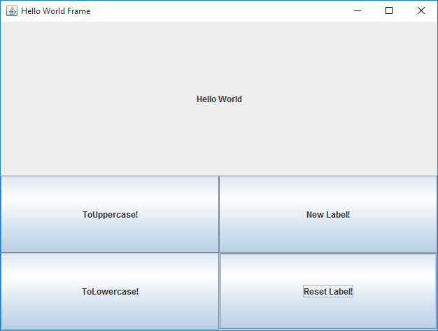

# Summary

Hello World GUI set of classes in java. Kept main method in separate Driver class for convenience. Used intelliJ IDEA community IDE. Used consts for user input and private functions with for easy modification/expansion and use in switch statements. Manually compiled and packed source for release to provide concise screenshots of functionality. Attempting to use javadoc comments as practice but no requirement to submit generated documentation.