Sean Blanton

Introduction to Java

Project 06

Oct 28 2015

**Programming Guidelines are followed (25pts)**

-Required comments present in class comment block

-Indentations consistent

-Block bracing consistent

-jar compilation and execution in screenshot

**Report is created with Screenshots (25pts)**

-This document

**FlashCards are stored in a Data Structure (25pts)**

-CardStack.java

**Data Structure is randomized (25pts)**

**public void** Shuffle()

**GUI function as required (25pts)**

-Additional JPanel for layouts

-Additional JPanel with 2 JLabels for Card side information and Stack progress

Screenshots below

# 

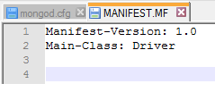

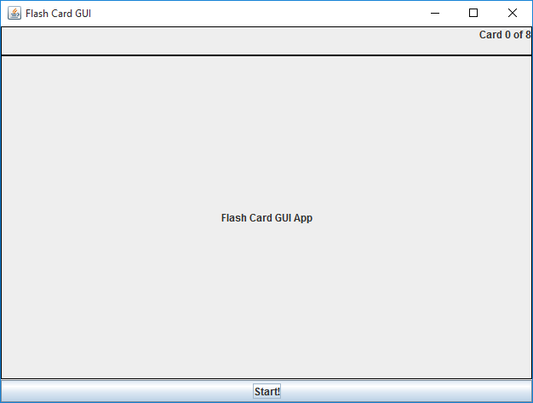

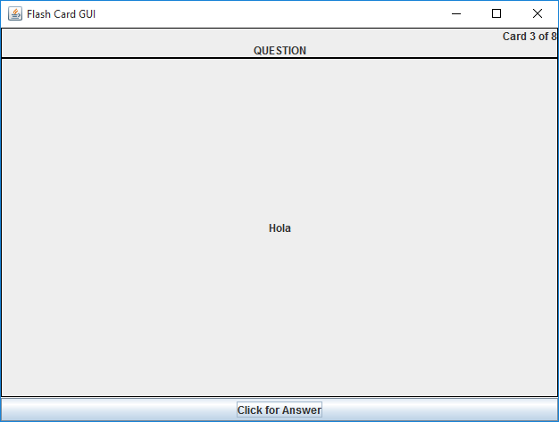



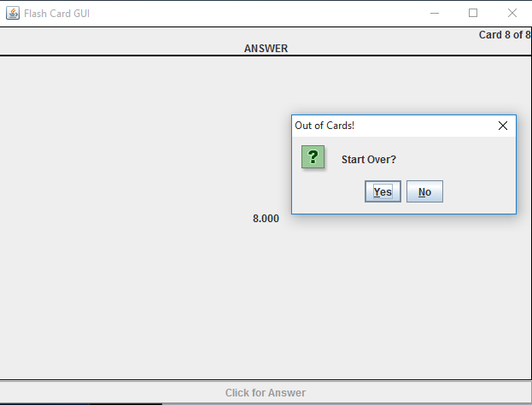

New Run, new Question 3

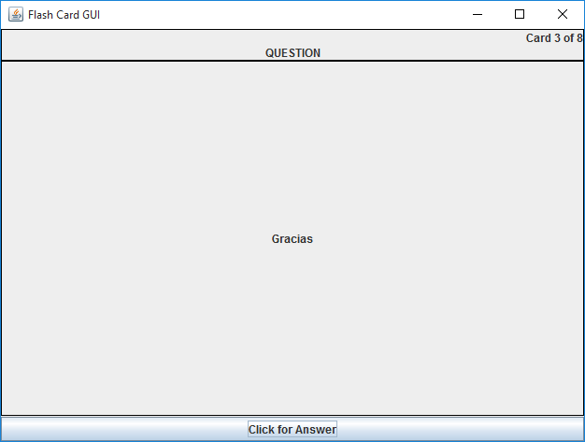

# Summary

Flash Card set of classes in java. Kept main method in separate Driver class for convenience. Used intelliJ IDEA community IDE. Used consts for user input and private functions with for easy modification/expansion and use in switch statements. Manually compiled and packed source for release to provide concise screenshots of functionality. Attempting to use javadoc comments as practice but no requirement to submit generated documentation. Added a couple of extra JLabels as personal preference to inform User of progress through the Card Stack. Created one JOptionPane that should never be triggered.