|  |
| --- |
| **PlayListr.**  **CSE394 Project Phase 1 – Prototyping & Design**  **Prototype Walkthrough and Design Diagrams** |
|  |
| **Author:** Ryan Schachte  **GitHub:** *https://github.com/Schachte/PlayListr*  **Version** 1.0 |

|  |
| --- |
| Site Map, MVC Diagram and Class Diagram |
|  |

01. Site Map / template

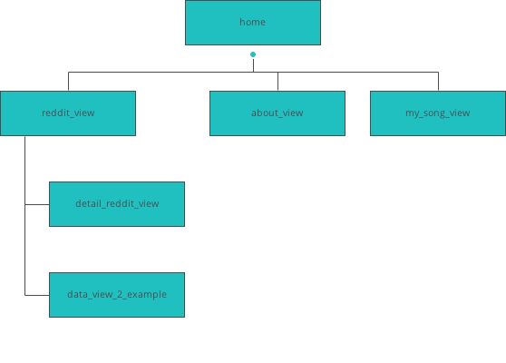

Story Board Overview

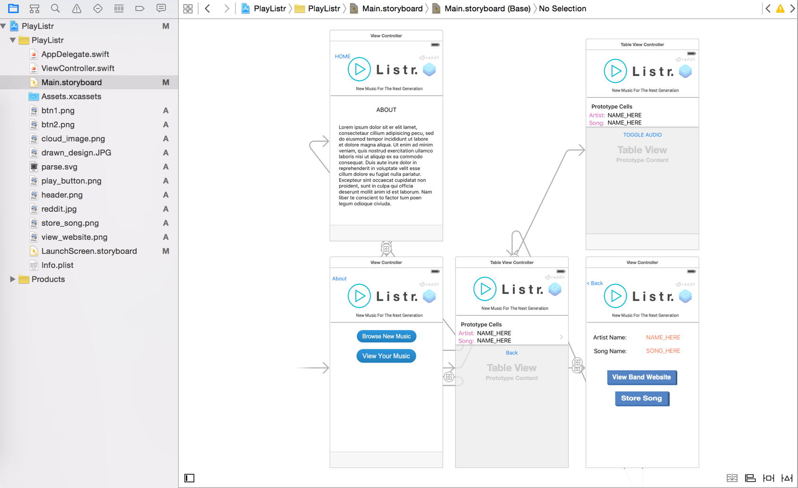

[Click For Full Size Version](http://i.imgur.com/MzRxpVB.png)

MVC Architecture Diagram

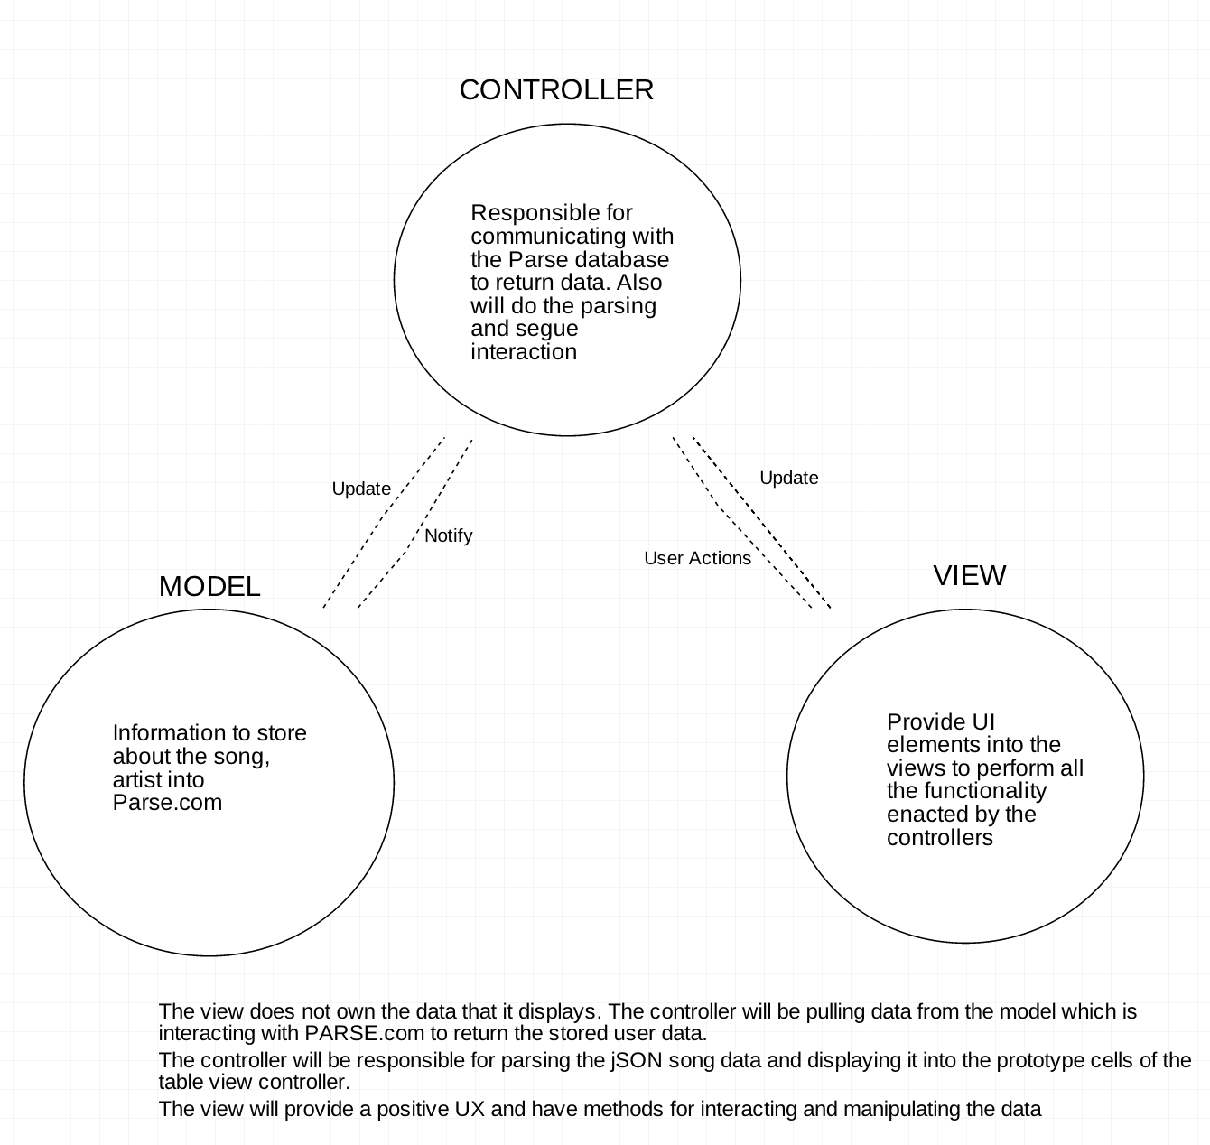

Class Diagram

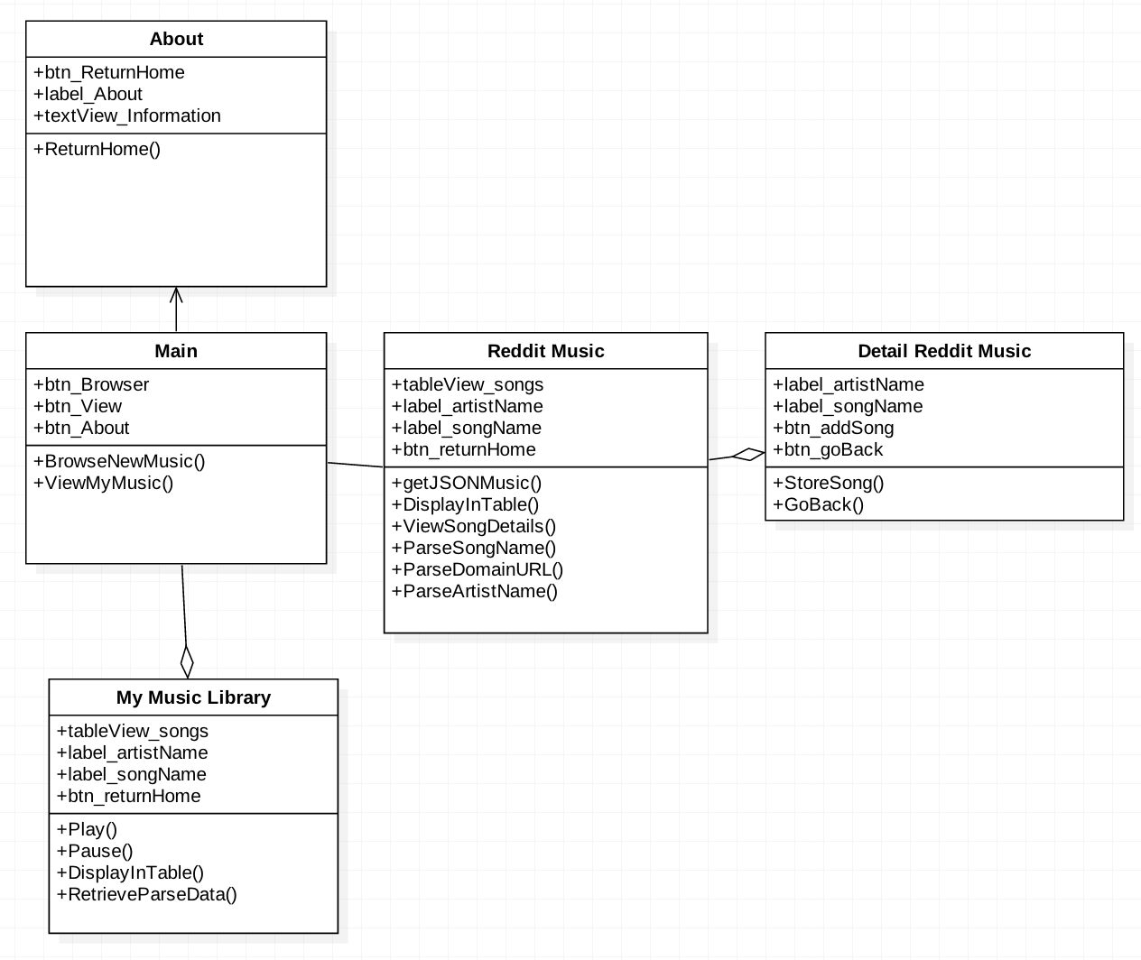

|  |
| --- |
| Views & UX Breakdown |
|  |

02. Screens / template

about_view

|  |
| --- |
|  |

Interactions

|  |  |
| --- | --- |
| 1 | **on Click:** goes to 'home' with effect: slide right 🡪 |

02. Screens / template

data_view_2_example

|  |
| --- |
|  |

Interactions

|  |  |
| --- | --- |
| 2 | **on Click:** goes to 'reddit_view' with effect: slide right 🡪 |

02. Screens / template

detail_reddit_view

|  |
| --- |
|  |

Interactions

|  |  |
| --- | --- |
| 3 | **on Click:** goes to 'reddit_view' with effect: slide right 🡪 |

02. Screens / template

home

|  |
| --- |
|  |

Interactions

|  |  |
| --- | --- |
| 4 | **on Click:** goes to 'reddit_view' with effect: slide left 🡪 |
| 5 | **on Click:** goes to 'about_view' with effect: slide left 🡪 |
| 6 | **on Click:** goes to 'about_view' with effect: slide left 🡪 |
| 7 | **on Click:** goes to 'my_song_view' with effect: slide left 🡪 |

02. Screens / template

my_song_view

|  |
| --- |
|  |

Interactions

|  |  |
| --- | --- |
| 8 | **on Click:** goes to 'home' with effect: slide right 🡪 |

02. Screens / template

reddit_view

|  |
| --- |
|  |

Interactions

|  |  |
| --- | --- |
| 9 | **on Click:** goes to 'detail_reddit_view' with effect: slide left 🡪 |
| 10 | **on Click:** goes to 'data_view_2_example' with effect: slide left 🡪 |
| 11 | **on Click:** goes to 'home' with effect: slide right 🡪 |