Job Spec

Initialise an Experiment
Models, inference routines, different specs for testing-data (noise, n of training data), test-problems, mcmc steps number of repetitions of experiment and the number of points used to compute the residuals are in experiment.ini:
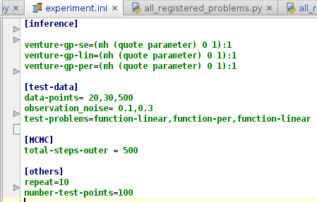

Inference

All models that are evaluated in an experiment need to be opted in under inference. They are assigned one or more inference routines that are tailored to the model.

This string needs to be a valid inference string for Venture or a stub indicating handwritten or matlab inference for cases where Venture is not used.

Every inference string is only one iteration (so that we can collect log-likelihood and residuals with it without having to rely on Venture's collecting mechanisms). We can deal with with one level (as in depth) of nesting at the moment as in:
[(REPEAT 10 (DO (MH (quote outer_scope) all 1) (MH (quote inner_scope) all 10) ) )].

More are possible, but will not be recorded.

The number of inner MCMC-steps is controlled by what comes after the colon. The number of outer MCMC-steps is controlled by the total-steps-outer in the [MCMC] section in experiment.ini. ',' indicate inference steps for different blogs.

Every single model must have at least one experimental setting for inference, more than one can be indicated with ';'.

Models

Pre-defined models are registered in all_registered_models.py and must of the type “Model” which has at least a method to run the experiments:
df=model.run(x_training,y_training,x_test,y_test,f_test,f_error,infer,outer_steps).

In this way, we can register basically any model we want while still controlling what we do experiments over in experiment.ini.

The is a subclass of model for Ventures GPs called

Run Experiments over conditions:

Every experimental condition of the experiment.ini file will be added to a list to be subsequently run with multi-process ( I guess that there are way more elegant solutions, yet mine is simple and easy to modify)

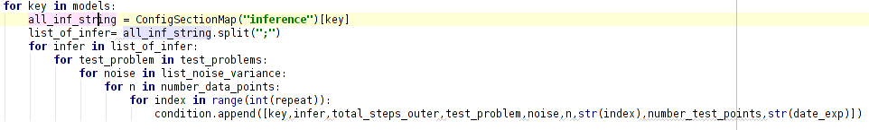

Data-Management:
Most of the stuff we need to know is already in the in the experiment.ini file. We are furthermore saving all results in a chronologically named directory (e.g. 2015-05-18, named automatically) as a Pandas-df with the experimental condition in the name so that we can later on use the experiment.ini file to read stuff into a program that does visualisation.

Experiments are never overwritten. In case the program crashes during a long run one can simply restart it without to much hustle. Plus, we can set a flag while starting the program indicating a date, so that when we want to add a condition to yesterdays experiment, all we need to do is set the flag and add the condition to the experiment.ini.

We are also automatically saving a readme into the chronologically named directories that should contain the dates of how often one ran experiments on a folder, how the experiment.ini changed and a short summary of how the experiment went (by hand, afterwards).

The training and test data are saved in a subdirectory of the chronologically named file.

Visualisation Tool

Define the date so that it knows what folder to look up the experiments

using facet grids, plot all the true function vs the amount of data used,

set a flag regarding which experiment.ini is to load.

Set df.iloc[::5, :]
constant so that the plots make sense

Call an averaging function that averages over residuals and logscores and saves everything into one df
experimental_df = load_experiments(exp_ini_str)

using facet grids, depicting all evaluated models, comparing performance
- for number of data-points vs. problems
- number of data-points vs. noise
- noise vs. problems

if there is different inference algorithm for one model, compare it's performance,
- for number of data-points vs. problems
- number of data-points vs. noise
- noise vs. problems

central are two functions
- plotting log-score for a certain condition
plot_log_score(key,test_problem,noise,n,infer='default',from=0,to=number_steps_mcmc,specific_mcmc_kernel=-1)
plot_residuals(key,test_problem,noise,n,infer='default',from=0,to=number_steps_mcmc,specific_mcmc_kernel=-1)
- from to

movie generation for some only for specific example only

