CIVE 202 Project 1 Report: Air Quality
Civil Engineering Analysis II (CIVE-202)
Schaefer Rogers
February 3, 2026

Contents
Introduction/Scope of Work 2
Project Goals 2
Project Tasks 3
Project Deliverables 3
Timeline 4
Methods 4
Results 5
References 8

Figure 1 Top 5 VOC 5
Figure 2 Top 5 PM 2.5 & Figure 3 Top 5 PM 10.0 5
Figure 4 Mean Pollutant Concentration and Temp. Level 6
Figure 5 Mean Pollutant Concentration and Humidity. Level 6

Introduction/Scope of Work

Project Goals
The goal of this project is to provide the UNMC Water, Climate and Health Group with an analysis of air quality conditions across Nebraska using AirPurple sensor data collected from February 2024 through March 2025. The project focuses on evaluating concentrations of VOCs, PM 2.5, and PM 10.0 to determine whether recorded values align with EPA air quality standards and to identify locations where pollutant levels may pose public health concerns. The group wants to understand potential air quality in NE and if it meets National Ambient Air Quality Standards (NAAQS) and locations that may be notable to public health concerns.
The analysis aims to determine the five locations in Nebraska with the highest mean and median pollutant concentrations, identify the dates and locations of maximum recorded values, and determine potential environmental or situational factors that may explain these maximums. Other objectives include examining how temperature and humidity categories affect pollutant levels and determining whether any recorded values classified as Air Quality Index (AQI) health risks - “unhealthy for sensitive populations.” The final objective is to assess whether sensor altitude has any relationship with air quality values.

Project Tasks
To complete the objectives outlined by the UNMC Water, Climate and Health Group, a series of tasks have been identified. Python and the pandas package will be utilized for data analysis.
The first task is to organize and prepare the air quality data for analysis in Python using Python functions. To do this, AirPurple dataset will be imported, turned into a data frame for manipulation, and grouped by sensor location (sensor name). A statistical analysis will then be done to determine the mean and median concentrations for VOC’s, PM 2.5 and PM 10.0. The five locations with the highest average and maximum pollutant levels will be identified.
In task two, dates and locations where maximum pollutant values occurred will be identified. The data will be organized in a manner that makes these values easy to determine, finding a single max for VOC, PM 2.5 and PM 10.0. The dates and locations for these maximum values will be researched in order to identify potential contributing factors, like weather, seasonal activity, or other local pollutant sources.
Task three involves assessing the influence of meteorological conditions on air quality, specifically humidity and temperature. The data will be categorized according to the humidity and temperature ranges specified by the client. For example, temperatures below 32 °F is categorized as below freezing. Pollutant levels will be analyzed across these categories to understand whether these factors affect the concentrations.
In task four, the EPA Air Quality Tables will be used to determine the range for PM 2.5 and PM 10 that pose health risks for sensitive population. The data will be analyzed to determine which days and locations these health risk pollutant concentrations were recorded. Similar to task two, potential causes for these values will be explored to provide context for the findings.
In task five, the data will be analyzed to observe whether sensor altitude has any measurable impact on pollutant concentrations. The data will be sorted by sensor altitude and a statistical analysis on pollutant levels, like that in tasks above will be done. With the sensor altitude and mean pollutant concentrations, conclusions about if sensor altitude influences pollutant concentrations will be made.

Project Deliverables
The project deliverables will be achieved through a structured approach. The client outlined six deliverables to be submitted. The raw data files (AirPurple Data CSV) used in the Python code analysis. The python code as a “.ipynb” file. A link to a GitHub folder that includes the Python code, CSV with data, and a README file which describes the project. A Scope of Work (this document). An annotate code document that serves as an explanation for the Python code. And a written report that summarizes the findings of the work.

Timeline
Deliverable | Due to Client by
Raw Data Files | 02/03/26
Python Code | 02/03/26
GitHub Link | 02/03/26
Scope of Work | 02/03/26
Annotated Code Document | 02/03/26
Written Report Summary | 02/03/26

Methods
The methods used for this project can be broken down into the 5 tasks outlined in the Scope of Work. All data analysis was done in python and utilized the pandas package for functions. All data was taken from the AirPurple Daily dataset and all results are based off that data.
For task 1 the data was imported and converted to a data frame for manipulation. For each pollutant (VOC, PM 2.5, PM 10.0) a statistical analysis was done to find the mean and median concentration. The data was grouped by sensor name and output to give the 5 locations with the highest mean and median concentrations of each pollutant. The user was the able to determine the 5 locations per requested in task 1.
For task 2, the max concentration for each pollutant was found. The data set was then filtered for each of these max values, and the row containing each max value was printed. The user can then see the day and location of each maximum per requested in task 2.
For task 3, categories for temperature and humidity were created according to the values given by the client. These categories were added to the dataset in the form of a new column for each category. Pivot tables containing the mean for PM 2.5 and PM 10.0 concentrations were created to show the average concentration at each category This was done for both temperature and humidity. The user can then look at these tables to see if the average pollutant concentration changes between categories. If it does, it can be determined that temperature and humidity do in fact affect air quality per task 3.
For task 4, the ranges of PM 2.5 and PM 10.0 concentrations that fall in the “unhealthy for sensitive groups” were found according to the EPA air quality tables provided by the client. The data was then filtered for pollutant concentrations within these ranges. The date, sensor name, and pollutant level were then printed. From this, the user can see each date and location there was an air quality health risk for each pollutant (PM 2.5 and PM 10.0) per the client request in task 4.
For task 5, a pivot table was created that gave the sensor altitude and the average for each pollutant at that given altitude. From this table, the user is able to see if average air quality varies by altitude and can draw a conclusion if sensor altitude affects air quality, per the request in task 5.

Results
The results for task 1 can be seen below in the tables created in the python data analysis. These tables show the 5 locations in NE with the highest mean and median concentrations of VOC (volatile organic compounds), PM 2.5 (fine particulate matter ≤ 2.5 µm) and PM 10.0 (fine particulate matter ≤ 10.0 µm). The 5 locations for VOC (figure 1) are the Southwest Nebraska Public Health Department in Ogallala NE (swnphd-ogallala), the Four Corners Health Department in York NE (FCHD-YPS), the Three Rivers Health Department in Fremont NE, The Elkhorn Logan Vally Public Health Department in Norfolk NE (ELVPHD Norfolk HD 4), and the Southwest Nebraska Public Health Department in McCook NE (Swnphd-mccook). The 5 locations for the PM 2.5 and PM 10.0 pollutants are identical and are Broken Bow NE, the Richardson County NE Courthouse, the Southeast District Health Department in Tecumseh NE, the North Central District Health Department in O’Neill NE (NCDHD O’Neill #11), and finally the Southwest Nebraska Public Health Department in McCook NE (Swnphd-mccook).
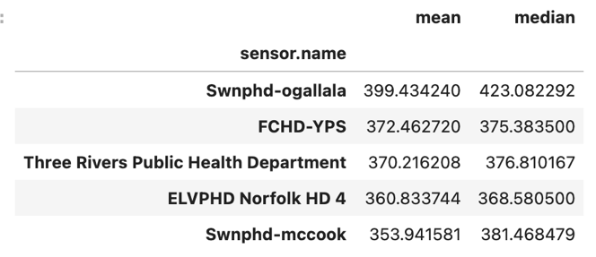
Figure 1 Top 5 VOC
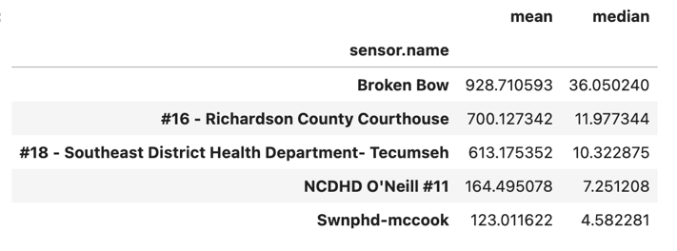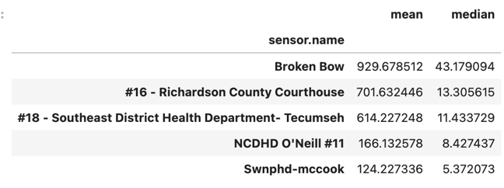
Figure 2 Top 5 PM 2.5 & Figure 3 Top 5 PM 10.0
For task 2, the data analysis found that the VOC maximum occurred on 06/24/24 at the Southwest Nebraska Public Health Department in Ogallala NE (swnphd-ogallala). The cause for this maximum is most likely wildfires that occurred in Colorado and Wyoming during June of 2024 (U.S. Environmental Protection Agency, 2024). A maximum of VOCs without a max in PM 2.5 or PM 10.0 means that the fires were farther away, as VOCs travel farther than PM 2.5 or PM 10.0. The maximums for both PM 2.5 and PM 10.0 both fell on 02/18/25 at the Richardson County Courthouse. Though no significant events happened on this date in Richardson County, the cause for these maximums may be related to significant wildfires in Central Nebraska in Feb. of 2025 according to the Nebraska Public Media (Howell, 2025).
For task 3, data analysis found that temperature and humidity do have an impact on air quality. Figure 4 clearly shows that as the temperature level increases from below freezing to hot, the average concentrations for PM 2.5 and PM 10.0 decrease. Additionally, figure 5 clearly shows that as humidity level increases from low to very high, the average concentrations for PM 2.5 and PM 10.0 also increase. These observations show that both temperature and humidity have a noticeable effect on air quality.
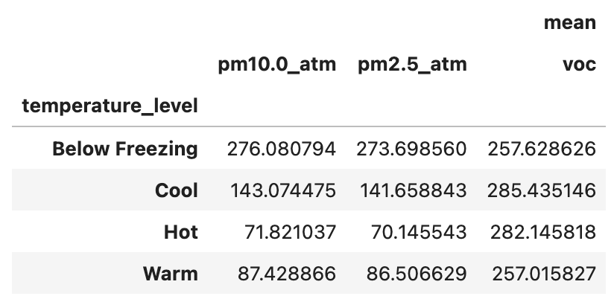
Figure 4 Mean Pollutant Concentration and Temp. Level
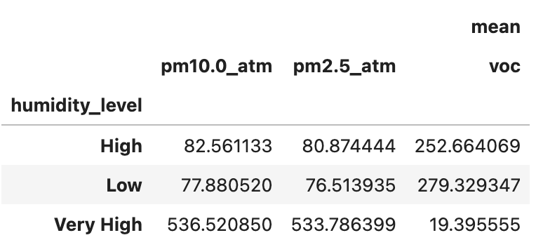
Figure 5 Mean Pollutant Concentration and Humidity. Level
The task 4 data analysis gave 3 dates and locations where the values for PM 2.5 and Pm 10.0 fell in the EPA’s air quality range for “unhealthy for sensitive groups.” These dates and locations are 06/14/24 at the Loup Basin Public Health Department in Burwell NE, 06/27/24 at the Southwest Nebraska Public Health Department in Benkelman NE, and 12/08/24 at the Richardson County Courthouse. For 06/14/24 the EPA Air Now maps show moderate air quality surrounding Nebraska to the East and West (U.S. Environmental Protection Agency, 2024). There were also wildfires in Colorado and Wyoming during this time, which could have been a source for poor air quality. Similarly, these fires were also probable causes for the air quality event on 06/27/24. These days were most likely high wind days which carried smoke long distances as strong winds blew from West to East. On 12/08/24, the EPA Air Quality map shows good air quality for Nebraska and surrounding states (U.S. Environmental Protection Agency, 2024). As a result, the reason for this air quality event is most likely a local source, like vehicles or local emissions. This event could also be caused from temperature inversions which trap poor air near the surface and happen during winter months.

Finally, the task 5 data analysis showed that sensor altitude does not have an impact on air quality. Looking at figure 6 and discarding the outliers, there is no measurable change as the sensor altitude increases. While there is a change at a few altitudes, there is not enough of a relationship between the values to justify that sensor altitude has an impact on air quality.

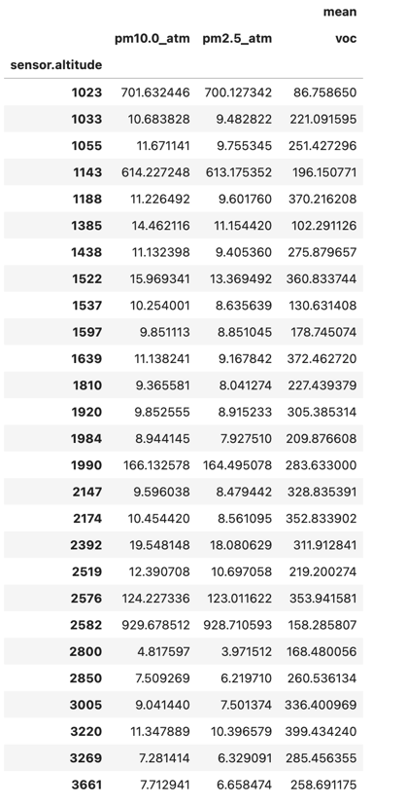
Figure 6 Sensor Altitude and Mean Pollutant Concentrations

References
U.S. Environmental Protection Agency. (n.d.). AirNow. https://www.airnow.gov/
U.S. Environmental Protection Agency. (n.d.). Air Quality Index (AQI): A guide to air quality and your health [PDF]. U.S. Environmental Protection Agency.
Howell, J. (2025, February 27). Gov. Pillen declares state of emergency as wildfires continue in Central Nebraska. Nebraska Public Media. https://nebraskapublicmedia.org/es/news/news-articles/gov-pillen-declares-state-of-emergency-as-wildfires-continue-in-central-nebraska/
PurpleAir. (n.d.). Air quality map. https://map.purpleair.com/air-quality-standards-us-epa-aqi?opt=%2F1%2Flp%2Fa10%2Fp604800%2FcC0#5.21/40.002/-97.008
PurpleAir. (n.d.). Data & API. https://community.purpleair.com/c/data/api/18

