CIVE 202 Project 2 Report: Air Quality
Civil Engineering Analysis II (CIVE-202)
Section 151 Group 07
February 24, 2026

Contents
Introduction/Scope of Work 2
Project Goals 2
Project Tasks 3
Project Deliverables and Timeline 3
Methods 4
Mix Scenarios Research and Documentation 4
1. Class 47BD Concrete (Bridge Decks) 5
2. Class 47B-HE Concrete (High Early Strength) 5
3. Iowa DOT Class C (Structural & Paving) 5
4. Colorado DOT (CDOT) Class D (Structural) 6
Results and Discussion 6
References 8

Table 1. Table of Deliverables 3
Table 2. Summary of Input Parameters for Four Selected DOT Concrete Mix Designs 6
Table 3. Summary of outputs for Four Selected DOT Concrete Mix Designs 7

Figure 1. List of User Defined Inputs 7
Figure 2. Weight Summary Table 7

Introduction/Scope of Work

Project Goals
The Nebraska Department of Transportation (NDOT) has asked this group to convert the information pertaining to concrete mix design from the given Excel sheet into a Python-based system that accomplishes the same task – providing a weight summary chart for given mix design parameters.
The main goal of this project is to replicate the logic contained in the Mix Design worksheet and automate it so users can enter different variables, such as material properties and other design parameters into it. The program needs to output a weight chart for one cubic yard of concrete. In order to achieve this, we must complete these project tasks which will be addressed in more detail below:
- Turn the logic from the Excel worksheet into Python modular functions.
- Put in a user input sequence that works with the design process.
- Create a mix weight chart for 1 cubic yard of concrete.
- Create 4 concrete mix designs using the NDOT system.
- Create the code and document the processes and reports.

Project Tasks
- Translate the Excel Logic into Python
To do this we must first understand the NDOT Mix Design Excel and find the information to convert to Python. Once all the inputs and calculations/equations have been identified, they can be defined in python using the “def” function. Variables for the material weights, ratios, aggregate proportions, air content adjustments, and conversions will all be made in Python and mirror that of the Excel.
- Implement Sequential User Inputs
To do this we must recreate the design inputs from excel and organize them into categories such as general info, cementitious material inputs, design parameters, etc. These inputs will be collected from the user in Python by utilizing “input()” functions. All inputs will be organized in a manner that mirrors the Excel.
- Generate a Final Mix Design Output
To do this, the program will take the user defined inputs from the previous task and use them in the defined functions from task 1. Once all calculations have been completed, we can utilize the “print()” function and f-strings to create a table-like output similar to the Excel.
- Prepare and Evaluate Four Concrete Mix Scenarios
For this task we must first research concrete designs using the NDOT documents and specifications, along with other resources, to determine the mix parameters for certain types of concrete. Then we can run them through the python model and compare the outputs for the mixes to ensure that our Python model is producing accurate results.

Project Deliverables and Timeline
The deliverables for this project are summarized in the table below and are due to the client no later than 2/24/26. The client has requested a GitHub repository populated with all the relevant project information and work.

Table 1. Table of Deliverables
Deliverable | Due to Client by
Gantt Chart | 2/13/26
GitHub | 2/24/26
Scope of Work | 2/24/26
Mix Scenarios Research and Documentation | 2/24/26
Python Code | 2/24/26
Annotated Code Document | 2/24/26
Technical Report | 2/24/26

Methods
The calculations used in the Mix Design Excel (Nebraska Department of Transportation, n.d.) were translated directly into Python functions in a Jupyter Notebook. Each Excel formula was reviewed and rewritten step by step to make sure the same mathematical relationships were preserved. The weight of water was calculated by multiplying the total cementitious materials (cement, fly ash, silica fume, and other SCM) by the selected water-cement ratio. The volume of each cementitious material was calculated by dividing its weight by the product of its specific gravity and the unit weight of water (62.4 lb/ft³). The total aggregate volume was then determined by subtracting the volumes of cementitious materials, air, and water from 27 cubic feet, which represents one cubic yard of concrete.
The aggregate weights were calculated using the selected percentage split between fine and coarse aggregates and their corresponding specific gravities. These calculations follow the same procedure used in the Excel sheet to ensure that the automated Python results match the manual spreadsheet process.
The notebook includes sequential user prompts using the input() function. This allows users to enter project information and mix design parameters directly into the program. The required inputs include cementitious material weights, water-cement ratio, air content, aggregate percentages, and specific gravities for each material. After the inputs are collected, the program applies the defined functions in sequence to compute water weight, material volumes, total aggregate volume, and final aggregate weights for one cubic yard of concrete.
The outputs generated by the program include the calculated water weight and the required weights of fine and coarse aggregates. These outputs were produced for four different mix design scenarios and reviewed to confirm that the automated calculations were consistent with the original Excel formulas and the applicable DOT specifications.

Mix Scenarios Research and Documentation
In concrete engineering, designing a mix involves proportioning fine and coarse aggregates, cementitious materials, and water to meet specific performance criteria like workability, strength, and durability. State DOT specifications define these classes to standardize construction for varying environments, from high-traffic pavements to structural bridge components.

1. Class 47BD Concrete (Bridge Decks)
This mix is specifically designed for bridge decks, featuring a higher cementitious material content and a lower water-to-cement ratio to increase durability and reduce permeability.
- Total Cementitious Materials: 658 lb/yd³ (minimum).
- Total Aggregate: 2,500 lb/yd³ (minimum) to 3,000 lb/yd³ (maximum).
- Air Content: 6.5% to 9.0%.
- Maximum Water/Cement Ratio: 0.42 lb/lb (typical NDOT standard for 47BD).
- Minimum Required Strength: 4,000 psi (at 28 days).
- Common Use: Bridge decks and bridge approach slabs.
- Reference: NDOT 2017 Standard Specifications Table 1002.02.

2. Class 47B-HE Concrete (High Early Strength)
This mix is used when rapid strength gain is required, such as pavement repairs or intersections that need to be opened to traffic quickly.
- Total Cementitious Materials: 752 lb/yd³ (minimum).
- Total Aggregate: 2,500 lb/yd³ (minimum) to 3,000 lb/yd³ (maximum).
- Air Content: 6.5% to 9.0%.
- Maximum Water/Cement Ratio: 0.40 lb/lb.
- Minimum Required Strength: 3,500 psi (typically required in as little as 48 hours depending on project needs).
- Common Use: Rapid-entry pavement repairs and "High Early" strength applications.
- Reference: Nebraska DOT (2017) Standard Specifications, Section 706 (Concrete Bridge Floors) and Table 1002.02

3. Iowa DOT Class C (Structural & Paving)
Iowa's primary structural mix used for highway paving and box culverts.
- Total Cementitious Materials: 611 lb/cy (approximate based on standard Iowa 50/50 split).
- Total Aggregate: ~3,100 lb/cy (total combined dry weight).
- Target Air Content: 6.5% (± 1.5%).
- Maximum Water/Cement (w/c) Ratio: 0.488 lb/lb (Target typically 0.43).
- Minimum Required Strength: 4,000 psi (at 28 days).
- Reference: Iowa DOT Standard Specifications Section 2403.

4. Colorado DOT (CDOT) Class D (Structural)
A high-density mix used for bridge decks, rails, and structural elements requiring higher strength.
- Total Cementitious Materials: 615 lb/cy (minimum).
- Total Aggregate: ~3,000 lb/cy (total dry weight).
- Target Air Content: 5.0% to 8.0%.
- Maximum Water/Cement (w/c) Ratio: 0.44 lb/lb.
- Minimum Required Strength: 4,500 psi.
- Reference: CDOT 2023 Standard Specifications Section 601, Table 601-1.

Table 2. Summary of Input Parameters for Four Selected DOT Concrete Mix Designs
Input Parameter | NDOT 47BD | NDOT 47B-HE | Iowa Class C | CDOT Class D
Cement (lb/cy) | 658 | 752 | 611 | 615
Max w/c Ratio | 0.42 | 0.40 | 0.488 | 0.44
Air Content (%) | 6.5–9.0% | 6.5–9.0% | 6.5% (± 1.5%). | 5.0–8.0%
Min. Strength (psi) | 4,000 | 3,500 | 4,000 | 4,500
Primary Usage | Bridge Decks | Pavement | Culverts | Dense Bridge Elements

Results and Discussion
This project aims to translate an existing concrete design mix model, originally based in Excel, into a fully functioning python-based program. The purpose of the transition from excel to python is to improve efficiency and accuracy. The program prompts users to enter specific design parameters such as the water-cement ratio, aggregate proportions, etc. (figure 1). These inputs influence the strength, durability, and usability of the final concrete mixture. The system will then lead the user through the necessary design process step by step. All necessary required information must be submitted before calculation takes place. The program calculates the quantities of cement, water, fine aggregate, and coarse aggregate needed to produce one cubic yard of concrete. A weight chart is then generated (figure 2). This chart summarizes the material quantities calculated in a clear and professionally formatted table. The chart is specifically designed based on the inputs of the user, allowing for a user friendly and professionally formatted data table to be made based on the user's needs. Mix designs were created to test the validity of the Python model. Results from the four scenarios documented above were then compared to the outputs of the excel spreadsheet. All values outputted in python matched with the values outputted in Excel with very minor differences due to rounding differences between the models (table 3) – the Python model includes more significant figures than the Excel.
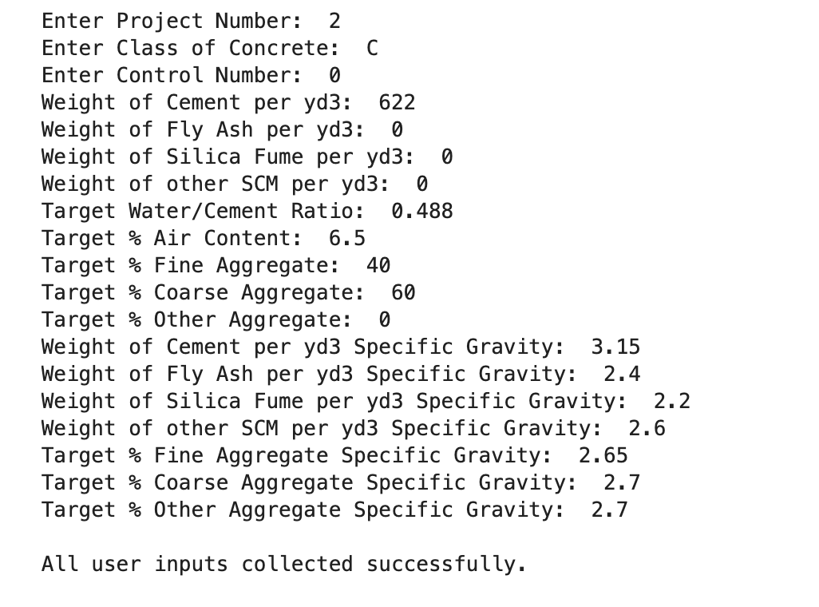
Figure 1. List of User Defined Inputs
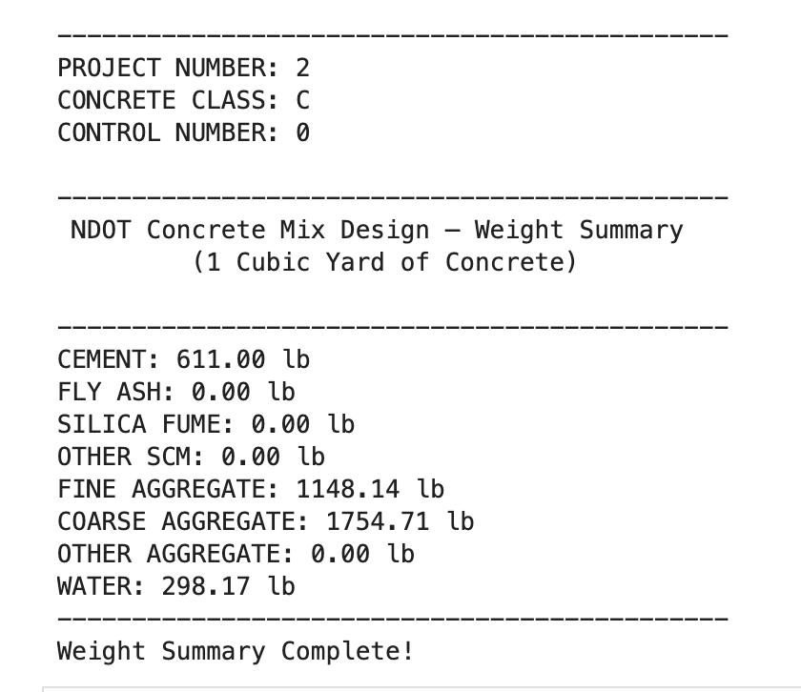
Figure 2. Weight Summary Table
Table 3. Summary of outputs for Four Selected DOT Concrete Mix Designs
 | Scenario one | Scenario two | Scenario three | Scenario four
Python Output | CEMENT: 658.00 lb  FLY ASH: 0.00 lb  SILICA FUME: 0.00 lb  OTHER SCM: 0.00 lb  FINE AGGREGATE: 1146.51 lb  COARSE AGGREGATE: 1752.22 lb  OTHER AGGREGATE: 0.00 lb  WATER: 276.36 lb | CEMENT: 752.00 lb  FLY ASH: 0.00 lb  SILICA FUME: 0.00 lb  OTHER SCM: 0.00 lb  FINE AGGREGATE: 1088.97 lb  COARSE AGGREGATE: 1664.28 lb  OTHER AGGREGATE: 0.00 lb  WATER: 300.80 lb | CEMENT: 611.00 lb  FLY ASH: 0.00 lb  SILICA FUME: 0.00 lb  OTHER SCM: 0.00 lb  FINE AGGREGATE: 1148.14 lb  COARSE AGGREGATE: 1754.71 lb  OTHER AGGREGATE: 0.00 lb  WATER: 298.17 lb | CEMENT: 615.00 lb  FLY ASH: 0.00 lb  SILICA FUME: 0.00 lb  OTHER SCM: 0.00 lb  FINE AGGREGATE: 1176.02 lb  COARSE AGGREGATE: 1797.31 lb  OTHER AGGREGATE: 0.00 lb  WATER: 270.60 lb
Excell Output | Cement: 658 lb  Fly Ash: 0 lb  Silica Fume: 0 lb  Other SCM: 0 lb  Fine aggregate: 1147 lb  Coarse aggregate: 1753 lb  Other aggregate:  0 lb  Water: 276 lb | Cement: 752 lb  Fly Ash: 0 lb  Silica Fume: 0 lb  Other SCM: 0 lb  Fine aggregate: 1089 lb  Coarse aggregate: 1664 lb  Other aggregate:  0 lb  Water: 301 lb | Cement: 611 lb  Fly Ash: 0 lb  Silica Fume: 0 lb  Other SCM: 0 lb  Fine aggregate: 1148 lb  Coarse aggregate: 1754 lb  Other aggregate:  0 lb  Water: 298 lb | Cement: 615 lb  Fly Ash: 0 lb  Silica Fume: 0 lb  Other SCM: 0 lb  Fine aggregate: 1175 lb  Coarse aggregate: 1796 lb  Other aggregate:  0 lb  Water: 271 lb

References
Colorado Department of Transportation. (2023). Standard specifications for road and bridge construction: 2023 specs book (943 pp.). https://www.codot.gov/business/designsupport/cdot-construction-specifications/2023-construction-specifications/2023-specs-book/2023-cdot-specs-book.pdf
Iowa Department of Transportation. (2012). Section 2403: Structural concrete (Standard Specifications for Highway and Bridge Construction, Series 2012). https://ia.iowadot.gov/erl/archiveoct2012/GS/content/2403.pdf
Nebraska Department of Transportation. (n.d.). Mix design submittal [Excel spreadsheet]. Nebraska Department of Transportation Materials. https://dot.nebraska.gov/business-center/materials/
Nebraska Department of Transportation. (2017). Standard specifications for highway construction: 2017 edition (Spec Book). Nebraska Department of Transportation. https://dot.nebraska.gov/media/g4qp4y0d/2017-specbook.pdf

