CIVE 202 Project 3 Report: Visualize Transportation Data
Civil Engineering Analysis II (CIVE-202)

Section 151 Group 06
March 31, 2026

Contents
Introduction/Scope of Work 2
Project Goals 2
Project Tasks 3
Project Deliverables and Timeline 5
Methods 5
Results and Discussion 7
References 12

Table 1 Summary of Deliverables 5

Figure 1 Bar Chart of Number of Vehicles in Each Fuel Type Category 7
Figure 2 Vehicle Age Distribution 8
Figure 3 Boxplot of Vehicles per Household by Household Location 9
Figure 4 Follower Speed Comparison Across Vehicle Trajectories 10
Figure 5 Gap Distance vs. Time for Trajectory 1 10
Figure 6 IDM Simulation for Acceleration - Trajectory 2 11

Introduction/Scope of Work

Project Goals
The overall goal of this group is to assist the professional engineer (PE) in understanding transportation usage and system performance to further help the client – Federal Highway Administration (FHWA). Utilizing the National Household Travel Survey (NHTS) and the Next Generation Simulation (NGSIM) databases, the group will assist by providing valuable insights concerning the characteristics of transportation usage and driving behavior. The subgoals of this group are broken down below.

Goal 1 – Analyze and Understand Transportation Data
The group will need to examine travel behavior trends using data from the National Household Travel Survey (NHTS). This includes analyzing driver behavior and vehicle performance using the Next Generation Simulation (NGSIM), as well as identifying key variables that are meaningful for transportation planning.
Goal 2 – Help Develop Clear and Informative Visualizations
This project requires the group to create certain plots (bar chart, histogram, boxplot, and time-series graphs). These visualizations will be customized through the python libraries: matplotlib and seaborn. The results must be presented in a way that is capable of properly informing those making decisions for the Federal Highway Administration.
Goal 3 – Demonstrate Technical and Analytical Skills
The group is tasked with using Python to efficiently clean and analyze large datasets. Then they must conduct a simulation using the Intelligent Driver Model (IDM). During the course of the work, it is important to clearly document code, simulation findings, and time spent to evaluate workflow efficiency.

Project Tasks
The tasks the group will complete to accomplish the goals above and complete this project are discussed below.
Task 1 – Pick Variables to Visualize
The group picked variables to plot and visualize. These are summarized below.
- Fuel Type – This is included in the NHTS data and gives a list of possible fuel categories for vehicles such as gas, hybrid, full electric, etc.
- Vehicle Age – This is found in the NHTS data and gives an age in years of each vehicle listed
- Vehicles per Household – This is found in the NHTS data and lists the total number vehicles per household
- Household Location – This variable is found in the NHTS data and groups home locations into 2 categories, urban and rural.
- Trajectory – Found in the NGSIM data, this variable demonstrates a specific set of data points for a pair of vehicles (leader and follower). For example, in trajectory 1, there is data for a specific leader and follower vehicle across a certain time interval. In trajectory 2, there is a different set of data for a new vehicle pair across a certain time interval. There are 16 total trajectories in the NGSIM dataset.
- Follower Speed – Found in the NGSIM data, this variable demonstrates the speed (m/s) of a following car at a given time in the dataset.
- Gap Distance – In the NGSIM data, this variable represents the distance (m) between the leader and the follower pair at a given time.

Task 2 – Create Clean and Simple Visualizations
The group will utilize Python libraries such as Matplot and Seaborn to assist in creating clear and concise visualizes that summarize the necessary information for the PE. Visualizations will include a bar chart to categories within a specific variable, a histogram to show the distribution of a variable, a boxplot to show the distribution of a variable in each category, and multiple time-series plots to show an analysis of driving behavior. Variables to plot will be chosen to provide relationships between relevant and important topics that align with transportation needs. To demonstrate Python proficiency to the PE, the group will alter plots to create a cleaner product. For example, colors will be adjusted to highlight contrast and improve readability.
Task 3 – Simulation Study
Using the Intelligent Driver Model equation, the group will select 2 different independent variables. Each of these will be an independent variable in the simulation, while the other is controlled. All other variables will be control variables, except for the dependent variable. The goal of the IDM simulation is to analyze how the selected variables concerning vehicle behavior influence vehicle trajectory.
Task 4 – Time Sheet Documentation
The group will utilize an Excel spreadsheet to properly track the hours spent working on the project. Each member will be responsible for logging their own hours and writing a short description of what work they did. Near the end of completion, we will take the hours worked and calculate the cost of labor for the project.

Project Deliverables and Timeline
The project deliverables and their corresponding file names and due dates are summarized in the table below
Table 1 Summary of Deliverables
Deliverable | File Name | Due Date
Gantt Chart | CIVE202_Spring2026_P3-G06_Project3_GanttChart | Initial: 02/27/2026  Final: 03/31/2026
Scope of Work (SOW) | CIVE202_Spring2026_P3-G06_Project3_SOW | Initial: 03/06/2026  Final: 03/31/2026
Python Code | CIVE202_Spring2026_P3-G06_Project3_PythonCode | 03/31/2026
Annotated Code Document (ACD) | CIVE202_Spring2026_P3-G06_Project3_ACD | 03/31/2026
Time Sheet | CIVE202_Spring2026_P3-G06_Project3_TimeSheet | 03/31/2026
Data Files Used | Provided in GitHub | 03/31/2026
GitHub | GitHub Repository Link | 03/31/2026
Technical Report | CIVE202_Spring2026_P3-G06_Project3_Report | 03/31/2026

Methods
The group used Python in a Jupyter Notebook to go through both the NHTS and NGSIM datasets. The first thing they did was load everything in with pandas and look through the columns to figure out what was needed. There was a lot of extra stuff in the files, so the group mainly focused on fuel type, vehicle age, vehicles per household, and whether the household was urban or rural. For the NGSIM data, the group looked at follower speed, spacing, and trajectory data.
Cleaning the data took a little bit of time. Some columns weren’t in the right format, so we had to convert them to numeric before doing any calculations. There were also some missing values that had to be removed, so they didn’t mess up the results. Once everything was cleaned up, the data was a lot easier to work with. And could be called in for use in the visualizations.
After that, the plots were made by utilizing Seaborn and matplot library. The group used bar charts for fuel types, a histogram for vehicle age, and a boxplot to compare urban vs rural households. For the time-series plots, they made time-based plots to see how variables like speed and spacing changed over time. These helped show how traffic behaves instead of just looking at averages.
They also ran the IDM simulation using the IDM equations contained in the Python code and defining a function that would calculate the follower acceleration, speed, and position as it iterated through the NGSIM data. They kept most variables constant and changed a couple of inputs (v - current speed of follower vehicle, s - the current gap distance between the leader and the follower, and delta_v - the speed difference between the follower and leader) to see how the follower vehicle reacted. Then they compared the simulated results to the real NGSIM data and provided a plot for simulated follower acceleration. This part was mainly to see how close the model gets to real driving behavior.

Results and Discussion
The visualizes and simulations done in this project are discussed below.
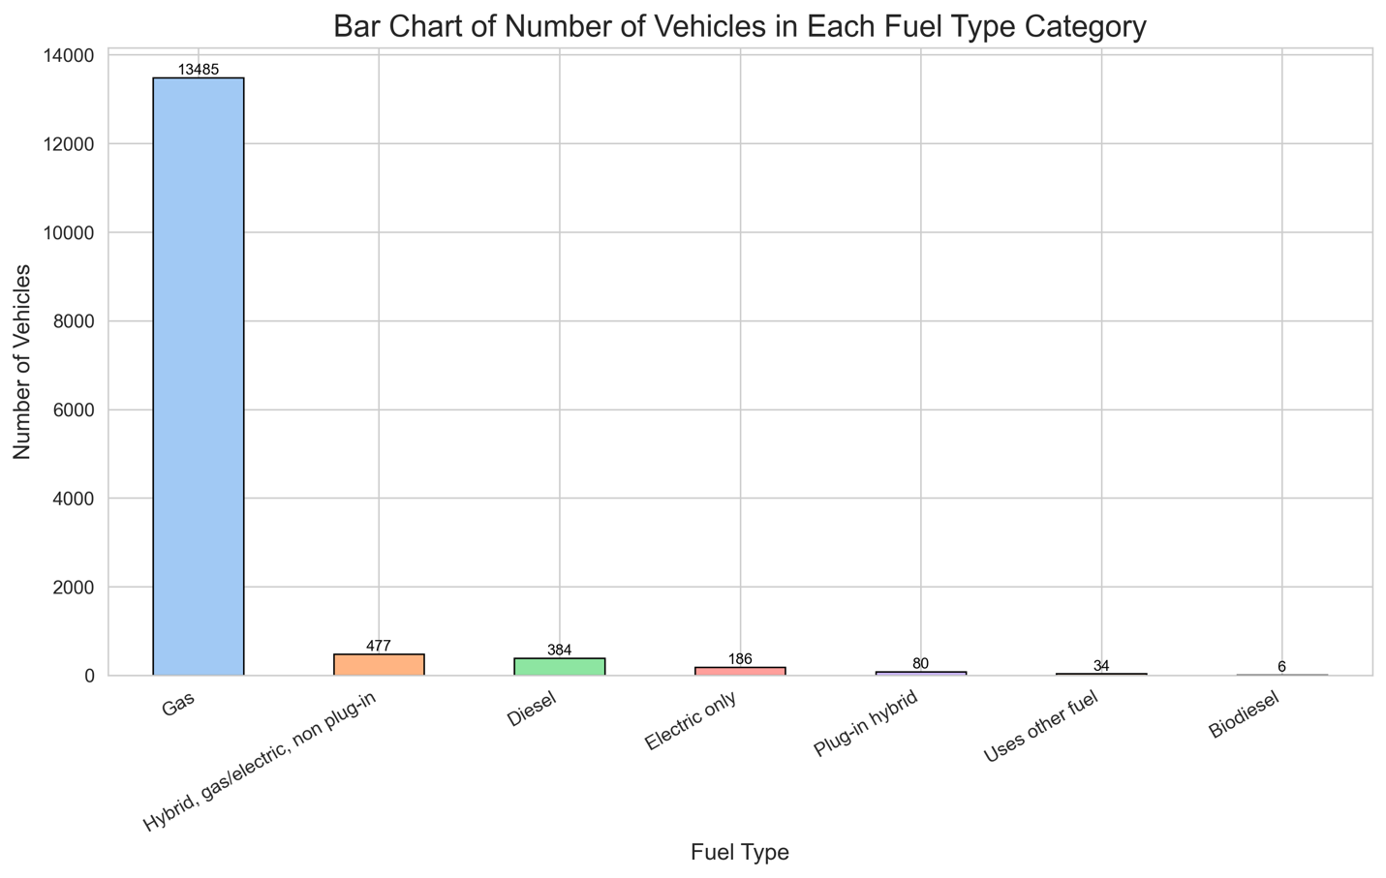
Figure 1 Bar Chart of Number of Vehicles in Each Fuel Type Category
The first plot is a bar chart of the number of vehicles in each fuel type category. This plot helps show the most common fuel types used, which can be helpful in understanding the current fuel needs for transportation. The fuel type results were fairly one sided. Gas vehicles completely dominated the dataset with about 13,485 vehicles, while everything else was way smaller. Hybrids were around 477, diesel was 384, and electric only vehicles were only about 186. The rest were basically negligible. This wasn’t too surprising, but the gap was bigger than expected. It shows that even though people talk a lot about electric vehicles, gas is still by far the most common.
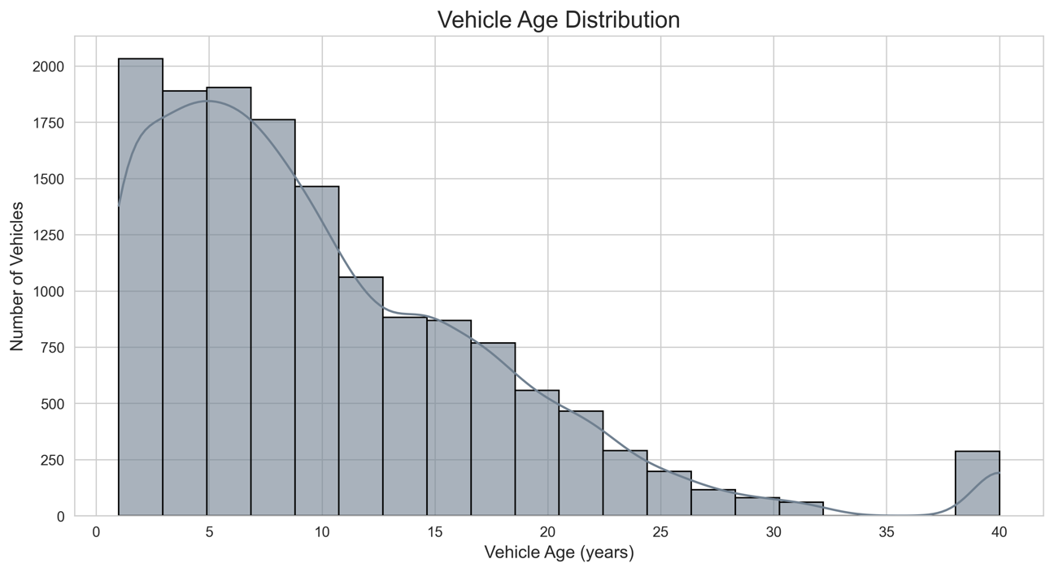
Figure 2 Vehicle Age Distribution
The next plot is a histogram showing the distribution of vehicle age. This information could be helpful to transportation planning because it can help determine what technology is being used. For example, the relatively newer distribution could help inform decisions on infrastructure needs, emission standards compliance, and fuel efficiency benchmarks. The vehicle age histogram shows most vehicles were somewhere between about 3 and 10 years old, dropping off steadily after that. There were still some old vehicles, but not many. It makes sense people don’t usually keep cars forever, but there are always a few outliers.
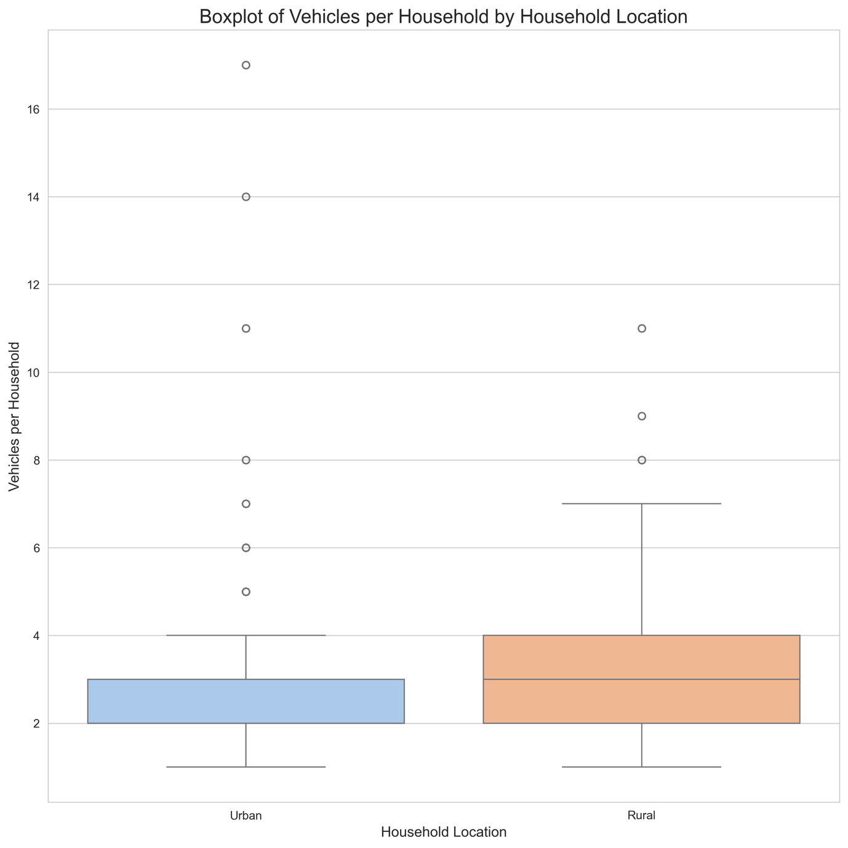
Figure 3 Boxplot of Vehicles per Household by Household Location
The third plot is a boxplot showing the distribution of vehicles per household in urban and rural locations. This is helpful because it gives information on where transit investments should be made. The lower vehicles per household in urban locations suggest they rely more on public transportation or other methods. The higher vehicles per household in rural locations suggest they rely more on individual transportation methods. The urban vs rural boxplot showed a clear difference. Rural households tended to have more vehicles and a wider range overall. Urban households were more grouped around 2 to 3 vehicles. This actually stood out a lot because it reflects real life pretty well. In rural areas, you basically need a car for everything, so it makes sense that households would have more.
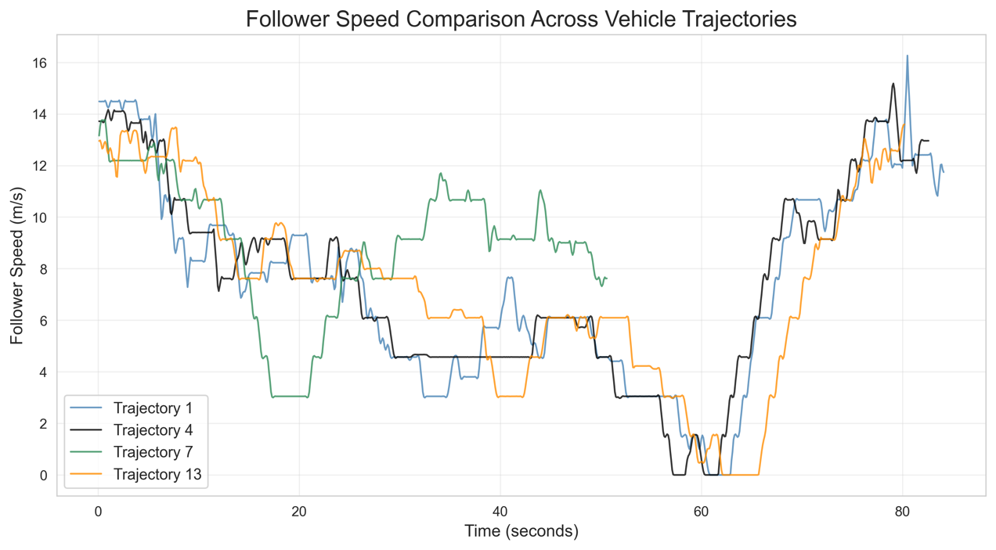
Figure 4 Follower Speed Comparison Across Vehicle Trajectories
The next plot is a follower speed comparison across multiple vehicle trajectories. This is helpful in giving information about how the NGSIM data was collected. For example, speed going to 0 m/s around the 60 s mark suggests there was likely a stoplight or heavy traffic. Looking at the NGSIM data, the speed plots showed a lot of variation depending on the trajectory. This suggest that the data was collected in different locations and different traffic conditions – good for providing a range of data helpful for simulating multiple scenarios.
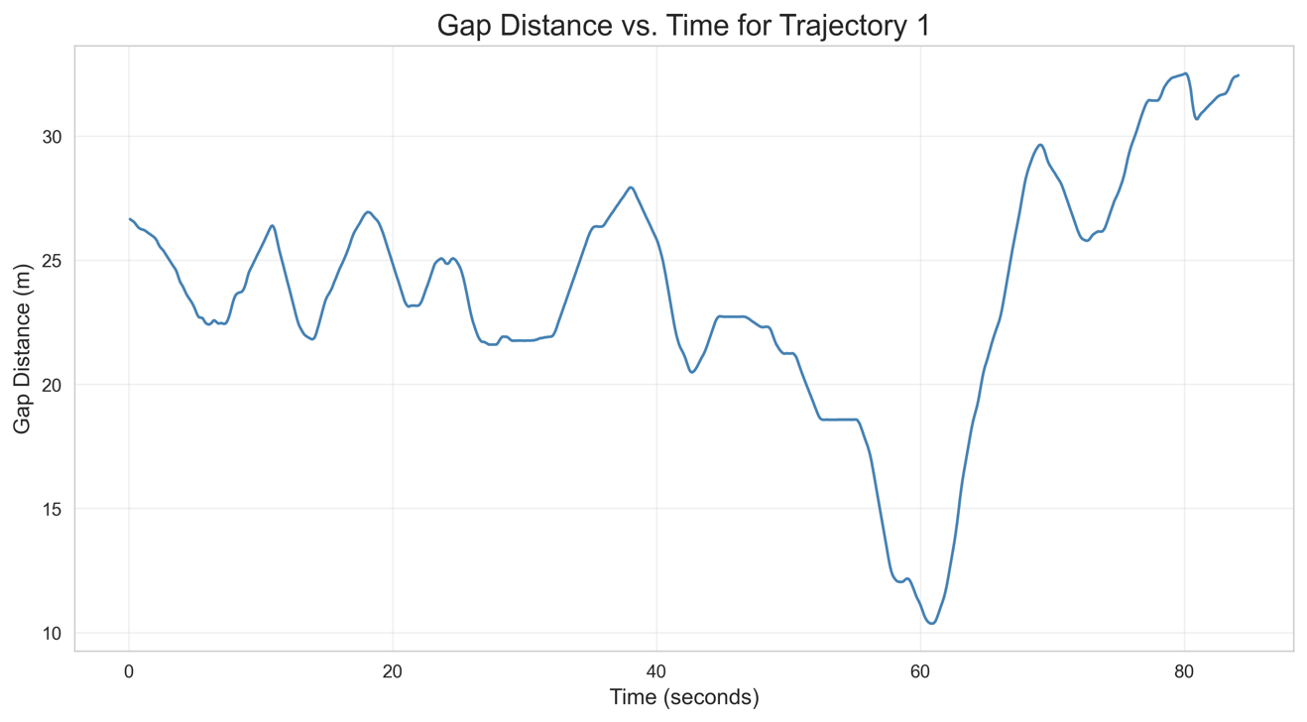
Figure 5 Gap Distance vs. Time for Trajectory 1
The next plot is a graph showing the gap distance vs. time for trajectory 1. Again, this plot is helpful in understanding the data and how it was collected. The spacing stayed mostly between 20 and 30 meters, but there was a big drop around 60 seconds before it increased again. That kind of behavior suggests drivers are constantly adjusting based on what’s happening in front of them, like stopping at a light or hitting traffic.
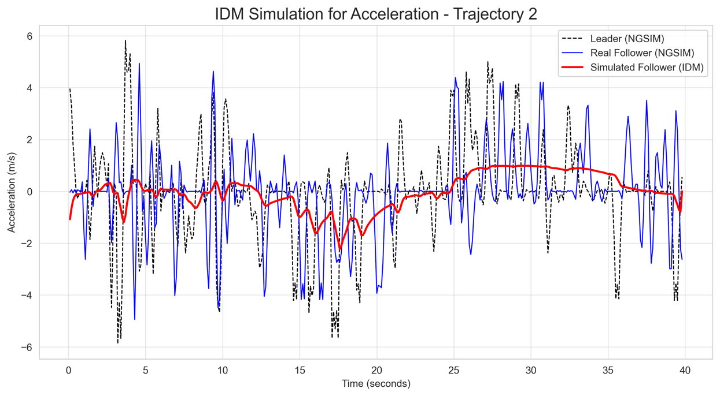
Figure 6 IDM Simulation for Acceleration - Trajectory 2
The final visualization is a plot showing the IDM simulation results. The IDM simulation was compared with the real data. The simulated acceleration followed the general trend, but it was way smoother than the actual data. The real follower had a lots more small fluctuation. So, the model works for the overall behavior, but it doesn’t capture every little change. This data suggests that the IDM simulation is helpful for understanding a broad trend, but is difficult for predicting the small inputs that vary from person to person -that makes sense since real drivers don’t act perfectly like models.
Overall, the results lined up well with what was expected. Gas vehicles dominate, rural areas rely more on personal vehicles, and real traffic behavior is a lot more variable than a model can fully capture.

References
Federal Highway Administration. (n.d.). National Household Travel Survey (NHTS). https://nhts.ornl.gov
Federal Highway Administration. (n.d.). Next Generation Simulation (NGSIM) vehicle trajectory data. https://ops.fhwa.dot.gov/trafficanalysistools/ngsim.htm
Python Software Foundation. (n.d.). Python documentation. https://www.python.org
Hunter, J. D. (2007). Matplotlib: A 2D graphics environment. Computing in Science & Engineering, 9(3), 90–95.
Waskom, M. L. (2021). seaborn: Statistical data visualization. Journal of Open Source Software, 6(60), 3021.

