CIVE 202 Project 4 Report: Interpret Data
Civil Engineering Analysis II (CIVE-202)

Section 151 Group 14
April 21, 2026

Contents
Introduction/Scope of Work 2
Project Goal 2
Study Area: States 2
External Resources 3
Current NRI Definition of Risk 3
NRI Calculation Method 3
Tasks 3
Project Deliverables and Timeline 4
Methods 4
Define Levels of Risk 4
Comparison of Risk Definitions 7
Categorical Bias and Ethical Implications 7
Implications for Future Funding 7
References 8

Table 1. Summary of Deliverables 4

Figure 1 Comparison of Tornado Risk Definitions in Rhode Island 5
Figure 2 Comparison of Tornado Risk Definitions in Oklahoma 6
Figure 3 Risk Comparison Heatmaps of Oklahoma and Rhode Island 6

Introduction/Scope of Work

Project Goal
Our group has been hired by Risk Averse, LLC to conduct a sensitivity analysis of the FEMA National Risk Index (NRI). The goal is to find categorical bias by comparing the current NRI methods against an alternative risk scoring model developed by our team (Risk = probability * impact). This study focuses on census-tract level data across two states to evaluate how different risks impact community priority and funding eligibility.

Study Area: States
For this analysis, our group will examine the following states:
- Oklahoma
- Rhode Island
The group will focus on the risk of tornadoes in each state. These states were picked because they sit on opposite ends of the tornado risk spectrum. Oklahoma sits in the heart of Tornado Alley and is subject to extreme tornado exposure. Rhode Island, on the other end, has very few tornadoes per year and therefore has a very low tornado risk level. Comparing these two states will allow the group to understand how sensitive the risk model is.

External Resources
In addition to the primary NRI dataset, the following external resources will be used to support the development of our alternative risk scoring method.
- CDC/ATSDR Social Vulnerability Index (SVI): This dataset will be used to cross-reference social factors (poverty, housing, vehicle access) that show how a community prevents human suffering and financial loss in a natural disaster.
- FEMA Hazus Technical Manuals: Since Hazus 6.0 provides the building and population exposure data for the NRI, we will use it to understand how “Expected Annual Loss” is modeled. This is important for finding if the physical damage models favor certain types of infrastructure or high-value urban areas.

Current NRI Definition of Risk
Per the FEMA National Risk Index, risk is defined through these lenses:
- Risk: The potential for negative impacts (human, physical, and economic) resulting from a natural hazard.
- Expected Annual Loss: The average cost resulting from natural hazards each year, buildings, people, and agriculture.
- Social Vulnerability: The susceptibility of social groups to the impacts of natural hazards.
- Community Resilience: The ability of a community to prepare for anticipated hazards, and adapt, withstand, and recover from these hazards.

NRI Calculation Method
The National Risk Index is calculated by the following:
Risk Index = (Expected Annual Loss) * Social Vulnerability / Community Resilience

Tasks
- Data Processing: Download and clean NRI and SVI data for Oklahoma and Rhode Island
- Model Development: Create an alternative risk definition and implement it using Python.
- Visualization: Create summary tables, a sensitivity analysis comparison, and a GeoPandas risk map.
- Final Report: A document detailing methodology, ethical implications of bias and impacts on future FEMA mitigation funding.

Project Deliverables and Timeline
The deliverables for this project and their associated file names, and due dates are summarized in the table below.
Table 1. Summary of Deliverables
Deliverable | File Name | Due Date
Gantt Chart | CIVE202_Spring2026_P4-151-14_Project4_GanttChart | 04/21/26
Scope of Work (SOW) | CIVE202_Spring2026_P4-151-14_Project4_SOW | 04/21/26
Python Code | CIVE202_Spring2026_P4-151-14_Project4_PythonCode | 04/21/26
Annotated Code Document (ACD) | CIVE202_Spring2026_P4-151-14_Project4_ACD | 04/21/26
Time Sheet | CIVE202_Spring2026_P4-151-14_Project4_TimeSheet | 04/21/26
Written Report (With Bias Discussion) | CIVE202_Spring2026_P4-151-14_Project4_Report | 04/21/26
GitHub (All Files Used) | GitHub Repository Link | 04/21/26

Methods
To begin, all the necessary data is loaded into Python. Both the SVI and NRI (for each state) datasets need to be combined for use as a single dataframe. To accomplish this, a common column is created in both data sets and the merge() function is used to combine the two. To make sure this is repeatable, any data containing null or NA values for the selected variables (TRND_AFREQ or TRND_EXB) were removed from any calculations during the cleaning process.
After all the data was properly combined and arranged, a new value for risk could be calculated according to the methods below. This new value was included in all datasets, the shapefile for both states, and the combined SVI and NRI dataset for both states.
After this was complete, visualizations comparing the new risk definition, and the original NRI definition can be made to understand the sensitivity of the model. These results are compared and can be analyzed for conclusions.
For more information on detailed code (functions used, order of operations, etc.) please view the Annotated Code Document which outlines all the functions used and what they accomplish.

Define Levels of Risk
In compliance with the client’s request, the group created a new definition of risk to explore biases that may exist with the current NRI risk definition. The NRI currently calculates risk as Risk Index = (Expected Annual Loss) * Social Vulnerability / Community Resilience. In this analysis, the group will use their own definition: Risk Index = Probability * Impact. In Python, the group needed to find specific values that represent both the probability and impact so that risk can be calculated accordingly. To find these terms, the group utilized the NRI data dictionary which. These terms are the Tornado – Annualized Frequency (TRND_AFREQ) as the probability variable, representing the expected number of tornado occurrences per year in a given area. For impact, the group selected Tornado – Exposure – Building Value (TRND_EXPB) which represents the total dollar value of buildings exposed to tornado hazard. Both variables are defined in the NRI Data Dictionary and are represented at county level. In Python, these two columns are multiplied together and stored in a new column called “tornado_building_risk,” yielding a risk index measured in an arbitrary unit of “dollar-years.” This approach allows risk to be compared across counties based on physical hazard likelihood and exposure, excluding social and resilience factors so that the NRI’s risk index can be examined.
Results and Discussion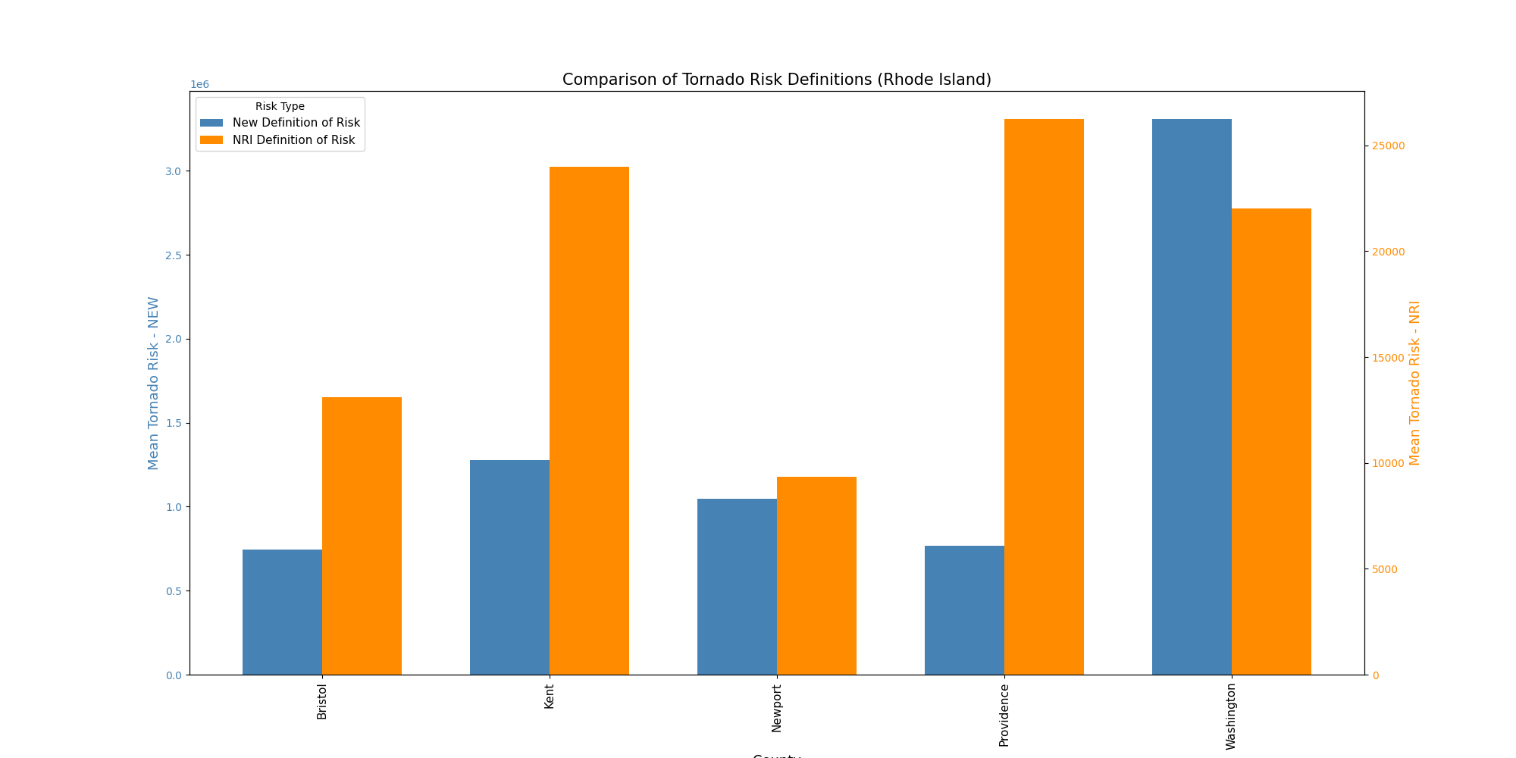
Figure 1 Comparison of Tornado Risk Definitions in Rhode Island
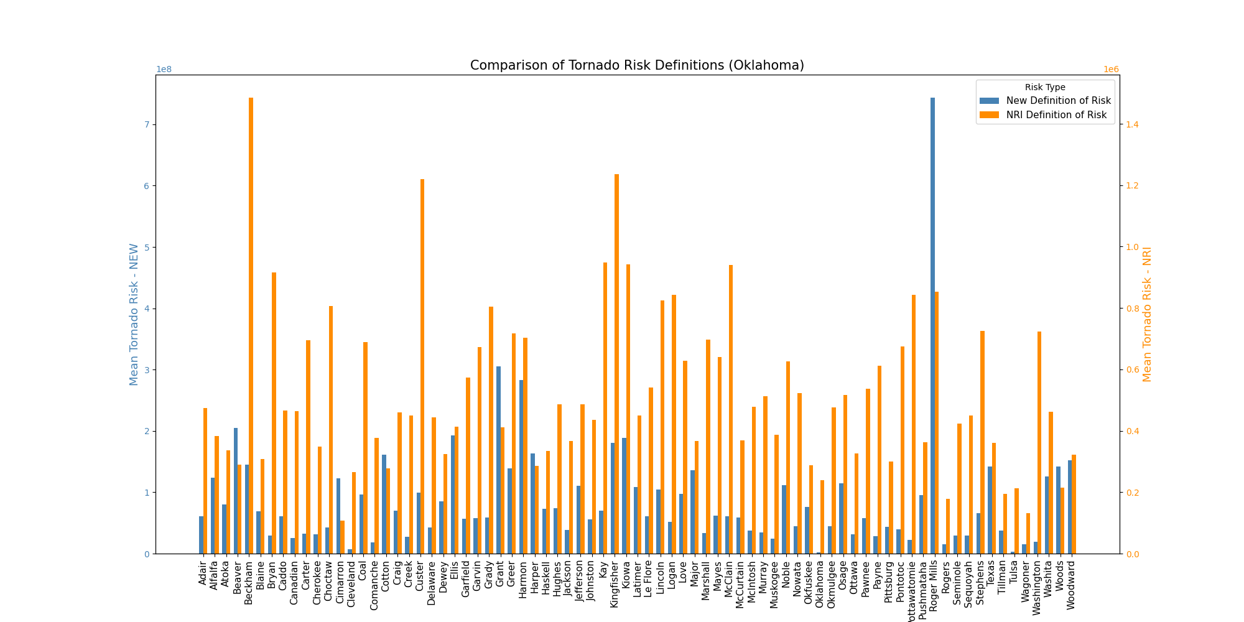
Figure 2 Comparison of Tornado Risk Definitions in Oklahoma
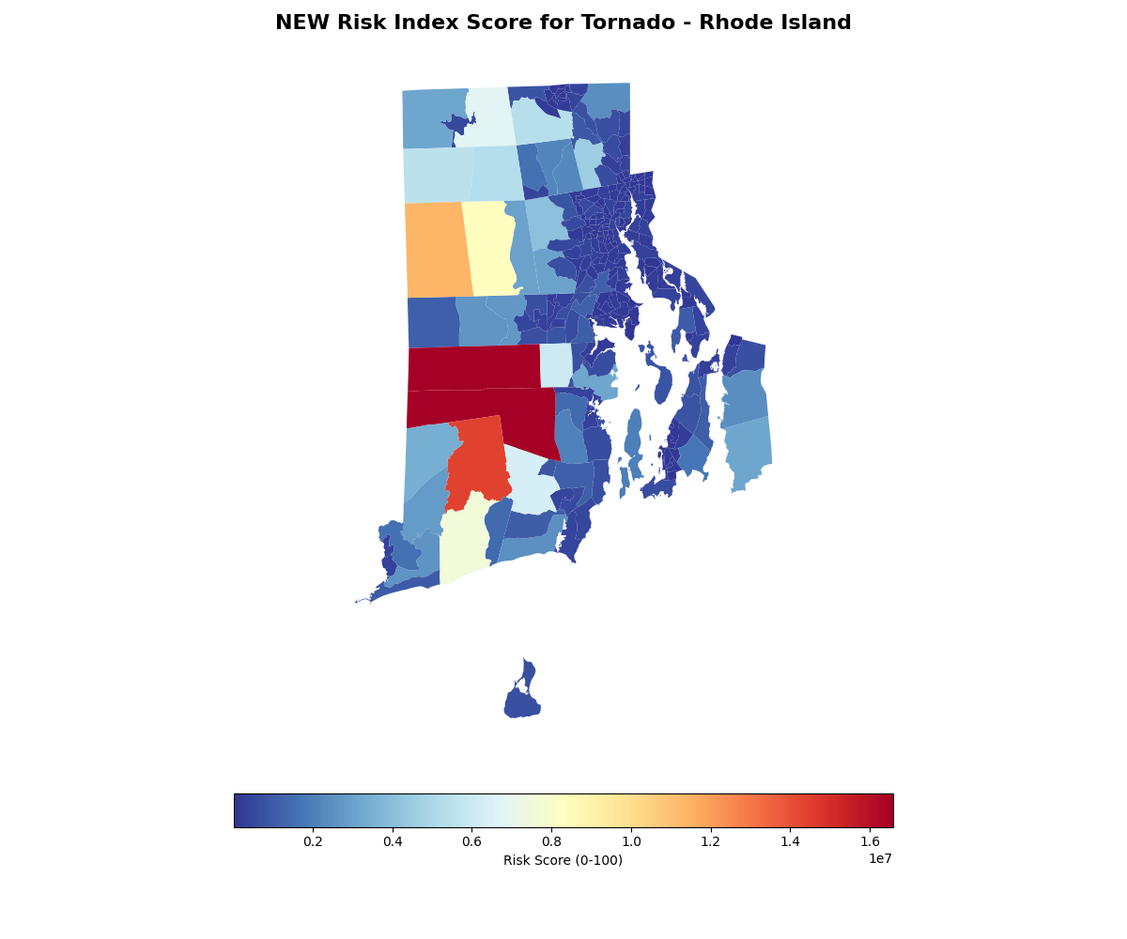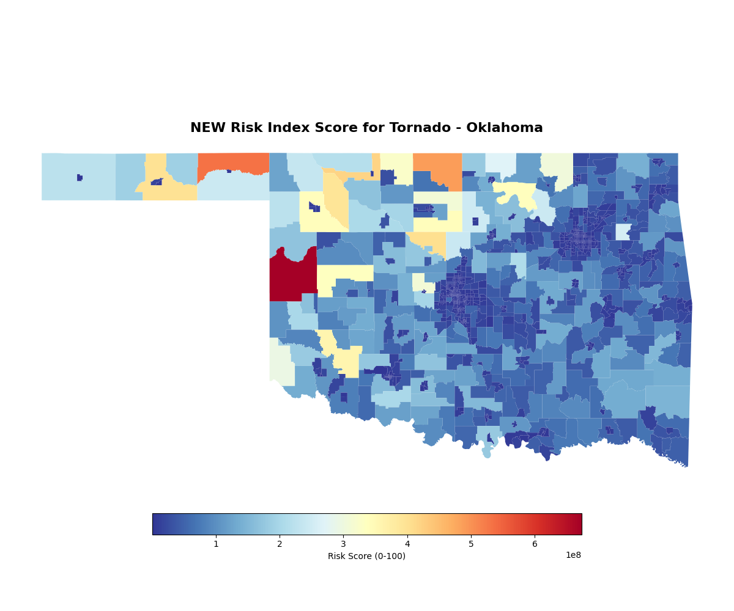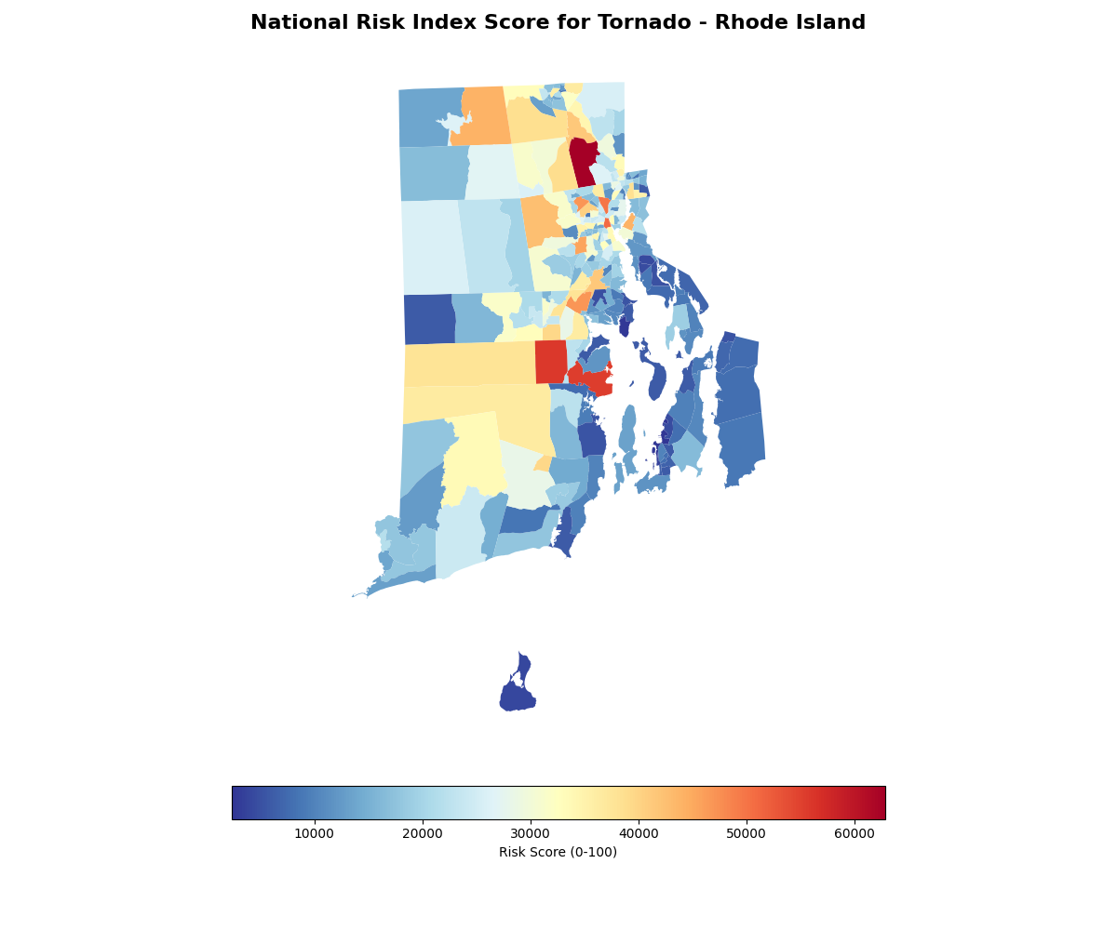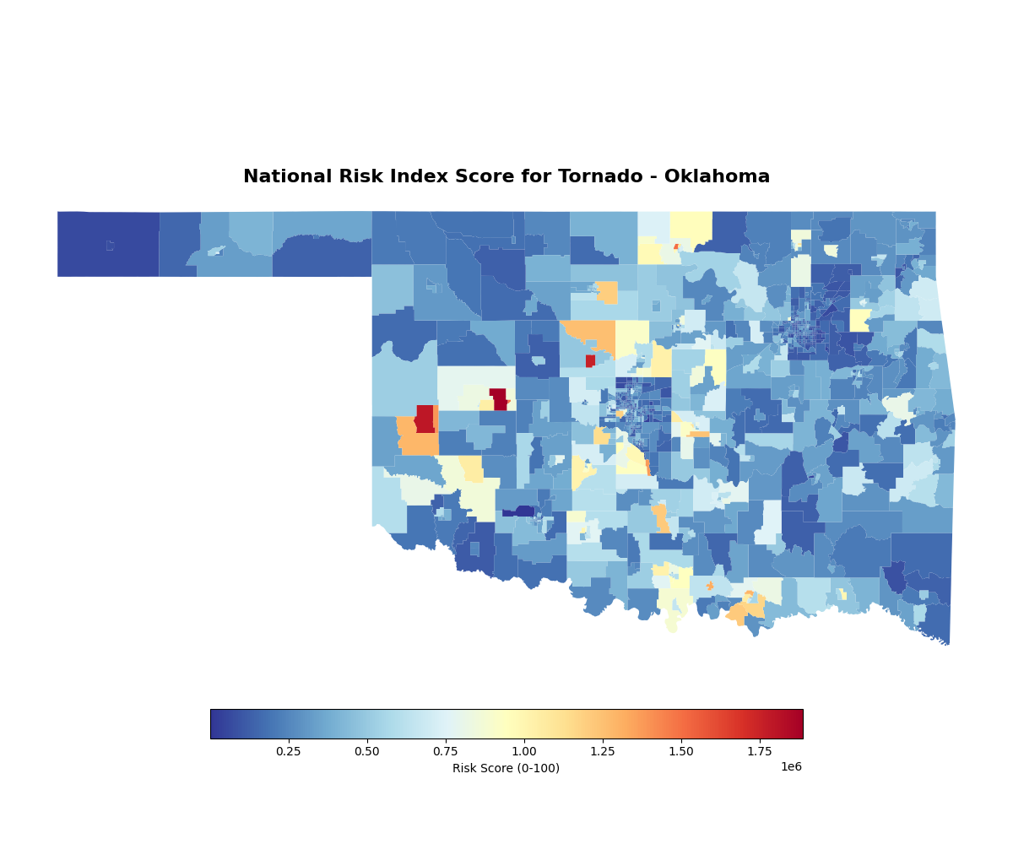
Figure 3 Risk Comparison Heatmaps of Oklahoma and Rhode Island

Comparison of Risk Definitions
The difference between the NRI’s definition and our proposed definition is the exclusion of social context. Our model, which is derived from the FEMA Hazus Technical Manuals, focuses only on the “Expected Annual Loss” of monetary assets. By focusing only on the Building Value, our model treats risk as only an economic risk, and not a population one. The NRI’s definition uses the Social Vulnerability Index (SVI), which adjusts risk based on a community’s ability to “prevent human suffering” rather than just a financial loss. This can be seen in Figure 2, where Roger Mills County, Oklahoma has nearly double the risk value in our calculation compared to the NRI’s risk calculation, this is because the NRI’s “social vulnerability” and “community resilience” may be dampening the score due to variables outside of just economic loss. Additionally in Figure 1, the NRI’s dataset has risk of counties like Providence and Kent Rhode Island significantly higher than our calculation. This means that their additional variables are inflating the risk values in these counties.

Categorical Bias and Ethical Implications
Our sensitivity analysis reveals a significant Bias in the proposed Probability * Impact model. Because our definition uses the building value as the weight for impact, which favors high-value urban areas over low-income areas. In Oklahoma, this shifts the “Very High” risk ratings toward developed metropolitan centers, which could potentially overlook rural or lower income areas that still have a high tornado frequency.
Ethically, this creates a “Wealth Bias”, which highlights why including a population aspect is important. If risk is defined only by monetary value, one luxury development project could be deemed a higher risk than an entire low-income neighborhood. Additionally, lower-income residents often have lower access to insurance, transportation, and stable housing, leading to slower recovery after a disaster.

Implications for Future Funding
These definitions have direct consequences for how states and communities interpret data and policies. If Risk Averse, LLC were to use our proposed definition to advise on FEMA mitigation funding, money would be funneled toward protecting expensive investments disproportionately to lower income areas. This would severely disadvantage states like Rhode Island, which already has low tornado frequency, as well as poorer neighborhoods in Oklahoma. By using the NRI’s method (which includes Community Resilience), funding can be more fairly distributed to include low-income communities.

References
Agency for Toxic Substances and Disease Registry (ATSDR). (2024). CDC/ATSDR Social Vulnerability Index (SVI): Data and Documentation. U.S. Department of Health and Human Services. https://www.atsdr.cdc.gov/place-health/php/svi/svi-data-documentation-download.html
Federal Emergency Management Agency (FEMA). (2025). National Risk Index: Data Resources and Metadata. U.S. Department of Homeland Security. https://hazards.fema.gov/nri/data-resources
Federal Emergency Management Agency (FEMA). (2025). Understanding Scores and Ratings. National Risk Index. https://hazards.fema.gov/nri/understanding-scores-ratings
Federal Emergency Management Agency (FEMA). (2025). Hazus Technical Manuals. https://www.fema.gov/flood-maps/tools-resources/flood-map-products/hazus/documentation
National Academies of Sciences, Engineering, and Medicine. (2019). Framing the Challenge of Urban Flooding in the United States. Washington, DC: The National Academies Press. https://doi.org/10.17226/25381

