CIVE 202 Project 5 Report: Examine TCR Violations
Civil Engineering Analysis II (CIVE-202)

ENVRN-02-14
May 8, 2026

Contents
Introduction/Scope of Work 2
Project Goals 2
Project Tasks 3
Methods 4
Results and Discussion 5
References 12

Figure 1 Violations by State 6
Figure 2 Violations by County - MI 7
Figure 3 Violations by County - ME 7
Figure 4 Violations by County - VA 8
Figure 5 Violations by County - NE 9
Figure 6 Violations by County - MI 9
Figure 7 Violations by System Size 10
Figure 8 Active TCR Violations Per Month by State (static) 11

Introduction/Scope of Work

Project Goals
A research team at the University of Massachusetts Amherst (UMass Amherst) has asked our group to aid in their study of Total Coliform Rule (TCR) violations across the United States. The goal of this project is to conduct a thorough analysis of the Safe Drinking Water Information System (SDWIS) and provide UMass Amherst with helpful information to aid in their research. Specifically, the group will look at TCR violations across 5 different EPA regions (one state in each region) to better understand where these violations occur in the U.S and differences between them. In addition, the group wants to determine the potential reasons for differences in these TCR violations. While completing this analysis, the group will also note differences in TCR violations between small and large water systems to draw a conclusion of which system presents more violations and possible reasons associated.

Project Tasks
The following tasks will be required by the professional engineering team to complete the project goals.
Task 1: Data Analysis
For this study, violation records will be obtained from the Safe Drinking Water Information System (SDWIS) database to analyze TCR violations across multiple states, representing different EPA regions. Utilizing the SDWIS database, relevant information will be identified and downloaded. This data will be compiled cleanly into a .csv file for analysis. The data will be cleaned and organized by addressing any missing values and possibly converting data types where needed. Some additional research may be necessary here to understand the SDWIS terminology, EPA system-size definitions, and other context so the data can be correctly interpreted.
Task 2: Project Code
To examine TCR violations across five states, a Python coding environment will be utilized to easily analyze the data. Several packages will be imported such as pandas for data manipulation and matplot for visualization purposes. A function may be defined to streamline repeated tasks, such as summarizing violations or comparing large and small water systems. Visualizations will be created to represent TCR violations over time and to compare violation trends across EPA regions and systems of different sizes. Throughout the coding process, documentation of each coding decision will be made using comments in Python.
Task 3: Scenario Development and Testing
Several analytical scenarios will be developed to ensure the analysis accurately reflects the TCR violations across the United States. The scenarios will be designed to evaluate how TCR violations differ across states, EPA regions, and between small and large water systems. Each scenario will focus on a specific comparison such as TCR violation trends over time for a single state, multiple states, different EPA regions, and isolating differences between large and small water systems within the same regions. After scenarios have been designed, the Python code will be used to test them by filtering data, summarizing violation counts, and generating visualizations that describe the data in a meaningful way. This testing will also verify that the code produces consistent results and confirming that the visualizations accurately represent the data. Throughout the process, the team will document any assumptions, limitations, or sources of bias.
Task 4: Documentation and Reporting
All findings will be documented and compiled in a report prepared for the UMass Amherst Water Research Team. A Jupyter Notebook presenting the code structure in sequential order, alongside the results from the project. Next, a document annotating the code will describe all logic in detailed explanations. The written report (technical and non-technical executive summaries) will include an introduction, methods, results, and discussion sections. There will be an established GitHub repository storing all code along with a README file with User Guide information. Finally, a Gantt Chart will display all tasks and milestones for the project.

Methods
The following procedures were used to fulfill client requests outlined in the scope of work. All calculations were completed using Python Jupyter Notebook with pandas library to manipulate data, matplotlib and seaborn for visual analysis and customization. Raw water data was collected from the Safe Drinking Water Information System (SDWIS) public database. This data was further cleaned and organized into a CSV for more analysis and manipulation in Python. One state was selected from each of the five EPA regions to provide a greater analysis of Total Coliform Rule (TCR) violations across the entire United States.
First SDWIS data was downloaded, cleaned, and compiled into a CSV, which was loaded into Python as a dataframe - using the pandas package - to check for any conversions and formatting needed. Additional research was conducted to understand EPA classifications, terminology used by SDWIS, and to find context on regulations for a greater understanding of the data. EPA definitions were used to categorize water data based on the population it served.
Next, TCR violations for each state selected within the five regions were organized by state. A plot showing the violations per state was created using Seaborn. Additionally, Seaborn was used to create 5 plots (one per state) showing the violations by county; which is helpful for understanding the location of violations and then determining a cause.
An analysis of what type of water system experiences more TCR violations was conducted. Utilizing a Python function which sorts each violation by population served, the data was grouped into size of water system (very small, small, medium, etc.). A visual was generated to compare count of violations between water system sizes. Research was conducted to understand results of which water system presents more violations.
A time series plot was created using the Plotly package. This package allows an interactive plot to be created, showing the violations over time in each state. This also allows the user to manipulate the time scale to zoom in and better understand the data. Using the beginning and end date for each violation, an active violation period was created and the total active violations were plotted at each time interval (day, month, year).
An annotated code document was developed to explain each section of code. Within the documentation, all limitations, bias, and assumptions were noted with reasoning. All code, data, and documentation were stored in a GitHub repository containing a README to provide any user background information for replicable results.

Results and Discussion
Total Coliform Rule (TCR) is the rule that the Environmental Protection Agency (EPA) set up to monitor and limit the allowable concentration of total coliform bacteria in drinking water. This rule was created in 1989 and later revised in 2013 into the Revised Total Coliform Rule (RTCR). Coliforms are defined as any type of bacteria, viruses, or parasites that could cause harm to humans if consumed and introduced into the body.
The TCR violations per state was the first data set that was evaluated. The states that were reviewed were Michigan, Maine, Virginia, Nebraska, and Mississippi. The state that had the most violations by more than a factor of two was Michigan. This is to be expected mainly because Michigan has had many problems with water quality over the past decades. A main instance of a problem with the water quality in Michigan was in 2014 in the Flint water crisis. Although it was not from TCR but rather lead poisoning, it showed the poor condition and maintenance of the pipes transporting drinking water. These circumstances can cause a biofilm to be created in the pipes which would spread the contamination of bacteria. Also, Lake Erie is prone to algae blooms, which are very harmful and rapidly impact water quality and with Michigan’s aging infrastructure, it is very difficult for the purification process to keep up with the demand. This is further supported by the Michigan Water Stewardship Program.
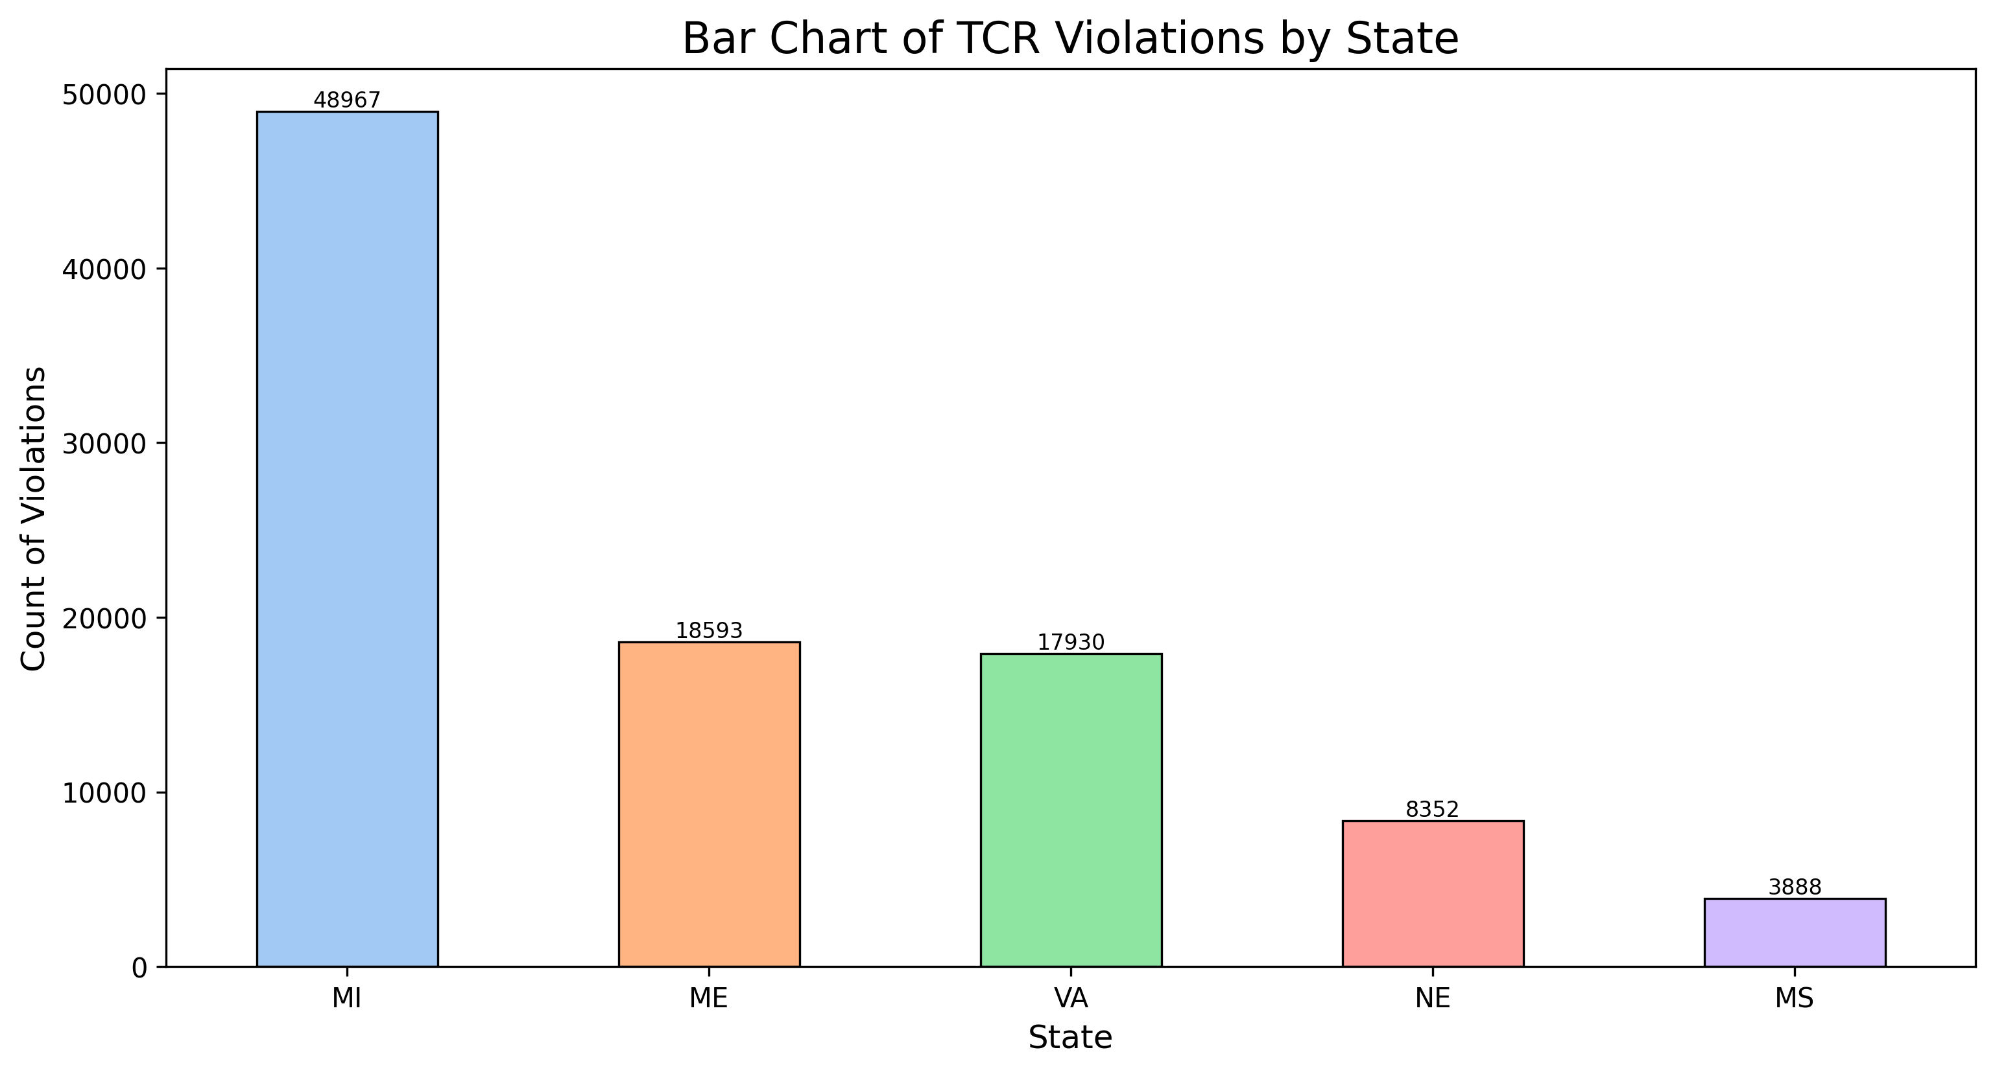
Figure 1 Violations by State
Going into more depth into the TCR violations in each county of Michigan, the main areas with the highest TCR violations were in the counties of Oakland, Lapeer, and Genesee. Oakland and Lapeer are very close to Detroit, Michigan, which has struggled with water quality issues because of the prominent industrial zoning in the area. Genesee, which contains Flint, like previously stated, has also struggled with many water quality problems in the past and is still ongoing.
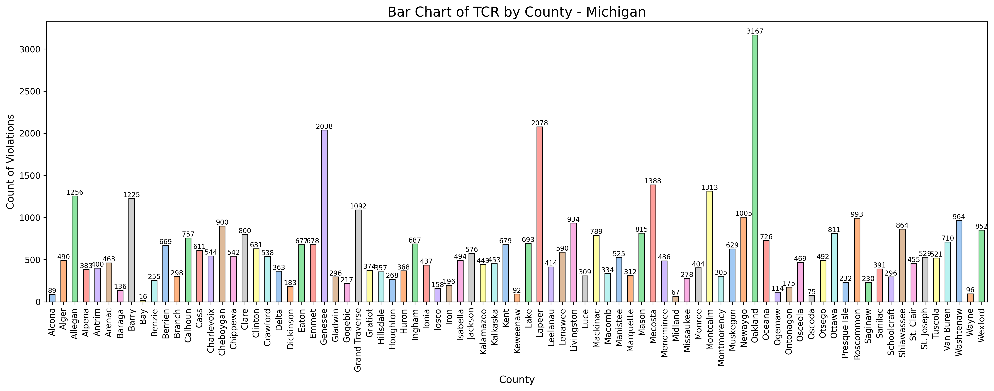
Figure 2 Violations by County - MI
Maine has considerably fewer violations compared to Michigan, but it still has the second-highest amount out of the five states. The three main counties with the most violations are Cumberland, Hancock, and Penobscot. These three counties contain most of the population in the state, including the cities of Portland, Bangor, and Ellsworth. The vast majority of these violations were caused by old infrastructure that needs to be replaced.
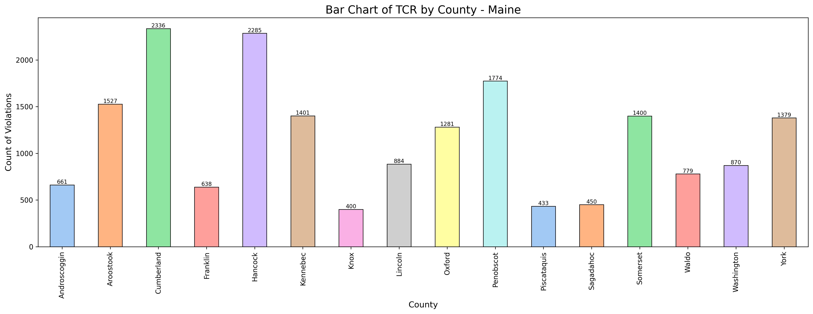
Figure 3 Violations by County - ME

Virginia has a very similar number of violations compared to Maine. It is also very easy to tell where the hotspots are located because Virginia’s counties are much smaller compared to those in Maine. The counties with the most violations are Accomack, Northampton, and Fauquier. The first two counties are on the east side of the Chesapeake Bay and are separated from the greater area of Virginia, so they are forced to purify their own water with a much lower budget than a city would have. Fauquier is on the outskirts of Washington, D.C., on the Virginia side, so it is very similar to the previous counties, but it still has a high level of population. 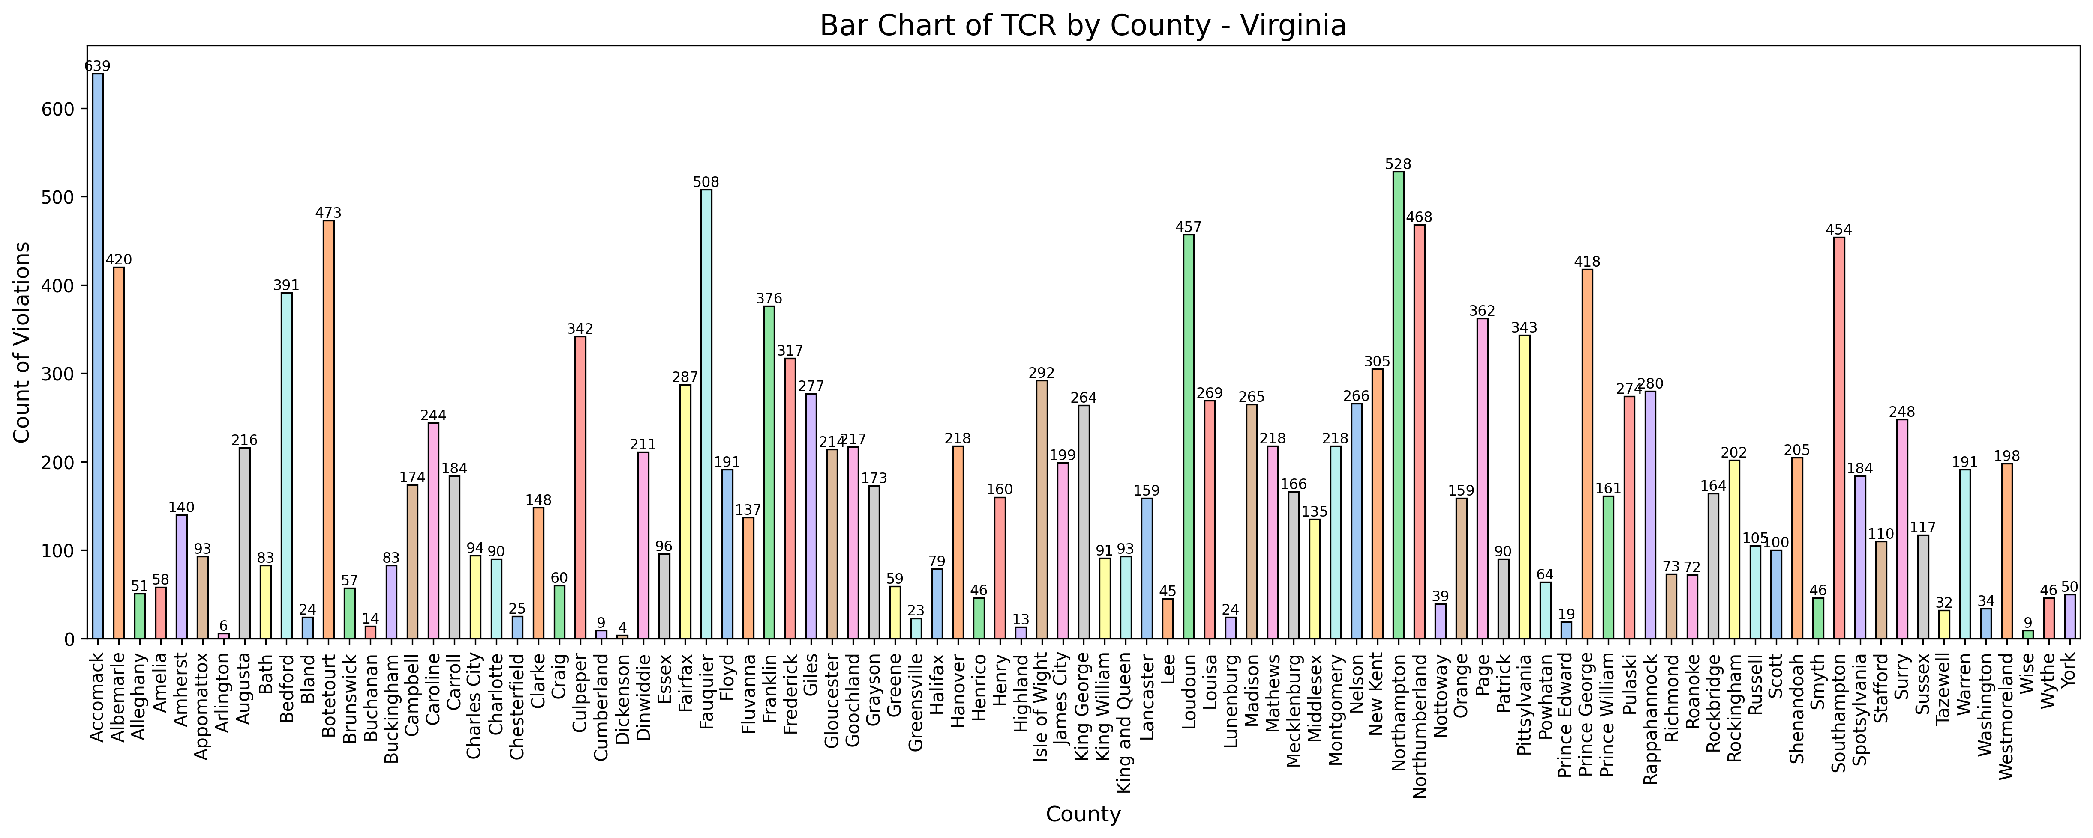
Figure 4 Violations by County - VA
The next State with the highest violations is Nebraska. The violations in Nebraska seem very evenly distributed around the state, however, most of the violations follow the Platte River across Nebraska. These violations are most likely caused by collecting water from the River whereas in other locations, the water is most likely drawn from the aquifer, which is not affected by coliforms.
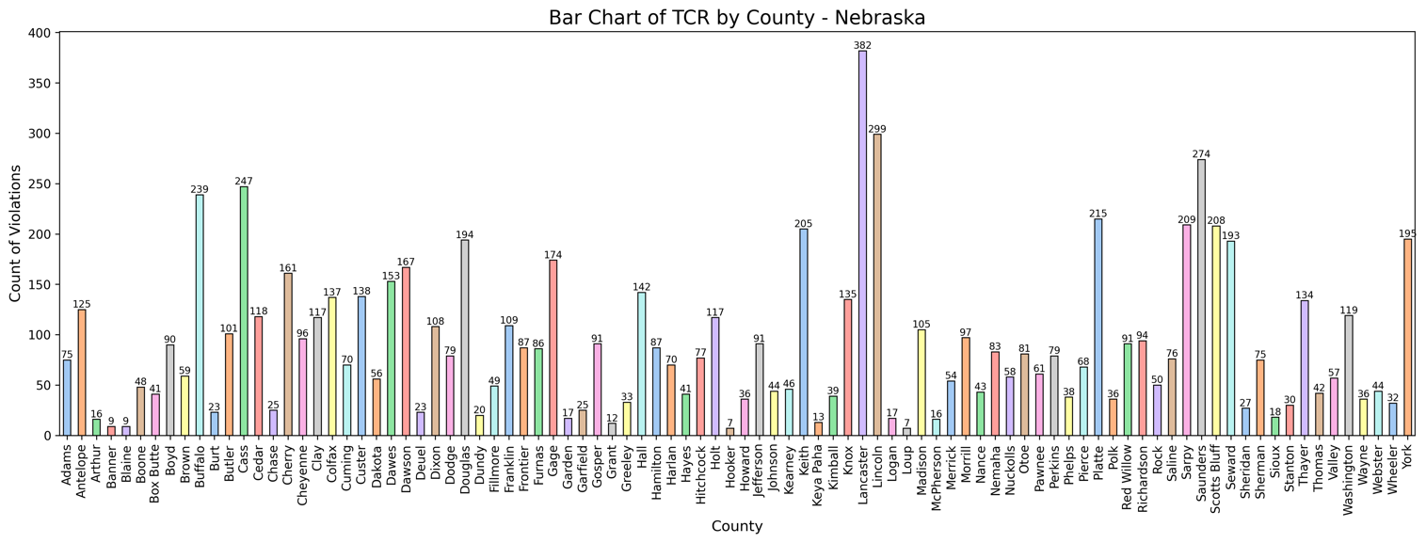
Figure 5 Violations by County - NE
The State with the lowest violations out of the selected states is Mississippi. The quality of the water is considered relatively good compared to the rest of the United States of America because of the strict enforcement of water purification and the natural filtration of local bodies of water.
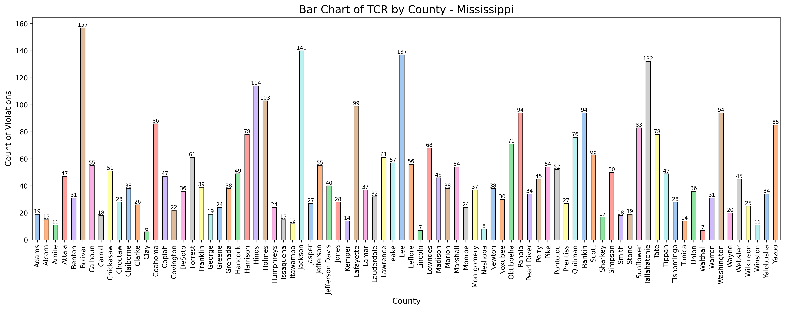
Figure 6 Violations by County - MI
The violations were sorted by the population that was affected by the violations. Very small system size is less than 500 people, Small is between 500 and 3,300, Medium is between 3,300 and 10,000, Large is between 10,000 and 100,000, and finally Very large is above a population of 100,000 people. When the Violations were sorted into these classifications, the very small system size had the most. This makes sense because the smaller towns have less money and funding to have more advanced purification of their water, so those systems have a higher chance of having pathogens in the water. This conclusion is supported by the American Water Works Association’s (AWWA) article small towns, big challenges: Does rurality influence Safe Drinking Water Act compliance? This article talks about how rural areas have different violations compared to larger cities and it also stated that the smaller towns didn’t have as much resources to provide as much protection as the larger systems can.

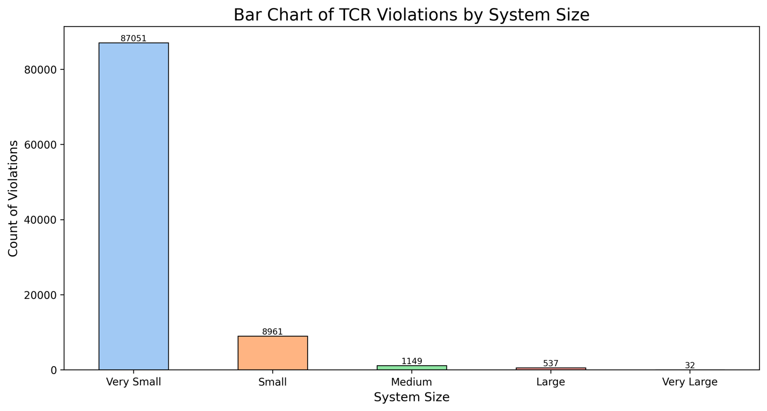
Figure 7 Violations by System Size
The group created an interactive map that shows the number of violations in each state over time. The user can also change the time frame that they want to view with the slider at the bottom. Click Here for Interactive Graph file. File must be downloaded to view.
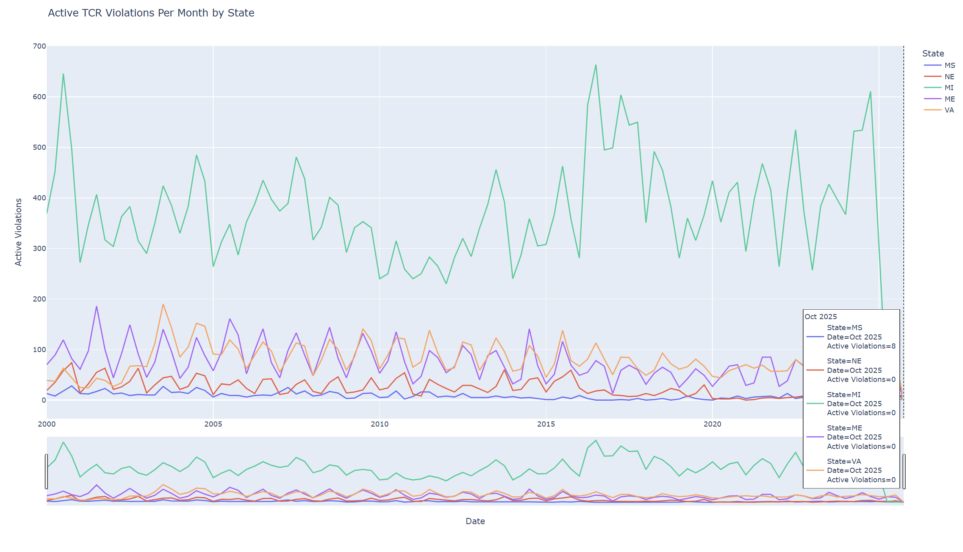
Figure 8 Active TCR Violations Per Month by State (static)

References
U.S. Environmental Protection Agency. (n.d.). Safe Drinking Water Information System (SDWIS) federal reporting services. https://sdwis.epa.gov/ords/sfdw_pub/r/sfdw/sdwis_fed_reports_public/1
U.S. Environmental Protection Agency. (2026, March 2). Drinking water dashboard help. ECHO. Epa.gov
US EPA. (2025, February 19). Revised Total Coliform Rule And Total Coliform Rule. US EPA. https://www.epa.gov/dwreginfo/revised-total-coliform-rule-and-total-coliform-rule
Marcillo, C. E., & Krometis, L. H. (2019). Small towns, big challenges: Does rurality influence Safe Drinking Water Act compliance? AWWA Water Science, 1(1). https://doi.org/10.1002/aws2.1120
Michigan Water Quality Issues – MI Water Stewardship. (n.d.). Michigan Water Stewardship Program. https://miwaterstewardship.org/michigan-water-issues/

‌

‌

