E-Commerce Sales & Profit Analytics Project

1. Project Overview
This project analyzes E-Commerce sales performance using Power BI, SQL, Python, and Excel. The dashboard helps businesses monitor sales trends, profit margins, customer segments, regional performance, and product-level insights.

2. Tools Used
Tool | Purpose
Excel | Data Cleaning & Preparation
SQL Server | Data Querying & Analysis
Python | Data Analysis & Visualization
Power BI | Interactive Dashboard Creation

3. Key KPIs
- Total Sales: 12.6M
- Total Profit: 1.47M
- Total Orders: 25.03K
- Total Quantity Sold: 178.2K
- Profit Margin: 11.60%

4. Dashboard Insights
- Technology category generated the highest sales and profit.
- Furniture category showed lower profitability compared to sales.
- Sales increased significantly during November and December.
- Consumer segment contributed the highest percentage of sales.
- Higher discounts negatively impacted profit margins.

5. Sample SQL Queries

-- Total Sales --
select sum(Sales) as Total_Sales from E_Commerse;

/* Total Profit */

select sum(Profit) as Total_Profit from E_Commerse;

/* Total orders */

Select Count(order_ID) as total_orders from E_Commerse;

/* Total Quantity Sold */

select sum(Quantity) as Total_QTY_Sold from E_Commerse;

/* Profit Margin % */

select Round((sum(Profit) / Sum(Sales)) * 100,2) as Profit_Margin from E_Commerse;

/* Monthly Sales */

Select Month(order_date) as Month_No,
DATENAME(Month, order_date) as Month_Name,
sum(Sales) as Monthly_Sales from E_Commerse
group by Month(order_date), DATENAME(Month,order_date)
order by Month_No;

/* TOP 10 PRODUCTS BY SALES */

select top 10 Product_Name,sum(Sales) as Total_Sales from E_commerse
group by Product_name
order by Total_Sales Desc;

/* Sales by Category */

select Category, sum(sales) as category_sales from E_commerse
group by category
order by category_sales desc

/* region wise sales */

select Region,Sum(sales) as Region_sales from E_commerse
group by Region
order by Region_sales desc;

/* Category wise profit */

select Category , sum(Profit) as total_profit from E_commerse
group by Category
order by total_profit desc;

/* Discount Vs Profit */

select Discount,sum(profit) as Total_profit from E_commerse
group by Discount
order by Total_profit desc;

/* Profit vs Shipping cost */

select Shipping_Cost,Profit from E_commerse
order by Shipping_Cost desc;

/* Customer Segment */
select segment, sum(sales) as total_sales, sum(profit) as total_Profit from E_Commerse
group by segment
order by total_Profit,total_sales desc;

6. Sample Python Analysis
import liabraries
import pandas as pd
import numpy as np
import matplotlib.pyplot as plt
Sales_df = pd.read_excel("C:/Users/charp/OneDrive/Desktop/Data Analytics projects/Amazon E-commerse project/ECOMM DATA-2..xlsx")
Sales_df.head()

- Total Sales
Total_Sales = Sales_df['Sales'].sum()
print("Total sales:",Total_Sales)
- Total profit
Total_Profit = Sales_df['Profit'].sum()
print("Total Profit:", Total_Profit)

- Total orders
Total_orders = Sales_df['Order ID'].nunique()
print("Total orders:", Total_orders)

- Total Quantity Sold
Total_Qty = Sales_df['Quantity'].sum()
print("Total Quantity Sold:", Total_Qty)

- Profit Margin %
Profit_Margin = (Total_Profit / Total_Sales)*100
print("profit Margin:", Profit_Margin)

- Monthly Sales Trend
Monthly_sales = Sales_df.groupby("Month")["Sales"].sum()
print(Monthly_sales)
Monthly_sales.plot(kind ='line',marker ='*', figsize = (10,7))
plt.title("Monthly Sales Trend")
plt.xlabel("Month")
plt.ylabel("Sales")
plt.grid(True)
plt.show()
- Sales by Category
Sales_by_Category = Sales_df.groupby('Category')['Sales'].sum().sort_values(ascending = False)
Sales_by_Category.plot(kind = 'barh', figsize = (8,6))
plt.title("Sales by Category")
plt.xlabel("Sales")
plt.ylabel("Category")
plt.show()
- Top 10 Products
Top_products = Sales_df.groupby("Product Name")["Sales"].sum().sort_values(ascending = False).head(10)
Top_products.plot(kind='barh',figsize=(10,10))
plt.gca().invert_yaxis() ## to show the top highest value at top
plt.title("TOP 10 Product by Sales")
plt.xlabel("Sales")
plt.ylabel("Product Name")
plt.show()

- Region wise Sales
country_sales = Sales_df.groupby('Country')['Sales'].sum().reset_index()

fig = px.choropleth(
country_sales,
locations='Country',
locationmode='country names',
color='Sales',
hover_name='Country',
color_continuous_scale='Blues',
title='Country Wise Sales Map')
# Increase map size

fig.update_layout(
width=1200,
height=700)
fig.show()

7. Dashboard overview
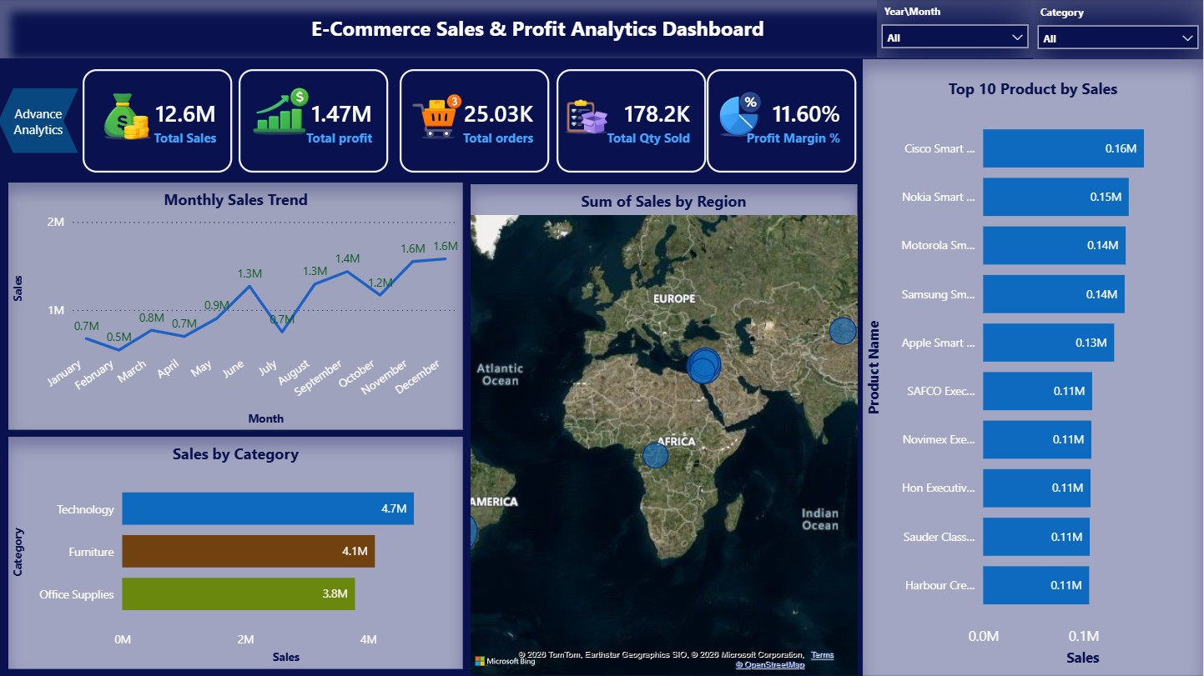

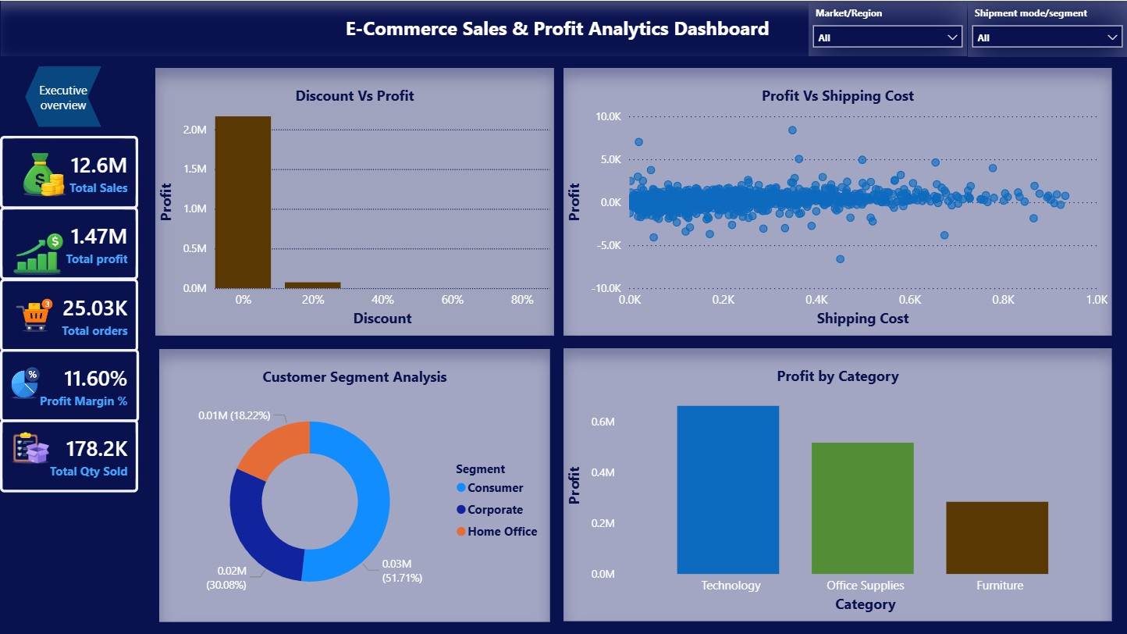

8. Conclusion
This project successfully transformed raw e-commerce data into meaningful insights using data analytics and visualization Tools The dashboard highlights key business metrics such as sales, profit, and product performance, enabling faster and smarter decision-making. Overall, it demonstrates how data-driven analysis can improve business strategy and operational efficiency.

