# Analysis Ultrasound Lab – Benedikt Gregor

## Experiment and procedure

In this lab an experiment was conducted which and is similar to the double slit experiment with light waves. Instead of light ultrasound waves are used which is useful because the wavelength is in the centimetre range which makes things easier.

The computer was used to collect data points when rotating the transmitter relative to the receiver. The receiver itself was placed at approx. infinite distance (more like **302.4 +- 0.5cm**) from the transmitter. The transmitter was set up so that it was pointed to a concave mirror (looks like a satellite dish) to reflect the signal towards the slits. Slits and slats were attached to a frame in front of the transmitter. The panes could slide in an out to reveal many or fewer slits. Additionally, there was a thermometer in the room to read the room temperature which will be important later for the evaluation of the speed of the sound waves.

First the temperature of the room was read: **24.5 +- 0.5°C**. Then the distance between the transmitter and receiver was measured. They are placed opposite of another on two separate tables and a tape measure was be used to measure this distance.

Then measurements of the slits and slats were taken. Callipers were used to measure the inner distance of the slits on various spots (recorded in code in analysis appendix).

Also, part of the setup is finding the angle theta = 0 position for the turntable relative to the receiver. First the turntable was adjusted so that it is roughly perpendicular to the setup. Whilst having an eye on the oscilloscope the turntable is adjusted until the maximum amplitude is observed. The turntable was attached to a potentiometer which was used to get a voltage reading to accurately note the position. The maximum amplitude was observed at a voltage of **1.1613 VDC** which describes θ = 0°

Next the frequency of the transmitter was adjusted to get a maximum amplitude on the oscilloscope. Making sure to move the hand away from the nob to not interfere with the electronics after adjustment. By moving around the max with small turns of the dial the maximum amplitude was recorded when the frequency was at **40081Hz**. Then the gain was adjusted until a maximum was seen on the oscilloscope without introducing clipping.

## Analysis

The Keithly digital multimeter was used in the experiment to both read the signal form the receiver device as well as the potentiometer reading from the turntable. These two signals can be distinguished because the receiver signal also passes through the oscilloscope.

The following graphs show the data read and expected amplitude of the signal as an overlay. Each graph includes numbers for AN in the top left corner and the angle of the second highest peaks with its error.

Comparing the graphs, the collected data mostly falls nicely along the expected curves. The central peaks are especially accurate and are almost spot on except for the 1slit data in Figure 1. The second peaks left and right from the centre vary more and the tertiary bumps even more so. However, it is interesting to see how sometimes the small waves along the bottom of the curve in between the peaks align sometimes better than the peaks as in Figure 2 of the 4-slit data. The reason for the discrepancy of the maximum amplitude measured and the expected value could be due to a lack of enough data point. It is possible that whilst measuring the peak was barely missed which would explain stark differences. After adjusting the collected data, it also aligns well with the calculated curves and has less error as well. One thing that stood out was the significantly lower secondary peak on the positive x axis versus the negative side in Figure 3 of the 2 slit data. Most surprising of all is the comparison of the 1 slit data and the expected results in Figure 4. The orange curve draws a line which seems to connect the peaks of the data points. Non-coincidentally the error bars are by far the largest in Figure 4 which suggests the reasoning behind the data and curve not aligning too well.

What can also be considered regarding the discrepancy of the 1 slit data graph is the correlation between it and the noise data collected. Figure 5 which shows the noise data was overlayed with a smaller scale y axis to effectively show similarities between it and Figure 4. Even though the data looks somewhat random at first the peaks of the single slit data indubitably fall on the same x axis positions as the noise data. I see correspondences in the very low data point at about 44°, the big peak at about -30° of the red data with the small hump of the blue data, the almost identical peak at around -18° for the blue data seems to be shifted towards zero in the red points, the peak at around 30°, the single red point at 0° and the almost perfect alignment of data points at around 15°.

The reason for the correlations might be the fact that the single slit data is supposed to be a smooth curve with a single maximum as the orange curve shows in Figure 4 which is not what is observed. The smooth base curve is plain and makes it easier to spot the noise because fluctuations are not covered by the waviness of the curve itself.

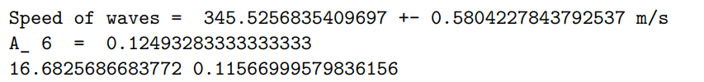

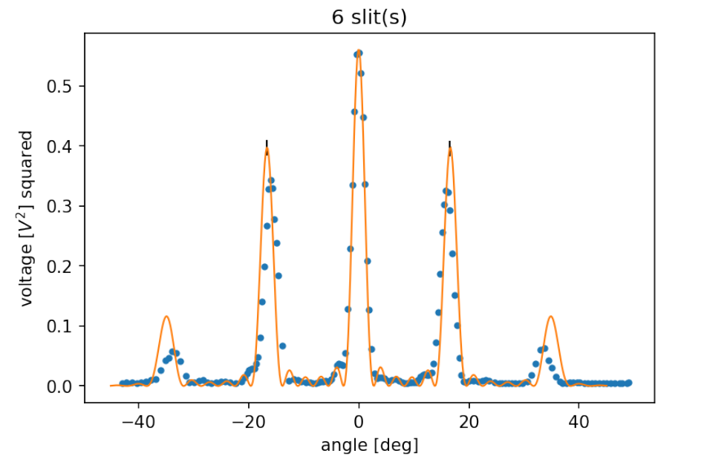

Figure : 6 slit data with expected curve overlayed in orange and black error bars

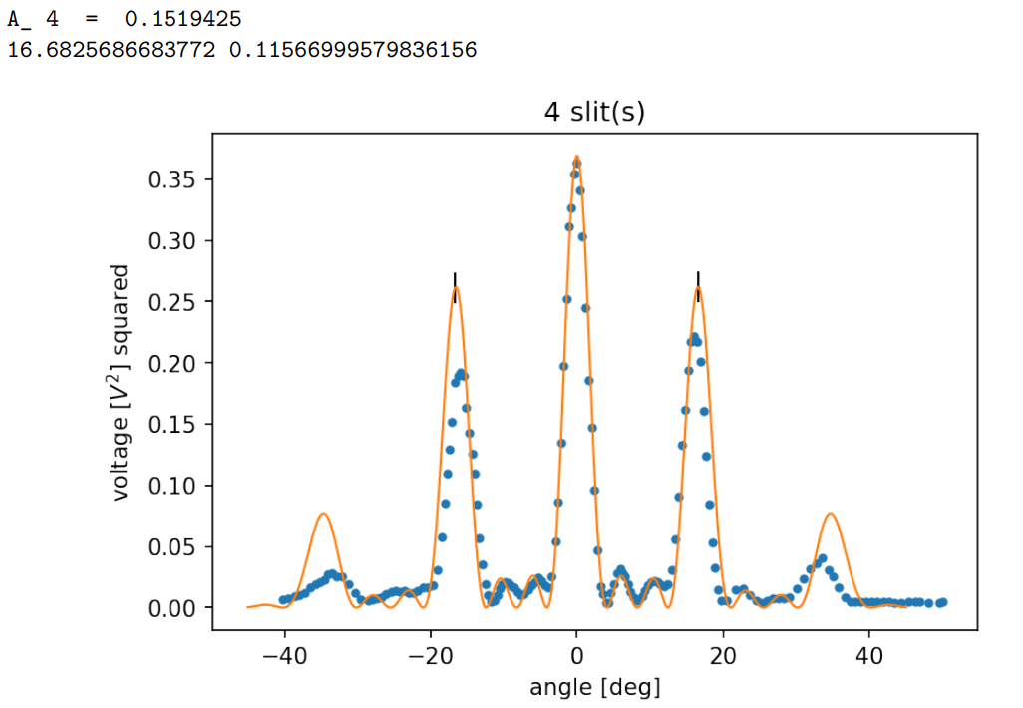

Figure : 4 slit data with expected curve overlayed in orange and black error bars

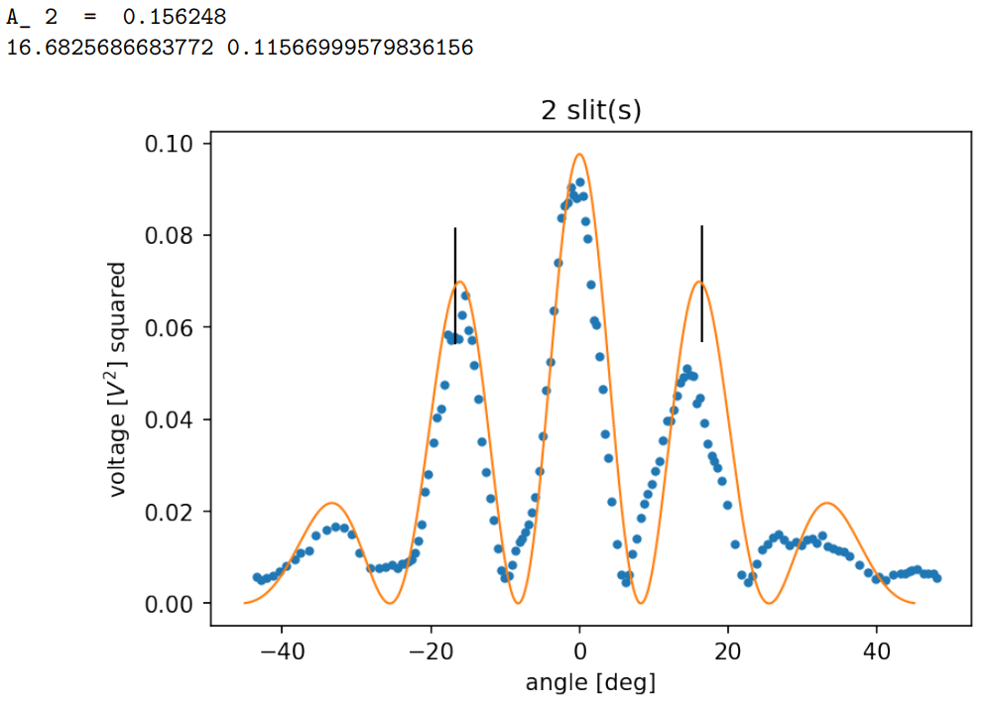

Figure : 2 slit data with expected curve overlayed in orange and black error bars



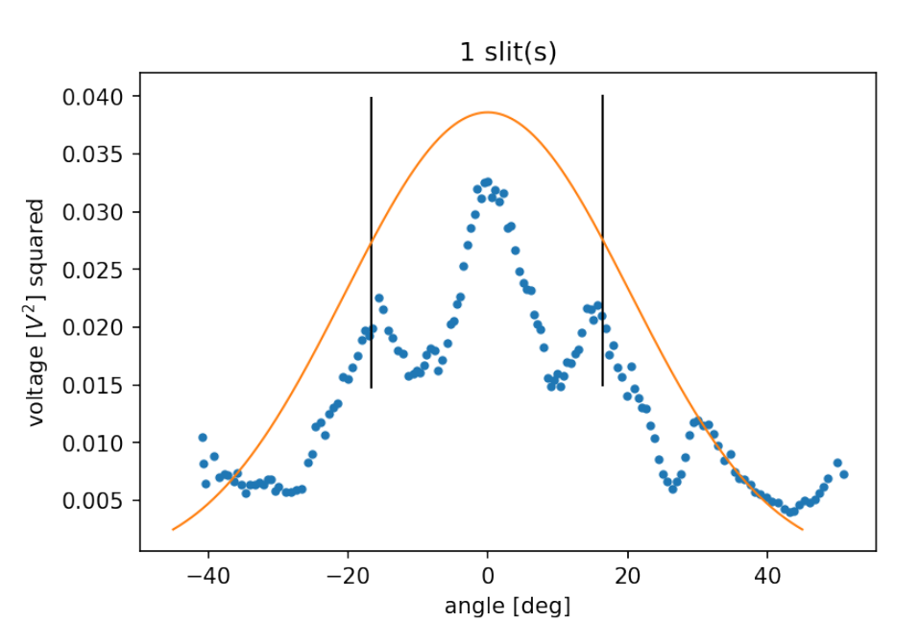

Figure : 1 slit data with expected curve overlayed in orange and black error bars

## Calculations

The peak error was approximately 0.013 V for the predicted results which can be seen as the black lines in the graphs. The error for the peak position was about 0.12 degrees Even though the error bars are there, this error is too small to see on the plots. The errors were calculated using Eq. 1 and Eq. 2.

Amplitude squared was calculated with Eq. 3 and the angle phi was evaluated using Eq. 4. Beta was determined with Eq. 5, speed of soundwaves at room temperature with Eq. 6.

|  |  |
| --- | --- |
| $$∆z={[{\left(∆x\right)}^{2}+ {(∆y)}^{2}]}^{1/2}$$ | 1 |
| $$\frac{∆z}{z}= {[\frac{∆x^{2}}{x^{2}}+\frac{∆y^{2}}{y^{2}}]}^{1/2}$$ | 2 |
| $$A^{2}=A_{N}^{2}*\frac{{\sin\left(\frac{ϕ}{2}\right)}^{2}}{{\left(\frac{ϕ}{2}\right)}^{2}}*\frac{{sin⁡(\frac{Nβ}{2})}^{2}}{{sin⁡(\frac{β}{2})}^{2}}$$ | 3 |
| $$ϕ=kb*sin⁡(θ)$$ | 4 |
| $$β=\left(\frac{2π}{λ}\right)*d*sin⁡(θ)$$ | 5 |
| $$v_{w}=331*√\frac{T}{273.15}$$ | 6 |

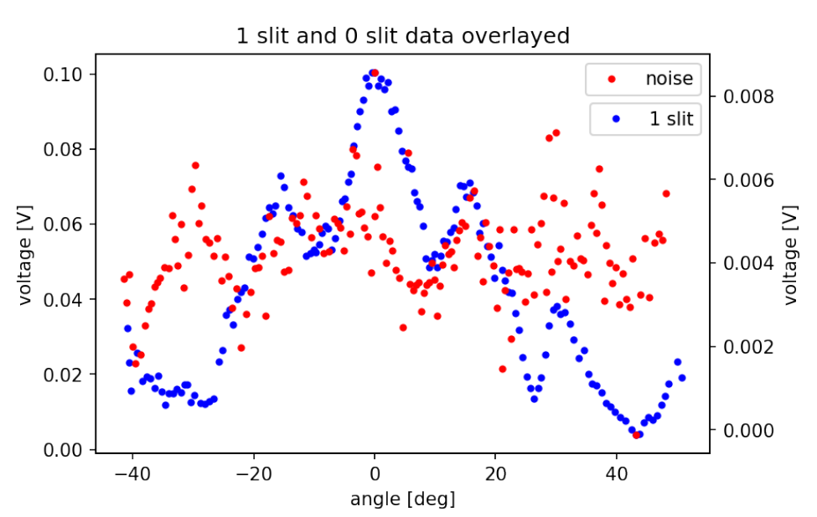

Figure : 1 slit and 0 slit data overlayed with differently scaled y axis to compare them