# Analysis Hysteresis Lab – Benedikt Gregor

## Experiment and procedure

Physical measurements of components were taken. After the measurements we turned on the oscilloscope (2534 digital storage oscilloscope bk precision) and set channel 2 to a function of channel one, pressing horizontal and select x-y. Then we used a BNC to banana plug adapter and inserted it into channel one. Then the cables for the H field coming from the transparent box were plugged into the adapter for the x axis. Then was the B field plugged in for channel 2 also with an adapter and two banana cables.

We slid the iron sample into the secondary coil so that it is centred and then placed on the top of the yoke. With the variac set to 0 we turned it on and gradually increased the voltage. With the increase in voltage the oscillations in the yoke caused an ever louder buzzing sound.

The hysteresis loop started to appear gradually from the centre of the oscilloscope screen. It spread from the middle into its shape. To make the curve smoother the averaging function on the oscilloscope was used by pressing acquire and average for 256 cycles. The voltage was then further increased until the curve spans 400mV on the x axis. The scale was between 50 and 60 on the variac and the amperemeter read 3 on the A.C. scale.

Next, the oscilloscope was set back to the time domain by selecting horizontal, main. The time resolution was set to 5ms per division. Then a USB stick was plugged into the oscilloscope and data was saved with save/load, external storage, new, file type csv.

Iron sample loop progression: The oscilloscope was returned to x-y mode again to examine the hysteresis loop progression. The Variac was turned, and voltage was increased to about 30 on the scale with an amperemeter reading about 0.5. Using the manual cursor with channel one as the source and the scale set to CH1=50mV and CH2=100mV data points were collected. The variac was then increased to 40 on the scale with the amperemeter reading about 1 and the scale is changed to CH1=100mV. Followed up with an increase to 50 with the amperemeter showing about 1.5. Between those settings at least 15 data points were recorded.

Iron sample energy losses: The temperature of the iron sample was measured with an infrared temperature gun by mastercraft reading about 41.2°C. For comparison a 40W lightbulb was also measured which resulted in 42.5 °C.

## Analysis

Using the data visualized in Figure 1 the remanence and coercive force were determined to be 0.597 +- 0.013 T, 108.56 +- 5.43 A/m for iron and 0.443 +- 0.010 T, 3964.76 +- 198.37 A/m for steel. The equations used to calculate the magnetic field and the flux density were Eq. 3 and Eq. 4. All errors here and further in the analysis were calculated using standard deviation for measurements and a mixture of Eq. 1 and Eq. 2 for error propagation.

The iron would be better suited than steel for electric motors because the curve shows that for a small increase in H a big increase in B can be achieved and it is therefore also easier to reverse. It also has a smaller area which means less power loss due to internal heat generation. The steel is better for magnetic memory or a permanent magnet because a larger increase in H is needed to change the field which means it is harder to alter the permanent magnet which is for obvious reasons desirable. Comparing power dissipation calculated and the temperature and wattage of a lightbulb the results make sense. The 40W lightbulb was slightly warmer than the iron and steel yoke. So, an estimate of around 30W is what I would’ve guessed for power dissipation. The calculated numbers lie at 26.51 +- 0.32 W and 16.34 +- 0.20 W for steel and iron using Eq. 5. Steel falls close to the initial estimate. Due to this close resemblance, I see the use of the magnetizing length for steel justified.

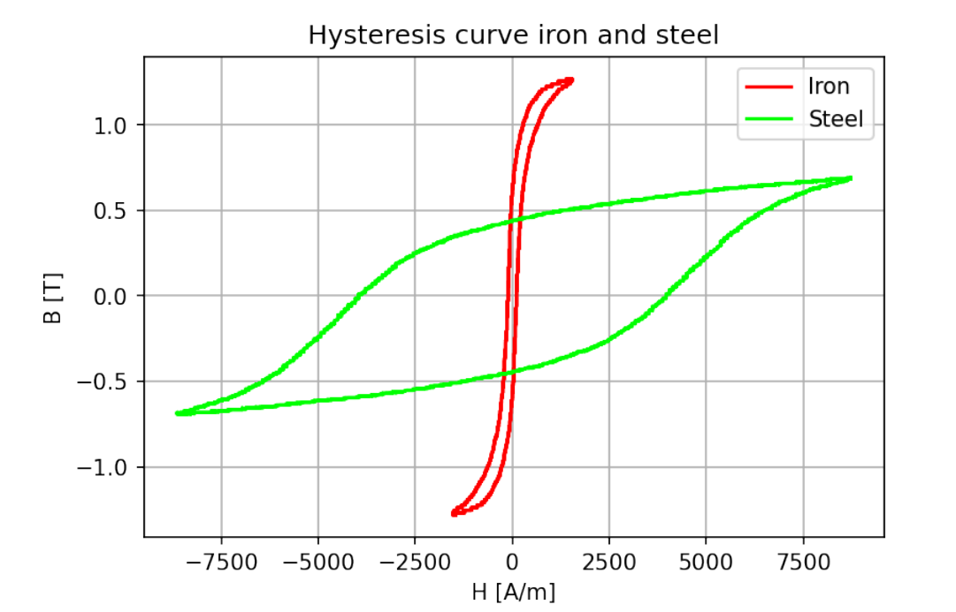

Figure : Hysteresis curve of iron and steel overlayed showing the stark difference of the two materials

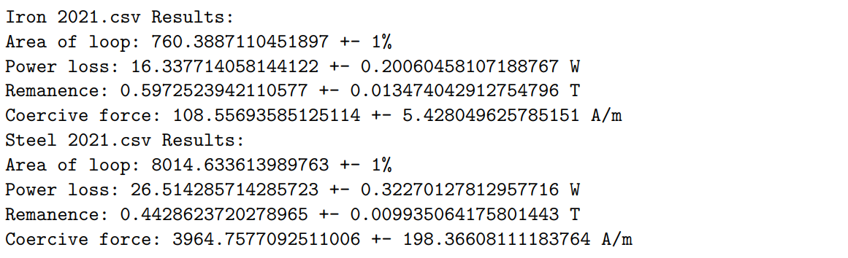

Figure : Values which were calculated using the data shown in Figure 1

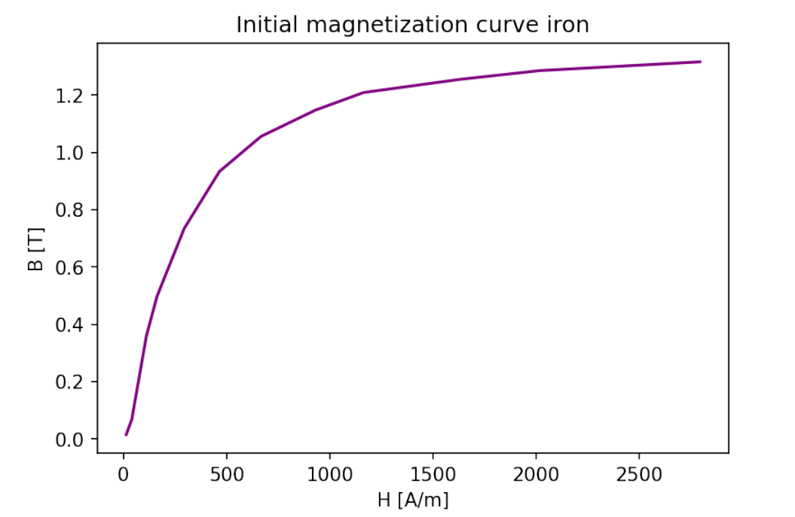

Figure : Initial magnetization curve for iron using 14 data points

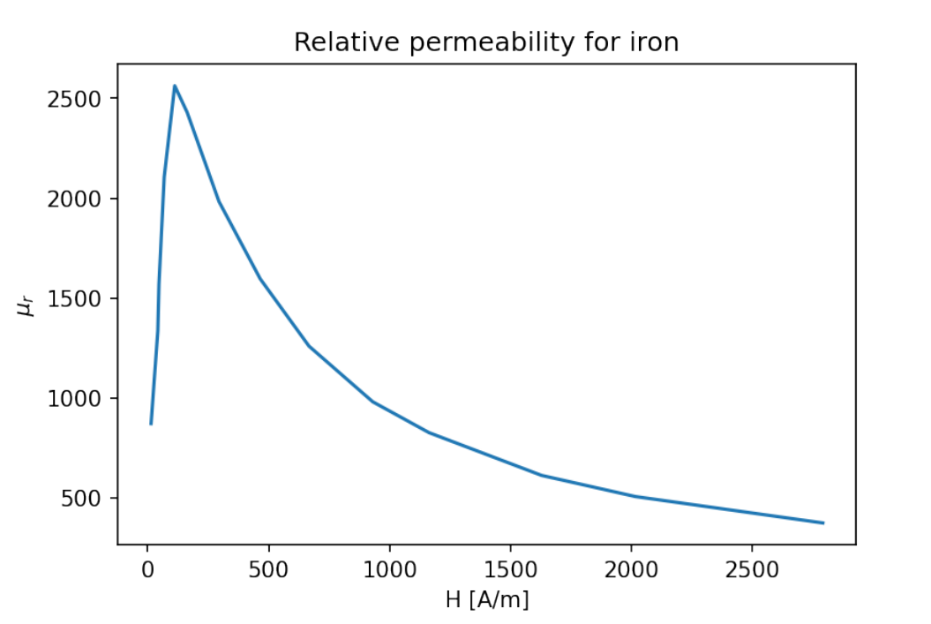

Figure : Permeability of iron shown as a function of H [A/m] relative to the permeability of free space



Figure : Maximum relative permeability for iron and where it occurs

The maximum relative permeability of 99.8% pure iron according to “engineering toolbox” (<https://www.engineeringtoolbox.com/permeability-d_1923.html>) is 5000. Considering that the relative permeability of carbon steel is just 100 there seems to be a wide range for materials based on iron. Under the assumption that the sample and yoke made of iron used aren’t of 99.8% purity the maximum value of 2562.21 +- 140.55 seems realistic. The maximum occurs at 111.66 +- 5.58 A/m. The result for the permeability were obtained using Eq. 6.

Next the effects of plastic and copper spacers on the loop were tested. The spacer was slid between the iron core and the yoke so that it also passes through the secondary coil. With the plastic inserted the variac was turned up to around 70 (5.4 on amp scale) and the hysteresis loop looked more like a curve now with no discernible area using scales: CH1=200mV and CH2=200mV. The copper spacer was only turned up on the variac to about 15 (1.8 on amp) on the scale. The instruments started shaking under the vibrations and the hysteresis loop had become oval shaped, or in other words a big increase in area. This was observed with the scales: CH1=100mV and CH2= 20mV. The big increase in area means higher power loss. The oval shape of the loop also is more centred which means that it doesn’t extend as far out on x and y axes which implies a weaker magnetic field.

The same steps were then conducted with the steel sample. Turning the variac up to about 50 again (3 on amp) the hysteresis curve immediately looks like it has more area than the iron loop with scale CH1=100mV and CH2=100mV. The same can be said here about power loss and the generated magnetic field as with iron and the added spacers.

|  |  |
| --- | --- |
| $$∆z={[{\left(∆x\right)}^{2}+ {(∆y)}^{2}]}^{1/2}$$ | 1 |
| $$\frac{∆z}{z}= {[\frac{∆x^{2}}{x^{2}}+\frac{∆y^{2}}{y^{2}}]}^{1/2}$$ | 2 |
| $$B=\frac{R*C}{n_{2}*A_{c}}*V_{c}$$ | 3 |
| $$H=\frac{n_{1}}{L*S}*V_{s}$$ | 4 |
| $$P=A*V*f$$ | 5 |
| $$μ_{r}=\frac{B}{H*μ_{0}}$$ | 6 |